Bonneville Power Administration

FY 2002 Provincial Project Review

PART 2. Narrative
Project ID: 199901900

Title: Restore Salmon River (Challis ,Id) Area, Idaho

Section 9 of 10. Project description

a. Abstract

Recent geomorphic studies have shown that the cumulative effect of piecemeal bank protection, diking and poor vegetation management during the past century has resulted in a straightening of over 14 miles of river near Challis. This effect has worsened braiding tendencies in the reach, resulting in an unstable channel, increased bank erosion, a high width-to-depth ratio at low flows, and elevated temperatures (over 78oF has been observed). The channel incision has reduced connectivity with the floodplain and associated wetlands. NRCS and IDFG have worked with a County Watershed Advisory Group (WAG) to build a collaborative effort, with cost share funding from NRCS, IDFG, Thompson Creek Mine, USFWS, USFS, BLM, BOR, Army Corps of Engineers, and NMFS. Private landowners also cost-share by conserving land within the corridor, committing to future maintenance and assisting in construction activities. The primary goal of the project is anadromous fish habitat enhancement, but the WAG also plan for enhancement of habitat for resident fish and wildlife, water quality, and management of fine sediments. Locally, this reach of the Salmon river at Challis is referred to as the “twelve-mile reach”.

b. Technical and/or scientific background

The Salmon River at Challis is a degraded river system with extensive diking, rip-rapped banks and instabilities have led to increased width to depth ratios and a tendency to braid. Studies of the geomorphology of the reach, completed during the past two years have documented the recent changes and problems associated with local stabilization projects. The goal of the project is to improve anadromous and resident fish habitat by reducing sediment in the spawning gravels, increase the amount of riparian vegetation and provide adequate instream flows for migration, spawning and rearing in the upper Salmon River basin. This project will also (a) establish effectiveness assessment methodology to evaluate whether the predicted biological and physical outcomes are achieved, (b) increasing trend in number, quality and diversity of fish habitat types (including pools, riffles, runs and glides), (c) increasing riparian vegetation particularly along channel banks and floodplain wetlands, (d) increasing trend in the number, density and percent composition of salmonid fish species - specifically chinook salmon, steelhead trout, bull trout, (e) increasing use of the project reach by indigenous resident fish, waterfowl, upland wildlife and other aquatic, wetland or riparian dependent species and (f) restore/enhance key physical processes.
Several sources of biological data exist. In Challis, on the Salmon River, the Fish and Game has been monitoring chinook spawning by counting redds since the 1950's and monitoring juvenile anadromous and resident fish densities by snorkel surveys since 1991. Similar data exists in the adjoining basins. Physical characteristics of fish habitat are available from several sources. Channel cross-section have been surveyed in 1999 and 2000 and can be compared to 1970 surveys. Geomorphic characteristics and evolution of the study reach (including cottonwoods) has been traced back to 1893. Flow records have been generated or measured for a 70 year period. Temperature has been monitored annually since 19 . Photopoints have also been established throughout the study reach, including at recently monumented cross-sections. On a larger watershed scale, several data sources exist for tracking and comparing project performance including the NWPPC EDT and research efforts by the USFS.

c. Rationale and significance to Regional Programs

SALMON SUBASIN SUMMARY (DRAFT) MAY 25, 2001.
Listed below are the summary goals, objectives, and strategies addressed by this project.
Goal 1. Provide for safe, timely and unobstructed fish migration.
Objective 1. Minimize losses of migrating fishes caused by irrigation withdrawal and diversions.
Strategy 1. Assist the Idaho Fish Screen Program and BoR in prioritizing screening activities and recovery actions in critical occupied anadromous habitat.
Strategy 2. Investigate and implement new low impact diversion and screen structures in cooperation with private landowners, Idaho Fish Screen Program, and BoR.
Strategy 3. Investigate opportunities for securing instream flows (according to Idaho State water laws) through the purchase, lease, exchange, or seasonal rental of water rights in dewatered critical occupied habitat or migration corridors.
Strategy 4. By 2010, restore connectivity by providing adequate flows to at least 50 miles of tributary habitat in the Upper Salmon Subbasin for migrating fluvial trout and char and anadromous fishes.
Objective 2. Reduce the number of physical barriers hindering fish migration.
Strategy 1. Identify and implement remedial actions at problem diversions and fish barriers in conjunction with the IDFG, BLM, USFS, BoR, and Shoshone Bannock Tribes.
Strategy 2. Consolidate irrigation diversions in cooperation with irrigators, IDFG, and BoR where feasible and migration delays can be reduced.
Strategy 3. In cooperation with the NRCS, BoR, IDFG, SBT, and others, design and improve irrigation diversion structures to ensure safe, passable structures and to reduce the impacts of traditional diversions to stream channels.
Goal 2. Improve stream/riparian habitat and water quality for al life stages of fishes.
Objective 1. Reduce sediment and water temperatures to improve water quality and fish spawning/rearing habitat in critical areas.
Strategy 1. By 2010, implement grazing control measures in at least 70 miles of critical occupied habitat to adjust the duration and magnitude of grazing impacts including the use of fences (riparian pastures, exclosures), easements, and /or grazing management plans.
Strategy 2. Riparian vegetation restoration/plantings in areas slow to respond to actions implemented in strategy one.
Strategy 3. In conjunction with the NRCS, IDEQ, SCC, and others, implement feed lot improvements and relocations.
Strategy 4. Pursue off-stream livestock water development in sensitive areas to protect/reestablish riparian values.
Strategy 5. Work with private and public landowners to implement floodplain restoration in simplified streamside habitats in priority areas.
Strategy 6. Work cooperatively with willing irrigators to restore streamflows in dewatered tributary stream reaches where cooperative agreements can be negotiated and resource benefits are maximized.
Strategy 7. Continue development of the IMPACT model in the Upper Salmon Basin with the University of Idaho to determine priority sequence for the above strategies.

The goals and objectives from the Salmon Subbasin Summary will be implemented by means of the foregoing strategies through the coordination efforts of this Salmon River (Challis) Watershed Project. The purpose of the project is to ensure that all human activities affecting salmon production within this ecologically important reach are coordinated on a comprehensive watershed basis.

2000 COLUMBIA RIVER BASIN FISH AND WILDLIFE PROGRAM

Objectives for biological performance

Anadromous fish losses
- Halt declining trends in salmon and steelhead populations above Bonneville Dam by 2005. Obtain the information necessary to begin restoring the characteristics of healthy lamprey populations.
- Restore the widest possible set of healthy naturally reproducing populations of salmon and steelhead in each relevant province by 2012. Healthy populations are defined as having an 80 percent probability of maintaining themselves for 200 years at a level that can support harvest rates of at least 30 percent.
- Increase total adult salmon and steelhead runs above Bonneville Dam by 2025 to an average of 5 million annually in a manner that supports tribal and non-tribal harvest. Within 100 years achieve population characteristics that, while fluctuating due to natural variability, represent on average full mitigation for losses of anadromous fish.

This proposed project will restore the natural physical processes throughout the Salmon River at Challis, which will restore fish habitat in a sustainable manner, restore connectivity with side channels and floodplain and lower temperatures.

Resident fish losses
- Maintain and restore healthy ecosystems and watersheds, which preserve functional links among ecosystem elements to ensure the continued persistence, health and diversity of all species including game fish species, non-game fish species, and other organisms.
- Protect and expand habitat and ecosystem functions as the means to significantly increase the abundance, productivity, and life history diversity of resident fish at least to extent they have been affected by the development and operation of the hydrosystem.
- Achieve population characteristics of these species within 100 years that, while fluctuating due to natural variability, represent on average full mitigation for losses of resident fish.

Watershed actions for the protection, restoration, and complexity of fish habitat enhance ecosystems and ecosystem function which are beneficial to resident and anadromous fish.

Wildlife losses
- Coordinate mitigation activities throughout the basin and with fish mitigation and restoration efforts, specifically by coordinating habitat restoration and acquisition with aquatic habitats to promote connectivity of terrestrial and aquatic areas.
- Maintain existing and created habitat values.

Watershed actions for the protection, restoration, and complexity of fish habitat enhance ecosystems and ecosystem functions beneficial to wildlife species.

Habitat Strategies

Primary strategy: Identify the current condition and biological potential of the habitat, and then protect or restore it to the extent described in the biological objectives.
- Build from strength
- Restore ecosystems, not just single species
- Use native species wherever feasible

Habitat projects coordinated Salmon River restoration project at Challis focus on protection of existing high quality habitat, restoration of ecosystems which support multi-species, and revegetation practices which emphasize use of native plant species.

2000 FCRPS BIOLOGICAL OPINION, DECEMBER 21, 2000.

Action 149b: The Corps shall implement demonstration projects to improve habitat in subbasins where water diversion-related problems could cause take of listed species.
Action 149c: BPA addresses passage, screening, and flow problems where they are not the responsibility of others.
Action 150: In subbasins with listed salmon and steelhead, BPA shall fund protection of currently productive non-federal habitat, especially if at risk of being degraded.
Action 151: BPA shall, in coordination with NMFS, experiment with innovative ways to increase tributary flows by, for example, establishing a water brokerage.
Action 152: The Action Agencies shall coordinate their efforts and support offsite habitat enhancement measures undertaken by other Federal agencies, states, Tribes, and local governments by the following:
Action 152a: Supporting development of state or Tribal 303(d) lists and TMDLs by sharing water quality information, project reports, and data.
Action 152 b: Participating, as appropriate, in TMDL coordination or consultation meetings or work groups.
Action 152c: Using or building or building on data management structures, so all agencies will share water quality and habitat, data, databases, data management, and quality assurance.
Action 152d: Participating in the NWPPC’s Provincial Review meetings and subbasin assessment and planning efforts, including work groups.
Action 152e: Sharing technical expertise and training with Federal, state, tribal, regional, and local entities (such as watershed councils or private landowners).
Action 152f: Leveraging funding resources through cooperative projects, agreements and policy development (e.g., cooperation on a whole-river temperature or water quality monitoring or modeling project).
Action 153: BPA shall, working with agricultural incentive programs such as the Conservation Reserve Enhancement Program, negotiate and fund long-term protection for 100 miles of riparian buffers per year in accordance with criteria BMP and NMFS will develop by June 1, 2001.
Action 154a: BPA shall work with the NWPPC to ensure development and updating of subbasin assessments and plans; match state and local funding for coordinated development of watershed assessments and plans; and help fund technical support for subbasin and watershed plan implementation from 2001 to 2006.
Action 154b: The action agencies will work with other Federal agencies to ensure that subbasin and watershed assessments and plans are coordinated across non-federal and federal land ownerships and programs.
Action 183: Implement at least three tier3 habitat effectiveness monitoring studies within each ESU by 2003. In addition, at least two studies focusing on each major management action must take place within the Columbia River Basin.

This project will contribute to all of the above actions in the upper Salmon basin. The project will be under the guidance of the Upper Salmon Basin Watershed Project, the Custer Soil and Water Conservation District and the Idaho Governor’s Office of Species Conservation.
- Habitat demonstration projects – Currently working with Corps of Engineers on the Challis reach of the Salmon River to restore the natural flood plain function.
- Protection of productive non-federal habitat – Work with SWCDs, NRCS, and ISCC, IDEQ, BoR, and BPA in coordinating technical and financial assistance for habitat protection and enhancement projects on private land. This coordination is especially important as most fish spawning and rearing habitat is on private land.
- Habitat enhancement projects – Coordinate and prioritize on-the-ground projects through the USBWP Technical Team and Advisory Committee to assure effectiveness and consistency for project application.
- Data management - Maintain existing project data base and continue to compile available physical and biological information into a common, web-accessible data base.
- Assessments and plans – Provide information in the development of subbasin assessment and plans in Upper Salmon River Basin – particularly related to temperature modeling through the mainstem Salmon River..
- Funding integration – Bring together funds from all available sources to achieve fish habitat goals. Funds currently being integrated include: Private landowners; BPA; US Army Corps of Engineers, Bureau of Reclamation; Idaho Department of Fish and Game; Natural Resources Conservation Service-Environmental Quality Incentive Program, Cooperative River Basin Study, Continuous Conservation Reserve Program, and Small Watershed Program; EPA-319 program; Idaho Soil Conservation Commission – Water Quality Program for Agriculture and Resource Conservation and Rangeland Development Program; U.S. Fish and Wildlife Service – Partners for Wildlife Program.
- Long term habitat protection – Acquisition of easements and fee title will is being used for long term protection.
- River temperature, water quality monitoring, and modeling - We are using available predictive tools such as Mike-11 to incorporate data collected from temperature monitors, USGS gage stations, and sediment traps to refine habitat restoration strategies and to prioritize restoration opportunities on non-federal lands within the watershed.

RECOMMENDATIONS OF THE GOVERNORS OF IDAHO, MONTANA, OREGON AND WASHINGTON FOR THE PROTECTION AND RESTORATION OF FISH IN THE COLUMBIA RIVER BASIN
July, 2000

Partnerships
- Because much of the habitat is on non-federal lands, state, tribal and local governments, as well as private landowners, must be full partners in the recovery effort.

Water for Fish
- Stream and river reaches throughout the Columbia River Basin have flow and water quality problems that impede regional fish recovery efforts.
- We support voluntary exchanges to obtain needed water for fish and support the development of water markets to effect exchanges among willing buyers and sellers. We believe this strategy has potential to contribute to fish recovery, and we are committed to support changes in state law or policies to facilitate this
- Building upon successes elsewhere, we endorse creation of salmon sanctuaries that protect key aquatic habitats and related uplands through voluntary conservation easements, leases, land purchases, and tax-incentive donations.

Local Recovery Plans
- We strongly endorse the concept of local planning for recovery of salmonids and other aquatic species. This concept has the advantage of bringing together local and tribal governments with local citizens to develop and implement local recovery plans.

Fish Passage
- In the Columbia River Basin, over one-half of the original habitat area for salmon and steelhead has been blocked by mainstem and tributary dams.
- For the mainstem Columbia and Snake rivers, we must focus not only on currently accessible habitat, but also look for opportunities to increase the current level of habitat access with all dams remaining in place.
- Each state commits, by October 1 this year and annually thereafter, to provide a list of priority fish passage projects to the Council for proposed funding. The list could include such things as screening diversions and replacing culverts, as well as removal of, or passage at, tributary dams.

The project addresses the Governor’s recommendations by:
- Partnerships between the local landowners, federal agencies, state agencies and the local Soil and Water Conservation District
- This is a local recovery plan – conceived and developed in the Challis-Salmon region.
- The project will improve habitat and water quality

This project has identified the instabilities in the Twelve-Mile reach, that include channel degradation, braiding and high width-depth ratios. Temperatures through this reach have reached 79ºF in recent years. Channel instability has resulted in extensive bank erosion, loss of land, riprapping of channel banks and levees. This project attempts to take a holistic view to improve habitat, reduce temperatures, restore floodplain function and reduce fine sediments from bank erosion.

d. Relationships to other projects

Upper Salmon Basin Watershed Project Administration/Implementation Support, Project No. 199202603

Idaho Upper Salmon Basin Watershed Habitat Projects, Project No. 199401700
Salmon River Anadromous Fish Passage Enhancement, Project No. 199306200
Upper Salmon River Diversion Consolidation Project, No. 199600700
East Fork Easement, Project No. High Priority
Through the USBWP technical team and the CSWCDs, site-specific habitat limitations in the project area are identified and priorities established for on-the-ground habitat protection and restoration projects. Technical assistance to landowners and financial assistance for project installation is coordinated through the USBWP to ensure technical integrity of project installation, consistency in project application among land owners, and to respond to RPAs 149, 150, 151, 152, 153 and 154.

In FY 02 the USBWP will be restructured consistent with a geographic approach for project selection, planning, implementation, and monitoring. The temperature and flow modeling being undertaken as part of this project will allow the cumulative benefits of other projects in the sub-basin to be assessed through the use of key indicator parameters.

Salmon River Section 206 Aquatic Ecosystem Restoration – US Army Corps of Engineers

The Walla Walla District Corps of Engineers is conducting a Feasibility Study under Section 206, Aquatic Ecosystem Restoration on the 12 mile reach of the Salmon River near Challis, Idaho. The study is being conducted in partnership with the Custer Soil and Water Conservation District, Bonneville Power Administration, University of Idaho (U of I), Idaho Fish and Game, Upper Salmon Basin Watershed Project and others. One of the major goals of the study is to meet specific habitat needs for Snake River spring/summer Chinook salmon, steelhead and bull trout listed under the Endangered Species Act. Chinook salmon use the Round Valley reach of the Salmon River as a holding area for adults and a rearing area for juveniles with a small amount of spawning occurring. Steelhead use the area as a holding area for adults, a rearing area for juveniles with significant spawning occurring within the reach. Bull trout likely pass through the area seasonally with some adults and juveniles overwintering in the area.

Habitat and natural river functioning have been impeded by various human-induced practices since settlement in the valley. In addition to improving habitat conditions for fish, the partners in this restoration effort wish to restore, to the extent possible, natural floodplain functioning to provide a healthy functional river system. To accomplish this, private landowners will have to become an integral part of the project by providing lands where a variety of restoration measures can be implemented.

The U of I has conducted conceptual hydraulic modeling of the reach that visually demonstrates floodplain areas prone to inundation under various flow levels. This modeling will be used to develop site-specific plans on individual land-owners’ parcels. The intent will be to satisfy the landowners’ needs (e.g., bank erosion) while providing environmental benefits and fairly compensate the landowners for the use of their lands. Measures may include development of a riparian corridor, construction of habitat and cover structures, fencing, opening of side channels for periodic flooding, and removing or breaching of existing flood control structures.

The feasibility portion of this project is expected to be completed in late winter of 2002 with construction beginning during the summer of 2002. Construction is likely to occur over the course of several years as different landowners become partners.

This collaborative effort between the CCWSD, the Corps of Engineers and other agencies is an important feature of this large-scale restoration initiative which allows agency expertise and funding to be shared.

e. Project history (for ongoing projects)

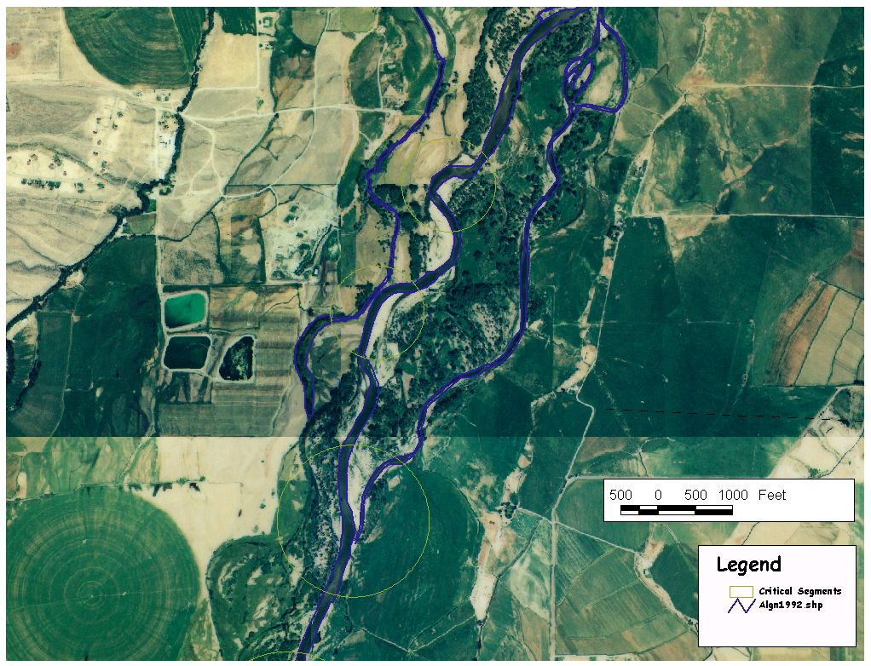
Initial project funding occurred on October 1, 1998. Preliminary concepts of possible strategies for river restoration were developed with local agencies and landowners. Concerns were raised about the risks of induced flooding or accelerated bank erosion if “piecemeal” implementation of bank stabilization is undertaken. A geomorphic analysis has been undertaken that shows how
Meanders move downstream
Higher flows likely in East Branch

Figure 1: Identification of stable and unstable reaches from historic channel mapping

the channel has evolved during the past century, identified the most active and unstable channel reaches and indications of how the channel might evolve in the future with no restoration action.
An aerial survey and ground survey of the upper reach of the river and floodplain in the study area has been completed, allowing detailed GIS coverages to be prepared.

In addition, a hydrodynamic model has been developed for the study area and flows can be simulated under lowflow and highflow conditions. This model has allowed different floodplain restoration alternatives to be evaluated and the risk of induced flooding of property as a result of restoration to be assessed. The model provides animations of flood conditions superimposed on either aerial photographs or DEMs.

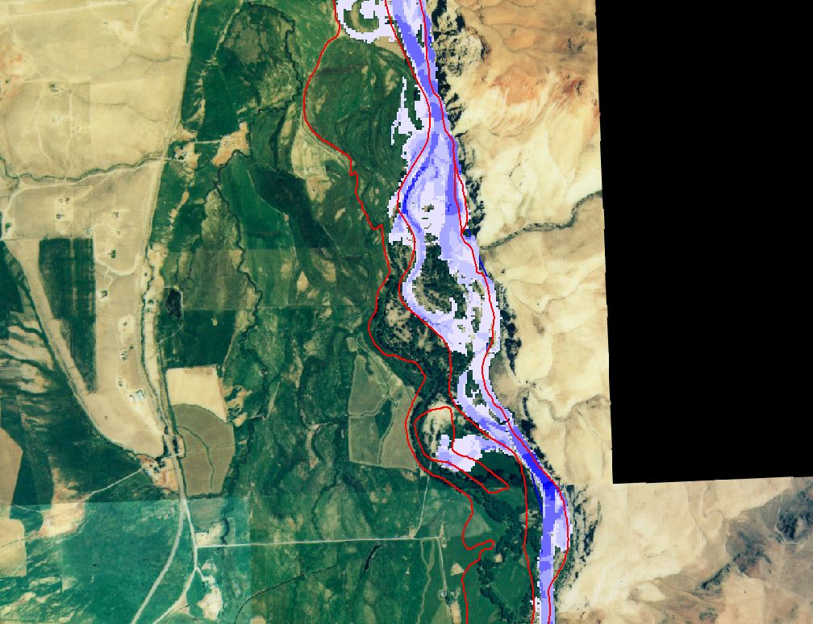
Figure 2: Example of simulated 1996 flood superimposed over aerial imagery

Development of a riparian or meander corridor and site specific plans for individual landowners is now in progress. Riparian Enhancement and fencing and bank stabilization on 0.75 miles of river channel has been completed.

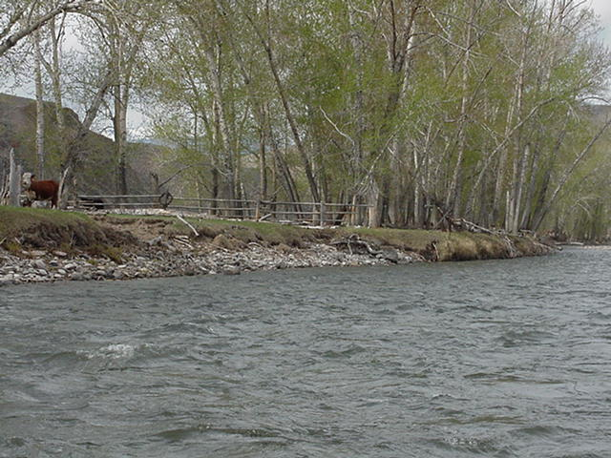
Figure 3: Example of a typical benefit of fencing within the Twelvemile Reach

In 1999, the Walla Walla District of the Corps of Engineers (COE), offered to partner with the Custer County Soil and Water Conservation District to provide federal assistance in the implementation of the project. The COE is providing planning and engineering assistance to this project.
f. Proposal objectives, tasks and methods

Planning and Design

Objective 1. Establish Database for Design and Adaptive Management of the Twelve-mile Reach

Task a. Compile available physical and biological information into a common, web-accessible database maintained by a state agency to be identified in early 2002.
Method: A diverse range of agencies, universities and other entities are collecting data in this region. A data/monitoring meeting will be convened that outlines required data format for information reporting, schedule for data submission, and data quality control protocols. For the first two years, this database will be assembled and managed through the Computational Center of the Ecohydraulics Research Group at the University of Idaho. During this period the CSWCD, Office of Species Conservtion (OSC) and Upper Salmon Basin Watershed Project (USBWP) will decide on the most appropriate longterm location for this web-accessible database.
Results: GIS coverages, database of information related to physical conditions, habitat and aquatic resources. Most data will be made available through a web portal.

Task b. Prepare a written report to summarize existing information on habitat conditions biological conditions and fish status within the watershed and on the status of natural processes affecting the formation, maintenance, and quality of this habitat.
Task c. Identify data gaps and outline an approach to filling them, in the same written report.

Method (tasks b and c): One version of a draft report will be prepared, and one version of the final report will be posted on the Twelve-Mile website.
Results: A database and a report describing available data and gaps-in-data.

Objective 2. Use available predictive or other tools (including EDT and others) to build on existing knowledge, to refine habitat strategies, and to help prioritize restoration opportunities on non-federal lands in the watershed.

Task a. USBWP Technical Team and others will use the results of tasks 1a-c, EDT, MIKE-11 or other appropriate models to predict habitat trends, future conditions, and the relative benefits of varied habitat strategies and measures.
Task b. A temperature model of the mainstem Salmon River will be applied to address the severe concerns of some USBWP Technical Team members about the high and low temperature extremes in the river. Current water temperatures on the Salmon River are extreme for salmonids. Winter water temperatures may be sub-freezing during nighttime lows. Summer water temperatures may exceed 70 degrees fahrenheit frequently during the afternoon with daily fluctuations of 15 degrees fahrenheit on a day/night cycle. These water temperature extremes stress trout and salmon, certainly reducing growth potential and possibly causing direct mortality and thermal barriers. Most salmonids exhibit optimal growth with water temperatures in the mid-to-upper 50 degree fahrenheit range. Water temperatures should not fall below 32 degrees F and not rise above 70 degrees F to limit direct mortality to salmonids. As a general guideline, optimal growth for salmonids will occur when water temperature extremes range only from 38 degrees to 68 degrees, and the mean annual water temperatures hover near 55 degrees. Three on-the-ground actions may be used to improve water temperature regimes. 1. Shading – planting willows and cottonwoods or other vegetation will provide shade and moderate temperature extremes (most effective in smaller streams). 2. Flow – increasing water flow from tributary streams or reducing diversions will moderate temperature fluctuations. 3. Reducing the width to depth ratio will reduce heat loss and heat gain, thus buffering temperature extremes. Study design should provide which actions could provide the best water temperature regime for salmonids by river section (ie: in some river sections reducing river width may be more practical than other river sections), and how much of each action would be required to bring temperatures within acceptable ranges. This analysis will also include the relations between geomorphic characteristics and thermal barriers or problems: decreased width to depth ratio (and what this does to thermal gain), frequency and depth of pools, quantifying the value of pools as thermal refugia, quantifying how pool habitat is improved as a result of restoration activities.

Task c. USBWP Advisory Committee will work collaboratively with the Technical Team to prioritize available restoration opportunities in a way consistent with the Basin-wide Salmon Recovery Strategy and Sub-basin Summary and Assessment.

Methods: Several tools are being developed for the Upper Salmon region (NMFS, EDT and USFS). The focus of this objective is to develop the physical process models that can feed more refined and accurate information into fish population and viability models used by other agencies. The physical models will also be used directly to assess the consequences of restoration activities. The model used is MIKE-11 (DHI Water and Environment) and was selected due its graphical interface, documentation, direct integration with ARCView and ArcInfo, rigorous treatment of the temperature budget (in a simplified or comprehensive options), compatibility with other modeling efforts by the State of Idaho Department of Water Resources. The model will be able to predict flows, velocities, depths, and temperatures.
The results of all these models will be reviewed in the context of regional planning initiatives for fish and wildlife, and a list of the most important projects from scientific criteria will be assembled. This list of priorities will then be compared with the regions of willing landowners and the ability of individual projects to be maintained in the longterm. Finally, the list of projects throughout the entire reach of the mainstem will be reviewed to ensure that a phased implementation strategy will not result in induced temporary destabilization of the channel, induced flooding or other adverse impacts. For example a region of floodplain restoration and levee removal could flood areas proposed for future phases of restoration.
Expected Results: A calibrated temperature model of the study reach will be prepared. For the study reach, the relative importance of shading, geomorphic characteristics and increased tributary flows will be assessed in the main channel. Side channels and tributaries. A consensus of restoration actions in a phased approach throughout the study area.

Objective 3. Complete project designs for selected restoration opportunities, by working closely with landowners, local community and agencies.

Task a. Use Mike-11 and/or other physical models where appropriate to predict future conditions and refine project designs.
Task b. Complete preliminary engineering and design work for projects throughout study reach.
Task c. USBWP Biologist will contribute information the Environmental Compliance Specialist (funded under BPA Contract 1992-026-03) needs to complete written biological assessments.
Task d. USBWP Biologist will assist the Environmental Compliance Specialist in conducting environmental surveys and completing associated documents (NEPA, HAZMAT).
Task e. USBWP Biologist will help a cultural resources specialist assess potential project impacts and assure design adjustments where appropriate.
Task f. Prepare final design packages.
Task g. USBWP Biologist will assist the Environmental Compliance Specialist in obtaining needed permits.
Task h. USBWP Biologist and Engineer will help the Environmental Compliance Specialist assemble information needed to procure appraisals for acquisition of fee titles or easements.

Methods: The COE planning and engineering sections will work with CCSWCD and USBWP consultants and representatives to develop the final designs and documentation.
Expected Results: Detailed designs of each specific restoration activity will be prepared. Examples will include extent of the floodplain or wetlands designated as conservation easements or detailed engineering drawings of biostabilization measures. The documentation will include permits, and fee titles or easement arrangements.

Objective 4. Quantify benefits at the watershed scale - particularly related to temperature and fine sediments

Task a: Identify major causes and locations of thermal gains (adjust monitoring as necessary)
Task b. Identify sources and sinks of fine sediment through study reach
Task c: Extend hydrodynamic model to include temperature
Task d: Estimate local and watershed temperature benefits for different restoration strategies

Methods: One of the key questions raised by the ISRP and other independent reviewers in the subbasin is quantifying the benefits of restoration projects such as the Twelve-mile project at the subbasin level. This series of tasks uses the combination of monitoring data and the MIKE-11 model to (a) identify the most significant factors in extreme high or low temperatures, (b) assess the temperature changes associated with changes in the physical characteristics as a result of specific restoration actions (c) using the model, predict how far downstream these benefits would remain significant (d) introduce the concept of scale. For example, shade may be most important in the side channels, but have relatively little influence on the main Salmon River
Expected Results: This approach will quantify the benefits of restoration actions on geomorphic characteristics and temperature. This analysis will allow conclusions to be made on the relative environmental benefit of individual actions, and the spatial extent that the benefit is significant.

Objective 5. Obtain permits and agency approvals

Task a: Submit stream alteration permit to US Army Corps of Engineers and Idaho Department of Water Resources
Task b: Consult as necessary for ESA species

Methods: The time frame to achieve permits will be determined and dates for the permit application set to ensure the permits are available for each construction season.
Expected Results: Permits obtained prior to each construction season.

Construction and Implementation

Objective 1. Implementation and restoration and bank stabilization work on the Twelve- mile section of Salmon River
Task a. Develop alternative management practices which include fencing riparian areas.
Task b. Complete final engineering documents for major biostabilization sections of channel
Task c. Construct biostabilization elements.
Task d. Reduce/remove selected dikes and levees
Task e. Remove riprap/concrete blocks/construction debris in selected locations to promote natural meandering tendencies and allow vegetated banks

Methods:
- Install restoration features including bioengineered bank treatments and grade control structures. Deformable, bioengineering features are installed to stabilize highly erodable streambank areas until native riparian vegetation establishes to provide the long-term stabilizing force. Rock grade control structures are located as necessary to either raise low-flow surface water elevations or to check further channel bed degradation.
- Provide on-site construction communications. Effective coordination of field season activities ensures all in-channel work is completed within the narrow construction window imposed by regulations protecting important life stages of fish and wildlife and habitat.
- Supervise and manage restoration activities. Management personnel remain on-site during the implementation phase to supervise construction activities, coordinate various work crews, transfer information, and provide administrative support. Field season activities are planned carefully to minimize impacts to other land uses within the watershed. DEQ is kept informed at all times of water quality status during project implementation.

Expected Results: A coordinated and phased approach that progressively creates the plan identified in Planning and Design Phase.

.
Objective 2. Restore meadow and riparian plant communities
Task a. Collect and/or grow plant material.
Task b. Plant seedlings and willow poles in areas slow to respond to other management changes.
Task c. Install erosion control fabric and/or seed

Methods:
- Collect seed and willow poles and grow plant material. The seed will be cleaned and stored in a commercial greenhouse facility. Seed is stratified and sown in trays for greenhouse production of container seedlings early in 2002. Willow poles are planted one year post construction. During early spring of 2003, willow poles will be collected and trimmed. The poles are stored, in dormant condition, sealed in shrink-wrap, in a dark nursery cooler until out-planting.
- Plant seedlings and willow poles. Willow pole planting can begin as early as mid-April depending on weather and soil conditions. Container seedlings can be planted beginning in early June to ensure sufficient root growth, plant development, and high survival rates. Plants are installed at locations and densities predetermined by the revegetation specifications, soil erosion potential of various stream reaches, and hydrologic requirements of individual plant species. Irrigation is routinely supplied during the first planting season to improve survival of planted seedlings and willow poles and to ensure vigorous, healthy root systems that are able to provide some protection to newly constructed streambanks against spring flood flows.
- Install erosion control fabric, sedge/meadow sod, and seed. Newly exposed streambank soils and construction equipment travel corridors are extremely vulnerable to erosive forces. These areas are seeded with a native seed mix, planted with salvaged sedge/meadow sod, and/or protected with bioengineered bank treatments. Erosion control fabric is installed on banks with the highest erosion potential.

Expected Results:
Accelerate re-establishment of wetland and meadow plant communities.

Objective 3. Allocate critical conservation/access easements
Task a. Work with landowners to develop easements - to allow river to naturally recapture its meandering planform and restore floodplain function
Task b: Acquire easements and fee titles from willing landowners, for long-term habitat protection.

Methods: Secure conservation easements. Continue to explore easement options with private landowners within the lower meadow. Coordinate the easement process with real-estate easement specialists, land appraisers, environmental protection specialists, attorneys, landowners, and easement holders. Use computer graphics, animation of flood events and geomorphic mapping to explain the importance of any easements and to assist landowners in deciding if they wish to participate in this program.

Expected Results: An integrate series of easements, flow paths, back channels and wetlands.

Objective 4. Oversee contractors during construction projects.
Task a. Conduct ongoing engineering inspections.
Task b. Complete final engineering inspection and sign off on completed work.

Methods: Engineer will conduct site inspections and sign off on funded work to ensure it has been completed in accordance with design specifications.
Expected Results: A means of tracking completed work is in available.

Operation and Maintenance

Objective 1: Use an adaptive management approach to protect investments directed toward habitat restoration and to ensure that restoration objectives are achieved.
Task a. Review annual M&E results (see Task 3a) and identify necessary actions.
Task b. Modify project approaches and/or design criteria as needed to improve effectiveness.
Task c: Management and/or replant vegetation as necessary
Task d. Maintain access roads as necessary
Task e. Repair wildlife/stock exclusion areas
Task f. Perform any adaptive management actions identified by monitoring program and approved by Watershed Advisory Group

Methods:

- Manage and/or replant vegetation as necessary. Vegetation remains critical for developing the stability and integrity of constructed and existing streambanks on the LRRMRP. The potential exists for newly established seedings, seedlings, or willow poles to fail to grow or thrive for any number of factors. This task ensures that some measure are taken to maintain diverse and healthy vegetation, particularly in critical areas.
- Maintain access roads and projects as necessary.
- Perform any adaptive management actions identified by the monitoring program and approved by the CCWD and USBWP. The monitoring program and adaptive managment feedback loop is designed to highlight variations from expected outcomes.
Expected Results:
The project area should function as projected in the Planning and Design phase.

Monitoring and Evaluation

Objective 1: Implementation Monitoring. Ensure biostabilization and other activities are constructed as intended by Watershed Group and permit conditions are met

Task a: Collect short-term monitoring data including as-built surveys, construction related turbidity and Watershed Group field reviews.
Task b. Document and analyze implementation (short-term) monitoring data.

Objective 2: Effectiveness Monitoring. Evaluate the performance of features to restore stream channel and floodplain function, enhance fish and wildlife habitat and reestablish indigenous native riparian plant communities

Task a. Refine long-term monitoring program for completeness and cost-effectiveness
Task b. Collect longterm monitoring data to measure sediment balance, bank erosion, substrate, temperature, vegetative canopy, other fish habitat metrics, floodplain and wetland function.
Task c. Compile, analyze and report longterm monitoring data.
Task d. Feedback to future design phases through adaptive management
Task e. Summary of information and experiences to provide guidelines for other projects in the Upper Salmon Basin.

Objective 3: Review and recommendations – implementation of adaptive management in the design, implementation and post-construction phases.

Task a. Evaluate monitoring data annually and recommend appropriate refinements to USBWP predictive tools, restoration priorities, and programs. Summarize these evaluations and resultant recommendations in a written report every year.
Task b. Post annual monitoring report to the website.
Task c. A pre-construction field tour and review of the monitoring program will be organized in March.
Task d. A post flood and post-construction field tour will be conducted in October. Field tours are open to the Watershed group and all interested parties.

Methods:
The expanded and coordinated monitoring program for the entire Upper Salmon Subbasin is a major development from previous years. The monitoring undertaken for the Salmon River at Challis will contribute to the Subbasin Monitoring Program.

Expected Results: A coordinated monitoring program across the subbasin. Past data and new annual monitoring will be synthesized and stored –at the University of Idaho for the first two years. This need was identified during the Salmon Subbasin Summary.

g. Facilities and equipment

No major facilities of equipment is requested in this proposal.

h. References

Reference (include web address if available online) | Submitted w/form (y/n)
Upper Salmon Basin Watershed Plan  Upper Salmon River Basin Stream Habitat Inventory Report:  Upper Salmon Basin Watershed Studies: http://www.efw.bpa.gov/cgi-bin/ws.exe/websql.dir/FW/PROJECTS/ProjectSummary. | N  N  N

Section 10 of 10. Key personnel

Mike Larkin - Salmon Region’s Fish Manager (Full Time) for the Idaho Department of Fish and Game for the last seven years. Mike, as a member of the Model Watershed Technical Team, has been involved in numerous habitat enhancement and water conservation projects. Prior to his position in Salmon, Mike held the Statewide Resident Fish Hatchery Managers position in IDFG’s headquarters office in Boise. In that position Mike provided oversight on numerous hatchery construction and remodeling projects. Mike has trained and supervised over 50 permanent and temporary fisheries employee’s during his diverse career in fisheries. Mikes career in fisheries spans over 25 years. He has worked in Iowa, Utah, and Idaho.

Education:
Utah State University BS Fisheries Biology
University of Idaho MS Fisheries Resources

Tom Curet is a Regional Fisheries Biologist (Full Time) for the Idaho Department of Fish and Game. Tom is also a member of the Model Watershed Technical Team has also been involved in numerous habitat enhancement and water conservation projects. Prior to his employment with the IDFG, Tom worked in numerous temporary fish positions throughout the states of Idaho, Washington and Alaska. Since Tom has been with the IDFG he held the Regional Anadromous Research Biologist position in Salmon conducting anadromous research until this last July when he transferred to a resident fish management job. Tom has supervised temporary fisheries crews ranging in size from 1-12 people.

Education:
University of Idaho BS Fisheries Resources
University of Idaho MS Fisheries Resources

Peter Goodwin, P.E. Project Responsibilities: Analysis (0.04 FTE)
University of Idaho Monitoring and Evaluation (0.04 FTE)
Office:
College of Engineering, Boise Telephone: (208) 364-4081
800 Park Blvd., Suite 200 Fax: (208) 387-1246
Boise, ID 83712 e-mail: pgoodwin@uidaho.edu
Education:
1986 Ph.D. Hydraulic Engineering, University of California, Berkeley
1982 M.S. Hydraulic Engineering, University of California, Berkeley
1978 B.Sc. Civil Engineering, University of Southampton, U.K.

Relevant Experience: Dr. Goodwin has been the PI, lead hydrologist, or project manager of several large scale river or watershed management studies including: 'Living River Strategy' for the Napa River Watershed (1991-present), Sediment Management Plan for the North Fork Feather River (1993-96), Russian River Enhancement Plan (1992-95), Floodplain Restoration of the Willamette River (1995-96), Tijuana River and Wetland Enhancement Plan (1995-present), Review of the Sedimentation issues of the Three Gorges Dam (1995), and San Lorenzo Flood Management Plan (1985-1996). These projects utilized adaptive management strategies. He is scientific advisor to several related projects including the San Dieguito Wetland Enhancement Project and the Napa River Salt Ponds restoration in California. Recent related research grants include projects funded by NSF, NATO, FEMA, BPA and NOAA.
Related Activities: Dr. Goodwin is the founder of the Ecohydraulics Research Group at the University of Idaho. He is involved in several national and international activities closely related to this proposal, including the International Association of Hydraulic Research (IAHR) Ecohydraulics Committee and is chair of the American Society of Civil Engineers committee on wetland restoration. He was the co Organizer of the NATO Advanced Research Workshop on “New Approaches to River and Estuarine Management” in April 2001 (www.boise.uidaho.edu/eco). Dr. Goodwin is also the organizer or instructor on several short courses on environmental river and wetland management including the ASCE Continuing Education Course on Wetland Restoration (August 1997), the University of Idaho course on Environmental River Management (May 1997), Geomorphology in River Restoration at the University of California, Berkeley, and “Approaches and Processes in Watershed and River Restoration” (University of Idaho, April 2001).
Relevant Work Experience:
1996-present: Associate Professor, Department of Civil Engineering, University of Idaho
1989-1996: Technical Director, Philip Williams & Associates, Ltd., San Francisco.
Relevant Publications:
Slaughter, C.W., P.Goodwin and R. Marbury*, 2000. Watershed Considerations for Integrated Stream Modeling. International Journal of Sediment Research, 15(1). 42-50.
Goodwin, P. and T. B. Hardy , 1999. Integrated Simulation of Physical, Chemical and Ecological Processes for River Management. Journal of Hydroinformatics 1(1). IAWQ. August 1999. 33-58
Weinstein, M., P., K.R. Philipp and P. Goodwin. 2000. Catastrophes, Near-Catastrophes and the Bounds of Expectation: Success Criteria for Macroscale Marsh Restoration. In Weinstein, M. P. and D. A. Kreeger, eds., Concepts and Controversies in Tidal Marsh Ecology. Kluwer Academic Publishing: Dordrecht, The Netherlands.
Goodwin P., J. Muskatirovic*, K. Overton and B. Rieman, 2000. Aquatic Systems Review. Invited opening keynote lecture, 4th International Conference on Hydroinformatics, Hydroinformatics 2000. Iowa Institute of Hydraulic Research, 23-27 July. International Association for Hydraulic Research. xxviii and 1-17.
Beattie, G.S. *, P. Goodwin, S.R. Clayton*, S. Bauer and A.W. Minns, 2000. Performance Evaluation of River Restoration. In New Trends in Water and Environmental Engineering for Safety and Life: Eco-compatible Solutions for the Aquatic Environment. U. Maione, B.M. Lehto, R. Monti (eds.). A.A. Balkema, 18-29.

JOHN M. BUFFINGTON
University of Idaho

Office:
Dept. of Civil Engineering, Boise voice: (208) 364-4082
800 Park Blvd., Suite 200 FAX: (208) 387-1246
Boise, ID 83712 E-mail: jbuff@uidaho.edu

Education:
1998 Ph.D. Geomorphology, University of Washington, Seattle
1995 M.Sc. Geomorphology, University of Washington, Seattle
1988 B.A. Geology and Geophysics, University of California, Berkeley

Relevant Expertise: Dr. Buffington has conducted numerous research projects examining geomorphic processes of mountain drainage basins and the interaction between physical and biological systems, with a particular emphasis on fluvial processes and salmonids. He co-developed a process-based channel classification scheme that forms the foundation for legislated watershed analyses in the state of Washington (WAC 222), and he has developed several tools for assessing and predicting ecosystem response to natural and anthropogenic disturbance. Dr. Buffington has collaborated with numerous state, private, and federal agencies, and has published 15 related papers in the last 5 years. He has been a scientific advisor for a variety of environmental projects, including the: Long-Term Ecological Monitoring Plan for North Cascades National Park (1998), San Miguel River Coalition (Telluride, CO, 2000), Geomorphic Study of the Lower Hoh River Floodplain (Hoh Indian Tribe, 1997), Weyerhauser Watershed Analysis Program (1994), Washington Forest Practices Board (1993), and FERC re-licensing of the North Umpqua Hydroelectric Project (1995, 1999) and the Hells Canyon Complex (2000-current). Recent funding agencies include the National Research Council and the USDA Forest Service.

Relevant Work Experience:
2000-present: Assistant Professor, Fluvial Geomorphology and River Mechanics, Department of Civil Engineering, University of Idaho
1998-2000: Research Associate, National Research Council, U.S. Geological Survey, Water Resources Division, Boulder, Colorado
1991-1998 Research Assistant, Geomorphic Processes of Mountain Drainage Basins, University of Washington, Seattle
1993 Field Assistant, Fluvial Processes in Urban Watersheds, King County Surface Water Management, Seattle
1989-1991: Hydrologist, USDA Forest Service, Pacific Northwest Research Station, Juneau, Alaska

Relevant Publications:
Montgomery, D. R., Buffington, J. M., Peterson, N. P., Schuett-Hames, D. and Quinn, T. P., Streambed scour, egg burial depths and the influence of salmonid spawning on bed surface mobility and embryo survival, Can. Jour. Fish. Aquat. Sci., 53, 1061-1070, 1996a.
Montgomery, D. R. and Buffington, J. M., Channel reach morphology in mountain drainage basins, Geol. Soc. Amer. Bull., 109, 596-611, 1997.
Buffington, J. M. and Montgomery, D. R., Effects of hydraulic roughness on surface textures of gravel-bed rivers, Water Resour. Res., 35, 3507-3522, 1999b.
Buffington, J. M. and Montgomery, D. R., Effects of sediment supply on surface textures of gravel-bed rivers, Water Resour. Res., 35, 3523-3530, 1999c.
Woodsmith, R. D. and Buffington, J. M., Multivariate geomorphic analysis of forest streams: Implications for assessment of land use impact on channel condition, Earth Surf. Processes Landforms, 21, 377-393, 1996.

C. MICHAEL FALTER
Limnologist

Present Position: Professor, Fish & Wildlife Resources, University of Idaho
Office Address: Department of Fish & Wildlife Resources, College of Forestry, Wildlife, & Range Sciences University of Idaho, Moscow, Idaho 83844-1136
Office Phone: (208) 885-7123 FAX: (208) 885-9080 email: cmfalter@uidaho.edu

Education and Experience:
B.S. Wildlife Conservation 1964 Kansas State University
M.S. Aquatic Ecology 1966 University of Pittsburgh
Ph.D Fishery Sciences 1969 University of Idaho
Assistant and Associate Professor of Fishery Resources, University of Idaho, 1969-1977
UNDP lake management evaluation, Lakes Victoria and Tanganyika, East Africa, 1974
Professor of Fishery Resources, University of Idaho, 1977-Present
One year leave with the Department of Zoology, University of Adelaide, South Australia, 1977-1978
Research project design and evaluation, Tanzania (1974), Senegal, Guinea, and The Gambia (1983 and 1984) for USAID and OMVG
Acting Associate Dean, College of Forestry, University of Idaho, Spring, 1986
Curriculum Design Assignment, Dept. of Natural Resources, Univ. of Edinburgh, Summer, 1986
Department Head, Fish & Wildlife Resources, University of Idaho, 1989-1992
Specialty Areas:
Technical expertise in limnology, aquatic ecology, and management of lakes, streams, and reservoirs. Emphasis areas have been on limnology & lake management, aquatic pollution ecology, water impacts (especially land use, mining, and pulp mill impacts), biotreatment, biomonitoring, in-stream effects of pollutants, and primary productivity, especially of aquatic macrophytes and attached benthic algae.
He has been principal Investigator of ~60 research projects on stream ecology and biota in the Columbia and Snake River basins from 1969-2001. Major research areas have been the Snake River (entire length), the mid Columbia R., Kootenai R., Boise, Wood, Bear, Clearwater, and Payette R. systems, and numerous upland streams throughout the Columbia R. drainage. These projects have beeen conducted for a variety of federal, state, and regional entities.
Recent and Current Research:
• Pre- and post impoundment limnology of Dworshak Reservoir and the lower Snake R. reservoirs, ID-WA
• Causes and management of hypereutrophication in the mid-Snake River, Idaho.
• Ecological Modeling of the Lower Boise River, Idaho
• Small stream ecology in the Northern Rocky Mountains
• Nutrient loading and limnology of Idaho lakes (e.g. Waha, Cocolalla, Black, Payette, and Twin Lakes)
• Near-shore productivity and limiting factors of the Spokane River and Pend Oreille Lake, Idaho.
• Limnology and management plan development of the Pend Oreille River, Washington.
• Factors regulating aquatic macrophytes in the Snake and Pend Oreille Rivers, Idaho & Washington.
• Limnology of the mid-Columbia River, Washington
Recent Publications:
Falter, C.M. and M. Kraemer. 2000. Littoral ecology of Priest Rapids and Wanapum pools, mid-Columbia River, Washington. Grant County PUD, May, 2000. 25 pp. + 80 pp. App.
Falter, C.M., and 3 others. 2000. Nutrient Loading Targets on the Clark Fork River, Montana-Idaho, Tri-State Implementation Council, December, 2000.
Falter, C.M. 2000. Attached benthic algae of Rocky Reach Reservoir, mid-Columbia River, Washington. Chelan County PUD, WA.
Wagner, T., and C.M. Falter. 2001. Response of an aquatic macrophyte community to fluctuating water levels in an oligotrophic lake. Lake and Reservoir Management. Sept. 2001, In Press.
Falter, C.M. 2001. Watersheds and Streams. Chapter 10 In: Conservation and Management of Forests and Renewable Resources,. 7th edition, McGraw-Hill, Inc., New York, NY. In Press.

Klaus Jorde Project Responsibilities: Habitat Modeling
University of Idaho Monitoring and Evaluation (0.1 FTE)

Office:
College of Engineering, Boise Telephone: (208) 364-4085
800 Park Blvd., Suite 200 Fax: (208) 387-1246
Boise, ID 83712 e-mail: jorde@uidaho.edu

Education:
1996 Ph.D. Hydraulic Engineering, University of Stuttgart, Germany
1987 M.S. Civil Engineering, University of Stuttgart, Germany

Relevant Experience: Dr. Jorde has been the head of the Hydroecological Research Group at the Institute of Hydraulic Engineering at the University of Stuttgart, Germany, for the past 10 years. We has initiated several large research projects related to the interaction between hydropower development and other human activities and river system ecology and how these can be described and evaluated quantitatively with the aid of computer simulation tools. These newly developed tools have been used in numerous applied project carried out by his group. Most of these projects were related to hydropower construction and use, especially instream flow and water diversion, hydropeaking, river impoundments, reservoir management, and river restoration projects.

Related Activities: Dr. Jorde is the founder of the Hydroecological Research Group Stuttgart. He is involved in several national and international activities closely related to his groups’ activities including the International Association of Hydraulic Research (IAHR) Ecohydraulics Committee as their secretary, the International Aquatic Modelling Group IAMG and the EU funded European Aquatic Modeling Network. He is a member or the Organizing Committee and scientific advisory board of the Ecohydraulics conference series

Relevant Work Experience:
2001-present: NSF Professor, Department of Civil Engineering, University of Idaho
1987-2001: Senior scientist, Institute of Hydraulic Engineering, University of Stuttgart, Germany.

Relevant Publications:

JORDE, K., M. SCHNEIDER & F. ZOELLNER (2000): Analysis of Instream Habitat Quality - Preference Functions and Fuzzy Models. Stochastic Hydraulics 2000, Wang & Hu (eds.), Balkema, Rotterdam, pp. 671 - 680.
GIESECKE, J. & K. JORDE (1998): Simulation and Assessment of Hydraulic Habitat in Rivers. Proceedings "Modelling, Testing and Monitoring for Hydro Powerplants - III, Aix-en-Provence 1998, The International Journal on Hydropower & Dams, Sutton, UK, pp. 71-82.
JORDE, K. & C. BRATRICH (1998): Influence of River Bed Morphology and Flow Regulations in Diverted Streams on Bottom Shear Stress Pattern and Hydraulic Habitat. In: Bretschko G. & Helesic J. (Eds.), Advances in River Bottom Ecology IV, Backhuys Publishers, 47-63.

Piotr Jankowski, Ph.D. Project Responsibilities: Decision Support (0.02 FTE)
University of Idaho Decision Analysis (0.02 FTE)

Office:
Department of Geography Telephone: (208) 885-6452
McClure Hall 305B Fax: (208) 885-2855
Moscow, ID 83844-3021 e-mail: piotrj@uidaho.edu

Education:
1989 Ph.D. Geography, University of Washington
1979 Informatics and Operations Research, Poznan University of Economics
Relevant Experience: Dr. Jankowski has been the PI and Co-PI on several funded research projects dealing with spatial decision support system development and testing, collaborative decision making, mapping and Geographic Information Systems. His project experience includes grants funded by NSF, USDA, Idaho State Board of Education and National Institute of Libraries and Archives. Relevant projects include: Design for watershed management using GIS and simulation models (USDA: 2001-2002), Geographic and Numeric Digital Data Center (National Institute of Libraries and Archives: 1999-2001), Collaborative Decision Making Under Distributed Space and Time Conditions (Idaho State Board of Education: 1996-1997), Collaborative Spatial Decision Making with Geographic Information Technologies and Multicriteria Decision Models (NSF: 1994-1997).

Related Activities: Dr. Jankowski is a member of the Ecohydraulics Research Group at the University of Idaho. He brings in the expertise in GIS, decision analysis and collaborative decision support techniques. His recent book “Geographic Information Systems for Group Decision Making”, co-authored with Timothy Nyerges, was published by Taylor & Francis

Relevant Work Experience:
2001-present: Professor, Department of Geography, University of Idaho
1996-2001: Associate Professor, Department of Geography, University of Idaho
1989-1996: Assistant Professor, Department of Geography, University of Idaho

Relevant Publications:
- P. Jankowski and T. Nyerges. 2001. GIS for Group Decision Making. Taylor & Francis, London.
- P. Jankowski, N. Andrienko, G. Andrienko. 2001. Map-centered exploratory approach to multiple criteria spatial decision making. International Journal of Geographical Information Science, 15(2), p.101-127.
- P. Jankowski. 2000. Collaborative spatial decision making in environmental restoration management: and experimental approach. Journal of Hydroinformatics, 2:3, pp.197-206.
- P. Jankowski, A. Lotov, and D. Gusev. Application of Multicriteria Trade-off Approach to Spatial Decision Making. 1999. In: J-C. Thill (Ed.) GIS and Multiple Criteria Decision Making: A Geographic Information Science Perspective, London: Ashgate.
- P. Jankowski, M. Stasik, 1997. Spatial Understanding and Decision Support System: A Prototype for Public GIS, Transactions in GIS, 2:1, pp73-84.
- P. Jankowski, 1997. T. Nyerges, A.Smith, T.J.Moore, and E.Horvath, Spatial Group Choice: A Spatial Decision Support Tool for Collaborative Decision Making, International Journal of Geographical Information Systems, 11:6, pp.577-602.
- P. Jankowski,G.Haddock. 1996. Integrated Nonpoint Source Pollution Modeling System. In GIS and Environmental Modeling: Progress and Research Issues, eds. M.F. Goodchild, L.T. Steyaert. Fort Collins, Colorado, GIS World Books, pp.209-211.

