Bonneville Power Administration
FY 2002 Provincial Project Review

Part 2. Narrative

Project ID: 28004

Title: Lawyer Creek Subwatershed-Steelhead Trout Habitat Improvement Project

Section 9 of 10. Project description

a. Abstract

By implementing best management practices to upland agricultural lands, sediment delivery to Lawyer Creek and the lower Clearwater River will be reduced, and upland water storage to lower peak flows and sustain summer base flows will be enhanced. Reducing nonpoint source pollutants into Lawyer Creek, repairing poorly functioning riparian zones and increasing water retention in the upper portion of the watershed will reduce erratic flow regimes. As an end result, steelhead trout habitat is expected to improve.

With a watershed size of approximately 137,400 acres (215 square miles), Lawyer Creek extends from the headwater areas of Cottonwood Butte to the Clearwater River near the town of Kamiah, Idaho with the confluence at river mile 68. Predominant land use is agriculture with approximately 82,400 acres of cropland and pastureland.

b. Technical and/or scientific background

Lawyer Creek, a tributary to the Clearwater River, is located within the Lower Clearwater Assessment Unit (Clearwater Subbasin Summary, May 2001, page 5).
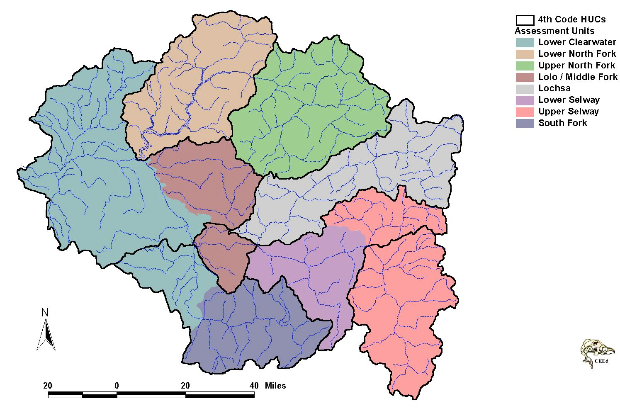
Lawyer Creek Subwatershed
Map source: Clearwater Subbasin Summary, Figure 2. Comparison of assessment units
(colored areas)
and 4th code HUC boundaries (black outlines) in the Clearwater subbasin , March 2001.
Lawyer Creek Specifics:

Lawyer Creek currently provides spawning and rearing habitat for steelhead trout and is considered one of the primary producing drainages in the Clearwater River subbasin (BLM 2000). Lawyer Creek, preceded by Lolo Creek, the Potlatch River, Big Canyon and Lapwai Creeks, have the highest potential within the Clearwater River subbasin for habitat restoration benefiting steelhead production (BLM 2000). Spring Chinook salmon may use the lower reach for juvenile rearing, and reports exist that very large cutthroat trout were caught during the 1970s (BLM 2000). Within the Clearwater River subbasin, steelhead trout use is widespread and most accessible tributaries are used yearlong or seasonally (BLM 2000). Other fish reported as occurring in Lawyer Creek include pikeminnow, chiselmouth, bridgelip sucker, and abundant speckled dace and sculpin.

The only remaining steelhead trout runs in the Clearwater River subbasin with limited or no hatchery influence occur in the lower Clearwater River tributaries (A-run fish) (BLM 2000, originally cited by Busby et al. 1996 as referenced in the CSS page 85). Wild steelhead trout historically occupied all major drainages and a majority of the tributaries within the Clearwater River subbasin. Both A-run and B-run steelhead trout are included in the Snake River ESU. Low order streams provide early rearing habitat (CSS 2001 pages 84-87).
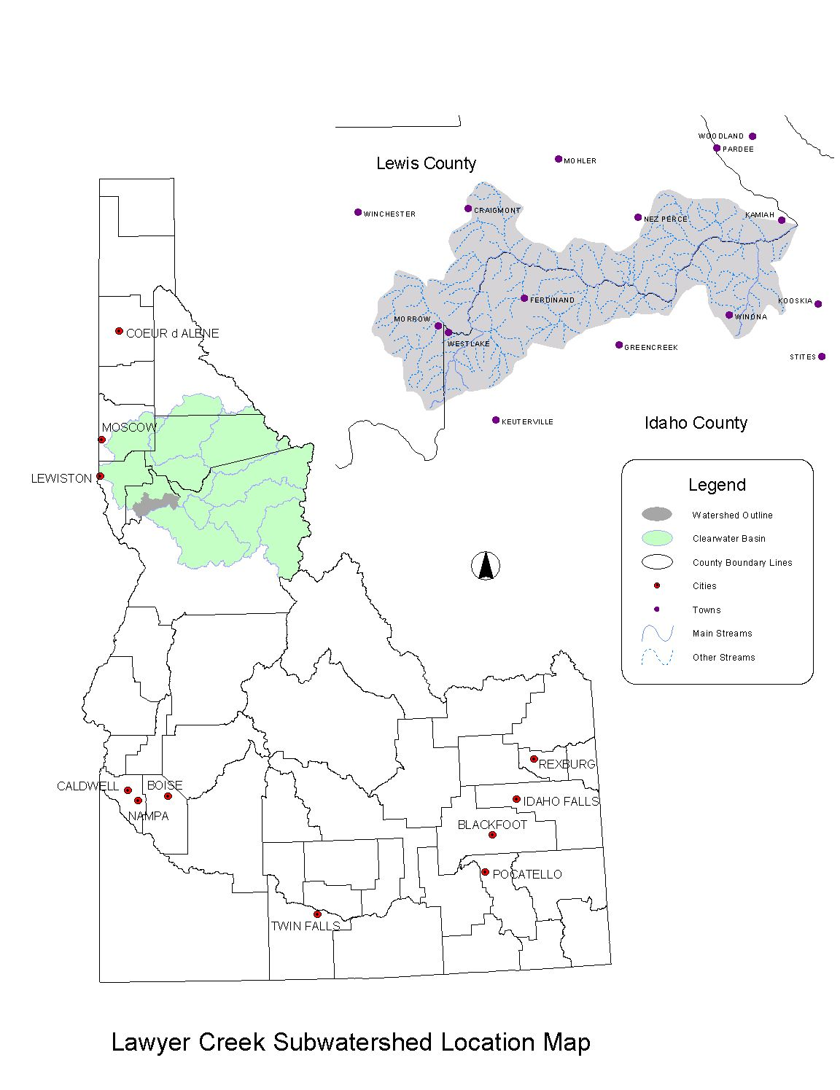
Watershed Description:

With a watershed size of approximately 137,400 acres (215 square miles), Lawyer Creek extends from the headwater areas of Cottonwood Butte to the Clearwater River with the confluence at river mile 68. The watershed is very narrow, averaging 7 miles wide (north to south) along its approximately 35-mile length (east to west). Channel density is very high, averaging 3 to 4 miles of stream per square mile of drainage area (NRCS 2000). Tributaries tend to be straight, steep, and enter the main channel at approximately right angles. As a result of the narrow basin shape and high stream density, most of the basin is within 400 feet of a stream channel. The mainstem is generally in a deep canyon and has a rapid fall with an average slope of about 105 feet per mile. In the lower 3 miles, the stream slope reduces and the stream emerges from its canyon onto an alluvial fan that has an average slope of approximately 60 feet per mile. The lower boundary of Lawyer Creek flows through the community of Kamiah, Idaho. Other communities in the watershed (near the headwaters) include Craigmont and Ferdinand.

Nearly 90% of the watershed is privately owned and over 80% of the land lies within the Nez Perce Indian Reservation. Predominant land use in the watershed is agriculture with approximately 82,400 acres, or 60% of the watershed. The major crops grown are winter wheat and spring cereal grains. Other important crops grown are spring peas, lentils, canola and bluegrass. Timber harvest has primarily occurred in the headwater areas. Grazing occurs in meadow and pasture areas in moderately sloped headwaters, while the canyonlands provide the majority of the rangeland grazing. Approximately 12 miles of the upper reaches of the stream flows through dryland farming and pasturelands grazed by livestock. Predominant soil type found on the uplands are in hydrologic soil group C (moderately slow infiltration rate) and include Nez Perce-Uhlorn-Shebang mapping units (formed in loess and very deep with a clayey and loamy subsoil).

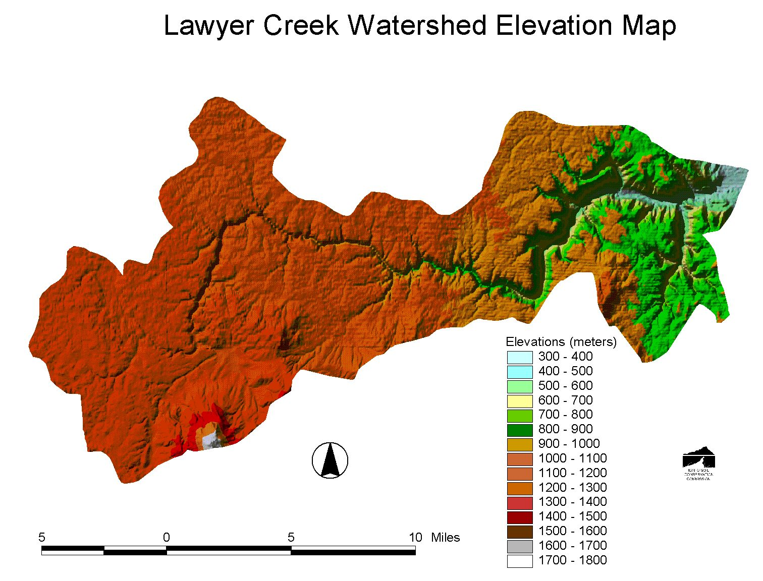

Problems Within Lawyer Creek:

Limiting factors to fish in the Lower Clearwater assessment unit tributaries are associated with climatic and land use patterns and include temperature, sediment and flow issues (CSS 2001 page 142). Because of the remarkably uniform, high-gradient slope throughout most of the watershed, Lawyer Creek gains considerable energy with which to transport sediment. Therefore, no naturally occurring sediment storage reaches exist within the watershed (Fuhrman et al. 1999). The nature and mobility of the streambed sediments in the lower reaches of Lawyer Creek suggest that there is an abundance of sediment supply (Fuhrman et al. 1999).

According to the BLM (2000), the Lawyer Creek drainage is in overall poor to fair condition as a result of agricultural activities, riparian degradation from grazing, road construction and logging. According to a report by Kucera et al. (1983), heavy siltation and poor water quality conditions exist, producing marginal to poor anadromous salmonid habitat.

Lawyer Creek and major tributary, Sevenmile Creek, are on the State of Idaho 1998 Section 303(d) list (Lawyer Creek is listed for bacteria, dissolved oxygen, habitat alteration, flow alteration, ammonia, nutrients, oil/gas; Sevenmile Creek is listed for habitat alterations). The majority of the watershed is below 4,000 feet elevation and is therefore susceptible to winter rains and rain-on-snow runoff events. Land cover and subsequent management have resulted in dramatic changes to runoff and peak discharge from the watershed during storm events, playing an important role in the overall effects on fisheries (BLM 2000).

According to a report by the Nez Perce Tribe (Fuller et al. 1984), cobble embeddedness was at 50% in their upper Lawyer Creek monitoring site, indicating a siltation problem that could reduce salmonid production. Summer stream velocities were below the optimum range for juvenile rainbow-steelhead trout.

The lower 75% of Lawyer Creek is usable for upward fish migration. A potential barrier to fish passage is located at about stream mile 26 in a steep gorge area and renders the upper 25% unusable for migrating fish (BLM 2000). This area contains many cascading waterfalls of up to seven-foot vertical drops.

Hydrology plays an important role in the overall effects on fisheries (BLM 2000). The peak stream flow discharge from a 25 year, 24 hour rainfall precipitation event under current conditions is 1.6 times, or 60% greater compared to historic conditions. Total volume for the 25 year, 24 hour runoff event is 40% greater under current conditions compared to historic conditions.

Water moves quicker through the watershed today producing higher peak flows and larger volumes as a result of change in vegetation and ground cover in the uplands. Less water is retained or stored in the basin for base flow after runoff events and higher peak flows impact stream channels by widening and scouring channels and provide the energy for transporting and moving large substrate downstream.
Through modeling, it is shown that much less water is stored in the current conditions of the watershed than in historic conditions (NRCS 2000). Because much of the timber and grasslands have been converted to annually cropped agricultural fields, water moves quicker through the watershed today producing higher peak flows and larger volumes as a result of change in vegetation and ground cover. Higher peak flows impact stream channels by widening and scouring channels and provide the energy for transporting and moving large substrate downstream. In addition, less water is retained or stored in the basin for base flow after runoff events. Reduced upland water storage results in shallow or subsurface base flow as was recently seen during subsequent seasons following the 1996/97 flood events (BLM 2000). As the creek emerges from the canyon, it carries under flood conditions a considerable amount of debris and bed load material and reduces channel capacity.

The stream has a history of periodic flooding, with the last severe flooding in 1996 and 1997 and previous flood events have also resulted in severe channel scouring, lower reaches have been channelized and severely altered as a result of flood damage.

The following figure illustrates the percent flow stability, showing low stability (high fluctuation of flow variations in the watershed).
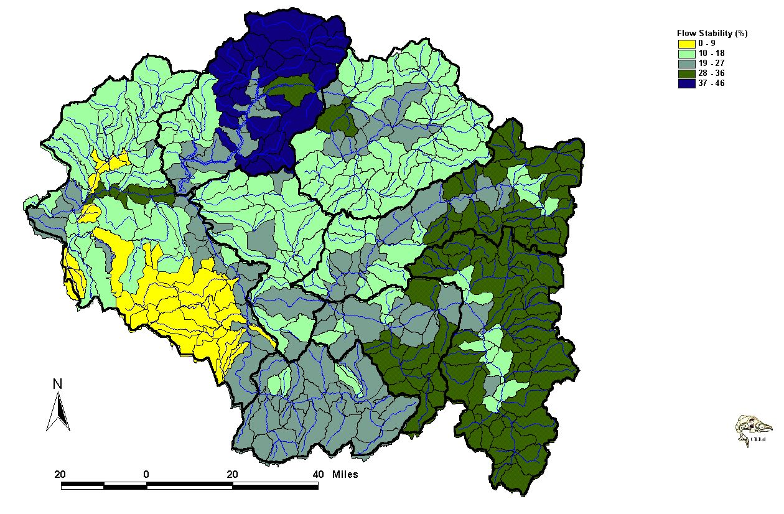

Lawyer Creek Subwatershed

Map source: Clearwater Subbasin Summary, Figure 9. Flow variation for the Clearwater subbasin,
summarized at the 6th field hydrologic unit.

Large woody debris is lacking instream. The primary limiting factors for fish production include low flows, high summer water temperatures, poor pool/riffle ratios, lack of quality pools, and lack of instream cover. Due to past flooding, present riparian understory vegetation consisting of cheatgrass brome and Kentucky bluegrass, yellow starthistle, teasel, poison hemlock and burdock. Common upland nonforested habitat types include bluebunch wheatgrass and Idaho fescue; however, these grasslands have been degraded by past livestock grazing and many range sites are now dominated by noxious weeds.

High summer water temperatures limit use of the lower reaches during summer months for spring Chinook salmon, although the fish is reported to use the lower reaches for juvenile rearing (BLM 2000).

According to Fernandez (2001), surface soil erosion is the dominant type of erosion from most cultivated lands in the watershed, and is one of the important sources of sediment and water quality problems. Predominant land use in the watershed is agriculture with approximately 82,400 acres, or 60% of the watershed. Sediment clogging stream channels can contribute to increased stream temperature as water flow is slowed and spread over a greater surface area. Stream productivity is decreased as sediment reduces light penetration necessary for photosynthesis of aquatic plants.

Summarized by the Clearwater Subbasin Summary (CSS 2001 page 247), in order to protect, enhance and/or restore fish habitat, streambank stability, watershed hydrology, and floodplain function to the Lower Clearwater River, best management practices must be developed and implemented on agricultural lands. The summary also states the need to synthesize historic and existing fish and wildlife resource data to determine what is known about the subbasin, and identify gaps for more efficient and meaningful assessment, monitoring and evaluation work.

c. Rationale and significance to Regional Programs

Summarized by the Clearwater Subbasin Summary (CSS 2001 page 247), in order to protect, enhance and/or restore fish habitat, streambank stability, watershed hydrology, and floodplain function to the Lower Clearwater River, best management practices must be developed and implemented on agricultural lands. The summary also states the need to synthesize historic and existing fish and wildlife resource data to determine what is known about the subbasin, and identify gaps for more efficient and meaningful assessment, monitoring and evaluation work.

This projects works towards fulfilling many of the goals and objectives for fish/aquatic resources and wildlife/terrestrial resources described in the Clearwater Subbasin Summary (2001), pages 204 through 222. Because the project will protect and improve fish habitat in Lawyer Creek and the Lower Clearwater River, this project aligns well with the goals and objectives of other agencies and groups. An abbreviated list of agency and group goals and objectives (and CSS reference page numbers) are listed below:

- Idaho Department of Environmental Quality (CSS 2001 page 205)
  - Goal—Restore cold-water biota and salmonid spawning beneficial uses to full support.
    - Objectives—1) Complete TMDL Subbasin Assessments, pollutant reduction allocations, and implementation plans for impaired water bodies, and 2) Implement actions identified in TMMDL Implementation Plans to restore aquatic life beneficial uses.
- National Marine Fisheries Service (CSS 2001 page 213)
  - Goal—achieve the recovery of steelhead trout resources and Snake River fall Chinook salmon in the Clearwater subbasin.
    - Objectives—Development of watershed-wide properly functioning conditions at a viable population level according to standards and criteria identified by NMFS, including the actions which will develop riparian vegetation, restore stream flow and appropriate hydrologic peak flow conditions, passage improvements and other activities.
- Nez Perce Tribe (CSS 2001 page 213)
  - Goal—Emphasize restoration strategies that rely on natural production and healthy river systems.
    - Objectives—1) Produce healthy productive ecosystems for the increase of anadromous fish populations, 2) Protect, restore, and enhance watershed sand all treaty resources, and 3) Monitor the status of salmon and steelhead populations and supporting fish habitat.
- US Bureau of Land Management (CSS 2001 page 219)
  - Goals—Work cooperatively to implement watershed plans, initiate actions to reduce adverse water quality impacts to tributary streams and mainstem rivers, and initiate restoration actions to improve flood damaged stream channels and riparian areas.
- Clearwater Focus Program, Idaho Soil Conservation Commission component (CSS 2001 page 228)
  - Goal—Coordinate multiple agencies goal and objectives in the Clearwater River subbasin to maximize program success and use of available funding.
    - Objectives—1) Participate and facilitate subbasin assessment and regional planning processes to organize ecosystem enhancement and restoration efforts, 2) Facilitate funding coordination and searches for enhancement and restoration implementation throughout the subbasin for plans that emphasize fish and wildlife habitat enhancement or restoration and/or reduction of nonpoint source pollution and other water quality issues, and 3) Provide technical and programmatic support with emphasis on private landowners, soil conservation districts, etc.
- Idaho Conservation Partnership Strategic Plan 2001 (CSS 2001 page 230)
  - Goals—Improve water quality in Idaho, increase quality of agricultural lands in Idaho, reduce sediment production and delivery from agricultural lands in Idaho, promote and facilitate conservation plans addressing riparian health, threatened/endangered species.
    - Objectives—1) Erosion on all crop/grazing/forest lands in Idaho will be reduced to the acceptable soil loss level for land use criteria, 2) Sediment control practices will be installed on all croplands in Idaho by 2010.
- USDA Natural Resources Conservation Service (CSS 2001 page 236)
  - Goal—Reduce unintended adverse effects of natural resource development and use to ensure a high quality environment.
    - Objective—Protect water resources from agricultural non-point sources of impairment.
- Lewis Soil Conservation District (CSS 2001 page 233 and 234)
  - Goals—Eliminate or reduce nonpoint source pollution delivery to receiving streams and reduce erosion to acceptable levels and improve soil resources on all lands.
    - Objectives—1) Develop resource conservation projects within prioritized watersheds—Lawyer Creek, and 2) Promote riparian, rangeland, and nutrient management programs and appropriate BMPs
- Idaho Soil and Water Conservation District (CSS 2001 page 232)
  - Goals—Encourage and promote BMPs to reduce soil erosion, and enhance water quality
    - Objective—Participate in the bi-district Lawyer Creek project.

The Fish and Wildlife Program (NPPC 2000) will accomplish the vision of sustaining an abundant, productive, and diverse community of fish and wildlife within the Columbia River ecosystem by protecting and restoring natural ecological functions, habitats, and biological diversity. This project directly relates to that vision by enhancing steelhead trout habitat, as well as habitat for numerous resident fisheries, in Lawyer Creek.

Wild steelhead trout historically occupied all major drainages and a majority of the tributaries within the Clearwater River subbasin, the only remaining steelhead trout runs in the Clearwater subbasin with no hatchery influence occur in the lower Clearwater River tributaries (A-run fish) (BLM 2000). Both A-run and B-run steelhead trout are included in the Snake River ESU.

According to the Kucera et al. report (1983), considerable potential exists to improve anadromous salmonid habitat within the Clearwater River basin and Lawyer Creek through enhancement measures. Enhancement measures suggested included flow augmentation, instream enhancement and riparian enhancement. However, according to Kucera et al., because of the stream’s length and generally poor habitat throughout the system, any enhancement efforts on Lawyer Creek would likely involve high capital expenditures.

In addition to reducing erosion and sediment delivery to the stream system by as much as 75%, habitat destroying peak flows can be tempered with an upland land treatment program. According to the NRCS Hydrologic Investigation of Lawyer Creek (2000), improved land treatment has the potential to lower 10-year peak flows by as much as 39%. A basin wide change in land use and hydrologic condition creates the largest change in peak runoff at the outlet.

Lawyer Creek and major tributary, Sevenmile Creek, are on the State of Idaho 1998 Section 303(d) list (Lawyer Creek is listed for bacteria, dissolved oxygen, habitat alteration, flow alteration, ammonia, nutrients, oil/gas; Sevenmile Creek is listed for habitat alterations). By implementing best management practices to upland agricultural lands, sediment delivery to Lawyer Creek and the lower Clearwater River will be reduced, and upland water storage to lower peak flows and sustain summer base flows will be enhanced. Reducing nonpoint source pollutants into Lawyer Creek, repairing poorly functioning riparian zones and increasing water retention in the upper portion of the watershed will reduce erratic flow regimes. These actions will not only work towards steelhead trout habitat improvements, but will compliment the water quality improvement efforts subscribed in the TMDL which is to be completed in 2003.

BMPs are being implemented in the Lawyer Creek watershed, on a limited basis, with funding through Farm Service Agency. NRCS personnel from the Grangeville (Idaho County) and Nezperce (Lewis County) offices work with area producers to implement Conservation Reserve Program options where cropland is set aside for a number of years and planted to native or introduced grasses, legumes, shrubs and trees.

In keeping with the language of the project review and selection guide (FCRPS 2000), reasonable and prudent actions that line up with this Lawyer Creek Subwatershed-Steelhead Trout Habitat Improvement Project include:

- RPA 150. This project is targeted at protecting steelhead trout (A-run) and spring Chinook salmon habitat in the lower Clearwater Assessment Unit by implementing upland land management practices on private lands. Steelhead trout are included in the Snake River ESU.
- RPA 151. This project will enhance upland water storage through implementation of best management practices on the croplands in the upper Lawyer Creek watershed. BMPs including ponds, sediment basins, conservation tillage and riparian habitat improvements and protection will promote upland water storage. This enhanced water storage will decrease peak flows b as much as 39% in lower Lawyer Creek (NRCS 2000), and consequently increase tributary flows throughout the seasons.
- RPA 152. This RPA suggests that the Action Agencies shall coordinate their efforts and support offsite habitat enhancement measures undertaken by other Federal agencies, states, Tribes and local governments by supporting development of state TMDLs by sharing water quality and biological monitoring information, project reports and data from existing programs, and subbasin or watershed assessment products. This project aligns directly with those actions.
- RPA 153. Combining programs within the project area (such as Conservation Reserve Enhancement Program, Conservation Reserve Program, Idaho State Wildlife Improvement Project, etc.) with this project’s upland treatment of cropland and pasturelands will stretch dollars farther and treat more acres to help achieve combined goals.

d. Relationships to other projects

This proposal is coordinated through the Clearwater Focus Watershed Program (BPA Project No. 199608600). This project is sponsored the Lewis Soil Conservation District and is similar to the Little Canyon Creek Project (BPA Project No. 199901400) and Nichols Creek Project (BPA Project No. 199901500) which are also sponsored by local conservation districts within Idaho. Both of these ongoing projects work towards implementing enhanced levels of conservation through best management practices to help reduce erosion and sediment delivery to their respective receiving streams. Conservation Districts have worked with private landowners on conservation projects for nearly 60 years, and assists in combining local, state and federal programs to address natural resource issues and needs.

The Nez Perce Tribe is sponsoring a proposal to investigate the status of A-run steelhead in the lower Clearwater tributaries. The Tribe also continues to monitor water quality at the mouth of Lawyer Creek, as well as other Big Canyon Creek tributaries including Little Canyon, Cold Springs and Six Mile Creeks. Monitoring efforts include analyzing the following parameters: suspended solids, bedload transport, temperature, bacteria, nutrients and discharge. Their monitoring efforts are in coordination with the BLM and have been ongoing since 1999 (Storrar 2001). A total of 5 data collections have been performed at the mouth of Lawyer Creek, and although none of those values show State water quality exceedances for turbidity or total suspended solids, monitoring efforts have not been able to collect turbidity or total suspended solids data during high flows, and an analysis of data and comparison of results was not available at the time of this writing.

To primarily address sediment concerns (as well as bacteria, temperature, nutrients, ammonia, dissolved oxygen and habitat alteration), the Idaho Association of Soil Conservation Districts within Division II (north central Idaho Conservation Districts including Lewis, Latah, Clearwater, Nez Perce and Idaho SCDs) is pursuing a recently proposed project, which is expected to receive funding from the Idaho Nonpoint Source Grant Program (319 Program). In conjunction with the Idaho Soil Conservation Commission, Natural Resources Conservation Service and the Idaho State Department of Agriculture, the Idaho Association of Soil Conservation Districts will promote best management practices on animal feeding operations throughout Division II. Because the proposed project covers such a large span of watershed acreages, project activity and funding availability within the Lawyer Creek watershed will be very limited. This Lawyer Creek proposal will coordinate implementation activities to compliment available ongoing programs which reduce erosion and sedimentation.

Flooding and the build up of sediment currently threaten a number of homes along with community infrastructure for the City of Kamiah. As a result of the 1996 and 1997 severe flooding, the vulnerability of homes in Kamiah was highlighted. Through Flood Emergency Management Act funds, the Clearwater Economic Development Association (CEDA), of Lewiston, Idaho, recently contracted with the Eco-Hydraulics Research Group from the University of Idaho to conduct a flood mitigation and river enhancement plan (efforts took place through an initiative referred to as Project Impact). The conceptual plan (Fuhrman et al. 1999) presents opportunities for reducing the community’s flood risk and improving stream function. In pursuit of these opportunities, CEDA will implement portions of the conceptual plan through the FEMA Project Impact program. CEDA has also retained Water Consulting, Inc. to pursue BPA funding to restore degraded portions of lower Lawyer Creek by improving aquatic and riparian habitat critical to threatened steelhead and Chinook salmon. The restoration efforts presented by this proposal are targeted toward BMP implementation on agriculturally impacted lands. The projects compliment each other and do not duplicate efforts.

Upper watershed management, although not a focal point of the conceptual plan designed by Fuhrman et al. (1999), are recommended to be a part of the overall implementation. The conceptual plan recognizes that land use practices in the upper watershed have resulted in increases in runoff and erosion. Fuhrman et al. suggest erosion control treatment possibilities including slope support structures, conservation tillage, re-vegetation, and contouring. Grade control structures and stream bank re-vegetation could also be implemented to stabilize channels and reduce downstream flood and debris flows. Fuhrman et al. suggests that failure to consider the entire watershed in a flood management or river enhancement project can result in significant sums of wasted funding.

The University of Idaho is currently developing a soil moisture routing model to the Clearwater River Basin, while Washington State University is working on an erosion and sediment yield predicting model using geographic information systems. Their continued work and information will be coordinated with this Lawyer Creek best management practice implementation program to compliment continued data collection and evaluation of sediment reduction efforts.

e. Project history (for ongoing projects)

(Replace this text with your response in paragraph form)

f. Proposal objectives, tasks and methods

The Lewis Soil Conservation District sponsors this proposal to seek funding though the NWPPC’s Fish and Wildlife Program to address fish habitat in the Lawyer Creek watershed, a tributary in the Lower Clearwater Assessment Unit. The Lewis Soil Conservation Districts has worked with private landowners on conservation projects for nearly 60 years, and assists in combining local, state and federal programs to address natural resource issues and needs. By implementing best management practices to upland agricultural lands, sediment delivery to Lawyer Creek and the lower Clearwater River will be reduced, and upland water storage to lower peak flows and sustain summer base flows will be enhanced. Reducing nonpoint source pollutants into Lawyer Creek, repairing poorly functioning riparian zones and increasing water retention in the upper portion of the watershed will reduce erratic flow regimes. As an end result, steelhead trout habitat is expected to improve.

Soil and water conservation districts are non-regulatory subdivisions of Idaho state government. A board of supervisors, who are local landowners that volunteer their time, are elected and govern the district board. Districts develop and implement programs to protect and conserve natural resources on nonfederal lands (CSS 2001 page 200). The Lewis Soil Conservation District coordinates conservation on private lands in Lewis County and manages their five-year plan that is reviewed and updated annually (CSS 2001 page 202). Lawyer Creek best management practice implementation is identified as a high priority in that plan (CSS 2001 page 232 and 233).

Agricultural best management practices (often abbreviated BMPs) are defined as component practices, or a combination of component practices, that can most effectively and practicably prevent or reduce the amount of pollution generated by nonpoint sources to a level compatible with water quality goals (Gilmore 1995). BMPs are techniques that will begin restoration and protection of aquatic habitat impacted by land management decision-making in the watershed uplands. BMPs proposed are endorsed by the BPA in 1) Watershed Management Program: Final Environmental Impact Statement DOE/EIS-0265, Appendix A Available Management Techniques; 2) the NRCS Field Office Technical Guide, Volume IV; and 3) the Idaho Agricultural Pollution Abatement Plan. Specific BMPs are listed in Table 1. The purpose of the BMP and its overall efficacy towards reducing erosion and subsequent sediment delivery to receiving waters is also displayed.

BMPs are being implemented in the Lawyer Creek watershed with funding through Farm Service Agency on a limited basis. NRCS personnel from the Grangeville (Idaho County) and Nezperce (Lewis County) offices work with area producers to implement Conservation Reserve Program options. The Lewis Soil Conservation District communicates with the Nez Perce Tribe Land Resources department to inform the department of conservation activities and programs ongoing within the county.

A share of the cost of each practice will be offered through this project proposal as an opportunity for farmers and ranchers to implement agricultural BMPs that result in an increased and enhanced level of conservation (referred to in Part 1. Administration and Budgeting, Section 5, Objective 4, Task g.). This “cost-share” approach will allow participants to use conservation tillage equipment they do not already own (no-till equipment), and implement structural practices placed on their farm (erosion and sediment control structures such as the construction of sediment basins, ponds, gully plugs, grassed waterways etc.).

Each BMP has a defined purpose. The practice’s purpose and efficacy are displayed in Table 1. A suite of BMPs is compiled to address erosion reduction and enhanced water retention in the uplands of the Lawyer Creek drainage. Together, the selected BMPs add to a positive cumulative effect to enhance fish habitat in Lawyer Creek and the lower Clearwater River.

Practices selected for implementation that control and reduce erosion and subsequent sedimentation include:

- Conservation Tillage (no-till)
- Sediment Basins
- Water and Sediment Control Basins (often referred to as Gully Plugs)
- Culvert Outlets
- Grade Stabilizations
- Grassed Waterways
- Permanent Vegetation (i.e. filter strips, grass seeding, tree plantings)

Practices that promote upland water storage include:

- Ponds and Sediment Basins
- Conservation tillage (no-till)
- Riparian Habitat Improvement and Protection (including fencing and grazing management, off site water supply development, tree and shrub planting and upland grass seeding)

An estimated 82,400 acres of agricultural land exist within the Lawyer Creek watershed (including cropland and pastureland). Upland treatment on all the agricultural lands would require a very large outlay of cost share dollars; therefore in an effort to work towards initiating enhanced conservation within a reasonable budget, a phased approach to BMP implementation will be initiated. To initiate this first phase (Phase I), two sixth field HUCs are selected to define the treatment area, including the Upper Lawyer Creek and Craigmont subwatersheds. This includes approximately 18,300 acres of cropland and pastureland (see figure found on page 14 of this proposal) and will be referred to as Phase I.

The distribution and allocations of BMPs per category of purpose and efficacy is based on the Little Canyon Creek project (BPA Project No. 199901400), which is currently in its third year of implementation and administered through the Lewis SCD. Because of the success of that project, the wide acceptance from participants to implement the practices for erosion control and enhance water retention efforts, and because of the determined effectiveness of the projects at reducing erosion, this project proposes similar BMP cost-share dollars and distribution among practices. The proposed budget for BMP implementation (excluding operation, maintenance and administration of the project and monitoring) is $150,000. The amount is distributed among these suites of BMPs:

Practices | BMP Implementation Funds*
Sediment reduction practices (including grass seeding, grade stabilization, conservation tillage (no-till) and grassed waterways | $60,000
Watershed water retention practices (includes sediment basins and ponds) | $50,000
Riparian treatment practices (includes tree and shrub plantings, offsite-watering systems) | $40,000

*Referred to in Part 1. Administration and Budgeting, Section 5, Objective 4, Task g.

Upper Lawyer Creek and Craigmont subwatersheds are located in the upper northwest portion of the Lawyer Creek watershed. The Craigmont subwatershed contains 87% cropland and 9% pastureland, while the Upper Lawyer Creek watershed contains 68% cropland and 18% pastureland. These subwatersheds were prioritized by the Lewis Conservation District for several reasons: 1) the predominant land use in each subwatershed is cropland; 2) cropland and pastureland activities take place on each side of, and adjacent to, Lawyer Creek and major tributaries; 3) soils have a high erosivity rating and low permeability rating; and 4) drainageway lengths are short within each of the subwatersheds, in other words—land use activities that result in erosion have a high potential for immediate sediment delivery to receiving waters.

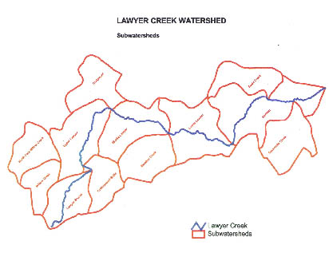
The middle and lower section of upland BMP implementation efforts will be phased in as Phase II and III, respectively, as funds allow. Phases II and III may also be projects as a result of the Lawyer Creek TMDL implementation plan (scheduled for completion in 2004).
Upper Lawyer Creek and Craigmont Subwatersheds define this project’s boundaries.

(Map displays Lawyer Creek watershed and 6th field HUCs.)
Table 1. Agricultural BMPs Proposed for Project Implementation

BMPs | Purpose | BMP Efficacy
Practices that control and reduce erosion and subsequent sedimentation

Conservation Tillage (no-till) | Reduce water induced soil erosion by protecting the surface by implementing an increased level of crop residue management. | 82% effective in reducing soil erosion*
Sediment Basins | Reduce or abate pollution by providing basins for deposition and storage of silt and preserve the capacity of waterways and streams. | 50 to 60% effective at trapping sediment, thereby reducing off-site sediment delivery, *
Water and Sediment Control Structures (Gully Plugs) | Reduce watercourse and gully erosion, trap sediment, reduce and manage onsite and downstream runoff, improve downstream water quality by trapping overland flow in constructed basins and routing water underground to a safe outlet to eliminate the formation of gully erosion. | Very effective in reducing water induced soil erosion by intercepting overland flow; nearly 99% effective in trapping coarse sediment*
Culvert Outlets | Reduce watercourse and gully erosion, trap sediment, reduce and manage onsite and downstream runoff, improve downstream water quality by trapping culvert water discharge in constructed basins and routing water underground to a safe outlet. | Very effective in reducing water induced soil erosion by intercepting overland flow
Grade Stabilizations | Reduce watercourse cutting by stabilizing the gradient of the slope. | Very effective in reducing water induced soil erosion by controlling the cutting action of overland flow
Grassed Waterways | Reduce watercourse and gully erosion, improve downstream water quality by constructing and seeding permanent vegetation in waterways. | Very effective in reducing water induced soil erosion*
Permanent Vegetation (i.e. filter strips, grass seeding, tree plantings) | Sediment and other pollutants are removed from overland flow by filtration, deposition, infiltration and adsorption. | Effectively removes sediment and nutrients from runoff*
Pracitces that promote upland water storage

Ponds and Sediment Basins | Store water in the uplands. | Effective at storing overland flow in upland areas
Conservation Tillage (no-till) | Improve soil water holding capacity by implementing an increased level of crop residue management, enhancing soil organic matter, and increase water infiltration. | Effective at increasing water holding capacity through increased organic matter and overall soil health
Riparian Habitat Improvement and Protection (including fencing and grazing management, off site water supply development, tree and shrub planting and upland grass seeding) | Protection of riparian area provides improved function of floodplains. | Effectively improves water holding capacity and sediment reduction by increasing riparian functionality
* efficacy results derived from Gilmore 1995

Proposal Objectives, Tasks and Methods

- Initiate Project Plan

  - Lewis SCD initiate contract with selected consultant
Method: Lewis SCD to modify contract each fiscal year and coordinate contract services to implement project.
  - Review and update USDA NRCS standards and specifications for planned BMPs. Determine and document any additional standards and specifications that the Lewis SCD elects to apply.
Method: Best management practices will follow USDA NRCS standards and specifications. Lewis SCD and contractor will verify compliance with up to date standards and specifications as they develop.

- Initiate Project Participation

  - Lewis SCD and Clearwater Focus Watershed Program co-sponsor coordinate and present initial public meeting.
Method: Meetings will be hosted before the onset of each fiscal year’s program to generate interest and input in project implementation and successes.
  - Initiate contact with landowner/operators within project area.
Method: Lewis SCD and contractor will contact interested participants to prepare proposals.

- Evaluate BMP Implementation Needs

  - Conduct field inventory, identify specific problems, and solutions.
Method: Contractor will meet with project participants within the watershed to review land use management, identify specific problems, and suggest solutions for erosion and sedimentation control measures, riparian habitat improvement and protection, and enhance water storage through structures. Adopted best management practices that offer effective control and reducing erosion and subsequent sedimentation include conservation tillage (no-till), sediment basins, water and sediment control structures, culvert outlets, grade stabilizations and grassed waterways. Pracitces that promote upland water storage include ponds, sediment basins, residue management through no-till practices, permanent vegetation (i.e. filter strips, grass seeding, tree plantings). Riparian habitat improvement and protection include fencing and grazing management, off site water supply development, tree and shrub planting and upland grass seeding.

  - Develop precursor designs on proposed solutions.
Method: A design is developed once the solutions are selected to estimate cost of the practice and schedule implementation.

- BMP Implementation

  - Communication with cooperators regarding selected practices.
Method: Participants are notified which practices the Lewis SCD will cooperate with, based on available funding, amount of funding requests, and alignment with Lewis SCD priorities for implementation efforts.
  - Prepare/update contractors list.
Method: Qualified contractors are approved by the Lewis SCD prior to construction, tillage or seeding BMP implementation efforts begin.
  - Schedule BMP Implementation with cooperators.
Method: Contractor and Lewis SCD coordinate practice implementation efforts with participants by scheduling activities.
  - Finalize designs.
Method: Designs are finalized according to USDA NRCS standards and specifications.
  - Layout, mark and flag BMP implementation designs.
Method: Contractor initiates implementation of practices on the ground with participants.
  - Coordinate construction and tillage practices
Method: Review specifications, designs and requirements with
cooperators.
  - Inspect implementation activities and final contractual agreements with cooperators for cost-share reimbursement.
Method: Once contractor determines practice meets standards and specification guidelines, practice is recommended to the Lewis SCD for cost share funding to help participant off set the cost of these enhance conservation efforts. Participant applies for cost share funds through the Lewis SCD.

- Survey baseline instream and riparian habitat conditions

  - Survey instream and riparian habitat conditions in Lawyer Creek.
Method: Monitoring will take place the first summer of the project (summer of 2002) to establish a baseline set of data, the stream section transect methods described in Kucera et al. (1983) will be followed.

- Monitor water quality parameters

  - Monitor water qualilty parameters immediately below the Phase I project area in the mainstem of Lawyer Creek near the Highway 95 bridge crossing.
Method: Monitoring will take place on a monthly basis to track water quality on selected parameters. Monitoring will include grab samples from one site representing the upper watershed (portion under treatment). Parameters to be analyzed will include discharge, total suspended solids, turbidity and water temperature.
  - Coordinate monitoring efforts with Idaho DEQ (TMDL work) and Nez Perce Tribe (continuous monitoring efforts at the mouth of Lawyer Creek)
Method: Communicate monitoring results and with cooperating agencies to share data, implementation efforts, and verify expected and predicted water quality improvements.

- Documentation and Reporting

  - Prepare quarterly reports including activities, problems encountered, and plan for the following quarter.
Method: Lewis SCD will prepare and deliver a quarterly report to BPA including task accomplished, problems encountered, and proposed plan of activities for the following quarter.
  - Prepare end of year report to recap BMPs implemented, evaluate BMP effectiveness, and make recommendations for future work.
Method: Lewis SCD will prepare and deliver an end of year report to BPA including task accomplished and monitoring results as available. Best management practice implementation and resulting effectiveness in achieving the projects goal will be evaluated using erosion prediction modeling. End of year reports will be distributed to Idaho SWCD (neighboring District), project participants and agency personel associated with the project efforts and interests in the project outcome.
  - Coordinate annual tour of watershed implementation activities and host discussion and review of monitiring results and evaluation.
Method: In an effort to transfer technology and implementation successes, an annual tour will be conducted, discussion and review of monitoring results and evaluation will also take place.
  - Initiate feedback loop mechaism (adaptive management)
Method: Method: From the success of determined BMP effectiveness, related fisheries density and habitat quality index results, continued results generated by the Nez Perce Tribe water quality monitoring efforts ongoing at the mouth of Lawyer Canyon Creek, monitoring results from the upper portions of the watershed, IDEQ TMDL evaluations, the efficacy of the program will be evaluated. Depending on the results, program adjustments will be made to the second and third fiscal year implementation efforts; e.g. it may be determined that residue management (no-till) practices are realizing the largest erosion and sediment control outcomes. In that scenario, adjustments will be made to promote the practices with the highest efficacy toward reaching this project’s goal.

g. Facilities and equipment

No special or high-cost equipment will need to be purchased for the implementation of this project.

h. References

Reference (include web address if available online) | Submitted w/form (y/n)
[BPA et al. 2001] Bonneville Power Administration, Northwest Power Planning Council,  Columbia Basin Fish and Wildlife Authority, Independent Scientific Review Panel. Fiscal  Year 2002 Project Review and Selection Guide. March 2001. | N
[BLM 2000] Bureau of Land Management, Cottonwood, ID. Clearwater River, North Fork  Clearwater River, and Middle Fork Clearwater River Subbasins-Biological Assessment  Biological Assessment of Ongoing and Proposed Bureau of Land Management Activities on  Fall Chinook Salmon, Steelhead Trout, Bull Trout, and BLM Sensitive Species. March 2000. | N
[Boll et al. 2001] Jan Boll, Rob Sentz and Erin Brooks. Department of Biological and  Agricultural Engineering. University of Idaho. Development and Application of the Soil Moisture Routing Model to the Clearwater River Basin: Lawyers Creek Application. A progress report of 06/12/01. Submitted to Thomas Cichosz, WSU. | N
[CSS 2001] Authors numerous, including Thomas Cichosz, et al. Clearwater Subbasin  Summary. Draft. May 18, 2001. Prepared for the Northwest Power Planning Council. | N
[Fernandez 2001] Corina Fernandez. Washington State University. Predicting Erosion and Sediment Yield Using Geographic information Systems: Application to the Lawyers Creek Watershed. First Draft presented to Claudio Stockle, WSU. June 12, 2001. | N
[FCRPS] 2000 FCRPS Biological Opinion, section 9.6.2. December 21, 2000. | N
[Fuller et al. 1983] Fuller, Johnson and Bear. March 1984. A Biological and Physical Inventory of the Streams Within the Lower Clearwater River Basin, Idaho. Annual report for the 1983 field season. Agreement DE-AI79-83BP10068. Project 82-1. | N
[Fuller 1985] Fuller R.K.1985. A Biological and Physical Inventory of the Streams Within the Nez Perce Reservation. Final Report. Agreement DE-AI79-82BP33825. | N
[Fuhrman et al. 1999] David Fuhrman, Dr. Peter Goodwin, Dr. James Milligan, and Dr. Anthony Minns. Lawyer Creek Flood Mitigation and River Enhancement Conceptual Plan. Discussion Draft. June 30, 1999. Eco-Hydraulics Research Group, University of Idaho. | N
[Gilmore 1995]. Shelly Gilmore, Resource Planning Unlimited, Moscow, Idaho. BMP Effectiveness Review. Prepared for Latah Soil and Water Conservation District. | N
[Kucera et al. 1983] P.A. Kucera, J.H. Johnson, and M.A. Bear. A Biological and Physical Inventory of the Streams within the Nez Perce Reservation. February 1983. | N
[NPPC] Northwest Power Planning Council. November 20, 2000. 2000 Columbia River Basin Fish and Wildlife Program. A multi-species Approach for Decision-making. NPPC, Portland, Oregon. Council document 2000-19. | N
[NRCS 2000] Natural Resources Conservation Service, Boise, ID. Lawyer Creek Hydrologic Study. April 2000. Prepared by NRCS for Lewis Soil Conservation District, and Idaho Soil and Water Conservation District. | N
[Storrar 2001] Storrar, Ann. 2001. Electronic mail correspondence between Ann Storrar, Nez Perce Tribe Water Resources Department, and Shelly Gilmore, Resource Planning Unlimited, Inc. on July 11, 2001. | N

Section 10 of 10. Key personnel

This project is administered by the Lewis Soil Conservation District, which consists of a voluntary board of supervisors (5 supervisors) and a full-time paid administrative assistant. The Lewis SCD will select a contractor to implement and coordinate project activities when notification of funding is received. Contractors will be required to demonstrate a level of professionalism in erosion and sediment control, such as a possessing a Certified Professional in Erosion and Sediment Control license (CPESC licenses are issued and administered through the Soil and Water Conservation Society).

The administrative assistant and NRCS District Conservationist will function as support for the Lawyer Creek subwatershed project (abbreviated resumes follow). The Clearwater Focus Program will also provide project assistance.

Lewis Soil Conservation District Administrative Assistant

Sharon Kinzer, Lewis Soil and Water Conservation District Administrative Assistant/Public Outreach Specialist (1 FTE)

Employment History: 1991-Present. Lewis SCD, Administrative Assistant and Public Outreach Specialist. Administer payments to landowners for state agriculture contracts; Perform accounting and administrative functions for all SCD programs, including financial statements and tax reporting obligations; Write, publish, and distribute at least 12 newsletters per year; Coordinate monthly SCD Board meetings; Responsible for reporting obligations to Idaho Division of Environmental Quality and the Idaho Soil Conservation Commission; Prepare and give public outreach presentations and workshops; Coordinate SCD public meetings; Assist ISCC conservationist, NRCS district conservationist and staff.

District Conservationist-USDA Natural Resources Conservation Service

Rob Fredericksen, Natural Resources Conservation Service, District Conservationist
(1 FTE)

Employment History: 1989-Present. NRCS, District Conservationist. Assure technical adequacy of all BMPs implemented in district; Write, review, and approve conservation plans and revisions; Assist landowners/operators with BMP implementation; Manage district office work and personnel; Presentations to local and state groups; Participate in promotion and education of agricultural conservation work; Responsible for NRCS project output from district office. 1978-1988: NRCS, various professional positions within NRCS.

Education: University of Idaho, B.S. Soil Science/Agricultural Economics, 1983.

