Project 28015
Benefit/Risk Analysis to Promote Long-Term Persistence of Chinook Salmon in the Middle Fork Salmon River

Response to ISRP Preliminary Review

Nez Perce Tribe
Department of Fisheries Resources Management
P.O. Box 365
Lapwai, ID 83540
October 10, 2001

ISRP Comment No. 1
Do not fund projects 28012, 28015, 28055, 28056, and 28057; an integrated response is needed from the various proposers with participation by NMFS that addresses the ISRP concerns and demonstrates that the Four-Step Safety-Net Process is well coordinated, scientifically sound, and consistent across the basin.

Response to Comment No. 1
A steering committee is being organized by Steve Smith (NMFS) to oversee all Safety-Net Artificial Propagation Programs (SNAPP). Attachment 1 is an integrated response for the SNAPP projects. We are participants in that process, but are also pursuing separate funding for this proposal due the unique nature of the Middle Fork Salmon River chinook salmon population and to expedite the development of a benefit-risk analysis and supporting products not addressed by the SNAPP process. The SNAPP steering committee includes all co-managing agencies responsible for fisheries resources within the geographic area. We are participating in this process through Jay Hesse (NPT) and Chris Beasley (CRITFC). Other participants includes Keith Kutchins (Shoshone Bannock Tribe); Herb Pollard, Brian Brown, Larry Rutter, and John Drake (NMFS); Sharon Kiefer and Pete Hassemer (IDFG); Joe Krakker (USFWS); Bruce Suzumoto (APAC and NWPPC); and Gary James (CBFWA-Anadromous Committee). This group is currently formulating a set of standard analyses to be employed for all SNAPP analyses. We are pursuing funding proposal

It seems that there has already been a pre-determined opinion by the ISRP that the Four-Step Safety-Net Process outlined in the Biological Opinion is not scientifically sound. This process is a plan of action for ESA listed stocks that are “critically depressed” and nearing extinction. When populations levels get so low that there has to be drastic intervention (captive broodstock) to save them such as the California condor or the Stanley Basin sockeye salmon, we believe managers have waited too long and it may be too late for recovery. We see the four-step process as a sound scientific process for considering different levels of intervention before we are in a situation like the sockeye. This benefit/risk analysis for the Middle Fork Salmon River chinook is to closely examine the current stock status in the subbasin, determine what if any intervention is warranted, and get consensus from all salmon managers that the preferred alternative is best for recovery purposes.

ISRP Comment No. 2
Data available for extinction risk assessments are going to provide no more than crude estimates of risk.

Response to Comment No. 2
The data we have for chinook salmon populations within the Middle Fork Salmon River drainage are the most extensive we have in Idaho and includes redd count information and associated spawner abundance estimates to date in all major tributaries in the Middle Fork since 1957 (Table 1). Regression analysis on spawner abundance over the last 43 years clearly shows a highly significant (p<0.01) decline and all populations are approaching the extinction line (Figures 1 and 2) (from Kucera and Blenden 1999). We acknowledge that redd counts are not exact measurements of spawner abundance, however, it is the best data that we have. When you walk a stream and find no redds and no salmon, as such is the case in some of the major tributaries to the Middle Fork Salmon during recent years (Table 1), you can say with certainty that these populations are in trouble, and clearly at risk of extinction.

ISRP Comment No. 3
Caution is needed with statements and models that include carrying capacity, since it is itself a dynamic value.

Response to Comment No. 3
We do not mention carrying capacity in our proposal, however, we point out that habitat conditions in the Middle Fork Salmon River drainage are nearly pristine and in a designated wilderness area with little room for improvements in habitat.

ISRP Comment No. 4
Confidence in risk estimates will be very low and a source of disagreement. The process must be developed via methods that will ensure buy-in by all agencies. There must be agreement as to what confidence levels are acceptable before an action is taken. Standards need to be defined for the type and quality of data minimally required for such assessments, including population and sub-population structure. Proposing to obtain only review and comment by the associated agencies cannot be expected to produce support for the process.

Response to Comment No. 4
Confidence levels for some risk estimates will be low and will depend on the extent and quality of data that go into the model. For the Middle Fork, we believe the data on the number of spawners are about as good as we are going to get without putting in adult weirs or counting stations such as video weirs. A number of agencies (IDFG, NMFS, US Forest Service and the Nez Perce Tribe) are involved in the long-term monitoring of chinook populations in the Middle Fork Salmon River and will be included in this benefit/risk analysis, defining management options, and determining a course of action for recovery.

Table 1. Estimated salmon spawner abundance in lower and upper Big Creek, Bear Valley Creek, Elk Creek, Marsh Creek, Sulphur Creek and Loon Creek from1957 to
2000 (after Hassemer 1993).

Year | Lower  Big  Creek | Upper  Big  Creek | Bear  Valley  Creek | Elk  Creek | Marsh  Creek | Sulphur  Creek | Loon  Creek
1957 | 1,284 | 540 | 1,586 | 955 | 1,099 | 914 | 1,020
1958 | 811 | 310 | 749 | 862 | 629 | 314 | 463
1959 | 521 | 211 | 914 | 1,099 | 211 | 98 | 295
1960 | 845 | 372 | 926 | 830 | 718 | 94 | 802
1961 | 384 | 905 | 1,620 | 1,394 | 1,262 | 290 | 314
1962 | 864 | 535 | 1,162 | 1,022 | 818 | 187 | 377
1963 | 528 | 355 | 1,104 | 1,570 | 893 | 336 | 626
1964 | 290 | 122 | 1,382 | 1,020 | 1,702 | 118 | 866
1965 | 199 | 175 | 722 | 487 | 970 | 77 | 398
1966 | 132 | 295 | 1,282 | 1,260 | 974 | 341 | 118
1967 | 226 | 161 | 1,068 | 1,008 | 1,560 | 322 | 394
1968 | 79 | 216 | 1,378 | 1,159 | 1,118 | 341 | 324
1969 | 173 | 156 | 854 | 838 | 533 | 331 | 264
1970 | 55 | 163 | 802 | 725 | 1,094 | 223 | 103
1971 | 125 | 77 | 259 | 415 | 674 | 139 | 190
1972 | -- | 144 | 530 | 509 | 749 | 170 | 360
1973 | -- | 230 | 929 | 900 | 1,243 | 187 | 187
1974 | -- | 67 | 312 | 259 | 504 | 72 | 113
1975 | -- | 185 | 516 | 406 | 482 | 120 | 77
1976 | -- | 53 | 182 | 146 | 115 | 34 | 74
1977 | -- | 22 | 310 | 206 | 235 | 12 | 149
1978 | -- | 228 | 442 | 499 | 648 | 154 | 70
1979 | -- | 36 | 166 | 118 | 113 | 36 | --
1980 | -- | 10 | 36 | 19 | 22 | 5 | 22
1981 | -- | 53 | 144 | 55 | 151 | 17 | 72
1982 | -- | 17 | 94 | 22 | 96 | 7 | 55
1983 | -- | 65 | 134 | 91 | 79 | 19 | 17
1984 | -- | 101 | 132 | 65 | 144 | 0 | 10
1985 | 34 | 168 | 322 | 67 | 259 | 24 | 67
1986 | -- | 98 | 178 | 132 | 242 | 156 | 50
1987 | 55 | 58 | 245 | 358 | 360 | 26 | 55
1988 | -- | 223 | 679 | 792 | 521 | 98 | 12
1989 | -- | 62 | 36 | 84 | 106 | 5 | 38
1990 | -- | 31 | 149 | 101 | 137 | 53 | --
1991 | -- | 29 | 113 | 130 | 96 | 62 | 38
1992 | -- | 55 | 98 | 137 | 156 | 12 | 53
1993 | -- | 110 | 355 | 581 | 288 | 60 | 74
1994 | -- | 5 | 24 | 19 | 12 | 0 | 2
1995 | -- | 2 | 22 | 0 | 0 | 0 | 0
1996 | -- | 2 | 36 | 41 | 24 | 22 | 2
1997 | -- | 62 | 91 | 206 | 149 | 36 | 53
1998 | -- | 31 | 245 | 252 | 216 | 60 | 101
1999 | -- | 10 | 79 | 24 | 0 | 0 | 5
2000 | -- | 24 | 166 | 247 | 86 | 7 | 24

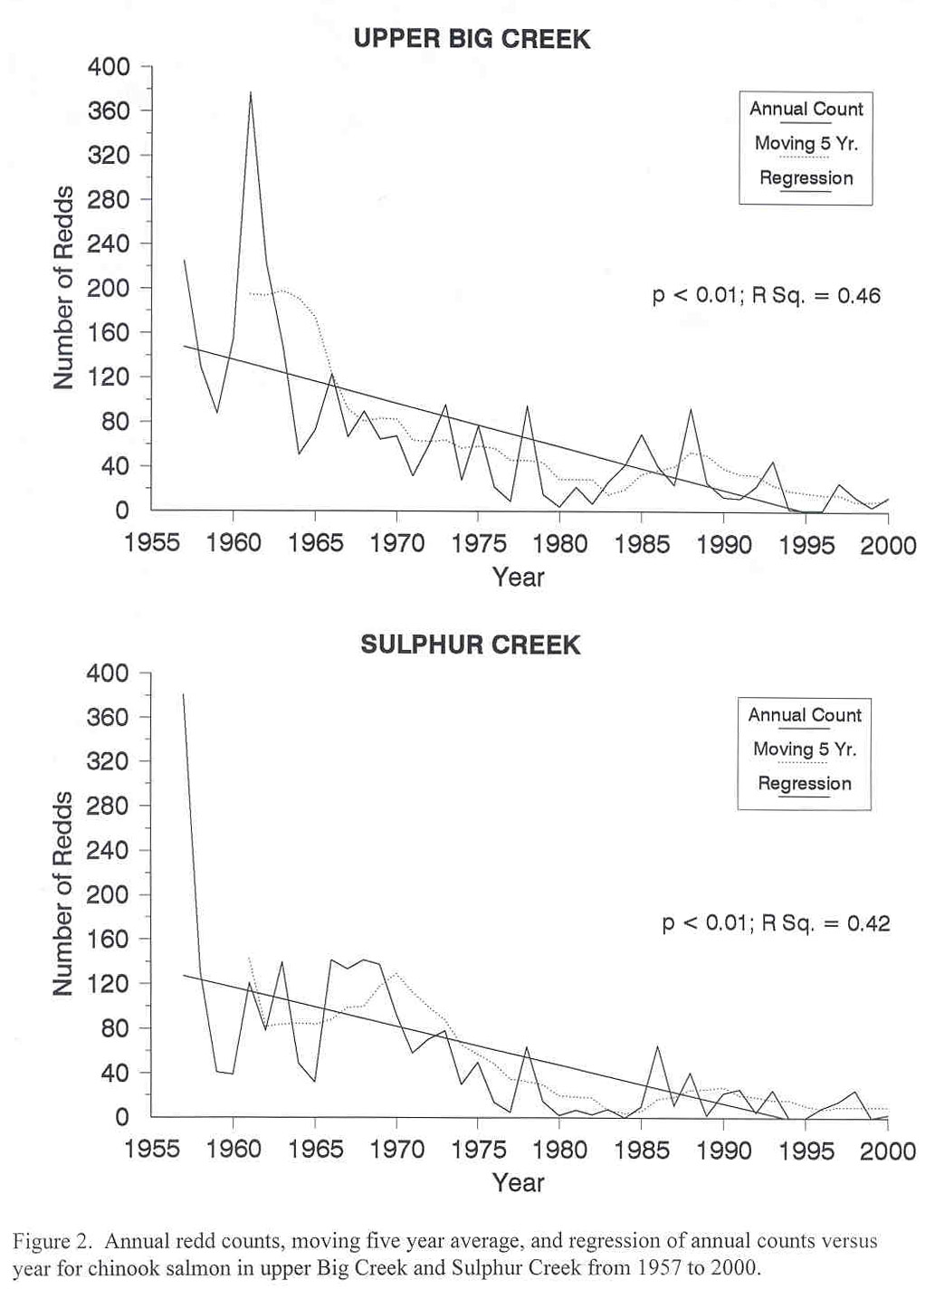

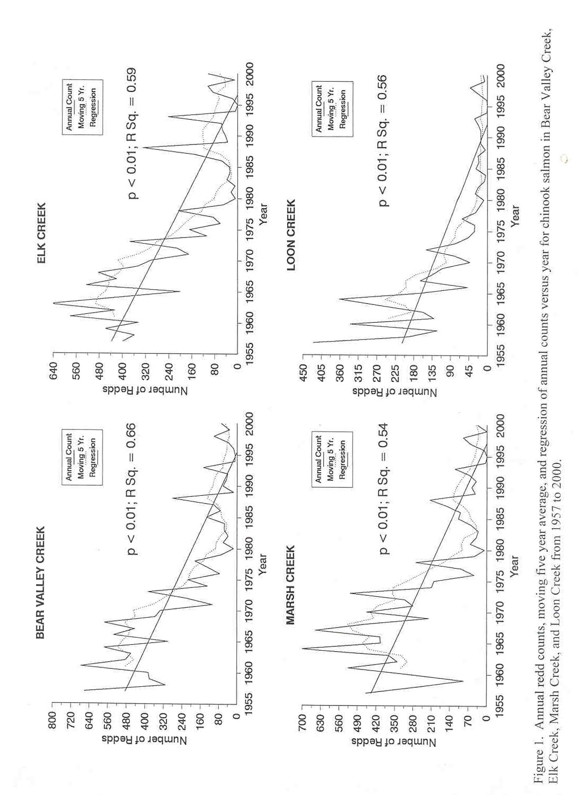

ISRP Comment No. 5
The process is meant for critically depressed populations. Some populations seem to have been identified for consideration before any process was specified to identify “critically depressed stocks.” The process, if initiated, should be designed to include a systematic process for identifying these stocks across the basin.

Response to Comment No. 5
There should be little question that chinook salmon populations in the Middle Fork Salmon River are severely depressed (see Table 1). In our proposal we quote NMFS Draft Cumulative Risk Initiative (CRI; NMFS-NOAA July 17,2000): “The seven Snake River spring/summer chinook salmon index stocks are experiencing a decreasing trend in population change. This trend appears to have worsened in the most recent years for which we have complete data (1990-1994). Without additional intervention, the long-term prognosis for these stocks is clearly extremely poor.” Three of the seven index stocks are in the Middle Fork Salmon River. In the proposal we point out that in the PATH analysis (Beamesderfer et al. 1998) and draft CRI that the three index stocks in the Middle Fork streams have population growth rates (lambda) below replacement for 1990 through 1999. And, the key finding of number 8 in the Draft CRI’s Summary of Key Findings states: “The most recent data for Snake River Spring/Summer Chinook salmon reveal that this ESU may be doing worse than was previously thought. It is now even less likely that dam breaching BY ITSELF will mitigate imminent risks faced by Snake River Spring/Summer chinook salmon. Importantly, there are no data to indicate that improvements in any of the other H’s (i.e., habitat, harvest, or hatcheries) could BY THEMSELVES, mitigate the extinction risks faced by the Snake River Spring/Summer chinook ESU.”

ISRP Comment No. 6
The process assumes that artificial propagation can provide a safety net for critically depressed stocks when identified. What database is available from the Snake River to provide that confidence? Recent reports including project 199102800 in the Mountain Snake Province, conclude that survival of migrants to Lower Granite Dam declines with increasing abundance. These results may implicate artificially high densities caused by release of hatchery fish as an additional cause for decline of wild fish.

Response to Comment No. 6
These comments relate to other the SNAPP proposals. Our proposal develops focuses on the development of a Benefit Risk Analysis in which all possible management action will be evaluated.

ISRP Comment No. 7
There seems to be misunderstanding of the intent of the process. Use of donor stocks was identified in one proposal as a possible need. How can a donor stock be considered for use under a program designed to preclude extinction of a local population? Another proposal indicated that the process was going to help increase abundance in the target population, and it was described as any other project trying to cause increase in population size with hatchery fish.

Response to Comment No. 7
We do not refer to donor stocks but mentioned in our presentation that we would use indigenous stocks for artificial propagation in the Middle Fork if was the preferred management action that resulted from Objective 4 in our proposal.

We did not refer to using hatchery intervention as the primary goal of this proposal but rather to look at the current population status, get all agencies and independent scientists to look at the data we have, and then decide on a strategy to help this severely depressed salmon population.

ISRP Comment No. 8
Fish populations in the Middle Fork Salmon River have declined as a result of problems in the migration route or ocean. These problems should be solved rather than acting (use of hatchery fish) to further jeopardize fish populations in the Middle Fork. If, at some time in the future it can be demonstrated that these populations are in imminent danger of extinction, and at the same time it can be shown there will be immediate action to fix conditions in the migration route or ocean, it may make some sense to cryopreserve gametes or use short-term propagation as “last ditch” efforts to save some of the genetic material, but a sound technical basis for the required assessment does not exist.

Response to Comment No. 8

As stated earlier, there should be no question that the Middle Fork Salmon River chinook population is in imminent danger of extinction. We do not want to wait until were in a Snake River sockeye situation to look at doing a benefit/risk assessment for the Middle Fork. We believe a sound technical basis exists and supports the development of this benefit/risk assessment parallel to the SNAPP process.

ISRP Comment No. 9
The last step in the process is development of a HGMP for each propagation program. The ISRP’s opinion is that the template for preparation of these documents provides little confidence that the strict requirements needed for artificial propagation of endangered species will result. The template calls for detailed information concerning how a hatchery presently operates and some inquiries as to how the potential impact of the program will be reduced. If the 4-step process is to proceed, detailed guidelines for operation of these facilities must be developed.

Response to Comment No. 9
This proposal is only a benefit/risk analysis and does not address artificial propagation measures specifically if this were the outcome of the preferred management action. However, if managers are in agreement that we need to intervene in the Middle Fork, the next step would be to develop a HGMP. Detailed guidelines for artificial measures in the HGMP will be developed through the SNAPP process in which we will play a part.

ISRP Comment No. 10
In summary, the ISRP concludes that the 4-step process is not ready to go forward, and may even be a flawed strategy. Its technical credibility depends on objective selection of populations for safety net consideration, on the availability of information to permit development of strategies that will do more good than harm, and on standards for management of artificial production. In addition, the process does not seem to be coordinated with the subbasin planning effort. None of these elements are in place.

Response to Comment No. 10
The 4-step safety net process is a process identified in the NMFS Biological Opinion that has been put forth to aid in the recovery of ESA listed salmon populations. The SNAPP process was only started recently by NMFS and others to coordinate efforts throughout the basin on which populations to consider for emergency actions. The technical credibility of the process will be compilation of current population data, expertise from all management agencies on the current stocks’ status, and hopefully a consensus on the preferred course of action for each of these areas.

It is pointed out in our proposal that the Salmon Subbasin Summary (Servheen et al. 2001) reported that chinook salmon population in the Middle Fork Salmon River is clearly at a high risk of extirpation. The Salmon Subbasin Summary also recommends implementing/continuing artificial propagation or supplementation programs on salmon and steelhead stocks deemed at risk. Again, we stress that this is only a benefit/risk assessment to see what our management alternatives may be for chinook salmon in the Middle Fork Salmon River.

References

Beamesderfer, R.C.P., H.A. Schaller, M.P. Zimmerman, C.P. Petrosky, O.P. Langness,
and L. BaVoy. 1998. Spawner-recruit data for spring and summer chinook populations in Idaho, Oregon, and Washington. Section 2, Chapter 1 In: D.R. Marmorek and E.N. Peters, eds. Plan for Analyzing and Testing Hypotheses (PATH): Retrospective and prospective analyses of spring/summer chinook reviewed in FY 1997. Compiled and edited by ESSA Technologies, LTD., Vancouver, B.C.

Kucera, P. and M. Blenden. 1999. Chinook salmon spawning ground survey in Big
Creek and tributary streams of the South Fork Salmon River, Idaho 1992-1995. Assessment of the status of salmon spawning aggregates in the Middle Fork Salmon River and South Fork Salmon River. Technical Report 99-7. Nez Perce Tribe Department of Fisheries Resources Management. Lapwai, Idaho.

NMFS-NOAA July 17, 2000. Draft CRI.

Servheen, Greg, C. L. Huntington, T. Curet, J. Brostrom, K. Apperson, S. Rust, P. Hassemer, P. Kline, G. Painter, C. Petrosky, J. Brimmer, E. Smith, D. Taki, D. Saul, J. Gebhards, P. Kucera, and I. Jones. 2001. Salmon Subbasin Summary. Review Draft prepared for Northwest Power Planning Council, 25 May 2001.
Attachment 1
October 10, 2001

Independent Scientific Review Panel
851 S.W. 6th Avenue, Suite 1100
Portland, Oregon 97204

Dear ISRP Members,

We have reviewed your comments concerning the Four Step Safety-Net Process and offer the following background, update of activities, and responses to your concerns.

The National Marine Fisheries Service, U.S. Fish and Wildlife Service, and the Bonneville Power Administration (acting on behalf of the Action Agencies for the Federal Columbia River Power System) have formed a Safety-Net Artificial Propagation Program (SNAPP) to implement RPA measures 175 – 178 from the FCRPS Biological Opinion. The purpose of this program is to establish contingency action plans, potentially applying the best available artificial propagation techniques, to prevent extinction of key populations of ESA-listed salmon and steelhead while necessary improvements to main-stem passage and tributary habitats are effectuated. The program’s goal is to reduce the short-term risks of population extinctions and preserve stock structure and genetic variability that will contribute to future recovery actions.

Since submission of project proposals for the Mountain Snake Province, we have begun coordinating with state and tribal co-managers (IDFG, Nez Perce Tribe, Shoshone-Bannock Tribes, and the Columbia River Inter-Tribal Fish Commission) responsible for fisheries management in the Salmon and Clearwater sub-basins of Idaho. Working with this core group, and coordinating more broadly with other fishery managers, we will be revising safety-net proposals to achieve a completely integrated and consistent approach to implementing SNAPP.

Our current activities involve:
- Reviewing and revising the list of “at-risk” populations that will initially be analyzed via the 4-step planning process. The FCRPS Biological Opinion included 10 populations in the Salmon and Clearwater sub-basins. The above fishery managers are reviewing the spring/summer Chinook population structure described in the August 1997, draft of the Snake River Salmon Recovery Plan and the steelhead population structure more recently used in U.S. v. Oregon management discussions. From this review, we expect to have a consensus list of populations later this month to initially analyze in SNAPP.
- Reviewing alternative methods for conducting each of the four steps of SNAPP to achieve a consensus approach. When SNAPP was conceptualized in early 2001, methods for conducting the 4-step planning process were proposed. With safety-net proposals submitted by IDFG and CRITFC (on behalf of the Nez Perce Tribe), the group is now reviewing a broader suite of alternative methods and the likely population data available to analyze. We anticipate achieving a consensus on methodology later this month that will be reflected in revised SNAPP proposals.

- Expanding our coordination with other fishery managers and the public.
A briefing about SNAPP has been scheduled with the NW Power Planning Council’s Artificial Production Advisory Committee. Additionally, a regular sequence of coordination briefings will be established with the Production Advisory Committee of U.S. v. Oregon, the Technical Review Team, the FCRPS Biological Opinion’s Action Agencies, and others desiring regular informational updates. Our initial efforts at contacting the ISRP were inadequate and unsuccessful. We would be pleased to offer regular briefings and further responses to your scientific and policy questions and concerns.

Upon achieving consensus on populations and methods, we intend to place a revised and improved set of project proposals and budgets into the Mountain Snake Provincial review process and before BPA for procurement of critical FCRPS actions. Our intent is to take each of the selected populations through Step 1, Extinction Risk Analysis, then review the results prior to deciding which “at-risk” populations should proceed through the remaining three steps of the process (propagation options development, benefit/risk assessment, and HGMP). Our expected outcome is a set of conservation propagation contingency plans that would be available for implementation when the benefit/risk assessments deem them appropriate to reduce the risk of population extinctions. We also want to be sure that if intervention is necessary, that it occur while there are sufficient fish in the target population to avoid the genetic and demographic risks of a very small founding population and the high costs of extreme safety-net options such as captive brood programs.

We understand that after, or even during, this initial safety-net planning effort, new information may become available on the status or geographic extent of populations under review. We anticipate that Hatchery & Genetic Management Plans may need to be revised to keep them current with best available information and technology. Our objective is to maintain a viable contingency program to mitigate for adverse environmental conditions and cycles or inadequate performance from habitat recovery actions. SNAPP will also consider additional populations for the 4-step review, as provided in the FCRPS Biological Opinion, using the same methods should the populations’ perceived status so warrant. The lead times required for funding and developing conservation propagation programs dictates that effective contingency plans be completed prior well ahead of their need.

Specific Responses to ISRP Comments:

1. “Data available for extinction risk assessments are going to provide no more than crude estimates of risk.”
SNAPP participants realize the scarcity of data for many anadromous fish populations, particularly steelhead. We intend to use the best available data and appropriate methods to analyze extinction risk. As better data are collected from monitoring programs in upcoming years, the extinction risk assessments used by SNAPP will be revised and contingency plans reviewed and amended as appropriate. As the purpose of SNAPP conservation propagation programs is to reduce the short-term risk of extinction, any programs initiated early on can be amended or terminated should later information demonstrate lack of need or greater risks with a program than without it. But at this time, scarce data alone should not be a reason to avoid conducting extinction risk analyses and developing contingency plans.

- “Proposing to obtain only review and comment by the associated agencies cannot be expected to produce support for the process.”
SNAPP products will be made available for comment by fishery managers and the public. We will specifically include the ISRP in the distribution for comments. Your comments will be appreciated.

- “The process assumes that artificial propagation can provide a safety net for critically depressed stocks when identified.” …
The benefit/risk assessment that is conducted in step three of SNAPP will comprehensively review the pertinent information as to the likely benefits of propagation alternatives to ensure that actual intervention would result in net benefits to the target population and the ESU overall. This assessment will, by necessity, also review the information on the likely cumulative effects of hydro, habitat, and harvest actions to recover “at-risk” populations in the absence of a SNAPP program.

- “The last step in the process is development of a HGMP for each propagation program. The ISRP’s opinion is that the template for preparation of these documents provides little confidence that the strict requirements needed for artificial propagation of endangered species will result.”
The quality of any propagation plan using the HGMP template likely depends on the motives and capabilities of the sponsor and the decision requirements of the funding and permitting agencies. Any HGMP arising from SNAPP will be thorough and complete. The step one extinction risk analyses and step three benefit/risk analyses will be thorough and integrated into the HGMP. Conservation propagation programs arising from SNAPP will be detailed and meet NMFS’ requirements for endangered species.

We appreciate your comments on the CRITFC and IDFG proposals responding to the safety net propagation RPA’s of the FCRPS Biological Opinion. As we progress in developing a coordinated and consistent approach to the safety net program via SNAPP, we will provide our products to the ISRP for your information, consideration, and comment. We look forward to your continued interest. I am available at 503-263-1253 and at huntersmith@canby.com. We would be pleased to provide you any additional information or briefings should you desire.

Sincerely,

Stephen H. Smith
SNAPP Coordinator

Cc:
SNAPP oversight team: H. Pollard, NMFS; J. Krakker, USFWS; BPA
NWPPC: B. Suzumoto, D. Warren, D. Marker
PAC Chair: G. Nandor, ODFW
NMFS: L. Rutter, R. Jones, J. Drake
IDFG: S. Kiefer
SB: K. Kutchins
NPT: D. Johnson
CRITFC: C. Beasley

[ISRPletter1001]

