Bonneville Power Administration

FY 2002 Provincial Project Review

PART 2. Narrative
Project ID: 28020

Title: Nez Perce Tribal Harvest Monitoring Program

Section 9 of 10. Project description

a. Abstract
The 2002 project proposal describes the Nez Perce Tribe’s efforts to monitor the fisheries currently ongoing. Sampling strategies are designed to provide greater data precision in catch reports, age distribution, and exploitation rates during our fishery seasons. Harvest management is intertwined with all Columbia Basin artificial production programs and affects the status of naturally produced stocks as well.

b. Technical and/or scientific background

The Nez Perce Tribe has monitored its fisheries primarily by funding sources outside the Northwest Power Planning Council (NPPC) process. However, the subbasin planning process has incited the need to incorporate this very important aspect of fisheries management within the existing Fish and Wildlife Program. This proposal is submitted through the Mountain Snake Review process although Tribal fisheries occur throughout the Columbia Basin.

Treaty Rights and Nez Perce Fisheries

Within the 761,000 acre Nez Perce Reservation, the Tribe has exclusive jurisdiction to regulate its own tribal members and any other Indian authorized to fish by tribal authority. As a general rule, state jurisdiction within Indian Country is preempted both by federal protection of tribal self-government and by federal treaties and statutes on other subjects relating to Indians, tribes, their property and federal programs.

The Nez Perce Tribe has what might be deemed near exclusive jurisdiction to regulate tribal members exercising treaty reserved fishing rights at all off reservation, usual and accustomed locations. The Nez Perce Tribe has usual and accustomed fishing locations not only within that portion of the 13,204,000 acres (Figure 1) that have been found to been exclusively used and occupied by the Tribe including the major portions of the Snake, Salmon and Clearwater Rivers and their drainages situated in three states-Washington, Oregon, and Idaho, but there are many Nez Perce usual and accustomed fishing sites located beyond that aboriginal territory as well. Undoubtedly the best example of that is represented by the rights the Nez Perce Tribe to fish pursuant to treaty rights in the lower Columbia River as determined by the U.S. v. Oregon litigation.

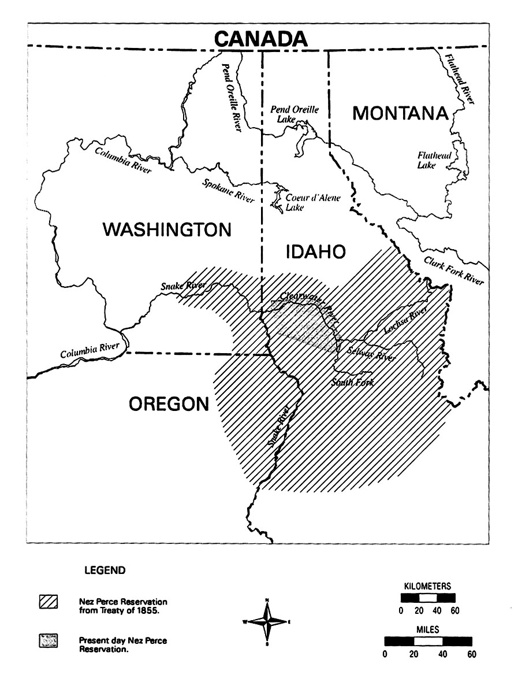
Salmon and other migratory fish species are an invaluable food resource and an integral part of the Nez Perce Tribe’s culture. Anadromous fish have always made up the bulk of the Nez Perce tribal diet and this dependence on salmon was recognized in the treaties made with the Tribe and the United States. In 1855, representatives of the United States government negotiated a treaty with the Nez Perce in which the Tribe reserved:

the exclusive right of taking fish in all the streams where running through or bordering said reservation is further secured to said Indians; as also the right of taking fish at all usual and accustomed places in common with citizens of the Territory; and of erecting temporary buildings for curing, together with the privileges of hunting, gathering roots and berries, and pasturing their horses and cattle upon open and unclaimed land (12 Stats., 957-Article 3).

Thus, the legal, historic, economic, social, cultural, and religious significance of the fish to the Nez Perce Tribe continues to this day, which makes the decline of fish populations in the Columbia River Basin a substantial detrimental impact to the Nez Perce way of life.

The Nez Perce Tribe continues to play a key role in anadromous fish management. However, instead of being the sole manager as it was over a century ago, the Tribe works amidst the multitude of state, federal and tribal agencies having management authority. In aboriginal times as well as recently, the Nez Perce Tribe was free to resort to fishing sites in the lower Columbia River and frequently did so to participate in the earliest part of the anadromous fish runs. At that time, fishing could occur nearly a year round basis because of the numbers and sizes of the runs. Commercialization of the anadromous fish by non-Indians, the fish wheels, dams and a number of other events have severely decreased the numbers of fish that ascend and descend the Columbia River (Vigg 1998).

Currently, tribal fisheries occur at various locations throughout the Snake River and Columbia River Basins (Table 1). This monitoring program will help in assessing harvest such that management of the resources and rights described above can occur.

Table 1. Tribal fishing locations and dates (by NPT payperiod).
Date | Tributary Stlhd | Zone 6 Sturgeon | Zone 6 Spring Chinook | Tributary Sp Chk | Zone 6 Su Chk | Tributary Su Chk | Zone 6 Fall Chinook
Dec 24 - Jan 6 | X
Jan 7 - Jan 20 | X
Jan 21 - Feb 3 | X | X
Feb 4 - Feb 17 | X | X
Feb 18 - Mar 3 | X | X
Mar 4 - Mar 17 | X | X
Mar 18 - Mar 31 | X |  | X
Apr 1 - Apr 14 | X |  | X
Apr 15 - Apr 28 | X |  | X
Apr 29 - May 12 |  |  | X | X
May 13 - May 26 |  |  | X | X
May 27 - Jun 9 |  |  | X | X | X
Jun 10 - Jun 23 |  |  |  | X | X
Jun 24 - Jul 7 |  |  |  | X | X | X
Jul 8 - Jul 21 |  |  |  | X | X | X
Jul 22 - Aug 4 |  |  |  | X | X | X
Aug 5 - Aug 18 |  |  |  | X
Aug 19 - Sep 1 |  |  |  |  |  |  | X
Sep 2 - Sep 15 |  |  |  |  |  |  | X
Sep 16 - Sep 29 |  |  |  |  |  |  | X
Sep 30 - Oct 13
Oct 14 - Oct 27 | X
Oct 28 - Nov 10 | X
Nov 11 - Nov 24 | X
Nov 25 - Dec 8 | X
Dec 9 - Dec 22 | X

c. Rationale and significance to Regional Programs

The primary objective of the Harvest Management Program of the Nez Perce Tribe is to develop and implement a biologically sound harvest monitoring program through the collection of more precise catch data that would give brood year contribution rates, exploitation rates by brood, and contribution rates from different hatcheries. The secondary objective is maintaining harvest strategies consistent with treaty reserved fishing rights. The Harvest Monitoring program is discussed in the 2000 Columbia Basin Fish and Wildlife Program as follows:

2000 Columbia River Basin Fish and Wildlife Program

The Council continues to recognize that the Indian tribes in the Columbia River Basin
have vital interests directly affected by activities covered in this program. These Indian tribes are sovereigns with governmental rights over their lands and people, and with rights over natural resources which are reserved by or protected in treaties, executive orders, and federal statutes. The United States has a trust obligation toward Indian tribes to preserve and protect these rights and authorities. Nothing in this program is intended to affect or modify and trust or treaty right of an Indian tribe. The Council also recognizes that implementation of this program will require significant interaction and cooperation with the tribes and commits to working with the tribes in a relationship that recognizes the tribes’ interests in co-management of affected fish and wildlife resources and respects the sovereignty of tribal governments.

The primary strategy for the FWP is to assure that subbasin plans are consistent with harvest management practices and increase opportunities for harvest wherever feasible.

Monitoring and reporting: The Council’s recommendations include:

  - Monitor inriver and ocean fisheries and routinely estimate stock composition and stock-specific abundance, escapement, catch, and age distribution. Expand monitoring programs as necessary to reduce critical uncertainties. Manage data so that it can be easily integrated and readily available in real time.
  - Manage harvest consistent with the protection and recovery of naturally spawning populations.

The Statement of Fish and Wildlife Needs from the Clearwater Subbasin Summary identifies the following items pertaining to harvest monitoring.

Fisheries / Aquatic Needs
General
2. Continue ongoing mitigation programs to provide sport and tribal fisheries

Monitoring and Evaluation
- Continue Nez Perce Tribal Hatchery Monitoring and Evaluation to determine hatchery chinook performance, natural production responses, competitive interactions, harvest management and provide for applied adaptive management.

- Continue Lower Snake River Compensation Hatchery Monitoring and Evaluation to determine hatchery chinook and steelhead performance, natural production responses, competitive interactions, harvest management and provide for applied adaptive management.

d. Relationships to other projects

(Replace this text with your response in paragraph form)

e. Project history (for ongoing projects)

(Replace this text with your response in paragraph form)

f. Proposal objectives, tasks and methods

Ultimate Goal: The objective is to develop and implement a biologically sound, comprehensive, harvest monitoring program for the Nez Perce Tribe for the Columbia River Basin and tributaries.

Planning and Design

Objective 1: Program Design

Task A: Consult Columbia River Intertribal Fish Commission (CRITFC) Biometrician to establish and implement monitoring strategies for the NPT for the Columbia River Basin and tributaries.
Methodology: Contact CRITFC staff and arrange a meeting to identify critical monitoring/data collection strategies to employ during the Snake River Basin fisheries. Implement devised sampling strategies consistent with management objects for the Harvest Management and NPTH programs. Planning for sampling will include the following issues: sample the catch and harvest, determine how much to sample, determine what data to collect, and analysis of collected data, logistics of sampling, and random sampling design.

Task B: Consult TAC members to acquire current computer modeling exercises that will allow analysis of various harvest proposals.
Methodology: Contact TAC members to identify computer models that analyzes proposed levels of harvest rates within the Snake River Basin, to allow greater degree of precision in implementing and managing tribal fisheries.

Task C: Establish harvest regimes based on escapement goals that enable the recovery and restoration of all salmon and other fish and wildlife species.
Methodology: Coordinate with co-managers to implement abundance-based management for tribal and non-tribal harvest, maximize all available production space, and support NPTH adult salmon outplanting proposals on annual fish returns, via discussions with parties to U.S. v. Oregon.

Task D: Monitor the Tribe's position in the Pacific Salmon Treaty through interaction with the Tribal policy representative.
Methodology: Establish effective monitoring of the issues and concerns regarding the Tribe’s involvement in the Pacific Salmon Treaty forums to assess implications on fisheries management.

Monitoring and Evaluation

Objective 1. Develop and implement a biologically sound harvest monitoring program.

Task A: Personnel Hiring
Methodology: Develop and advertise job descriptions for Harvest Technician and Biological Aides (Monitors) positions. Screening process will be conducted by the Human Resources Department, interviews performed by the Harvest Biologist followed by approval from the Executive Director

Task B: Prepare a training program via technical review and field trials for hired staff.
Methodology: Develop a training protocol for personnel through literature review, personal experience, inter-departmental and external professional consultation. Training methods would include (may not be limited to) slide presentation and field trials to educate employees to the importance of data collection methods in producing sound, scientific data.

Task B: Supervise and evaluate staff; coordinate office and field work with management staff; monitor project expenditures and ensure contract deliverables are met; maintain inventory, order supplies and equipment maintenance.
Methodology: Develop office standards of operation to promote efficient, quality working conditions between the Harvest Biologist, Harvest Tech, and Biological Aides in conducting monitoring/data collection activities that correspond to the objectives and tasks outlined. Create a database that accurately tracks project expenditures via the line items of the proposed budget.

Task C: Coordinate with Project Leaders within the DFRM to address harvest and harvest monitoring issues of tribal projects.
Methodology: Contact Project Leaders within the Department of Fisheries Resource Management to identify and implement monitoring/data collection projects involving NPTH supplementation program. Recommend and develop fisheries research projects required for the conduct of biologically-sound harvest management as described in Monitoring and Evaluation Plan for the Nez Perce Tribal Hatchery: Action Plan.

Task D: Facilitate Department of Fisheries Resource Management inter-office relations between Harvest Monitoring Program and Conservation Enforcement staff regarding enforcement issues
Methodology: Contact Conservation Enforcement office to identify conservation monitoring issues and concerns for tribal harvest activities. Develop a framework that establishes cooperative monitoring efforts that ensures tribal fishers compliance with adopted fishing regulations.

Task F: Develop and utilize a fisheries harvest and monitoring database
Methodology: Develop a database to input catch data to provide information on brood year contribution rates, exploitation rates by brood, and contribution rates from different hatcheries within the Clearwater River Subbasin.

Objective 2. Develop, implement, and maintain harvest strategies that are consistent with Treaty Reserved fishing rights.

Task A: Prescribe Biological Assessment/Management Plans with review by Nez Perce Tribal Executive Committee and Nez Perce Tribe Fish and Wildlife Commission.
Methodology: Draft seasonal Biological Assessments and/or Tribal Management Plans that address the proposed fisheries and escapement objectives for the Clearwater River and its tributaries.

Task B: Establish harvest regimes consistent with the Conservation Principles of U.S. v. Oregon, other applicable case law, Treaties and Executive Orders, that account for and properly apportion all direct and indirect sources of mortality.
Methodology: Research, consult, and implement tribal activities that advocate for equitable accounting of harvest attributed to all sources of mortality throughout the salmon life cycle.

Task C: Create a report via interview process with Tribal elders and fishers, documenting the impact of a reduction in fishing opportunities has on Tribal cultural values and fish consumption deficiencies in meeting our dietary needs. Describe the effect of the conservation burden has had on the Tribe's well-being.
Methodology: Establish and implement an interview process which documents the impacts to tribal culture, dietary deficiences associated with a decrease in fish consumption, and the effects on tribal fishermen carrying the conservation burden.

g. Facilities and equipment

h. References

Reference (include web address if available online) | Submitted w/form (y/n)
(Replace this text with your response; use regular Word commands to add/del/move rows)

Section 10 of 10. Key personnel

Joseph Y. Oatman
Education | 1992-1993, 1997-1999 University of Idaho Moscow, Idaho  B.S., Fishery Resources, Fish Management Option  1993-1996 Lewis & Clark State College Lewiston, Idaho  B.S., Environmental Field Biology (Not completed-Jr. status)  - Lapwai High School Lapwai, Idaho  High School Diploma
Professional experience | 1996- Present DFRM-Production Division Lapwai, Idaho  College Intern  - Assisted in population abundance study on outplanted coho salmon  - Trained in fish aquaculture techniques: fish nutrition, fish health issues, spawning protocols  - Performed fish marking duties, fish loading and transportation, and supplementation release strategies for juvenile and adult salmon  - Monitoring and Evaluation duties performed: screw trap and fish weir operation and data collection, snorkel surveys, PIT-tagging procedures, minnow-trap and electroshocking fish sampling methods, stowaway and RTM data collection
1995 (Seasonal) CRITFC Portland, Oregon
Fisheries Technician I
- Trained in juvenile salmonid species identification
- Participated in a pilot study on Gas Bubble Trauma Disease conducted in the lower Columbia River reservoirs; trained by National Biological Service staff in identifying external symptoms of GBD in steelhead and listed chinook species
- Performed boat fish sampling techniques using both a purse seine and beach seine, limited boat operation and maintenance duties
1992-1994 DFRM-Production Division Lapwai, Idaho
College Intern
- Worked with IDFG staff conducting fall chinook salmon M & E surveys in the Snake River and Clearwater River watersheds
- Screw trap duties in the Imnaha River
- Stream flow measurements
- Meadow Creek experimental supplementation project: before/after fish release snorkel surveys and stream profiling
- Duties pertaining to Sweetwater Springs hatchery operation and maintenance
1991 USFS, Lochsa Ranger District Kooskia, Idaho
High School Co-Op : Biological Aide
- Performed stream riparian surveys, habitat restoration analysis, tree stand-plot exams, and plant species identification
Additional professional activities | Secretary/Treasurer, Nez Perce Tribe Fish and Wildlife Commission  Member, Columbia River Inter-Tribal Fish Commission (CRITFC)  Participant, Harvest and Production in the Columbia River Basin Workshop
Professional memberships | Member, Native American Fish & Wildlife Society  Member, American Indian Science & Engineering Society (AISES)

