Project 28020
Nez Perce Tribe Harvest Monitoring Program

Response to ISRP Preliminary Review

Nez Perce Tribe
Department of Fisheries Resources Management
P.O. Box 365
Lapwai, ID 83540
October 10, 2001

ISRP Comment No. 1
Response required. The data currently being collected may be inadequate to estimate harvest with the precision required. This information is fundamental to stock assessment. Adequate catch statistics are essential to stock assessment and management. Why, then, is this project split out, from the hatchery M and E? In this proposal, no biological information would be collected. Refine the proposal to correct this weakness.

Response to Comment No. 1
The Nez Perce Tribal Hatchery Monitoring and Evaluation (NPTH M&E) and the Nez Perce Tribe Harvest Monitoring Program are two components of the Department of Fisheries Resources Management (DFRM) that propose to collect data on tribal harvest activities. Management objectives and geographic extent are the principal elements that differentiate hatchery M&E from the Harvest Monitoring Program monitoring and data collection activities.

The NPTH M&E monitoring and biological data collection is outlined in the Monitoring and Evaluation Plan for the Nez Perce Tribal Hatchery: Action Plan and identified under Objective 1; Task C in the project proposal. The Action Plan describes the implementation of a comprehensive monitoring and evaluation program for Phase 1 of the Nez Perce Tribal Hatchery (NPTH). This section describes the types and locations of sampling to be conducted, as well as data and analysis products that will be used to achieve the objectives. Both the objectives and tasks focus on the “Why” of sampling, and the objectives, tasks, and activities and subactivities transition to the “How” of sampling. Goal to be achieved by this M&E Plan are to monitor and evaluate results of the Nez Perce Tribal Hatchery so that operations can be adaptively managed to optimize hatchery and natural production, sustain harvest, and minimize ecological impacts. One of the five objectives described in the plan, is to determine how harvest opportunities on spring, early-fall, and fall chinook salmon can be optimized for tribal and non-tribal anglers within Nez Perce treaty lands.

Preliminary discussions regarding the collection and dissemination of biological data between the Research Division and the Harvest Monitoring Program focused on Task 4.3 with corresponding activities:

Task 4.3 Develop run prediction and harvest monitoring to allow harvest of only the

surplus fish in NPTH.

Activity 4.3.1 Develop run-size predictor for hatchery and natural fish in each stream.
Harvest Monitoring Program Response: Information provided by NPTH from the run-size predictor for the hatchery and natural components of the run to each stream is to be utilized in harvest regulations and season settings.

Activity 4.3.2 Develop estimates of spawner escapement that results in maximum production in each study stream.
Harvest Monitoring Program Response: NPTH estimates of spawner escapement for each study stream will be evaluated with the preseason run-size prediction to establish appropriate harvest regulations and season settings.

Activity 4.3.3 Estimate capture rates and ratios of hatchery and natural chinook obtained by various fishing methods and fishing locations.
Harvest Monitoring Program Response: The Harvest Monitoring Program will monitor and produce the catch data on fish harvested at non-target streams in the Clearwater River subbasin and off-reservation usual and accustomed fishing areas that encompass various fishing locations, timing of fishing seasons, and targeted species for commercial, ceremonial or subsistence purposes. This fishery data will benefit the NPTH investigation into minimizing capture of natural fish by employing certain time, area, or gear restrictions on the harvest of hatchery chinook salmon.

Activity 4.3.4 Estimate effects on survival and spawning success of catching and releasing chinook during each type of fishery in the Clearwater Basin.
Harvest Monitoring Program Response: NPTH M&E will conduct this activity to evaluate the effects on identified performance characteristics to gain information on handling mortality associated with certain gear types and fishing methods utilized by tribal fishers.

Biological data collected for the NPTH M&E Action Plan is specific to study streams of the Clearwater River subbasin. The M&E Action Plan is designed to estimate the total catch of hatchery and natural fish once a fishing season has been authorized for targeted streams in the Clearwater River subbasin. A detailed sampling design for each creel survey will be developed when expected returns exceed streams’ capacity or broodstock needs and it becomes evident a season may be authorized. Harvest of NPTH chinook salmon is not anticipated in the Clearwater River subbasin for another 5-10 years after Phase 1 starts. In addition to the harvest information described above, it is likely that hatchery M&E data regarding the presence/absence of adipose fin, Visual Implant Tag, Coded-Wire-Tag, and/or Pit-Tag will also be collected.

The project also proposes to generate total catch estimates and fishing effort on ongoing fisheries for the Snake River Basin, and at all usual and accustomed fishing areas (see Part 2. Narrative; Table 1). This management area includes major portions of the Snake, Salmon and Clearwater Rivers and their drainages situated in three states-Washington, Oregon, and Idaho. The Nez Perce Tribe has exclusive jurisdictional authority to regulate tribal members exercising treaty reserved fishing rights at all off reservation, usual and accustomed locations. The Nez Perce Tribe authorizes fishing seasons pursuant to treaty rights in the lower Columbia River as determined by the U.S. v. Oregon litigation. The Harvest Monitoring Program has been re-established to evaluate and recommend potential fisheries in the Columbia River Basin where the Tribe is a co-manager and has treaty secured fishing rights. Further discussion and review is necessary to evaluate the viability of administering mark identification procedures or other bio-sampling data collection surveys when observing or interviewing tribal fishers during a specific fishery.

ISRP Comment No. 2
Questions remain about the consistency, quality, and reliability of the data that are being collected until more detail on the catch monitoring plan is provided.

Response to Comment No. 2
The Harvest Monitoring Program developed a harvest monitoring plan to cover the six geographic units described in the Biological Assessment of Impacts of Proposed 2001 Fisheries in the Snake River Basin on Snake River Salmon and Steelhead Listed Under the Endangered Species Act. These include units comprise the mainstem Snake River, Tucannon River Subbasin, Clearwater River Subbasin, Salmon River Subbasin, and the Grande Ronde Subbasin (the Imnaha River Subbasin is being proposed under the Tribal 4(d) Rules) . These fisheries had the potential to affect Snake River (SR) salmon and steelhead listed under the ESA in natural production areas located in South Fork Salmon River, Imnaha and Grande Ronde rivers. Fisheries directed at hatchery-origin spring/summer chinook in Lookingglass Creek (Grande Ronde Subbasin), Rapid River (Salmon River Subbasin), Clearwater River and drainages, and mainstem Snake River, were not likely to adversely affect SR sockeye, SR fall chinook salmon, or SR steelhead because of timing consideration and absence of listed fish from these fishing areas. The tributaries containing ESA listed chinook salmon received constant monitoring to report total catch. Sampling protocol was devised and established for Rapid River and Clearwater River subbasin to estimate catch and fishing effort. The Rapid River monitoring strategy represented a short geographic length and received a separate approach. The tributaries to the Clearwater River were grouped together based on the level of fishing effort applied and proximity to each other for travel purposes (Figure 1.). The following sampling design for the Snake River Basin illustrates the basic monitoring and data collection efforts required to meet management objectives outlined in the project proposal.

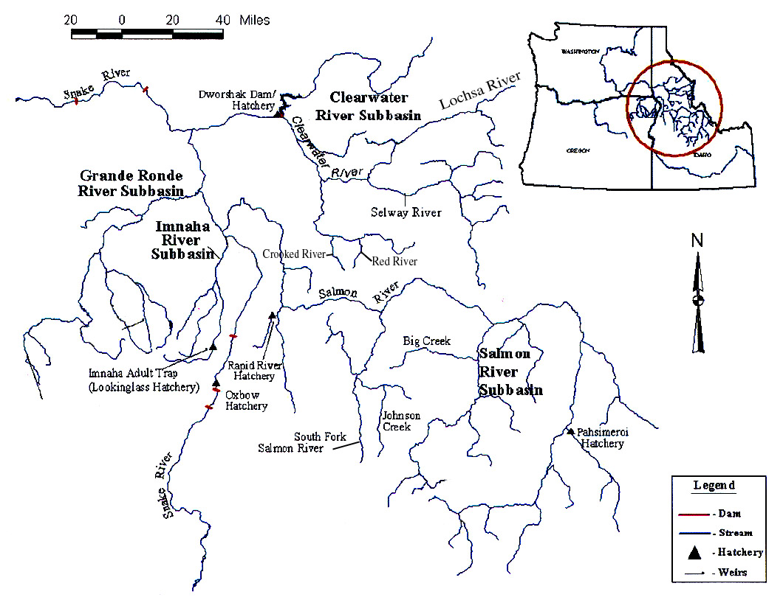
Figure 1. Snake River Basin watershed.

Sampling Design

The monitoring strategies were developed to produce baseline catch data in a stratified statistical design. The accessibility of fishing sites, timing and size of the spring/summer chinook returns to hatchery racks, and required fishing effort, were variables that required substantial sampling effort to produce statistically reliable, consistent, and comparable data. Information to be collected in the proposed fisheries included the following: 1) number of fishers, 2) number of catch per fishermen (CPUE), 3) time period engaged in fishing activity, and 4) hatchery or wild fish harvested for streams containing listed species. Preliminary design focused on fishing efforts received at each tributary followed by stratification of the fishing time period (AM versus PM) to determine high versus low fishing effort, and weekday versus weekend fishing preference. The collected data was synthesized quantitatively according to statistical requirements imposed by the selected sampling design in order to meet the program objectives. Hours monitored were selected randomly for the Clearwater River subbasin and Rapid River fisheries. Each week the data collected was aggregated into hourly strata and entered into a spreadsheet to expand for hours in the time period not monitored. The expansion produced a harvest estimate for that fishing location and season duration. The results generated from monitoring were used to estimate harvest by fishery and to evaluate statistical effectiveness of the sampling design. Rapid River was monitored on a 24-hour schedule divided into four time periods representing high and low fishing efforts based on previous reports. The Clearwater River Subbasin monitoring schedule was designed using a 16-hour period from 6 AM to 10 PM.

Mainstem Snake River

Sampling strategy to be employed here will be the use of 1 harvest monitor to randomly document fishing effort and catches during 1 day of the week and 1 weekend day. If fishing pressure is low then the monitoring effort could be modified or decreased. Due to reported low fishing effort the mainstem Snake River is currently not being monitored for harvest impacts on listed spring chinook to provide monitoring in drainages containing listed stocks.

Tucannon River

Due to the absence of tribal fisheries occurring in this tributary in recent years, the need for monitoring was not evident. Instead, routine patrols were conducted by Conservation Enforcement officers to observe harvest in this fishery.

Clearwater River Subbasin

The fisheries to occur in the Clearwater River Subbasin will include the North Fork of the Clearwater, Clear Creek, Lochsa River, Selway River, Red River and Crooked River (tributaries of the South Fork Clearwater River). Monitoring strategy for the subbasin was to document catch and effort from Tribal fishers and to get an estimate of the amount of fish harvested for each tributary during a 16-hour period. Night fishing was omitted from data collection based on previous reporting of minimal fishing activity in this subbasin. A random number generator spreadsheet was developed for the Clearwater River subbasin which determined monitoring days for the various linked tributaries. Based on the spreadsheet output one harvest monitor would cover the North Fork of the Clearwater River and Clear Creek, one monitor covers Selway River until the harvest quota was met (established via tribal regulation as 100 fish), then monitors Lochsa River with the Red River/Crooked River fishery (Red and Crooked River are evaluated as one system). Four days are scheduled randomly using the random number generator then the fifth day would be a flip of the coin. Lochsa was monitored 1 day of the weekend with the other day being Red River/Crooked River (same strategy for NF of Clearwater and Clear Creek).

Salmon River Subbasin

The presence of ESA listed chinook in this tributary requires constant and accurate monitoring efforts from DFRM. Random monitoring efforts will concentrate on the three delineated zones located on Rapid River. Initial sampling design employed the use of 1 monitor to randomly document the harvest of hatchery spring chinook and determine wild/natural chinook take up to the 36 fish limit. The sampling strategy was modified to incorporate 2 monitors for greater accuracy in reporting catch and fishing effort.

The proposed fishery in the South Fork Salmon River involved a sampling strategy, which included 2 monitors working 3.5 days on/3.5 days off for the duration of the fishery season. The sampling strategy allowed monitors to observe and interview all Nez Perce tribal fishers to derive total hatchery and wild/natural fish harvest number for this tributary.

Grande Ronde Subbasin

The Lookingglass fishery was essentially developed as a means to control returning Lookingglass stock hatchery fish in this tributary, thus it was a limited catch of hatchery fish by tribal and non-tribal members alike. The use of a monitor was not recommended.

ISRP Comment No. 3
Catch reporting should be a condition of licensing, but licensing is not an issue here since this project deals with Treaty Reserved Fishing Rights. Perhaps a first step should be to institute a process of licensing of the harvest, followed by design of a reporting template (form). Please provide the suggested catch reporting form. The cost of licensing should support the cost of the catch monitoring, and probably should be much lower than what is reported here.

Response to Comment No. 3
The Nez Perce Tribe reserved, in its 1855 Treaty with the United States, the right to take fish at all usual and accustomed places. The Tribe’s treaty-reserved fishing rights have been repeatedly upheld by the federal courts and the Tribe is a recognized sovereign co-manager of the salmon resource. The Nez Perce Tribe’s monitoring program contained in this proposal provides a via, on-the-ground, method for obtaining real-time catch data from tribal members exercising their treaty-reserved fishing rights. The following reporting template (for tributaries that contain listed and nonlisted species) is proposed for use in documenting this data (Figure 2.).

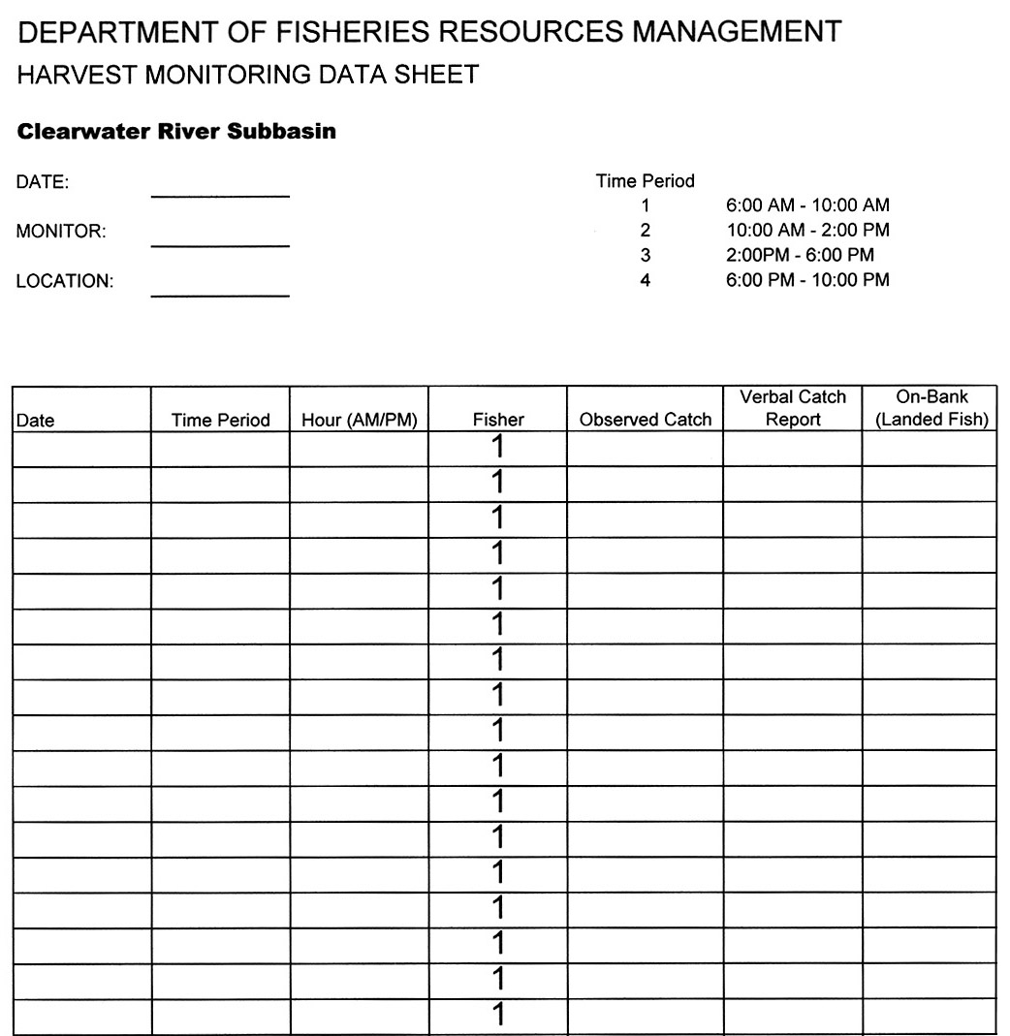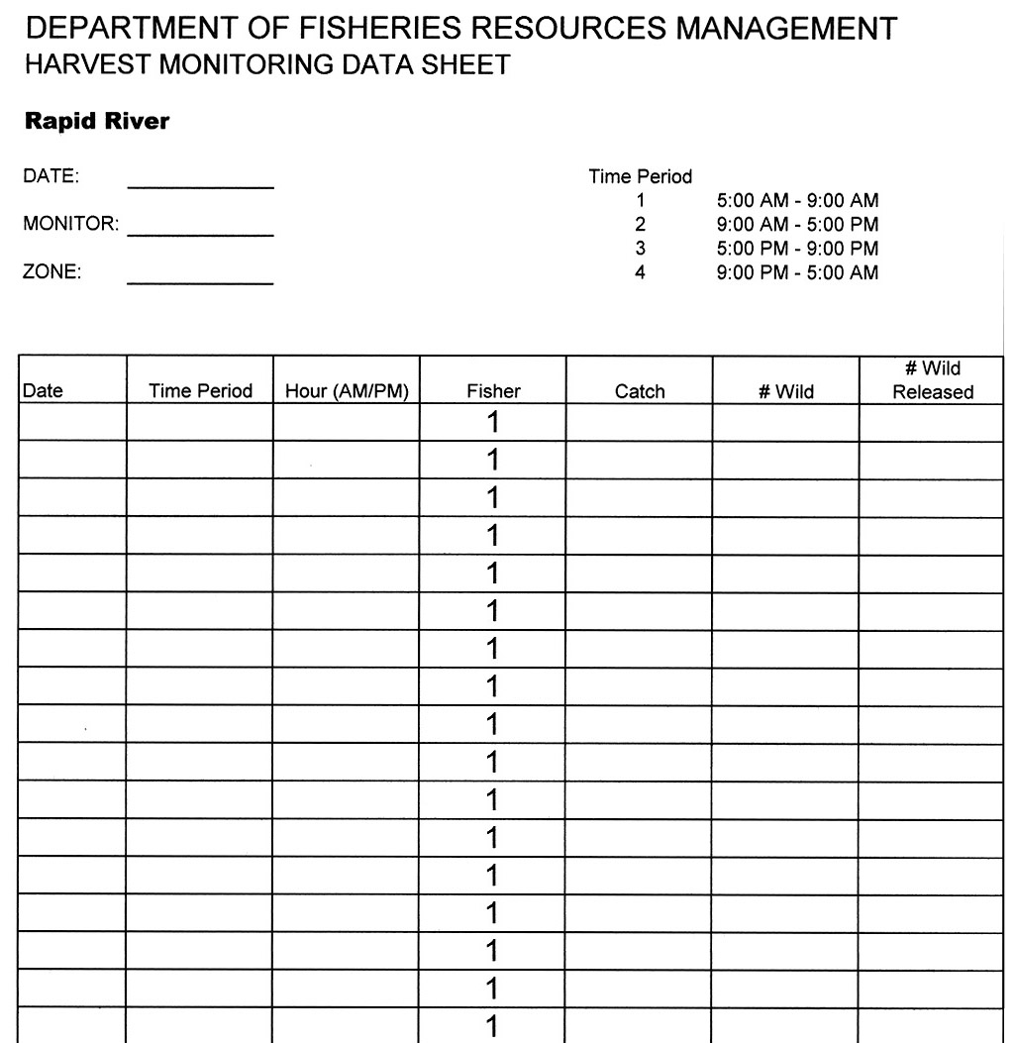

Figure 2. Proposed data collection sheets for the Clearwater River Subbasin and Rapid River.
ISRP Comment No. 4
Support may be justified for Task A: Consult Columbia River Intertribal Fish Commission (CRITFC) Biometrician to establish and implement monitoring strategies for the NPT for the Columbia River Basin and tributaries. We request a report from the biometrician that recommends a catch monitoring strategy, to be followed by a resubmitted proposal after peer review of the report. The proposal embodies the right approach, provided appropriate statisticians are available to design the sampling. Measuring catch per hour for the fishers contacted is fairly easy, but making valid estimates of fishing effort (number of fishers and how many hours they fished in total) will be very hard. An output of the project should be calculations of the degrees of uncertainty of the estimates. Please indicate how this uncertainty will be calculated.

Response to Comment No. 4
The basic consideration undertaken by the Harvest Monitoring Program in collecting harvest data has been to determine what statistical sampling design provides the best quantitative estimate of the tribal fishery characteristics (as outlined in Response to Comment No. 2). The approach in developing the sampling design has been implementing an adaptive management framework that incorporates the biological needs of the fish while maximizing harvest opportunities for tribal fishers, to fit the temporal and spatial dimensions of sampling the Snake River Basin. The information to be collected and sampling area will be expanded to all usual and accustomed fishing areas. The ESA listing of Snake River salmon and steelhead within the Snake River Basin has required the tribe to structure its fisheries to avoid or limit catch of these protected fish. The monitoring design is customized to tributary listing status and fits spatial and temporal characteristics of the drainages and tribal fishing activities.

Catch Monitoring Methodology

Data collection under the developed stratified sampling design will be attained by direct observation for a seven-day timeframe (Sunday-Saturday). Data will be collated and entered into a spreadsheet by hour increments contained in a 16- or 24-hour sampling period. Mean catch per fisher hour and fisher effort data will be used to derive weekday and weekend estimated catch. Weekday and weekend catch will be summed to give total weekly catch and weekly CPUE computed by weekly catch divided by weekly fisher effort. The spreadsheet generated an expansion for the time not monitored during the week by the following equation:

C = Sum days (weekdays or weekends)*(P X CPUE X HA/HS)
C = estimated catch
P = mean fishing pressure
CPUE = mean catch per fisher hour
HA = hours available for fishing for a give time period
HS = hours actually surveyed for a given time period

Replication on the weekday/weekend sampling for each tributary and strata will give a measure of variance, which could then be incorporated into generating the level of uncertainty in the estimates. Calculating the standard deviation and 95% confidence interval for each tributary and strata will produce a upper and lower range to the weekly harvest estimates. This approach has been evaluated to increase the precision of the harvest estimates produced from the 2001 spring season sampling design.

A detailed catch monitoring strategy report can be provided should funding for this proposal be approved. Sampling design refinements for the various proposed fisheries will continue throughout the Planning and Design and Monitoring and Evaluation phases of the proposed project to address the comments toward developing suitable sampling strategies that address catch per hour for fishers, fishing effort, and statistical approach to calculating the degrees of uncertainty of harvest estimates.

ISRP Comment No. 5
The terms, TAC and DRFM, found in the proposal are not defined.

Response to Comment No. 5
TAC- Technical Advisory Committee (of the U.S. v. Oregon)
DFRM- Department of Fisheries Resources Management (of the Nez Perce Tribe)

