Bonneville Power Administration

FY 2002 Provincial Project Review

PART 2. Narrative

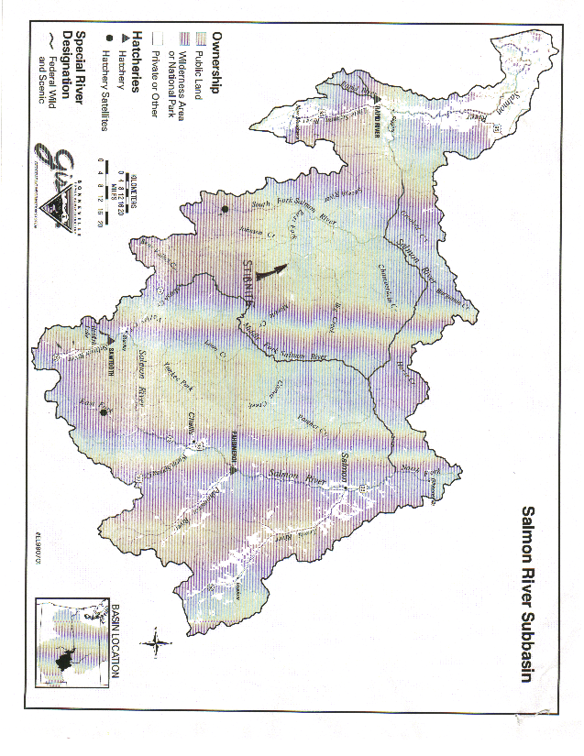
Project ID: 28058

Title: Restore Fish Passage and Habitat on the Upper East Fork of the South Fork of the Salmon River

Section 9 of 10. Project description

a. Abstract

The Salmon is a priority subbasin under the National Marine Fisheries Service (NMFS) Biological Opinion (BI-OP) with respect to the Columbia River Basin. Downstream migration of juvenile Snake River spring/summer chinook salmon, and summer steelhead, and the upstream migration of late summer adult chinook salmon depends on passage through critical reaches of the Lemhi and Salmon Rivers.

This project will utilize native materials that exist at an abandoned mine Site (the Yellow Pine Mine) to recreate fish passage through a pool and plunge spillway where fish passage has been curtailed when the mine was excavated within the center of the East Fork of the South Fork of the Salmon River at Stibnite (EFSFSR). In addition to providing access to over seven miles of recently rehabilitated spawning and rearing habitat in the Upper EFSFSR, the construction of the fish passage will result in reclamation of abandoned mined lands and restoration of approximately one mile of fisheries habitat within the construction footprint.

Materials utilized to construct a pool and plunge structure, which is suitable for fish passage at both high and base flows, will be extracted from relatively inert overburden waste dumps at the Yellow Pine Mine. The materials will be sorted to produce several sized fractions of materials suitable to construct the pool and plunge system and withstand various flow regimes in the EFSFSR. Once the foundation of the passage is constructed from boulders, finer material will be bedded in the bottoms of pools to help retain adequate volumes of water in the pools for fish to rest, accelerate as they leap from pool to pool, and land prior to entering the next successive pool.

Standard reclamation practices will be applied to the construction, barrow and access areas prior to completion. This will involve recontouring to minimize erosion and sediment delivery, soils construction and revegetation with native species to provide for a self-sustaining surface area, and evaluatio0n to ensure that construction and reclamation actions were effective.

Implementation of the project will require consultation and coordination with the Nez Perce Tribe, Idaho Departments of Water Resources, Fish and Game, and Environmental Quality. Additional stakeholders in the project include the National Marine Fisheries Service, Fish and Wildlife Service, Army Corp of Engineers, and USDA Forest Service – Payette and Boise National Forests. Currently, the Nez Perce Tribe, Idaho Departments of Water Resources, Fish and Game, Environmental Quality, and USDA Payette National Forest have expressed great interest in participating as cooperative entities in the project, and will provide either in-kind matching funds or sub-contractual services.

b. Technical and/or scientific background

The mines at Stibnite were the sources for over 90% of the world’s production of antimony oxide in the mid 20th Century, and were, therefore, targeted as strategic during World War II. Stibnite also produced substantial amounts of tungsten and gold. During support of the war effort, miners at Stibnite diverted the EFSFSR through a two-mile tunnel in order to mine the ore body located beneath the river. The Yellow Pine Pit, which became more familiarly known as the “Glory Hole” was excavated to nearly 500 feet in diameter and 300 feet deep. After the mine played out, the river diversion was eliminated, and the EFSFSR cascaded into the Glory Hole, and began to down cut through the colluvium in the valley floor upstream of the “Glory Hole. The fine sediment from this down cutting continues to be delivered to critical spawning, rearing and over wintering habitat on the Lower EFSFSR and Lower South Fork of the Salmon River (SFSR). Although the EFSFSR continues to down cut headward in the watershed the cascade may be stabilizing as a permanently impassable barrier to fish migration fish, especially during base flows in late summer and fall.

NMFS’s has provided an opinion on this cascade in its “Biological Opinion of the U.D. Forest Service and U.S. Army Corps of Engineers Authorizations for Stibnite Mining Inc. Commercial Road Use Permits and Garnet Pit Mining (1995)”. In this biological opinion, NMFSs states that “This waterfall (in the Glory Hole) has presented a complete migration barrier to returning adult chinook salmon. During the last fifteen years, the Glory Hole waterfall has experienced an accelerated rate of streambed down cutting. The EFSFSR now flows over a cascade that is 20 to 30 feet high and about 100 feet long before it enters the Glory Hole. An alluvial fan has developed in the Glory Hole pond at the base of the waterfall. As a result of both down cutting and alluvial fan development, the cascade reach is decreasing in steepness. There is now anecdotal evidence that adult cutthroat trout can migrate up the cascade reach (Don Anderson, IDFG Biologist, June 7, 1994, personal communications). Continuing stream bed down cutting should make the Glory Hole Cascade significantly less difficult for chinook salmon to pass through in the future.” Whereas more recent observations are that the cascade itself is stabilizing before reaching a configuration that is conducive to fish passage, some anthropogenic influence is necessary to fully recover fish passage at this location, particularly if it is to be part of a short term recovery process.

From 1997 through 2000, the private companies Exxon-Mobil and Hecla Mining Companies worked at Stibnite as “Potentially Responsible Parties (PRPs). Although it was later determined that the PRPs’ participation at the site had a de minimus effect relative to historic mining activities, the PRPs spent in excess of $4 million dollars performing site characterization, risk assessments and remedial activities at the site with a primary focus on toxicology, habitat and fisheries conditions, and rehabilitation. The PFPs’ work resulted in the reopening of over 6,000 feet of historic stream channel, and much of the site characterization data and maps (attached), which will serve as the engineering and biological baseline for this project. Consequently, the PRPs contributions to developing this project was listed as $100,000 (approximate cost for site characterization of the Glory Hole) in the matching funds portion of Part One of this proposal.

State and federal agencies have been attempting to creatively fund reclamation of the Glory Hole for almost twenty years. Recently the agencies have evaluated natural resource damages actions, the use of the Comprehensive Environmental Response Compensation and Liabilities Act, Clean Water Action Grants (CWA Section 319), and Idaho’s State Abandoned Mined Lands (AML) Reclamation Funds. Thus far the agencies have been unable to tie viable responsible parties to the project, nor identify grant or AML funds of sufficient magnitude to complete a fish passage project. Furthermore, where this action is not mandated by court order or state law, it is likely that if funds are not made available very soon, the project will be abandoned, and fish passage to the Upper EFSFSR be impaired until well after threatened and endangered species recovery efforts have been completed.

The Salmon Subbasin assessment states that “road construction, logging, and mining have contributed to heavy sedimentation and degraded habitat conditions, and (poor) water quality in the South Fork of the Salmon River and other Salmon River tributary streams,” which are significant limiting factors to protection and recovery efforts being made for anadromous and resident species of fish. Idaho’s Southwest Basin Bull Trout Problem Assessment (PA) adds that “man-made barriers for Bull trout (and other resident and anadromous fish species) passage includes: culverts in Goat Creek, Tailholt Creek and Reegan Creek; artificial waterfalls above the Glory Hole at Stibnite; and the outlet at Warm Lake” represent an additional limiting factor to protection and recovery.

This project is consistent with the Subbasin Management Goals, Objectives and Strategies. The reconstruction of fish passage will improve smolt to adult survival, juvenile rearing, and restore depressed populations of native anadromous fish. Concurrently, the project will: ensure persistence, health and diversity of resident species
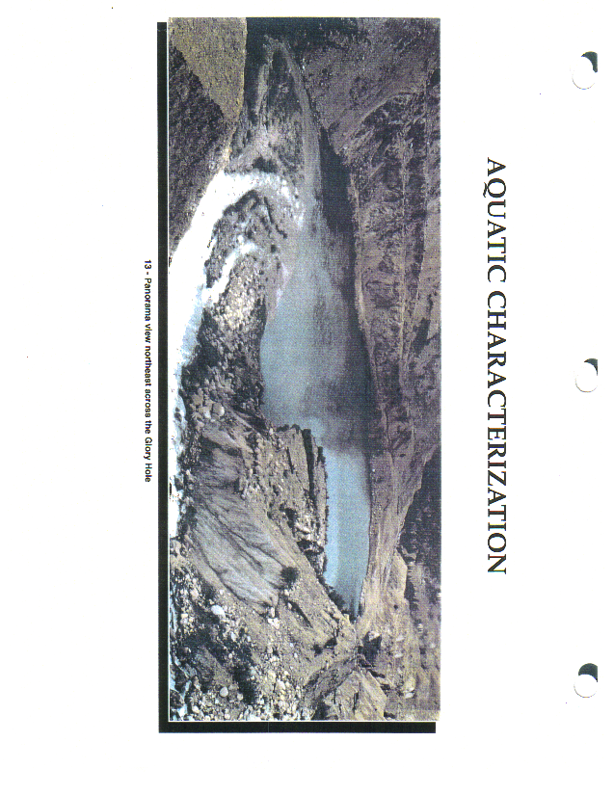
by reducing or removing the impacts caused by habitat degradation in the Upper EFSFSR; and the project will provide for restoration of native resident (and anadromous) fish populations to near historic levels in the Upper EFSFSR. It will do so by adding additional spawning and rearing habitat to the South Fork Subbasin, provide additional native brood stocks for recolonization of the Upper EFSFSR, and it will significantly reduce or eliminate substantial sources of fine sediment and heavy metals which contribute to habitat loss in the Lower SFSR.

c. Rationale and significance to Regional Programs

Species present include: Snake River Spring/Summer Chinook Salmon (Oncorhynchus tshawytscha), Snake River Summer Steelhead trout (Oncorhynchus mykiss), Salmon River Basin Bull trout (Salvelinus confluentus), and Salmon River Basin Cutthroat trout (Oncorhynchus clarki lewisi).

Documents written by the National marine Fisheries Service to list chinook salmon and steelhead, and to designate critical habitat under the Endangered Species Act cite the loss of mainstem river habitat and tributary connectivity as one of the reasons for the decline in these species. Furthermore, the U.S. Fish and Wildlife Service has also state in its Biological Opinion that loss of habitat and connectivity between tributaries and mainstem rivers has also contributed to the listing of bull trout.

One of the objectives in the Idaho Department of Fish and Game draft Fishery Management Plan – 2001-2005, is to “Maintain and improve habitat quality throughout the Lemhi and Salmon River drainages.” This one-time project proposes to mitigate the potential effects of a power system by providing for passage of migrating fish on the East Fork of the South Fork of the Salmon River (EFSFSR), improve aquatic and riparian habitats, and eliminate significant sources of sediment which adversely impact critical spawning, rearing and over wintering habitat for resident and anadromous fishes in the SFSR Subbasin.

The nature of the risk on the Upper EFSFSR is blocked passage, both upstream and downstream, for fish. This risk will be mitigated prior to December 2002 through a coordinated and direct, on-the-ground action that will provide fish passage for the upstream migration of late summer adult Chinook salmon and downstream migration of juvenile Snake River Spring/Summer Chinook salmon and summer steelhead, and mid-summer migration of Salmon River Basin Bull trout to six miles of additional spawning and rearing habitat, which has recently been recovered, but has lain inaccessible to fish for almost sixty years. As a secondary benefit, reconstruction of the fish passage will eliminate a significant sediment source, which contributes to the adverse effects on spawning, rearing and overwintering habitat on the SFSR below the project. And as stated, the benefits to both ESA- and non-listed species will be realized during the 2003 migration seasons.

U.S. Army Corps of Engineer’s and Idaho Department of Water Resource’s permits will be in place by the time work is ready to begin in the summer of 2002. Consultation with the Nez Perce and Shoshone bannock Tribes, the U.S. Fish and Wildlife Service and National Marine Fisheries Service will also be completed prior to implementation of the project.
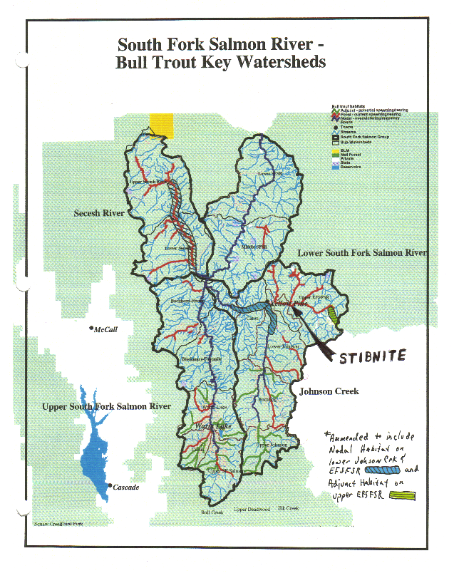
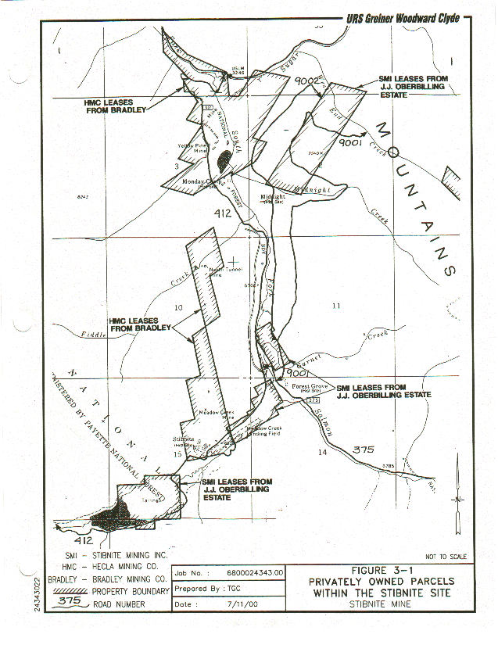

d. Relationships to other projects

The objective of this project is to promote native anadromous and resident fish habitat enhancement and recolonization on private and public land using a watershed approach in the upper EFSFSR Basin. The vision of IDEQ is to provide a basis of coordination and cooperation between local, private, state, tribal and federal fish and land managers, land owners and others to protect, restore and enhance anadromous fish passage and habitat. IDEQ has lead a dynamic site characterization and planning process that has been effective in implementing projects to recreate fish passage and habitat, while developing a long-term plan to address some of the more controversial aspects of watershed management. Since IDEQ and the USDA Forest Service undertook the lead in aquatic habitat restoration projects on public and private lands at Stibnite over three miles of high quality spawning and rearing habitat have been recreated in the Upper EFSFSR, and metals and sediment loading from historic mining has decreased by over 60 %. IDEQ has, with the assistance of IDFG, contractors and volunteers planted over 30,000 sapling riparian and upland species, seeded and fertilized over 80 acres of barren mining wastes, and isolated heavy metals laden wastes. Although the IDFG and Nez Perce Tribe are successfully recolonizing the Upper EFSFSR with hatchery brood stock, IDEQ’s plan will provide for access of native chinook and steelhead spawning and rearing.

IDEQ would facilitate the implementation of the project through coordination of landowners, local government, state government, and federal agencies. On the EFSFSR, work will resume in 2002 to mitigate the effect of mine tailings at the Stibnite Mine. This work will be conducted through a cooperative effort comprised of federal, state and local interest. This will involve some stream alteration. Additionally, the EFSFSR and its tributaries are listed on the State of Idaho’s 1998 303(d) list as an impaired water body due to sediment and metals loading.

e. Project history (for ongoing projects)

Not Applicable

f. Proposal objectives, tasks and methods

Objective 1). Recreate fish passage through the existing EFSFSR cascade into the Glory Hole.
Objective 2). Recreate aquatic and riparian habitat within the fish passage construction zone and barrow sites.

Under the NMFS BI-OP, downstream migration of juvenile Snake River spring/summer chinook salmon and summer steelhead and upstream migration of late summer adult chinook salmon and resident bull trout and cutthroat depends on passage through critical reaches of the Lemhi and Salmon Rivers.

Documents to list Chinook and steelhead salmon and designate critical habitat under the Endangered Species Act cite loss of tributary connectivity as one of the reasons for the decline of the species. Loss of habitat and connectivity between tributaries and mainstem rivers has also contributed to the listing of bull trout.

The primary focus of this project will be to recreate fish passage where a two hundred foot cascade was created when World War Two strategic minerals production resulted in the development of an open pit mine in the center of the Upper EFSFSR at Stibnite, Idaho. In order to reconstruct fish passage, native materials (earth) will be excavated and sorted according to size (boulders, cobbles, gravel, and sand/silt). Boulders will be placed in the stream channel in such a way as to provide plunges and pools which provide for the fish places to rest, to accelerate for leaping cascades, and to land prior to entering the next successive pool. Once the foundation of the passage is construction of boulders, the interstitial spaces in the boulders will be sealed with the sand/silt, overlain by gravels and cobbles, respectively. The addition of the smaller fractions will reduce volume of water passing through the substrate (ie there will be more water available for the fish to swim through), will provide an better growing medium for aquatic plants, and will reduce erosion of the structure.

A secondary focus of the project will be to reconstruct approximately one mile of aquatic and riparian habitat in the “footprint” of the project. The foundation for this habitat will be constructed as unstable and oversteepened stream banks which consist of mine waste, are pulled back from the EFSFSR to a more stable bank configuration. Most of the mine waste removed will be sorted and used in construction of the pool and plunge system. Some of the material, however, will be sorted and replaced as an armor to erosion. Sand/Silt fractions will be blended will soil building materials (compost, mulch and large woody debris) and used to provide a growing medium along the stream and riparian areas. The remaining fines will be blended with soil building materials and used elsewhere at Stibnite (for other reclamation projects) as topsoil. The regraded and topsoiled stream channel and riparian areas will then be covered with large woody debris (50% coverage), and planted with native forbs, grasses, shrubs and trees.

Post-Construction monitoring of the structural stability of the plunge and pool system, adjacent erosion controls, top soils, vegetation, water quality, and aquatic communities will be provided for in a project monitoring plan. The project monitoring plan will be implemented prior to construction and concluded approximately five years after construction has been completed. The monitoring plan establish engineering, chemical and biological metrics against which the efficacy of the will be measured.

The planning, and implementation/construction portion of this project will be completed by December of 2002. Monitoring of construction and reclamation work may result in minor rehabilitation work for a period of approximate four to five years. Subsequently, the site should be relatively stable and self-sustaining.

Ongoing information will be provided through annual engineering, environmental and financial reports to ISRP and BPA by the the Nez Perce Tribe, Idaho Departments of Water Resources, Environmental Quality, Fish and Game. A final white paper report will be presented at the Idaho Non-Point Source Symposium in January 2007 by Key Project Personnel.

This project meets the following proposal criteria: (1) It will address risks to the survival of ESA-listed salmon, steelhead, and resident bull trout affected by the power system by improving tributary habitat passage. (2) The proposed project will have all the planning, permitting, compliance and landowner agreements necessary so on-the-ground implementation may occur this year. (3) This is a short term funding project that will comply with the Endangered Species Act and will be consistent with the Northwest Power Act and also comply with applicable state law, and Federal government treaty and trust obligations.

Under this solicitation, the projects described here address all three criteria. The first criterion addresses the survival of ESA-listed salmon and steelhead. All projects here address this criterion, as chinook, and steelhead recolonize the Upper EFSFSR drainage. The second criteria, to address the survival of non-listed salmon, steelhead and resident fish, is also considered in these projects, as resident bull trout and cutthroat trout inhabit the drainage. As a result of this, joint benefits will be realized for both ESA-listed species and non-listed species, satisfying the third and final criteria.

g. Facilities and equipment

Facilities and equipment available through the cooperating agencies which includes Idaho Departments of Fish & Game, Water Resources, Environmental Quality and private entities through the Upper Salmon Basin Watershed Project (as shown in Cost Share section of Part I).
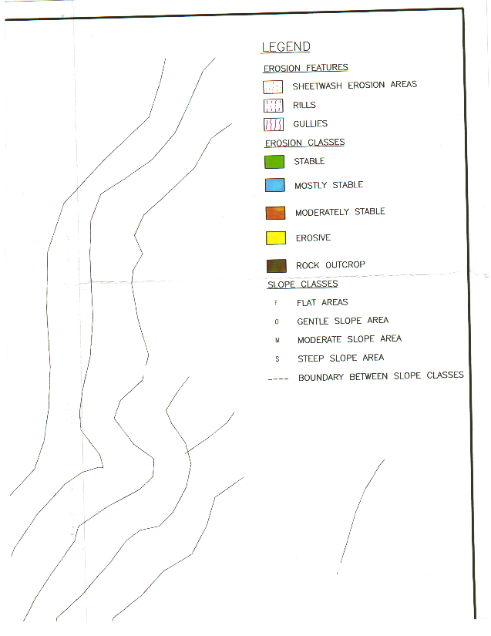
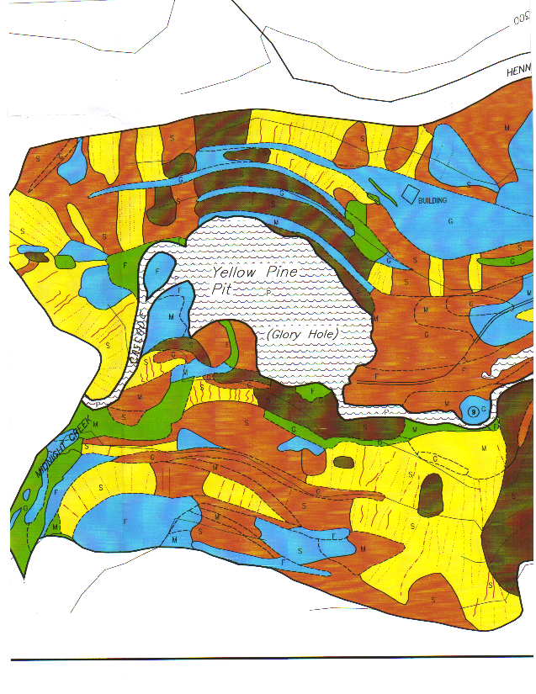
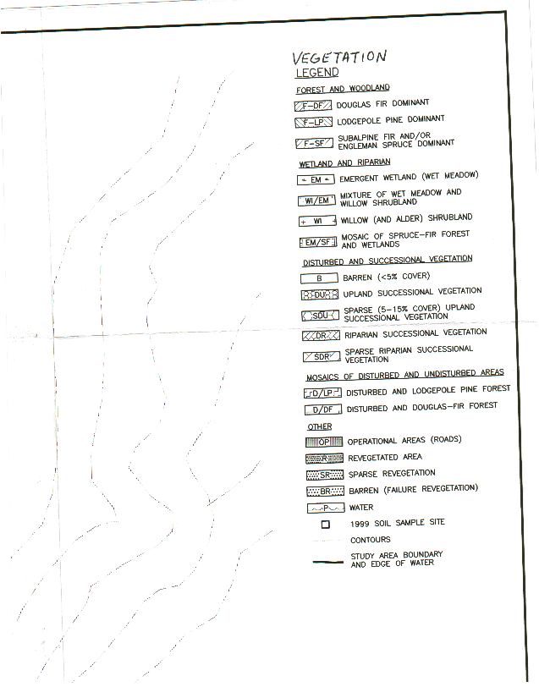
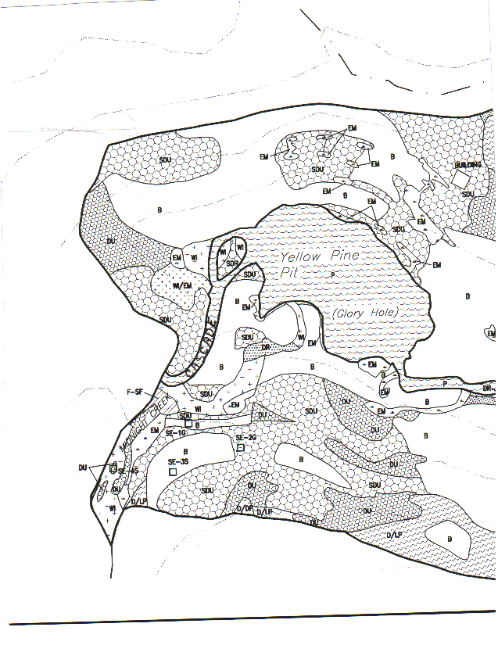

h. References

Reference (include web address if available online) | Submitted w/form (y/n)
1. Northwest Power Planning Council. 1994. Columbia River Basin Fish and Wildlife Program. Northwest Power Planning Council, Portland, Oregon.
2. U.S. Government, Federal Register. (57 FR 14653). Listing of Snake River fall Chinook and Salmon River spring/summer Chinook as threatened. April 22, 1992. Washington, D.C., 57:14653.
3.______. (59 FR 42529). Reclassification of Snake River fall Chinook and Salmon River spring/summer Chinook as endangered. August 18, 1994. Washington, D.C. 59:42529.
4. Conservation of Columbia Basin Fish, Draft Basin-wide Salmon Recovery Strategy, Update of the All-H paper, July 27, 2000.
5. ____________.1995. Biological Opinion of the U.S. Forest Service and U.S. Army Corps of Engineers Authorizations for Stibnite Mine Inc. Commercial Road Use Permits and Garnet Pit Mining. USDA Forest Service, Payette National Forest and US Army Corps of Engineers. June 29,1995, pp. 9.
6.State of Idaho’s Comments, Draft Biological Opinion On Operation of the Federal Columbia River Power System and Draft Basin-wide Salmon Recovery Strategy (Final Draft, All H Paper)(July 27, 2000).
- Upper Salmon River Key Bull Trout Watersheds Problem Assessment, Prepared for the State of Idaho by the Salmon Basin Bull Trout Technical Advisory Team, December 1998.
- URS Griener Woodward Clyde. 2000. Stibnite Area Site Characterization Report. Volumes 1-3.
- Aquatic Biology Associates, Inc. (ABA).1996. Benthic Invertebrate Injury Studies – 1995. East Fork of the South fork of the Salmon River, Idaho. Payette National Forest, Krassel Ranger District. June.
- Aquatic Biology Associates, Inc. (ABA).1997. Benthic Invertebrate Injury Studies – 1996. East Fork of the South fork of the Salmon River, Idaho. Payette National Forest, Krassel Ranger District. June.
- Aquatic Biology Associates, Inc. (ABA).1998. Benthic Invertebrate Injury Studies – 1997. East Fork of the South fork of the Salmon River, Idaho. Payette National Forest, Krassel Ranger District. June.
- Aquatic Associates. 1998a. Physical Habitat Characterization for the East Fork of the South Fork of the Salmon River Drainage in Vicinity of the Stibnite Mine Facility. September 1997. Prepared for Woodward-Clyde Consultants. May.
- Elms-Cockrum, T.J. 1998 Salmon Spawning Ground Survey,1997. Pacific salmon treaty Program Award No. NA77FP0445. Idaho Department of Fish and Game IDFG 98-46.November.

Section 10 of 10. Key personnel

Bruce A. Schuld, Project Manager.
Mr. Schuld is the statewide Mine Waste Projects Coordinator for the Idaho Department of Environmental Quality and has been the project manager for mined lands remedial actions in several watersheds in southwestern Idaho. Project management’s purpose and objectives at the remedial projects is focused on recovery of land and aquatic resource values. Mr. Schuld has specialized in designing remedial actions to recover of critical aquatic and riparian habitat utilized by listed threatened or endangered anadromous and resident species in the salmon River Subbasin.

Education
Mr. Schuld graduated from University of Missouri - Rolla in 1979 with a Bachelor of Science Degree in Mining Engineering. He also graduated with honors from Boise State University in 1986 with a Bachelor of Science Degree in Geology.
Background
Mr. Schuld has twenty years of minerals exploration, construction management and reclamation design experience he received while working in the mining industry. Mr. Schuld also has 14 years of state regulatory experience in which he worked on the Snake River Basin Adjudication, evaluating, permitting and sometimes designing pollution prevention or abatement plans, stream channel restoration plans, and mine reclamation plans.
Publications or Major Technical Reports:
Schuld. B. 1990. "Preliminary Analyses of the State of Idaho's Statutory and Regulatory Authorities for Mine Waste and Materials Management. Western Governors Association
Schuld. B. 1990. Preliminary State Fiscal Analyses for Implementing a State Mine Waste Management Program. Western Governors’ Association.
Schuld. B. 1990 . Idaho’s Mined Lands Inventory and Analysis. Western Governors’ Association.
Schuld B. et al. 1991. Best Management Practices for Mining in Idaho. Idaho Mining Advisory Committee.
Schuld. B. 1993. Water Quality Status Report for the East Fork of the South Fork of the Salmon River. Idaho Department of Health and Welfare – Division of Environmental Quality.
Schuld, B. 1994. Water Quality Status Report for Deep Creek, Adams County, Idaho. Idaho Department of Health and Welfare – Division of Environmental Quality.
Schuld, B. et al. 1994. Reasonable and Prudent Alternatives for Stibnite Mine Incorporated's Commercial Road Use Permit and Mine Expansion. USDA Forest Service. Payette National Forest.
Schuld. B. 1995. Water Quality Status Report for the East Fork of the South Fork of the Salmon River. Idaho Department of Health and Welfare – Division of Environmental Quality.
Schuld, B. et al. 1995. Field Manual for Water Quality Monitoring. Idaho Department of Health and Welfare – Division of Environmental Quality.
Schuld, B. and Apperson, K. 1998. Problem Assessment for the South Fork of the Salmon River Watershed Bull Trout Subpopulation. Southwest Basin Native Fish Watershed Advisory Group.

Legal Documents Negotiated and/or Written:
Memorandum of Understanding for the State and Federal Administration of Large Mines in Idaho (1990)
Memorandum of Understanding for Interagency Coordination and Administration of the Stibnite Mining Area as amended to include Thunder Mountain (1990)
Voluntary Consent Order with Alta Gold Corporation (1991) for the engineering evaluation and implementation of corrective actions for problems related to acid rock drainage at the Red Ledge Mine in Adams County, Idaho.
Notice of Violation: Stibnite Mine Incorporated; Fuel spill at power plant facilities for mine (1990).
Consent Order with Stibnite Mine Incorporated (1991) for site characterization and corrective actions specific to a diesel spill at the company power plant facility.
Notice of Violation: Dave Byers Little Goose Creek Fuel Spill (1992)
Consent Order with Dave Byers (1992) for diesel and gasoline cleanup after a spill in the Little Goose Creek drainage near McCall, Idaho.
Notice of Violation: Stibnite Mine Incorporated; Fuel spill at companys ore processing facilities
Voluntary Consent Order with Stibnite Mine Incorporated (1993) for Site characterization and corrective actions specific to a diesel spill at the companys ore processing facility.
Voluntary Consent Order with Mobil Corporation, Hecla Mining Company and Stibnite Mine Incorporated (1996)
Memorandum of Agreement between the U.S. Environmental Protection Agency and Idaho Division of Environmental Quality: Stibnite Mine Site (1997)
Voluntary Consent Order with Monarch Greenback LLC (1997)

Robert Steed, Project Water Quality Analyst and Policy Advisor
Mr. Steed has eleven years of experience as a senior level water quality specialist in nonpoint source pollution control and abatement plan design, implementation and monitoring. Mr. Steed has been responsible for the program development and implementation of IDEQ’s Beneficial Use Reconnaissance Project, and three major Sub Basin Assessments and Total Maximum Daily Load. For the last four years, Mr. Steed was responsible for the development and implementation facilitator of the Southwest Idaho Native Fish Advisory Technical Group. Mr. Steed is proficient in computer systems and programs, particularly data bases, hydrologic models and AutoCAD programs.
Education
Mr. Steed received a Bachelor of Science Degree in Geology in 1991 from Boise State University where he received the Jack Tarr Award for “Outstanding Student” from the Idaho Association of Professional Geologists. Mr. Steed has also studied for a degree in computer science at the College of Marin.
Publications and Technical Papers
Cascade Reservoir Forest Source Plan Team. 1996. Cascade Reservoir Forest Source Plan. (technical contributor)
Idaho DEQ. 1994,1995,1996,1997,1998,1999. Idaho Beneficial Use Reconnaissance Project Workplan. Idaho Department of Health and Welfare, Division of Environmental Quality. Beneficial Use Reconnaissance Project Coordinators. (contributor)
Idaho DEQ. 1996. Waterbody Assessment Guidance, A Stream to Standards Process. Idaho Department of Health and Welfare, Division of Environmental Quality. (principle contributor)
Idaho DEQ. 1999. Middle Fork Payette river Sub-basin Assessment and Total Maximum Daily Load Project. Idaho Department of Health and Welfare, Division of Environmental Quality. (principle author for SBA, and co-author for TMDL portions)
Steed, R. 1992. Global Positioning System Application for Depth to Groundwater Measurements Quality Assurance Project Plan. Idaho Department of Health and Welfare, Division of Environmental Quality. (principle author)
Steed, R. 1995. Beneficial Use Reconnaissance Project and Preliminary Assessment Process. Presentation to Intermountain Forest Industry Association Annual Meeting. Coeur d’Alene. (presenter)
Steed, R. 1995. Beneficial Use Reconnaissance Project Update, Author Attended Poster Session. 1995 Annual Nonpoint Source Workshop. (presenter)
Steed, R. 1995. Beneficial Use Reconnaissance Project and Preliminary assessment Process. Presentation to Columbia River Basin EIS Team (presenter)
Steed, R. 1995. Procedures and Guidelines for QA/QC of 1995 Beneficial Use Reconnaissance Project (BURP) data. Idaho Department of Health and Welfare, Division of Environmental Quality. (principle author)
Steed, R. 1997. Idaho’s Bull Trout Program, update. Presentation at 1997 salvelinus confluentus Curiosity Society Meeting. Rock Creek, Montana. (presenter)
Steed, R. 1999. Idaho’s Bull Trout Program, update. Presentation at 1999 Salvelinus confluentus Curiosity Society Meeting. Lake Pend Oreille, Idaho (presenter)
Steed, R. 1999. Upper Owyhee Watershed Temperature Monitoring Workplan (primary author)
Steed, R., B. Horsburgh. 1996. Beneficial Use Reconnaissance Project and Preliminary Assessment Process. Presentation and demonstration at Idaho Conservation League annual retreat. (presenter)
Steed, R., G. Winter, J. Cardwell. 1992. Idaho Snake-Payette Rivers Hydrologic Unit Ground Water Quality Assessment, West Central Idaho. Idaho Snake-Payette Rivers Hydrologic Unit Planning Project Agricultural Nonpoint Source Ground Water Quality Assessment. Idaho Department of Health and Welfare, Division of Environmental Quality. 48 pp. (principle author)
Steed, R., M. McIntyre. 1994. Beneficial Use Reconnaissance Project Preliminary Results, attended Poster Session. Water Quality 2000 Conference. 1994 (presenter)
Steed, R., R. Danahy. 1998 Volunteer Assessment of Stream Road Crossings. Boise River Key Watersheds. Idaho Department of Health and Welfare, Division of Environmental Quality. Boise Cascade. (principle author)
Steed, R., T. Burton, S. Grunder. 1998. Boise River Bull Trout Problem Assessment. Attended poster session at 1998 American Fisheries Society annual meeting. (principle author)
Steed, R., T. Burton, S. Grunder. 1998. Boise River Bull Trout Problem Assessment. South West Basin Native Fish Watershed Advisory Group. (principle author)
Steed, R., T. Burton, S. Grunder. 1998. Goldfork, Squaw Creek Bull Trout Problem Assessment. South West Basin Native Fish Watershed Advisory Group. (principle author)
Steed, R., W. Clark, M. McIntyre. 1994. Beneficial Use Reconnaissance Project Preliminary Results, Attended Poster Session. 1994 Annual Nonpoint Source Workshop. 1994. (presenter)

Erv Ballou , Project Stream Channel Protection Specialist and Permits Coordinator
Mr. Ballou is the State Coordinator for the Idaho Department of Water Resources (IDWR) Stream Channel Protections Program. As the primary author of Idaho’s statutes for stream channel protection and “Standards for Stream Channel Alterations,” Mr. Ballou’s thirty years of technical experience in IDWR will provide critical design and policy expertise to the project team from its inception through final evaluations.
Education
Mr. Ballou received his Associate Degree in Advanced Technology and Bachelor of Science in Industrial Technology from Boise State University. He continued his post graduate work in Riparian Management, Natural Resources Management and River Hydrology.
Experience
Mr. Ballou has been the primary author of IDWR’s rules governing stream channel alterations and recreational dredge mining. Mr. Ballou has worked extensively with state and federal regulatory agencies and industry to develop state of the day best management practices for mining and stream channel protection. Under his guidance, a joint CWA 401/404 permitting process was developed with the US Army Corps of Engineers, with whom he has forged an exceptionally effective symbiotic relationship. He represents IDWR on the Idaho’s Mining Advisory Committee and Idaho’s Mined Lands Reclamation Awards Committee. Mr. Ballou has been the principal contact and negotiator for IDWR during the development of Memoranda of Understanding between IDWR and the Idaho Transportation Department, Idaho department of Lands, USDA Forest Service, US Bureau of Land Management and US Army Corps of Engineers for stream channel protection.

Kim Apperson, Project Fisheries Biologist
Ms. Apperson will be the primary fisheries biologist on the project, and will be principally responsible for interpretations of fish passage criteria applicable to the construction project, and for the biological monitoring components for the project. Ms Apperson has gained considerable knowledge of the administrative process for ESA consultation and interagency coordination during her eight years as IDFG’s regional Anadromous Fisheries Biologist. Ms Apperson also has 20 years of field experience in fisheries monitoring and evaluation.
Education
Ms Apperson received a Bachelor of Arts Degree, with a major in Biology and a Minor in Geology from California State University at Fresno. Ms. Apperson continued her education and received a Masters of Science in Zoology from the University of Idaho at Moscow.
Experience
Ms. Apperson is currently the Regional Fisheries Biologist for the IDFG McCall, and is responsible for Responsible for evaluating regional fish populations and sport fisheries for both management and research divisions of the Department. Participate in developing fishing regulations, and in designing anadromous research projects. Co-author annual management and research progress reports. Other activities include riparian restoration projects, instream water rights. Participate on interagency teams to develop comprehensive basin water plans, watershed assessments, and bull trout problem assessments. Typically supervise seven temporary employees, including two year-round technicians. Ms Apperson has also: been the Project leader in research of white sturgeon in the Kootenai River; evaluated status and investigated environmental factors limiting recruitment; lead the cooperative project with Kootenai Tribe, Montana State, and British Columbia; Conducted literature review and developed outline of existing information regarding management, life history, genetics, habitat requirements, and population dynamics of Westslope cutthroat trout for co-authored publication; been Principal author of completion report for a three-year study of salmonid populations and fisheries, and habitat quality in the upper Spokane River drainage; led an intensive chinook smolt monitoring research project in upper Salmon and Crooked rivers, for which objectives included developing and using methods to evaluate habitat and rearing potential, parr-to-smolt survival, and smolt production and evaluation of supplementation.

Ira Jones – Nez Perce Tribe, Subbasin Focus Coordinator
Habitat/Watershed Manager
Mr. Jones will be the primary contact with the Nez Perce Tribe, and will assist the Project Manager to appropriately consult with the Nez Perce Tribe, coordinate remedial activities such that they are conducive to The interest of the Nez Perce Tribe, and wherever necessary provide technical and contractual assistance in implementation and monitoring the project.
Education: Wildlife - University of Montana, Missoula, MT
Experience: Currently, Mr. Jones is responsible for planning and implementation of Early Action Watershed Projects, analyze programs, laws, policies related to watershed management, facilitate development of criteria to identify critical fisheries habitat, develop a system to apply criteria to watershed for project development and administration, prepare and plan documents for watershed habitat coordination, provide educational presentation and workshops for watershed management and proposal development, and provide assistance to project proponents with proposal development, implementation, monitoring and assessment. Mr. Jones also has experience as the Tribal Government Program Manager, Facilities Manager, and Fire Cache Work Leader for the U.S.D.A. Forest Service Region I. He has coordinated National, Multi-Regional, and Regional Civil Rights Conferences, 2) Facilitated treaty rights workshops with host tribes and multi-governmental agencies, 3) Organized and conducted Tribal Relations Training primarily for management level from the U.S. Forest Service, Tribes, Bureau of Land Management, and bureau of Indian Affairs, 4) Introduced, implemented, and managed the Inter-tribal Youth Practicums for career in natural resources and leadership within the Forest Service Regions 1, 5, 9, and 10. 5) Developed an intergovernmental Personnel Act (IPA) position to work with the Salish Kootenai College to teach environmental science courses and develop a four-year natural science curriculum at the college. This three-year position and the program developed into a four-year accredited degree program in the fall of 1996. Since joining the tribal staff I have accomplished many activities which include: 1. completing the Clearwater Subbasin Summary and Assessment, 2. the individual assessments on Newsome, Lapwai and Big Canyon Watershed, 3. Master Challenge Cost-Share Agreement between the Nez Perce Tribe and the Clearwater and Nez Perce National Forests, 4. our program has received the Chief of the Forests Rise to the Future Award in 2000and nominated again in 2001, and 5. represented the Nez Perce Tribe in the MeadowFace Stewardship Project.

Felix M. McGowan - Nez Perce Tribal Watershed Coordinator
Mr. McGowan may work, under a subcontract agreement, during technical activities within the Nez Perce Fisheries, wildlife, water resources, and cultural resources. These activities will include habitat assessments and designs, research, and production as it relates to watershed management, coordinate with participating stakeholders, work with interdisciplinary teams, inventory and evaluate habitat conditions, and coordinate riparian protection and restoration efforts.
Education: 1994 – B.A. in Biology – Gonzaga University Spokane, WA
Experience: Mr. McGowan has been responsible for coordinating all activities within the Nez Perce Fisheries, wildlife, water resources, and cultural resources. These activities have included habitat assessments and restoration , research, and production as it relates to watershed management, coordinate with cooperating agencies, work with interdisciplinary teams, inventory and evaluate habitat conditions, and coordinate riparian protection and restoration efforts. Mr. McGowan has a broad educational base in the natural sciences that allows an understanding of different natural processes. The training he has received over the past year has greatly increased his understanding in fisheries and hydrological sciences. These are two of the most important sciences involved in watershed work.
Relevant Training:
- Riparian Proper Functioning Condition Training, 1998, Bureau of Land Mgmt.
- Integrated Ecosystem Watershed Management Workshop, 1998, OSU
- Road Obliteration Training, 1998, USDA Forest Service
- Introduction to GIS with ArcView 3.0a. 1998, BIA
- Applied Fluvial Geomorphology, 1998, Wildland Hydrology
- River Morphology and Applications, 1999, Wildland Hydrology
- River Assessment and Monitoring, 2000, Wildland Hydrology
- Coldwater Fish Culture, 1998, U.S. Fish & Wildlife Service

Stephanie Bransford - Nez Perce Tribal Habitat Biologist
Ms. Bradford may provide additional subcontract services in completeing habitat and stream channel assessments. Ms Bradford has a broad educational base in the natural sciences coupled with engineering principles. This allows for an understanding of different natural processes and creative and practical solutions to environmental problems. The training she has received over the past year has greatly increased her understanding in watershed restoration and hydrological sciences.
Education: 1999 – B.S. in Biological Systems Engineering – University of Idaho, Moscow, ID
Experience: Ms. Bradford has been the Project leader for the Newsome Creek Project. Responsible for road surveys and assessments, culvert inventories and assessments, and mainstem channel surveys. In charge of all NEPA work for the project and relevant Biological Assessments, as well as required permits and reports for consultation (NMFS, USFWS, and SHPO), implementation, and monitoring of results. Responsible for keeping lines of communication open with Forest Service and other partner agencies and publics.
Relevant Training:
- Riparian Proper Functioning Condition Training, 2001, Bureau of Land Mgmt.
- Road Obliteration Training, 2001, USDA Forest Service
- NEPA Training, 2001, Herrera Environmental Consultants
- Road Survey Training, 2000, USDA Forest Service and Nez Perce Tribe

REBECCA A. LLOYD - Water Quality Speci alist
Nez Perce Tribe
Ms Lloyd may also provide subcontract services, through the Nez Perce Tribe, in watershed monitoring and modeling.
Experience
Ms Lloyd has developed and implemented: comprehensive watershed monitoring and evaluation plans; watershed restoration projects; training and coordination of field crews in watershed restoration projects such as road obliteration. Ms Lloyd has also represented the Nez Perce Tribe at regional meetings coordinating and developing restoration projects.

Education
Ms. Lloyd graduated from Indiana University at Bloomington Masters of Science in Environmental Science specializing in Water Resources. Ms. Lloyd also attended the University of Wisconsin – Stevens Point where she studied Water Chemistry, Hydrogeology, Hydrology, and Groundwater Computer Modeling. Ms. Lloyd has a Bachelor of Arts from Washington University – Saint Louis in International Environmental Studies.
Specialized Training
•American Water Resources Association Member since 1997.
•Laboratory proficiencies: Ion Chromatographs, Atomic Adsorption, pH meters, Spectrophotometers, Conductivity, Fecal Coliform analysis, alkalinity, and TSS.
•Field skills: Water quality sample collections both manual and with ISCO automated samplers, flow meters, Rosgen channel typing and cross sections, pebble counts, macroinvertebrate sample collection and i.d., hydrolabs, dissolved oxygen, fish sample collection and id both using electroshockers and seining, algal sample collection and i.d., and plankton sample collection and i.d.
•Specialized training: First Aid/CPR 1999. Off-road ATV and 4x4 vehicle training. Wildfire fighter Red Card. Chainsaw safety. Herbicide preparation and application. Helicopter safety. Aerial photo and topographic map interpretation. Certified as a Wetland Scientist.
•Proficient with a variety of spreadsheets, graphics programs, GIS, and word processing programs to calculate and present data.

Robert Cordtz – Project Minerals and Lands Reclamation Specialist
Mr. Cordtz will be the primary influence on project reclamation tasks. He has and extensive background in mined lands reclamation, forest fire rehabilitation projects. Mr. Cordtz’s particular specialties include landscaping, soil reconstruction and native species revegetation on nutrient and organic poor mine and mill tailings.

Amber Bigelow – Office Specialist
Ms. Bigelow will provide and direct administrative support for the project. Ms Bigelow has an extensive background in office and files management employee supervision and computer sciences. Ms. Bigelow is currently responsible for updating and managing several electronic data bases and is proficient in Access, MicroSoft Word, and preparing PowerPoint presentations.

