Restore Fish Passage and Habitat
in the Upper East Fork of the South Fork
of the Salmon River
Project ID 28058
Response to ISRP Comments – Preliminary Mountain Snake and Blue Mountain Review

INTRODUCTION

This project will utilize native materials that exist at the abandoned Yellow Pine Mine (Glory Hole) to recreate fish passage through a pool and plunge spillway. Fish passage was obstructed when the mine was excavated within the center of the East Fork of the South Fork of the Salmon River at Stibnite (EFSFSR). The project will also result in construction of additional fisheries habitat and abatement of sediment production and delivery from abandoned mine waste dumps and unstable stream banks.

Materials utilized to construct a pool and plunge structure, which is suitable for fish passage at both high and base flows, will be extracted from relatively inert overburden waste dumps at the Yellow Pine Mine. The materials will be sorted to produce several sized fractions of materials suitable to construct the pool and plunge system and withstand various flow regimes in the EFSFSR. Once the foundation of the passage is constructed from boulders, finer material will be bedded in the bottoms of pools to help retain adequate volumes of water in the pools for fish to rest, accelerate as they leap from pool to pool, and land prior to entering the next successive pool.

Standard reclamation practices will be applied to the construction, barrow and access areas prior to completion. This will involve recontouring to minimize erosion and sediment delivery, soils construction and revegetation with native species to provide for a self-sustaining surface area, and evaluation to ensure that construction and reclamation actions were effective.

Implementation of the project will require consultation and coordination with the Nez Perce Tribe, Idaho Departments of Water Resources, Fish and Game (IDFG), and Environmental Quality (IDEQ). Additional stakeholders in the project include the National Marine Fisheries Service (NMFS), Fish and Wildlife Service, Army Corp of Engineers, and USDA Forest Service – Payette and Boise National Forests. Currently, the Nez Perce Tribe, Idaho Departments of Water Resources, Fish and Game, Environmental Quality, and USDA Payette National Forest have expressed great interest in participating as cooperative entities in the project, and will provide either in-kind matching funds or sub-contractual services.

NMFS’s has provided an opinion on this cascade in its “Biological Opinion of the U.S.D.A. Forest Service and U.S. Army Corps of Engineers Authorizations for Stibnite Mining Inc. Commercial Road Use Permits and Garnet Pit Mining (1995)”. In this biological opinion, NMFSs states that “This waterfall (in the Glory Hole) has presented a complete migration barrier
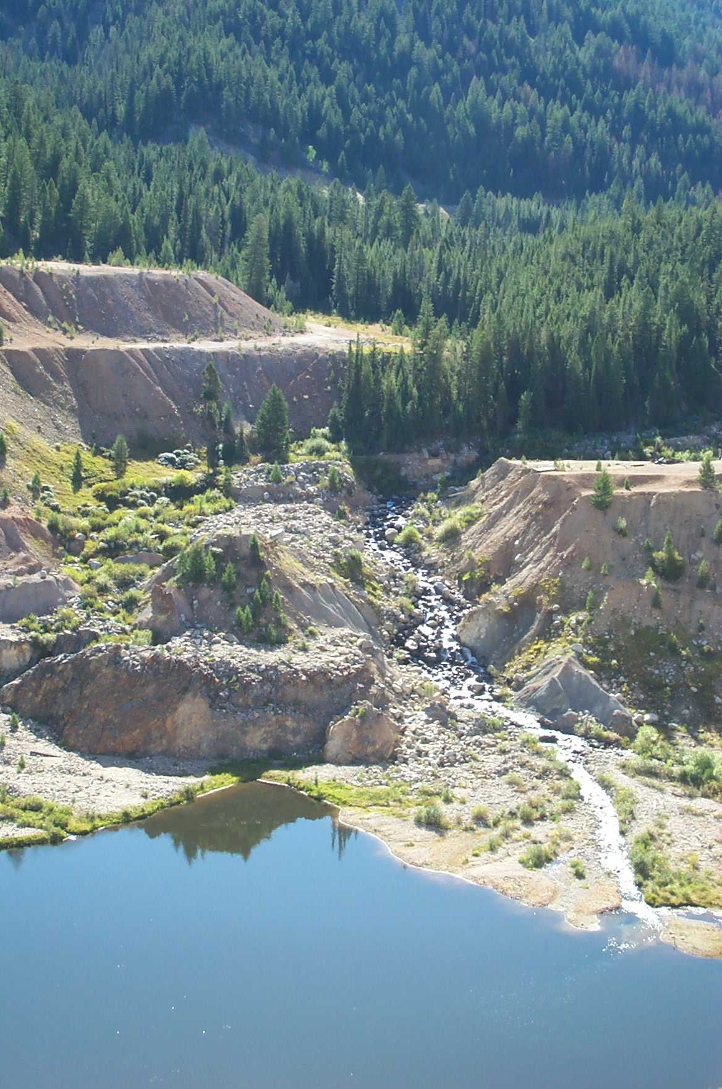
to returning adult chinook salmon. During the last fifteen years, the Glory Hole waterfall has experienced an accelerated rate of streambed down cutting. The EFSFSR now flows over a cascade that is 20 to 30 feet high and about 100 feet long before it enters the Glory Hole. An alluvial fan has developed in the Glory Hole lake at the base of the waterfall. As a result of both down cutting and alluvial fan development, the cascade reach is decreasing in steepness. There is now anecdotal evidence that adult cutthroat trout can migrate up the cascade reach (Don Anderson, IDFG Biologist, June 7, 1994, personal communications). Continuing stream bed down cutting should make the Glory Hole Cascade possible for chinook salmon to pass through in the future.” More recent observations, however, indicate that the cascade itself is stabilizing and will likely not attain a configuration that is conducive to anadromous fish passage, some anthropogenic influence is necessary to fully recover fish passage at this location, particularly if it is to be part of a short term recovery process.

Expected Gains in Fish Populations

As a direct result of the proposed action, populations of both anadromous and resident fish species may be expected to rise sharply in the Upper EFSFSR and Meadow Creek, and become as productive as those found in other tributaries to the EFSFSR located below the Glory Hole. Four separate studies of the fisheries populations and density have been completed and additional studies are being completed. The data presented below was compiled from the completed studies by K. Kuzis, et al, in WATERSHED ANALYSIS OF THE UPPER EAST FORK SOUTH FORK of the SALMON RIVER.

No Man’s, Boulder, Profile, Quartz, Sugar, Salt, Pepper, Tamarack creeks and the Upper EFSFSR below the Glory Hole are unobstructed tributaries, and are very similar to the Upper EFSFSR above the Glory Hole and Meadow Creek. The data collected and evaluated from these streams, therefore, may indicate the success which can expected for the EFSFSR and Meadow Creek. The following table, indicates productivity numbers which may be achieved in the Upper EFSFSR and Meadow Creek within five to ten years after the completion of the project. In sum, it may be expected that steelhead, chinook, bull trout and westslope cutthroat trout densities may reach 10.03/100m², 23.89/ m², 8.00/ m², and 7.01/ m², respectively.

Also attached is a map of the upper watershed around Stibnite. The increase in available spawning and rearing areas in the upper watershed are depicted on this map. The reaches highlighted for potential spawning and rearing areas will, during the course of the implementation and biological trend monitoring at Stibnite, be more accurately delineated and reported. Never-the-less, it appears that at least two miles of prime steelhead and chinook spawning areas will result from the project, an undetermined length of spawning areas will become available to fluvial bull trout, and an additional six to eight miles of rearing habitat will become available for all fish species.

Interagency Support and Idaho Department of Fish and Game Perspective.

Interagency support, particularly by the Idaho departments of Fish and Game and Water Resources, and the Nez Perce Tribe may best be evaluated by the rapid response of those agencies in providing key personnel and their resumes for the initial proposal. Although each of these agencies are experiencing resource constraints, each has offered their services in
EFSF Fish density (fish/100m²) summary by subwatershed. (after Kuzis et al 1997)
Subwatershed | Total acres | Fish Observations  (most common species sampled in bold)
No Man's/Boulder | 9178 | tribs. –unknown  Main EFSF(to Profile) -  - Steelhead - densities (3.4-8.21) all sites all samples 3-8” size dominant  - Chinook- densities (1.2-9.4) all sites in most samples Age 0 dominant  - Cutthroat & Bull trout at low densities not observed in all samples or at all sites
Profile Creek | 12429 | - Bull trout-densities (.5 to 8.0) at all sites in all samples  - Cutthroat-low densities not in all samples or at all sites  - Steelhead - low densities near mouth
Quartz Creek | 12285 | - Bull trout density=3.7  - Steelhead density=.08  (only 1 sample in lower reach)
Sugar Creek | 10571 | - Bull trout - densities (.92 - 6.88; 0 in 1994 IDFG samples in lower present in all other sites and samples)  - Cutthroat - densities ( 0- .85; 0 in ’85 sampling, 0 in Cinnabar Creek)  - Chinook- densities (0-23.89) only occur near mouth  - Steelhead- densities (.5- 5.79) near mouth, one record in Cinnabar Creek
Salt and Pepper | 11516 | tribs. –unknown  Main EFSF (Profile to Sugar)  - Steelhead - densities (3.68-10.26) at all sites in all samples  - Chinook- densities (0 -69.23)  - Bull trout-densities (0-1.73) not sampled in 1985 or two 1994 IDFG sites  - Cutthroat- densities (0-3.91) not sampled in 1984, 1985 or at one 1994 IDFG site
Tamarack Creek | 11740 | - Bull trout- densities (.29-1.48) in all samples all sites; only species in upper reaches & trib densities very low compared to Profile  - Steelhead- densities (.66-10.03) only in lower reaches  - Chinook- densities (0-2.73) only in lower reach  - Cutthroat- density (0.18) only occurred in one mid-reach site
Upper East Fork including Meadow Creek | 15994 | - Cutthroat- densities (0-7.01) no fish in reach below Glory Hole, fish in all sites and samples above Glory Hole  - Bull trout- densities (0-.64) no fish in 8 out of 12 samples  - Chinook- densities (0)  - Steelhead- densities (0-4.85) sampled near mouth of Sugar, lower Meadow & Blowout Creek
Total Watershed | 83713

coordinating existing efforts in the watershed and expanding those efforts if and when contract funds were made available. IDEQ has tentatively identified roles and responsibilities for each agency, which are contingent upon funding and contract negotiations.

The IDFG has acknowledged that “completion of this project would provide an estimated minimum of 3 to 8 additional miles of spawning and rearing habitat for fluvial bull trout and cutthroat trout, and for steelhead trout and chinook salmon in the upper East Fork South Fork Salmon River sub-watershed (Kim Apperson, IDFG, personal communication). Brook trout have not been documented in streams that will be affected by this project, therefore potential expansion of brook trout populations is not anticipated. Stabilization of the eroding banks at the inlet to the Glory Hole should help ensure maintenance of water quality in reaches of the watershed with existing populations of these native salmonids.” They have also assured IDEQ of a willingness to participate in the project for both design and monitoring.

Time Critical Limitations

Proposal 28058 states that “it is likely that if funds are not made available very soon, the project will be abandoned, and fish passage in the Upper EFSFSR will be impaired until well after threatened and endangered species recovery efforts have been completed.” The critical timeframe for this project hinges more on construction schedules and less on biological needs. A large mine reclamation project is continuing at Stibnite which can and will accommodate the construction proposed for the passage barrier removal if the proposal can be implemented within the next two years, during which time the funded reclamation actions will have been completed. Eliminating the obstruction is, however, also time dependent for those salmon returning to the
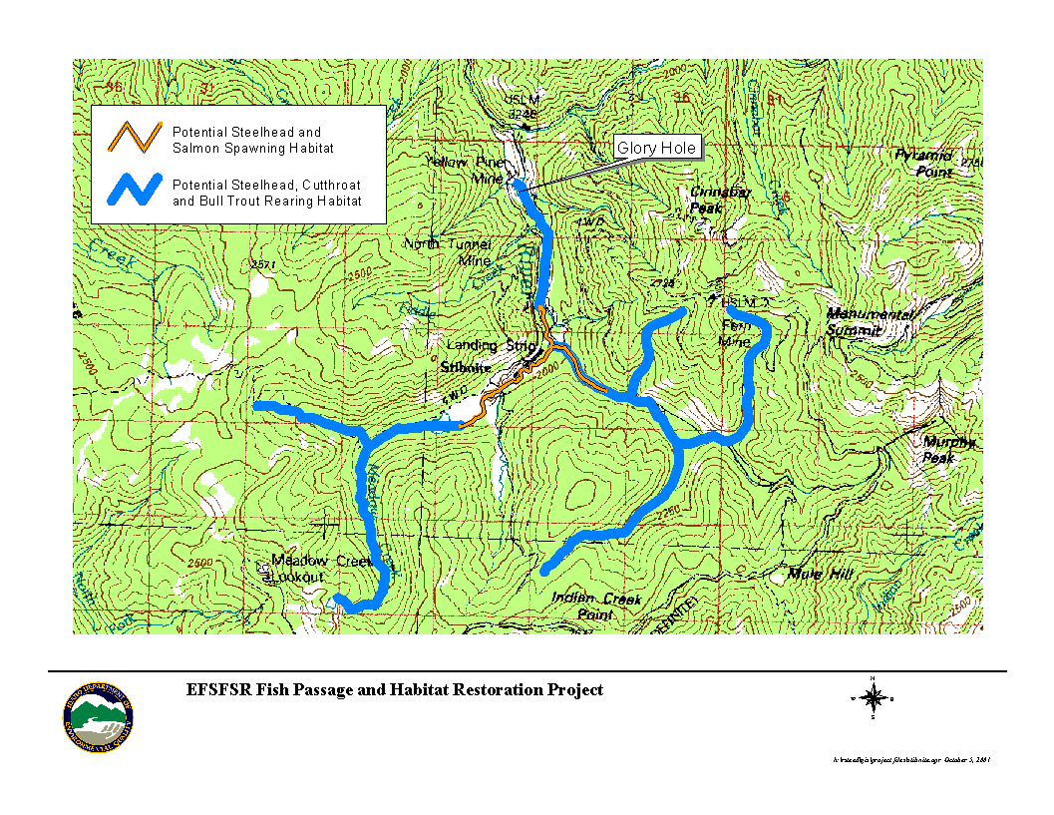
EFSFSR in three to five years. These salmon will include the next generation of fish resulting from IDFG’s and the Nez Perce out planting project in the upper watershed.

The current reclamation plans would accommodate the proposal by providing a relatively level upland repository for final disposition of fines screened out of borrow materials used in construction of the fish passage. The volume of these fines may be measured in tens of thousands of yards, and should be placed in a level and hence stable repository where surface and ground water management systems can control sediment production and delivery.

Biologically, the project is probably critical, meaning it does not have to be completed in the next year or two. However, it is anticipated that chinook progeny, the result of out planted surplus hatchery fish from the South Fork Salmon River in 2000 and 2001 (a cooperative IDFG and Nez Perce Tribe program), will return as adults in three to five years. If the existing barrier is removed these naturally produced fish will be able to escape to their natal stream reaches to spawn .

The EFSFSR may, within a geomorphic timeframe, naturally down cut through the fish passage barriers. It is anticipated that this timeframe is twenty to one hundred years, but this natural process will result in the production and delivery of tens of thousands of tons of fine sediment from the cascade, destabilized stream banks and mine waste dumps in and above the Glory Hole. The Glory Hole is one of the last remaining isolated sources of fine sediment which can and should, as the ISRB has pointed out in its comments, be stabilized. To do so, stabilization must be completed and coordinated with the reclamation actions at the Stibnite Mine.

Monitoring and Evaluation

Since 1981, the Upper EFSFSR watershed including Sugar, Hennessy, Midnight, Garnet and Meadow creeks are being intensively monitored according to several water quality monitoring plans and academic studies. The IDEQ and USDA jointly monitor water chemical parameters at twenty six monitoring sites, biological and physical parameters at ten monitoring, and have completed habitat and soils surveys around the Stibnite Mine. The IDFG and Nez Perce Tribe have jointly monitored fish populations relative to resident and anadromous fish , including effects of the introduction of hatchery chinook above the Glory Hole. IDEQ intends to provide additional funding through this grant and state general funds to continue those efforts if this proposal is approved. In addition, IDEQ will be expanding its monitoring efforts during the construction and post-construction to evaluate effectiveness of best management practices, engineering designs, and overall project performance.

The IDEQ/USDA monitoring plans provide for collecting chemical, biological and physical water quality data from as many as twenty-six surface and ground water monitoring stations (Schuld 1991). Chemical parameters include: dissolved and total arsenic, antimony, iron, mercury, selenium, and zinc; total and weak acid dissociable cyanide; temperature; hardness; turbidity; dissolved oxygen; filterable and non-filterable suspended sediment. Attempts are made annually to cluster measurements of these parameters before during and immediately after the peak of the spring flows in the tributaries, and then once again after base flows are attained. Benthic macroinvertebrates have been collected annually at ten monitoring sites since 1983. Although analyses of trends in benthic macroinvertebrates communities are the primary focus of the monitoring, IDEQ has occasionally collected stream sediment, benthic macroinvertebrates and algae for tissue analyses to determine to potential risks associated with bioaccumulation of metals in the food chain (Aquatic Biology Associates 1998). Physical parameters at ten monitoring stations have included cobble embeddedness, surface fines, green line and canopy measurements, and relative bank stability. The IDEQ/USDA intensive monitoring plan was expanded during the 1997 and 1998 field seasons during which time a site wide characterization and risk analyses was completed to evaluate the site for remedial activities.

The IDFG and the USDA Forest Service have and will continue to coordinate efforts to survey fish populations and associated habitat in streams around Stibnite. It is anticipated that plans to collect these data will be modified as needed to provide for trend analyses of resident and anadromous fish productivity in the Upper EFSFSR above the Glory Hole and its tributaries. Existing funding for this effort will be supplemented, in part by grant monies and IDEQ participation.

The IDFG and the Nez Perce Tribe have coordinated outplanting and monitoring of South Fork Salmon hatchery chinook in the Upper EFSFSR and Meadow Creek. Although their primary means of evaluating the success of this program has been snorkling for parr data, they are also implementing redd counting protocols. This monitoring will be continued and modified to evaluate trends. Parr monitoring efforts, in particular, will be expanded in the upper watershed through this grant in order to assess the effectiveness of steelhead and chinook passage, spawning and rearing above the Glory Hole. Although redd counts for chinook will continue, redd counts for steelhead is not considered appropriate, due to the inaccessibility of the area in spring .

Implementation monitoring will be incorporated as modifications to IDEQ’s and IDFG’s existing monitoring plans in order to demonstrate the effectiveness of the project. This is particularly important with respect to assessing the ability of anadromous species and fluvial bull trout to pass above the Glory Hole and successfully spawn and rear in the upper reaches of the watershed. There are several key objectives to implementation of monitoring including; effectiveness monitoring of best management practices used to prevent sediment production and delivery during and post construction activities; effectiveness monitoring of engineered structures including the fish passage and waste repository; and effectiveness monitoring of reclaimed habitat. The methods used to implement monitoring will include; standard water quality monitoring techniques such as the use of hydrolabs and flow meters; use of photo points; annual stream surveys for riparian habitat development and stream bank stabilization; annual redd and parr surveys; and creel surveys.

Currently, protocols, by Peterson et al, for determining bull trout presence are in draft form, but will be incorporated in a monitoring plan as applicable, to evaluate effectiveness of fish passage for fluvial bull trout. As the benefits to bull trout are a specific State objective, implementation and trend monitoring in the upper EFSFSR watershed will be an important component to the project. IDEQ will either solicit a contractor to develop and implement a monitoring plan specific to bull trout, or as an addendum to an existing plan.

Intensive monitoring data for the Upper EFSFSR was used to develop the Stibnite Area Risk Evaluation Report (URS 1999) for aquatic biota in the upper watershed. This report identified and evaluated localized limiting factors for adult-to-smolt and smolt-to-adult survival which is similar to some of the objectives of the Idaho Natural Production Monitoring and Evaluation Project ID#199107300. The trend monitoring techniques and data, particularly the general parr data, which has been collected and will continue to be collected, may be incorporated in IDFG’s data base as maintained through that project. IDEQ intends to coordinate with IDFG, to continue the trend monitoring and to evaluate the habitat enhancement projects at Stibnite. Generally speaking, this coordination will support IDFG’s response to RPA 180 of the National Marine Fisheries Service biological opinion which calls for the development of hierarchical monitoring programs, it will therefore, become a project priority.

References

Anderson.Donald.1994. Verbal Communiqué. Idaho Department of Fish and Game.

Apperson.K.2001. Verbal Communiqué. Idaho Department of Fish and Game.

Aquatic Biology Associates, Inc. (ABA).1997. Benthic Invertebrate Injury Studies – 1998. East Fork of the South Fork of the Salmon River, Idaho. Payette National Forest. June.

Kuzis. K. et all.1997. Watershed Analyses of the Upper East Fork of the South Fork of the Salmon River, Idaho. Payette National Forest.

Schuld.B. 1991. Water Quality Study Plan for the Upper East Fork of the South Fork of the Salmon Area around the Stibnite Mine. Idaho Department of Health and Welfare – Division of Environmental Quality.

URS Griener Woodward Clyde.1999. Stibnite Area Risk Evaluation Report. Idaho Department of Environmental Quality. September.

