Bonneville Power Administration

FY 2003 Provincial Project Review

PART 2. Narrative
Project ID: 29010

Title: Restore Passage on Private Lands in Beaver Creek Drainage to Benefit Spring Chinook, Steelhead and Bulltrout

Section 9 of 10. Project description

a. Abstract

Culverts and dams currently block fish passage to important tributary habitat in the in the Beaver Creek drainage. Beaver Creek is a major tributary of the Methow River located in the Methow subbasin. Spring chinook, summer chinook, steelhead, and bull trout all use the Methow River for spawning, rearing and as a migration corridor. Spring chinook are known to use the area around the mouth of Beaver Creek for rearing, and steelhead and bull trout are known to use the Beaver Creek drainage for spawning, rearing and migration. Steelhead spawn and rear in Beaver Creek from between the mouth to Frazer Creek and South Fork Beaver Creek (WSCC 2000).

A 1998 inventory of fish passage barriers conducted by the Washington Department of Fish and Wildlife’s Salmonid Screening, Habitat Enhancement and Restoration Division (SSHEAR) in cooperation with the Methow Wildlife Area Manager, Enforcement Program officers, and property owners, identified 55 culverts and 23 dams which created partial and full fish passage barriers (39 full barriers and 39 partial barriers) in the Beaver Creek drainage (WSCC 2000). Since that time, all known water diversions in the drainage have been screened. Restoration and preservation of this important tributary habitat is an essential component of regional efforts to recover endangered and threatened fish species in the upper Columbia River. There are 21 remaining known fish passage barriers located on private property within the Beaver Creek drainage. These barriers include 12 culverts and 9 dams, which continue to impede fish passage on Beaver Creek, Frazer Creek and Shorer Creek. Washington Department of Fish and Wildlife (WDFW) proposes to restore connectivity and access to habitat within this drainage by addressing these 21 barriers. Correction of these passage barriers will restore approximately 48,000 square meters of spawning habitat and 102,000 square meters of rearing habitat (approximately 10 miles of stream).

b. Technical and/or scientific background

The sheer quantity of intact, and in some cases, nearly pristine, habitat within the Methow subbasin, in concert with the presence of six species of fish that are federally listed as endangered, threatened, or species of concern (spring chinook, summer steelhead, bull trout, redband trout, pacific lamprey, and westslope cutthroat), make the Methow subbasin a regional priority for salmon restoration activities. Over 80 percent of all of the lands in the Methow subbasin are owned by the federal government and managed by the United States Forest Service and a significant percentage of these lands are protected by wilderness designation. Nevertheless, a number of factors limit the capacity of the subbasin’s habitat to sustain healthy self-perpetuating populations of spring chinook, steelhead and bull trout. Among those, insufficient or intermittent stream flow, passage barriers, loss of riparian habitat and degradation of instream habitat are key factors.

Beaver Creek, a 22.3-mile long major tributary to the Methow River, is located in the Middle Methow subwatershed. The Beaver Creek drainage encompasses about 71,400 acres and feeds into the Methow River at RM 35.2. Spring chinook, summer chinook, steelhead, and bull trout all use the Methow River for spawning, rearing and as a migration corridor. Spring chinook are known to use the area around the mouth of Beaver Creek for rearing, and steelhead and bull trout are known to use the Beaver Creek drainage for spawning, rearing and migration (WSCC 2000). Frazer Creek and Shorer Creek are tributaries within the Beaver Creek drainage. Steelhead are known to spawn and rear in Beaver Creek from the mouth to Frazer Creek as well as up to South Fork Beaver Creek.

The lower eight miles of the Beaver Creek drainage is largely privately owned and is dominated by agriculture and residences. The majority of the upper drainage is federally owned and managed by the U.S. Forest Service for timber harvest, range, and wildlife habitat (WSCC 2000). High road densities, seasonal, or irrigation related water quantity problems, sediment loading caused by logging activities, and cattle grazing, have contributed to degradation of habitat in the lower reaches of the drainage. However, in recent years a great deal of cooperative work to restore and reconnect habitat has been accomplished (see section outlining related projects). A 1998 inventory of fish passage barriers conducted by the Washington Department of Fish and Wildlife’s Salmonid Screening, Habitat Enhancement and Restoration Division (SSHEAR) in cooperation with the Methow Wildlife Area Manager, Enforcement Program officers, and numerous property owners, identified 78 partial and full fish passage barriers in the Beaver Creek drainage. Since that time, all known water diversions in the drainage have been screened.

Figure 1. Location of general vicinity of proposal site
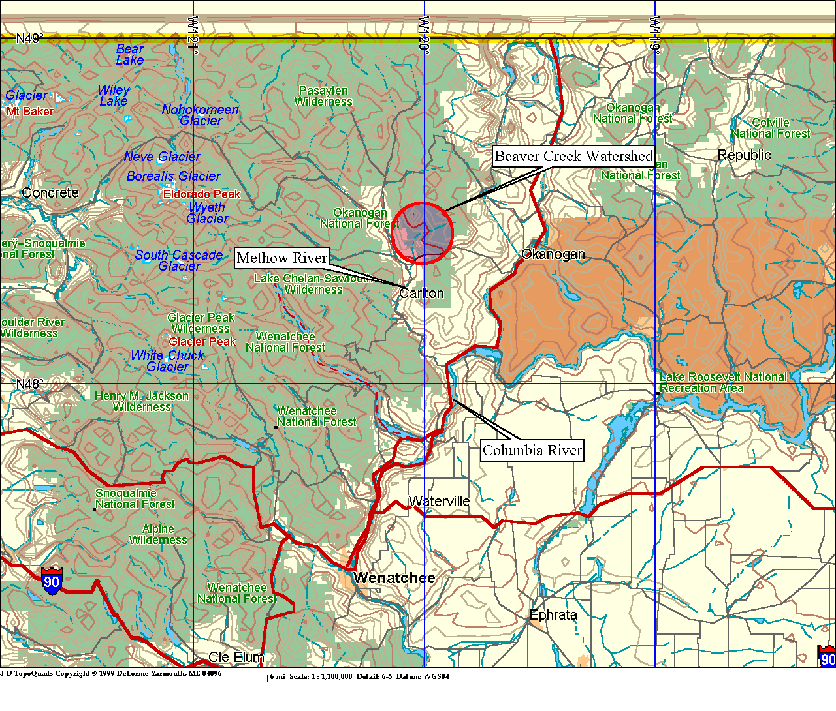
Twenty-one known remaining fish passage barriers are located on private lands within the Beaver Creek drainage. Additional passage barriers also exist on federal lands in the upper reaches of the Beaver Creek drainage (to be corrected by USFS). Of those 21 barriers located on private land, 3 dams and 1 culvert obstruct passage on Beaver Creek, 5 dams and 9 culverts block fish access to valuable habitat on Frazer Creek, and 1 dam and 4 culverts keep fish from habitat in Shorer Creek. Restoration and preservation of this Methow River tributary habitat is an essential component of regional efforts to improve habitat to benefit endangered and threatened fish species in the upper Columbia River. Actions taken through this proposal would restore approximately 48,000 square meters of spawning habitat and 102,000 square meters of rearing habitat in the Beaver Creek drainage (approximately 10 miles of stream).

Figure 2. Location of dams and culverts to be corrected
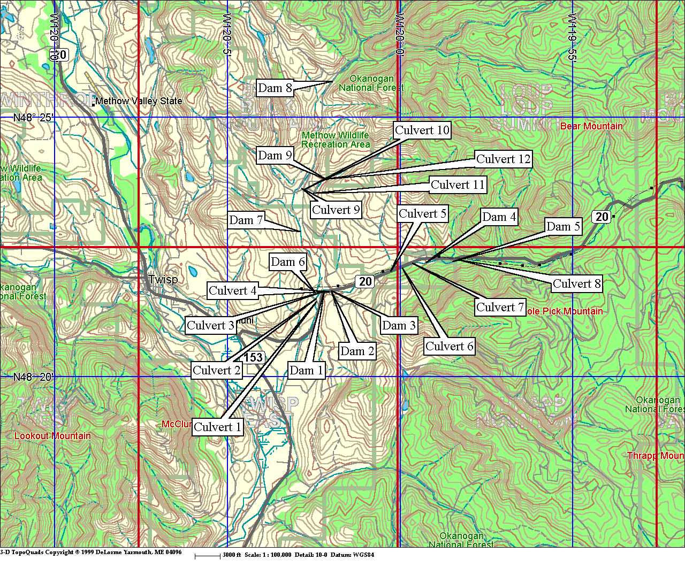
In the first year of this project WDFW will conduct engineering surveys and pre-project monitoring at each of the 12 culvert and 9 dam sites and develop engineering design and construction specifications to replace and correct them. During the second and third years existing culverts will be removed and replaced with bottomless arch structures or oversized round pipes that simulate natural stream channels. Rock weirs will be installed to provide backwater for continued water diversion operation and suitable passage at the 9 diversion dams. In addition to the correction of barriers, second and third year activities will include riparian plantings to restore and enhance habitat.

WDFW envisions this specific habitat restoration work as part of a three-phase approach to restoring passage and reclaiming valuable habitat throughout the Beaver Creek drainage. The first phase is currently underway and involves removal of 5 fish passage barriers by the Okanogan Conservation District (see related projects), this proposal represents the second phase which would remove the remainder of passage barriers located on private lands in the lower reaches of the Beaver Creek drainage, the final phase will include correction of the remaining barriers located in the upper reaches of the drainage on federal lands managed by the USFS. All three phases will also involve riparian habitat restoration and, where appropriate, and installation of fencing to protect riparian areas from grazing activities. In this proposal WDFW is requesting funding for only the WDFW coordinated phase, the removal or 21 barriers in the Beaver Creek drainage.

Removing barriers to provide unobstructed passage is an important step towards restoring functional habitat. Activities undertaken in this project will increase available tributary habitat for ESA listed fish including spring chinook which are known to use the mouth of the Beaver Creek drainage for rearing, and steelhead and bull trout which are known to use areas within the drainage for spawning, rearing and migration. While much habitat protection and restoration work remains to be done in this drainage, (such as restoring channel complexity, resolving water quantity issues, road obliteration work, and restoration/protection of riparian zones) the many efforts taking place within this drainage have clear mutual benefits that will gain a momentum and generate additional support of their own.

c. Rationale and significance to Regional Programs

Removing barriers to fish passage and enhancing habitat in the Beaver Creek drainage of the Methow subbasin speaks directly to the vision, goals, objectives and strategies outlined in the major salmon recovery documents guiding restoration efforts within the Columbia River Basin. Correcting barriers to fish passage in this drainage specifically addresses survival of ESA listed fish by making available essential habitats associated with those species. Restoring this habitat also addresses local and regional salmon recovery priorities as well as related subbasin needs and objectives identified in the Methow Subbasin Summary.

The Northwest Power Planning Council’s (NPPC) 2000 Fish and Wildlife Program

The NPPC 2000 Fish and Wildlife Program (Program) embraces an ecosystem-based approach to habitat restoration and function. This approach acknowledges that rebuilding healthy, naturally producing fish and wildlife populations requires protection, mitigation, and restoration of habitats and the biological systems within them, including anadromous fish migration corridors.

One of the central strategies guiding the Program is the concept of “building from strength.” The idea is to expand adjacent habitat that has been historically productive or that has a likelihood of sustaining healthy population by reconnecting or improving habitat. The Methow subbasin has been identified as a region with significant intact habitat. The habitat restoration resulting from removing the Beaver Creek fish passage barriers supports the concept of building out from and supplementing functional habitats.

NMFS 2000 Biological Opinion & Reasonable and Prudent Alternatives (RPA)

The Biological Opinion (BiOp) encourages the Action Agencies to support a Basin wide Recovery Strategy. The BiOp lists measures to avoid jeopardy, and gives specific tributary habitat objectives, which include providing passage and diversion improvements, and supporting overall watershed health of riparian and upland habitat.

The specific BiOp action item addressed by this proposal is:
Action 149 - BOR shall initiate programs in three priority subbasins (identified in the Basinwide Recovery Strategy – the Methow subbasin is one of the three identified for the first year) per year over 5 years, in coordination with NMFS, FWS, the states and others, to address all flow, passage, and screening problems in each subbasin over 10 years. The Corps shall implement demonstration projects to improve habitat in subbasins where water-diverson-related problems could cause take of listed species. Under the NPPC program, BPA addresses passage, screening, and flow problems, where they are not the responsibility of others. BPA expects to expand on these measures in coordination with the NPPC process to complement BOR actions described in the action above.

Upper Columbia Salmon Recovery Board (UCSRB)

The UCSRB has noted that the Methow subbasin has a “high proportion of pristine habitats, relative to other subbasins in the region.” The UCSRB has identified restoration of stream flow as the priority objective in the Methow subbasin, and a secondary, but critical, restoration objective of correcting passage barriers created by irrigation diversion dams and road culverts. This proposal directly addresses this secondary objective.

Methow Subbasin Summary

This proposal also supports the overall goals identified in the Methow Subbasin Summary which include, protection and restoration of anadromous and resident fish species and wildlife species within the Methow Subbasin, use of strategies that rely on natural production and healthy habitat to achieve restoration and protection goals, passing on to future generations a functioning ecosystem capable of supporting self-sustaining populations of anadromous and resident fish and wildlife species with intact populations of those species, and balancing economic viability of local communities with fish and wildlife needs through development of cooperative processes that promote adaptive and creative problem solving.

d. Relationships to other projects

This project is directly and indirectly related to numerous projects to restore fish passage and enhance habitat conditions throughout the Methow subbasin. Many fish screening, passage correction and habitat enhancement projects have been undertaken in the Beaver Creek drainage over the course of the last 20 or more years. These efforts have included both cooperative and individual work by private landowners, agencies and local government organizations including USFS, USFWS, WDFW, Okanogan Conservation District, and Okanogan County.

A partial list of relationships to other projects in the area includes:

- Department of Transportation (DOT) work to correct a barrier on SR 153. DOT also has scheduled correction of two crossings on SR 20 in 2002 (one on Beaver Creek and another on Frazer Creek, a tributary of Beaver Creek).

- Okanogan Conservation District has initiated the Beaver Creek Fish Passage Barrier Amelioration project funded by SRFB to correct conditions at 5 diversion dams (outside of the scope of this project) in the Beaver Creek drainage, with work to be completed by 2005.

- Okanogan County, in conjunction with the Methow Basin Planning Unit, contracted with Golder Associates and USGS to install two continuous stream gage stations in 2000 as part of an effort to assess surface flow throughout the Methow Basin. One of these gages was removed in 2001. Okanogan County also contracted with USGS to monitor water levels in 20 wells in the Beaver drainage as part of a Methow basin hydrogeology assessment.

- In this current project solicitation, the Okanogan Conservation District (OCD) is requesting funding to fence the riparian habitat adjacent to the state campground. OCD is also proposing a Coordinated Resource Management Plan (CRMP) in the Beaver Creek drainage. The Coordinated Resource Management would serve as a planning and problem-solving tool to help landowners and government agencies identify and address fish and wildlife habitat concerns on private lands.

- OCD is also implementing an irrigation water management in the Beaver drainage and throughout the Methow Basin starting 2002. This will include assistance in on-farm water management and irrigation system upgrades.

- The Salmon and Steelhead Habitat Inventory and Assessment Program (SSHIAP) which is a partnership-based information system that characterizes freshwater and estuary habitat conditions and distribution of salmonid stocks in Washington at the 1:24,000 scale.

- Methow Basin Screening (BPA 26015) A recent change in SOW for the Rockview Screen funds will be used to install a well to provide irrigation water in lieu of screen replacement. This project provides fish screen facilities upgrades, and new fish screen construction, on a number of Methow River Basin irrigation diversions. Methow Basin Screening (Project #200106300). Provide fish screen facilities and new fish screen construction at Methow Subbasin irrigation diversions including Foghoorn, Rockview, McKinney Mountain, Kum Holloway. Some equipment upgrades are also included under the project. Project is ongoing.

- Methow Valley Irrigation District, Reorganization to wells, 1999 to 2000 (Funding WDOE and BPA). Lower ditch was shut off and individuals served by the lower ditch were converted to wells.

- Early Winters Creek Habitat Restoration (Project #199802500). Restored historic fish, riparian and floodplain habitat, identified methods to augment instream flow to increase spawner success and juvenile survival. Project was completed the summer of 2000 with some follow-up monitoring in 2001.

- Mid-Columbia Coho Feasibility Reintroduction Study, Yakama Nation (Project #9604000). This project was initiated in 1996. The project is designed to gather data and develop and implement plans for coho restoration in the Methow, Entiat, and Wenatchee river basins in concert with various state and federal agencies. The project is centered on the development of a localized broodstock while minimizing potential negative interactions among coho and listed and sensitive species.

- Hancock Springs Passage and Habitat Restoration Improvements, Yakama Nation (Project #23024). The project is designed to increase juvenile salmonid access to, and enhance the habitat of Hancock Springs, a spring fed off-channel to the upper Methow River. Project objectives are to 1) increase the number of juvenile spring chinook and steelhead utilizing Hancock Springs, and 2) increase the over-winter survival of juvenile spring chinook and steelhead in the Methow River.

- Goat Creek Instream Habitat Restoration (Project #199802900). Instream habitat restoration work and instream rehabilitation.

- Arrowleaf/Methow River Conservation Easement (Project #200103700). Purchase prime riparian habitat in the form of a conservation easement.

- Methow Watershed Project II (Implemented by WDFW). An ongoing $12 million effort to identify and secure more than 5,000 acres of critical riparian/floodplain habitat and linkages to protected upland through fee title acquisition and conservation easements. BPA contributed over $2 million to purchase conservation easements on portions of over 1000 acres of habitat.

- Methow Conservancy Conservation Easement Program Purchasing easements to protect of riparian habitat throughout the Methow Basin. (SRFB funding).

- Pacific Watershed Institute and USFS - Early Winters Creek Restoration

- Skyline Ditch Pipe Installation. Assisted in piping part of the 6.2 mile Skyline Ditch in high water loss areas. This irrigation diversion is located on the Methow River. (Okanogan County SRFB Funding)

- Airey/Risley Ditch Removal. Removed an irrigation diversion structure and reduced the length of conveyance on an irrigation canal on the Twisp River. (Okanogan County SRFB Funding)

- Buttermilk Creek Ditch Fish Screen. Installed a fish screen on the Buttermilk Creek irrigation ditch on the Twisp River. (Okanogan County SRFB Funding)

- Skyline Ditch. Repaired the headgate at the Skyline Ditch diversion on the Chewuch River and replaced the delivery ditch with pipe in a high water loss area. (Okanogan County SRFB Funding)

- Aspen Meadows Ditch Piping. Replaced a portion of the Aspen Meadows irrigation ditch with pipe to prevent water loss on Little Bridge Creek, a tributary to the Twisp River. (Okanogan County SRFB Funding)

- Fulton Ditch Lining Project. Lined a portion of the Fulton irrigation canal to prevent seepage/water loss. The Fulton diversion is located on the Chewuch River. (Okanogan County SRFB Funding)
- Eagle Creek Ditch Fish Screen. Removed an irrigation ditch and installed a well on Eagle Creek, a tributary to the Twisp River. (Okanogan County SRFB Funding)

- Tourangeau Ditch. Abandoned the Tourangeau irrigation canal and installed a well on Little Bridge Creek, a tributary to the Twisp River. (Okanogan County SRFB Funding)

- Early Winters Ditch Diversion Structure. Constructed a fish friendly diversion structure that ensures flow to the Early Winters irrigation canal. (Okanogan County SRFB Funding)

- Little Bridge Creek Culvert. Provided engineering & design work to determine alternatives and costs associated with solving a culvert blockage problem on Little Bridge Creek. (Okanogan County SRFB Funding)

e. Project history (for ongoing projects)

N/A

f. Proposal objectives, tasks and methods

Project Goal: Protect, restore and enhance salmonid habitat and salmonid populations in the Beaver Creek drainage of the Methow subbasin.

Objective 1. Develop passage restoration plan for Beaver, Frazer and Storer creeks in the Beaver Creek drainage

Task 1.a. Complete engineering and design work and pre-project monitoring for 12 culverts and 9 diversion dams

Task 1.b. Acquire all necessary permits (NEPA, etc.)

Task 1.c. Review by WDFW of engineering and design work

Methods: A private contractor and or engineering staff with Okanogan Conservation District (OCD) will develop site-specific engineering designs during the first year of the project for both culverts and diversion dams. Engineering will reflect that most current wisdom and research regarding replacement of antiquated culverts and diversion dams. WDFW will work with OCD to apply for all necessary permits. The OCD is currently applying for some permits in this reach, which is expected to facilitate the timeline for this process.

Objective 2. Restore fish passage on private lands on Beaver, Frazer and Storer creeks within the Beaver Creek drainage

Task 2.a. Replace or realign 7 culverts and remove 5 diversion dams on Frazer Creek

Task 2.b. Replace or realign 1 culvert and remove 3 diversion dams on Beaver Creek

Task 2.c. Replace or realign 4 culverts and 1 diversion dam on Shorer Creek

Task 2.d. Restore native riparian vegetation in areas disturbed by actions to correct barriers

Methods: During the second and third years of the project culverts will be removed and replaced with bottomless arch structures or oversized round pipes that simulate natural stream channels. An excavator, backhoe, and dump truck will be used to do the work, which will be contracted out. Rock weirs will be installed to provide suitable passage at the 9 diversion dams. In addition to the correction of barriers, second and third year activities will include planting native riparian vegetation to restore and enhance riparian habitat where disturbances occurred to remove the barriers. The actual construction and planting work will be done through the combined efforts of WDFW, the Okanogan Conservation District, private contractors, and the Upper Columbia Regional Fisheries Enhancement Group.

Objective 3. Maintain fish passage in Beaver, Frazer and Storer creeks within the Beaver Creek drainage

Task 3.a. Replace, as necessary, any native vegetation restoration plantings that fail to thrive

Task 3.b. Correct any problems associated with installation of culverts or rock weirs.

Methods: In the second and third years of the project any riparian plantings that fail to thrive will be replaced. In addition, unforeseen problems associated with installation, design, or construction of the replacement culverts or rock weirs, will be corrected.

Objective 4. Develop and implement a monitoring plan

Task 4.a. Assess fish passage at new structures annually and document site using fixed point photo analysis

Task 4.b. Conduct snorkeling and/or spawner surveys to confirm fish presence about and below former site of barriers

Task 4.c. Prepare annual reports to submit to BPA

Methods: Subsequent monitoring efforts will include analysis of temporal and spatial fixed-point photos. In addition, fish passage will be assessed at all project sites on a bi-annual basis based on guidelines described in the WDFW, "Fish Passage Barrier And Surface Water Diversion Screening Assessment and Prioritization Manual." Snorkeling/spawner surveys will be also be conducted to confirm salmonid presence and to verify success of the project. All monitoring activities will correlate with NPPC guidelines and support adaptive management principles and implementation.

g. Facilities and equipment

WDFW Region 2 facilities have standard office equipment including phones, computers, fax machines that will be used in meeting requirements of this projects. There are no additional equipment needs since use of heavy equipment for removing barriers and subsequent construction of replacement structures will be subcontracted out.

h. References

Reference (include web address if available online) | Submitted w/form (y/n)
Gower, E. and E. Espie. 1999. Beaver Creek Fish Passage and Water Diversion Inventory. Washington Department of Fish and Wildlife, Habitat and Lands Services Program, Salmonid Screening, Habitat Enhancement and Restoration (SSHEAR) Division, Olympia, WA. | N
Mullan, J.W., K.R. Williams, G. Rhodus, T.W. Hillman, and J.D. McIntyre. 1992b. Production and habitat of salmonids in mid-Columbia River tributary streams. U.S. Fish and Wildlife Serv. Monogr. I. 489pp | N
National Marine Fisheries Service. 2000. 2000 Biological Opinion. Re-initiation of Consultation on Operation of the Federal Columbia River Power System. | N
Northwest Power Planning Council. 2000. 2000 Columbia River Basin Fish and Wildlife Program. | N
Upper Columbia Regional Technical Team (RTT). 2001. Draft – A Strategy to Protect and Restore Salmonid Habitat in the Upper Columbia Region, A Report to the Upper Columbia Salmon Recovery Board. | N
Washington State Conservation Commission (WSCC). 2000. Salmon, Steelhead and Bull Trout Habitat Limiting Factors, Water Resource Inventory Area 48. Final Report. | N

Section 10 of 10. Key personnel

Craig Nelson, Okanogan Conservation District Coordinator
Short Professional Biography

B.A. Geography & Land Studies, minor in Environmental Studies; Central Washington University, 1995.

Cartographer, Natural Resources Conservation Service. Primary Role: digitizing soil map unit boundaries in a GIS for Naches Ranger District Soil Survey project. August 1995 to September 1995.

District Technician, Kittitas County Conservation District. Primary Role: working with local Kittitas Valley irrigators in reducing sediment runoff using various best management practices including application of polyacrylamide and irrigation water management. February 1996 to November 1996.

District Manager, Okanogan Conservation District. Primary Role: coordinated development of Okanogan Watershed Water Quality Management Plan with Okanogan County, completed a stream restoration project near Elmer City, co-coordinated a Jobs For the Environment restoration crew, written several successful grant applications, develop yearly budgets, track grant progress and expenditures, and supervise thirteen full-time staff. December 1996 to Present.

Councilmember, City of Okanogan. Primary Role: participate on seven member Council, participate on two sub-committees (streets & sewer), chair one sub-committee (parks) Overseeing development of Central Valley Sports Complex facility, review budget development, and develop partnerships with business, agencies, and citizens. July 2000 to Present.

Robert J Anderson
Professional Biography

Education: B.S. Forest Management: specializing in Wildland Recreation.
Washington State University 1979.
Work History:
Okanogan Conservation District. Field Coordinator, 1999 to Present
Coordinate grant related field projects as directed by DM. Supervise four full time employees in Barrier Survey and various restoration projects, write grants and work with landowners.

Log Buyer, Zosel Lumber Co. 1992-1998
Purchase logs for mill, Cruise timber sales on Government and private land, develop bid and bid sales at auction. Act as industry representative on various planning and working groups.

Log Buyer, Spokane Lumber Co. 1988-1991
Same as above
State of Wash Department of Natural Resources 1979-1988
Field Forester, Active in all phases of land management

Mark Cookson, WDFW

Fish and Wildlife Biologist,
Watershed Stewardship Team,
2001-present
Duties: Contribute to the success of Lead Entities and Regional Fisheries Enhancement Groups and others pursuing salmonid conservation and recovery. Will be providing technical and scientific information to private landowners, OCD and UCRFEG regarding the implementation of this project.

Pierce Conservation District 1999-2001

Natural Resource Technician
Department of Interior, National Park Service 1994-1998

Biological Science Technician

