Bonneville Power Administration

FY 2003 Provincial Project Review

PART 2. Narrative
Project ID: 29017

Title: Prepare a Master Plan for Protecting and Restoring Salmon Habitat in Channelized Portions of Okanagan River

Section 9 of 10. Project description

a. Abstract

Through channelization 50 years ago, the Canadian portion of the Okanagan River has been reduced by 24km (50%) and has lost 88% of its riparian area (Bull, Gaboury and Newbury, 2000). Protection of the limited remaining salmon habitat is critical, and restoration of some of the channelized sections of river has been recommended.

A Master Plan is the logical first step for protecting and restoring salmon habitat. Existing documents will be reviewed and advice will be sought from authorities (such as fisheries managers, water managers, local governments, and First Nations) as well as major stakeholders. The review and consultation process will identify protection and restoration methods and locations. From this review a comprehensive plan will be prepared which must meet with approval in principle from the agencies and major stakeholders. The plan will outline benefits, costs, risks and the steps required for implementation.

b. Technical and/or scientific background

The habitat protection aspects of this plan are critical and need to be worked out. Some possible methods for the restoration portion have been suggested. Bull, Gaboury and Newbury (2000) recommend that riparian parcels be secured so that dykes could be removed or set back (Figure 1) to allow the restoration of a natural, fully functional river (Figure 2). Seventeen vertical drop structures (VDSs) were installed within the length of Okanagan River between Osoyoos and Vaseaux Lakes at the time the river was channelized in the mid-1950s. A VDS is a low-head dam which functions to dissipate hydraulic energy and allow the river channel between each the VDSs to have a flatter profile. Within these areas they suggest that concrete drop structures be replaced with natural rock pool/riffle complexes. A series of riffles (about 4 for every VDS) could do the same job while providing more fish habitat, safer conditions for recreational swimmers and boaters, and less maintenance. Natural vegetation, large woody debris, and gravel could be added initially to speed up recovery, but the system would eventually become self-sustaining.

Bull et. al point out that within restored sections, point bars would develop on the insides of the meanders, pools on the outside, and riffles at the crossover points. Silt would once again be deposited on the floodplain rather than in the main channel and gravel deposits would appear at the crossovers. The hydraulic head formerly associated with concrete drop structures could be transferred to natural rock pool/riffle complexes allowing for spawning areas to be developed. Proof of this concept was provided in 2001, when a test series of 4 pool/riffle spawning complexes were built to create hydrological complexity in association with one of the vertical drop structures. Prior to the installation of the pool/riffle complexes, sockeye were not observed spawning in the area. However, after the completion of the project, approximately 60 sockeye and 6 redds were observed in October 2001.

When the restoration plan is implemented, results should be productive, long term and self-sustaining. Sockeye will benefit from reduced velocity and hydrological variability, more natural migration, additional spawning areas, and escape cover. Other native fish species found in the system may also benefit.

c. Rationale and significance to Regional Programs

The project addresses the following NPPC program measures: 4.1B which states, “Historical records show that Columbia River Basin Indian Tribes relied extensively on salmon and steelhead. Because most of the tribes are located in the upper portion of the basin, the decline in numbers of fish, combined with the shift of fish production from the upper to lower basin, had an incalculable impact on tribal economies, cultures and religion.”. Also, this project mirrors the NPPC program measure of 7.6C.5 which states, “… manage riparian and flood plain areas to promote the protection and re-establishment of natural ecological function and thereby protect and improve salmon and steelhead habitat”.

By determining the most essential or productive stream reaches in which to restore natural ecological function this project is directed at the 2000 SCRPS Biological Opinion 9.6.2.1 actions related to tributary habitat, particularly “watershed health, manage both riparian and upland habitat, consistent with the needs of the species.”.

This proposal is directed toward restoring habitat conditions as identified in the Okanagan/Similkameen Subbasin Summary, “habitat degradation due to human influences such as agriculture, urban development, and forestry have negatively impacted the Okanagan and Similkameen watershed. The streams and lakes within these basins no longer have the carrying capacity to support the historical numbers of species once found in these waters.”. Thus, this project is directed towards restoring the carrying capacity of the most productive reaches of the Okanagan River and consequently strengthening the anadromous salmonid stocks in the Upper Columbia River Basin.

The Independent Scientific Review Panel (ISRP) of Northwest Power Planning Council recommends shifting emphasis from enhancement projects to protection and restoration of natural habitat (such as is proposed here). They say:

“A major conclusion…is the need to restore a greater degree of naturalness to the river than exists today…Habitat restoration…must receive high priority and be directed at providing habitat opportunities that historically supported salmonids in their natural state…The diverse habitats found in the floodplains and gravel-cobble segments are especially important.” (Williams et.al. in Fisheries – American Fisheries Society, V 24, #3, March, 1999).

Canadian fisheries authorities agree. A long-term, self-sustaining, ecosystem based approach that emphasizes natural methods and benefits all species is preferred (personal communication - E. Fast, Chair, Okanagan Basin Technical Working Group). The Okanagan Basin Technical Working Group (OBTWG) is comprised of management and technical staff from the Okanagan Nation Fisheries Commission, Fisheries and Oceans Canada, and the Ministry of Water, Land and Air Protection. These agencies work within a tri-lateral forum to initiate and coordinate programs designed to conserve and restore Okanagan fisheries resources within an ecosystem based management framework

d. Relationships to other projects

This Master Plan would provide an overall vision for Okanagan River and would inter-connect various fisheries initiatives. For instance, habitat protection and restoration work would be linked with restoration of a natural hydrograph, fish passage at McIntyre Dam and other projects. This would create a cohesive package and a critical path for implementation. The combination of habitat protection, restoration and a more natural hydrograph will increase spawning area, rearing area and will increase survival for sockeye and other native species. The Okanagan Sockeye stock has been declining over the past two decades and escapement for 2002 is predicted to be less than 5000 sockeye (Dr.Kim Hyatt, Stock Assessment Biologist, Fisheries and Oceans Canada, personal communication). The ISRP recommends that all projects in the Columbia Basin have a conceptual foundation within which work can be carried out in a logical manner (Williams et.al. in Fisheries – American Fisheries Society, V 24, #3, March, 1999).

A number of fisheries initiatives have been undertaken or planned on the Okanagan River. For instance, the Okanagan Basin Technical Working Group and Douglas County Public Utility District are planning a project that attempts to restore a more ‘fish friendly’ hydrograph that will increase production of Okanagan sockeye. As another example, BPA project 200001300, The Evaluation of an Experimental Re-introduction of Sockeye Salmon into Skaha Lake, is presently evaluating the risks associated with extending the run further into its historical range and Canadian agencies are giving consideration to extending the migratory route of sockeye.

e. Project history (for ongoing projects)

Not Applicable.

f. Proposal objectives, tasks and methods

- The first objective is to compile and record relevant information and knowledge.

  - One task within that objective is to summarize all current and historical information pertaining to sockeye and their habitat. Another is to interview key agency staff and others who can provide important information that is not yet formally recorded.

- The second objective will provide a long-term vision for the river and options for accomplishing that vision through habitat protection and restoration.

  - The first task will involve extensive consultation to develop the vision.
  - The second task will develop and rank options for protecting and restoring river habitat. This task will also require extensive consultation. Costs, benefits and risks of each option will be considered and the agencies and critical stakeholders will prioritize the options.
  - The third task within this objective will be to prepare a draft plan based upon the preferred alternatives.

- The third objective will be to finalize a plan.

  - This will involve distributing the draft plan, allowing time for agency/stakeholder comment and improving the draft based upon the comments.

g. Facilities and equipment

The Okanagan Nation Fisheries Commission (ONFC) located in Westbank, British Columbia will manage the project. The ONFC employs a full time Program Manager, Biologist, 4 Fisheries Technicians, and a Financial Administrative Assistant. The ONFC also contracts a Registered Professional Biologist to advise and monitor fisheries projects. Associated with program and project management, the ONFC owns office equipment (computers, internet access, fax, etc), 3 full-size 4X4 trucks, motorized and non-motorized boats, water quality equipment, fish sampling equipment, and stock assessment equipment and supplies.

h. References

Reference (include web address if available online) | Submitted w/form (y/n)
Bull, C., M. Gaboury and R. Newbury, 2000. Setback dyke and meander restoration designs for the Okanagan River. | n
Personal communication - E. Fast, Chair, Okanagan Basin Technical Working Group | n
Williams et.al. in Fisheries – American Fisheries Society, V 24, #3, March, 1999 | n

Section 10 of 10. Key personnel

Christopher J. Fisher
P. O. Box 862
Omak, WA 98841
Ph: (509) 422-7427
Chris.Fisher@colvilletribes.com

Education: University of Georgia South Dakota State University
School of Forest Resources Dept. of Wildlife and Fisheries Sciences
B. S. Forest Resources 1990 M. S. Wildlife & Fisheries Science 1996
minor Fisheries management (Fisheries option)

Experience:
Job title: Anadromous Fisheries Biologist II
Employer: Colville Confederated Tribes, Nespelem, WA 99155

Duties: My duties include the management of anadromous fish stocks for
population viability and subsistence for tribal members. I conduct and evaluate
creel surveys, analyze catch data and develop regulations. I also participate
planning and implementation for watershed restoration projects. I prepare
correspondences and reports (monthly, quarterly, annually, and conditionally)
needed to maintain good communications within the Tribal organization and
Federal, State, and Tribal fishery agencies. I develop budget contract proposals,
modifications, and reports as required by Tribal policy or established under
contract agreements.

Job title: Fishery biologist
Employer: U.S. Forest Service, Okanogan National Forest (Jan 96 to Mar 97)
U.S. Forest Service, Boisen National Forest (Apr 94 to Nov 95)

Job title: Fishery technician
Employer: Idaho Department of Fish and Game, McCall (Jun 90 to Nov 91)

Job title: Research technician
Employer: School of Forest Resources, University of Georgia (Apr 88 to Sep 89)

Expertise:
By acquiring my education in the southwest and midwest and being employed by
both state and federal agencies in three different regions of the country my
experience in fisheries is extensive and diverse. My wide range of experience has
provided me with expertise in collecting, analyzing and interpreting a variety of
data and the ability to communicate the results of management activities and
research to professional and civic groups via technical reports or presentations.
Recent job completions include coordinating culvert replacement, installation of
multiple instream structures, evaluating effects and conducting follow up
monitoring of fire retardant spill on Omak Creek.
Deana Machin
Program Manager
Okanagan Nation Fisheries Commission
3255-C Shannon Lake Road
Westbank, BC V4T 1V4
Telephone: (250) 707-0095
DeanaMachin@syilx.org

EDUCATION  AND TRAINING | - B.Sc. (Ecology and Environmental Biology), University of British Columbia, B.C., 1999  - Backpack Electrofishing certified  - WCB level 1 First Aid with Transportation Endorsement  - Swiftwater Safety Certificate
PROFESSIONAL AFFILIATIONS | - Biologist in Training, Association of Professional Biologists of British Columbia
SUMMARY OF EXPERIENCE | - Management of fisheries program  - Experience in Project management of fisheries related projects  - Experience in Fisheries Renewal BC SRP reporting.  - Experience in managing Northwest Power Planning Council Fish and Wildlife Program projects.  - Experience in water quality, fish sampling and stream assessments  - Projects included fish habitat assessments, terrestrial habitat assessment, and environmental baseline studies
PROFESSIONAL RECORD | 2000-present | - | Program Manager  Okanagan Nation Fisheries Commission  Involved in overseeing whole program and 17 staff, project and contract management, development of proposals, environmental monitoring of instream works, water quality/stream flow monitoring, literary research, project correspondence and reports, quarterly program reports to the tribal organization and member bands, and liaise with First Nations, Provincial and Federal fisheries agencies.
 | 1999-2000 |  | Natural Resources Coordinator  Okanagan Nation Alliance  Coordinated efforts of seven bands of the Okanagan Nation, land use referrals, consultation framework and correspondence, environmental assessment project review committees, monthly program reports to the tribal organization and member bands, liaise with First Nations, Provincial and Federal resource agencies.

Chris Bull
Author of Proposal
Ph. 250- 496-4059
cbull@vip.net

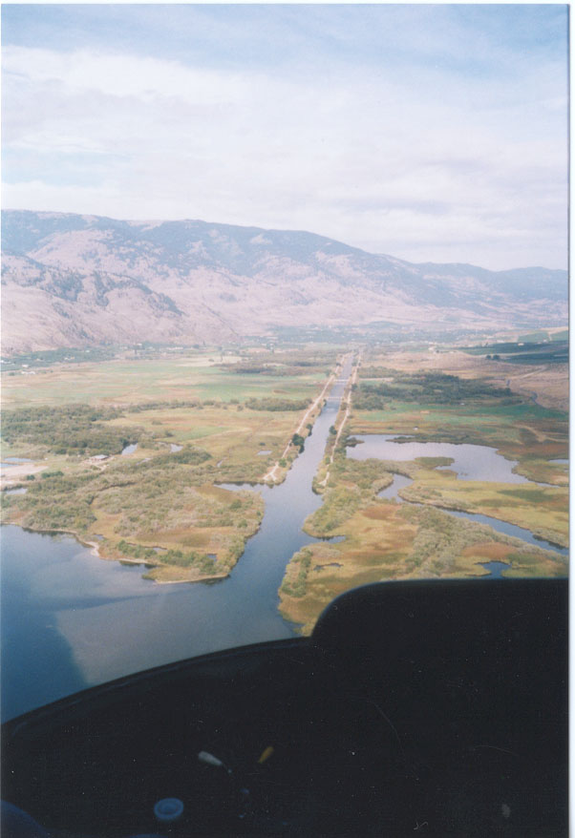

Figure 1. Arial view of the dyked section of the Okanagan River as it flows
into Osoyoos Lake.
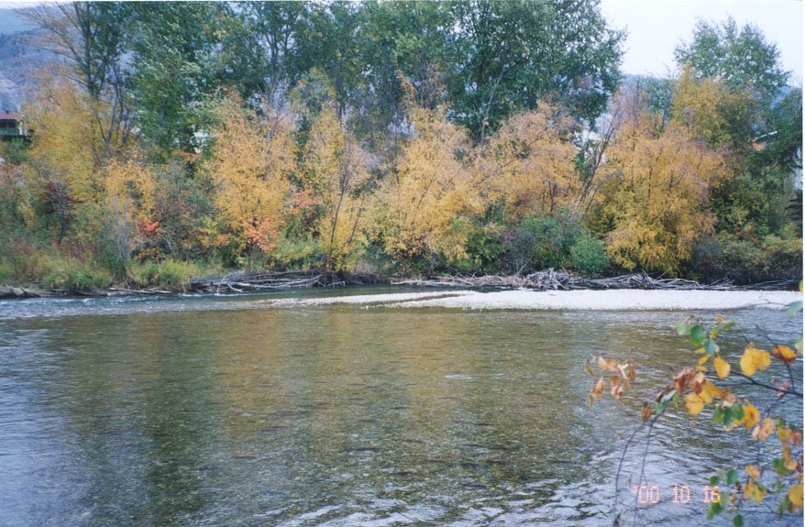

Figure 2. Photo of sockeye salmon spawning in the natural section.
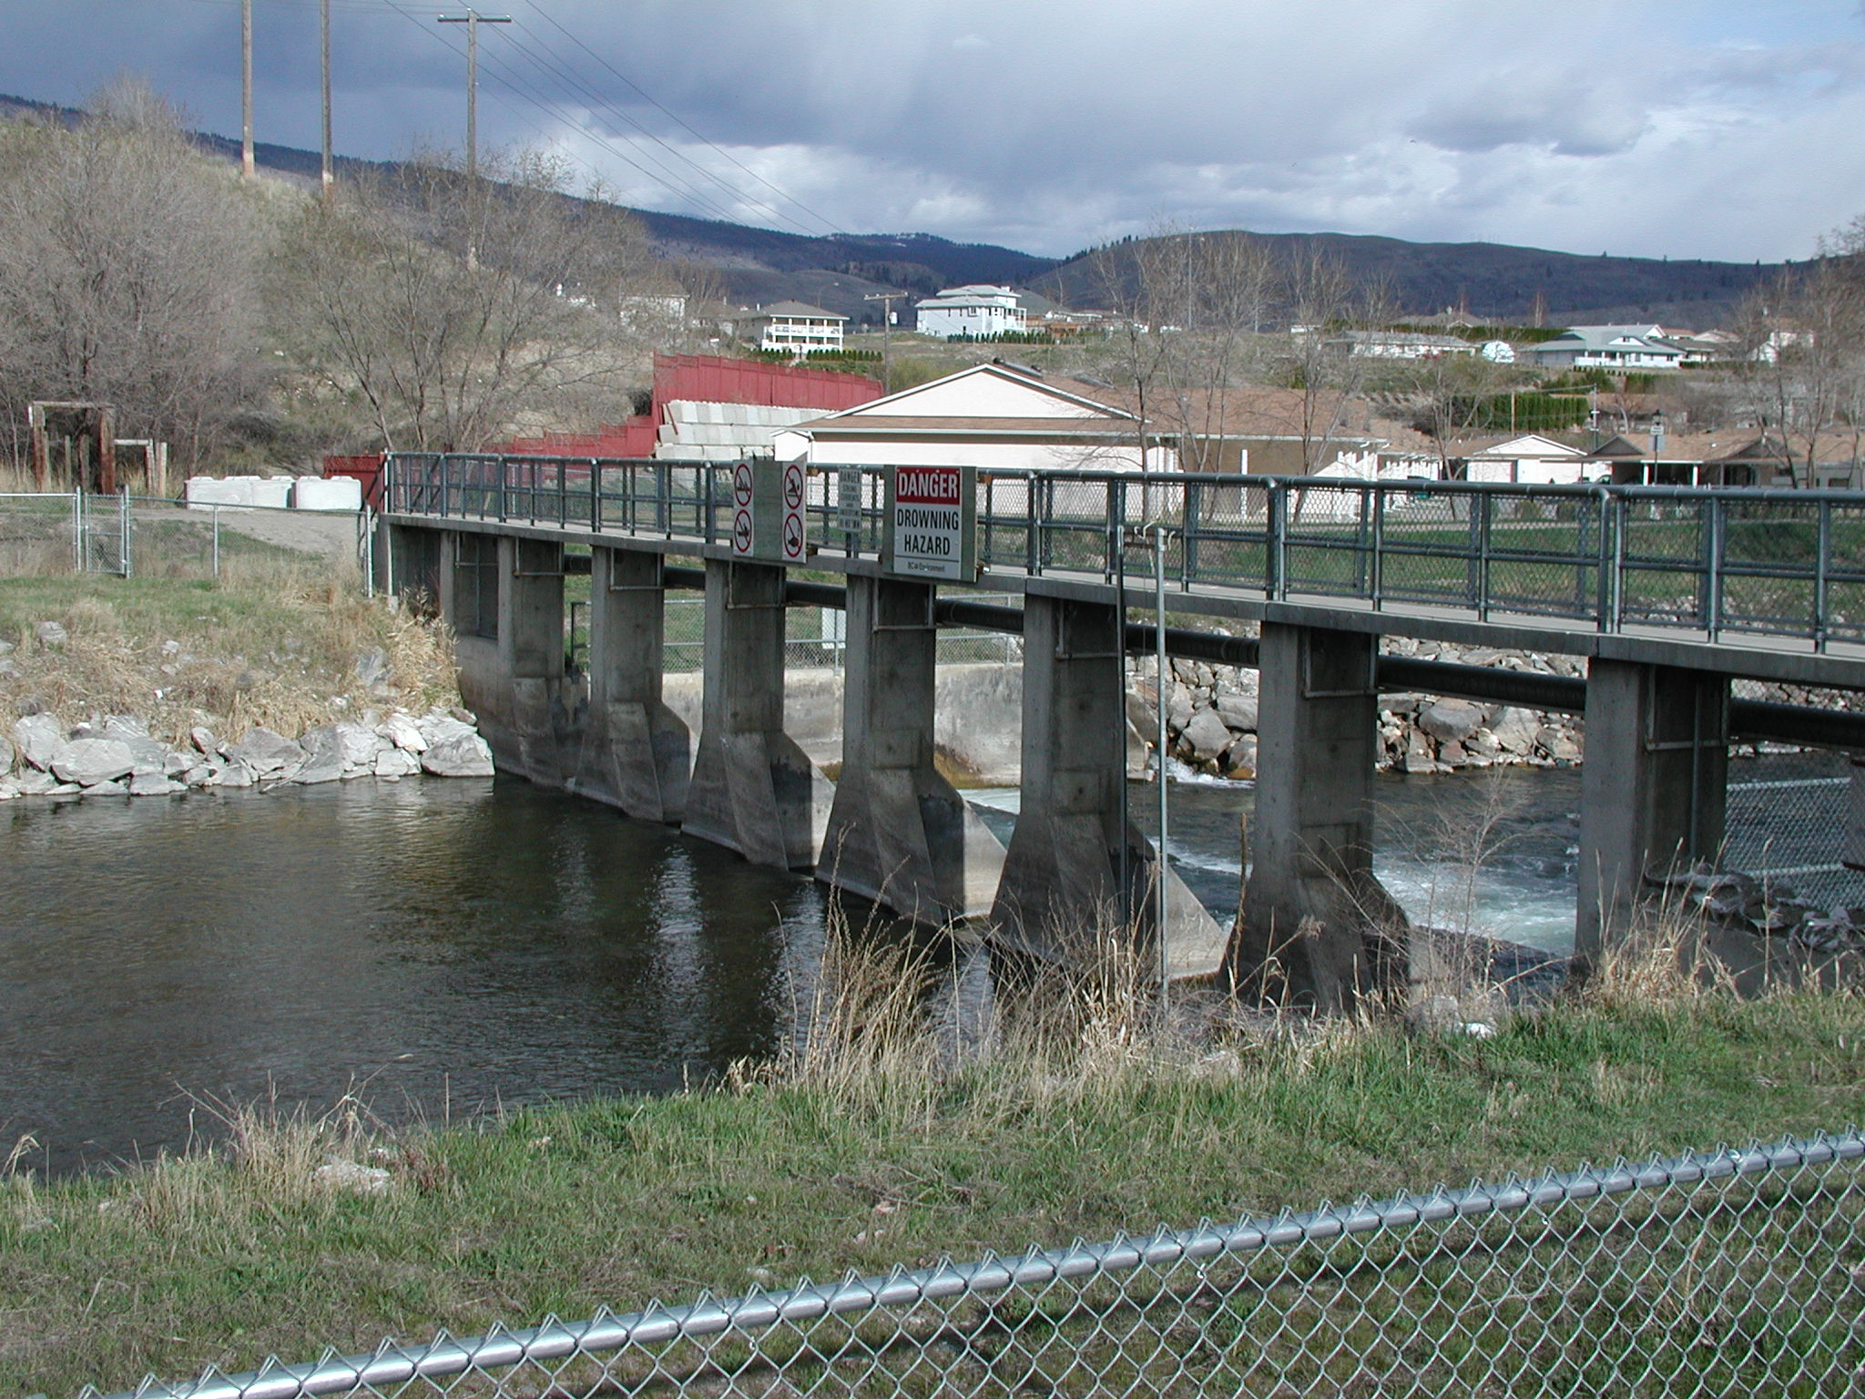

Figure 3. Vertical Drop Structure 13 looking downstream

