Bonneville Power Administration

FY 2003 Provincial Project Review

PART 2. Narrative
Project ID: 29055

Title: Columbia Cascade Water Rights Acquisition Program

Section 9 of 10. Project description

a. Abstract
The Department of Ecology (Ecology) intends to increase and protect instream flows to benefit at risk salmonid populations and allow stream habitat to recover. Ecology will target streams and tributaries with a history of flow problems and focus on areas with listed species. The following factors will be examined on each target stream and tributary: the importance of the area for spawning, rearing or migration; relative condition of the habitat in the stream or reach; number of water diversions; the size of stream and amount of water needed to improve flow conditions; and opportunities for water rights acquisition.

Under this proposal, Ecology will lease or purchase water rights in the Methow, Wenatchee, Entiat and Okanogan Subbasins, to restore and enhance instream flows where significant needs of listed fish have been identified in those subbasins. The water obtained through the program will be placed in the state’s water trust—assuring that the water is “wet”, and that it stays in the rivers and streams.

This water rights acquisition proposal is consistent with the FCRPS Biological Opinion, particularly Habitat RPA Action 151, and the NWPPC Fish and Wildlife Program.
In addition, the Entiat, Methow and Wenatchee Subbasins have been identified as priority subbasins in the All-H Paper.

Ecology is requesting funding from BPA for approximately half of the program costs over the next three years i.e., $1.6 million for three years. BPA funding will be matched by approximately $1.6 million in state funds for the same period. This proposal is a great opportunity to develop a partnership between BPA, NPPC and the State of Washington and to establish a long term and effective water rights acquisition program throughout the Columbia Cascade Province.

b. Technical and/or scientific background
The rivers and streams within the Columbia Cascade subbasins (the Wenatchee, Methow, Okanogan, and Entiat river basins) provide important spawning and rearing habitat for anadromous and resident fish. As described in the subbasin summaries these river basins support chinook, and sockeye salmon and summer run steelhead populations.

Over the past century, populations of salmon and trout have declined markedly relative to historical abundance. Distribution has also changed significantly. Two species are listed as endangered under the Endangered Species Act-- spring chinook listed in March 1999 and summer steelhead listed in August 1997. The Washington State Salmon and Steelhead Stock Inventory (SASSI) report classified several stocks as depressed.

These species are dependent on adequate cool, clean water and accessible and suitable habitat. Current water conditions are poor for most, if not all life stages. Forestry, farming, irrigation diversions, road construction and urbanization have damaged critical salmonids spawning and rearing habitat and impacted migration corridors. The timing of spawning (e.g., August to September for spring Chinook) and the extended period the species spend in fresh water (the young spring Chinook salmon remain in the fresh water for more than one year) make them very vulnerable to water quality degradation and extreme low flow conditions. See subbasins summaries.

Many factors have reduced salmon and trout populations over the years. Most notable are current and past water withdrawals and impoundments for agricultural purposes that have resulted in extreme low flows in some streams. The Washington Statewide Strategy to Recover Salmon, issued in November 1999, has classified three of the subbasins—Wenatchee, Okanogan and Methow as over-appropriated—meaning more water is being withdrawn from rivers and streams in those subbasins than what is naturally available, especially in late summer and early fall, when fish need water for migration, spawning or rearing. The low summer flows are also associated with higher water temperature and higher concentrations of pollutants, which can be debilitating or even lethal to anadromous and resident fish.

State laws protecting instream flows did not exist prior to the middle of the 20th century. Thus, nearly 100 years of water rights development in the subbasins occurred without regard to the effects dewatering streams has on fish and other aquatic species. In 1949 the first legislative action was taken which recognized the importance of fish and wildlife. The Department of Ecology established instream flows for the Wenatchee in 1983, Methow in 1976, and Okanogan in 1976. The Entiat does not have an established instream flows, but Ecology and a local watershed group are in the process of developing instream flow recommendations.

Unfortunately, most development in the subbasins occurred before instream flows were established. Consequently, instream flows established in the subbasins are junior to most existing diversionary water rights. As a result, most established instream flow rights exist only on paper as most rivers and streams are over allocated. There is an urgent need to set and/or modify existing instream flows to support salmonids stocks. Collaborative watershed management efforts are underway in the Methow, Wenatchee and Entiat subbasins to address instream flow setting and restoration. The work is being done by local watershed planning units established under the 1998 Watershed Planning Act. State agencies, tribes, local governments and various interests are represented in the Watershed Planning Units. We anticipate similar effort in the Okanogan subbasin.

Setting insteam flows does not put water back into a stream for basins with chronic low flow conditions. For many stream reaches in the four subbasins the most important and immediate need is to get water back into the streams. Water rights acquisitions are considered the most important and effective way to put water where and when it is most needed. The acquisitions are well suited for small streams and tributaries. In several areas in the subbasins individual farmers and ranchers holding turn of the century water rights grow irrigated hay and/or irrigated pasture, and holding turn of the century water rights. A number of these small farmers and ranchers have indicated a willingness to reduce or forgo irrigation in exchange for monetary compensation. The amount of water that can be obtained, while it may seem small, can be very significant in small streams that have low flows or are dewatered during irrigation season.

Recognizing that a water acquisition program provides ecological, economic and social benefits, and addresses legal constraints within the Water Code, the Washington State Legislature in 1989 and 1991 provided a significant new tool for restoring instream flows. A Trust Water Right Program was established authorizing the Department of Ecology to acquire senior water rights for instream flow and transfer them to the trust water right program, retaining the seniority of the acquired right. The trust water right program has been active in many basins in the state. In 2001 the legislature strengthened and clarified the trust water law and added provisions for water donations. In addition, Ecology is actively developing and/or implementing restoration measures, such as financing water conservation and efficiency, water reuse, and water storage, enforcing against illegal water users and promoting water rights acquisition.

During the 2001 drought Ecology was able to move quickly to acquire water rights in several stream reaches identified as high priority by our Department of Fish and Wildlife. See section d. The process used for water rights acquisition, consultation with appropriate agencies and public and private entities will be followed for this proposal (see section f.).
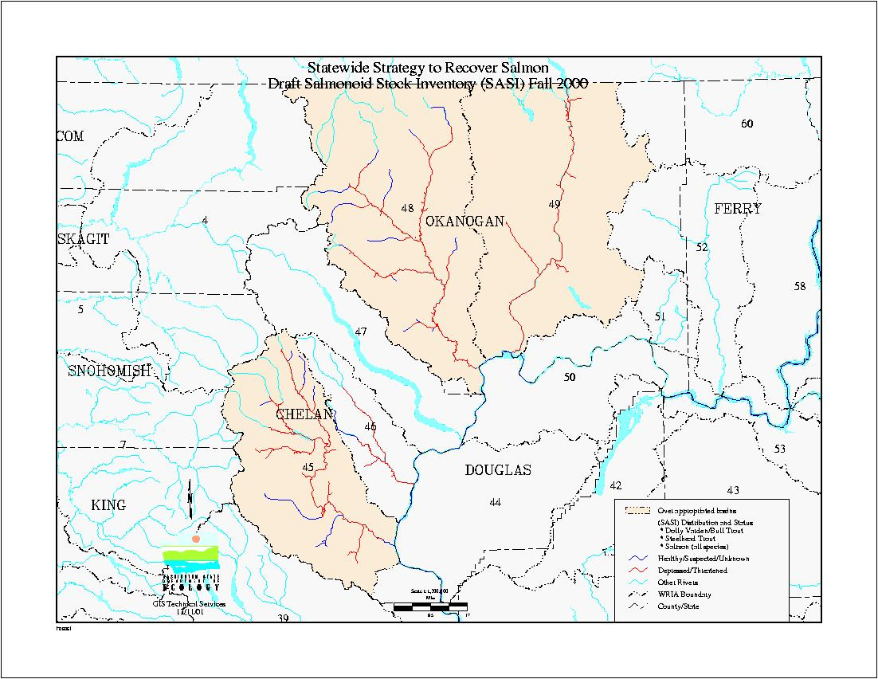

This map illustrates the four subbasins. It highlights the over-appropriated areas and the condition of salmonids populations in the subbasins.

Note: the numbers refer to the Water Resources Inventory Areas (WRIAs) or watersheds established in Washington State.
WRIA 45 Wenatchee subbasin
WRIA 46 Entiat Subbasin
WRIA 48 Methow subbasin
WRIA 49 Okanogan subbasin

c. Rationale and significance to Regional Programs
This proposal is a very important offsite compensation project. Three of the subbasins i.e., Methow, Wenatchee and Entiat have been identified as high priority subbasins in the All-H Paper. Moreover the Northwest Power Planning Council, NMFS and other Action Agencies have recognized the fundamental need for water rights acquisition. The subbasin summaries call for water restoration in many streams and their tributaries.

The 2000 Columbia River Basin Fish and Wildlife Program (FWP) notes that “experience implementing this program has shown great advantages in being able to move quickly and flexibly to acquire interests in land and water rights for the purpose of protecting or enhancing fish and wildlife habitat”, see FWP page 66.

The necessity of water right acquisition has also been recognized by NMFS in the Federal Columbia River Power System Biological Opinion (NMFS, 2000). The component of aquatic habitat restoration section 9.6.2.1, Actions Related to Tributary Habitat provides that tributary habitat efforts shall have as objective an: “water quantity—increase tributary water flows to improve fish spawning, rearing, and migration.”
Additionally, the proposed project supports RPA actions 151: “BPA shall, in cooperation with NMFS, experiment with innovative ways to increase tributary flows by, for example, establishing a water brokerage.”

Ecology understands that a water acquisition fund is being established by BPA in cooperation with the NWPPC. Once operational it will provide a dedicated funding source for water and land acquisition. A complementary program at the state level is needed to ensure that water rights acquisition work is legally and effectively carried out, and that Ecology is able to contribute to the work of the water brokerage. While other entities can acquire water rights, only Ecology can hold the acquired right in a “trust water right” for instream flows. Thus Ecology plays a key role in ensuring long term protection of the rights acquired as well as protection of federal and state investment. Ecology can also cost share BPA financial obligation under Action 151.

The streamflow objectives and strategies outlined in the subbasin summaries for the Wenatchee, Entiat, Methow, and Okanogan are directly supported by this proposal. Examples are described below.

Wenatchee subbasin
Goal 1. Maintain and protect existing high quality habitat and the native populations inhabiting those areas, as described in the “Habitat Areas and Quality” and “Fish and Wildlife Status”:
- Objective 4: Maintain favorable streamflow and riparian conditions
Goal 2. Restore degraded areas, and return natural ecosystem functions to the subbain as described in “Habitat Areas and Quality.”
- Objective 4: Restore habitat to support well-distributed populations of native plant, and riparian-dependent species, including habitat necessary for sustaining salmonids at critical life history stages of spawning, rearing and migration.
- Objective 5: Increase amounts of water to protect and restore fish habitat.
- Objective 6: Restore the water quality necessary to support healthy riparian, aquatic and wetland ecosystem.
Goal 4. Increase the information and knowledge needed to protect, restore and manage fish, wildlife and their habitats.
- Objective 5: Inform and educate landowners, recreationists and the general public about the need to protect, restore and manage natural resources.
Goal 5. Improve management, regulation and enforcement, public involvement and government incentives and funding to maintain and restore natural ecosystem and the species they support.
- Objective 3: Use incentives and government funding to support the protection and restoration of fish, wildlife and their habitats.
- Objective4: Build support by involving and mobilizing citizens to assist in restoration, conservation and enhancement of fish and wildlife habitat.

Methow subbasin
- Objective 2: Improve instream water quantity and quality within the subbasin.
- Objective 11 for spring chinook and summer steelhead--Improve smolt to adult survival in the mainstem migration corridor
- Objective 7: for summer Chinook—improve smolt to adult survival in the mainstem corridor.

Entiat subbasin
- Objective 4: Enhance water quality and quantity--strategy19 create a water conservation trust fund to pay for conservation improvements that will return saved water to instream flows.

Okanogan subbasin
The Upper Columbia Salmon Recovery Board.
Goal: Protect and restore salmonid habitat in the Okanogan subbasin.
- Objective 3: Water rights should be purchased or secured through trust for increasing late-summer instream flows of tributary streams.
Confederated Tribes of the Colville Reservation.
Goal: maintain and protect instream and riparian habitat and support ecological function in these habitats.
- Objective 2: Maintain adequate stream flow in the Okanogan watershed to support salmonids at all life stages. Strategy 2 –develop a water market in the Okanogan subbasin.

d. Relationships to other projects

Ecology began efforts to acquire water rights after receiving direction from the state legislature in 1999. A bill was passed in the 2000 session to appropriate $1 million to fund a pilot program for purchase and lease of water rights in 16 critical basins, including the Methow, Wenatchee, and Okanogan.

The appropriation bill also included specific criteria for prioritizing water rights that might be acquired under this program. The criteria states that, in evaluating proposals for acquisition, consideration should be given to proposals which:
- Provide the greatest benefit for restoring and protecting fish.
- Include benefits in addition to protecting fish critical streams and rivers.
- Include funds from other sources.
- Indicate a broad level of support among interested parties.
- Require the lowest administrative costs to implement.
- Require the lowest overall cost within the context of the local marketplace.

Ecology initially focused on acquiring water rights in the Methow and Dungeness basins. Ecology worked with the Washington Water Trust to identify willing sellers or lessors in these basins. Ecology also contacted other non-profit groups, as well as state and federal agencies, to let them know that Ecology would collaborate on water right purchases or leases. The partnership strategy worked well.

Ecology implemented a wide range of outreach strategies to raise interest in the pilot water buying program. Ecology developed and distributed Fact Sheet describing the program. Ecology has conducted public outreach meeting with irrigator associations, non-profit groups, federal agencies, and other state agencies, sent direct mailings to water rights holders on tributaries within the basins, and held workshops to explain the program to the general public.

Accomplishments of the Pilot Water Buying Program in the Columbia River Subbasins
Walla Walla Basin – Ecology purchased 8.11 cubic feet per second (cfs) of water from an irrigator on the Walla Walla River. This amounts to 1,710 acre feet of water per year.

Methow Basin – Ecology has signed one lease for 190 gallons per minute (gpm) of irrigation water in the Methow basin. The Washington State Department of Fish and Wildlife (WDFW) is also temporarily placing two of its irrigation water rights into the state trust water program. Ecology collaborated with Washington Water Trust to secure these additions to instream flows.

In an effort to focus on the Methow basin water rights, Ecology met with the Methow Basin Planning Unit in May, 2000, and conducted workshops in the basin in November, 2000. Ecology has also used direct mailings, advertised in local papers, and worked through local contacts to promote the water buying/leasing program. Several additional water purchases and leases will likely be signed as a result of the recent workshops.

Yakima Basin – Ecology partnered with the U.S. Bureau of Reclamation (Reclamation) and WDFW to acquire water rights in the Yakima basin. Ecology completed joint purchases of water and land on Taneum Creek and Wenas Creek in December 2000. Ecology contributed $100,000 to each of these transactions. Ecology is also working on several other joint purchases and leases in the Yakima Basin. Because of the success of Bureau of Reclamation’s established land and water acquisition program, we believe that Ecology will have many opportunities to partner with the USBR on acquisitions throughout the Yakima basin.

Water leases during the 2001 drought
The winter of 2001 saw the declaration of a statewide drought. This enabled the state to utilize funds in an emergency drought account to lease water rights to increase instream flows to benefit fish. Ecology worked closely with the Washington Department of Fish and Wildlife, the Washington State Conservation Commission and the Washington Department of Agriculture to prioritize and publicize leasing of water rights during the drought. Contacts were made with the help of irrigation districts and conservation districts.

Emergency rules were adopted to guide the use of funds during the drought. WAC 173-167-085 lists the criteria for buying or leasing water for fish as follows:
(1) Ecology may lease or purchase valid water rights to alleviate drought conditions affecting the state's fish resources. Water rights which are leased or purchased under the authority of this rule must be located in an area receiving, or having been forecast to receive, less than seventy-five percent of its normal seasonal water supplies.
(2) Priority consideration for purchasing and leasing water rights will be given to water rights identified as being most likely to contribute to the survival of threatened or endangered fish stocks by the Washington Department of Fish and Wildlife, potentially affected Indian tribes, and the federal National Marine Fisheries and Fish and Wildlife Services.

To the fullest possible extent, purchasing and leasing water rights will also be based on consideration of the following priorities:
(a) The water right to be purchased or leased:
(i) Has sufficient documentation to allow ecology to make a tentative determination as to its extent and validity;
(ii) Has a sufficiently early priority date to ensure it will provide a benefit for restoring and protecting fish;
(iii) Was put to use in the previous year;
(iv) Will provide the relatively greatest benefit for restoring and protecting fish;
(v) Will provide benefits in addition to restoring and protecting fish, such as meeting water quality requirements; and
(vi) Is reasonably priced within the context of the local market for water.
(b) Lease or purchase of the water right would:
(i) Receive a broad level of support among interested parties;
(ii) Be accomplished with partial funding from other sources;
(iii) Require minimal administrative costs; and
(iv) Would provide the longest possible period of benefit for fish.

(3) Ecology will not purchase or lease:
(a) Water rights for water which will not increase streamflow in the year 2001; or
(b) Water rights which are subject to regulation to protect minimum flows established under chapter 90.22 RCW and chapter 173-500 WAC during the period for which ecology is seeking to enhance fish benefits.

To help fish populations in the Columbia River basin, Ecology entered into an agreement with the Bonneville Power Administration (BPA), U.S. Bureau of Reclamation (USBR) and the Columbia-Snake River Irrigators Association to take advantage of BPA efforts to address potential power production shortfalls. Under the agreement, BPA paid growers in the Columbia Basin Project to remove 75,000 acres from agricultural production. The action kept extra water in the river during the most critical drought months.

Some of the Columbia Basin Project water was made available to downstream irrigators with interruptible water rights. Ecology reimbursed BPA $1 million and the Reclamation bureau $40,000 for lost revenue. The Columbia-Snake Irrigators Association donated $10,000 to purchase water rights to keep water in several Columbia River tributaries where fish were struggling to survive.

During the drought the state leased water rights from farmers to keep trust water in fish-bearing streams located in:

- Libbey Creek, located in the Methow River basin—one lease for 160 acre feet from July 1 to October 1, 2001.
- Yakima and Teanaway rivers, located in the upper Yakima River basin—three leases for 640 acre feet from July 1 to October 1, 2001.
- Touchet River, located in the Walla Walla River basin—four leases for 267 acre feet from July 1 to October 1, 2001.

After the Drought
Ecology, in partnership with the US Bureau of Reclamation has a draft contract with the Fowler Ditch Company to purchase water on the Yakima River. Ecology expects this contract to be completed by the end of the year. The contract will authorize the expenditure of $222,000.00 for 370 acre feet of water.

Ecology is also negotiating a sale of water on Loup Loup Creek, a tributary of the Okanogan River.

e. Project history (for ongoing projects)

f. Proposal objectives, tasks and methods
Goal: Protect and restore instream flows required by wild salmonids.

Objective 1: Increase and protect instream water to benefit at risk salmonid populations and allow stream habitat to recover, in the four subbasins.

Strategy 1. Generate interest, knowledge and trust of the water right acquisition program by:
- Continuing existing and developing new relationships with organizations and individuals within the subbasins.
- Partnering with water and land trusts, watershed planning units, tribes, Washington Department of Fish and Wildlife, Tribes, US Bureau of Reclamation, Natural Resources Conservation Service, counties, conservation districts, and others to develop outreach strategies to raise interest in the program, provide targeted information, and hold public workshops.

Strategy 2. Conduct public Outreach—advertising and marketing water right acquisition program by:
- Targeting mailings to irrigation and farming organizations and potential sellers.
- Making contact through the workshops, and other avenues, with water right holders that might be interested in selling, leasing or donating their rights
- Acquiring more understanding of each subbasins’ local market place.

Task 1. Identify potential critical water rights acquisition/lease areas
- Coarse screen--Identify critical areas where low flows are limiting salmonids populations within the four subbasins in the Columbia Cascade Province. Limiting Factors Analysis, EDT and IFIM studies, and stream flow and water quality data will be used. The areas will be mapped in GIS and shared with key partners.
Develop partner with key stateholders including, but not limited to: Upper Columbia Salmon Recovery Board, Watershed Planning Units, Counties, Tribes, Washington Water Trust, state agencies (primarily the Departments of Fish and Wildlife, and Ecology, and the Conservation Commission), federal agencies (National Marine Fisheries Service, Fish and Wildlife Service, US Forest Service, US Bureau of Reclamation, BPA, EPA) and senior water rights holders.
- Identify critical stream reaches, specific geographic areas, and target sites within each of the four subbasins. This includes researching counties’ records to identify names and addresses of landowners with senior water rights. This effort will be done in consultation with the Department of Fish and Wildlife, the Tribes, local conservation districts, and local Watershed Planning Units.
Examples of areas for water right acquisitions. During the drought the following areas within the Columbia Cascade Province (see map 2) were identified for potential water rights acquisition:

1. Wenatchee– Lower Mainstem of Icicle Creek 45.0474
Importance of Enhancing Instream Flows in the Affected Reach: the Icicle Creek supports natural spawning and hatchery stocks of spring Chinook, steelhead (ESA listed), as well as a number of other salmonid and non-salmonid species, and is one of the larger tributaries in the Wenatchee River System. Two diversions in the lower Icicle divert a total of about 40 cfs. During extreme low flow conditions instream flows are reduced to the extent that a migration barrier to adult spring Chinook is formed, preventing spring chinook from migrating to the hatchery and into the upper watershed. The lower Icicle is also a very popular sport fishing area, and augmentation may help preserve the sport fishing opportunities within this reach.

Amount of Water Needed: although it would be desirable to provide sufficient continuous flows for both rearing and migration, migration flows are of the highest priority. It is expected that about 10-20 cfs would need to be acquired in the lower Icicle Creek to provide sufficient passage for spring Chinook between May and July. Much of the water in the Icicle River is used to irrigate grass hay and pasture and it is reasonable to assume water purchases may be acquired

2. Methow River Basin--Lower Chewuch River RM 0.0-8.0)
Importance of Enhancing Instream Flows in the Affected Reach: there are three federally listed ESA species. Spring Chinook and summer steelhead are listed as endangered and bull trout are listed as threatened. Adult migration of spring Chinook is the most critical life history stage likely to be affected by extreme low flows. Within the Chewuch River watershed/sub basin, between the years 1987 – 1999, 25.6% of spring Chinook spawning in the Methow basin occurred in the Chewuch River.
The stream should remain viable with existing natural flow for rearing habitat although it may be significantly reduced. The Chewuch Ditch and the Fulton Ditch collectively divert up to about 45 cfs in the lower Chewuch River. It is of critical importance to provide adult passage flows into the upper watershed should passage barriers result due to drought conditions.

Amount of Water Needed: NMFS has established a target flow of 75 cfs for the lower Chewuch River. Although passage has not been hindered by extreme low flow conditions in the recent past, an additional 10 cfs or more may be necessary during the extreme low flow conditions to provide for adult passage (May to July) into the upper watershed. Flows may be acquired from the Chewuch Ditch and the Fulton Ditch users as well as users in Eightmile Creek.

3. Methow River Basin-- Early Winters Creek, affected Reach – Early Winters Ditch Company (RM 0-0.5)
Importance of Enhancing Instream Flows in the Affected Reach: three federally listed salmonids reside in Early Winters Creek. Spring Chinook and summer steelhead are listed as endangered, and bull trout are listed as threatened. It is expected that stream flows during the drought may drop to levels which result in passage barriers to spring Chinook and possibly bull trout. Available rearing habitat may also be affected due to low flow conditions.
Amount of Water Needed: it is estimated that acquiring approximately 7cfs of the total 14 cfs diverted by the Early Winters Diversion would provide sufficient flow to pass spring Chinook into the upper spawning areas. The irrigation district may be interested in selling water during the adult migration period.

4. Methow River Basin – Lower Mainstem of Twisp River (RM 0-6.9)
Importance of Enhancing Instream Flows in the Affected Reach: the Twisp River supports natural spawning stocks of spring Chinook, steelhead (ESA listed), as well as a number of other salmonid and non-salmonid species , and is one of the larger tributaries in the Methow River System. Two diversions in the lower Twisp divert a total of about 42 cfs. During extreme low flow conditions it is expected that instream flows will result in a migration barrier to adult spring Chinook.
Amount of Water Needed: although it would be desirable to provide sufficient flows for both rearing and migration, migration flows are of the highest priority. It is expected that about 20 cfs would need to be acquired in the lower Twisp River to provide sufficient spring Chinook passage. Much of the water in the Twisp River is used to irrigate grass hay and it is reasonable to assume water purchases may be acquired. The Twisp Power Canal diversion (RM 6.9), and the Twisp-Methow (West Canal) diversion, can contribute significantly to decreased flows below RM 3.9.

5. Okanogan—
Several creeks have been identified as potential for instream flow augmentation through the trust water right. They include:
Salmon, Loup Loup, Sullivan, Chiliwist, Antoine, and Tonasket creeks.
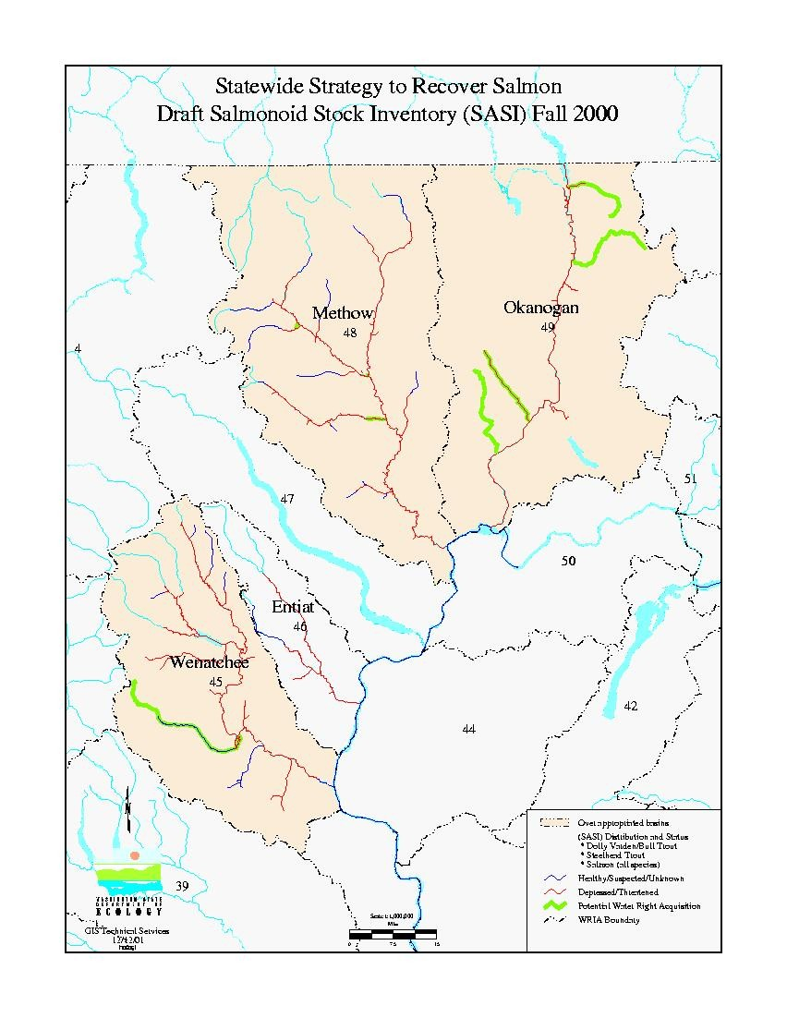
Map 2. Examples of Potential Water rights Acquisition Areas

Task 2. Evaluate Water Rights Proposals
- Verify with local entities to determine if the proposal is “real”.
- Ecology will consult with local partners (Tribes, water and salmon groups, WDFW, federal agencies, etc.) to ensure the problem being addressed is related to water withdrawal in the stream segments involved.
- Determine whether the proposal would:
-Be within the area identified as high priority by WDFW and the Tribes.
-Provide relatively greater and longer term benefits for fish than other proposals.
-Get the water back instream when and where needed to do any good for fish
- Evaluate the characteristics of the water right (validity, seniority, is it ‘wet’ water?) applying the four tests for water rights: public interest, beneficial use, water is available, and no impairment to others
- Make a tentative determination as to its extent, validity and benefit to restore and protect salmon
- Ensure a public process is in place to provide the opportunity for input

Task 3. Negotiate Purchases/leases
- Determine the fair market value of the water rights.
- Consult with the Bureau of Reclamation and others who have experience with water right appraisals.
- Negotiate the price to be offered and the conditions of the agreement.
- Prepare the final acquisition agreement document.

Task 4. Acquire the water rights
- Acquire up to 30 cubic feet per second of senior water rights for instream flow purposes.
- Transfer the water right to the trust water program.

Objective 2: Collect and analyze data and information about the water rights acquisition program to assess its success and needs for improvements.

Task 1. Verification/validation of Lease or Purchase Conditions
- Verify and determine if the “seller” fulfilled the terms of the transaction (e.g., curtail the use to the degree specified and in a timely fashion).
- Evaluate local public acceptance—through surveys, workshops and other means.

Task 2. Effectiveness Monitoring
- Install and operate stream gages and fund measuring devices on existing diversions within the affected reaches.
- Verify the availability and delivery of water purchased by collecting continuous flow data during the time period specified in the trust water rights.
- Conduct site visits to measures flows and amount of water diverted to ensure that water right holders in proximity of the trust water right dedicated to instream flows are not impacting it. Ecology regional offices have responsibility for monitoring and compliance.
- Evaluate with the assistance of the Department of Fish and Wildlife whether the transaction accomplished its stated purpose—did the water put back into the stream benefit the targeted species?
- Track and report by subbasin and stream reaches the number, type and purpose of transactions, amounts of water and funding involved, lessons learned, and other pertinent information.

g. Facilities and equipment

To monitor instream flow the department of Ecology has several Swoffer velocity meters along with one Acoustic Doppler Profiler which automatically measures the depths and velocities across rivers and streams. We also have several boats equipped with USGS equipment for measuring rivers. To evaluate the benefits to fish from our water acquisitions, our fish biologist and the fish biologists that work with us from the Washington Department of Fish and Wildlife have the capability to survey streams for fish presence with a variety of methods.

Ecology plans to purchase and install 25 staff gages at $1,000 each. These gages will be used in conjunction with continuous stream gages (see other Washington State proposal to BPA for stream gages within the Wenatchee, Entiat, and Okanogan), and the velocity meters to accurately monitor stream flows during the period of time specified in the trust water rights. In addition measuring devices (funded by the state) will be installed on diversions within the affected reaches to measures withdrawals.

h. References

Reference (include web address if available online) | Submitted w/form (y/n)
References:  Statewide Strategy to Recover Salmon, Extinction is Not An Option, State of Washington Governor’s Salmon Recovery office, November 1999.  Hopkins, Brad, Washington Department of Ecology, Determination of Instantaneous Flow Measurement on Rivers and Streams (protocols for gauging, in-preparation), 2001.  Washington Department of Ecology, Environmental Assessment Program, Information on gauging activities is available on Ecology’s website at: ttp://www.ecy.wa.gov/programs/eap/flow/shu_main.html  Laundry, Clay J., Political Economy Research Center, Saving Our Streams Through Water Markets, 1998.  Lowe, Laura, Washington Department of Ecology, 2000 Report to the legislature, Water Rights Purchasing Pilot Project, Progress Report and Recommendations, publication no. 00-11-009, 2000. (available on website, http://www.ecy.wa.gov/biblio/0011009)  Nelson, Cynthia, Washington Department of Ecology, Trust Water Rights Program Guidelines, publication no. 92-088, 1992. (available on website, http://www.ecy.wa.gov/biblio/92088.html)  Washington Department of Ecology. 2002.  Washington Department of Ecology, Instream Flows Draft Programmatic Environmental Impact Statement, In preparation and available in January 2002 from Ecology’s Water Resources Program.  Washington Department of Ecology, Instream Flows Non-Project Review Form for Environmental Analysis, 2001, Water Resources Program, http://www.ecy.wa.gov/programs/wr/instream-flows/isflowhome.html  Revised Code of Washington, RCW 90.42 Water Resources, codified changes on Trust Water Rights from 2001 legislative session.  Independent Economic Analysis Board of the Northwest Power Planning Council, River Economics: Evaluating Trade-offs in Columbia River Basin Fish and Wildlife Programs and Policies, 1999.  Andonaegui, Carmen, Washington Conservation Commission, Habitat Limiting Factors Report, Entiat WRIA 46, 1999, executive summary available at website www.conserver.org  Andonaegui, Carmen, Washington Conservation Commission, Habitat Limiting Factors Report, Methow WRIA 48, 2000, executive summary available at website www.conserver.org  Andonaegui, Carmen, Washington Conservation Commission, Habitat Limiting Factors Report, Wenatchee WRIA 45, 2001, executive summary available at website www.conserver.org  Golder and Associates, Washington Conservation Commission, Draft Habitat Limiting Factors Report, Okanogan WRIA 49, 2002, executive summary available at website www.conserver.org  Draft Methow Subbasin Summary prepared for the NPPC, October 5, 2001.  Entiat Subbasin Summary prepared for the NPPC, October 5, 2001.  Wenatchee Subbasin Summary prepared for the NPPC, October 5, 2001.  Okanogan/Similkameen Subbasin Summary prepared for the NPPC, October 2001. | N  N  N  N  N  N  N  N  N  N  N  N  N  N

Section 10 of 10. Key personnel
Peggy Clifford
Peggy Clifford joined the Washington Department of Ecology in 1984. She has worked in the Water Resources Program for four years, the last year of which was focused on coordinating the state’s water acquisition program. Peggy’s job over the past year has included public outreach, negotiating leases and sales, drafting contracts, coordinating regional reviews of water rights, coordination with fish biologists, and coordination of other program details. Previously she coordinated the state’s efforts with local water conservancy boards, a new program created by the state legislature which allows local county boards to change and transfer water rights, with final review and approval by Ecology. Prior to that she coordinated the first year of a new Watershed Planning Grant program.

Peggy received her B.A. in Geography and Regional Planning at Western Washington University and her Masters in Public Administration from Evergreen State College.

Brad Caldwell
Brad received his Master of Science degree in Fish Biology from Colorado State University and began working at the US Fish and Wildlife Service’s Instream Flow Group, which evaluated all existing instream flow methodologies. The Group combined the best of these principles into a system of procedures and principles, which became known as the Instream Flow Incremental Methodology (IFIM).
- From 1980 until 1983, he conducted IFIM studies on the instream flow needs of fish in Colorado and Utah.
- In 1983, he was hired by the Washington State Department of Fisheries to conduct IFIM studies on the instream flow needs of fish in Washington.
- Brad Caldwell joined the Washington Department of Ecology in 1985. He continued doing IFIM studies, gathering more comprehensive IFIM information for establishing instream flows.
- From 1985 to Present, he has acted as the statewide expert for Ecology on matters relating to fish, fish habitat, and instream flows.

David Burdick
Dave Burdick joined the Washington Department of Ecology in 1988. Dave received a Business Finance degree from Washington State University and took advance accounting from Seattle University.
- From 1998-1995 Dave worked as budget analyst for the Water Resources Program and the Shorelands and Environmental Assistance Program.
- From 1995-2001, Dave worked as a floodplain specialist in the Shorelands and Environmental Assistance Program providing technical assistance to local government in developing comprehensive flood damage reduction plans and implementation of flood reduction projects including acquisition of flood prone properties.
- In July of 2001, Dave joined the Water Resources program as Contracts Coordinator providing expertise in negotiating the various contractual obligations of the program, including water purchase and leasing.

Bob Barwin
Bob Barwin has worked with the Washington Department of Ecology since May 1979. Mr. Barwin worked from August 1977 to May 1979 as an engineer in Oregon's Water Resources Department. He has worked 12 years in Ecology's Water Resources Program as an engineer and manager and is currently responsible for the water rights administration in Ecology's Central Regional Office in Yakima. He also worked for 10 years as the manager of Ecology's Water Quality Program in Yakima.

In total, Mr. Barwin has nearly 25 years experience in all aspects of water resources management, including water rights administration, instream flow protection, State and Federal water quality permitting and enforcement, and administration of water quality grants and loans.

Bob has a Bachelor's Degree in Civil Engineering from Oregon State University and is a registered professional engineer in Washington State.

John Stormon
John Stormon started working at Ecology in 1990. He is Ecology’s watershed planning lead, working with planning units in the Methow Basin and Moses Coulee/Foster Creek basins.

He has a BS in Geology from Michigan State University.

John Monahan
John Monahan joined the Washington Department of Ecology in 1995. He has a Bachelor and Master of Science degrees in Fish and Wildlife Management from Michigan State University. His Master's research and subsequent graduate-research at the University of Minnesota in the late '80'a and early 90's were cooperative efforts with the USFWS Instream Flow Group and Electric-Power Research Institute, respectively, which refined instream flow analytical techniques used in the Instream Flow Incremental Methodology and Individual-Based Population Modeling.

As a consulting fisheries scientist from 1993 to 1995, Mr. Monahan worked cooperatively with irrigation districts, the Bureau of Reclamation, the Yakama Nation, the USFWS, WDFW and others analyzing and managing fish and water resources in the Yakima River Basin. Since joining Ecology in 1995 John has worked within the Water Resources and Shorelands and Environmental Assistance Programs on cooperative efforts to address water, fish, and related watershed issues primarily in the Upper Columbia River Basin. Currently, Mr. Monahan supports Watershed Planning in Chelan County and is the Department of Ecology's regional technical expert on instream flow, fish, and water resource issues tasked with supporting salmon recovery in the Upper Columbia River Basin.

Susan Burgdoff-Beery
Susan Burgdoff-Beery came to work at Ecology in 1990. She received a B.S. degree in Biology from Western Washington University. She has been working as a Water Rights Compliance Specialist (Watermaster) with the Water Resources program in Ecology’s Central Regional Office in Yakima since April 2000. Susan Burgdoff-Beery work responsibilities include investigation of water rights, field monitoring of interruptible water right holders (when rivers are below minimum flows), measurement of water diversions, water right complaint response and water right enforcement.

Vacant water buying position in Yakima
Ecology will soon be filling a new position in the Central Regional Office in Yakima. The position will be dedicated to tasks supporting the water rights acquisition program. This position will evaluate water rights for lease or purchase, and help with public outreach for the water rights acquisition program.

Hal Beecher
Hal Beecher began work for the Washington Department of Fish and Wildlife (then Dept of Game) in 1979 after working for The Nature Conservancy. At the Department of Fish and Wildlife Hal has had responsibility for instream flows, including: testing & development of instream flow methods & tools (research on fish habitat selection), review of water right applications, instream flows for major projects (hydroelectric, irrigation, municipal, industrial), agency instream flow policy, development of national instream flow standards through National Instream Flow Program Assessment and Instream Flow Council, and watershed management planning.

Hal’s education includes an A.B. in Biology in 1970 at Middlebury College, Middlebury, VT; a M.S. in Biology in 1973 at the University of West Florida, Pensacola; and a Ph.D. in Biological Science in 1979 at Florida State University, Tallahassee.

Arthur G Larson

Washington Department of Ecology
300 Desmond Drive
P.O. Box 47710
Olympia, WA 98504
360-407-6560 (Work)
Email:arla461@ecy.wa.gov

Education
1979 Ph.D., Physical Hydrology, University of Washington
1973 M.S. Forest Hydrology, University of Washington
1968 Officer Candidate School, United States Navy, Newport, Rhode Island
1968 B.S. Forest Engineering, University of Washington

Experience
- 1987-present: Hydrogeologist

Washington Department of Ecology
Principal investigator for studies on the effects of surface water and ground water withdrawals on streamflow. Investigated the extent of pesticide contamination in various agricultural areas of Washington State. Studies of the relationship between groundwater and surface waters.
- 1980 – 1987: Environmental Consultant

Streamflow monitoring, site assessment, geohydrologic investigations, and general water resource consulting.

- 1978-1980: Faculty Research Associate
University of Washington College of Forest Resources
Project director of hydrologic research on the Olympic Peninsula.

