Project ID: 30004

Title: Blind Slough Restoration Project Brownsmead, Oregon
Section 9 of 10. Project description

a. Abstract
The project restores tidal exchange between the Columbia River Estuary and Blind Slough in the community of Brownsmead, Oregon. BPA funding will provide 25% cost share for Section 1135 of Army Corps of Engineers environmental restoration program to partially underwrite the cost of project implementation, planning, engineering, and design. BPA funds will also be used to develop and implement an effectiveness monitoring program for the project. The Columbia River Estuary Study Taskforce (CREST), Clatsop Diking Improvement Company No. 7, and the Army Corps have prioritized the following array of activities to restore Blind Slough: installation of water control structures to breach the Blind Slough dike, replacement and/or installation of five (5) constricted culverts, and channel enhancement. The goal of these activities is to restore historic hydrologic and bio-physical connection to the Columbia River Estuary. Restoration of Blind Slough enhances water quality and reconnects seven (7) miles of habitat for aquatic species including migrating salmonids.

Funds will provide 25% of construction costs during the project implementation phase, as well as engineering, planning and required environmental feasibility studies. In addition, funds are used to develop an effectiveness monitoring program that partners Clatsop Diking Improvement Company No. 7, CREST, the Nicolai-Wickiup Watershed Council, and volunteer landowners from the Brownsmead area. The monitoring activities assist in testing scientific assumptions developed about reconnecting diked tidelands to the estuarine tidal prism. These assumptions were identified in part by the success of previous restoration projects implemented in the Brownmead area which demonstrated water quality improvements and increased fish access to tidal wetland habitat. Through the development of a comprehensive effectiveness monitoring program, information on water quality improvements and increased fish use of the Blind Slough will be compiled and applied to future restoration projects.

b. Technical and/or scientific background
Tidal wetland habitat loss has been identified as a priority concern in the Columbia River Estuary. Historic analysis and recent estuary science literature cite the loss of historical wetland types as a major modifier to estuary ecosystem function and processes. Over the past 100 years a high percentage of tidal lowlands have been modified and/or diked for agricultural, livestock, and residential land uses (figure 1). The effect of these activities resulted in floodplain disconnection vital to historic bio-physical habitat structure and processes. Tidal marshes and swamps within the Columbia River Estuary have been reduced by 65%. (D. Thomas, 1983) Disconnection of tidal channels from diurnal tidal exchange contributes to water quality degradation stemming from hydrologic stagnation and channel bottom accretion thereby raising water temperatures and lowering levels of dissolved oxygen. Columbia River Estuary floodplain disintegration has lead to isolating areas historically used for juvenile salmonid habitat needed for life history rearing, foraging, and refuge.

Figure 1: Historic Habitat Changes 1870-1980, L. Columbia River (mouth to RM 46)
Through anthropogenic changes the Columbia River Estuary’s abundance and extent of wetland habitat has been reduced. Flood control structures and dikes placed in the Brownsmead area during the 1910s and 1930s effectively attenuated and/or deterred flow into inland slough waterways. While dike construction and tide gate installations provided flood control for land use needs of Brownsmead residents, these activities fragmented Blind Slough’s connectivity to the Estuary (figure 3). Salmon at River’s End (D. Bottom, et. al. 2001) and the Nicolai-Wickiup Watershed Assessment (E & S Environmental Chemistry, 2000) cite that diking and filling activities reduced tidal connections and isolated emergent estuarine and forested wetlands thereby reducing
rearing capacity for juvenile salmonid life histories.

Figure 3: Tidal Channel Change in the Brownsmead Area 1875-1977 (D. Thomas, 1983)
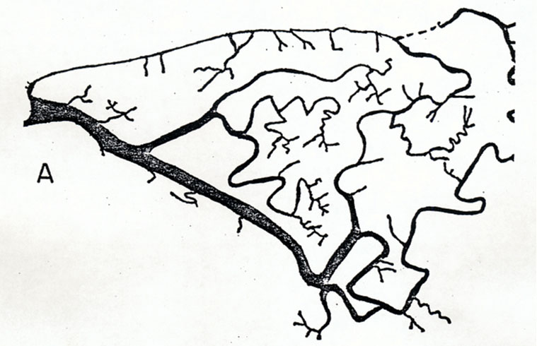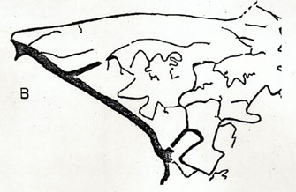
Brownsmead 1977
Brownsmead 1875

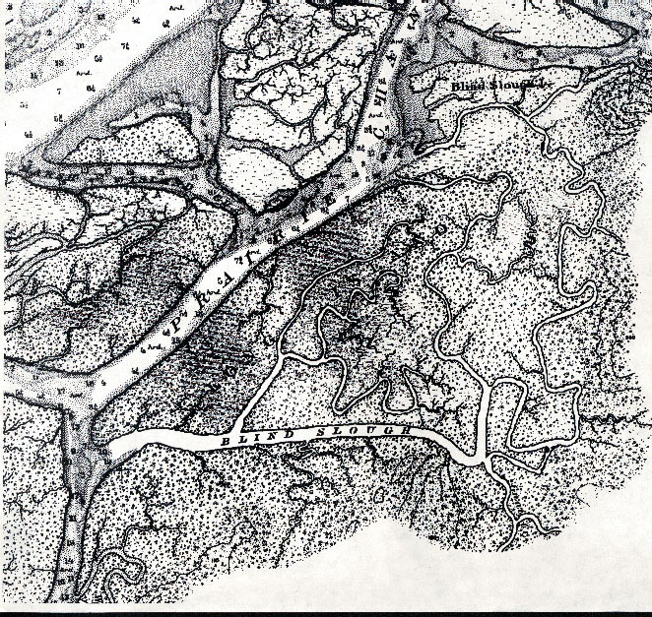
Figure 4: Blind Slough 1890 (United States Coastal Survey )
Cathlamet Bay
Blind Slough

Blind Slough’s proximity and historic connection (figure 4) to the biologically productive and physically complex Cathlamet Bay island network increases its ecological importance for restoration. Blind Slough is located in the oligohaline zone located in the tidal area between Horseshoe Island (RM 29) and Tongue Point (RM 18). The oligohaline zone has been identified as a critical staging area for subyearling salmon when they first encounter and must acclimate to saltwater. (D. Bottom, et al. 2001)

Historic flooding influenced Blind Slough’s wetland structure and extent. These events assisted in the development of a mosaic of wetland habitat types consisting primarily of tidal wetland marshes and swamps. These wetland types historically provided a variety of ecological functions for the Cathlamet/Blind Slough system. Estuarine literature cites emergent and forested wetlands as valuable areas for detrital input. Detrital delivery plays a pivotal role in primary and secondary food web production of the Estuary. Additionally, at low tide juvenile salmonids utilize slough channels that are close to shallow water feeding areas. (Levy and Northcote, 1982)

It is also likely that Blind Slough historically served as low energy refugia areas for subyearling cover from predation and strong currents. Estuarine studies of salmon use suggest that subyearling salmon remain within water depths between 10cm and 2m (Healy, M.C., 1982). Juvenile salmonid use of estuary habitat types is also due in part by the degree of energetic constraints such as stream velocity (Beamish, F.W.H., 1978). Using variables such as velocity and depth, current and historic function of Cathlamet Bay were examined in modeling data developed by the Oregon Graduate Institute and presented in Salmon at River’s End. Based on these variables the modeling currently targets Cathlamet Bay as an area of “habitat opportunity” for juvenile salmonid use of the estuary. (D. Bottom, et al. 2001)

Salmon at River’s End also offers several recommendations related to the effectiveness monitoring component (see Objective 3) of the Blind Slough restoration project. Effectiveness monitoring in the context of project implementation is valuable to developing an understanding of estuary ecosystem response to on the ground restoration actions. The following are monitoring related recommendations cited as ways as to advance understanding of salmon-rearing requirements:

- Establish experimental restoration projects at a few representative wetland sites to evaluate the effectiveness of dike removal as a method of salmon recovery. Conduct a monitoring program at experimental and previously unaltered (undiked) reference sites to assess rates of habitat recovery, and identify conditions that affect salmonid use and performance.

- Establish performance criteria for evaluating whether management activities in the basin will impact salmon diversity and the productive capacity of the estuary.

c. Rationale and significance to Regional Programs
Blind Slough’s historic connection to the Columbia River Estuary elevates its restoration significance. Recent program and policy initiatives point to the Columbia River Estuary as an important component in the overall ecological integrity of the entire Columbia Basin. Described below are the extent of existing strategies, policies, and/or programs in the Columbia River Estuary and how they manifest in the justification of the Blind Slough restoration project.

Sub-Basin Summary-Columbia Estuary Province
The Sub-basin summary demonstrates the importance of estuarine habitats for important nursery and rearing areas for young salmon and steelhead, and for adults as temporary holding areas during their return migration from the ocean to upstream spawning areas. All listed species of salmon must traverse and utilize estuarine habitat as juveniles and adults. The 12 Evolutionarily Significant Units (ESU) of Threatened and/or Endangered salmon that pass through the Estuary include:

- Snake River Spring/Summer Chinook
- Snake River Fall Chinook Salmon
- Upper Columbia River Spring-run Chinook Salmon
- Upper Willamette River Chinook Salmon
- Lower Columbia River Chinook Salmon
- Snake River Steelhead
- Middle Columbia River Steelhead
- Upper Willamette River Steelhead
- Lower Columbia River Steelhead
- Columbia River Chum Salmon
- Snake River Sockeye Salmon
- Upper Columbia River Steelhead

Estuaries are considered important to rearing of juvenile salmon and represent an integral component of the continuum of habitats that salmon occupy for significant periods of time. Changes in the environment and the loss or degradation of habitat have contributed to decreased runs of native fish. Estuaries contain food sources to support the rapid growth of salmon smolts, but adequate natural habitat must exist to support the detritus-based food web.

All salmon life history types in the Columbia Basin use the Columbia River Estuary and the Lower Columbia River as a migratory corridor to move between freshwater and marine habitats. Adequate food resources and free flowing and high quality water are important attributes that are required for recovery of all endangered salmon stocks. However, this region is particularly important to endangered stocks of salmon that exhibit an ocean-type life history pattern. Juvenile salmon that emulate an ocean-type pattern migrate to and rear in the lower river and estuary for extended periods of time (months).

The juveniles of spring chinook salmon stocks in the Columbia Basin exhibit some distinct juvenile life history characteristics. Generally, these stocks remain in the basin for a full year. However, some stocks migrate downstream from their natal tributaries in the fall and early winter into larger rivers, including the Columbia River, where they are believed to over-winter prior to outmigration the next spring as yearling smolts. Adult summer chinook begin river entry as early as June in the Columbia. Coho begin to leave the river a full year after emerging from their gravel nests with the peak outmigration occurring in early May. Coho use estuaries primarily for interim food while they adjust physiologically to saltwater. Also, the processes that contribute nutrients and woody debris to these environments must be maintained to provide cover from predators and to sustain the food web. Common disruptions to these habitats include dikes, bulkheads, dredging and filling activities, pollution and alteration of downstream components such as lack of woody debris and sediment transport.

2000 National Marine Fisheries Service Biological Opinion on the Operation of the Federal Columbia River Power System (FCRPS)

RPA Actions Related to Estuarine Habitat
The Blind Slough restoration project fits restoration planning and implementation objectives stated in the NMFS Biological Opinion relating to hydropower in the Columbia River system. The Bi-Op outlines how the Corps is to play a lead role in developing and funding restoration projects with BPA primarily providing cost-share funding. The Blind Slough Restoration Project is proposed for implementation through the Corps Section 1135 with BPA funding the required 25% match. The Bi-Op defines five (5) estuary related Reasonable and Prudent Alternatives (RPAs) defining action items for agency implementation. RPA action 160 relates directly to the Blind Slough restoration proposal. It states:

“the Corps and BPA, working with LCREP, shall develop and implement an estuary restoration program with a goal of protecting and enhancing 10,000 acres
of tidal wetlands and other key habitats over 10 years, beginning in 2001, to
rebuild productivity for listed populations in the lower 46 river miles of the
Columbia River.”

The Bi-Op also states how the Action Agencies are to provide planning and engineering expertise to implement the non-federal share of on-the-ground habitat improvement efforts. Finally, the document lists examples of “acceptable estuary habitat improvement work”. Listed below are the activities that directly relate to the Blind Slough restoration proposal:

• Breaching levees
• Improving wetlands and aquatic plant communities
• Enhancing moist soil and wooded wetland via better management of river flows
• Reestablishing flow patterns that have been altered by causeways
• Creating shallow channels in inter-tidal areas
• Enhancing connections between lakes, sloughs, side channels, and the main channel

Furthermore, the NMFS Biological Opinion emphasizes the need to compile information to assess effectiveness of management activities. The monitoring component built into the Blind Slough restoration project assists in tracking pre and post project implementation results that will be useful in the design of future restoration activities in the Columbia River Estuary.
NWPPC Fish and Wildlife Program 2000

The proposed project is consistent with the 2000 Fish and Wildlife Program objectives for biological performance for anadromous fish loss which states “restore the widest possible set of healthy naturally reproducing populations of salmon and steelhead in each relevant province by 2012”. The Blind Slough restoration proposal fits within the “Compromised Habitat” strategy defined in the Fish and Wildlife program designed to meet the biological objective stated above.

The Fish and Wildlife Program recommends approaches that may be used to improve habitat. The applicability of these approaches to the Blind Slough project are underlined below:

- Build from strength: Efforts to improve the status of fish and wildlife populations in the basin should protect habitat that supports existing populations that are relatively healthy and productive. Next, we should expand adjacent habitats that have been historically productive or have a likelihood of sustaining healthy populations by reconnecting or improving habitat. In a similar manner, this strategy applies to the restoration of weak stocks: the restoration should focus first on the habitat where portions of that population are doing relatively well, and then extend to adjacent habitats.

- Restore ecosystems, not just single species: Increasing the abundance of single populations may not, by itself, result in long-term recovery. Restoration efforts must focus on restoring habitats and developing ecosystem conditions and functions that will allow for expanding and maintaining a diversity within, and among, species in order to sustain a system of robust populations in the face of environmental variation.

- Use native species wherever feasible: Even in degraded or altered environments, native species in native habitats provide the best starting point and direction for needed biological conditions in most cases. Where a species native to that particular habitat cannot be restored, then another species native to the Columbia River Basin should be used. Any proposal to produce or release non-native species must overcome this strong presumption in favor of native species and habitats and be designed to avoid adverse impacts on native species.

- Include the estuary: The estuary is an important ecological feature that is negatively affected by upriver management actions and local habitat change. While less is known about the potential for improvement in the estuary than is known about the potential for improvement in most other parts of the Columbia River Basin, there are indications that substantial improvements are possible and that these improvements may benefit most of the anadromous fish populations. The estuary will be included as one of the planning units for this program. (The freshwater plume and the ocean itself are also important habitats for salmon and are addressed in the Ocean Conditions section of this program.)

Columbia River Estuary Study Taskforce (CREST)/Lower Columbia River Partnership (LCREP) Wetland Program

Currently CREST is implementing a habitat restoration strategy with the Lower Columbia River Partnership (LCREP) that identifies and prioritizes wetland habitat restoration opportunities based on existing habitat data and recently developed habitat restoration criteria. The Blind Slough restoration project is a direct outcome of the CREST/LCREP Wetland Program.

Habitat Criteria Development
As part of the CREST/LCREP Wetland Program, a habitat restoration workshop was held in Astoria sponsored by CREST, LCREP, Army Corps of Engineers, and American Rivers. Attendees of the June 2001 workshop represented a variety of regional and national estuary experts. The outcome of the workshop was a set of habitat restoration criteria to identify and prioritize habitat protection and restoration projects on the Lower Columbia River and Estuary. The criteria serves as a foundation for a more integrated collaborative restoration strategy for the Columbia River Estuary and Lower Columbia River. CREST is working closely with the LCREP Science Work Group to continue identifying opportunities for habitat project coordination and development. The criteria themes are as follows:

- Habitat Connectivity
- Areas of Historic Habitat Type Loss
- Linkages to Reference Site(s)
- Passive Habitat Restoration over Habitat Creation
- Monitoring and Evaluation
- Community Support and Participation

LCREP Management Plan

The states of Oregon and Washington, with congressional authorization from the EPA, have developed a Comprehensive Conservation and Management Plan (CCMP) through the Lower Columbia River Estuary Partnership (LCREP). 12 of the 43 actions in the CCMP are dedicated to the issue of habitat loss and modification. The CCMP actions directly related to the Blind Slough restoration project are as follows (note: underlined actions are specific to the Blind Slough proposal):

- Action #2: Protect, conserve, and enhance identified habitats, particularly wetlands, on the mainstem of the lower Columbia River.
“Reclaim habitat by selectively using tools such as seasonally managing or breaching dikes, augmenting inadequate stream flows, decompacting wetland soil, lowering surface elevations of mainstream reservoirs, modifying dam operations, re-establishing sustained peak flows, installing fish friendly tidegates, not disposing of dredge sediment in streams, restoring riparian floodplain connections, and removing or modifying structures that prevent natural flows”

- Action #5: Restore 3,000 acres of tidal wetlands along the lower 46 river miles to return tidal wetlands to 50 percent of the 1948 level.
“Work with landowners and local diking districts to undertake tidal wetland improvement projects on private lands. These efforts could include removing tidegates or replacing tidegates with ones that allow greater water exchange, and breaching dikes.”

- Action #6: Monitor the effectiveness of habitat protection, restoration, and mitigation projects
“Develop criteria (including indicator species and best assessment tools) for evaluating the effectiveness of habitat protection, restoration, and mitigation projects.”

Nicolai-Wickiup Watershed Assessment

Blind Slough is a sub-basin of the Nicolai-Wickiup Watershed. The Nicolai-Wickiup Watershed Council completed a scientifically based Watershed Assessment in 2000 (E & S Environmental Chemistry, 2000). The following recommendations were defined in the assessment by the watershed council and relate to the Blind Slough restoration project:

- Prioritize estuarine wetlands for restoration options based on their value to salmonids for restoration, creation, or maintenance.
Blind Slough restoration has been identified as a high priority project as part of the Watershed Council’s action planning process.

- Prioritize and replace undersized culverts.
Blind Slough restoration project activities include the replacement and/or installation of 5 culverts that have been surveyed by Army Corps of Engineers and the Diking Districts of Brownsmead.

- Develop a systematic water quality monitoring program for areas with high priority for restoration activity. Focus the water quality monitoring on constituents that are important for the specific area being restored. Include a plan for long-term monitoring in any restoration plan to measure the effects of the restoration activity. Begin to develop the capacity within the watershed council to conduct high quality, long-term water quality monitoring to document the success of restoration activities.
Objective 3 of this project includes an effectiveness monitoring program that will be built into a comprehensive monitoring program for the watershed.

d. Relationships to other projects
The Blind Slough restoration project represents a multitude of efforts representing both the interests of the local community and regional collaborative wetland planning efforts of the Columbia River Estuary and the Lower Columbia River. Clatsop Diking Improvement Company No. 7, representing the landowners of Brownsmead, has demonstrated the success of previous restoration work through partnerships with the Nicolai-Wickiup Watershed Council. The diking district received initial approval from Brownsmead community members and the Nicolai-Wickiup Watershed Council members to recruit restoration planning assistance from the Army Corps of Engineers. This led to a Preliminary Restoration Plan outlining cost estimates and feasibility of potential restoration activities.

The Blind Slough restoration project proposal represents an opportunity to apply information compiled from previous wetland planning initiatives in the region. CREST and LCREP have compiled current and historical wetland habitat information detailing wetland habitat type, extent, and function. The criteria developed at the June 2001 workshop continues to be refined and tested by members of the LCREP Science Work Group whose representatives include public federal, state, and local agencies and area NGOs with interests in the Columbia River Estuary. The Science Work Group provides a multiple discipline forum for coordinating scientific guidance on habitat assessment, criteria, monitoring, and habitat project development.

Project Linkage to ongoing Monitoring Projects in the Estuary
The monitoring component of the Blind Slough restoration project will complement existing studies of juvenile salmonid behavior and existing habitat information. NMFS, University of Washington, ODFW, and the Oregon Graduate Institute, are collaborating on a study to identify important estuarine habitats and to evaluate the role of the Columbia River Estuary to juvenile salmon. There is, however, a general lack of science-based information concerning attributes of these tidal freshwater and oligohaline transition zones needed to support juvenile salmon, particularly in the Columbia River Estuary. Regions include shallow water areas either adjacent to peripheral forests and wetlands or centrally located in the river, dendritic and channel margins, and backsloughs.

NMFS also recognizes the need to place the salmon habitat associations in a historical context by evaluating river discharges and sediment inputs into the estuary for the past 100 years and reconstructing past and present availability of salmon habitat through the Lower Columbia River and Estuary using GIS mapping. NMFS recommends developing a regional 3-dimensional numerical model of the system that can be used to characterize the impact of physical processes (flow, bathymetry, salinity, temperature, etc.) on potential availability of juvenile salmon habitat. Additional efforts in continuing years will include refining and evaluating methodologies to estimate habitat opportunity for juvenile salmon in Cathlamet Bay.

Proposed Objectives of NMFS, UW, ODFW, OGI Monitoring Project:
- Compare trends in abundance and life histories of juvenile salmon at a landscape scale on representative transects of shallow-water habitat between Puget Island and the Columbia River mouth.
- Describe salmonid use and performance in selected emergent and forested wetlands and their relationship to local habitat features.
- Characterize historical changes in flow and sediment input to the Columbia River estuary and change in habitat availability throughout the lower river and estuary.

e. Project history (for ongoing projects)
The Blind Slough Restoration Project is a new project.

f. Proposal objectives, tasks and methods
PROJECT GOAL: Restore tidal connection between the Columbia River Estuary and Blind Slough through the breaching of dikes, replacement and/or installation of culverts, installation of water control devices, and channel enhancement. Pre and post project monitoring of Blind Slough will determine project effectiveness in water quality improvement of Blind Slough's channel network as well as increased fish access to spawning and off-channel rearing habitat for salmonid species.

Local projects initiated by Brownsmead area residents demonstrated successful reconnection of tidal channels by replacing tidegate structures thereby promoting a higher volume of tidal exchange. Replacing iron tide gate lids with lighter aluminum design and installing a high volume water intake gate at the main channel has improved tidal circulation in Brownsmead. As a result of these projects, fish access and water quality improved.

This proposal builds on the success of these locally initiated projects. These enhancements demonstrated that by reconnecting historic tidelands to the estuary, physical aquatic habitat opportunities and water quality conditions improve. A comparison of current and historic information on Brownsmead show channel slough signatures relatively intact (figure 3). The proposed project advocates to reconnect remnant sloughs channels that have been cut off from their historic pattern to approximate historic ecologic structure and function of Blind Slough in the context of the Columbia River Estuary system.

A Preliminary Restoration Plan (PRP) has been developed by the Army Corps of Engineers with input from CREST and members of Brownsmeads’ local diking districts. The tasks and methods summarized below are detailed in the Corps PRP. The entire PRP is available if more details are needed for this proposal.

Objective 1: Complete necessary feasibility studies, engineering, planning, and specifications required for project design and environmental compliance.

Tasks/Methods

Task 1a: Conduct an Environmental Assessment (EA) that addresses the environmental impacts associated with project implementation.

Task 1b: Conduct required survey work at proposed sites that provides engineering and modeling information for more detailed plans and specifications during the construction phase.

Task 1c: Develop an Ecosystem Restoration Report outlining results of engineering, plans, and specifications.

Objective 2: Restore Blind Slough’s connectivity to seven (7) miles of slough channels previously isolated from tidal influence due to dikes and constrained culverts.

Tasks/Methods (NOTE: See figure 2 at beginning of proposal for historical context and attached map below referencing location of proposed activities)

Task 2a: Install 81 x 59 inch arch culvert and new water control structure at Aldrich Point. (#1 on map)

Task 2b: Install 81 x 59 inch arch culvert through railroad embankment. (#2)

Task 2c: Excavate historic channel through Long Island Dairy property reconnecting Blind Slough to arm of Saspal Slough. (#3)

Task 2d: Install 48 inch culvert to restore connection to Saspal Slough. (#4)

Task 2e: Install 81 x 59 inch arch culvert to enhance channel connection at Leino Lane road crossing. (#5)

Task 2f: Breach dike crossing by installing two 81 inch culverts with aluminum lid tidegates. (#6)

Task 2g: Install 48 inch culvert at Anderson road crossing. (#7)

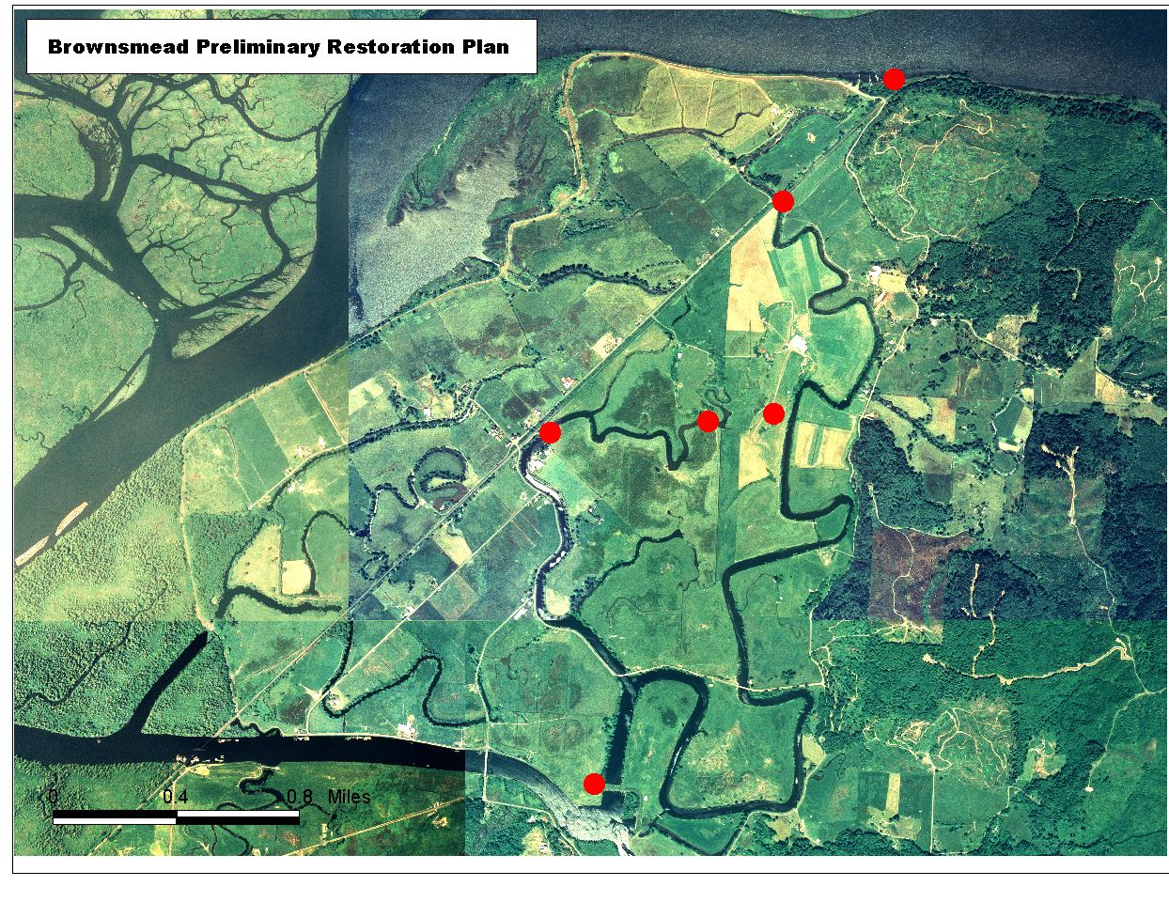
6
5
3
4
2
1
7

Objective 3: Establish one year pre-project implementation monitoring and four year continuous post project effectiveness monitoring program measuring both water quality changes and anadromous fish use of Blind Slough.

Methods
Objective 3 tests assumptions associated with hydrologic alteration of tidal areas. These assumptions are stated in the context of an experimental design process stating monitoring objectives in terms of two (2) hypotheses.

Hypothesis #1-Water Quality: Increasing the intensity and extent of tidal exchange in Blind Slough will enhance and/or modify water quality in three parameters: Temperature, Dissolved Oxygen, Salinity.

Tasks-Hypothesis #1-Water Quality

Task 3.1a CREST staff working with the Oregon Department of Environmental Quality, the Nicolai-Wickiup Watershed Council, and the LCREP Science Workgroup, will develop a water quality monitoring plan determining monitoring site locations, data gathering strategy, methods, QA/QC, as well as data storage and dissemination.

Task 3.1b Starting in Summer 2002, set up three (3) water quality monitoring stations adjacent to representative project construction areas in Blind Slough area using multiple-parameter continuous monitoring devices measuring daily fluctuations in temperature, salinity, and dissolved oxygen.

Proposed areas include:

Site #3 – Long Island Dairy
Site #4 – Leino Lane culvert replacement
Site #6 - Blind Slough dike crossing

Task 3.1c From May 2002-May 2003 download water quality data quarterly to characterize Blind Slough pre-construction temperature, salinity, and dissolved oxygen trends for three monitoring locations.

Task 3.1d From Summer 2003-Summer 2007 monitor post-construction water quality changes in Blind Slough temperature, salinity, and dissolved oxygen.

Task 3.1e Compile data at CREST for future analysis and reporting.

Hypothesis #2-Fish Use: Increasing the level of connectivity between Blind Slough’s channel network and the Columbia River Estuary raises the probability of anadromous fish use for rearing, foraging, and spawning.

Tasks-Hypothesis #2-Fish Use

Task 3.2a Recruiting input from ODFW and LCREP Science Work Group develop a fish monitoring plan outlining field protocols, site locations, and permit requirements for three (3) sites in Blind Slough area. Include at least one site at the Anderson creek area to specifically assess spawning habitat.

Task 3.2b From Summer 2002-Summer 2003 use seining capture techniques once/quarter at each monitoring site location to assess pre-construction fish presence and composition in Blind Slough.

Task 3.2c From Summer 2003-Summer 2007 replicate post-construction fish presence and composition at three (3) sites, 2x each quarter in Blind Slough area, including Anderson Creek area.

Task 3.3d Compile data at CREST for future analysis and reporting.

g. Facilities and equipment
Project uses resources and equipment under Section 1135 authority of the Portland District Army Corps of Engineers. CREST, the project’s sponsor, will contribute office supplies, computers, GIS and AutoCad assistance, and water quality monitoring experience. Project proposal includes the purchase of fish survey equipment, three (3) YSI multiple parameter continuous monitoring devices, and handheld data downloading device.

h. References
Reference (include web address if available online) | Submitted w/form (y/n)
Beamish, F.W.H. Swimming capacity. In W.S. Hoar and D.J. Randall, (editors), Fish Physiology, Academic Press, New York, 1978 | N
Bottom, Dan. et. al. Salmon at Rivers End: The Role of the Estuary in the Decline and Recovery of Columbia River Salmon, National Marine Fisheries Service, January 2001 | N
Columbia River Estuary Study Task Force, Lower Columbia River Estuary Program, Army Corps of Engineers and American Rivers. Draft Habitat Criteria Summary/Workshop Outcomes, Lower Columbia River. 2001 | N
Columbia River Estuary Study Taskforce & Lower Columbia River Estuary Program. Habitat Restoration Site Inventory. 2001 | N
E&S Environmental Chemistry, Inc. Nicolai-Wickiup Bay Watershed Assessment. 2000 | N
Healey, M.C. Juvenile Pacific salmon in estuaries: the life support system, 1982 | N
Levy, D.A. and Northcote, T.G. Juvenile salmon residency in a marsh area of the Fraser River estuary. Can. J. Fish. Aquat. Sci. 39:270-276. 1982 | N
Thomas, D. Changes in Columbia River Estuary Habitat Types Over the Past Century. Columbia River Data Development Program. 1983 | N

Section 10 of 10. Key personnel

U.S. Army Corps Staff at the Portland District will implement the project through Section 1135 restoration program. Key contacts are John Todd and Geoff Dorsey who both have extensive experience managing and constructing Corps authorized environmental restoration projects.

Matthew Van Ess, Executive Director, and Allan Whiting, Wetlands Coordinator, of the Columbia River Estuary Study Taskforce will oversee and coordinate project planning and implementation and conduct the effectiveness monitoring program. CREST is a bi-state Council of Local Governments that has conducted research and natural resource planning in the Columbia River Estuary since 1974. Both Allan Whiting and Matthew Van Ess have experience in working with local community groups to implement restoration and monitoring projects.

Ed Johnson and Dirk Rohne of Clatsop Diking Improvement Company # 7 are key community liasons, project sponsors, and will oversee and maintain all portions of the project on the ground. Ed Johnson and Dirk Rohne have combined experience of over 30 years in agriculture and with the local diking district in Brownsmead.

Resumes and current contact information for Corps staff John Todd and Geoff Dorsey, Matthew Van Ess and Allan Whiting of CREST, and Ed Johnson and Dirk Rohne of Clatsop Diking Improvement Company # 7 are included below.

John Todd, P.E.
Civil Engineer, Portland District, U.S. Army Corps of Engineers
CENWP-EC-DC
PO Box 2946
Portland, Oregon 97208-2946
(503) 808-4915 john.d.todd@ usace.army.mil

Graduate of University of Portland, 1978
B.S in Civil Engineering
P.E. license July 1983

Employed by the Portland District, Corps of Engineers since November 1984. Technical lead for various Section 1135 environmental Restoration projects (Fox Creek and Richardson Park), and have worked as Civil Engineer on other various Environmental Restoration projects (Salmon Creek, Section 206; Dorena Lake Marsh Restoration, Section 1135; and Gross Creek Restoration, Section 206).

Technical Lead and Civil Engineer for Brownsmead - Section 1135, Planning & Design Analysis (PDA) project. Technical Lead is responsible for overall coordination of the project and ensuring the objectives and tasks are completed. These tasks will include Surveys, Hydraulics & Hydrology Studies, Civil & Structural Studies, Economic Studies, Environmental Assessment Preparation, HTRW Assessment, Real Estate Plan (LERRD’s & draft PCA), Baseline & Government Cost Estimates, Preparation of Plans & Specifications, Technical Reviews and Certifications, Advertise/Award/ and Construction. As Civil Engineer will be responsible for the Civil Studies (plan formulation, quantities, and report preparation), and Preparation of Plans & Specifications.

Geoffrey L. Dorsey
Wildlife Biologist, Portland District, U.S. Army Corps of Engineers
CENWP-PM-E
PO Box 2946
Portland, Oregon 97208-2946
(503) 808-4769 geoffrey.l.dorsey@ usace.army.mil

B.S. 1977 Wildlife Science, Oregon State University
M.S. 1982 Wildlife Science, Oregon State University

Employed by the Portland District, Corps of Engineers from April 1981 to present. Provide technical assistance on design, habitat development and construction methodologies for various Section 1135 and Section 206 Environmental Restoration projects (Fox Creek Stream Restoration, Fern Ridge Waterfowl Impoundments and Marsh Restoration efforts, Trestle Bay Restoration (estuarine), Coos Bay North Spit Western Snowy Plover Habitat Restoration, Gross Creek Stream Restoration, Salmon Creek Restoration (riparian forest and wetland habitat), Dorena Lake Marsh Restoration). Responsible for preparation of biological assessment addressing wildlife, plant and insect species potentially impacted by Columbia River Channel Improvement Project (CRCIP). Responsible for preparation, in concert with multiple-agency team, of the wildlife mitigation plan. Responsible for producing sections of the Environmental Impact Statement addressing wildlife resources in the project area plus potential CRCIP impacts to these resources. Typical duties revolve around development of restoration project objectives, development of NEPA/ESA documentation, habitat restoration measures and means of implementation, and coordination with resource agencies. Similar duties are conducted for more typical Corps projects.

Matthew Van Ess
938 Kensington Avenue
Astoria, Oregon 97103
(503) 325-0435
mvaness@columbiaestuary.org

Education
University of Oregon, Eugene, Oregon 1996-1998
Master of Community and Regional Planning - Graduate Teaching Fellow
Coastal zone management focus with research in estuarine and marine protected areas.

Towson University, Towson, Maryland 1988-1993
Bachelor of Science: Geography and Environmental Planning
Concentration in natural sciences, physical geography, and Geographic Information Systems.

Experience
Columbia River Estuary Study Taskforce, Astoria, Oregon 1998-Present
Executive Director - Coastal Estuarine Planner
As Executive Director oversee CREST project management and budget as well as provide estuary impact assessment and natural resource planning support to local governments, watershed groups, and port districts surrounding the Columbia River Estuary in Oregon and Washington. Projects: Columbia River Channel Deepening EIS review and comment, Columbia River Estuary Goal 17 Coastal Shorelands Inventory, Clatsop County Rural Community Plans, Wahkiakum County Shoreline Management Program planning, City of Seaside local wetland inventory mapping, Port of Astoria and Port of Ilwaco sediment sampling and permitting, watershed mapping and action plan development.

Division of Environment and Conservation, Apia, Western Samoa 1998
Conservation Area Planner, Micronesia and South Pacific Program
Worked with local community, Samoa Division of Environment and Conservation, and South Pacific Regional Environment Programme to update management plan for O’Le Pupu Pu’e National Park.

Bureau of Lands and Surveys, Koror, Republic of Palau 1997
Technical Assistant, Micronesia and South Pacific Program
Palau Automated Lands and Resources Information System project combined aerial photography, parcel maps, land records, soils, and natural resource data to support national environmental planning.

Coastal Management Program, Pago Pago, American Samoa 1996
Coastal Planner, Micronesia and South Pacific Program
Initiated Tutuila Island coastal hazards assessment project by organizing GIS data layers of landslide potential, flood zones, wetlands, mangroves, and zoning for hazards planning and mitigation.

Seminole Environmental, Silverton, Oregon 1996
Restoration Assistant - Winchester Tidelands Restoration Project
Project restored 12 acres of diked farmland to tidal wetlands in the Coos Estuary.

South Slough Estuarine Research Reserve, Charleston, Oregon 1995
Research Intern
Set up desktop GIS to organize information about the Reserve by importing existing digital information and creating estuary shoreline, tidal channels, wetlands, and seagrass baseline data layers, using aerial photography interpretation and GPS field surveys.
Fieldwork: 1995 and 1996 NOAA MacArthur research cruises, fish habitat assessments and stream characterization, water quality monitoring, bathymetric surveys, and wetland restoration.

GIS Specialist 1992-1995
Consultant for several consulting firms, projects included parcel databases and land use change.

Allan H. Whiting
1091 Irving Avenue
Astoria, OR 97103
503.325.0435
awhiting@columbiaestuary.org

EDUCATION
M.C.R.P. Community and Regional Planning, University of Oregon, Eugene, OR

B.A. International Relations-Political Science and Latin American Studies, Beloit College, Beloit, WI 1992

EXPERIENCE
Wetlands Coordinator, Columbia River Estuary Study Taskforce (March 2001-present)
Prioritizing wetland restoration projects and effectiveness monitoring for tidally influenced wetlands of the Columbia Estuary. Project entailed project scoping, development, fundraising, and community outreach to multiple interests of the Lower Columbia River and Estuary.

Project Manager, Oregon Department of Environmental Quality (May 2000-March 2001) Worked with growing rural community in identifying and prioritizing watershed health related issues including water quality, flood management, and wetlands. Collaborated with local leaders to generate community based solutions to problems through the development of partnerships and leveraging of financial resources.

McKenzie, Long Tom, South Santiam, and N. Umpqua Watersheds (1998-2001)
Designed a GIS-based database inventorying channel modification activities of the S. Santiam Watershed. Created a geo-referenced database for water quality monitoring program of the McKenzie Watershed. Authored a grant piloting a GIS database targeting ecological restoration and land acquisition opportunities for the McKenzie Watershed Council and local land trust organization. Authored a comprehensive Watershed Assessment describing historical and current conditions of a 6th field watershed. Received certification in Army Corps of Engineers wetland delineation protocols.

Project Manager, Applegate Watershed Council (1998-1999)
Lead a multiple party effort designing a collaborative process for local community members and national environmental groups. Organized three workshops identifying needs, concerns, and goals for action plan development. Outcome lead to the drafting of a monitoring framework for Applegate community.

Land Use Consultant, Community Planning Workshop, University of Oregon (Jan.-June 1998)
Worked with a graduate student team assessing redevelopment potential of former timber mill. Outcome included a formal feasibility analysis for the development of a Recreational Vehicle facility.
Rural Community Educator, U.S. Peace Corps Volunteer (1994-1996), Costa Rica, Central America
Worked for 2 years in a land-resettlement community addressing educational and infrastructural needs. Designed and implemented pre-school and environmental education programs for two primary schools. Developed curricula for adults in non-formal education environment that included a parenting class and exercises in pesticide safety. Created and organized a woman’s group whose projects included a small business and construction of a women’s center.
Ed Johnson
94436 Mustonen Rd
Brownsmead, Oregon 97103
Phone: (503) 458-6398
Email: yinni@pacifier.com

QUALIFICATIONS
Resident of Brownsmead for 26 years.
Director of Diking Improvement Co. for 24 years.
Applied for and received an OWEB grant and LCREP grant to implement water quality improvements in the Blind Slough system in 1999.

EDUCATION
1963 B.S. Animal Husbandry, University California Davis

EMPLOYMENT
4/76- 12/01 Sheep Farmer
Manager Knappa Water Association
Day to day operations. Liaison with state agencies, budgeting, purchasing, long-term planning.

11/74-11/75 Staff research associate, U.C. Cooperative Extension.
Developed and implemented outdoor education programs for children of migrant farmers. Curriculum development, teacher training, site selection, intra-agency coordination.

12/68-12/74 Assistant agriculturalist, U.C. Cooperative Extension.
Advisor to landscape architects, contractors, park superintendents, golf course superintendents, and landscape maintenance personnel in planning and developing plants in the urban landscape with reference to soils and turf grass management. Also responsible for production of agronomic crops, livestock, and plantation grown Christmas trees.

12/66-12/68 Staff research associate, U.C. Cooperative Extension.
Field research to include test plot design, data collection, and statistical analysis with alfalfa, sugar beets, small grains, corn, and sorghum.

9/65-9/66 Manager Warm Springs Hereford Ranch, Romoland, CA
Select animals, maintain records, dry land farm.

3/65-8/65 Foreman King Farms, Ukiah, CA
Develop vineyards, manage pear orchards, irrigated pasture and range sheep operation.

2/63-2/65 First Lieutenant U.S. Army
Rifle platoon leader, weapons platoon leader, company executive officer. Retired as Lieutenant Colonel U.S. Army Reserve, 1991.

Dirk Rohne
43738 Gerttula Lane
Brownsmead, OR 97103
dirkrohne@hotmail.com
(503) 458-6821

Education: Oregon State University
Bachelor of Science, Business minor 1999

Work Experience: Stahlbush Island Farms (Corvallis Oregon) 1997
1,000 acre + crop farm, multiple crops, processing facilities

Evergreen Farms (State College Pennsylvania) 1998
1600 cow Dairy Farm, crop farm

Backenholz Farm (Schleswig-Holstein, Germany) 1999
Organic Dairy Farm, with production of Organic Cheese

Marvin Farm Services (Matamata, New Zealand) 1999-2000
Placement service/ work-experience program
The experience consisted of working/managing farms by working on 5 different farms of varying size and scale

Occupation: Dairy Farmer (Brownsmead, Oregon)
200 acre 180+ cow farm
I purchased the family farm in October of 2000

