Project ID: 30006

Title: Effectiveness monitoring of the Chinook River estuary restoration project

Section 9 of 10. Project description

a. Abstract

Certain estuarine habitat types are recognized as important rearing and staging areas for some salmonid species – especially those that exhibit ocean-type life history patterns. Over the past 150 years, the Columbia River estuary has suffered considerable loss of these critical habitat types due to a variety of development activities. It is possible that restoration of these estuarine habitat types will aid in the recovery of some endangered Columbia River salmon stocks. However, since little is known about the ecological importance of the estuary for Columbia River salmon, current restoration plans in the estuary are based on inferences from studies in other watersheds. Therefore, it is important that any early restoration projects in the Columbia River estuary be carefully monitored in order to evaluate salmon responses to estuary restoration. The Chinook River estuary restoration project offers an excellent opportunity to answer some of the uncertainties regarding estuary restoration and salmon recovery. The project described in this proposal will design and implement a long-term monitoring and evaluation plan to investigate salmon responses to the Chinook River estuary restoration project. We will establish a pre-restoration baseline condition of existing estuary use by juvenile salmon as well as monitor certain habitat attributes. We will continue to monitor these parameters after the restoration project is completed in order complete pre and post project comparative analyses. We will use a variety of capture and marking techniques to determine abundance and length of residency of salmon in the Chinook River estuary. We will also implement a concurrent habitat monitoring component to measure specific habitat attributes by installing 5 data loggers for continuous monitoring of temperature, salinity, dissolved oxygen and tidal stage.

b. Technical and/or scientific background
Overview
The importance of estuaries as rearing environments for some species of Pacific salmon (Oncorhynchus spp.) has been documented in a number of watersheds outside the Columbia River Basin (Aitkin 1998; Cornwall 2001; Levy et al. 1979; Levy and Northcote 1981; Reimers 1973; Simenstad 1996). In contrast, the ecological significance of estuarine habitats for Columbia River salmon is not well understood (Bottom et al. In Review). Nevertheless, many of those charged with the task of recovering endangered salmon in the Columbia River Basin have become interested in assessing and restoring estuarine habitats. The Subbasin Summary for the Columbia River Estuary Province discusses the potential importance of the estuary for endangered salmon stocks that exhibit an ocean-type life history strategy. Evolutionarily Significant Units (ESUs) with this life history pattern include Snake River Fall Chinook Salmon, Upper Willamette River Chinook Salmon, Lower Columbia River Chinook Salmon, and Columbia River Chum Salmon. The summary also recognizes that extensive portions of important estuarine habitats have been lost after a century and a half of diking, filling, dredging and dredged material disposal, jetty construction, and operation of the Columbia River hydropower system. An historical habitat analysis by Thomas (1983) revealed that by 1970 tidal swamps and marshes (habitat types believed important for salmon) retained only 35 percent of their former area. Given the known importance of estuaries to salmon in other watersheds, it is conceivable that this substantial loss of habitat has contributed to the decline of Columbia River salmon stocks that historically exhibited life history patterns with estuary rearing.
The acknowledged degraded state of the Columbia River estuary and a growing appreciation for its potential ecological importance for salmon has led many to conclude that an ecosystem-based recovery strategy should incorporate significant estuary habitat restoration. However, given the level of uncertainty surrounding estuary restoration in the Columbia River, it is important to treat any early projects as experiments in order to quantify the effectiveness of such projects and better direct future recovery actions in the Columbia River estuary.
The project described in this proposal will implement a monitoring plan to evaluate the effectiveness of the Chinook River estuary restoration project to meet its outlined objectives.
Chinook River Estuary Restoration Project
Located at River Kilometer (RKm) 9.3, the Chinook River is the western most salmon-bearing tributary to flow into the Columbia River. It drains a relatively small watershed that encompasses 8,000 acres (12.5 square miles). One of the watershed’s most prominent features is the size of its historic estuary. Prior to development, the Chinook River estuary was characterized by a 1,500-acre expanse of tidal marshes, complex networks of dendritic tidal channels, and peripheral tidal swamps (Figure 1). The estuary probably provided productive habitat for a variety of fish and wildlife - including salmon. The construction of dikes in the late 1800s and the subsequent placement of a causeway and tidegate at the river’s mouth in the 1920s effectively eliminated the tidal energy that shaped and maintained these habitats. The elaborate complexes of sinuous tidal channels were filled and replaced by straight-lined drainage ditches, and the land area was claimed for agricultural uses. The net result was a reduction in the ecological benefit this habitat may have provided for salmon and other endemic organisms.

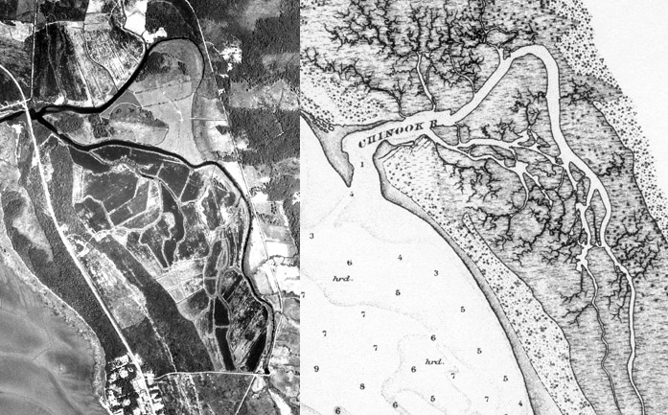
FIGURE 1.—The Chinook River estuary – present-day condition (left), and as surveyed in the 1870s (right).

The restoration project will attempt to restore tidal influence to as much as 1,000 acres of the Chinook River estuary – over 65 percent of its historical area – and restore the estuary’s ecological benefit to the watershed and greater Columbia River estuary. This project is a critical component of Sea Resources’ salmon recovery effort in the Chinook River watershed. Restoring estuary function is identified as a priority project in the Chinook River watershed restoration plan (Dewberry 1997). The plan outlines a whole-basin approach to salmon recovery and emphasizes restoration of impaired natural watershed processes that shape and maintain aquatic and terrestrial habitats necessary for the survival of all freshwater and estuarine life stages of salmon.
The specific objectives of the restoration project are outlined below.
- Increase the abundance and life history diversity of salmon stocks that use the Chinook River estuary as rearing habitat. We believe that the project will benefit salmon that originate both from the Chinook River proper and from other watersheds in the Columbia River Basin. Salmon species that we believe will receive the greatest benefit are chum salmon (O. keta), fall chinook salmon (O. tshawytscha), and coastal cutthroat trout (O. clarki clarki). Coho salmon (O. kisutch) and steelhead trout (O. mykiss) should also benefit from the project.
- Improve water quality conditions in the lower Chinook River. Recent monitoring suggests that during certain times of the year, water quality parameters such as dissolved oxygen and temperature may be limiting salmon use and passage in the lower river. We expect that complete tidal exchange will improve water quality conditions.
- Improve access to the estuary for both juvenile and adult salmon. Removal of the existing tidegate will improve access to the lower river by both juvenile and adult salmon. Early monitoring has shown that, even in its present condition, juvenile salmon from other watersheds use the Chinook River estuary. It is plausible that improving the ecological function of the estuary would aid in recovery of these stocks as well.
- Restore historical plant community structure. Plant community structure is an important habitat attribute that provides cover for juvenile fishes and acts as primary source of organic material for the estuary’s detritus based food web. Existing plant communities are dominated by salt intolerant grass species and a variety of exotic plants.
Restoration actions will include removal of the tidegate at the river’s mouth, filling artificial drainage ditches, reconnecting historic tidal channels to the mainstem Chinook River, and construction of a levy and tidegate system to protect adjacent landowners. The restoration is considered a “passive” action because natural tidal forces will act to recreate and maintain lost habitat. The project is being planned and completed by a broad group of agencies and organizations that are providing a variety of financial and technical support. Primary partners include the Natural Resources Conservation Service, Washington Department of Fish and Wildlife (WFDW), Sea Resources, Ducks Unlimited, Columbia Land Trust, Lower Columbia Fish Recovery Board, and U.S. Fish and Wildlife Service. The National Marine Fisheries Service (NMFS), Columbia River Estuary Study Taskforce, Lower Columbia River Estuary Partnership (LCREP), University of Washington, and others are providing other technical support.
Project engineering is underway and will be completed by early March 2002. Once permitting requirements have been met, construction will commence – probably in the spring of 2003. Engineering tasks include hydrologic and hydrodynamic modeling to predict the extent of tidal influence and to determine the placement of water control structures needed to protect adjacent landowners. We anticipate that the results of the engineering study will also determine the feasibility of additional land acquisition contiguous with the project area.
The project outlined in this proposal will support the continued development and implementation of a long-term monitoring plan designed to evaluate the effectiveness of the Chinook River estuary restoration project. We will measure appropriate parameters to track progress towards achieving the objectives listed above. Monitoring results will also allow the application of adaptive management strategies if certain objectives are not being met. We believe that this work will also contribute significantly to the existing body of knowledge regarding salmon response to estuary restoration. It provides one of the first real opportunities to test the hypothesis that estuary restoration increases the survival and therefore abundance of salmon stocks that utilize estuary habitat for rearing.
We believe our proposed monitoring work will complement other related research efforts in the estuary (NMFS, University of Washington, etc) because it expands the overall sampling effort and begins to investigate salmon responses to restoration. Year round monitoring of juvenile salmonid use and concurrent monitoring of important habitat attributes, such as water quality, is critical in understanding both habitat and fish response to habitat restoration.
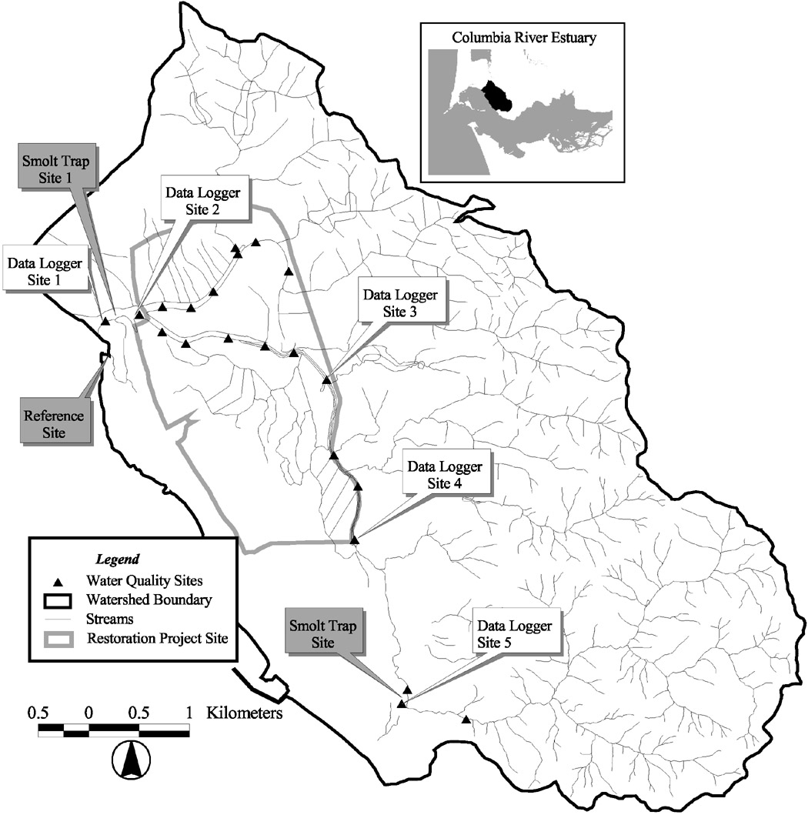
FIGURE 2.—Chinook River watershed showing monitoring sites, smolt trap locations, reference site, and restoration project area.

Preliminary Monitoring

Salmonid Life History
In February 2000, we installed two rotary screw smolt traps to investigate migration patterns and natural production levels of salmon populations in the Chinook River watershed (Figure 2). One trap was located at the river’s mouth, just below the tidegate, and the second was located at Sea Resources facilities at approximately RKm 6.2. During 2000, the lower trap ran weekdays through September, and only total catch, length, and species information was gathered. The trapping effort provided an insight into the timing and magnitude of emigration for all five salmonid species existing in the Chinook River as well as documenting use of the Lower Chinook River by juvenile salmon from outside the watershed. In 2001, trapping effort was increased to seven days a week and trap efficiencies were calculated at both traps in order to determine estimates of out-migrating juvenile salmon. Monitoring in 2001 also documented the use of the lower Chinook River by out-of-basin juvenile salmon, though their exact origin is unknown.
In 2001, we also initiated a broader monitoring to describe existing life history patterns among salmon species in the Chinook River watershed. The intent of this work was to document existing pre-restoration life history diversity and overall abundance of natural and hatchery salmon. This information would then be used in future post-project comparative analyses.
Sampling was expanded to include seining in the lower river and hook and line sampling in the middle and upper reaches. Marking and tagging objectives were met by using Passive Integrated Transponder (PIT) tags and MicroJECT needless dye injectors. Smolt traps were also used as a means to capture, mark, and PIT tag fish. Table 1 shows a summary of marking and tagging activity during 2001. In 2001, we also initiated a mass-marking program in the hatchery in order to differentiate natural vs. hatchery salmon encountered in our sampling efforts.

TABLE 1.—Chinook River life history monitoring marking summary – February, 2001 through October 2000.
Species |  | Dye mark only | PIT tag |  |  |  | Coded wire tag | PIT tag/dye mark
 |  | Dye mark only | NMFS | Recaps | SR | Recaps | Coded wire tag | PIT tag/dye mark
Chinook salmon  O. tshawytscha | Hatchery | 107 | 2888 | 27* | 102 | 14 | ~30,000 | 2
Chinook salmon  O. tshawytscha | Natural | 25 |  |  | 46 | 11 |  | 5
Coho salmon  O. kisutch | Hatchery | 199 |  |  | 50 | 10 |  | 3
Coho salmon  O. kisutch | Natural | 164 |  |  | 293 | 28 |  | 171
Chum salmon  O. keta |  | 9
Cutthroat trout  O. clarki clarki |  | 13 |  |  | 106 | 22 |  | 31
Steelhead trout  O. mykiss |  | 5 |  |  | 25 | 6 |  | 4
Total |  | 522 | 2888 | 27 | 622 | 91 |  | 216
*This is a preliminary value as not all PIT tag detector files have been input into the database.

Water Quality
In 2001, we integrated the water quality component to our monitoring program designed to characterize the gradient of water quality conditions from the mouth upstream to RK 7 (Figure 2). Monitoring was performed weekly from April through October, and twice monthly the rest of the year. Using hand held YSI digital meters, we measured a variety of water quality parameters including, dissolved oxygen, temperature, salinity, pH, and turbidity. While this effort provided a rough characterization of water quality conditions and comparative analysis over the course of the year, it did not provide information about changing conditions through to course of a day’s tidal cycles. This information would be especially critical in the lower 2 – 3 kilometers of the river, where we expect the greatest change in salinity and tidal prism after restoration actions are completed.

Plant Community Composition
In 2000 and 2001, Sea Resources participated in the Lower Columbia River Estuary Partnership’s high-resolution hyperspectral mapping project. The objective of the project was to characterize estuarine habitats in the Columbia River estuary. The Chinook River estuary was one of three focus areas and Sea Resources staff and volunteers preformed all ground truthing activities at 13 sites in 2000, and 8 sites in 2001. This project provides a very detailed description of current pre-restoration plant community structure. Post restoration repetitions of this assessment process will allow us to perform very precise and detailed change analyses.
Lower Columbia River Chum Salmon Recovery Program
Sea Resources has been cooperating with WDFW to reestablish a viable population of chum salmon in the Chinook River. In March 1999, NMFS listed Lower Columbia chum salmon under the Endangered Species Act. Currently, only two population centers of Lower Columbia chum salmon exist – the Grays River stock and the Hamilton and Hardy Creek stock. The objective of the chum salmon recovery program is to reestablish stable populations of chum salmon in additional watersheds in order to reduce the risk of extinction in the short-term, and to achieve complete recovery of the stock in the long-term. Wild Grays River chum salmon are the brood stock used for this reintroduction effort. The eggs are fertilized using a factorial spawning design and incubated at the WDFW Grays River hatchery. Incubating eggs are thermally marked and reared to the fry stage when they are transported to the Sea Resources hatchery. They are then reared for several weeks until they reach the smolt stage when they are released into the Chinook River. The spring of 2002 will be the third year of this reintroduction program. Chum salmon releases were as follows: 1999 brood year - 68,820; 2000 brood year - 74,512; and 2001 brood year we expect roughly 100,000. Grays River chum will be delivered for nine more years – for a total of twelve years (three generations).
Habitat degradation is considered the primary cause for the stock’s endangered status. Any artificial reintroduction and supplementation efforts such as this will require the concurrent restoration of adequate spawning and rearing habitat. Chum salmon are one species dependent upon estuary rearing habitats; therefore, restoration of the estuary is a key component of the recovery effort.
Columbia River Avian predation study
While this project has only a tangential relationship with our restoration and monitoring effort, it does allow us to PIT tag large numbers of both hatchery and natural Chinook River salmon. In 2001 we tagged 3,000 hatchery chinook smolts and in 2002 we expect to implant PIT tags into 3,000 hatchery reared coho salmon smolts, 3,000 natural coho salmon smolts, and 3,000 hatchery reared fall chinook salmon smolts. This work will allow us to track individual fish from smolt to adult and possibly determine differential survival benefits for a variety of life history strategies.
c. Rationale and significance to Regional Programs
Fish and Wildlife Program
Vision for the Columbia River Basin
The underlying vision of the Northwest Power Planning Council (Council) is to restore and maintain an ecosystem that supports an abundant, productive, and diverse community of fish and wildlife by mitigating for the effects of the hydrosystem. The program emphasizes the restoration and protection of natural ecological functions, habitats, and biological diversity in the Columbia River Basin. To achieve this vision, the Council adopted a policy that management “actions must be taken in an adaptive, experimental manner…This includes using experimental designs…and integrating monitoring and research with those management actions to evaluate their effects on the ecosystem.”
Strategies
Habitat Strategies include the protection and restoration of mainstem habitat conditions as a “critical piece of this habitat-based program.” The Council also believes that “the choice of which approach to use is best left to a local, site-specific decision, subject to scientific review”. Sea Resources is a community-based watershed restoration and education organization. We make every attempt to be consistent with the most current scientific thinking available regarding our efforts by maintaining awareness of similar ongoing projects, and consulting with our Science Advisory Committee regarding the strategies we employ to meet our restoration objectives. Members of this committee include Dan Bottom (NMFS), Charley Dewberry (Ecotrust), Jim Lichatowich (Alder Fork Consulting) and Charles Simenstad (University of Washington).
The program’s Habitat Strategies also addresses the need to include the estuary in its restoration analysis, and that improvements to the estuary may benefit most anadromous salmonids. Given its location near the mouth of the Columbia, all salmon produced in basin will have the opportunity to access the Chinook River estuary for rearing.
We believe this project meets the standard outlined for monitoring and evaluation in that the restoration project has measurable, quantitative biological objectives (see methods section below) and that our monitoring will collect data that are appropriate for measuring the biological outcomes identified in the objectives. The data will be available in electronic format, and our methods will be available for approval by the Council.
2000 FCRPS Biological Opinion
RPA Section 9.4.2.8 Research, Monitoring, and Evaluation Plan
Action 9: This action concerns the development of a Research, Monitoring, and Evaluation Plan. Monitoring, and evaluation data resulting from this project will help resolve some uncertainties related the present use of estuarine habitats by salmon and population responses to estuary restoration.
9.6.2.1 Actions Related to Tributary Habitat
Action 157: This action stresses the need to improve Lower Columbia River chum salmon habitat. The restoration of the Chinook River estuary will improve passage for returning adult chum salmon as well as improve rearing conditions for juvenile chum salmon. The restored habitat will be accessible to juveniles originating from both the Chinook River and other upriver sources. The monitoring effort described in this proposal will also provide information regarding use of restored estuarine habitats by juvenile chum salmon.
9.6.2.2 Actions Related to Estuarine Habitat
The Federal agencies support actions described in the Lower Columbia River Estuary Program’s (LCREP) Comprehensive Conservation and Management Plan (CCMP) that work to protect and restore salmon. The restoration and monitoring work described in this proposal are consistent with the LCREP CCMP actions outlined below.
LCREP CCMP Action 2: Protect, conserve, and enhance identified habitats, particularly wetlands, on the mainstem of the lower Columbia River.
Reclaim habitat by selectively using tools such as seasonally managing or breaching dikes, augmenting inadequate stream flows, decompacting wetland soil, lowering surface elevations of mainstream reservoirs, modifying dam operations, re-establishing sustained peak flows, installing fish-friendly tide gates, not disposing of dredge sediment in streams, restoring riparian floodplain connections, and removing or modifying structures that prevent natural flows.
LCREP CCMP Action 5: Restore 3,000 acres of tidal wetlands along the lower 46 river miles to return tidal wetlands to 50 percent of the 1948 level.
LCREP CMMP Action 6: Monitor the effectiveness of habitat protection, restoration, and mitigation projects
Action 158: This action describes the importance of understanding the connection between habitat attributes in the estuary and rearing salmon. This project will measure several habitat parameters and document changes in the parameters after restoration actions are completed. We will measure juvenile salmon use patterns in the estuary (of both hatchery and natural origin), variability in salinity, temperature, water depth (tidal stage), pH, and dissolved oxygen.
Action 159: This action will develop a plan for addressing specific estuary habitat needs of salmon. This project will investigate current use of estuarine habitats by juvenile salmon and seek to establish habitat/life history relationships.
Action 162: The action calls for the development of a conceptual model that describes the relationship between salmon populations and estuary habitat conditions. Our work could contribute to this effort as it seeks to provide similar information, especially as it relates to salmon populations in the Chinook River watershed.
Chinook River Sub-Basin Stock Summary and Habitat Priorities (Washington State Limiting Factors Analysis)
This document prioritizes factors limiting salmon abundance and potential restoration and preservation needs in the Chinook River watershed. It places a high priority on removal or replacement of the tidegate system at the river’s mouth and the subsequent restoration of the estuary. The analysis states that restoration of the Chinook River estuary will improve fish passage, decrease the likelihood of thermal and dissolved oxygen barriers, and increase floodplain connectivity. The analysis also identifies the need to determine how juvenile salmonids from the Chinook River and other Columbia Basin watersheds use the estuary to better target restoration efforts. A medium priority action also identified is to increase water quality monitoring in the Chinook River watershed to provide better guidance for restoration efforts.
d. Relationships to other projects
Estuarine Habitat and Juvenile Salmon – Current and Historic Linkages in the Lower Columbia River and Estuary, NMFS and U.S. Army Corps of Engineers.
In 2000, the National Marine Fisheries Service (NMFS), U.S. Army Corps of Engineers, University of Washington, Oregon Department of Fish and Wildlife, and the Oregon Graduate Institute initiated a study to understand historic and present-day ecological links between juvenile salmon and estuarine habitats in the Columbia River. This project will compliment this work by expanding the spatial extent of sampling and by investigating salmon population response to restoration work.
Lower Columbia Chum Salmon Reintroduction Program, WDFW
Described above, Sea Resources is cooperating with WDFW to reintroduce Lower Columbia chum salmon into the Chinook River. This proposal will monitor use of the lower Chinook River by juvenile chum salmon and the success of the reintroduction effort.
e. Project history (for ongoing projects)
not applicable
f. Proposal objectives, tasks and methods
Objective 1. Determine relative abundance and length of residence of both hatchery reared and naturally produced juvenile salmonids in the Chinook River estuary prior to and after restoration actions.
The information collected to meet this objective is intended to describe existing juvenile salmonid use of the Chinook River estuary and an adjacent reference site in Baker Bay. PIT tagging will also allow the possibility to begin inferring life history/habitat relationships and survival benefits of different life history strategies.
Task 1.a. Mark all hatchery-reared salmon.
Unique external marks will be applied to all hatchery reared smolts (except chum salmon) in order to differentiate between Sea Resources hatchery salmon and salmon originating from other hatcheries.
Methods
All hatchery salmon will be marked according to the follow schedule:
- All hatchery coho salmon will receive an adipose fin clip and freeze brand.
- All hatchery fall chinook salmon will receive a coded-wire tag (WDFW), adipose fin clip, and freeze brand.
- All hatchery chum salmon will be thermally marked.
Both hatchery and natural juvenile salmon will receive PIT tags according to the schedule shown in Table 2.

TABLE 2.—PIT tagging schedule.
Species |  | Year
 |  | 2002 | 2003 | 2004 | 2005
Chinook salmon  O. tshawytscha | Hatchery | 3,000 | 500 | 500 | 500
Chinook salmon  O. tshawytscha | Natural | 3,000 | 500 | 500 | 500
Coho salmon  O. kisutch | Hatchery | 3,000 | 500 | 500 | 500
Coho salmon  O. kisutch | Natural | 200 | 500 | 500 | 500
Cutthroat trout  O. clarki clarki |  | 500 | 500 | 500 | 500
Totals |  | 9,700* | 2,500 | 2,500 | 2,500
*9,000 of these tags are supplied as part of the NMFS avian predation study.

Task 1.b. Capture, mark, tag, and collect scale samples from juvenile salmonids according to pre-determined year-round schedule.
Methods
All captured fish, regardless of capture method, will be anesthetized in MS-222, identified to species, closely examined for any external marks, scanned with portable PIT tag detector, measured (fork length), and have scale samples taken. A sub-sample of each species/size class greater than 55 mm will also receive PIT tags (Table 2).
In addition to the above processing, fish caught in the lower river smolt trap will also receive a lower lobe caudal clip and then released 300 meters up river for efficiency calculations. At least 25 fish of each species/size class will be marked daily and efficiencies will be pooled for weekly estimates of total migrants.
All fish captured in seining and trap netting efforts will be processed as described above and receive a dye mark unique to the week sampled. Dye marking will be achieved by injecting a dye formulation into the fin rays of fish using a MicroJECT needless dye injector. A dye-marking schedule will be developed varying fin and dye color combinations per week of sampling.
- Lower river sampling will be accomplished by using a 150’ x 10’ x 3/16” pull seine. Sampling will occur weekly from February through August and twice-monthly during the remainder of the year.
- An 8’ diameter rotary screw smolt trap will be operated at the mouth of the Chinook River to estimate emigration of juvenile salmonids and to capture fish for tagging purposes.
- A double winged fyke net will be used to capture fish at the reference site in Baker Bay. Trapping will occur twice monthly.
- Hook and line sampling will occur in the middle reaches of Chinook River where other capture methods are not practical.
- A 5’ diameter rotary screw smolt trap will be used and Sea Resources facility to capture smolt emigrating from the upper watershed (This trap is also used to evaluate natural production upstream from the hatchery). This trap provides another opportunity to tag/mark naturally produced fish originating from the Chinook River watershed.
Task 1.c. Detect previously PIT tagged and marked fish during continued monitoring at project sites and at rotary screw smolt traps.
Methods
All fish captured, regardless of method, will be examined for existing marks and tags.
Objective 2. Determine origin and life history of juvenile salmonids utilizing the Chinook River estuary.
Task 2.a. Prepare scale samples for analysis
Methods
Scale samples will be prepared either by mounting scales in resin onto microscope slides or by creating impressions in 5 mm acetate. Scales will then be read on a microfiche reader to determine freshwater and estuarine rearing and growth patterns.
Objective 3. Characterize water quality conditions and tidal dynamics in the lower Chinook River and estuary prior to and after restoration actions.
Task 3.a. Maintain and operate data loggers according to year-round schedule.
Methods
Data loggers will be deployed at five sites in the watershed. All five data loggers will measure salinity, dissolved oxygen, pH, and temperature at 30-minute intervals. Two data loggers will also measure tide stage at 30-minute intervals and be fitted with radio telemetry and solar array panels to allow for real time data acquisition. Data from the other data loggers will be downloaded by hand.
Objective 4. Develop a computer database to house all life history information collected through this and past projects.
Task 4.a. Create and maintain a computer database that will contain all data collected during this and other relevant projects.
Methods
Design and build a computer database using Microsoft Access software that houses all life history and habitat attribute data. The database will allow for query, analysis, and distribution of the data resulting from this project.
Objective 4. Complete data analysis on an annual basis.
The results will be released in complete yearly reports due by March 1 of each year. Each report will contain detailed descriptions of methods and outcomes of monitoring activities. Copies will be provided to appropriate management entities as well as placed on Sea Resources’ web site in Adobe Acrobat format.
Task 4.a. Analysis of juvenile salmonid life history data.
Task 4.b. Analysis of water quality data.
Task 4.c. Analysis of juvenile salmonid scale samples.
g. Facilities and equipment
This project will be conducted out of Sea Resources’ facilities in Chinook, WA. All work will be conducted within a 5-mile distance of these facilities. Sea Resources will provide office space and associated administrative assistance and services (i.e., copying, mailing), computer hardware and software for word processing, database management, Internet access, electronic mail, data analysis, and file management. Sea Resources will provide 2 rotary screw smolt traps, MicroJECT needless dye injectors and dyes, a 12’ aluminum boat, 5 hp motor, boating accessories, and vehicles.
The project will require one double winged fyke net, 5 multi-parameter data loggers and necessary maintenance accessories and housings ($32,000), one laptop computer for field downloading dataloggers and PIT tag data ($1,500), two portable PIT tag detectors ($5,200) , 2,500 PIT tags, coded wire tagging ($116 per 1,000), a 150’ x 10’ pull seine with 3/16” mesh, MS-222, and bucket aerators.
Scale sample preparation and analysis will be completed by Sea Resources staff.

h. References
Reference (include web address if available online) | Submitted  w/form (y/n)
Aitkin, J. K. 1998. The importance of estuarine habitats to anadromous salmonids of the Pacific Northwest: a literature review. U. S. Fish and Wildlife Service, Lacey.
Bottom, D. L., C. A. Simenstad, A. M. Baptista, D. A. Jay, J. Burke, K. K. Jones, E. Casillas, and M. H. Schiewe. In Review. Salmon at river’s end: the role of the estuary in the decline and recovery of Columbia River salmon. National Marine Fisheries Service, Seattle. | n
Cornwell, T. J., D. L. Bottom, and K. K. Jones. 2001. Rearing of juvenile salmon in recovering wetlands of the Salmon River Estuary. Oregon Department of Fish and Wildlife, Information Reports 2001-05, Portland. | n
Dewberry, T. C. 1997. Restoring the river: a plan for the Chinook watershed. | n
Levy, D. A., T. G. Northcote and G. J. Birch. 1979. Juvenile salmon utilization of tidal channels in the Fraser River estuary, British Columbia. Westwater Research Centre, The University of British Columbia. Technical Report No. 23. | n
Levy, D. A. and T. G. Northcote. 1981. The distribution and abundance of juvenile salmon in marsh habitats of the Fraser River estuary. Westwater Research Centre, The University of British Columbia. Technical Report No. 25. | n
Reimers, P. E. 1973. The length of residence of juvenile fall chinook salmon in Sixes River, Oregon. Research Reports of the Fish Commission of Oregon 4(2):2-42. | n
Simenstad, C. A. 1996. The relationship of estuarine primary and secondary productivity to salmonid production: bottleneck or window of opportunity? U.S. Dept. Commerce, NOAA Technical Memorandum NMFS-NWFSC-29: Estuarine and Ocean Survival of Northeastern Pacific Salmon. | n
Thomas, D. W. 1983. Changes in the Columbia River estuary habitat types over the past century. Columbia River Estuary Data Development Program. Columbia River Estuary Study Taskforce, Astoria. | n

Section 10 of 10. Key personnel

Robert Warren, Principle Investigator (.5 FTE)
Education
M.S. Environmental Science – Aquatic Ecology, University of Idaho, 1999
B. Arch. University of Idaho, 1993
Current Employment
Executive Director, Sea Resources, Chinook, WA, May 2000 – Present
Current Responsibilities
Administration and oversight of restoration and education programs; implementation of the Chinook River watershed restoration plan; restoration project design, management and coordination; organizational financial management; grant proposal writing; personnel supervision; public speaking and presentations; project proposal development; and participation in delivery of educational program.
Previous Related Employment
- Natural Resource Specialist, Columbia River Estuary Study Taskforce, Astoria, Oregon. September 1998 – May 2000
- Field Technician, Department of Fish and Wildlife, University of Idaho, Moscow, ID, Summer 1997.
  - Project: Lower Snake River Primary Productivity Assessment Project.
- Fisheries Biological Aid, US Forest Service, Potlatch District, Potlatch ID, Summers 1991 & 92
- Fisheries Biological Aid, Idaho Department of Fish and Game, Idaho Falls, ID, Summers 1986-89
Skills
Project proposal development; report writing; project management; field data collection; database management; fish handling and identification; screw trap operation; seining; hook and line sampling; water quality monitoring; GIS analysis; GPS equipment operation; boat operation and maintenance; PIT tagging; dye marking; freeze branding; and fin clipping.
Professional Affiliations and Volunteer Positions
- American Fisheries Society - Oregon Chapter
- Columbia Riverkeeper – Board of Directors
- North Coast Watershed Council Association – Board of Directors
- Salmon for All – Science Team Member
Garth Gale, co-Principal Investigator (.75 FTE)
Education
B.S. in Fisheries Science – Oregon State University, 1997
Current Employment
Fish Biologist, Sea Resources, Chinook, WA, September 1997 – Present
Current Responsibilities
Manages and supervises field monitoring activities; manages Sea Resources artificial production program; employee supervision; restoration and monitoring project design and implementation; and delivery of educational programs.
Skills
Field data collection; database management; fish handling and identification; screw trap maintenance and operation; operation and management of adult weirs and traps; seining; hook and line sampling; PIT tagging; dye marking; freeze branding; fin clipping; an all aspects of artificial production program operation and management.
Professional Affiliations
- American Fisheries Society - Oregon Chapter

