Bonneville Power Administration

FY 2003 Provincial Project Review

PART 2. Narrative
Project ID: 200007900
Title: Assess Resident Fish Stocks Of The Owyhee/Bruneau Basin, D.V.I.R.

Section 9 of 10. Project description

a. Abstract
This is an ongoing project to determine level of hatchery introgression on native redband and genetic purity of bull trout. We are purposing a continuation of this project to assure an accurate and scientifically valid survey of all occupied habitats on the Duck Valley Indian Reservation. Work in 2001/2002 was limited to the East Fork Owyhee River. The watersheds that will be inclusive of this proposal are the Three Forks and Mary’s Creek (Bruneau River Drainage) areas as well as other streams in the East Fork drainage, South Fork drainage, and the Blue Creek drainages and their tributaries.
The Bruneau drainage originates on the DVIR and is a historic area for ESA listed Bull Trout. Bull trout were observed in early 1998 during presence/absence snorkel surveys
In the Mary’s Creek drainage.
As part of a larger project to mitigate for societal and tribal losses associated with the extirpation of anadromous and decline of resident fish resources within the Columbia River basin, the Shoshone-Paiute Tribes are interested in identifying the distribution, species richness, density, relative abundance, and genetic structuring of fish populations in all portions of the Duck Valley Indian Reservation. This research project will provide baseline information on genetic variation within and among populations of native salmonids within the Owyhee and Bruneau River drainage. Also, all native and non-native species will be identified and quantified for further use as a management tool in the basin. Data collected from this research will assist our tribal biologists and managers in determining direction for restoration and enhancement efforts. The usefulness of information gained from this work will be the identification of genetically pure populations from which interior redband trout and bull trout are located so protective measures and enhancement efforts will assure the existence and viability of these populations. The Tribes wishes are to locate these populations to promulgate these species for out-planting to historic areas and to our reservoirs.

b. Technical and/or scientific background

The purpose of this project is to identify the distribution, species richness, density, relative abundance, and genetic composition of fish species in the portion of the upper East Fork Owyhee River and Bruneau River drainage located on the Duck Valley Indian Reservation. This portion of the Owyhee River also is known as the Upper Owyhee watershed, USGS Cataloging Unit 17050104. Results from this study will enable the SPT to develop management plans and identify locations from which interior rainbow trout can be collected for culture purposes and subsequent stocking into Lake Billy Shaw and other waters on the Duck Valley Indian Reservation. Bull trout locations will also be identified and protective and enhancement measure implemented for their protection. Three BPA funded projects that would immediately benefit from this work are Projects 1995015060, 198815600, and 199500600. These projects are described in a subsequent section.

This project is a systematic genetics study of resident fish in the East Fork of the Owyhee River Basin within the Duck Valley Indian Reservation. This project has been envisioned since the 1995 Amendments to the Northwest Power Planning Council’s Fish & Wildlife Program. The project’s outputs will be part of the Shoshone-Paiute Tribes of the DVIR’s contributions to the overall subbasin summary/planning activities for the Owyhee Subbasin. The Council’s Provincial Review Process and Subbasin Planning for the Middle Snake Province is scheduled to begin in July 2002 but might be delayed for several months. This project was envisioned as a three- year project however currently is only funded for one year. The following protocols have been approved by BPA and the NWPPC with data being collected on a small portion of the streams of the DVIR. We purpose to continue work on the remaining streams in the Bruneau and Owyhee subbasins of the DVIR. The project is scheduled for three years but will be modified should work exceed what is planned.

With the information from this study the Tribes will better be able to make an informed decision on where to focus their habitat and enhancement work on the DVIR. The project will aid the Tribes in determining where best to proceed with specific restoration and enhancement efforts, such as improved grazing practices, fencing of streams and headwater springs. We will also know where to limit fishing. In knowing where the genetically “pure” populations of redband trout and bull trout are located we can direct our efforts towards those streams and sub-watershed areas. Along with knowing which streams have these populations, we will be able to determine which streams have large enough populations to take the needed fish for brood stock development in an existing or new hatchery. We can also determine the best areas for possible reintroduction of redband on the DVIR.

Study Objectives
This study will:
- Provide baseline information on genetic variation within and among populations of redband trout within the East Fork Owyhee River and Bruneau River drainage, and
- Assess the extent of hatchery introduced rainbow trout introgression within these populations.
- Provide baseline information on bull trout populations on the DVIR.

Experimental Design
Genetic investigation of East Fork Owyhee River and Bruneau River drainage redband trout populations will be done using non-lethally collected fin tissue samples. Study objectives will be addressed using Restriction Fragment Length Polymorphisms (RFLP) analysis of one nDNA intron gene, RFLP analysis of two mtDNA gene regions, and a screen of six microsatellite loci. Shoshone-Paiute Tribal biologists will collect all necessary samples during the 2001 summer field season. Samples will be stored in lysis buffer or ethanol, and shipped to the laboratory for analysis.

Sample Collection
Non-lethal fin clips will be collected from 10 populations within the East Fork Owyhee River and Bruneau River Drainage. Fin clips will be stored at room temperature in lysis buffer (EDTA 0.5M, 2M Tris, 5M NaCl, SDS 20%, dH₂O) or 95% ethanol prior to genetic analysis.

DNA Extraction-

Mitochondrial DNA and nuclear DNA will be extracted from non-lethally collected fin-clip samples using methods described by Paragamian et al. (1999), adapted from protocols by Sambrook et al. (1989) and Dowling et al. (1990).

CRA Amplification and restriction digestion of Nuclear DNA gene region-
DNA isolated from each sample will be amplified using the Polymerase Chain Reaction (PCR) with primers specific for the Protoncogene 53 (p53) nDNA gene region. Variation in allele frequency at the p53 locus has been observed in rainbow/redband trout populations from the Upper Columbia River drainage and rainbow trout from the Hayspur Hatchery (University of Idaho, unpublished data). Digests will be electrophoresed on 3% agarose gels with tris-acetate-EDTA buffer or 6% acrylamide gels with tris-borate-EDTA, stained with ethidium bromide, and fluoresced under UV-light to visualize alleles.

PCR AAmplification and Restriction Enzyme digestion of mtDNA gene region-
DNA isolated from each sample will be amplified with primers specific for two gene regions of the mitochondrial genome (ND2 and Cyt B) and digested with 10 restriction enzymes (Ava-I, Dde-I, Dpn-II, Hae-III, Hha-I, Hinf-I, Mse-I, Msp-I, Rsa-I and Taq-I). Eight of these restriction enzymes have been used in combination with the ND2 region in previous studies examining introgressive hybridization within redband trout populations (University of Idaho, unpublished data). Digests will be electrophoresed on 3% agarose gels with tris-acetate-EDTA buffer or 6% acrylamide gels with tris-borate-EDTA and visualized as band patterns (fragments) when stained with ethidium bromide and fluoresced under UV-light. The fragment size in base pairs was estimated by comparison to a size standard, a pUC-19 marker (Bio-Synthesis).

Microsatellite Amplification and allele scoring-

Allele frequency variation at six microsatellite loci (Ots-3, Omy-77, Ots-103, Ots-100, Ots-1, and Ots-108a) will be examined on all collected samples. Expected number of alleles observed, allele size range (bp), and PCR conditions are as follows:
(Note all PCRs have an initial 5-cycle 1°C/cycle touchdown, followed by 38 cycles at specified annealing temp., and ended with a 30 min final extension at 72°C):
Primer # alleles allele PCR
Locus repeat size conc. label observed size range (bp) annealing temp.
PCR-1
Ots-3 dinucleotide 0.3 μM ned 6 79-89 50ºC
Omy-77 dinucleotide 0.3 μM hex 20 99-149 50ºC

PCR-2
Ots-103 tetranucleotide 0.2 μM hex 9 59-93 55ºC
Ots-100 tetranucleotide 0.35μM ned 12 165-213 55ºC
PCR-3
Ots-1 dinucleotide 0.2 μM 6-fam 15 163-246 50ºC
PCR-4

Ots-108a tetranucleotide 0.3 μM 6-fam 25 97-269 46ºC

Assessments of genetic subpopulation structure will be made using the statistical genetic computer programs GENEPOP version 1.2 (Raymond and Rousset 1995). Heterozygosity components (H_{I}, H_{s}, H_{R} and H_{T}) calculated from generated allelic frequency data will be used to partition gene diversity within populations (F_{IS}), between populations within regions F_{SR(T)}, among regions (F_{RT}), and overall among populations (F_{ST}). The program GENDIST in the statistical software package PHYLIP (version 3.5c; Felsenstein 1993) will be used to calculate Nei’s (1978) standard distance (D) and Cavalli-Sforza and Edwards’ (1967) chord distance (CSE) for all populations. The neighbor-joining algorithm in the NEIGHBOR program (in PHYLIP) will be used to generate dendograms from these distance matrices. Maximum likelihood distance matrixes and dendograms will be calculated using the program CONTML (PHYLIP). Robustness of tree topologies will be assessed using the programs SEQBOOT and CONSENSE (PHYLIP). Dendrogram diagrams will be created in the programs DRAWTREE and DRAWGRAM (PHYLIP).
Above information is part of ongoing work being implemented in project 2000-079 with the Shoshone-Paiute Tribes and Hagerman Genetics Laboratory.

c. Rationale and significance to Regional Programs

This project will address NWPPC measures 10.8C.2, 10.8C.3, and part of 10.8C.5 of the 1995 Amendments to the Council’s Fish & Wildlife Program.

10.8C.2 Review Duck Valley Indian Reservation surface water and groundwater suitability for resident fish production facilities. Initiate a comprehensive genetic sampling program of the redband trout in Owyhee Basin. Based on results of these studies, develop and implement strategies to protect wild redband trout populations from potential impacts caused by hatchery programs.

10.8C.3 Evaluate alternative sources of catchable and fingerling resident fish.

10.8C.5 Implement, monitor and evaluate resident fish habitat improvement and protection measures at the Duck Valley Indian Reservation. Include the following habitat protection and improvement measures: 1) management recommendations for reservoir pool levels; 2) reservoir rehabilitation measures for non-game fish and aquatic vegetation control; 3) reservoir inlet and outlet screening; 4) improvement of recreational fishing sites; 5) stream riparian zone restoration by planting vegetation, fencing overgrazed areas and stream bank stabilization; and 6) base-line water quality survey to assess contaminants that may affect trout populations.

Owyhee Subbasin Summary (October 2001)

Objective

Expand redband trout genetics study
Strategy 1
Complete data collection on East Fork Owyhee River Tributaries
Strategy 2
Share information with pertinent state, federal, and private agencies
Strategy 3
Work collaboratively with IDFG, NDOW, BLM, USFWS, USFS, to identify data gaps and develop a research and monitoring plan to fill those gaps

Objective
Determine long - term viability of redband meta-populations in the Owyhee and Bruneau and Middle Snake River areas
Strategy 1
Determine priority risks to isolated redband populations in the S. Fork Owyhee River watershed
Strategy 2
Survey and assess condition of redband populations and habitat in the DVIR, lower Blue Creek and North Fork Owyhee River to develop data sets and assessment resources on par with information in other portions of the subbasin
Strategy 3
Determine function of DVIR habitat in maintaining connectivity and overall population viability in upper Owyhee subbasin
Strategy 4
Develop integrated databases and GIS resources that combine data collected in different states and jurisdictions to develop understanding of populations and habitat dynamics across the Owyhee subbasin.

The work proposed is also identified in the Statement of Fish and Wildlife needs:
- Continue to inventory native salmonids in the Owyhee Subbasin to determine current status and major factors limiting their distribution and a abundance, and based on these findings, develop and implement plans and strategies for recovery where populations are at risk of extirpation.
- Use genetic markers to detect and quantify levels of hatchery produced O. mykiss introgression with in native redband trout populations and to delineate genetic population structure of redband throughout their historic range.
- Compare rates of hybridization and introgression between hatchery produced O. mykiss and native populations of redband trout.
12. Survey habitat in the DVIR, the upper North Fork Owyhee, South Fork Owyhee, and in Oregon to determine status of redband and mountain whitefish populations in areas that are currently data gaps.
13. Determine degree of isolation and connectivity between salmonid populations and identify and implement strategies for increasing connectivity.
14. Investigate feasibility and implement if possible, genetic preservation actions for South Fork Owyhee populations of redband trout and other populations identified in risk of local extirpation.
15. Model historic redband population to determine ranges of variability in abundance and distribution within the subbasin.

Bruneau River Subbasin Summary (October 2001)
Same goals and objectives as Owyhee Subbasin Summary (see above)

d. Relationships to other projects

1997-011-00 -- Shoshone-Paiute Habitat Enhancement Project
Data gathered from this genetics study will assist the Tribes in management decisions on where to focus enhancement and protection work. In knowing where the genetically “pure” populations of redband trout are located we can direct our efforts towards those streams and sub-watershed areas.

1995-006-00 -- Shoshone-Paiute/Shoshone-Bannock Joint Culture Facility
This project was scheduled to begin construction in 2001 but the Council did not approve the Step Three Review at it’s April 26, 2001 meeting. Therefore, the Joint Culture Facility will not meet the production needs of Lake Billy Shaw. Alternatives to the Joint Culture Facility could include stocking from another hatchery or use of native fish. See project 1995-015-06.

1995-015-06 Lake Billy Shaw O&M
This dam and reservoir were completed in 1998 with initial filling begun in spring of 1999. The project will soon begin its third year with no fish still in the reservoir. The first five years of a new reservoir are crucial for stocking fish. This is the most productive time of a new reservoir and important for early fish growth. If this reservoir is to be a “trophy” fishery as initially intended, we need to get fish stocked in the waters as soon as possible.

As a result of the Council decision not to continue with the Joint Culture Facility project, a May 3, 2001, teleconference with tribal, state and federal staffs determined that environmental review, fish funds and a co-management agreement were available to stock Lake Billy Shaw with rainbow trout from IDFG hatcheries for one year. In a May 4, 2001, letter, the Council conditionally approved this interim approach. Upon further review from IDFG this option was discontinued. Conditionally the Tribes are stocking sterile rainbow trout in Lake Billy Shaw. A decision on a long-term source of fish for Lake Billy Shaw will be addressed in the Provincial Review process. This decision may include continued stocking from commercial hatcheries or else possible use of native redband trout if results of the genetics project make such an alternative feasible.

f. Proposal objectives, tasks and methods

Project Goal (Overall)

A comprehensive assessment of fish species distribution, richness, density, relative abundance, and genetic composition in the upper East Fork Owyhee River and Bruneau River drainage on the Duck Valley Indian Reservation.

Project Objectives:
Objective 1
Sign and manage a subcontract for genetic analysis with the Laboratory.

Tasks

Task 1-a
Submit a signed copy of the professional services agreement (subcontract) to BPA

Task 1-b
Manage subcontract and coordinate with Lab.

Deliverable:
- Report from the genetics laboratory in hard copy and electronic form containing … (list specifics as contained in subcontract )
- Database spreadsheet in MS-Excel on a floppy, Zip disk or CD-R.
.
Schedule:
- March – May
- BPA Review – May - June

Objective 2
Determine type and location of resident fish in the Owyhee/Bruneau Subbasin portion of the DVIR

Task 2-a
Collect fish samples in 10 streams/year. See map

Crew will collect tissue samples from trout collected in streams identified by biologist. Samples will be collected above and below blockages in streams (i.e.: water falls, log jams, etc). Trout collected from approximately 10 streams and two sites per stream (approx. 30-60 samples per site)

Task 2-b
Collect habitat information (see Appendix)

During collection take photos and conduct baseline habitat information on areas of collection. Fill out EPA habitat characterization forms/or appropriate habitat forms (PFC) one for each stream.

Task 2-c
Submit samples to genetics laboratory as per subcontract for appropriate electrophorectic and/or DNA analysis

Deliverable:
Task 1
30-60 samples per stream for 10 streams.
Task 2
Habitat forms for each stream or sample location for use in analysis and annual report.
Task 3
Samples delivered to genetics lab as per subcontract

Schedule:
Task 2-a June – August
Task 2-b June – August
Task 2-c June – August

Objective 3
Manage data from sample collection, lab analysis, results analysis and organize for reporting.

Tasks

Task 3-a
Enter data from field notes, GPS, laboratory (if lab data needs to be manipulated), EPA-Habitat evaluation forms, if needed, into spreadsheets. Use separate spreadsheet for sampling locations, Barrier locations and Barrier codes, as discussed with StreamNet.

Task 3-b
Format or adapt data spreadsheets from 8-1 and organize for use in analysis or reporting and submittal to BPA, StreamNet or STORET, as appropriate. Include relevant data tables, forms and field notes for use as appendices in the Annual report.

Deliverables:

Task 3-a
GPS coordinates for sampling locations and barriers. Spreadsheets or tables if appropriate for other field or analytical information.
Task 3-b
Adapted spreadsheet data if needed for analysis. Tables and forms for use in the Annual report.

Schedule:
Task 3-a Sept – December
Task 3-b Sept – December

Data sheets are attached. Field data books will also be utilized to record other data or information that may be pertinent once out in the field. Information will then be transferred to database for inclusion in StreamNet or other data management system.

The following was adopted after contact with StreamNet, EPA, and Idaho Fish and Game. These formats are compatible with what is occurring in the Owyhee and Bruneau Subbasin.

Data Exchange Formats (DEF)

- Data collected from sampling will be entered into Tribal database in MS Excel, with non-confidential information being entered into STORET /StreamNet (coordination with B. Butterfield, IDFG StreamNet)
- Data to be entered will included at a minimum: MS Excel to be able to coordinate with Tribes GIS system
-Water quality data (
Temp (degrees Celsius)
O2 (parts per million)
Conductivity (microseimens)
-Habitat data (riparian type, pool, run, riffle, woody debris/jams, width/depth of stream channel, substrate composition, overhead cover, bank stability)
-stream order
-elevation
All habitat information will be collected in meters or metric equivalent.
- Salmonid densities, population size-structure, and number of species sampled will be included in the database
- Genetic composition of salmonids (once received from lab) entered in database
- Latitude and longitude coordinates and elevations entered into database
- Electro-fishing effort will be entered into database

All data collected (biological and habitat) will be sent to StreamNet in either MSAccess or in Excel (pers. Comm. Mike Banach). The information will either be sent in spreadsheet form or will be extracted from Annual report.

Objective 4
Evaluate and analyze data results from genetics laboratory to determine levels of introgression with hatchery salmonids.

Data collected from this study will assure the Tribes ability to determine where there are “pure” redband trout populations present. The amount of genetic differentiation will be estimated using Nei’s (1978) measure of standard genetic distance. Genetic distance will be calculated with the BIOSYS-1 program (Swofford and Sclander 1981). Differences among populations will be examined using GENEPOP (Raymond and Rousset 1981).

This work will be completed using the laboratory contracted.

Assessment of Stock Status
Genetic relationships of Redband trout and bull trout will be assessed for the Duck Valley Indian Reservation through 1) Compilation of baseline/historical electrophoretic/intron analysis data where available, 2) Implementation of baseline genetic inventory using electrophoretic techniques and intron analysis, 3) Compilation and analysis of life history and genetic data.

Tasks

Task 4-a
Document results of genetic data in final report and relate it to other aspects of the study.

Task 4-b
Relate current resident fish composition to abundance and population estimates conducted in previous years and with other information available on species.

Task 4-c
Use data to update subbasin summaries and to develop Subbasin plans for the DVIR and Owyhee Basin.

Deliverable:

Task 4-a & 4-b
Analysis of habitat characteristic data, fish species distribution, richness, density, relative abundance, and genetic composition.
Task 4-c
Recommendations for native species restoration in the Owyhee/Bruneau Subbasin.

Schedule:
Task 4-a December – April
Task 4-b December – April
Task 4-c December – April

Objective 5
Complete annual and project reports required by BPA with possible submission to peer review journal for publication.

Use same approach as in work statements from other SPT projects. Task for annual report. Task for Data submission, property inventory, lessons learned, etc. can be combined with annual submitting Final quarterly addressing Bippy (or contract) requirements.

Tasks
5-a
Submit 6 - month report to BPA with information on status of collections and laboratory information to date on genetic samples.

5-b
Submit Annual (project technical) report to BPA. Hard copy of this report will be sent to COTR. Annual report will contain whatever is required in the contract and the Bonneville Purchasing Instructions such as methodology, lessons learned, etc. The property report for this project will be part of the Annual report, the final quarterly report or a separate submittal due with the Annual.

Upon completion of project a final report will be submitted to BPA. The information gathered from the project will be utilized for future projects and planning on the reservation.

5-c
Submit project database spreadsheets to BPA for eventual upload to BPA server, StreamNet or EPA-STORET. Databases can be on floppy, Zip disk or CD-R or e-mailed to BPA COTR. Data to reside on StreamNet can be uploaded or sent directly to StreamNet.

Schedule:

Task 5-a 180 days after Phase 2 start date. Or specify dates if project start date is fixed.

Task 5-b 60 days of contract end date (specify date if established by this work statement ) or other date approved by BPA COTR.

Task 5-c Databases due to BPA within 60 days after contract end.

Duck Valley Indian Reservation
Stream Inventory
From Which Sampling Locations Will be Selected
Samples streams will depend on fish availability in these streams. 10 streams/year will be selected out of the following.
* denotes work completed in 2001/2002 sampling

Stream Name
Three Forks
Black Canyon Creek
Indian Creek*
Old Man Creek
Papoose Creek*
Miller Creek*
Mud Creek
Bell Creek
Blue Creek
Boyle Creek
Skull Creek*
N. Fork Skull*
Mary;s Creek
Jones Creek*
Cow Creek
Reed Creek*
Fawn Creek*
Summit Creek*
Spring Creek*
Sheep Creek*
Lambs Reservoir
Creek
Circle Creek*
Dry Creek
Billy Shaw Creek
Yatahoney Creek
Mud Flats/Snow
Creek

e. Project history (for ongoing projects)

This project was begun in 2001 with the procurement of a modified contract form Bonneville Power Administration. The project was broke into two phases in order to assure protocols and laboratories were in line with the rest of the Columbia Basin. Sampling began in summer of 2001 with 5 of the 10 streams having fish collected. Due to a low water year the rest of the samples were not collected until spring. The Tribes have submitted monthly reports to BPA on this project and are currently awaiting preliminary results of samples sent to lab in October 2001. Many of the streams are located in the back - country and are not easily accessible, which is why the project is limited to 10-streams/ year.

Streams and Locations of sampling in 2001/2002
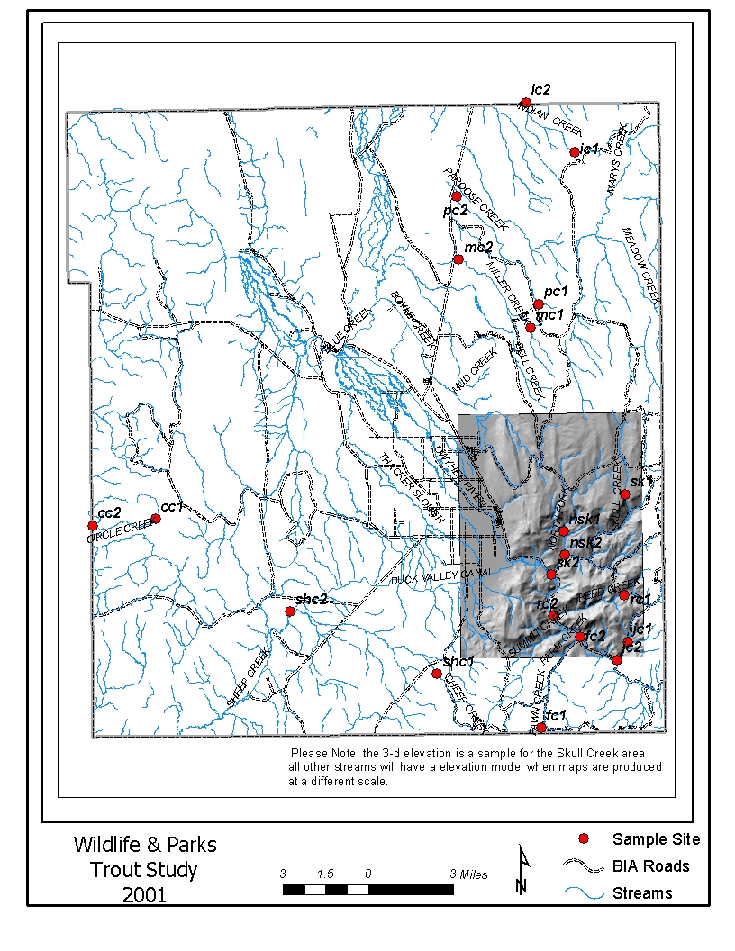
Map of perennial stream locations on DVIR
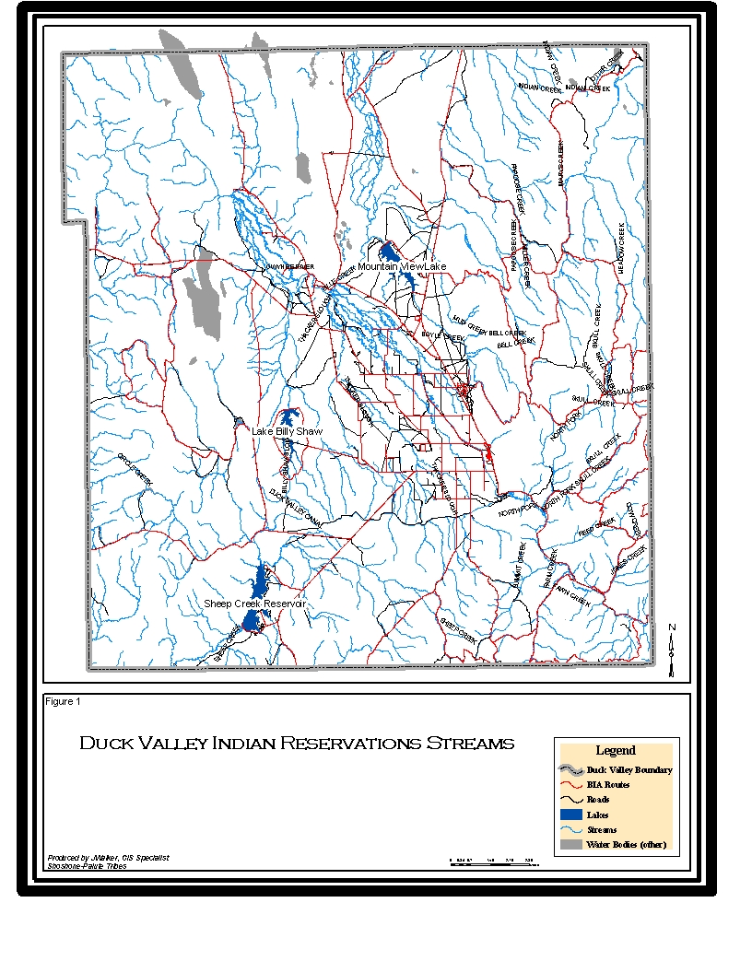

g. Facilities and equipment
The Habitat, Parks, Fish and Game Department of the Shoshone-Paiute Tribes is located on the Duck Valley Reservation and is operated from an office building, near Owyhee Nevada. The building includes office space for the Director, biologists, and secretary. The offices are equipped with computers (including scanner, printer, etc.), a telephone system, inter-net capabilities, and a 2-way communication system with field units. The building also includes a 6,000 sq. ft. shop for storage and maintenance. We currently have two 1997-4X4 pick-up trucks that are being leased through the Habitat Enhancement program as well as two vehicles that are used for our wildlife and parks program. The program has a variety of fisheries & limnological sampling gear, tools for maintenance, and light construction equipment. The facility has a fenced yard with storage tanks for diesel fuel and gasoline.

h. References

Reference (include web address if available online)
Submitted w/form (y/n)

Armour, C.L. 1990. Options for reintroducing salmon and steelhead above mid-Snake River Dams. USFWS, National Ecology Research Center, Fort Collins, Colorado.
n

Behnke, R.J. 1992. Native Trout of Western North America. American Fisheries Society, Monograph 6, Bethesda, Maryland.
n

BPA. 1997. Billy Shaw Dam and Reservoir -- Environmental Assessment and finding of no significant impacts. DOE/EA--1167.
n

Bureau of Reclamation. 1988. Review of the potential for constructing a fishing reservoir, Duck Valley Indian Reservation, Idaho-Nevada. Report to the Power Planning Council.
n

Burge, H.L. and W.H. Miller. 1990. Fishery Management Plan for the Duck Valley Indian Reservation -- Shoshone-Paiute Tribe. USFWS Report, October, 1990
n

Burge, H.L. and W.H. Miller. 1991. Fishery Management on the Duck Valley Indian Reservation -- Shoshone-Paiute Tribes. USFWS 1991 Annual Report, December 1991.
n

Burge, H.L. and W.H. Miller. 1993a. Fishery Management on the Duck Valley Indian Reservation -- Shoshone-Paiute Tribes. USFWS 1993 Annual Report, December 1993.
n

Burge, H.L. and W.H. Miller. 1993b. Fishery Management on the Duck Valley Indian Reservation -- Shoshone-Paiute Tribes. USFWS 1992 Annual Report, January 1993.
n

Cavalli-Sforza L.L. and Edwards, A.W.F. 1967. Phylogenetic analysis: models and estimation procedures. American Journal of Human Genetics. 19:233-257.
n

CH2M Hill. 1992. Joint culture facilities for resident fish substitution program, Snake River above Hells Canyon, Idaho. Feasibility study report. Bonneville Power Administration. Project No. 91-27.
n

Diggs, D. 1985. Evaluation of stocking commercially produced trout on the Duck Valley Indian Reservation in 1981 and 1982. USFWS Report.
n

Dodson Sr., G. 1997. Shoshone Paiute Tribes Fishery Management Plan. Submitted to Bonneville Power Administration, February 28, 1997.
n

Dowling, T.E., C. Moritz, and J.D. Palmer. 1990. Nucleic acids II: restriction site analysis. Pages 250-317 in D.M. Hillis and C. Moritz, editors. Molecular Systematics. Sinauer Associates, Sundurland, Massachusetts.

n

Duck Valley Tribal Council. 1991. Duck Valley Indian Reservation Soil Conservation Plan. Owyhee Nevada.
n

Duck Valley Tribal Council. 1994. Duck Valley Indian Reservation Natural Resource Plan. Owyhee, Nevada.
n

Felsenstein, J. 1993. PHYLIP (Phylogeny Inference Package) version 3.5c. Department of Genetics, University of Washington, Seattle.
n

Framework Project Ecological Workgroup.1998. Development of a Regional Framework for Fish and Wildlife Restoration in the Columbia River Basin -- A Proposed Scientific Foundation for the Restoration of Fish and Wildlife in the Columbia River Basin. NPPC.
n

Goldstein, D. B. and C. Schlotterer. 2000. Microsatellite Evolution and Applications, Oxford University Press, Oxford, 352 pp.
n

Idaho Department of Fish and Game (IDFG). 1996. Fisheries Management Plan, 1996-2000. Idaho Department of Fish and Game, Boise, Idaho.
n

Idaho Department of Fish and Game (IDFG). 1996. Idaho Wild Fish Management Policy. Idaho Department of Fish and Game, Boise, Idaho.
n

Independent Scientific Group (ISG). 1996. Return to the River -- Restoration of Salmonid Fishes in the Columbia River Ecosystem. Northwest Power Planning Council, Pre-Publication Copy 96-6.
n

Independent Scientific Group (ISG). 1997. Review of the Columbia River Basin Fish & Wildlife Program as directed by the 1996 Amendment to the Power Act. Northwest Power Planning Council, ISRP 97-1.
n

Independent Scientific Group (ISG). 1998. Review of the Columbia River Basin Fish & Wildlife Program for FY 1999 as directed by the 1996 Amendment to the Power Act. Northwest Power Planning Council, ISRP 98-1a.
n

Kalispel, Colville, Spokane, Coeur d’ Alene, and Kootenai tribes, and
WDFW. 1998. A Holistic Vision for Columbia Basin Fish & Wildlife Restoration – with equitable consideration for anadromous & resident fish in the “Blocked Area”. Regional Framework

n

Li, H.W., C.B. Schreck, C.E. Bond, and R. Rextad. 1987. Factors influencing changes in fish assemblages of Pacific Northwest streams. In: W.J. Matthews and D.C. Hains, Editors. Community and evolutionary ecology of North American stream fishes. Univ. Ok
n

Louisana State Division of Administration. 1996. Manageware -- a practical guide to managing for results. Version 2.0. A Publication of the Office of Planning and Budget, Division of Administration, State of Louisiana.
n

Lyons, J., L. Wang, and T.D. Simonson. 1996. Development and validation of an index of biotic integrity for coldwater streams in Wisconsin. North American Journal of Fisheries Management 16:241-256.
n

Miller, D.L., and 13 co-authors. 1988. Regional application of an index of biotic integrity for use in water resource management. Fisheries 13:12-20.
n

Moyle, P.B. and G.M. Sato. 1991. On the design of preserves to protect native fishes. Battle Against Extinction: Native Fish Management in the American West. W.L. Minckley and J.E. Deacon. Tucson, University of Arizona Press: 155-169.
n

National Research Council (NRC). 1995. Upstream: Salmon and Society in the Pacific Northwest. Washington, DC. (Prepublication Copy).
n

Nei, M. 1978. Estimation of average heterozygosity and genetic distance from a small number of individuals. Genetics 89: 583-590.
n

Nez Perce, Umatilla, Warm Springs and Yakama Tribes. 1995. WY-KAN-USH-MI WA-KISH-WIT, The Spirit of the Salmon. The Columbia River Anadromous Fish Plan of the Shoshone-Paiute, Umatilla, Warm Springs and Yakama Tribes.
n

Northwest Power Planning Council (NPPC). 1995. Columbia River Basin Fish and Wildlife Program. Publication 94-55. September 13, 1995. Northwest Power Planning Council, Portland, Oregon
n

Northwest Power Planning Council (NWPPC). 2000. Columbia River Basin Fish and Wildlife Program. Publication 2000-19. Northwest Power Planning Council, Portland, Oregon

N

Northwest Power Planning Council (NWPPC). 2001. Bruneau Subbasin Summary Northwest Power Planning Council, Portland, Oregon
N

Northwest Power Planning Council (NWPPC). 2001. Owyhee Subbasin Summary Northwest Power Planning Council, Portland, Oregon
N

Paragamian, V.L., M.S. Powell, and J.C. Faler. 1999. Mitochondrial DNA analysis of burbot stocks in the Kootenai River Basin of British Columbia, Montana, and Idaho. Transactions of the American Fisheries Society. 128:868-874.
n

Raymond, M., and F. Rousset. 1995. GENEPOP (ver 1.2): a population genetics software for exact test and ecumenicism. Journal of Heredity 86: 24-249
n

Resident Fish Manager’s Caucus of the Columbia Basin Fish & Wildlife Authority (RFM-CBFWA). 1997. Draft Multi-Year Implementation Plan for Resident Fish Protection, Enhancement & Mitigation in the Columbia River Basin. April 24, 1997 Draft. CBFWA.
n

Ryman N. and F. Utter, eds. 1987. Population Genetics and Fisheries Management. University of Washington Press, Seattle. 420 pp.
n

Sambrook, J., E.F. Fritsch, and T. Maniatis. 1989. Molecular Cloning: A laboratory manual. Cold Spring Harbor Press, Cold Spring Harbor, New York
n

Schmitten, R., W. Steele, Jr., and R. P. Jones, Jr. 1995. Proposed Recovery Plan for Snake River salmon. March 1995. U.S. Department of Commerce. National Oceanic and Atmospheric Administration, National Marine Fisheries Service.
n

Scholz, A., K. O’Laughlin, D. Geist, D. Peone, J. Uehara, L. Fields, T. Kleist, I. Zozaya, T. Peone, K., Teesatuskie.1985. Compilation of information on salmon total run size, catch, and hydropower related losses in the Upper Columbia River Basin. UCUT#2
n

Stanford, J.A., and J.V. Ward. 1992. Management of aquatic resources in large catchments: recognizing interactions between ecosystem connectivity and environmental disturbance. Pages 91-126 In: R.J. Naiman (ed.), Watershed Management.
n

State of Idaho. 1996. Bull Trout Conservation Plan. Office of the Governor, State of Idaho. July 1, 1996.
n

Vigg, S. (editor). 1995 Increased levels of harvest & habitat law enforcement and public awareness for anadromous salmonids and resident fish in the Columbia River Basin -- Project 92-024 Final Report for the demonstration period, 1992-94. June 31, 1995.
n

Vigg, S. and R. Stevens. 1996. Needs Assessment of Tribal law enforcement in Columbia River tributaries relative to anadromous salmonid mitigation & restoration. Final Report prepared on June 1, 1996 for CRITFC, by S.P. Cramer and Associates, Inc.
n

White Shield, Inc. 1990. Historical and future resource use to support Indian water claims, Duck Valley Indian Reservation. Draft Report to the Bureau of Indian Affairs.
n

Willis, D.W., and B.R. Murphy. 1996. Planning for sampling. Pages 1-15. In B.R. Murphy , and D.W. Willis, editors. Fisheries Techniques, 2nd Edition, American Fisheries Society, Bethesda, Maryland.
n

Zoellick, Bruce. 1997. Personnel communication regarding trout species and previous work in the Owyhee River subbasin. Letter & Attachments dated September 3, 1997. Idaho Bureau of Land Management, Boise, Idaho.

n

Section 10 of 10. Key personnel

Guy Dodson Sr. Director- Habitat, Parks, Fish and Game Department
Responsible for the day-to-day operation of the department. Attends meetings sponsored by Tribal Council, Northwest Power Planning Council, CBFWA and other important groups pertinent to this project(s). FTE (2080hrs)

RESUME

Guy Dodson Sr. - Project Director

Education Bacon Jr. College A.A
University Nevada at Reno
May 1979

Boise State University 3 quarters
Boise Idaho

Work Experience
April 1997 - Present Director - Habitat, Parks, Fish and Game
Department
Shoshone-Paiute Tribes-Duck Valley Indian Reservation
Owyhee NV 89832

January 1996- Present Director - Billy Shaw Wetlands Project
Shoshone-Paiute Tribes-Duck Valley Indian Reservation
Owyhee NV 89832

January 1990 - December 1996 Mental Health Director (Acting)
Owyhee Hospital
Shoshone-Paiute Tribes-Duck Valley Indian Reservation
Owyhee NV 89832

Previous work has included administration of contracts, grants, and programs for the Shoshone-Paiute Tribes including, but not limited to: education, vocational training, Dept. of Labor, EEOC, Job Corps, Job Training Partnership Act, Bureau of Indian Affairs.

Experienced in working with large and diverse groups of individuals and agencies. Experienced in the administration of large construction projects as well as participation in actual arena of labor for completion (ie. carpentry, pipelayer, masonry etc.)

Vincent Pero Tribal Biologist- Habitat, Parks, Fish and Game Department
Responsible for the biological aspects of the project(s), as well as the day-to-day operation of the temporary crew. Attends meetings pertinent to the project(s). (FTE (2080hrs)
Resume

Vincent D. Pero

Education University of Idaho - B.S.
Moscow Idaho
May 1996

Work Experience

March 1997-Present Tribal Biologist - Habitat, Parks, Fish and Game

Shoshone-Paiute Tribes-Duck Valley Indian Reservation
Owyhee, NV

May 1996-March 1997 University of Idaho
Fisheries Technician

My work experience includes five years as a field technician in fisheries work. Working with anadromous and resident fish as well as many habitat projects for Idaho Department of Fish and Game. I have construction experience both in Idaho and New York states, and am currently finishing up my first year as Tribal Biologist for the Tribes. My experience also includes work with the University of Idaho analyzing data and radio tracking steelhead and chinook salmon.

During this work I have been responsible for supervision of a four man crew, figuring budgets for many programs related to the Habitat Enhancement Project, attending pertinent meetings with state and federal agencies, writing proposal, reading and responding to various EA's and EIS's, and daily operation of our program.

