Bonneville Power Administration

FY 2003 Provincial Project Review

PART 2. Narrative
Project ID: 32006

Title: Compare the parr-smolt transformation of nonanadromous and anadromous populations of Oncorhynchus mykiss.

Section 9 of 10. Project description

a. Abstract

Idaho Department of Fish and Game (IDFG) proposes to investigate whether O. mykiss populations upstream of dams that block access to anadromous fish but were historically accessible to steelhead retain the ability to produce smolts. Personnel will trap migrating O. mykiss from streams during the fall and spring and compare their physiological response using gill Na+, K+-ATPase activity and other blood chemistry indices with a hatchery anadromous stock and a nonadromous hatchery rainbow stock. In addition, we plan to tag migrating O. mykiss with Passive Integrated Transponder (PIT) tags, transport and release them downstream of the dam blocking access to the sea, and monitor for detections at Lower Snake and Columbia River dams equipped with PIT-tag detectors.

b. Technical and/or scientific background

The relation between anadromous steelhead and resident rainbow trout is unclear. It is not known whether these populations are reproductively isolated or if “resident” rainbow trout found in anadromous waters are a life history adaptation/variation of anadromous steelhead. It is also unknown if “resident” steelhead/rainbow produce anadromous offspring. Using otolith microchemistry, Zimmerman and Reeves (2000) found that all adult steelhead they sampled in the Deschutes River, Oregon were progeny of anadromous steelhead females and all resident rainbow were progeny of maternal female resident rainbow. However, in the Babine River, British Columbia, they found evidence of a maternal resident rainbow in an adult steelhead and maternal anadromous steelhead parentage in resident rainbow trout. They did not assess resident rainbow paternal contribution in these anadromous populations. In many streams, precocial male rainbow/steelhead have been observed attempting to spawn with anadromous female steelhead (IDFG, unpublished data). The spawning success and the contribution of these precocial males to the next generation of steelhead smolts has not been assessed.

Idaho Department of Fish and Game proposes to investigate whether O. mykiss populations in streams that were historically accessible to anadromous steelhead but are now blocked by dams retain the ability to produce smolts. We chose to investigate O. mykiss populations in drainages blocked to the sea for these reasons: (1) it would be very difficult to distinguish smolt production from resident trout, anadromous steelhead, and matings between these two life-history forms in streams with anadromous steelhead populations, (2) if we demonstrate smolt production there is no doubt the smolts were the progeny of a resident population, (3) demonstrating smolt production in streams that have been blocked to anadromous steelhead for 30 to 75 years will have implications on decisions to recover listed steelhead populations.

Steelhead populations in Idaho were listed under ESA in 1997. Recent NMFS Technical Memorandum’s (Flagg and Nash 1999; Flagg, et al. 2000) discuss the use of supplementation and conservation hatcheries as a method to recover ESA listed stocks. In the NMFS 2000 Biological Opinion, Action 175 lists steelhead populations that are candidates for intervention using artificial production. If resident forms of O. mykiss contribute to the production of anadromous offspring, that contribution should be quantified and included in any population viability analysis. Captive brood, supplementation, and conservation hatcheries are costly and however well designed can not duplicate the selective forces that wild populations are subjected to. If it can be demonstrated that resident O. mykiss populations produce anadromous progeny the need for these costly and risky intervention schemes is minimized. In essence anadromous/resident steelhead may have a life history component that is a “de facto” captive brood subjected to natural selection. In addition to providing a source for future population growth once the limiting factors that reduced the anadromous population are corrected, these populations could serve as a brood source for a supplementation program and provide genetic material to infuse into existing hatchery stocks.

c. Rationale and significance to Regional Programs

If we demonstrate smolt production from resident O. mykiss populations this life-history component should be considered in any population viability analysis undertaken for the four step planning process described in the Biological Opinion RPA 175.

d. Relationships to other projects

This project, if funded, would work closely with the Steelhead Supplementation Studies (BPA Project 199005500), the chinook and sockeye captive programs based in Eagle (BPA projects 199107200 and 199700100), Clearwater Anadromous Hatchery, Oxbow Hatchery, and the Snake River Native Salmonid Assessment Project (BPA Project 199800200).

Steelhead supplementation project personnel and equipment can assist with this project’s trapping and PIT-tagging. The experience and knowledge of rearing wild fish that has been gained from the chinook and sockeye captive programs will be valuable for this project to rear wild O. mykiss through the winter (see methods section) in circular tanks. IDFG personnel at the Oxbow and Clearwater Anadromous hatcheries will assist rearing fish for this study, thereby reducing costs.

This project will collect data on bull trout and other resident species at the traps we intend to operate. The data will complement the information being gathered by the Snake River Native Salmonid project.

e. Project history (for ongoing projects)

No work has been done under this study as this is a new proposal. However, the Steelhead Supplementation Studies collected genetic samples from anadromous populations of O. mykiss throughout Idaho in 2000. We also included fish from O. mykiss populations in drainages that were historically accessible to steelhead but are no longer in the MF Payette River, Little Weiser River, Big Smoky Creek (Boise River), and Collins Creek (NF Clearwater River). The samples are being analyzed and results expected in 2002.

f. Proposal objectives, tasks and methods

Objective 1. Quantify smolt production of nonanadromous O. mykiss populations in streams that were historically accessible to anadromous steelhead but are now blocked by dams.

The purpose of this study is to look for evidence that nonanadromous O. mykiss populations can produce smolts. We propose to look for this evidence by PIT-tagging migrating O. mykiss and releasing them downstream of the dam blocking access to the sea and by holding a subsample of migrating O. mykiss over-winter and running a set of physiological tests designed to detect smoltification in the spring. We propose to do this research for two migration years.

We propose to study O. mykiss populations in the Little Weiser River or the MF Payette River and Collins Creek in the NF Clearwater River (Figure 1). The three potential study streams were historically accessible to anadromous fish but are now blocked by dams. We will operate a trap to collect migrating O. mykiss in the fall and spring. We will transport approximately 200 fall trapped O. mykiss to the Clearwater and Oxbow hatcheries to compare smolt physiological indices with a hatchery anadromous stock and a nonanadromous hatchery rainbow stock. We will PIT-tag additional O. mykiss trapped in Collins Creek and the Little Weiser River, transport and release them downstream of the dams blocking anadromous migration, and monitor detections at dams on the Lower Snake River and Columbia River.

Past hatchery rainbow stocking (primarily for catchable trout) should not influence this study. Most of the Collins Creek drainage is roadless and has never been stocked with hatchery rainbow trout. IDFG has not stocked the Little Weiser River since 1989. If we use the MF Payette River, we plan to collect O. mykiss from the roadless portion of the drainage near Dash Creek. This section is several kilometers upstream of the area stocked with hatchery rainbow trout. Beginning in 2000, IDFG only stocks sterile rainbow trout in the MF Payette River.

Methods:

Task a: Trap migrating O. mykiss in Collins Creek and the Little Weiser River during the fall (September 1 to November 15) and spring (March 15 to May 20). Record the length and weight of the fish. Estimate the number of migrants with mark-recapture methodology (Wu and Steinhorst 2000). We will PIT-tag O. mykiss between 125mm and 200mm that are not used for experiments outlined in task (c) and transport them downstream of the dam that blocks access to the stream. The length of most wild steelhead smolts from Idaho streams range from 125mm to 200mm (IDFG, unpublished data). We will release O. mykiss trapped in Collins Creek in the NF Clearwater River downstream of Dworshak Dam and those trapped in the Little Weiser River in the Snake River downstream of Hells Canyon Dam.

Task b: Query the PTAGIS database after July 1 to get the number of detections at Lower Granite, Little Goose, Lower Monumental, McNary, John Day, and Bonneville dams of PIT-tagged O. mykiss from Collins Creek and the Little Weiser River that were released downstream of Dworshak and Hells Canyon dams. Determine the detection rate of O. mykiss released in the fall and spring in both streams. The detection rate will be interpreted as the proportion of the O. mykiss released downstream of the dam that survived and underwent smoltification. Estimate the “smolt production” in each stream using the migration estimate obtained from the mark-recapture methodology and PIT-tag detection rate.

Task c: Transport 200 fall trapped O. mykiss between 125mm and 200mm from Collins Creek and the Little Weiser River to the Clearwater Anadromous Hatchery and Oxbow Hatchery, respectively. Randomly distribute the fish into five 110 gallon circular tanks. At each hatchery we will set up an additional ten 110 tanks and put 200 anadromous steelhead in five tanks (Dworshak stock at Clearwater Hatchery and Oxbow stock at Oxbow Hatchery) and 200 nonanadromous hatchery rainbow trout in five tanks. We will hold O. mykiss trapped during the spring from Collins Creek and the Little Weiser River in separate tanks. We will compare the physiological response of the four groups (fall migrants, spring migrants, hatchery anadromous, and hatchery nonanadromous) using 20-30 randomly chosen fish from each group on five occasions: about March 1, April 1, April 21, May 14, and June 14. We do not expect to have spring caught O. mykiss for the March 1 sampling.

Sampling procedures: Fish will be anesthetized in 200 mg/L buffered MS-222, a concentration that induces an irreversible deep plane of anesthesia in 2 to 3 minutes. Measure fork length of each fish to 1 mm and weight to 0.1 g. We will draw blood samples by puncturing the caudal vessels with a 20-gauge needle and aspirating a sample (0.2 to 0.4 mL) into a heparinized syringe. The blood samples will be centrifuged for 5 minutes at 1200 g and the plasma immediately frozen on dry ice. Gill filaments that are used for determination of Na⁺, K⁺–ATPase activities will be clipped from the second gill arch on the left side and frozen on dry ice in a buffer solution containing 0.3 M sucrose, 0.02 M disodium EDTA, and 0.1 M imidazole at pH 7.1. All blood and tissue samples will be stored at –80ºC and fish carcasses at –10ºC prior to analysis.

Condition factor: Fulton’s condition factor will be estimated as: weight (g) x 10⁵/Length (mm)³.

Lipid content: Frozen fish will be partially thawed, cut into several pieces, and dried to constant weight at 80ºC. The dried samples will be cooled in a desiccator, weighed, and homogenized in an electric grinder. Lipids will be extracted from subsamples (about 200 mg) of dried tissue by a modification of the Folch et al. (1957) method, with methylene chloride substituted for chloroform (Chen et al.1981; Erickson 1993), and lipid content will be determined by the sulphophospho-vanillin (SP-V) colorometric method (Frings et al. 1972).

Gill Na⁺, K⁺_ATPase activities: Gill Na⁺, K⁺_ATPase activities will be assayed using the whole homogenate procedure of Johnson et al. (1977).

Blood-chemistry indices: Plasma Ca⁺⁺, Mg⁺⁺, Na⁺, Cl–, total phosphate, glucose, total protein, cholesterol, and triglyceride concentrations and triacylglycerol lipase (lipase), alanine aminotransferase (ALT), aspartate aminotransferase (AST), lactate dehydrogenase (LDH), creatine kinase (CK) and alkaline phosphatase (AP) activities will be determined by autoanalyzer (Dimension AR-1MT, Dade Behring Inc., Newark, Delaware). To ensure accuracy and reproducibility, autoanalyzer assays (performed at Gritman Medical Center, Moscow, Idaho) will follow procedural guidelines for standardization and quality control established by the Joint Commission for Accreditation of Health Care Organizations and by the College of American Pathologists.

Data analysis: We will use a split plot in time ANOVA to test the null hypothesis of no difference among origin (fall trapped wild stream O. mykiss, hatchery anadromous steelhead, and hatchery nonadromous rainbow) of the fish. If we find a significant origin (between factor) x time (within factor) interaction, as would be expected if the three origin groups have different smoltification profiles, then post-hoc testing for differences between "origins" on each date would be done. The spring trapped wild O. mykiss will not be incorporated into the ANOVA because they were not held in circular tanks during the winter. We plan to compare the mean and standard error of the smolt indices of these fish with the three groups held at the hatcheries on each sampling date.

Task d: Upon completion of the first year of field work and data analysis prepare a annual report that summarizes the results. When the second year of field work and data analysis is completed, prepare an article(s) for inclusion in a peer-reviewed professional fisheries journal that presents the methodology and results of this study.

g. Facilities and equipment

This study will be a cooperative effort between IDFG and the Idaho Cooperative Fish and Wildlife Research Unit (ICFWRU) at the University of Idaho. The personnel, equipment, and infrastructure of IDFG and ICFWRU at the University of Idaho will be used to do this research. IDFG personnel will be responsible for running traps, tagging fish, transporting fish, and holding fish at hatchery facilities. The physiological tests and analysis outlined in task (c) in the previous section will be done by ICFWRU personnel.

h. References

Reference (include web address if available online) | Submitted w/form (y/n)
(Replace this text with your response; use regular Word commands to add/del/move rows)
Chen, I. S., C.-S. J. Shen, and A. J. Sheppard. 1981. Comparison of methylene chloride and chloroform for the extraction of fats from food products. Journal of American Oil Chemistry Society. 58:599-601.
Erickson, M. C. 1993. Lipid extraction from channel catfish muscle: comparison of solvent systems. Journal of Food Science 58:84-89.

Folch, J., M. Lees, and C. H. Sloan-Stanley. 1957. A simple method for the isolation and purification of total lipides from animal tissues. Journal of Biological Chemistry 226:497-509.

Frings, C. S., T. W. Fendley, R. T. Dunn, and C. A. Queen. 1972. Improved determination of total serum lipids by the sulfo-phospho-vanillin reaction. Clinical Chemistry 18:673-674.

Johnson, S. L., R. D. Ewing,. and J. A. Lichatowich. 1977. Characterization of gill (Na⁺ ,K⁺)-activated adenosine triphosphatase from chinook salmon, Oncorhynchus tshawytscha. Journal of Experimental Zoology 199:345-354.

Johnston, C. E., B. S. Horney, S. Deluca, A. MacKenzie, J. G. Eales, and R. Angus. 1994. Changes in alkaline phosphatase isoenzyme activity in tissues and plasma of Atlantic salmon (Salmo salar) before and during smoltification and gonadal maturation. Fish Physiology and Biochemistry 12:485-497.

Knight, J. A., S. Anderson, and J. M. Rawle. 1972.Chemical basis of the sulfo-phospho-vanillin reaction for estimating total serum lipids. Clinical Chemistry 18:199-202.

Wu, Y and K. Steinhorst. 2000. Confidence Intervals for Escapement Estimates derived from Stratified Samples. Report of the University of Idaho Statistical Consulting Center to the Idaho Department of Fish and Game, Boise, Idaho.
Zimmerman, C.E. and Reeves, G.H. 2000. Population structure of sympatric anadromous and nonanadromous Oncorhynchus mykiss: evidence from spawning surveys and otolith microchemistry. Can J. Fish. Aquat. Sci. 57:2152-2162.

Section 10 of 10. Key personnel

This research will be a cooperative effort between the IDFG and ICFWRU. Alan Byrne will be the project leader for IDFG and Dr. Jim Congleton will be the project leader for ICFWRU. Their resumes are included.

Alan Byrne
Idaho Department of Fish and Game
1414 East Locust Lane
Nampa, Idaho 83686
208-465-8404
e-mail: abyrne@idfg.state.id.us

EDUCATION

Master of Science in Fishery Biology, University of Idaho, 1988.
Bachelor of Arts in Biology, State University of New York, College at Potsdam, 1974.

WORK HISTORY

1992 - Present: Senior fishery research biologist, Idaho Department of Fish & Game, Nampa, ID.
Project leader of the steelhead supplementation research.

1988 - 1992: Research fishery biologist, U.S. Fish & Wildlife Service, Seattle, WA.
I conducted juvenile chinook salmon life-history research in the Skagit River estuary and the effect of fine sediment in salmonid spawning gravel on the Olympic Peninsula. I did statistical analysis of biological data and provided technical assistance for statistics, experimental design, computers, and software to other scientists at the research center.

1986 - 1988 Graduate assistant (fisheries), University of Idaho, Moscow, ID.
I collected fish densities from Clearwater River tributaries, set up and collected stream flow data from IFIM transects, and did statistical analysis of fisheries data.

1985: Fisheries technician, Pacific Northwest Research Center, Corvallis, OR.
I collected fish density and stream habitat data for research projects on Oregon coastal streams and the Mt. St. Helens volcanic blast area.

1978 - 1983: Forestry contractor, self-employed business, Kooskia, ID.
I ran a small forestry contracting business doing pre-commercial thinning, reforestation, timber stand exams, and forest habitat surveys for federal and state agencies in Idaho and Montana.

1976 - 1977: Forestry technician, Clearwater National Forest, Orofino, ID.
I worked on tree thinning , tree planting, fire, and watershed management crews.

PROFESSIONAL MEMBERSHIPS

Pacific Fishery Management Council, Scientific and Statistical Committee since 1999

JAMES L. CONGLETON

TITLE: Assistant Leader, Idaho Cooperative Fish and Wildlife
Research Unit (U. S. Geological Survey); Associate Professor

ADDRESS: Idaho Cooperative Fish and Wildlife Research Unit
Department of Fish and Wildlife Resources
University of Idaho
Moscow, Idaho 83844-1141
(208) 885-7521; FAX (208) 885-9080; jconglet@uidaho.edu

EDUCATION: Post-doctoral Fellow, University of Washington, 1970-71
Ph.D., Scripps Institution of Oceanography, 1970
B.S., University of Kentucky, 1964

POSITIONS HELD: Assistant Leader, ICFWRU, 1980-present
Associate Professor, Univ. Idaho, 1980-present
Adjunct Associate Professor, Univ, Wash., 1980-1990
Research Assistant Professor, Univ. Wash., 1974-1980
Biologist, Kramer, Chin and Mayo, 1971-1974

RECENT PUBLICATIONS (1997-present)

Congleton, J. L., and W. J. LaVoie. 2001. Comparison of blood chemistry values for samples collected from juvenile chinook salmon by three methods. Journal of Aquatic Animal Health 13:168-172.

Congleton, J. L., W. J. LaVoie, C. B. Schreck, and L. E. Davis. 2000. Stress indices in migrating juvenile chinook salmon and steelhead of wild and hatchery before and after barge transportation. Transactions of the American Fisheries Society 129:946-961.

Siegel, D.C., and J.L. Congleton. 1997. Bactericidal activity of macrophages of juvenile chinook salmon against Aeromonas salmonicida following exposure to live or heat killed Renibacterium salmoninarum or to the soluble proteins produced by R. salmoninarum. Journal of Aquatic Animal Health 9:180-189.

SELECTED RECENT PRESENTATIONS

Congleton, J. “Physiological studies on in-river migrating and barge-transported juvenile salmonids.” Annual Review of Anadromous Fish Evaluation Program (U.S. Army Corps of Engineers), Walla Walla, WA. November 2001

Congleton, J. “Energy reserves and nutritional status of juvenile chinook salmon emigrating from the Snake River Basin.” Fish Migration and Passage Symposium, International Congress of Fish Biology, Aberdeen, Scotland. July 2000.

RECENT REPORTS (2001)

Evaluation of the physiological differences in transported, in-river migrating and multiple-bypassed juvenile salmon. Annual Report for 2000 to U. S. Army Corps of Engineers. 38 pp.

Evaluation of the effects of multiple dam passage on the physiological condition of migrating juvenile salmon. Annual Report for 1999 to U. S. Army Corps of Engineers. 47pp.

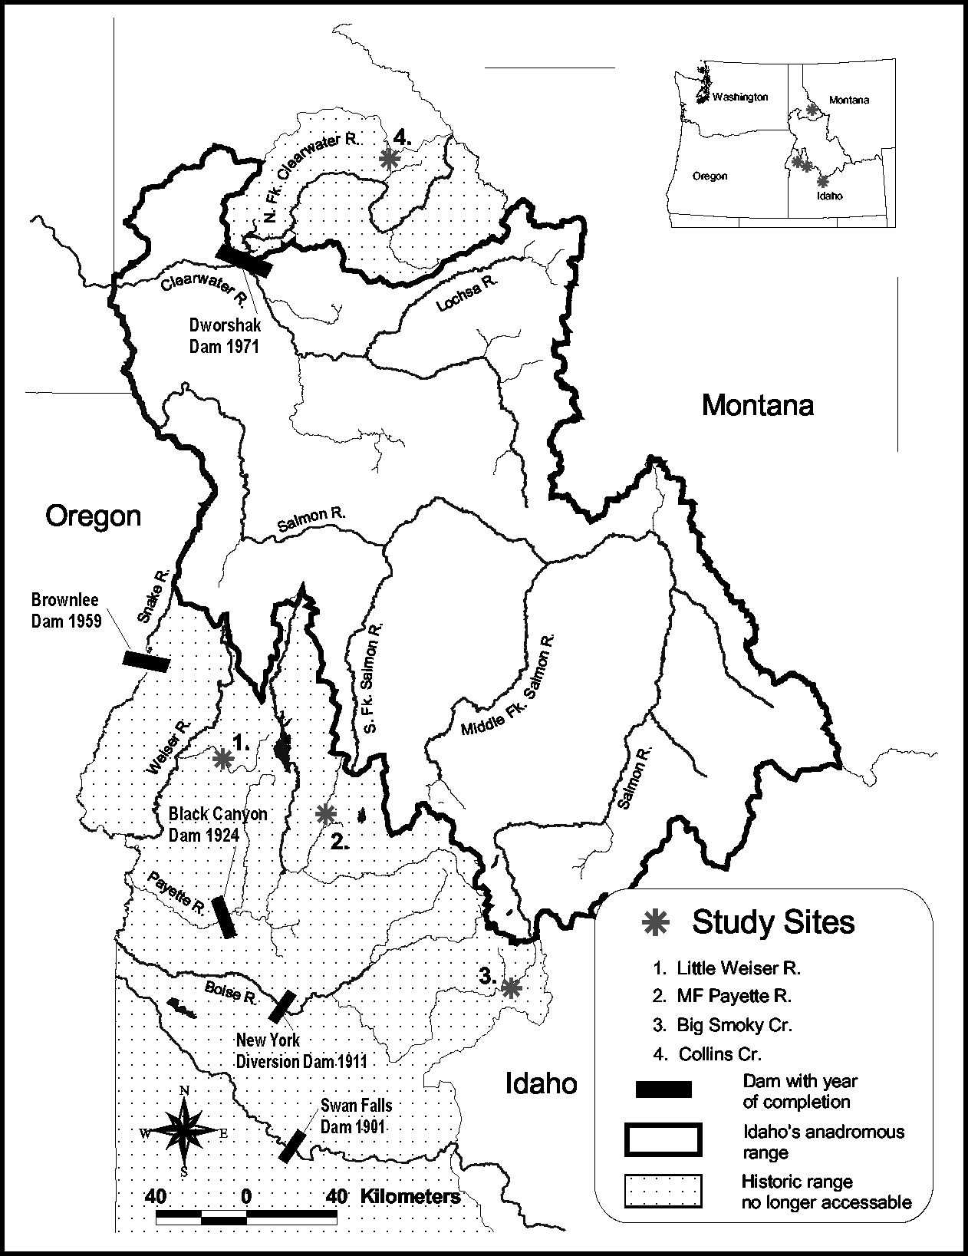

Figure 1. Proposed study sites and the year the dam was completed that blocked access to anadromous fish.

