Bonneville Power Administration

FY 2003 Provincial Project Review

PART 2. Narrative
Project ID: 32008

Title: Wildlife Inventory and Habitat Evaluation of Duck Valley Indian Reservation

Section 9 of 10. Project description

a. Abstract

The purposes of this project are threefold: (1) to gather information on wildlife species composition (with emphasis on USFWS listed or candidate species and species of concern), distribution and relative abundance (where possible) on the Duck Valley Indian Reservation; (2) to assess the condition of existing habitat; and (3) to disseminate this information for use in Reservation and subbasin planning efforts.

The Tribes propose to conduct two years of survey work after development and approval of a monitoring program for birds, mammals, amphibians and reptiles. More intensive investigations will be directed at species of concern (sage grouse, American white pelican, sensitive bat species, pygmy rabbit) and USFWS listed or candidate species (spotted frog). One of the first tasks to be initiated will be the delineation of habitat types on the Reservation. This will be achieved by having Landsat Thematic Mapper satellite images taken and analyzed by the University of Idaho Landscape Dynamics Lab. The resulting habitat map will assist in the selection of survey sites as well to identify appropriate species for the habitat evaluation procedures (HEP)(USFWS 1981) plan (field work to occur in FY2004). The Tribes will consult and with regional wildlife biologists from USFWS, IDFG, NDOW, USFS and BLM during both phases of this project. At the conclusion of the first field season, data will be analyzed and sent to cooperating agencies for review. Any modifications to the monitoring plan will be submitted to Columbia Basin Fish and Wildlife Authority (CBFWA) Wildlife Committee for their review and approval.

Information resulting from this research effort will be disseminated, through reports, GIS data layers and other appropriate means to the Idaho Conservation Data Center, Nevada Natural Heritage Program and the state and federal agencies responsible for managing wildlife resources in the region.

b. Technical and/or scientific background

The Duck Valley Indian Reservation lies in the Owyhee (~267,000 acres) and Bruneau (~23,000 acres) subbasins of the Middle Snake Province. The Nature Conservancy recently identified Duck Valley as one of four “priority conservation sites” in the subbasin due to its important riparian and wetland communities and high biodiversity of wildlife species (NWPPC 2001).” Many of the state and federal “species of special concern” listed in the Owyhee subbasin summary have been observed, or are thought to occur, within Reservation boundaries (Tables 1,2,3). To-date, no formal attempt has been made to document wildlife species composition, distribution and abundance on the Reservation. This data gap, identified in both the Owyhee and Bruneau subbasin summaries (NWPPC 2001a, 2001b), can be illustrated using GIS data from two monitoring efforts. A long-term monitoring program for the spotted frog (a USFWS candidate species) began in 2001 and a long-term sage grouse (a species of concern for the federal land management agencies) lek survey is ongoing. Data on both species (Figure 1 and 2) clearly indicate that our knowledge about these species’ distribution across the subbasin and region is incomplete without data from the DVIR.

Table 2. Sensitive mammal species - Owyhee subbasin
Sensitive Mammals | Scientific Name | Source | Comments
White-tailed antelope squirrel | Ammospermophilus leucurus | OR
Pallid bat | Antrozous pallidus | ID, OR
Pygmy rabbit | Brachylagus idahoensis | ID, OR | Likely in South Owyhee HUC
Townsend's big-eared bat | Corynorhinus townsendii | ID, NVH, NVE | Likely in South Owyhee HUC
Pale western big-eared bat | Corynorhinus townsendii pallescens | OR
Spotted bat | Euderma maculatum | ID, NVE | Likely in South Owyhee HUC
Silver-haired bat | Lasionycteris noctivagans | OR
Hoary bat | Lasiurus cinereus | OR
White-tailed jackrabbit | Lepus townsendii | OR
Dark kangaroo mouse | Microdipodops megacephalus | ID
California myotis | Myotis californicus | NVH
Western small-footed myotis | Myotis ciliolabrum | ALL | Likely in South Owyhee HUC
Long-eared myotis | Myotis evotis | ID, OR | Likely in South Owyhee HUC
Occult myotis | Myotis lucifugus occultus | NVE
Fringed myotis | Myotis thysanodes | ID, NVH, NVE | Likely in South Owyhee HUC
Long-Legged myotis | Myotis volans | ID, OR | Likely in South Owyhee HUC
Yuma myotis | Myotis yumanensis | ID, OR | Likely in South Owyhee HUC
California bighorn sheep | Ovis canadensis californiana | ID, OR
Little pocket mouse | Perognathus longimembris | ID
Pinon mouse | Peromyscus truei | ID
Western pipistrelle | Pipistrellus hesperus | ID
Preble's shrew | Sorex preblei | NVH, NVE, OR | Likely in South Owyhee HUC
Wyoming ground squirrel | Spermophilus elegans nevadensis | OR
Humboldt yellow-pine chipmunk | Tamias amoenus celeris | NVH
Kit fox | Vulpes macrotis | ID, OR
ID = Idaho Conservation Data Center, NVH = Nevada Natural Heritage Program Humboldt County, NVE = Nevada Natural Heritage Program Elko County, OR = Oregon Natural Heritage Program
Table 2 Sensitive birds - Owyhee subbasin
Sensitive Wildlife Species | Scientific Name | ID | NVH | NVE | OR
Northern goshawk | Accipiter gentilis |  | x | x
Clark's grebe | Aechmophorus clarkii | x
Western grebe | Aechmophorus occidentalis | x
Grasshopper sparrow | Ammodramus savannarum |  |  |  | x
Sage sparrow | Amphispiza belli |  |  |  | x
Black-throated sparrow | Amphispiza bilineata | x |  |  | x
Great egret | Ardea alba | x
Western burrowing owl | Athene cunicularia hypugaea | x | x | x | x
Cattle egret | Bubulcus ibis | x
Barrow’s goldeneye | Bucephala islandica |  |  |  | x
Bufflehead | Bucephala albeola |  |  |  | x
Ferruginous hawk | Buteo regalis | x | x | x | x
Swainson's hawk | Buteo swainsoni |  | x | x | x
Northern sage grouse | Centrocercus urophasianus phaios |  | x | x | x
Western snowy plover | Charadrius alexandrinus nivosus |  | x
Black tern | Chlidonias niger | x | x | x | x
Yellow-billed cuckoo | Coccyzus americanus | x | x | x | x
Common nighthawk | Cordeiles minor |  |  |  | x
Trumpeter swan | Cygnus buccinator | x |  | x
Bobolink | Dolichonyx oryzivorus |  |  |  | x
Snowy egret | Egretta thula | x
Eastern Oregon willow flycatcher | Empidonax traillii adastus |  |  |  | x
Horned lark | Eremophila alpestris |  |  |  | x
Peregrine falcon | Falco peregrinus anatum | x |  | x | x
Common loon | Gavia immer |  |  | x
Greater sandhill crane | Grus canadensis tabida |  |  |  | x
Bald eagle | Haliaeetus leucocephalus | x |  | x
Western least bittern | Ixobrychus exilis hesperis |  |  | x
Loggerhead shrike | Lanius ludovicianus | x |  |  | x
Northern mockingbird | Mimus polyglottos | x
Long-Billed curlew | Numenius americanus | x |  |  | x
Black-crowned night heron | Nycticorax nycticorax | x
Mountain quail | Oreortyx pictus | x | x |  | x
Flammulated owl | Otus flammeolus |  | x | x
American white pelican | Peeicanus erythrorhynchos |  |  |  | x
Double-crested cormorant | Phalacrocorax auritus | x
White-faced ibis | Plegadis chihi | x | x | x | x
Eared grebe | Podiceps nigricollis | x
Bank swallow | Riparia riparia |  |  |  | x
Broad-tailed hummingbird | Selasphorus platycercus |  |  |  | x
Western bluebird | Sialia mexicana |  |  |  | x
Forester's tern | Sterna forsteri | x
ID = Idaho Conservation Data Center; NVH = Nevada Natural Heritage Program Humboldt County; NVE = Nevada Natural Heritage Program Elko County; OR = Oregon Natural Heritage Program

Table 3. Sensitive amphibians and reptiles – Owyhee subbasin

Sensitive Species | Scientific Name | Source | Comments
Amphibians
Blotched tiger salamander | Ambystoma mavortium melanostictum | OR
Western toad | Bufo boreas | ID, OR
Woodhouse's toad | Bufo woodhousii | ID, OR
Columbia spotted frog - Great Basin | Rana luteiventris | ALL | Documented South Fork Owyhee HUC
Northern leopard frog | Rana pipiens | OR
Reptiles
Western rattlesnake | Crotalus viridis | OR
Mojave black-collared lizard | Crotaphytus bicinctores | ID, OR
Desert collared lizard | Crotaphytus insularis | OR
Sierra alligator lizard | Elgaria coerulea palmeri | NVH
Long-nose leopard lizard | Gambelia wislizenii | OR
Desert horned lizard | Phrynosoma platyrhinos | OR
Longnose snake | Rhinocheilus lecontei | ID
Northern sagebrush lizard | Sceloporus graciosus graciosus | OR
Ground snake | Sonora semiannulata | ID, OR
ID = Idaho Conservation Data Center; NVH = Nevada Natural Heritage Program Humboldt County; NVE = Nevada Natural Heritage Program Elko County; OR = Oregon Natural Heritage Program
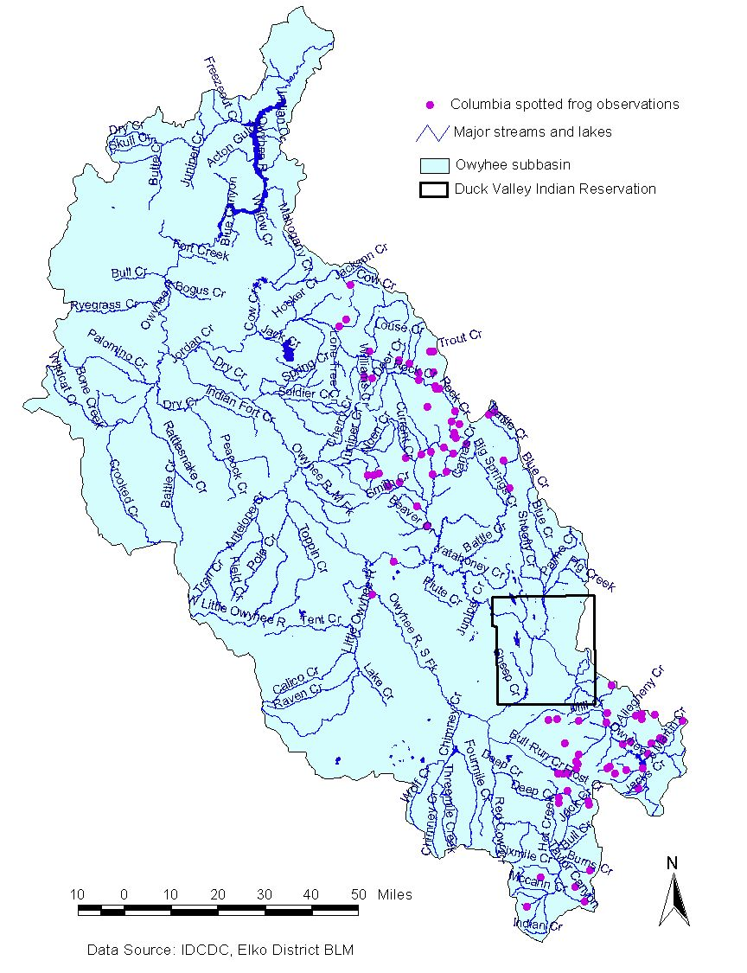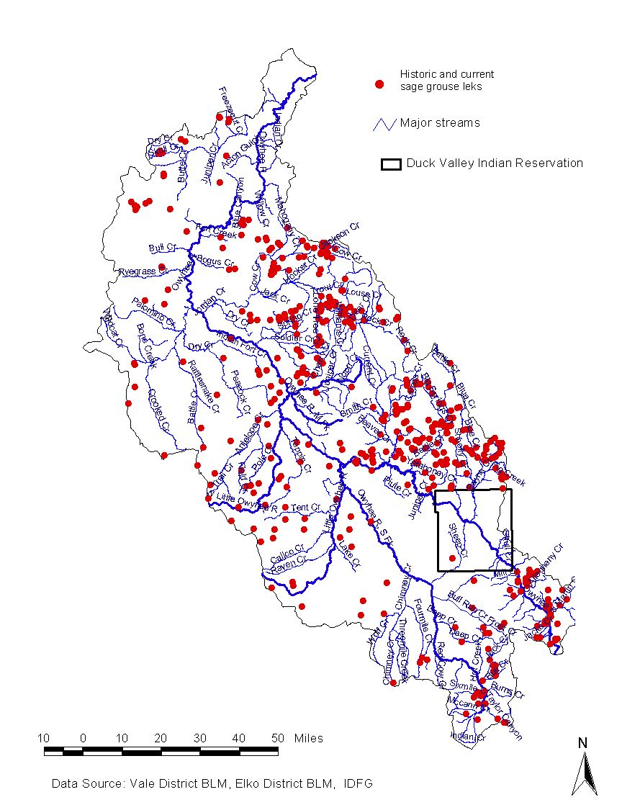

Figure 1. Spotted frog occurrences (OR data not avail.) Figure 2. Historic & current sage grouse leks (IDFG)

The goal of this study is to conduct a systematic assessment of the status of wildlife populations of the DVIR portion of the Owyhee and Bruneau subbasins and to share and utilize the information in Reservation natural resource planning efforts, subbasin planning efforts and to increase our knowledge about wildlife species across the region. To do this, we will develop a standardized methodology, protocol and a statistically sound sampling design to systematically assess the species composition, spatial and temporal distribution, relative abundance, and habitat utilization of wildlife populations. Standardized sampling methods and strict sampling protocols are required to reduce variation among samples and to detect changes in relative abundance over time. Several sampling methods will be considered and utilized (point counts, live trapping, aerial surveys, double sampling, radio telemetry) in order to adequately sample terrestrial wildlife species. The selection of sampling protocols will be derived, to a great extent, from recent research efforts that have been conducted in the region. This will facilitate the meaningful comparison of the data. We will rely heavily on regional wildlife agency expertise in the development and implementation of this research effort. In doing so, we hope to build stronger working relationships between the Tribes and land management agencies in the region. We hope to work collaboratively in the future to work towards a common goal of “a Columbia River ecosystem that sustains an abundant, productive, and diverse community of fish and wildlife…” (NWPPC 2000).

The value of wildlife inventories for monitoring and evaluation purposes is dependent upon a statistically valid sampling design. A sampling design based on stratified random sampling generally allows unbiased estimates of wildlife populations, temporal and spatial distribution, and relative abundance. Stratifying based on habitat features almost always yields gains in precision (Gibbs 2000). Gibbs (2000) suggests as a first step in designing a monitoring program, to identify species-habitat associations and generate regional habitat maps prior to surveying.

Subsequent wildlife monitoring efforts, based on this design and methodology, will enable the statistically valid determination of long term population trends.

c. Rationale and significance to Regional Programs

The Council’s 2000 program provides a template for subbasin planning. The subbasin summaries, recently completed, serve as the basis for BPA funding decisions during the first iteration of the rolling provincial review process. Fish and wildlife needs, the identification of data gaps, and an assessment of current fish and wildlife status were presented in these summaries. This project would serve to fill gaps in our knowledge about the distribution, abundance, and habitat relationships of wildlife species on the DVIR in particular, and the subbasin, in general. It will assist state and federal agencies, the Tribes, and others to manage wildlife resources more effectively on the lands they administer. A similar project proposal was submitted by the Tribes as a FY2000 project and was recommended for funding by the ISRP. CBFWA commented that the Council’s program, at that time, did not provide a mechanism for funding this type of proposal. The 2000 program does have provisions to allow funding these types of efforts: “The Council expects that the initial assessments in some subbasins will encounter significant data gaps requiring additional information. In such cases, the subbasin plan should identify this need, and include the measures necessary to meet it….The program will only fund new planning activities where there are clear gaps and omissions (NWPPC 2000).”

This project is consistent with the following wildlife needs identified in the Owyhee and Bruneau subbasin summaries:

- Fund the establishment of techniques, surveys, and programs to assess the health and trend of wildlife, wildlife habitat, and overall biodiversity in the subbasin. Existing surveys and information are inadequate, making it difficult to protect species or to evaluate progress towards goals stated in the summary.
- Cooperate on threatened, endangered, and sensitive species recovery or conservation strategy efforts in the subbasin.
- Establish and maintain permanent baseline monitoring systems for priority ecosystems and species.
- Conduct comprehensive survey of herptiles in the subbasin.
- Collect life history, habitat use, distribution, and movement information on bat species in the subbasin.
- Conduct comprehensive survey of avian species across the subbasin.
- Conduct research on DVIR population of sage grouse to gain understanding of the viability of the population and to assist in management of the population.
- Continue lek inventories throughout subbasin utilizing ground and aerial surveys.
- Map existing vegetation communities in GIS (referring to sage grouse)

This project also addresses the following goals, objectives and strategies outlined in the Bruneau and Owyhee subbasin summaries:

Entity - Shoshone-Paiute Tribes, Duck Valley Indian Reservation

- Determine wildlife species composition, distribution, and abundance on DVIR
  - Strategy 1: Work with USFWS to establish survey/monitoring protocols for candidate, threatened, and endangered species. Where appropriate, request USFWS assistance with field crew training.
  - Strategy 2: Work with IDFG, NDOW, BLM and other interested organizations and individuals to develop data collection methods
  - Strategy 3: Share wildlife information with appropriate agencies (Nevada’s Natural Heritage Program, Idaho Conservation Data Center, Rocky Mountain Elk Foundation, Ducks Unlimited)
  - Strategy 4: Develop long-term monitoring program for DVIR

- Develop and implement a sage grouse conservation plan on DVIR
  - Strategy 1: Participate in local sage grouse working groups (Owyhee, Jarbidge and Northeastern Nevada) to gather and share information and to identify collaborative opportunities
  - Strategy 2: Work with IDFG, NDOW, BLM and other biologists to assess sage grouse habitat on DVIR
  - Strategy 3: Have conservation plan reviewed by USFWS, IDFG, NDOW and BLM
  - Strategy 4: Secure funding source for sage grouse monitoring program

Entity – Owyhee County Sage Grouse Working Group

- Map locations of all known active and historic sage grouse leks in Owyhee County by the end of 2001.
- Identify and map sage grouse breeding (nesting and early brood) habitat associated with active leks by the end of 2004.
- Identify and map known sage grouse wintering habitat by the end of 2001.
- Perform a qualitative assessment of sage grouse breeding (nesting and early brood) habitat associated with active leks.
- Provide a reliable estimate of the distribution and populations of sage grouse in Owyhee County by 2004.
- Coordinate efforts by IDFG, BLM, ASAF and others to systematically survey and/or otherwise identify through landowner surveys all active leks and historic leks in the county by the end of the 2004 breeding season.

Entity – Idaho Conservation Data Center

- Maintain high quality, accurate, and timely information on the occurrence of rare, threatened, and endangered plant and animal species
  - Conduct appropriate population inventory monitoring work for priority species
- Maintain high quality, accurate, and timely information on the distribution, abundance, and ecological status of plant and animal habitats, representative ecological reference areas and plant communities
- Assist with species and ecosystem conservation management actions within the subbasin.

Entity – The Nature Conservancy

- Direct resources to highest priority projects within the subbasin as identified using a science-driven ecoregional planning process.
- Fund research and monitoring to address key uncertainties regarding management and protection of sage grouse.

d. Relationships to other projects

This project proposal is related to several other efforts currently underway in the subbasin:

Enhance and protect habitat and riparian areas on DVIR – BPA Project #970110
The habitat evaluation (HEP) portion of this project will be utilized to identify and prioritize areas for enhancement and/or protection. Spotted frog data would elucidate opportunities for riparian enhancement and sage grouse lek data would designate areas for protection.

Lake Billy Shaw O&M – BPA Project #9501506
The bird monitoring that will be occur during this project will complement the surveys that are being conducted at Lake Billy Shaw. To-date, presence/absence surveys have been conducted at all three reservoirs on the Reservation. Duck breeding pair counts and duck brood counts will be initiated at the reservoir during the 2002 nesting season to establish baseline conditions. In 2003, duck breeding pair and duck brood counts will be initiated on Sheep Creek and Mountain View reservoirs. The data gleaned from the surveys will provide a means to measure the wildlife benefits associated with shoreline enhancements at Lake Billy Shaw.

Spotted Frog Long-Term Monitoring Program – USFWS, Boise, Idaho
Conservation Agreement and Conservation Strategy: Columbia Spotted Frog, Great Basin Population, Nevada – USFWS, Reno, Nevada
The purpose of the Owyhee/Twin Falls County monitoring plan is to: (1) collect long-term monitoring information on the Owyhee subpopulation; (2) survey sites that are representative of the subpopulation; and (3) provide federal and state land management agencies with information they can use to modify land management practices to ensure the persistence of the species. The USFWS Nevada conservation strategy for the spotted frog suggests that the Jarbidge-Independence subpopulation is “likely part of a larger subpopulation extending up into southern Idaho” but does indicate that any portion of the species’ range falls within Reservation boundaries. Data gleaned from this research effort will help to fill the data gaps that exist in both USFWS regions and provide a clearer picture of current distribution of spotted frogs across the landscape.

Sage Grouse Research – Owyhee County, Idaho – IDFG
A sage grouse life history study is concluding in the Riddle/Grasmere area, just north of the Reservation. Sage grouse were trapped on leks and in late summer and their movements were tracked over a two-year time frame. Hens were followed throughout the spring and summer to determine nest site selection, hen success, and brood survival. Aerial surveys were conducted during the remainder of the year to determine overwinter survival rates. Habitat information was collected on nesting, brood rearing and summer habitats. Several of the birds migrated onto Reservation lands during a portion of the year. The lek data collected from this study will assist the IDFG in assessing the health of sage grouse populations across the area. A study similar in size and focus on the reservation would provide vital information on the migratory status of the Reservation population, as well as important information about sage grouse habitat quality.

Shoshone-Paiute Sage Grouse Conservation Plan – Shoshone-Paiute Tribes
The Tribes are in the process of drafting a sage grouse conservation plan for Reservation lands (Identified as an objective for Shoshone-Paiute Tribes in subbasin summary, page 85 and as a wildlife need on page 92. Tribal members identified that a data collection effort is needed to delineate sage grouse habitat, dancing grounds (leks), and important seasonal habitat. The information gleaned from this project will be used in land use planning activities as well the grazing management plan for the Reservation.

Owyhee County Sage Grouse Working Group –
The Owyhee County Sage Grouse Working Group is comprised of members from the state and federal management agencies, IDFG, Shoshone-Paiute Tribes, local conservation groups, ranching interests and concerned citizens. One objective of the sage grouse plan is to “map locations of all known active and historic sage grouse leks in Owyhee County…” The results of aerial surveys conducted on the Reservation will be shared with the working group to complete their data set. Another objective, “perform a qualitative assessment of sage grouse breeding (nesting and early brood) habitat associated with active leks” will be undertaken during the second year of the project and assessment procedures/methods will be discussed with the working group to determine if a standardized evaluation protocol can be adopted to allow for meaningful comparison of data.

e. Project history (for ongoing projects)

N/A

f. Proposal objectives, tasks and methods

This project consists of a planning and design phase and a monitoring and evaluation phase. The planning and design phase will take approximately five months to complete. During this time numerous wildlife professionals will be consulted about survey design, sampling methods and data analysis. A wildlife scientist (Ph.D) will be contracted with to review the plan to ensure it incorporates statistically sound methods and has the appropriate sampling design. The CBFWA Wildlife Committee will also be asked to review and approve the plan prior to the beginning of the first field season. The monitoring and evaluation phase will take approximately 2 years to complete and a final report, which will synthesize the data collected over the course of the research, will be forwarded to BPA in January 2005.

Planning and Design Phase:

- Develop wildlife monitoring plan –
  - Contract with University wildlife scientist (Ph.D) with expertise in wildlife sampling design.
  - Contract with Univ. of Idaho Landscape Dynamics Lab for satellite image of Reservation and analysis – GAP vegetation data is available for the Idaho portion of the Reservation but Nevada GAP data will not be complete until 2004 (at the earliest), and the information presently available is not at the same resolution as the Idaho data.
  - Develop plan to assess species composition, distribution and relative abundance on DVIR - The Tribes’ will work closely with IDFG and USFWS as well as regional wildlife biologists to develop a monitoring plan. The sampling protocols noted below are tentative and were selected to mirror methods used in similar research efforts in the subbasin to allow meaningful comparison of the data. During data collection efforts habitat information will be collected such as: description of primary vegetation types and structure, topography (slope, aspect, elevation), etc. as suggested by Karl et al. (1999). This data will be summarized and analyzed to detect species/habitat relationships. The habitat analysis portion of this research effort will be used to assess current habitat conditions across the Reservation and to identify areas in need of enhancement and/or protection. Using a stratified random sampling design, we will also evaluate the habitat conditions across three grazing allotments.
  - Submit draft monitoring plan to CBFWA for review and approval – The principle investigator will distribute copies of the plan to Wildlife Committee members and ask the committee to review and approve the plan.
  - Review of monitoring plan by technical consultant.
  - Finalize monitoring plan – Revisions will be incorporated based on input from CBFWA, the technical consultant and regional wildlife biologists.

- Purchase field equipment –
  - Purchase GPS unit, AnaBat2 bat monitoring system, field supplies, binoculars, etc.

- Prepare for data collection –
  - Set up databases, develop and generate sampling forms, construct traps, etc.

Monitoring and Evaluation Phase:

- DVIR Habitat Analysis –
  - Landsat Thematic Mapper satellite image taken of Reservation – Satellite images will be taken of the Reservation in late spring (May).
  - Groundtruthing – The Landscape Dynamics Lab (LDL) will provide the Tribes with a number of UTM coordinates and tribal staff will conduct the groundtruthing exercise.
  - Delineate habitat types and area extent – The LDL will incorporate the Tribes’ groundtruthing information and produce vegetation maps. The Tribal GIS director, along with the principle investigator, will evaluate the maps and delineate habitat types and extent from the data provided.
  - Incorporate habitat data into monitoring plan – The map data will be used to (1) determine wildlife species HEP models to utilize in habitat evaluations during year two and (2) to finalize the sampling design (several groups of species will be monitored during the second year of the study because the map data will not be available until the end of FY2003.

- Conduct Wildlife Monitoring –
  - Spotted frog surveys - The USFWS will work closely with the Tribes in 2002 to survey 1-3 sites on the Reservation and will assist the Tribes’ in identifying survey locations for 2003. Presence/absence surveys will be conducted according to the USFWS sampling and disease protocols outlined in the “Columbia Spotted Frog Great Basin Population (Owyhee Subpopulation) Long-Term Monitoring Plan” (2001) and Engle (2001). Upon reviewing 2003 survey data, a determination will be made on whether sentinel site monitoring will be included in the 2004 plan.
  - Sage grouse lek surveys – Due to the inaccessibility of many areas of the Reservation during late winter and early spring, aerial lek surveys will be conducted during the first year of the study. Idaho Department of Fish and Game (IDFG) survey forms will be used to record UTM coordinates, number of males present, and other pertinent information. Lek sites will be visited in late spring/early summer to evaluate the habitat characteristics of the lek site and surrounding area. The Tribes will explore the possibility of radio-tagging birds at lek sites during spring 2004 and tracking birds to determine habitat use on and off reservation (possibly working cooperatively with IDFG’s sage grouse research project in the Owyhee/Bruneau subbasins).
  - Waterfowl production surveys – The Tribes will consult with wildlife biologists at the Malheur National Wildlife Refuge to determine appropriate monitoring techniques for assessing wildfowl populations in the Blue Creek wetlands area. Duck breeding pair counts and duck brood counts will be conducted on Sheep Creek, Mountain View and Lake Billy Shaw Reservoirs according to Hammond (1970) waterfowl production survey methods.
  - Bat surveys – Surveys will be conducted between the last week of July and the second week of September according to sampling protocols described in Doering and Keller (1998). A combination of mist netting and ultrasonic echolocation call monitoring (using AnaBat2 equipment) will be used to determine species present and habitat associations. One departure from Doering and Keller’s protocol will be that bat activity will be recorded on a computer system, not a tape recorder. Recent research (White and Gehrt 2001) suggests that species identification is less reliable when taped data is compared to computer-recorded reference calls (the AnaBat2 software uses computer-recorded reference calls).
  - Raptor surveys – Raptor surveys will be conducted using ground searches as well as helicopter surveys. Boise State University, NDOW, Snake River Birds of Prey Area, and U.S. Forest Service have all conducted research on raptors in the region. Survey protocols will be developed to complement these existing regional efforts.
  - Point counts for avian species – Point counts will be conducted for avian species in accordance to habitat-based monitoring protocols described by Huff et al. (2000).
  - Small mammal surveys – Lincoln-Peterson mark/recapture method will be used to determine species diversity and to estimate abundance of rodent species. Pygmy rabbits will be surveyed in the following manner: during the first year of the study, wildlife and parks staff will record UTM coordinates of pygmy rabbit burrows they encounter during the field season and in winter months during road surveys (per Gabler et al. 2000). GIS analysis, using known burrow locations and the habitat map generated by the University of Idaho, will be used to predict areas of suitable pygmy rabbit habitat (other GIS layers will include slope, aspect, and geology types). The GIS predictive model will be field tested by randomly sampling areas designated as suitable and unsuitable habitat. Based on the findings of the predictive model, an appropriate survey method will be chosen for implementation during the second year of the study.
  - Amphibian and reptile surveys – Two methods will be employed to determine reptile and amphibian presence in survey areas: drift fences with funnel traps and visual searches of suitable habitats. Survey protocols and detailed information on drift fence configuration and placement are presented in Gerber et al. (1997).
  - Big game surveys – Where possible, aerial surveys will be conducted in conjunction with the wildlife management agencies in the subbasin (IDFG, NDOW).
  - White-faced ibis surveys – Methods of surveying this species will be determined after consultation with white-faced ibis experts at USFWS, Malheur National Wildlife Refuge, NDOW and USGS and upon review of a recent publication regarding breeding colony dynamics of the Great Basin Population (1998).

- Evaluate Wildlife Habitat –
  - Conduct HEP analysis – After habitat types are delineated, appropriate indicator species will be selected and a HEP plan will be designed for FY 2004. The plan will be submitted to CBFWA Wildlife Committee members for review and approval and committee members will be invited to participate in field sampling.
  - Analyze HEP data – Analysis of HEP data will occur in FY 2004 and FY 2005.

- Compile Data, Analyze and Report Results
  - Compile and analyze data – The appropriate statistical methods will be used to analyze data.
  - Share pertinent data with Conservation Data Center, Nevada Natural Heritage Program and appropriate management agencies – Procedures for submitting data to these agencies will be discussed prior to data collection in order to effect the most efficient transfer of information.
  - Review of data and monitoring protocols by technical consultant.
  - Meet with appropriate agencies to review data and to coordinate 2004 sampling – The Tribes will review data with the appropriate cooperating entities and draft the monitoring strategy for 2004.
  - Reports to BPA – produce three quarterly reports and annual report.
  - Produce final report – To be completed and submitted to BPA in January, 2005.

g. Facilities and equipment

The major equipment expenditures for this project are for an AnaBat2 Bat Detector, a Trimble Geoexplorer 3 GPS unit, and a GSA vehicle. The AnaBat2 system is a core component of the bat survey. The system allows detection of species typically difficult to trap in mist nets (i.e., spotted bats). It also aids in assessing the level of activity in a given area. The GPS unit (approximate cost of $4200) will be used extensively during this project and would also be utilized in other BPA funded projects such as Lake Billy Shaw O&M (Project #9501506) Habitat Enhancement and Protection (Project #970110)
and wildlife acquisition projects. The Trimble GPS unit is superior to the less expensive models because it is more accurate, has a much larger storage capacity, and can generate points, lines or polygons dependent on the needs of the project. These features will allow more precision in: marking capture locations (especially important when dealing with species with very small home ranges), mapping habitat types, weed infestations, etc.; and assessing habitat changes resulting from management actions.

h. References

References | Submitted w/form (y/n)
Cassirer, E.F. 1995. Wildlife Inventory, Craig Mountain, Idaho. Bonneville Power Administration, Portland, OR. Project No. DE-FG79-92BP62547. 196 p. | N
Doering, R.W. and B.L. Keller. 1998. A survey of bat species of Bruneau-Jarbidge River area in southwestern Idaho with special reference to the occurrence of the spotted bat (Euderma maculatum). Idaho Bureau of Land Management Technical Bulletin No. 98-10. Boise, ID. 29 p. | N
Earnst, S.L., L. Neel, G.L. Ivey, and T. Zimmerman. 1998. Status of the white-faced ibis: breeding colony dynamics of the Great Basin population, 1985-1997. Colonial Waterbirds 21:301-476. | N
Engle, J.C. 2001. Population biology and natural history of Columbia spotted frogs (Rana luteiventris) in the Owyhee uplands of southwest Idaho: implications for monitoring and management. M.S. Thesis. Boise State University, Boise, ID. 66 p. | N
Engle, J.C. 2001. Columbia spotted frog Great Basin population (Owyhee subpopulation) long-term monitoring plan; Owyhee and Twin Falls Counties, Idaho (Draft). U.S. Fish and Wildlife Service, Boise, ID. 37 p. | N
Gabler, K.I., J.W. Laundre, and L.T. Heady. 2000. Predicting the suitability of habitat in southeast Idaho for pygmy rabbits. Journal of Wildlife Management 64(3):759-764. | N
Gerber, M.E., J.C. Munger, A. Ames, and J. Stewart. 1997. Reptiles and amphibians in deep canyons: the Big Jacks and Little Jacks Creek drainages of Owyhee County, ID. Idaho Bureau of Land Management Technical Bulletin No. 97-1. Boise, ID. 21 p. | N
Gibbs, J.P. 2000. Monitoring Populations. Boitani, L. and T.K. Fuller (eds.) In Research techniques in animal ecology: controversies and consequences. Columbia University Press, New York. Pp. 213-251. | N
Hammond, M.D. 1970. Waterfowl brood survey manual. U.S. Fish and Wildlife Service. FWS/OBS-81/47. 111 p. | N
Huff, M.H., K.A. Bettinger, H.L. Ferguson, M.J. Brown, and B. Altman. 2000. A habitat-based point-count protocol for terrestrial birds, emphasizing Washington and Oregon. Gen. Tech. Rep. PNW-GTR-501. Portland, OR: U.S. Department of Agriculture, Forest Service, Pacific Northwest Research Station. 39 p. | N
Karl, J.W., N.M. Wright, P.J. Heglund, and J.M. Scott. 1999. Obtaining environmental measures to facilitate vertebrate habitat modeling. Wildlife Society Bulletin 27(2):357-365. | N
Northwest Power Planning Council. 2000. Columbia River Basin Fish and Wildlife Program. Council Document 2000-19. Portland, OR. | N
Northwest Power Planning Council. 2001. Bruneau Subbasin Summary (Draft). Portland, OR. 131 p. | N
Northwest Power Planning Council. 2001. Owyhee Subbasin Summary (Draft). Portland, OR. 112 p.
Titley Electronics. 2001. AnaBat II Bat Detector. Located at: www.titley.com.au/tanabat.htm | N
U.S. Fish and Wildlife Service. 2001. Conservation agreement and conservation strategy: Columbia spotted frog (Rana luteiventris) Great Basin population, Nevada. Jarbidge-Independence range and Ruby Mountains. Draft. U.S. Fish and Wildlife Service, Reno, NV. 95 p. | N
U.S. Fish and Wildlife Service. 1981.Ecological Services Manuals ESM 101, 102 and 103. Division of Ecological Services, Washington, DC. | N
White, E.P. and S.D. Gehrt. 2001. Effects of recording media on echolocation data from broadband bat detectors. Wildlife Society Bulletin 29(3):974-978. | N

Section 10 of 10. Key personnel
Wildlife Biologist 1.0 FTE

To be hired.

Minimum Qualifications: B.S. in Wildlife Biology (M.S. preferred)
Strong written and oral communications skills
Strong field work background
At least 1 year of supervisory experience
Proficient at Arcview GIS

