Bonneville Power Administration

FY 2003 Provincial Project Review

PART 2. Narrative
Project ID: 32010

Title: Lookout Mountain Road Decommissioning

Section 9 of 10. Project description

a. Abstract

This project will decommission approximately 2.5 miles of road. There are three different segments of road. One segment adjacent to Sisley Creek, which is in the Burnt subbasin, and the other segments are adjacent to Fox and Hibbard Creek, which are in the Lower Middle Snake subbasin. Although this project is within two different subbasins, the roads are very close together, and should be treated as one project to reduce equipment and personnel costs.

This project will reduce sedimentation by decommissioning stream bottom roads, removing culverts, and restoring native riparian vegetation adjacent to the stream channels. Decommissioning will involve subsoiling the road surface with a winged subsoiler, blocking the road to prevent vehicle and ATV traffic, and removing any culverts and/or fill from the stream crossings. All stream crossings will be re-contoured to the natural streambank and stream gradient. Where needed, rock vanes will be installed at the stream crossings to prevent headcutting of the stream channel. The roadbed will be seeded with native grass seed and planted with native hardwoods, conifers, and shrubs.

The Sisley Creek road is approximately 1.2 miles long and crosses one perennial stream, two intermittent stream channels, and three springs. Approximately 0.25 miles of this road is within the floodplain of the creek and will be re-contoured to the natural floodplain.

One segment of the Fox Creek road is approximately 0.9 miles long. This road has one intermittent and two perennial stream crossings. This road also crosses at least two springs. The second segment of road to be decommissioned is approximately 0.4 miles long between Fox Creek and Hibbard Creek. This road has one perennial stream crossing and also crosses numerous hillside springs.

The roads to decommission are shown in red on the following map. The BLM managed land is shown in yellow, and the streams are shown in blue.

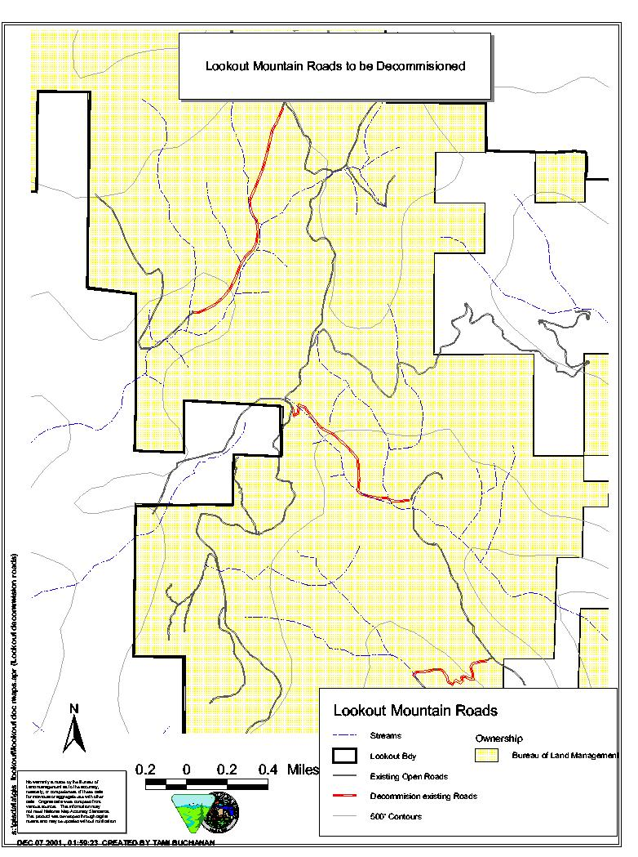
b. Technical and/or scientific background

The Bureau of Land Management (BLM) is in the process of finishing an Environmental Impact Statement (EIS) for management of the Lookout Mountain area. Identified in the Lookout Mountain EIS are the above mentioned roads to decommission because of their impacts to riparian habitat and water quality. The Lookout Mountain area is the headwaters area for several streams that flow into three different subbasins. Streams originating in the Lookout Mountain area flow into the Burnt, Powder, and the Lower Middle Snake subbasins. Both the Fox Creek and Sisley Creek roads originate at the Lookout Mountain road, which is located along the ridge between the Burnt and Lower Middle Snake subbasins. The Sisley Creek road is on the west side of the ridge and is within the Burnt subbasin. The Fox Creek road is on the east side of the ridge and is within the Lower Middle Snake subbasin.

At one point, these two roads that are planned for decommissioning are within one mile of each other, so although they are within different subbasins, it made sense to include them in one project proposal. Funding the decommissioning of the above mentioned roads as one project will save personnel time, save on contract writing and administration, monitoring costs, and equipment move-in and move-out costs.

As mentioned above, these roads have four perennial stream crossings, three intermittent stream crossings as well as numerous spring crossings. The roads are within the Riparian Habitat Conservation Areas (RHCA) and impacting riparian habitat and water quality. Because of the stream crossings and the location of the roads, much of the riparian area is occupied by the roadbed, which is limiting the amount of riparian vegetation that can be established, possible impacting stream temperatures. The locations of the roads are also increasing sediment delivery to the streams further impacting water quality and aquatic habitat, as well as reducing the amount of large woody debris delivered to the streams. Some of the stream crossings are low water crossings, resulting in direct sedimentation impacts to fish-bearing streams.

Sisley Creek supports red band trout within the project area. Red band trout are also within Fox and Hibbard Creek, but are downstream of the project area. Excess fine sediment in the water can stress fish, smother eggs, reduce aquatic insect production, fills inter-gravel hiding spaces, and increase cobble embeddedness. Loss of riparian vegetation leads to accelerated surface runoff and erosion. Loss of vegetation also increases solar insolation, elevating water temperatures in summer or reducing the tempering of water temperature in winter. Loss of riparian vegetation also reduces large woody debris input, which can lead to loss of channel structure.

None of the streams within the project area are on the Oregon 303(d) list. Sisley Creek is a tributary to the Burnt River, which is listed on the 303(d) list for flow modification and temperature. Fox and Hibbard Creek are tributaries to the Snake River, which is on the 303(d) list for temperature and toxics (DEQ, 1998).

c. Rationale and significance to Regional Programs

Decommissioning of these roads will directly reduce sedimentation in Sisley, Fox, and Hibbard Creeks, improve riparian and aquatic habitat, increase shade along the stream channel, restore native vegetation, decrease road density within RHCA’s, and decrease stream crossings in fish-bearing streams.

This project is related to numerous objectives listed in the Draft Burnt Subbasin Summary (BSS) and the Draft Lower Middle Snake Subbasin Summary (LMSS). Existing goals, objectives, and strategies outlined in the subbasin summaries that are addressed by this project are included under multiple subbasin cooperator headings. Goals, objectives, and strategies listed for federal agencies are many times the same as those listed by state, tribal, and private or non-profit agencies. Examples of objectives and strategies outlined in the subbasin summaries that are related to this project include: 1. Restore riparian habitat by revegetating streambanks with native vegetation, 2. Restore water quality, 3. Restore stream channel integrity, channel processes, and sediment regimes under which riparian and aquatic ecosystems developed, 4. Reducing stream sedimentation by identifying and fixing road related sources of sediment (BSS and LMSS, 2001)

Specific Fisheries/Aquatic needs identified as critical or needing immediate attention include; restore, protect, and create riparian, wetland and floodplain areas within the subbasin; reduce stream temperature, sediment and embeddedness levels to levels meeting appropriate state standards; reduce road impacts to aquatic resources; and address streambank instability issues (LMSS, 2001).

In addition to aquatic impacts, Table 18 in the LMSS points out 13 associated factors to wildlife due to roads, including snag reduction, down log reduction, and habitat loss and fragmentation (LMSS, 2001).

This project proposal can help alleviate some of the limiting factors identified in the subbasin summaries. Loss of quality habitat and habitat degradation is one of the overriding factors to fish and wildlife in the Burnt and Lower Middle Snake subbasins (BSS and LMSS, 2001). In the Snake River tributaries (which Fox and Hibbard Creek are), the limiting factor to tributary habitat is also degraded riparian habitat (LMSS, 2001). Road related activities are identified as some of the on-going impacts causing negative effects to resident fish habitat (BSS, 2001).

The decommissioning of 2.5 miles of road along riparian areas would benefit many wildlife species located in the area. Riparian habitat is used by approximately 150 wildlife species for the primary purposes of feeding and breeding. Many other wildlife species use riparian areas for travel corridors and cover locations. By removing a major disturbance to these areas, and allowing the natural vegetation to recover to provide additional habitat for wildlife, many species of wildlife would use these areas with more frequency than conditions allow for at this time.

Initial disturbance to wildlife in the area would occur during the decommissioning action. This would be a short term impact and wildlife would use the areas again in a relatively short time.

Roads, especially those in riparian areas, have significant impacts to aquatic and terrestrial species, water quality, and riparian vegetation and habitat. Completion of this project can help improve headwater riparian habitat adjacent to fish-bearing streams in the project area. Not only will numerous stream and springs crossings be restored, but native vegetation along the roadbed will also be restored, helping to improve aquatic and riparian habitat. As mentioned above, the loss of riparian habitat is one of the most significant problems within the subbasins.

d. Relationships to other projects

This project is not directly related to any other projects funded by FWP funds (there are no FWP funded projects in the Burnt subbasin).

The BLM, however, has been actively re-vegetating streams in Lookout Mountain area over the past few years through cost-sharing programs with the Baker School District and volunteers.

e. Project history (for ongoing projects)

While this is not an ongoing project funded by BPA, this proposal is only a portion of the restoration planned for the Lookout Mountain area on BLM managed lands. The EIS that the BLM is preparing addresses a number of forest health, wildlife, and riparian issues. In addition to the EIS, the BLM has also conducted Standards and Guidelines for Rangeland Health. These Standards and Guidelines help identify any concerns that grazing may be having in the area. Implementation of these Standards and Guidelines will result in more stringent riparian utilization levels in the Lookout Mountain area.

f. Proposal objectives, tasks and methods

Objectives:

Decommissioning roads to reduce direct and indirect effects to headwater streams in the Burnt and Lower Middle Snake subbasins. In particular, the decommissioning of roads will:
- Reduce sedimentation,
- Increase shade and riparian vegetation,
- Increase bank stability,
- Improve riparian and aquatic habitat and,
- Reduce road density within RHCA’s.

Tasks and Methods:

- Decommissioning of approximately 2.5 miles of road by subsoiling the road surface with a winged subsoiler. Removal of all culverts and fill from any stream crossings, and re-contouring the streambank where needed. Rock vanes may be installed in the stream channel at stream crossings to prevent headcutting of the stream channel when culverts and/or fill are removed. Decommissioning of the roads will reduce sedimentation by restricting vehicle traffic and reduce road density within RHCA’s. Removal of stream crossings will improve riparian and aquatic habitat by removal of culverts and fill that are currently in the stream channel.

- The 2.5 miles of road will be planted with approximately 3000 native shrub, hardwood, and conifer species after subsoiling. The road surface will also be seeded with native grass and sedge species. Stream crossings will also have native vegetation planted to increase bank stability and reduce sedimentation along with erosion control matting placed adjacent to the stream channel to reduce sedimentation until vegetation is established. Planting of the road surface will reduce sedimentation by vegetating land that is currently bare. Planting will also improve riparian and aquatic habitat by vegetating stream crossings, and establishing vegetation within the RHCA’s of Sisley and Fox Creeks, which is where the majority of these roads are located. This establishment of vegetation will result in increased shade to the stream channels.

- The decommissioned roads will be blocked with large rock, logs and/or tank traps, which will prevent vehicular traffic from traveling on the road surface. These blockage structures will be placed at the beginning and ending of the road segments that are decommissioned. Also, rock and logs may be placed at certain locations along the roads to discourage ATV traffic. Once the vegetation is well established and the trees and shrubs increase in size, blockage of the roads and off road travel should become less of a concern. Blocking of the roads will ensure that the vegetation becomes established, vehicles do not continue to increase sedimentation through the use of the roads and stream crossings, and that the riparian and aquatic habitat is protected by restricting vehicles crossing the streams.

Monitoring:

A monitoring plan will be set up in FY 2003 with a report issued annually for five years after completion of the project.

Survival surveys will be conducted in the planting areas to monitor survival of trees and shrubs that were planted to assess whether objectives are being met or areas need to be replanted. Survival of vegetation will be reported in percentage of trees and shrubs that survive of the initial 3000 planted.

Germination of seeding will be monitored. Areas seeded with native grass and sedge species will be monitored by percentage of ground occupied by the new vegetation compared to undisturbed land adjacent to seeding areas.

Photo points will be installed to document vegetation establishment on streambanks and roadbeds. Photos will be taken before decommissioning, after subsoiling, and after planting. Photo-points will be taken annually after planting to document trend of riparian habitat condition, including vegetation establishment and increases in bank stability.

Stream surveys will be conducted on one reach of Sisley Creek and one reach of Fox Creek. These surveys will include cross-section and longitudinal surveys. At least one stream crossing will be included in each reach surveyed to document channel stability after decommissioning and removal of stream crossing structures. These surveys will be performed annually for five years after project completion.

The blockades will be monitored at least three times annually after decommissioning to ensure vehicle traffic has been restricted. If vehicle traffic occurs after decommissioning, equipment will be brought in to re-enforce blockade, which may include placement of additional large rock and/or logs in the road surface.

Above monitoring activities will be reported annually in the monitoring report, which will be available at the BLM office in Baker City, OR as well as on the Vale District BLM website.

g. Facilities and equipment

Personnel involved in this project will be BLM employees working out of the Baker City, OR field office, which is part of the Vale District BLM. Adequate workspace, computers, and vehicles will be provided by the BLM to complete the work.

Monitoring equipment that would need to be purchased would be things such as field books for notes, tapes for measuring distances during channel cross-section surveys, metal tags and rods to monument the stream surveys so that they can be repeated annually and some other miscellaneous equipment necessary to complete the monitoring requirements.

h. References

Reference (include web address if available online) | Submitted w/form (y/n)
Oregon Department of Environmental Quality. 1998. Oregon’s Final 1998 Water Quality Limited Streams – 303(d) List. Portland, Oregon.  http://www.deq.state.or.us/ | N
Draft Lower Middle Snake Subbasin Summary. 2001. Prepared for the Northwest Power Planning Council.  http://www.cbfwf.org/ | N
Draft Burnt Subbasin Summary. 2001. Prepared for the Northwest Power Planning Council.  http://www.cbfwf.org/ | N

Section 10 of 10. Key personnel

Todd Kuck, Hydrologist for BLM Baker Field Office. BS Forest Resources Management, University of Montana, 1991. Previous experience as project lead for stream and riparian restoration projects with Vale District BLM and Roseburg District BLM. Project lead for Clean Water Action Plan restoration projects. Baker Field Office riparian and PFC coordinator.

Jackie Dougan, BLM Baker Field Office Fisheries Biologist. BS Fisheries Science, Oregon State University, 1988. Twenty years of fish habitat management, fisheries habitat and watershed restoration experience. Present Powder River Watershed Council official member (5 years), past project supervisor for the Powder River Restoration Project (3 years), past BPA watershed restoration project supervisor for the Umatilla National Forest (7 years), USFS Fish Biologist for the Umatilla and Wallowa-Whitman National Forest (11 years).

Clair Button, 24 years of experience with BLM. Nine of those as a wildlife biologist, partly working on rangeland-habitat restoration and monitoring. Fifteen years as a botanist, also part-time restoration and monitoring. Bachelor's degree in Natural Resource Management from University of Michigan, emphasis on wildlife, forestry, and botany.

