Bonneville Power Administration

FY 2003 Provincial Project Review

PART 2. Narrative
Project ID: 32020

Title: Inventory and Assessment of Stream/Riparian Resources, Upper Boise and Upper Payette River Subbasins, Idaho

Section 9 of 10. Project description

a. Abstract

An Ecological Classification that focuses on stream and riparian resources will be applied to the upper Boise River basin draining to Lucky Peak Reservoir in Idaho and the upper Payette River basin (consisting of the North Fork, Middle Fork and South Fork subbasins). Products will be an inventory and assessment of stream and riparian resources organized in a hierarchical landscape framework. Upper hierarchical levels will be used to identify stream/riparian resources with distinctive form, function and ecological potential. Lower hierarchical levels will be used to denote the condition of stream/riparian resources. Assessments will be based on a progression of states ranging from near natural to severely impacted.

The proposal addresses the need to “inventory and map the distribution of riparian plant communities” (Stovall 2001). Products will serve as basis for evaluating the effects of past, current and future management on stream and riparian resources and associated values to fish, wildlife and water quality. Products will also serve as a basis for identifying minimally impacted reference reaches, for refining TMDL assessments, as a basis for watershed analyses, for assessing priorities for enhancement and restoration, and as a basis for fish and wildlife interpretations.

b. Technical and/or scientific background

Introduction

Information regarding the extent, distribution, character, and condition of riparian habitats is lacking for the upper Boise and Payette River basins. The goal of the proposed study will be to provide this information through application of an Ecological Classification. The condition of stream and riparian resources will be evaluated relative to ecological potential and achievable conditions.

The upper Boise River basin (Figure 1) drains to Lucky Peak Reservoir, is 1,766 square miles and contains a stream network that is 6,576 linear miles, of which 3,356 miles (51 percent) is perennial. The upper Payette River basin (Figure 2) includes the North Fork, Middle Fork and South Fork subbasins. It is 2,086 square miles and contains a stream network that is 4,000 linear miles of which 2,504 miles (63 percent) is perennial. Subbasins identified on Figure 1 are 5th code Hydrologic Unit Codes (HUCs) identified by USGS. This proposal addresses the need to “inventory and map the distribution of riparian plant communities” stated in the Boise-Payette-Weiser Subbasin Summary (Stovall 2001). The project considers the whole watershed.
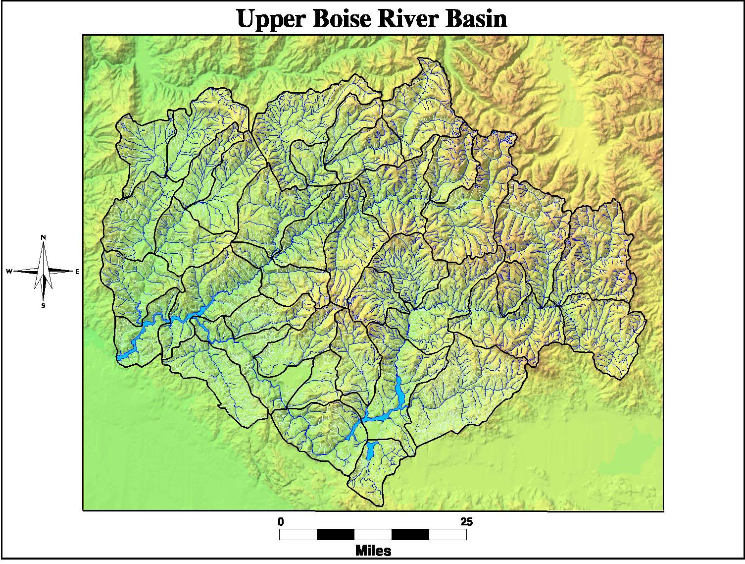
Figure 1. Upper Boise River basin.
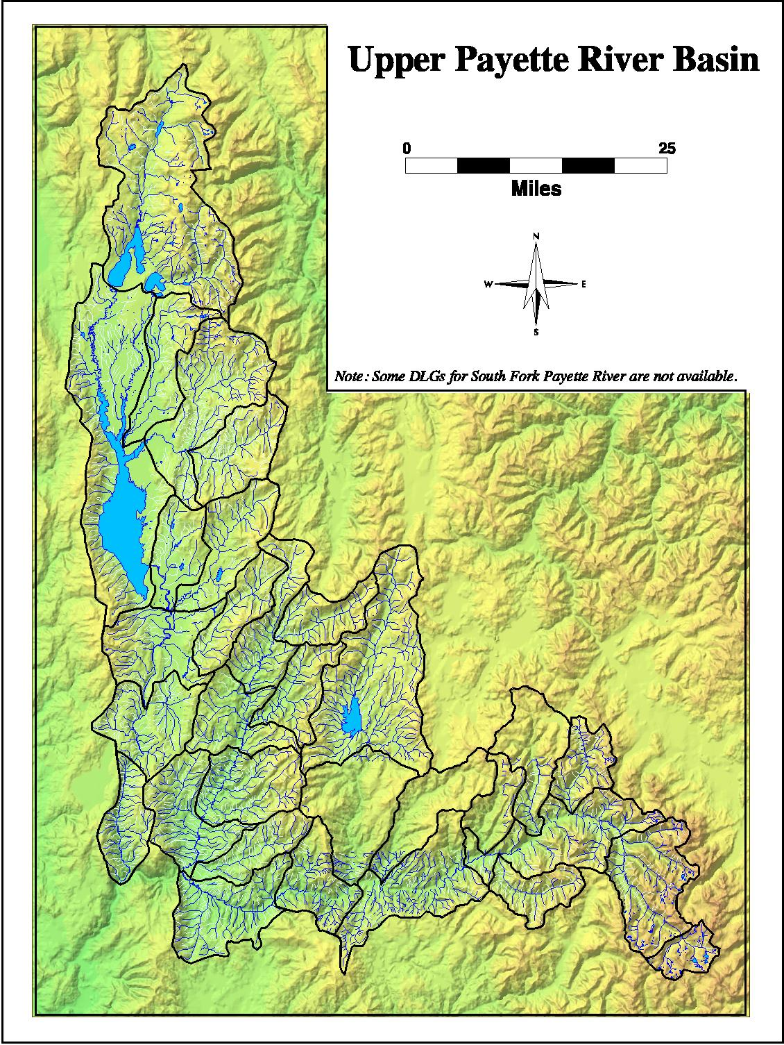
Figure 2. Upper Payette River basin.
Classification is a tool for dividing objects into groups and arranging these groups into orders, such that the objects and relationships between groups can be better understood (Mill 1891). Applied to landscapes, classification can serve to identify homogenous areas with similar functional character that will respond to management in predictable ways.

Bailey et al. (1978) distinguished between an aggregating (taxonomic) and a subdividing (regional) approach to the classification of landscapes. The taxonomic approach generally distinguishes classes of discrete resource components such as soils (Soil Survey Staff 1975), vegetation (Daubenmire 1968; Pfister et al. 1977; and Hansen et al. 1995) or streams (Rosgen 1994; Pflieger et al. 1981). Typically, the criteria for distinguishing taxonomic classes are dependent variables (e.g., soil texture; plant community composition; and stream parameters such as grade and substrate). For the taxonomic approach to be comprehensive knowledge of the variance within a population is required.

In contrast, the regional approach identifies a hierarchy of successively more homogeneous areas based on independent, causative variables such as climate, geologic structure, lithology and geomorphic history. Bailey (1995) used the regional approach to identify ecoregions of the United States and has argued (Bailey 1988) that since the interaction of energy and moisture control all biophysical processes, climate is the key to understanding ecosystems at all levels. Bailey (1985) reviewed the environmental factors used to map ecosystems and recommended a hierarchical scheme that permits a choice of the level of detail to suit different uses.

Omernik (1995) attempted to use Bailey=s map of ecoregions to stratify aquatic ecosystems on a continental scale, but was unsuccessful. The failure was attributed to Bailey=s dependence on a single criterion to identify classes at each hierarchical level, which was useful in some parts of the country, but not in others. Omernik (1987) first identified ecoregions at about 1:3,000,000 scale based on key features that may change from region to region. In some areas, key features might be geologic and topographic; in others they might be soils and vegetation; in others, several features might be coincident. Bryce and Clark (1996) carried the multi-variate ecoregion stratification a step further by identifying landscape level ecoregions within subregions in the upper Grande Ronde River basin that were intended to mesh with more thematic classifications of stream habitat (Frissel et al. 1986; Cupp, 1988; White Horse Associates 1992; Montgomery and Buffington 1993; Rosgen 1994). Because they are constructed through the use of different data sources, these levels do not have a specific theme, but are intended to represent an area of integrated ecosystem potential (Bryce and Clark 1996).

In contrast to the multi-variate approach, Wertz and Arnold (1972) proposed the Land Systems Inventory (LSI), a hierarchical classification founded on basic, largely independent components (e.g., climate, lithology and geologic structure) believed to control manifest components such as soils, landform and plant ecology. Each level of the LSI hierarchy has a specific theme and spatial scale for discriminating classes. The hierarchy is focused on uplands and ranges from physiographic provinces, typically 1000s of square miles, to landtypes and landtype phases smaller than a square mile. The distribution of lower level components is relatively dependent on those at the next higher level. The LSI has been applied extensively to National Forest lands in the western United States. Cole (1972) extended the LSI to include valley types. More recently, the USDA Forest Service adopted a hierarchical classification (ECOMAP 1993) that integrates domain, division, province and section (Bailey 1976) with subsection, landtype association, landtype and landtype phase (Wertz and Arnold 1972) for conducting ecosystem management assessments. A similar biogeoclimatic classification based on climate, vegetation and soil (including topography and parent material) is widely used in British Columbia (Pojar et al. 1987). Though the LSI has been extensively applied for interpretation of upland land use at various scales, it does not address wetland/riparian and aquatic (stream) habitats, which are generally treated as inclusions to the upland map unit.

Klijn and de Haes (1994) presented an international overview of regional ecological land classification. They observed that causative factors affecting the spatial dynamics of large areas such as regional climate and geologic structure tend to change very slowly, while those affecting the spatial dynamics of smaller areas (e.g., landform, soils and vegetation) tend to change more rapidly. They conclude that this correlation between spatial and temporal scales lends merit to a classification founded on a hierarchy of predominantly abiotic processes and suggest hierarchical levels similar to those advanced by Wertz and Arnold (1972), nested in regional levels like those of Bailey (1995) and Omernik (1987).

Many taxonomic approaches to classification of wetland/riparian ecosystems have been developed (Cowardin et al. 1979; Youngblood et al. 1985; Kovalchik 1987; Hansen et al. 1995; Hall and Hansen 1997) that focus primarily on the vegetative component. Harris (1988) found that the distribution of riparian vegetation in geologically and hydrologically similar watersheds of the Sierra Nevada were significantly associated with geomorphic valley types that differed in sensitivity to management.

Many taxonomic approaches to classifying aquatic habitats have also been proposed. Attributes used to classify streams include stream age (Davis 1899), channel stability and mode of sediment transport (Schumm 1963), and morphological features such as gradient, sinuosity, width/depth ratio, substrate, channel entrenchment, confinement and landform feature (Rosgen 1994).

Efforts to integrate the character of landscapes or watersheds with riparian/wetland and aquatic habitats have also been proposed. Lotspeich and Platts (1982) suggest an integrated land-aquatic classification system modeled after Bailey (1976) and Wertz and Arnold (1972). Benda et al. (1991) suggest that the distributions of stream habitats are related to geomorphology at several spatial scales. Montgomery and Buffington (1993) propose geomorphic province, watershed, valley segment, channel reach and channel unit as levels for channel classification.

The approach that will be applied to the upper Boise and upper Payette River basins integrates upland and riverine/riparian habitats, as suggested by Lotspeich and Platts (1982). The approach nests levels of classification based on causative factors of the LSI (Wertz and Arnold 1972) in broader level ecoregions (Omernik 1987) to identify landscapes with distinctive ecological potential, as suggested by Klijn and de Haes (1994). The concepts of the LSI are extended to identify valley-bottom types with distinctive form, function and ecological potential. Within these areas of distinctive potential, riverine/riparian habitat is further stratified as “states” (condition classes) that correspond with distinctive hydrologic, soil and vegetative conditions. A taxonomic approach will be applied to classification of riparian vegetation types at the most refined level of classification. The approach contrasts with that suggested by Bryce and Clark (1996) in that each level of classification is thematic, thus making valid comparisons and extrapolations between different areas more evident. Streams are viewed in the context of the landscape (top-down), which contrasts with the more taxonomic (bottom-up) classifications typically applied to streams.

The proposed inventory and assessment will integrate and compliment extensive mapping compiled for the Interior Columbia River Basin Ecosystem Management Project (ICRBEMP 2000) and will serve as a basis for enhancing and integrating more local watershed assessments within the basins. The approach is compatible with that stipulated in the Forest Service Integrated Riparian Evaluation Guide (USDA Forest Service 1991) and the process for assessing proper functioning condition (USDI Bureau of Land Management 1993). Products will be useful for refining existing TMDLs, for selecting effective areas for TMDL implementation, and will serve may serve as a basis for ongoing and yet to be initiated TMDL analyses in the basins. The EPA has accepted the approach to the proposed inventory and assessment as an effective means for addressing non-point source limited TMDLs in southern Idaho (White Horse Associates 1999a; 2001). Information will be used to better manage the watershed to enhance fish, wildlife and water quality resources and to prioritize enhancement efforts.

APPROACH TO ECOLOGICAL CLASSIFICATION

The approach to Ecological Classification was first developed for assessing non-point source impacts to stream and riparian habitats in the upper North Fork Humboldt River basin in northern Nevada (Jensen et al. 1989). It was subsequently refined through applications to other basins in Nevada (White Horse Associates 1994a; 1995a; 1995b; 1997a; 1998a; 1998b, 1999d), California (Platts and Jensen 1991), Washington (Chapman et al. 1994; White Horse Associates 1994b; 1996a), Oregon (White Horse Associates 1992), Idaho (White Horse Associates 1993; 1999a; 1999b, 2000, 2001) and Montana (White Horse Associates 1995c; 1995d; 1996b; 1997b, 1999c). Project areas where the classification has been applied are shown in Figure 3.

These Ecological Classifications are hierarchical and integrate climate, geology, geomorphology, hydrology and soils to identify successively more homogenous assemblages of habitats with distinctive form, function and ecological potential. At finer scales, assemblages of habitats with distinctive potential are further stratified into states (i.e. condition classes), landforms and vegetation types that denote existing condition. Stream and riparian habitats are typically the focus of Ecological Classifications. Ecological Classifications have been used to assess livestock impacts, select control and treatment areas for Natural Resource Damage Assessments (NRDAs), assess total maximum daily loads (TMDLs) and water quality, evaluate and/or predict mining impacts, assess forestry practices and to interpret fish and wildlife distributions. We have conducted 25 ecological classifications covering about 150,000 square miles in the western United States. An index and brief descriptions of completed ecological classifications and links to reports are available here (Link to Ecological Classification Index)

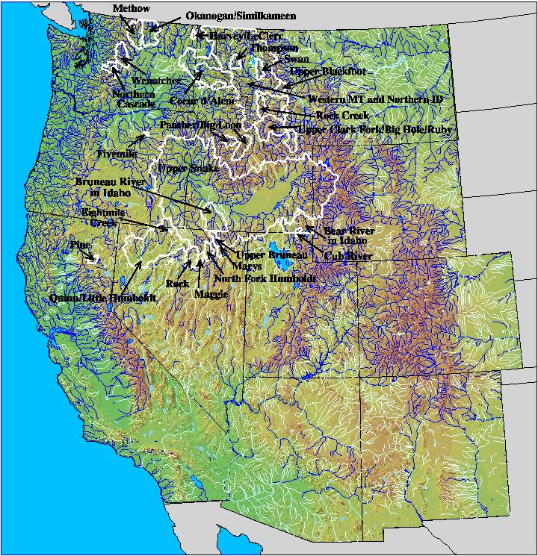
Figure 3. Ecological classification project areas.

A conceptual model (adapted from Klijn and de Haes 1994) incorporating several ecosystem components (Figure 4) served to guide the design of the classification. The model is hierarchical, meaning that for the most part lower components depend on those above. The model ranks and relates the processes that influence both the genesis and functional attributes of a landscape at successively finer spatial and temporal scales. The upper components (e.g., regional climate and geology) generally affect large areas and change over very long time-scales. Geomorphic processes affect landscapes at several spatial and temporal scales and are a major influence on hydrologic, soil and vegetative processes that affect smaller areas and change over shorter time-scales. The bottom-up influences of lower on upper components, though usually less evident, are also important.

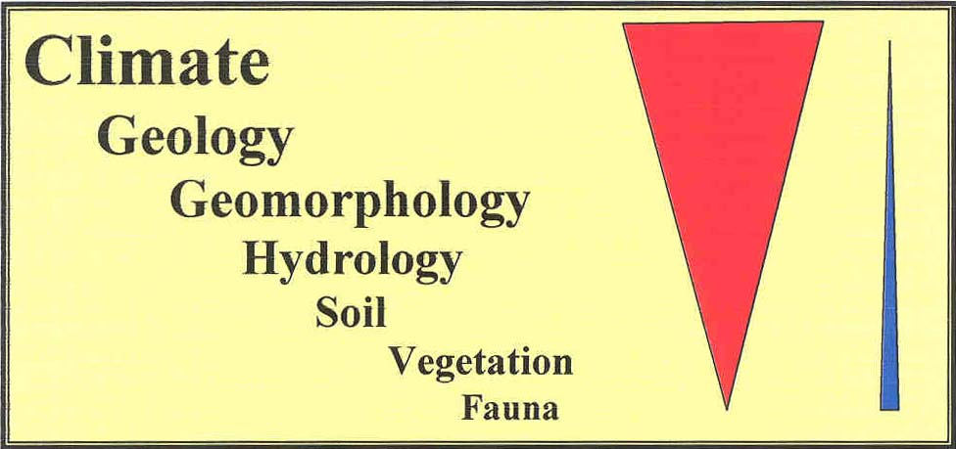
Figure 4. Hierarchical model of an ecosystem.

The goal of Ecological Classification is to group landscapes with distinctive form, function and ecological potential and to arrange these groups into orders, such that similarities and differences between groups can be better understood. The framework consists of hierarchical levels, arranged in sequence from large to small (Figure 5 and Table 1). The upper levels (ecoregion, geologic district and subsection) are founded mostly upon causative, independent variables. Subsections are divided into bottomlands, corresponding with the valley-bottom landtype, and uplands. Three levels of upland habitat (landtype association, landtype and habitat type) are based on the successively more manifest and dependent variables of position, soil and biotic potential.

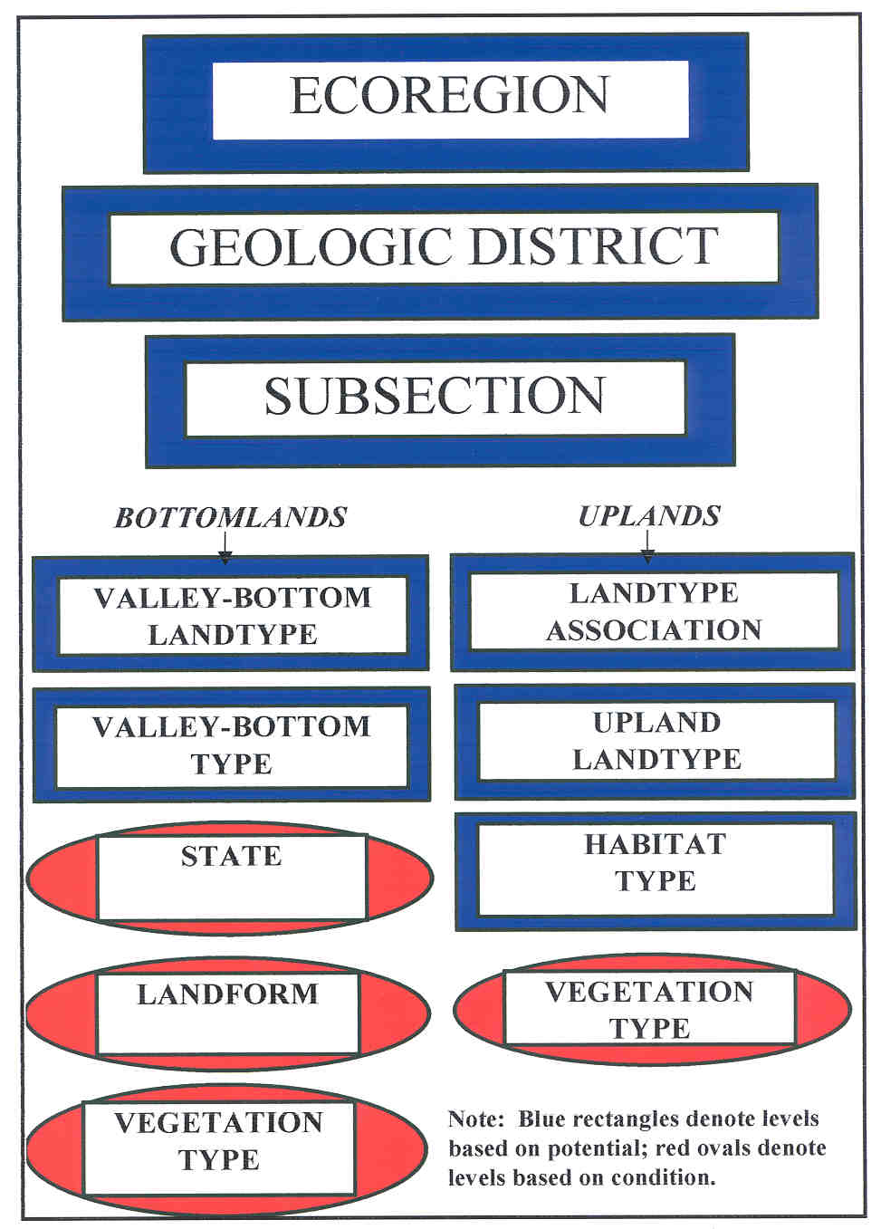
Figure 5. Classification hierarchy.

Table 1. Hierarchical levels of classification.

Ecoregion Ecoregions (Omernik 1987) are areas of distinctive land-surface form, potential natural vegetation, land-use and soil.
Geologic district Areas of distinctive parent materials that differ from surrounding districts in structure, degree of weathering, dominant size-fractions of weathering products and water- handling characteristics. They may contain several subsections.
Subsection Lands that evolved in response to distinctive geomorphic processes that correlate with landscapes of distinctive form -- mountains sculpted by alpine glaciers are distinguished from mountains dissected by streams and from more gentle terrain shaped by continental glaciation.
Valley-bottom landtype The valley-bottom landtype includes mostly depositional lands along stream courses. Landforms include those formed by alpine glaciers (basins and moraines), streams (floodplains, alluvial fans and terraces), and continental glaciation (glacio-lacustrine terraces). This level is used to focus on streams and associated riparian habitats.
Valley-bottom type Reaches of the valley-bottom landtype that generally correlate with subsections that are distinguished by effectiveness of the dominant geomorphic process. The valley-bottom in glacial lands can be divided as glacial basin (zone of scour), glacial train (zone of transport) and glacial outwash (zone of deposition). Valley-bottom types are distinguished based on valley grade and morphology. They correlate with streams and riparian habitats of distinctive ecological potential.
State Condition classes based on stream channel morphology. A valley-bottom type with distinctive ecological potential may be partitioned perpendicular to the valley axis into several states. States are defined based on channel morphology that dictates hydrologic parameters influencing the distribution of riparian vegetation.
Valley-bottom landform Areas of distinctive geomorphic character within the valley-bottom that generally correlate with distinctive soil. Common valley-bottom landforms include alluvial fan, terrace, floodplain, levee and channel.
Vegetation type Areas if distinctive floristic character that usually correlate with valley-bottom type, state and valley-bottom landform. Typically identified based on physiognomy, water regime and species composition.
Bottomlands correspond with the valley-bottom landtype (Figure 5) and are where streams and riparian habitats occur. The valley-bottom landtype within a subsection is divided into valley-bottom types (VBTs) that denote areas of distinctive ecological potential. Valley bottom types are further divided into states (i.e., condition classes) based on differences in channel morphology. Valley-bottom landforms and riparian vegetation types are distinguished at larger-scales. States, valley-bottom landforms and riparian vegetation types denote areas of distinctive condition that may change in response to common land uses. An application of the hierarchy to the stream/riparian resources of the Marys River basin (White Horse Associates 1997a) is presented as Figure 6. Each level of the Ecological Classification is subsequently discussed.
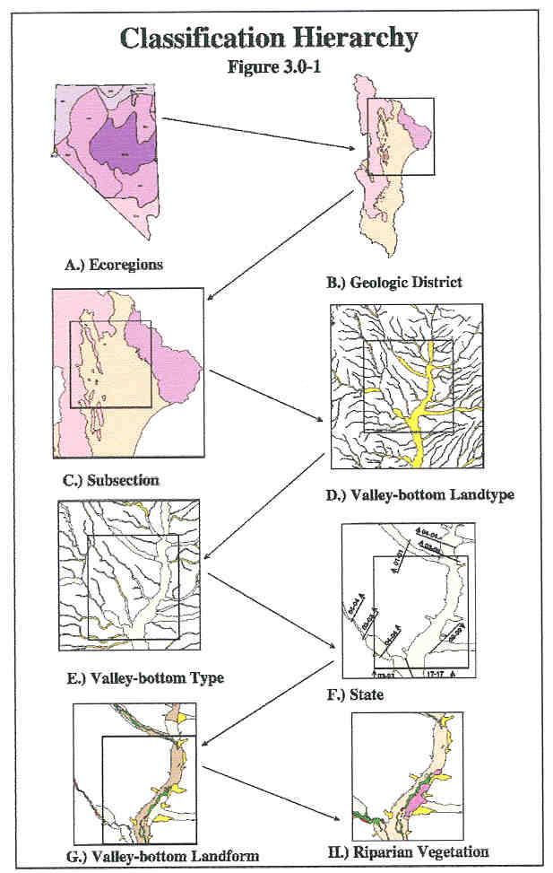

Figure 6. Example application of hierarchy.
Ecoregion

Omernik (1987) identified ecoregions (Figure 7) based on factors that cause regional variation in ecosystems or on factors that integrate the causes of regional variations. Principal factors used to identify ecoregions are land surface form, potential natural vegetation, land use and soils. These ecoregions have been used to identify streams of similar potential to facilitate impact assessments (Hughes and Gammon. 1986; Rohm et al. 1987) and for identifying streams with similar biotic and physicochemical characteristics (Hughes et al. 1987.

The upper Boise and upper Payette River basins encompass parts of three ecoregions:

Northern Rockies Ecoregion: Landscapes include rugged, high, sharply crested mountains with steep slopes dissected by narrow stream valleys. Coniferous stands of western white pine, lodge pole pine, western red cedar, western hemlock, western larch, Douglas fir, subalpine fir and Engelmann spruce are common. Soils are mostly derived from acidic rock types under a frigid or cryic soil temperature regime and are mostly Chryochrepts and Xerochrepts. Timber harvest is the major economy, but wildlife habitat, recreation and mining are also important land uses. Comprises 69 percent of the upper Boise River basin and 72 percent of the upper Payette River basin.

Snake River Basin/High Desert Ecoregion: Tablelands with moderate to high relief and plains with low hills and mountains. Sagebrush-steppe and saltbush/greasewood vegetation is common. Soils are mostly Aridisols and Aridic Mollisols. Livestock graze desert shrublands and irrigated agriculture are prominent land uses. Comprises 23 percent of the upper Boise River basin.

Blue Mountain Ecoregion: Landscapes are typically low to high open mountains. Potential natural vegetation is grand fir/Douglas-fir, western ponderosa pine, western spruce/fir, and Douglas fir. Soils are Mollisols and Inceptisols typical of interior mountainous regions. Livestock grazing and forestry are prominent land uses. Comprises 8 percent of the upper Boise River basin and 28 percent of the upper Payette River basin.

The diversity within different ecoregions varies with structure, geology, geomorphology and topography. The diversity within the Snake River Basin/High Desert Ecoregion, a relatively flat lava plateau is low relative to the Northern Rockies Ecoregion, with diverse structure, geology, geomorphology and resulting topography. Areas of similar geologic and geomorphic character, but in different ecoregions, are often more similar that areas of different geologic and geomorphic character in the same ecoregion. Riparian vegetation in alpine glaciated granitic lands in the Ruby Mountains (Northern Basin and Range Ecoregion) more closely resembles that in alpine glaciated granitic lands in central Idaho (Northern Rockies Ecoregion) than riparian communities typical of the Great Basin.
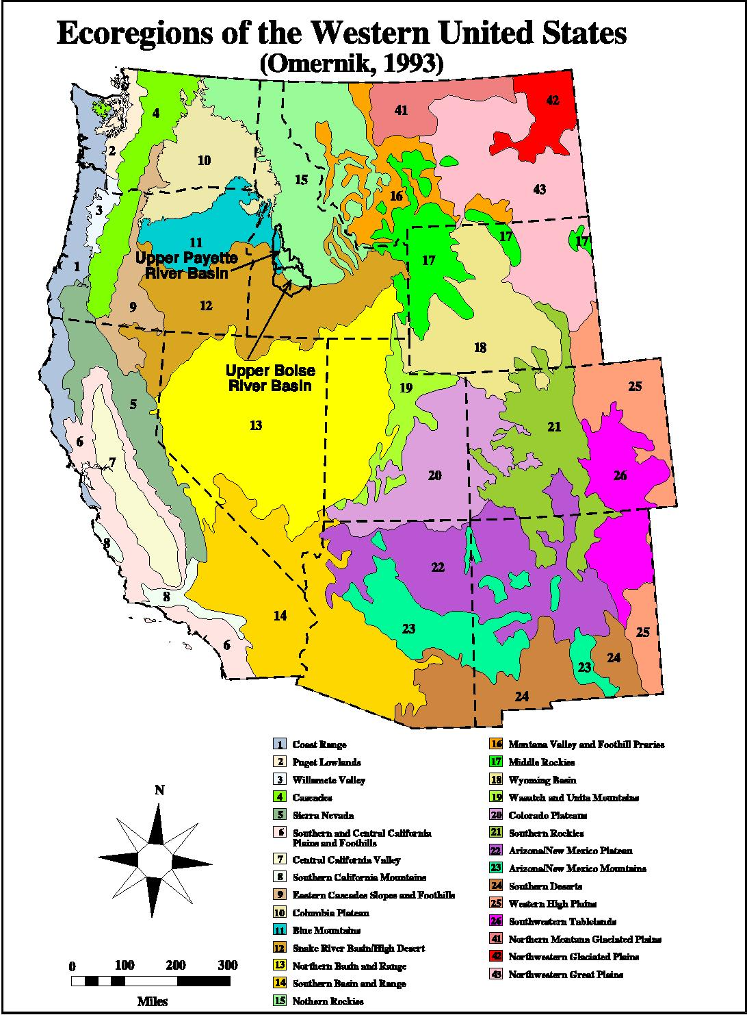
Figure 6. Ecoregions of the Western United States (Omernik 1993).
Geologic District

Geologic districts are areas of similar rock type or parent material that generally correspond with distinctive assemblages of upland potential plant communities, topography and hydrologic character. The hydrologic character of landscapes is also influenced by the degree to which parent material has been weathered (producing sediment) and the water-handling characteristics (e.g., porosity, retention, etc.) of the parent rock and its weathering products. The hydrologic character of hard rock (e.g., quartzite) that weathers slowly to mixed sizes (e.g., silt, sand, gravel and cobble) is different from that of soft rock (e.g., tuff) that weathers rapidly to fine-textured sediment. Geologic districts may be 10s to many 100s square miles. Geologic districts do not change (to other types) in response to cultural practices and include both uplands and bottomlands. They denote areas of more distinctive ecological potential.

A previous study of the upper Snake River basin (above the Salmon River confluence) serves as a basis for preliminary interpretations of geologic districts (White Horse Associates 1999a). A preliminary map of geologic districts (Figure 7) was developed from 1:500,000 scale, digital geologic maps of Idaho (Bond and Wood 1978), Nevada (Stewart and Carlson 1978), and Oregon (Walker and MacLeod, 1991). Similar rock types were combined as geologic districts. Major Lithology Classes identified by the ICRBEMP (2000) served to guide formulation of geologic districts.

Most of the upper Boise and upper Payette River basins is part of an extensive pluton of Mesozoic granitic rock known as the Idaho Batholith (Figure 7). Small areas of volcanic (mostly Miocene basalt) and metamorphic parent material are also present. A large area of alluvium (probably including glacial drift) is present in the North Fork Payette subbasin. Small areas of alluvium marked in the other subbasins will probably be included with the surrounding (granitic) geologic district. Concepts for geologic districts will be refined for the upper Boise and Payette River basins.

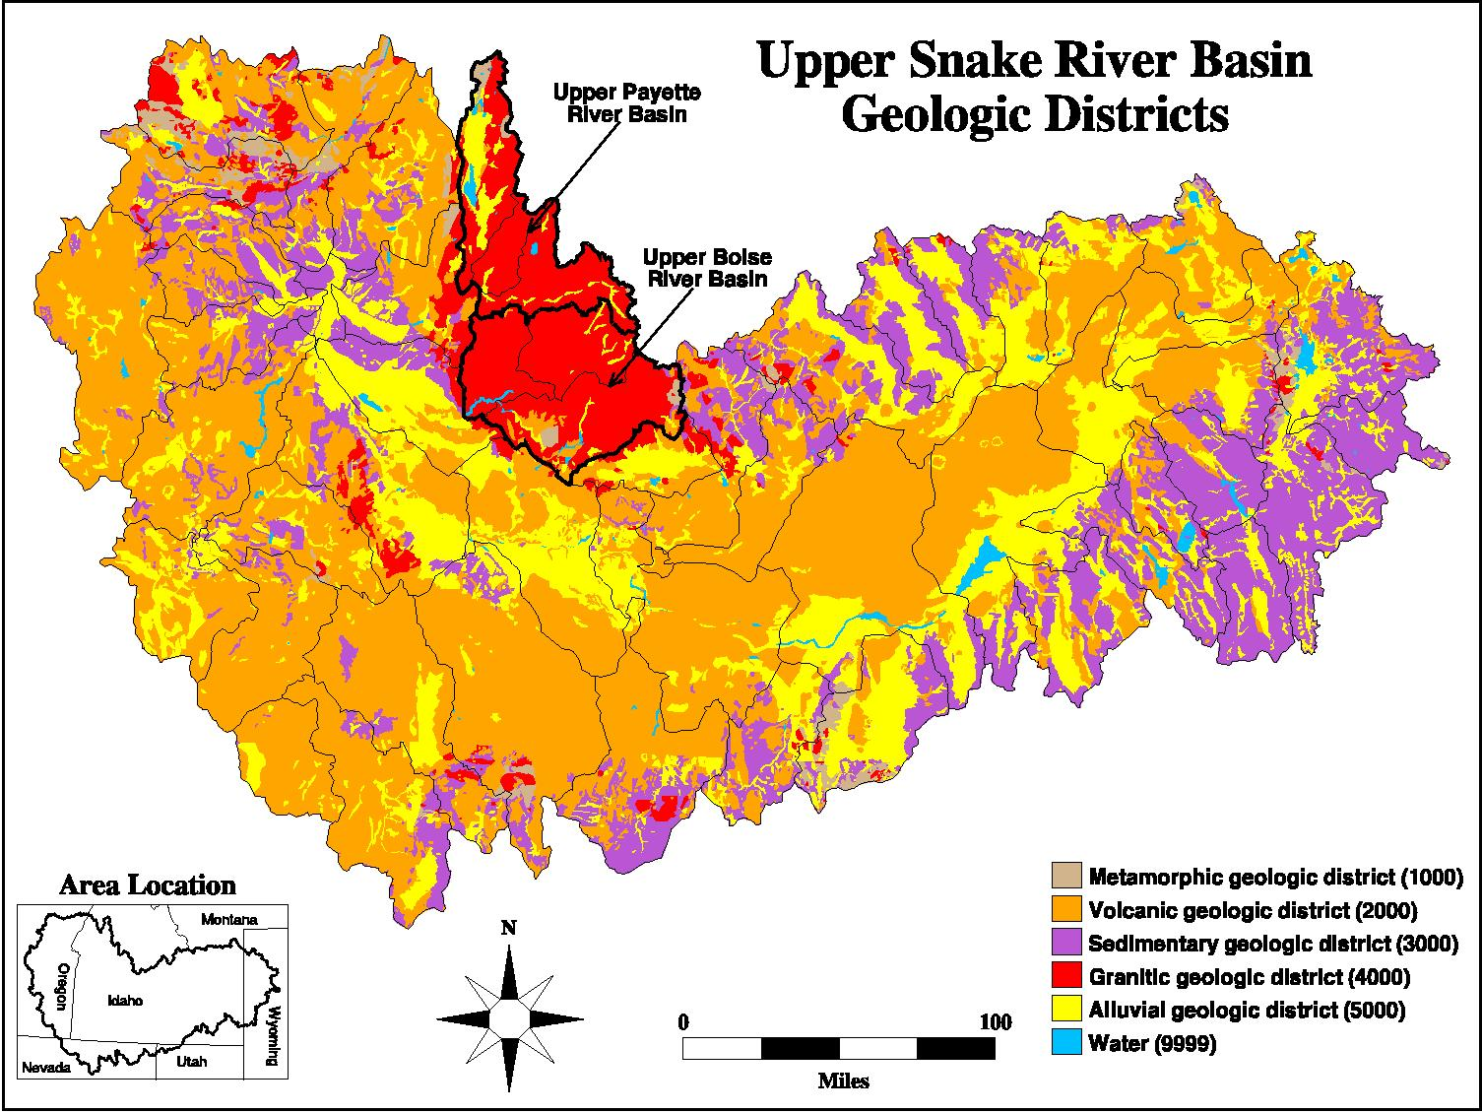
Figure 7. Upper Snake River basin, preliminary geologic districts.
Subsection

Subsections are the intersection of the previously discussed geologic districts and geomorphic classes, defined in terms of the broad-scale processes that have shaped the landscape. A previous study of the upper Snake River basin serves as a basis for preliminary interpretations of geomorphic classes (White Horse Associates 1999a). Geomorphic classes were first delineated on a 1:700,000 scale topography map generated from 1:250,000 scale DEMs. An overlay of dominant landform (Ford et al. 1997) served as a guide for delineating geomorphic class (Figure 8). Three preliminary geomorphic classes were identified in the upper Boise and Payette River basins:

Alpine glacial (erosional) lands: High mountain that were shaped by alpine glaciers; includes cirques and U-shaped valleys; elevations are mostly greater than 6,000 feet; dominant slopes are 10 to 22 percent; boundaries with fluvial lands are diffuse; other boundaries are generally clear.

Alpine glacial (depositional) lands: Broad, block-faulted valleys filled with course textured outwash from the melting of alpine glaciers; includes the valleys of Birch, Little Lost and Big Lost Creeks; elevations are mostly 4,000 to 7,000 feet; dominant slopes are less than 10 percent; boundaries with plateau lands are diffuse; other boundaries are generally clear.

Fluvial lands: Mountains with stream cut (V-shaped) valleys; elevations are mostly 3,000 to 7,000 feet; dominant slopes are 2 to 22 percent; boundaries with plateau and alpine glacial (erosional) lands are diffuse; other boundaries are generally clear.

Preliminary subsections were based on the intersection of geomorphic class and geologic districts (Figure 9). Three major preliminary subsections were identified: 1) Granitic alpine glacial (erosional) lands; 2) Granitic alpine glacial (depositional) lands; and 3) Granitic fluvial lands. Topography of the basins reflects a terrain that attained a mature erosional level by middle Tertiary and was subsequently uplifted, renewing valley incision (Stovall 2001). Quaternary alpine glaciation is evident, though classic glacial basins and U-shaped canyons are rare. Narrow, V-shaped canyons separated by sharp ridges characterize fluvial lands. Concepts for geomorphic classes and subsections will be refined for the upper Boise and Payette River basins.

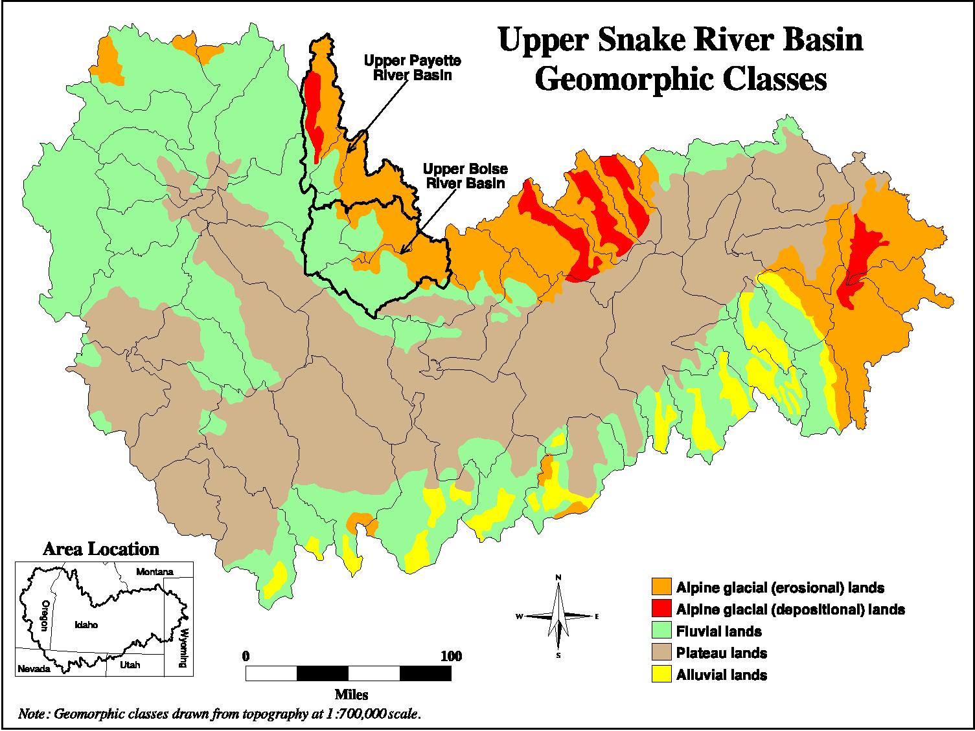
Figure 8. Upper Snake River basin, preliminary geomorphic class.
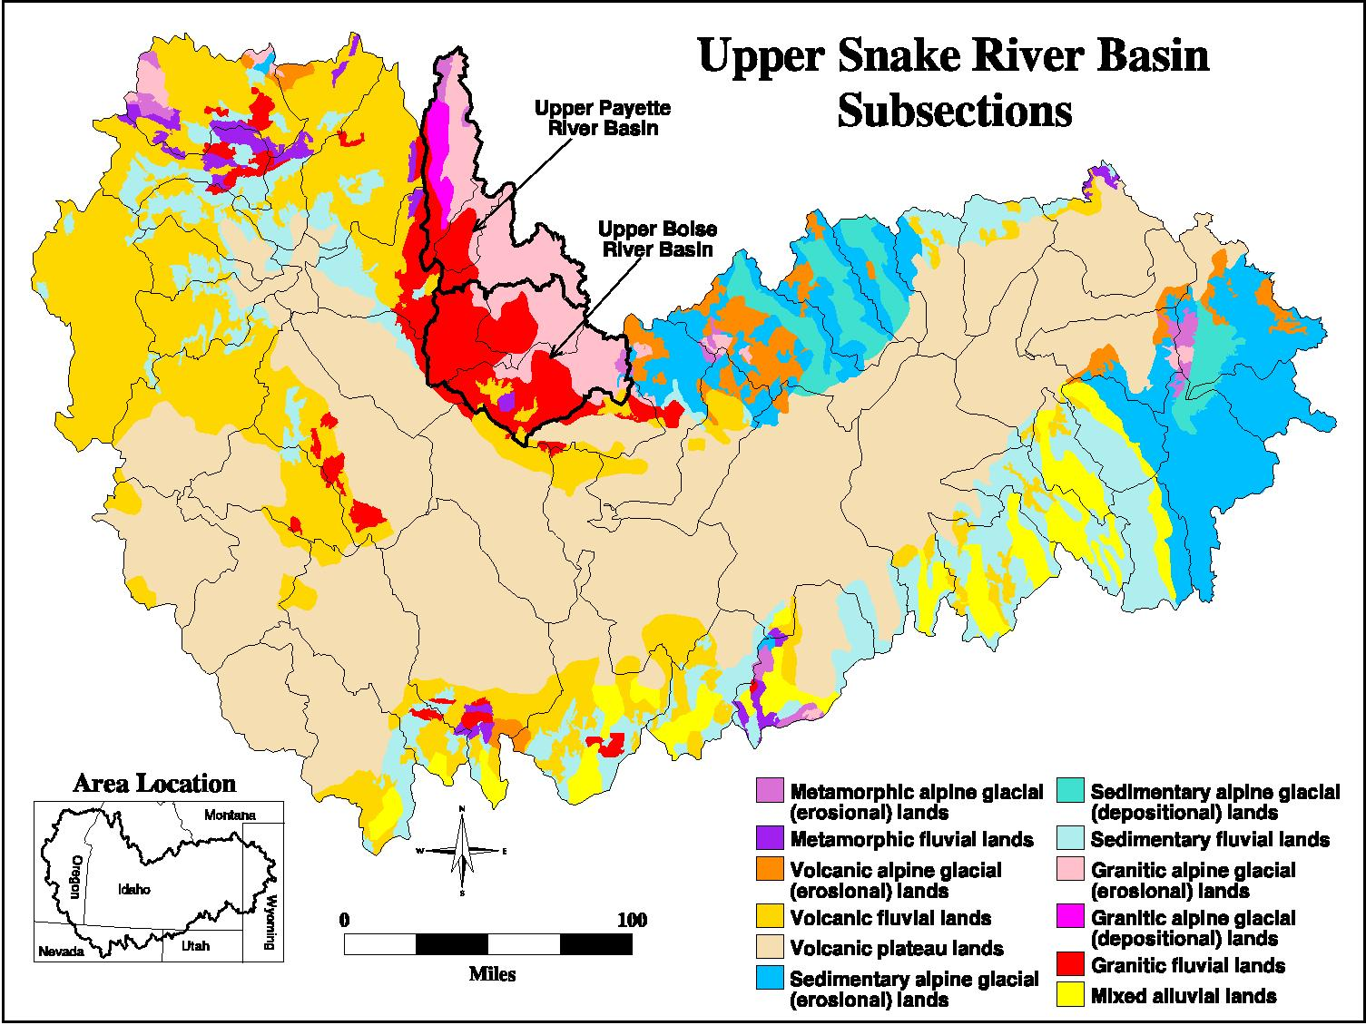

Figure 9. Upper Snake River basin, preliminary subsections..
Valley-bottom Landtype

The valley-bottom landtype corresponds with stream courses and includes stream channels, floodplains, terraces, alluvial fans, lateral moraines and lake basins. Soils are derived from secondary parent materials and are alluvial, fluvial or lacustrine in origin. The valley-bottom landtype is a simple concept for distinguishing bottomlands from uplands.

Valley-bottom Types
Valley-bottom types (VBTs) are subdivisions of the valley-bottom landtype within a subsection that are distinguished based on the mode and relative effectiveness of the dominant geomorphic process in shaping the valley-bottom. The valley-bottoms in alpine glacial land may be divided into glacial basin (zone of scour), glacial train (zone of transport) and glacial outwash (zone of deposition) VBTs. Similarly, the valley-bottom of fluvial lands may be divided into fluvial basin/cascades, V-shaped confined canyons (zone of transport), and V-shaped unconfined canyons (zone of deposition) VBTs. VBTs do not change (into different VBTs) in response to most land uses. Valley-bottom types denote assemblages of streams and riparian habitats with distinctive form, function and ecological potential. They are characterized by degree of valley confinement, gradient, landform distribution, stream sinuosity and substrate. These same attributes are common criteria for “bottom-up” classification of stream types (Rosgen 1994).

States
States are condition classes of valley-bottom types that are usually distinguished based on stream channel morphology. States typically differ between valley forms (e.g. glacial basin versus glacial outwash versus V-shaped confined canyon) and between different dominant land uses (e.g. forestry versus livestock grazing). While the states of similar valley-forms in different geologic districts (i.e. valley-bottom types) are generally similar, the susceptibility to deterioration and rates of recovery are often very different. Canyons in hard rocks (e.g. metasedimentary) that weather slowly and yield large substrates and fragmental soils are typically less susceptible to livestock impacts than those in soft rocks (e.g. tuff) that weather rapidly and yield fine sediments, though the later tend to recover from impacts more rapidly.

A generalized progression of six states developed to illustrate livestock impacts to V-shaped unconfined canyons in the Great Basin is illustrated in Figure 10.

- Natural state: A “fit” channel that overflows to dissipate the energy of floods across the floodplain; streambanks are stable and bordered by riparian vegetation. Overhanging banks may be present. Streambars and eroded banks are mostly absent.

- Eroded state: Overhanging banks are usually absent and active bank erosion is evident; stream channels are somewhat wider and/or more entrenched, corresponding with subtle lowering of stream and groundwater levels; the channel may overflow to floodplains and levees, but at somewhat higher discharge than the same channel in the natural state; concave banks are mostly eroded and streambars are common along convex banks; this is a critical state, beyond which impacts lead to significant increase in channel size, lowering of stream and groundwater levels and permanent reduction in the area of potential riparian habitat.

- Incised or broadened: Streams with fine substrates that are relatively homogeneous with depth tend to incise; streams with course substrates that become courser with depth tend to widen; streams of intermediary character tend to both broaden and incise to varying degrees; flood flows are usually confined within the channel; adjacent areas that were once floodplains and levees are now high-and-dry stream terraces; concave banks are actively eroding and streambars are usually continuous along convex banks.

- Blown out: The stream channel is significantly enlarged; streambars are usually present along both sides of the active channel; hydric, vegetated riparian habitat has been either scoured away or left high-and-dry on stream terraces; this is the endpoint of deterioration.

- Stabilized: Given rest, vegetation stabilizes the wetted channel bottom, encouraging deposition of sediments and a rise in stream and groundwater levels.

- Achievable: Continued aggradation and stabilization eventually leads to an achievable state that is similar to the natural state, but usually at a lower base level.

Harvey et al. (1985) describe a similar evolution of states for alluvial channels.
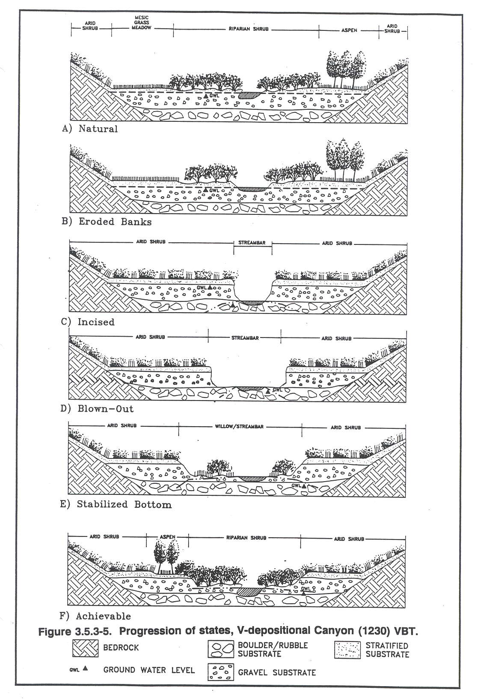
Figure 10. Generalized progression of states.
Other common miscellaneous states include: ponded state is identified where streamflow is impounded by beaver to a depth sufficient to raise water levels near the surface in riparian habitats adjacent to the stream; impounded state is used for lakes and reservoirs; channelized state is used for reaches that have been artificially deepened and/or straightened; and dredged state is used for rubble piles left by placer mining.

It is likely that states for VBTs in the upper Boise and Payette River basins influenced by debris flows, depletion of large woody debris, fire, extensive logging roads, flow alteration, inundation behind dams and mining will be different from those previously illustrated. States must be specific to the landscape setting (VBT) and be tailored to reflect the land/water uses in the basin. States resulting from forestry practices in the Northwest are different from states resulting from livestock grazing in the Great Basin. Protected areas may serve to identify relatively natural states of VBTs. White Horse Associates has developed many progressions of states specific to ecoregions, valley-forms and land uses.

States have been used to assess grazing, mining, and forestry impacts to stream and riparian resources and for identifying areas best suited for restoration and/or improvement. They have served as a basis for selecting control streams in several Natural Resource Damage Assessments (NRDAs). They have been used as a surrogate for water quality monitoring for TMDL analyses and as a basis for implementation of TMDLs in several watersheds in Idaho and Utah (White Horse Associates 1999a; 2001). Gebhardt et al. (1990) found states useful for comparing existing and reference conditions. The concept of states is a basis for the BLM approach for assessing proper functioning condition (USDI BLM 1993). The concept of VBT/states is similar to that of riparian complexes (USDA Forest Service 1991) in that they denote reaches of distinctive ecological potential and existing condition. States are also useful for assessing vegetation trend and successional status of riparian communities – changes in state lead to predictable changes in the distributions of landforms and riparian vegetation types. We have mapped states from aerial photos for over 10,000 miles of stream in the western United States.

Valley-Bottom Landforms
Valley-bottom landforms (e.g. channel, floodplain, levee, fan, terrace, moraine, etc.) are fine-scale geomorphic features that generally correspond with soils and hydrologic regime. Landforms may change in response to land use – livestock impacts may result in an increase in the size of stream channels at the expense of floodplains; when streams incise, floodplains are converted to terraces. It is important to view stream/riparian assessments in context with landforms – where streams abut alluvial fans, streambanks are inherently unstable relative to where floodplains abut the channel; the water regime and potential natural communities for stream terraces and alluvial fans are very different from floodplains and levees.

Riparian Vegetation Types

Riparian vegetation types are distinguished by community physiognomy, species composition and water regime. The local distributions of riparian vegetation types typically correspond with landforms, states and VBTs. For a given VBT and landform, changes in state lead to predictable changes in the distribution of riparian vegetation. Regional distributions of riparian vegetation types are influenced by subsection, geologic district and ecoregion. The distribution of riparian vegetation types in pristine or minimally impacted watersheds may serve as reference for impacted reaches of the same ecological class. Fish and wildlife resource values are closely linked to riparian vegetation types.

White Horse Associates has mapped riparian landforms and vegetation types for more than a half million acres along over 5,000 miles of stream. An example map denoting VBT/state, landform and vegetation types for a reach of McDermitt Creek (one of 37 subbasins evaluated in the Little Humboldt River basin) in northern Nevada (White Horse Associates 1999d) is presented as Figure 11. Riparian landforms are shown on the left map and corresponding vegetation types on the right map. Black arrows with black numeric codes denote valley-bottom type (2440—Volcanic plateau depositional notch canyon) and state (4 – blown out). A monitoring station (MCD4) and BLM assessments reach (1-FAR) are also marked on the map. The composition of the VBT/state complex can be easily summarized in terms of landform and riparian vegetation type. We anticipate developing similar maps for streams in the upper Boise River and upper Payette River basins.

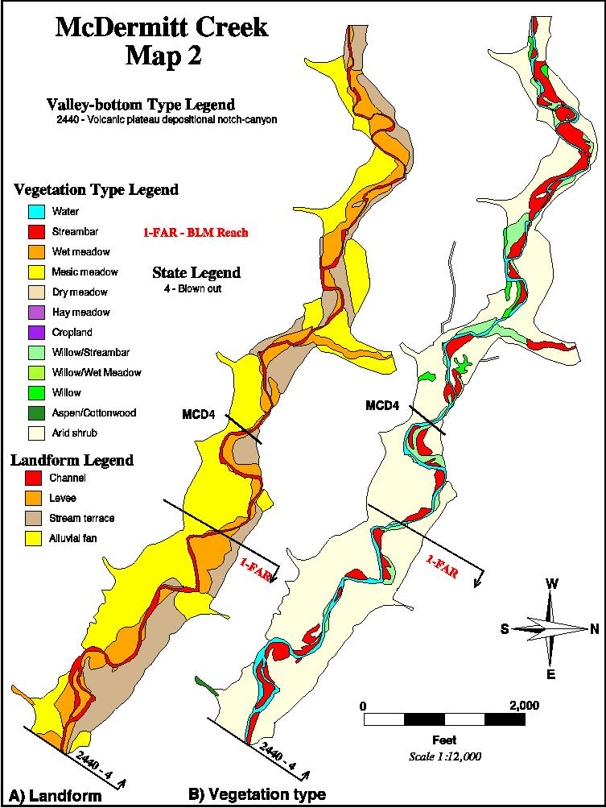
Figure 11. Example landform/vegetation type map.

c. Rationale and significance to Regional Programs

The proposed inventory and assessment of stream and riparian resources will serve all of the goals from which fish and wildlife needs in the Boise-Payette-Weiser subbasins were formulated. These goals (Stovall 2001) are to:

- Address limiting factors to fish, wildlife and plant communities;
- Fill gaps in current data and knowledge;
- Enhance existing programs critical to successful management of fish and wildlife resources; and
- Guide development of new programs to enhance fish and wildlife management.

The inventory and assessment will fill a gap in existing knowledge regarding the distribution and extent of riparian vegetation types, identify factors influencing the condition of stream and riparian resources, and serve to enhance management of the resources for fish and wildlife. Specifically, the study addresses the following need stipulated for Wildlife Riparian Plant Communities:

- Inventory and map the distribution of riparian plant communities

The proposed study may also contribute information useful for achieving several other needs specified in the subbasin summary:

- Inventory, map and gather population data for riparian associated wildlife and plant species.
- Improve trend and condition of the subbasin riparian plant communities located in critical sage grouse habitats.
- Reconnect historic streams to recover lost riparian plant communities and habitats.
- Cooperate on threatened, endangered and sensitive species recovery or conservation strategy efforts in the subbasin.
- Acquire existing ecological data sets where possible and compile metadata according to national standards.
- Establish and maintain permanent monitoring systems within ecological reference areas for priority ecosystems and species.
- Identify candidate sites for the establishment of ecological reference areas based on current needs and assessments. Periodically update ecological reference area needs assessments.
- Continue ongoing, and establish new, monitoring and evaluation programs for fish supplementation, habitat restoration and improvement, habitat baseline conditions, water quality and water quantity improvements, conditions and trends. These monitoring and evaluation activities are critical to evaluating the effectiveness of projects at improving habitat, watershed health and enhancing production of target species.

The proposed study will provide a basis for gathering population data for riparian associated plant and animal species. It will also provide quantitative information on habitat factors that may be limiting to fishery and wildlife resources. It will provide a map base from which the efficacy of grazing and riparian easements or modification of land use practices to improve water quality can be evaluated. Products will serve as basis for evaluating past, current and future management in the basin to enhance fish, wildlife and water quality parameters. Products will also serve as a basis for identifying minimally impacted reference reaches, for refining TMDL assessments, and as a basis for watershed analyses.

Stovell (2001) listed major factors limiting fisheries and wildlife in the basins including water resource development and operations, non-point source impacts to water quality, stream impacts resulting from timber harvest, livestock grazing and road construction, mining, and habitat loss/fragmentation. There has been widespread loss of riparian-wetland vegetation communities, affecting both aquatic and terrestrial species and resulting in dramatic alterations of floodplains and river channels, but few formal investigations to assess the magnitude and distribution of impacts. The proposed study will address the need to inventory non-point source impacts to stream and riparian resources and provide detailed inventories from which the lost benefits can be estimated. Products will also be useful for projecting benefits that may be gained through alternative management and/or restoration.

Livestock grazing is common on federal, state and private lands throughout the upper Boise and Payette River basins (Stovall 2001). Historically, improper livestock grazing has impacted stream and riparian resources. Since the mid-1990s federal land management agencies have been implementing changes in grazing practices on allotments to improve the condition of these resources. The proposed inventory and assessment will serve as a basis for evaluating the effectiveness of these management changes and to identify areas where more work is needed.

Habitat fragmentation and simplification is a critical problem in the upper Boise and Payette River basins (Stovall 2001). The proposed inventory and assessment will provide some quantification of the distribution of these problems resulting from non-point source impacts. Changes in state typically correspond with changes in the distribution of vegetation types upon which many fish and wildlife species are dependent. Map products will facilitate identifying both the independent parameters responsible for some habitat fragmentation (i.e. states) and the dependent parameters (e.g. distribution of riparian vegetation types).

Land use activities have adversely affected wildlife habitat over the last 200 years (Stovall 2001). Products of the Ecological Classification will enable resource managers not only to determine resource values for existing conditions, but also to project resource values for other (past or future) conditions. The distribution of riparian vegetation types and associated resource values inventoried for a VBT/landform in near natural state can be used to estimate habitat losses for the same VBT/landform in a degraded state. Similarly, comparisons can be used to predict gains in resource values for changes in management or restoration towards an achievable state.
Wildlife specialists typically utilize Habitat Evaluation Procedure (HEP) for estimating habitat units for particular species as part of EISs and other analyses. Descriptions of riparian vegetation types will include floristic parameters typically needed for HEP analyses (e.g. species composition, height, cover, etc.). Other spatial parameters commonly needed for HEP models (e.g. distance to water, elevation range, etc.) can be easily procured from the GIS database. Products of the proposed inventory and assessment will be useful input for subsequent HEP analyses.

The proposed study will facilitate prioritization and design of habitat restoration mandated by the Biological Opinion (BiOp issued by the NMFS in December 2000 and the Federal Caucus All-H Paper. Specifically, it will address Action 152 to coordinate and support offsite habitat enhancement measures among Federal agencies, states, Tribes and local government. The project will integrate ongoing TMDL monitoring conducted by IDEQ and provide valuable products for refining TMDLs in the basins. It will also provide needed mapping from which riparian buffers can be considered (Action 153), and as a basis for updating subbasin assessments (action 155). It will also enhance products of the ICBEMP by providing more refined information relevant to stream and riparian resources at larger scales. The proposed inventory and assessment will provide a more comprehensive basis for prioritizing actions and planning restoration activities.

The goal of the NMFS with respect to the Boise-Payette-Weiser subbasins is use stored water to provide enhanced flow and passage to achieve recovery of the Snake River spring/summer and fall Chinook, sockeye and steelhead resources (Stovall 2001). Achieving this goal will require management for proper functioning condition of stream and riparian resources. The proposed inventory and assessment will provide a baseline from which proper management can be evaluated.

The Forest Service and BLM manage salmonid habitat in the Boise-Payette-Weiser subbasins under direction of the Interim Inland Native Fish Strategy (INFISH). The program provides interim strategies to improve riparian habitat and water quality and facilitate meeting requirements of the ESA. More recently, the BLM and Forest Service released a Supplemental Draft EIS for the ICRBEMP that focuses on critical broad-scale issues related to landscape health; aquatic and terrestrial habitats; human needs; and products and services (Stovall 2001). The ICBEMP will guide efforts to develop revised Forest Plans, which will replace interim strategies. The proposed study will augment ICRBEMP inventories needed to evaluate and implement long-term management of stream and riparian resources in the upper Boise and Payette River basins.

Under mandate of the Environmental Protection Agency (EPA), the Idaho Department of Environmental Quality (IDEQ) has identified water quality limited (303d) streams in the upper Boise and Payette River basins. Most streams in the upper Boise and Payette River basins are listed for sediment. Total maximum daily loads (TMDLs) for the Middle Fork Payette subbasin was completed in 1998 and a plan for implementing the TMDL is anticipated soon. The TMDL for the South Fork Payette subbasin is due in 2002, North Fork Payette in 2003. The IDEQ is also working on TMDLs for the upper Boise River basin. The proposed inventory and assessment can be used to enhance both completed and ongoing TMDL efforts, and as a basis for remediation to achieve TMDLs. Where the TMDL process identifies water quality limited watersheds on a broad basis, the Ecological Classification will identify conditions for discrete stream reaches comprising the water quality limited watersheds. The EPA has accepted Ecological Classifications conducted by White Horse Associates as surrogates for more typical water quality monitoring for non-point source limited TMDLs in southern Idaho.

Ecological conditions of the upper Boise and Payette River basins were evaluated as part of the Interior Columbia River Basin Ecosystem Management Project (ICRBEMP 2000). Products of the proposed Ecological Classification will provide finer level map resolution at larger scales from which more specific interpretations can be derived. Integrating results for the upper Boise and Payette River basins for broader scale hierarchical levels identified in the ICRBEMP (e.g. geologic district, subsection and possibly valley-bottom type) may also allow extrapolation of significant findings to a much broader area.

Results will also be useful for refining existing and ongoing Biological Assessments for bull trout and other fish and wildlife species dependent on stream and riparian resources. Results will also address requirements of Section 404 of the Clean Water Act for wetland delineation – the refined mapped of state, landforms and riparian vegetation types anticipated from the proposed study will comply with reconnaissance level wetland delineations in that soil, hydrologic and vegetation criteria definitive of jurisdictional wetlands will be evaluated (albeit direct observations will be conducted for a subsample of potential wetland polygons).

d. Relationships to other projects

The Boise-Payette-Weiser subbasin summary (Stovall 2001) lists a single BPA-funded research project:

(Project No. 980002) – Snake River Native Salmonid Assessment (IDFG): Products of the proposed inventory and assessment are expected to be useful for interpreting results of this ongoing project to assess current status of native salmonids, identify factors limiting populations, and develop recovery plans.

The Forest Service Rocky Mountain Research Station (RMRS) is currently studying mass wasting following fire on granitic soils of the Idaho Batholith in the Boise and Payette River subbasins. Products of the RMRS study may provide useful background for the interpretation of states in the proposed study. The RMRS has also conducted extensive research regarding the effects of logging roads on water quality and quantity; measures of habitat, channel condition and temperature that may reflect the influence of management and natural disturbance; evaluated the temporal dynamics of fine sediment intrusion in salmonid spawning habitat; the effects of water diversions on riparian habitat and near-stream ground water level response to diversions in the Boise and Payette River basins; and temperature patterns in the Boise River basin. The Boise NF has also studied the effects of large and intense wildfires on native fish. These studies will serve as background for the proposed inventory and assessment.
The IDEQ has conducted extensive surveys of stream habitat, water quality and biotic conditions in the Boise-Payette-Weiser subbasins as part of the Beneficial Use Reconnaissance Program (BURP). Sample sites are scattered across each major hydrologic unit within the subbasins, but tend to be biased towards listed 303d streams and tend to be near major confluences. Results of this monitoring will be useful for characterizing states in the immediate vicinity of the BURP stations. Given that BURP stations are used to characterize relative extensive areas (upstream from the station), proposed inventory and assessment products can also serve to refine interpretations of BURP monitoring and more specifically identify major non-point source impacts contributing to the water quality limitation.

We expect to identify additional ongoing relevant studies in the course of project implementation.

e. Project history

New project/Not applicable

f. Proposal objectives, tasks and methods

Objectives

Objectives that address the need to inventory and map riparian vegetation in the Boise-Payette-Weiser subbasins (Stovall 2001) are:

- Inventory and assess stream/riparian resources in the upper Boise River basin.
- Inventory and assess stream/riparian resources in the upper Payette River basin.

Tasks (for each objective)
    - Compile existing information
    - Reconnaissance
    - Mapping
    - Description
    - Reports
    - QA/QC

Task A – Compile Existing Information

Existing information pertinent to the upper Boise and upper Payette River basins will be collected from the Boise-Payette NF and other sources. It is anticipated that existing information will include:

- Resource aerial photos (1:15.640 scale dated 1996 through 2000)
- Digital Ortho Quads (DOQs)
- 10m or 30m Digital Elevation Models (DEMs)
- 1:24,000 scale Digital Line Graphs (DLGs)
- Digital Raster Graphs (DRGs)
- USGS streamflow and water quality monitoring data
- USGS landuse/landcover
- Idaho GAP analysis mapping
- Climate monitoring data
- Land Systems Inventory (LSI) maps and documentation
- Forest soil and vegetation mapping
- Stream monitoring station locations and associated monitoring data.
- IDEQ Beneficial Use Reconnaissance Project (BURP) stations and monitoring data
- Watershed analysis documents
- Descriptive information pertinent to riparian resources.
- Land use information (e.g. livestock use; forest stand information; etc.)
- Broad-scale landscape mapping prepared for the ICRBEMP
- Other information pertinent to the upper Boise/Payette River basins and/or stream riparian resources in the vicinity of these basins

Spatial information will be compiled on GIS. Tabular information will be compiled as spreadsheets and linked to GIS.

The stream network for the upper Boise River basin will be compiled from 1:24,000 scale Digital Line Graphs (DLGs). A stream order based on Strahler (1957) will be assigned to each reach, defined as that between successive confluences. The headwater tributaries marked on 1:24,000 scale quads are order 1. The convergence of two order 1 streams makes an order 2 stream; the convergence of two order 2 streams makes and order 3; etc. Stream gradient will be estimated for each stream reach. The upstream and downstream elevations of stream reaches will be estimated from the 30 meter DEMs. Grade will be calculated as:

((E_{u} - E_{d})/L) * 100

Where: E_{u} = Upstream elevation of reach
E_{d} = Downstream elevation of reach
L = Length of reach from DLGs

A program will be used to estimate sinuosity of each reach. The program calculates sinuosity as the ratio of stream length to valley length. The distance over which valley length is measured varies for each reach to adjust for bends in the valley bottom. A confinement class will be assigned to each reach. Stream attributes will be used to characterize valley-bottom types. DEMs will also be used to develop elevation, slope and aspect classes used to characterize subsections.

Stovall (2001) notes that although many have collected and continue to collect diverse data pertaining to aquatic and riparian system health, there is no subbasin-scale program to coordinate the work conducted by all concerned. And that more careful examination of existing information might allow more efficient efforts across all subbasins. We intend to make a significant effort to acquire, review and integrate existing information pertinent to stream and riparian resources in the upper Boise and Payette River basins. Resource specialists for the Boise-Payette NF will coordinate these efforts. Pertinent information will be integrated using GIS.

Task B – Preliminary Reconnaissance

With aerial photos in hand, a preliminary reconnaissance will be conducted. The purposes of the reconnaissance will be to prepare a preliminary legend of distinctive valley-bottom types, states, landforms and riparian vegetation types and to learn to recognize these features from the aerial photos. Resource specialists from the Boise-Payette NF will assist in the preparation of legends. Their familiarity with the resources, land/water uses and historical perspectives will be invaluable for identifying functional land classes and especially for defining existing condition classes (i.e. states).

Representative riparian features will be marked on the aerial photos to serve as guides for subsequent mapping and photo interpretation. Sensible criteria for identifying states will be derived through ground observations paired with on-site photo interpretation. Field notes regarding the distribution, composition and characteristics of riparian resources will be saved to audiotape for transcription. Map unit concepts developed during the reconnaissance. Forest Service specialists will provide input to ensure map unit concepts are compatible with achieving management directions and goals.

Task C – Mapping

We anticipate that the existing Land Systems Inventory (LSI) and ICRBEMP mapping will serve as a basis for broad-scale inventory map layers (i.e. ecoregion, geologic district, subsection, and possibly valley-bottom type. States, landforms and riparian vegetation types will be mapped from 1:15,640 scale, natural color resource photos dated 1996 through 2000, DOQs and DRGs for major perennial streams (mostly order 3 and higher). Lower order perennial streams will also be mapped where significant and diverse riparian habitat is present. More general map interpretations will be used to inventory lower order streams. Large tracts of private lands in the basins where Forest Service photos may not be available will be mapped from 1:40,000 scale NAPP photos or other available imagery. We estimate that about 1,100 miles of major perennial streams will be mapped in the upper Boise River basin and 1,000 miles in the upper Payette River basin.

Map interpretations will be based on field reconnaissance and over 20 years experience delineating riparian features from aerial photos. An analytical plotting scope (APS) will be used to view the photos in stereo at large-scales and to produce very refined riparian mapping. Digital map output from the APS will be compiled as ArcInfo maps.

Riparian mapping will entail the following steps:
- Orient resource photos
- Map riparian features
- Compile GIS mapping
- Field verification
Orient Resource Photos

An AP190 APS that was designed for the Forest Service by Carto Instruments for resource mapping will be used to orient resource photos covering target stream reaches. Photos are mounted on glass plates controlled by very accurate micrometers. Parameters listed on the camera calibration files (e.g. distance between fiducials, focal length, radial distortion, etc.) are input to the orientation program. Fiducial points along the edges of aerial photos are used to accurately register the photos to the glass plates. Relative (common) points on adjacent photos are used to precisely link stereo pairs to within 0.03 mm. Absolute (control) points from quads or orthoquads are used to link photos to ground coordinates (UTM) to within 10 meters for X, Y and Z coordinates. Statistical programs built into the AP190 calculate the Residual root Mean Square (RMS) error for registration, relative and absolute parameters. These statistical measures are used to document accuracy and precision. Relative and absolute orientations are saved to the job file – each pair is oriented only once. We estimate that about 1,000 of the 1:15,640 scale resource photos cover the major perennial streams in the upper Boise River basin and 900 photos for major perennial streams in the upper Payette River basin. The orientation procedure takes about 20 minutes per photo pair.

Map Riparian Features

Valley-bottom types, states, landforms and riparian vegetation types will be mapped while viewing the resource photos in stereo at 1:1,000 to 1:15,000 scales (5 -15X) using the AP190. Features are delineated with a 0.03 mm dot in the viewfinder, allowing delineation of much smaller features than conventional mapping with a 0.5 mm pencil. Lines are written directly to a file, so the photos do not get cluttered up with lines. Distance between successive points of a line (each with an X, Y and Z coordinate) can be adjusted for the size and complexity of polygons (e.g. 1 mm for large polygons with simple boundaries or 0.1 mm for small, complex boundaries). Mapping from each photo pair is saved to a digital job file that can be copied to adjacent job files for accurate edge matching. Digital output from the AP190 are registered (UTM) and ortho-rectified images that can be compiled using ArcInfo GIS.

Valley-bottom types will be divisions of the valley-bottom landtype within a subsection distinguished by form, function and ecological potential. Valley-bottom types may range from less than a mile to many miles in length and can be distinguished at relatively small scales (e.g. 1:15,000). States (condition classes) are divisions of valley-bottom types distinguished by channel morphology and will be mapped from aerial photos viewed at somewhat larger scale (e.g. 1:6,000) coupled with field reconnaissance. States may range from a few hundred feet to several miles in length. Protected areas in the upper Boise and Payette River basins (including roadless areas, ecological reference areas, wild and scenic rivers, and Nature Conservancy reserves) may serve to identify relatively natural states of VBTs.

Landforms (e.g. channel, floodplain, terrace, fan, moraine, lake basin) will be mapped from resource photos viewed at about 1:3,000 scale. Landforms are distinguished by surface form (e.g. convex, concave, hummocky, undulating, etc.) and position relative to local gradients. Soil boundaries typically conform to landform boundaries. The smallest landforms delineated will be less than an acre. Long narrow landforms (e.g. stream channels) may be mapped as buffers on a central line. The distributions of riparian vegetation types typically conform with landforms.

Riparian vegetation types typically will be distinguished by physiognomy (conifer, deciduous forest, tall shrub, short shrub, herbaceous), dominant species composition in overstory and understory strata (e.g. Salix boothii/Calamagrostis canadensis) and apparent water regime (Cowardin et al. 1979; see Figure 12). Riparian vegetation types are expected to be similar to those described and classified for the Salmon/Middle Fork Salmon River watersheds immediately north of the upper Boise and Payette River basins (Tuhy and Jensen 1981). Information regarding wetland and riparian plant associations and community types in areas adjacent to the basins (Crowe and Clausnitzer 1995) will also be evaluated. The smallest riparian vegetation type delineations will be less than one acre.

We anticipate three types of riparian vegetation type map units:

- Consociations: Map units consisting of a single dominant riparian vegetation type that can be distinguished from surrounding types.

- Associations: Map units consisting of two or more riparian vegetation types that are distributed in a predictable manner, but that may be difficult to distinguish from the resource photos.

- Complexes: Map units consisting of two or more community types that are distributed in an unpredictable manner, but that recur in similar landscape positions. The components of complexes cannot be distinguished from the resource photos.

All riparian vegetation type map units will contain some defined level of inclusions of contrasting types (e.g. <15 percent).

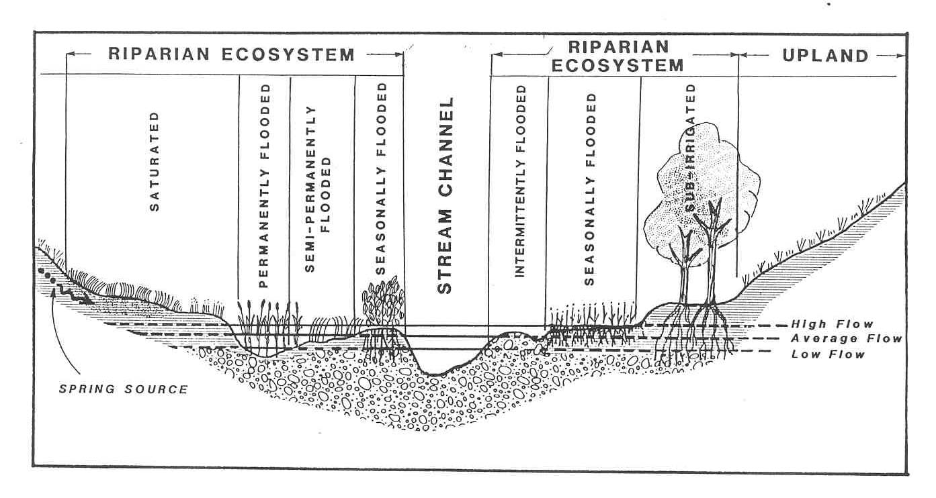

Figure 12. Water regimes (modeled after Cowardin et al. 1979).
Compile Mapping on GIS

Job files from the APS will be dumped to ArcInfo for subsequent compiling, editing, plotting and summarizing. Mapping will be compiled on black-and-white digital orthoquads (DOQs) for subsequent editing. While riparian features that can be distinguished by pattern, texture, density and contrast are quite apparent at 1:24,000 and larger scales, more subtle vegetation features distinguished by color (hue, value and chroma) may not be evident. While the black-and-white DOQ images are adequate for compiling and editing VBT/state complexes, landforms and most vegetation types mapped from the resource photos, color images would be better. Alternatives to the DOQs (e.g. ortho-rectified, CIR NAPP images) will be investigated.

ArcInfo GIS will be used to plot maps and summarize map parameters. Other GIS map layers (e.g. streams, slope, aspect, elevation, etc) may also be relevant to characterizing stream and riparian resources. ArcInfo files of discrete map elements (e.g. VBT/state, landform, riparian vegetation types, etc.) will be made available on the Boise NF web site. Links may also be established from other web sites specializing in landscape issues in the Columbia River basin (e.g. ICRBEMP).

Field Verification

Office edited mapping will be field checked for accuracy of boundaries and identifications. If consistent errors specific to a map unit are found, all delineations of that map unit will be reviewed. Field edits will be compiled on the digital map files.

Task D -- Descriptions

Existing map, descriptive and monitoring data will be used to characterize VBT/state complexes, landforms and riparian vegetation types to the extent possible. Where existing data is inadequate, field descriptions will be conducted to further characterize stream and riparian resources.

VBT/State Complex Descriptions

Valley-bottom types will be characterized mostly from existing map information. Attributes will include degree of valley confinement, stream and valley grade, stream sinuosity and substrate distribution. These same attributes can be used to determine the distribution of stream types (Rosgen 1994) for VBTs. We anticipate that existing stream channel monitoring conducted by the Boise-Payette NF and BURP monitoring conducted by IDEQ as part of ongoing TMDL analysis will be used to characterize VBT/state complexes. Parameters useful for characterizing states include bank stability, channel dimensions relative to stream dimensions, width/depth ratio, pool features, heterogeneity, substrate composition and embeddedness. Other parameters specific to landscape settings and land/water uses in the target watersheds may be identified. If existing monitoring information is inadequate for characterizing VBT/state complexes, additional monitoring will be conducted utilizing Level II methods in the Integrated Riparian Evaluation Guide (USDA Forest Service 1991). VBT/state complexes will also be described in terms of the distribution of riparian landforms and vegetation types.

Riparian Landform Descriptions

Existing soil survey information will be used to characterize riparian landforms if available. If not, representative landforms in each VBT will be described and classified according to Natural Resource Conservation Service (NRCS) procedures for describing and classifying soils. Where available, road-cuts, stream-cuts, and/or existing excavations will be described. Shallow pits and auger borings may also be used to characterize the range in soil characteristics (e.g. depth to groundwater).

Riparian Community Type Descriptions

Representative areas of riparian vegetation types will be described. Methods will follow those developed by Region 4 Forest Service for classifying riparian communities in the Intermountain Region (Tuhy and Jensen 1981; Youngblood et al. 1983). Replicate areas representative of distinctive vegetation types will be selected. Ocular estimates of plant species composition (percent aerial cover) and height will be recorded. Landform, soils and hydrologic characteristics will also be described. Resource specialists from the Boise-Payette NF will be consulted regarding other important parameters that may be useful for specific interpretations (e.g. HEP analyses for critical wildlife species). The locations of rare, threatened and endemic plant species encountered in the course of reconnaissance and riparian community type descriptions will be recorded.

Task E -- Reports

Draft and final reports will be prepared. ArcInfo map and spreadsheet files will also be provided on compact disks. Reports and map files will be made available on the Boise-Payette National Forest web site. The Boise-Payette NF will also be responsible for the long-term storage of products.

Task F -- QA/QC

Quality assurance/quality control will be maintained throughout all phases of the proposed study. Mapping on resource photos will be visually reviewed for consistency and accuracy relative to pattern, color, texture, density and contrast. The final map layers will be free of node, label and polygon errors.

Draft products will be reviewed by resource specialists from the Boise-Payette NF. This monitoring and evaluation (M&E) will be conducted to determine if the project met goals and objectives and to assess the usefulness of the products for use in management. Comments from the NF resource specialists will be addressed in final products.

g. Facilities and equipment

White Horse Associates (WHA) maintains a modern GIS/Mapping Lab in Smithfield, Utah. Some of the hardware and software we use include:
- ARC/INFO Versions 7.2 and 8.1 (Windows NT) GIS Program and associated modules
- ARC/VIEW Versions 8 and 7.2 (Windows NT) GIS Program
- GIS Workstation (Windows NT) with 80 GB hard disk capacity, RW-CD and RW-DVD
- Ap190 Analytical Stereo Plotter and software (Carto Instruments)
- Cal Comp Backlit Drawing Board III Digitizing tablet
- Hewlett Packard 3500CP Large format Inkjet Printer
- Nikon mirror stereoscope with 2X and 5X lenses
- Light table for backlighting aerial photos.
- Laminator (24 inch width)
- Three Windows NT workstations that are networked to the GIS Workstation

WHA also has two 4-wheel drive vehicles and an assortment of camp comforts.

h. References
Reference (include web address if available online) | Submitted w/form (y/n)
Bailey, R.G. 1976. Ecoregions of the United States. Map (scale 1:7,500,000). USDA Forest Service, Intermountain Region, Ogden, UT.  Bailey, R.G. 1985. The factor of scale in ecosystem mapping. Environmental Management. 9: 271-276.  Bailey, R.G. 1988. Ecogeographic analysis, a guide to the ecological division of land for resource management. USDA Forest Service Miscellaneous Publication 1465. 16 pp.  Bailey, R.G. 1995. Description of the Ecoregions of the United States. 2nd edition. USDA Forest Service Miscellaneous Publication No. 1391. 108 pp.  Bailey, R.G., Pfister, R.D. and J.A. Henderson. 1978. Nature of land and resource classification, a review. Journal of Forestry, October: 650-655.  Benda, L., Beechie. T.J., Wissmar, R.C. and A. Johnson. 1991. Morphology and evolution of salmonid habitats in a recently deglaciated river basin, Washington state, USA. Canadian Journal of Fisheries and Aquatic Science Vol. 49: 1246-1256.  Bond, J.G. and C.H. Wood. 1978. Geologic map of Idaho (1:500,000 scale). Idaho Dept. of Lands and US Geological Survey.  Bryce, S.A and S.E. Clarke. 1996. Landscape-level; ecological regions: linking state-level ecoregion frameworks with stream habitat classifications. Environmental Management Vol. 20, No. 3. pp. 297-311.  Chapman, D. , Giorgi, A., Hillman, T., Deppert, D., Erho, M., Hays, S., Peven, C., Suzumoto, B. and R. Klinge. 1994. Status of summer/fall chinook salmon in the Mid-Columbia region. 411 pp + APP.  Cole , G.F. 1972. Valley types, an extension of the land systems inventory to valleys. Boise National Forest, Boise, ID.  Cowardin, L.M., Carter, V., Golet, F.C. and E.T. LaRoe. 1979. Classification of wetlands and deepwater habitats of the United States. FWS/OBS-79/31.  Cupp, C.E. 1989. Valley segment type classification for forested lands of Washington. Timber, Fish and Wildlife Ambient Monitoring Program Report. Washington Department of Natural Resources. Olympia, WA 47 pp.  Daubenmire, R. 1968. Plant communities: a textbook of plant synecology. Harper and Row. New York. 300 pp.  Davis, W.M. 1899. The geographic cycle. Geographical Journal 14: 481-504.  ECOMAP. 1993. National hierarchical framework of ecological units. Unpublished administrative paper. Washington, DC: USDA Forest Service. 20 pp.  Ford, G.L. Maynard, C.L., Nesser, J.A. and D.S. Page-Dumroese. 1997. Landtype associations of the Northern Region: a first approximation. Digital maps and text on CD rom. Rocky Mountain Research Station; General Technical Report RMRS-GTR-2-CD.  Frissel, C.A., Less, W.M., Warren, C.E. and M.D. Hurley. 1986. A hierarchical framework for stream habitat classification: viewing streams in a watershed context. Environmental Management Vol. 10, No. 2, pp 199-214.  Gebhardt, K., Leonard, S., Staidl, G. and D. Prichard. 1990. Riparian and wetland classification review. USDI Bureau of Land Management Technical Reference 1737-5. 56 pp.  Hall, J.B. and P.L. Hansen. 1997. A preliminary riparian habitat type classification system for the Bureau of Land Management districts in southern and eastern Idaho. Idaho Bureau of Land Management, Technical Bulletin No. 97-11. 381 pp.  Hansen, P.L. Pfister, R.D., Boggs, K., Cook, B.J., Joy, J. and D.K. Hinckley. 1995. Classification and Management of Montana=s riparian and wetland sites. Montana Forest and Conservation Experiment Station, School of Forestry, University of Montana, Miscellaneous publication No. 54. Missoula, MT.  Harris, R.R. 1988. Associations between stream valley geomorphology and riparian vegetation as a basis for landscape analysis in the eastern Sierra Nevada, California, USA. Environmental Management Vol. 12 (2):219-228.  Harvey, M.D., Watson, C.C. and S.A. Schumm. 1985. Gully erosion. USDA Bureau of Land Management, Technical Note 366. U.S. Government Printing Office, Washington D.C. 181 pp.  Hughes, R.M. and J.R. Gammon. 1986. Longitudinal changes in fish assemblages and water quality in the Williamette River, Oregon. Transactions of the American Fisheries Society. Vol. 116, No. 2, 196- 209.  Hughes, R.M. Rextad, E. and C.E. Bond. 1987. The relationship of aquatic ecoregions, river basins and physiographic provinces to the Ichthyogeographic regions of Oregon. Coperia, 1987 (2), pp. 423-432.  Interior Columbia River Basin Ecosystem Management Project. 2000. www.icbemp.gov.  Jensen, S., Ryel, R. and W. Platts. 1989. Pilot study, classification of riverine/riparian habitat and assessment of non-point source impacts, North Fork Humboldt River, Nevada. Report to USDA Forest Service, Intermountain Research Station, Boise Fisheries Unit. 165 pp.  Klijn, F. and H.A. Udo de Haes. 1994. A hierarchical approach to ecosystems and its implications for ecological land classification. Landscape Ecology Vol. 9, No. 2:89-104.  Kovalchik, B.L. 1987. Riparian zone associations: Deschutes, Ochoco, Fremont, and Winema National Forests. USDA. Forest Service, Pacific Northwest Region, Ecology Technical Paper 279-87, Portland, OR.  Lotspeich, F.B. and W.S. Platts. 1982. An integrated land-aquatic classification system. North American Journal of Fisheries Management 2:138-149.  Mill, J.S. 1891. A system of logic, 8th ed. Harper and Bros., New York. 659 pp.  Montgomery, D.R. and J.A. Buffington. 1993. Channel classification, prediction of channel response and assessment of channel condition. Washing State Timber/Fish/Wildlife Agreement, Report TFW-SH10-93-002. 84 pp.  Omernik, J.A. 1987. Ecoregions of the conterminous United States. Annals of the Association of American Geographers 77:118-125.  Omernik, J.A. 1995. Ecoregions: A spatial framework for environmental management. p 49-62 in: Biological assessment and criteria, tools for water resource planning and decision making. Edited by Wayne S. Davis and Thomas P. Simon. Lewis Publishers, Boca Raton, London, Tokyo.  Pfister, R.D., Kovalchik, B.L., Arno, S.F. and R.C. Presby. 1977. Forest habitat types of Montana. GTRINT-34. USDA Forest Service, Ogden, UT. 174 pp.  Pflieger, W.L., Schene, M.A. and P.S. Haverland. 1981. Techniques for the classification of stream habitats, with examples of their application in defining the stream habitats of Missouri. Paper presented at the Symposium for Acquisition and Utilization of Aquatic Inventory Information, Portland, OR, October 28-30, 1981.  Platts, W.S. and S.E. Jensen. 1991. Pine Creek assessment. Report to Lassen National Forest; Susanville, CA  Pojar, J., Klinka, K. and D.V. Meidinger. 1987. Biogeoclimatic ecosystem classification in British Columbia. Forest Ecology and Management, 22: 119-154.  Rohm, C.M., Giese, J.W. and C.C. Bennett. 1987. Evaluation of an aquatic ecoregion classification of streams in Arkansas. Journal of Freshwater Ecology. Vol. 4, No. 1:127-140.  Rosgen, D.L. 1994. A classification of natural rivers. Catena 22, 169-199.  Schumm, S.A. 1963. A tentative classification of alluvial river channels. U.S. Geological Survey Circular 477. Washington DC.  Soil Survey Staff. 1975. Soil taxonomy, a basic system of soil classification for making and interpreting soil surveys. USDA Soil Conservation Service, Agricultural Handbook No. 436. U.S. Government Printing Office, Washington DC. 754 pp.  Steward, J.H. and J.E. Carlson. 1978. Geologic map of Nevada (1:500,000 scale). US Geological Survey and Nevada Bureau of Mines.  Stovall, S.H. 2001. Boise-Payette-Weiser Subbasin Summary. Northwest Power Planning Council.  Strahler, A.N. 1957. Quantitative analysis of watershed geomorphology. Transactions, American Geophysical Union; Vol. 38; pp 913-920.  Tuhy, J.S. and S.E. Jensen. 1981. Riparian classification for the upper Salmon/Middle Fork Salmon River drainages, Idaho. Report to USDA Forest Service, Region 4; Ogden, UT. 178 pp.  USDI Bureau of Land Management. 1993. Riparian area management, process for assessing proper functioning condition. Technical Reference 1737-9. Bureau of Land Management Service Center, Denver, CO. 51 pp.  Walker and McLeod. 1991. Geologic map of Oregon (1:500,000 scale). U.S. Geological Survey and Oregon Bureau of Mines  Wertz, W.A. and J.F. Arnold. 1972. Land systems inventory. USDA Forest Service, Intermountain Region, Ogden, UT. 12 pp.  White Horse Associates. 1992. Classification and inventory of riverine/riparian habitat: Five Mile Creek basin. US Forest Service, Umatilla National Forest. Pendleton, OR 169 pp.  White Horse Associates. 1993. Classification and assessment of Panther Creek, Big Creek and Loon Creek in northwest Idaho. Report compiled as part of a Natural Resource Damage Assessment to the Idaho State Attorney General.  White Horse Associates. 1994a. Classification and assessment of upland and riverine/riparian habitats, Bruneau River basin, Nevada (Volumes 1 through 4). Report to Rocky Mountain Elk Foundation, Northeastern Nevada Chapter Trout Unlimited, USDA Forest Service/Mountain City Ranger District and Bureau of Land Management/Elko District.  White Horse Associates. 1994b. Ecological classification, HCP project area. Report to Plum Creek Timber Company, Seattle, WA.  White Horse Associates. 1995a. Inventory and assessment of riverine/riparian habitats, Rock Creek basin, Nevada. Report to Barrick Goldstrike, Inc. and Elko District B.M., Elko, NV.  White Horse Associates. 1995b. Inventory and assessment of riverine/riparian habitats, Maggie Creek basin, Nevada. Report to Barrick Goldstrike, Inc. and Elko District B.M., Elko, NV.  White Horse Associates. 1995c. Stream classification and assessment. IN: Assessment of injury to fish populations: Clark Fork River NPL Sites, Montana; prepared by Don Chapman Consultants. Report to Montana Department of Justice, Natural Resource Damage Litigation Program, Helena, MT.  White Horse Associates. 1995d. Ecological classification, Swan River basin, Montana. Report to Plum Creek Timber, Columbia Falls, MT.  White Horse Associates. 1996a. Ecological classification, LeClerc/Harvey project area, Washington. Report to Plum Creek Timber, Columbia Falls, MT.  White Horse Associates. 1996b. Ecological classification, upper Blackfoot River basin, Montana. Report to Sevenup-Pete Joint Venture, Helena, MT.  White Horse Associates. 1997a. Ecological classification, Marys River basin, Nevada. Report to Bureau of Land Management and Trout Unlimited, Elko, NV.  White Horse Associates. 1997b. Ecological classification, Thompson River basin, Montana. Prepared for Plum Creek Timber, Columbia Falls, MT.  White Horse Associates. 1998b. Ecological classification, Eight Mile Creek basin, Nevada. Report to USDA Forest Service, Santa Rosa Ranger District, Winnemucca, NV.  White Horse Associates. 1999a. Ecological classification to facilitate sediment and total phosphorous export coefficients for grazing related activities in southern Idaho. Report to IDEQ; Twin Falls, ID.  White White Horse Associates. 1999b. Ecological classification, Bear River basin in Idaho. Report to IDEQ, Twin Falls, Idaho.  White Horse Associates. 1999c. Geologic districts and subsections, western Montana and northern Idaho. Report to Plum Creek Timber; Columbia Falls, MT.  White Horse Associates. 1999d. Ecological Classification, Winnemucca project area, Nevada. Report to the Winnemucca BLM District, Winnemucca, NV.  White Horse Associates. 2000. Ecological Classification, Coeur d’Alene, upper Spokane, St. Joe and St. Regis River subbasins, Idaho, Montana and Washington. United States of America v. Asarco Inc. et al. Expert Report.  White Horse Associates. 2001. Ecological Classification, Bruneau River basin, Idaho. Report to IDEQ, Twin Falls, ID.  Youngblood, A.P., W.G. Padgett and A.H. Winward. 1985. Riparian community type classification of eastern Idaho-western Wyoming. Intermountain Region, USDA Forest Service, R4-ECOC-85-01. Ogden, UT.  USDA Forest Service. 1991. Integrated riparian evaluation guide, Intermountain Region. Ogden, UT. 125 pp. | N  N  N  N  N  N  N  N  N  N  N  N  N  N  N  N  N  N  N  N  N  N  N  N  N  Y  N  N  N  N  N  N  N  N  N  N  N  N  N  N  N  N  N  N  N  N  N  N  Y  N  Y  Y  Y  Y  N  Y  Y  Y  Y  Y  Y  Y  Y  Y  Y  Y  Y  N  N

Section 10 of 10. Key personnel

Sherman Jensen (Principal Investigator): Sherman is president and founder of White Horse Associates. He received degrees in Soil Science from Utah State University in 1977 and 1979. Sherman has 22 years professional experience classifying, describing, mapping and monitoring riparian resources in the western United States. He began his career developing classifications of riparian community types in the Grays River basin in Wyoming (1980) and the upper Salmon/Middle Fork Salmon River basins (1981) under contract with the Forest Service. He has since conducted broad-scale classifications and mapping of over 100 million acres in the western United States, mid-scale inventories (valley-bottom type/state for over 12 million acres, and fine-scale mapping of riparian complexes, landforms (soils) and vegetation types for about a half million acres along about 5,000 miles of stream. He is an expert riparian ecologist and loves to map. Experience relevant to classification, wetland studies, riparian studies, restoration, modeling, and expert testimony can be viewed at www.whitehorseassociates.com. Sherman will coordinate the project and be principally responsible for mapping, assessment, interpretations and reports. (link to short vitae; link to long vitae)

Ted Dean (GIS Supervisor): Mr. Dean is Vice-President of White Horse Associates, Inc. He earned a degree in Geography, specializing in GIS applications, from Utah State University in 1988. He has 14 years hands-on experience applying ArcInfo GIS to natural resource inventories. He will be principally responsible for all GIS applications. (Link to vitae)

Frank (Buddy) Smith (Botanist): Mr. Smith received a degree in Plant Science from Utah State University in 1979. He has over 26 years plant taxonomic experience. He is a devoted field man and participated in many of the riparian studies conducted by White Horse Associates. In the course of many studies, Buddy has discovered 5 new plant taxa. He is a recognized expert in plant taxonomy. He has served as a consultant to White Horse Associates for over 20 years. Buddy will assist in characterizing riparian vegetation types. (link to short vitae; link to long vitae)

The following resource specialists from the Boise-Payette NF will assist the White Horse Associates staff:

T.J. Clifford, Forest Hydrologist
John Erickson, Forest Wildlife Biologist
Edna Vizgirdas, Forest Botanist
Michael Kellett, Forest Fish Biologist
Terry Hardy, Forest Soil scientist

They will coordinate the gathering of existing information, provide guidance for developing map unit legends, and insure that products will be useful for management.

