Bonneville Power Administration

FY 2003 Provincial Project Review

PART 2. Narrative
Project ID: 200001600

Title: Protect and Enhance Tualatin River National Wildlife Refuge Additions

Section 9 of 10. Project description

a. Abstract

The habitats of the Tualatin River watershed support a vast array of fish and wildlife species including ESA listed salmonids, and other wildlife designated as species of special concern. This proposed project seeks to acquire, restore, monitor, and maintain in perpetuity within Tualatin River National Wildlife Refuge (TRNWR) habitats that have been designated Essential Fish Habitat by the Pacific Fisheries Management Council under the Magnuson-Stevens Act. The project will continue to protect and restore critical habitats as they become available for acquisition. Fiscal year 2003 request is to acquire two parcels totaling 20 acres of intact high-quality riparian forest adjacent to main stem Tualatin River; restore an additional 230 acres of riparian forest, forested wetland, emergent wetland, and associated upland habitat; and conduct an extensive research and monitoring program to determine salmonid use of off-channel habitats among listed species. Acquisition and protection of intact riparian forest that is at risk to logging along the main stem Tualatin River will provide permanent habitat for a number of species such as Vaux’s swifts, rufous hummingbirds, pacific slope flycatchers, and red-breasted sapsuckers. Restoration of off-channel habitat will provide salmonid species such as winter run steelhead and spring Chinook shelter, resting, and predator avoidance areas during flood events. In addition, this project will restore wetland and upland habitat vital to myriad wildlife species including bald eagles peregrine falcons, western pond turtles, and red-legged frogs. The hydrology and habitat features of the Tualatin River Valley have been severely impacted the past 100 years by water diversions and floodplain drain tiles, agricultural practices, channelization, and urbanization. This project seeks to restore historic habitat values to benefit fish and wildlife by reversing alterations to historic hydrology. By installing levees and water control structures on off-channel areas we will mimic natural conditions in a highly altered system. Monitoring and research will be conducted on this and other refuge restoration projects to determine how salmonids use these areas. The refuge has in place a “state of the art” water control structure designed in consultation with National Marine Fisheries Service (NMFS). This structure is designed to enhance fish passage from off-channel wetlands to the river while producing high quality backwater habitats. Monitoring and research will determine the effectiveness of this structure and operations to aid in future restoration efforts.

This project is a continuation of acquisition opportunities initiated on behalf of TRNWR by the Oregon Wildlife Coalition (OWC), and restoration previously funded in part by Bonneville Power Administration (Bonneville). Previously OWC represented several partners in Oregon (project # 199705900) for submission of acquisition funding requests. However, under the new Provincial Rolling Review process it is no longer feasible for acquisition requests across the province to be handled by OWC. Therefore, TRNWR will assume both the roll for acquisition funding requests and restoration funding requests for this and all future projects.

b. Technical and/or scientific background

Agriculture, urbanization, water diversions, floodplain drainage systems, and municipal draw and discharge have heavily impacted the Tualatin River and its associated habitats including wetlands and riparian areas. These activities have led to decreased and degraded fish and wildlife habitat, fragmentation of suitable habitat, poor water quality, higher water temperature that is detrimental to listed anadromous fish, and floodplain habitats that no longer function as they did historically. Many lands used for agricultural purposes were ditched and drained to facilitate farming practices. These floodplain alterations caused a loss of wetland and backwater areas critical to fish and wildlife. The main stem Tualatin River is a low-gradient, slow-flowing, and relatively shallow river. The refuge’s biologically diverse wetland complex and upland habitat types provide critical benefits for wintering dusky and cackling Canada geese as well as wintering populations of mallard and northern pintail, breeding wood ducks, numerous migrating shorebirds, threatened and endangered species such as bald eagles, anadromous fish including steelhead and Chinook salmon, and over 100 species of breeding neo-tropical migrant landbirds. The Tualatin River system supports naturally spawning steelhead. The ESU for upper Willamette River steelhead includes the Willamette River and its tributaries upstream of Willamette Falls including the Tualatin River. The Tualatin River is the lowermost major tributary of the Willamette River upstream of Willamette Falls. By restoring off-channel wetlands, riparian forests, and associated uplands listed anadromous fish will benefit due to lower stream temperatures, improved water quality, shaded channels, input of large woody debris, improved food resources, and refuge from predators.

The refuge’s floodplain seasonal and permanent emergent wetlands, Oregon ash riparian hardwood, riparian shrub, coniferous forest, and Oregon white oak communities are among the best representative examples of these severely depleted habitats which remain in the Willamette Valley. Oregon’s Division of State Land’s Natural Heritage Program has referenced Oregon ash and Oregon white oak habitats as among the rarest which remain in the Valley and suggests they be considered highest in priority for protecting because of their former historical status and range of importance for promoting biological diversity. Their remnant status of today is reflected in declining populations of neo-tropical migratory birds that are heavily dependent on both communities for fulfilling breeding requirements. This project seeks to protect, restore, and enhance riparian, wetland, and upland habitats adjacent to the main stem Tualatin River while conducting research to determine the effectiveness of these activities.

Riparian habitats along river courses provide many essential elements for both fish and wildlife habitat and overall water quality. Riparian habitat helps to stabilize stream banks, provides shade to cool water, and produces structure and coarse woody debris for fish escape cover. Riparian forest also provides a multitude of benefits to a myriad of wildlife species. Two parcels proposed for acquisition are almost entirely mature riparian forest and lie adjacent to the main stem Tualatin River (Figures 1 & 2). The acquisition areas are located at river mile 14 and 17 within the approved boundary of TRNWR (Figure 3). Acquisition by TRNWR will protect these habitats in perpetuity.

Off-channel wetlands offer many benefits to fish and wildlife in addition to improving water quality. These wetlands provide protection for out-migrating salmonid smolts, including upper Willamette River steelhead and Chinook salmon during flood events, provide food resources, and trap and filter sediments. Wetlands provide habitats for such species as bald eagles, peregrine falcons, western pond turtles and red-legged frogs, all of which are listed as species of special concern in the Willamette Subbasin Summary (Draft) and currently are found on lands within TRNWR. The proposed project will include restoration of emergent wetlands, forested wetlands, riparian forest, and oak savanna habitat types. Upon completion of floodplain restoration, it will serve local communities throughout the greater metropolitan area of Portland by providing additional flood storage capacity, preserving open green space, and enhancing water quality for an improved environment. The project area will improve floodplain ecological functions of the Tualatin River watershed as well as biological diversity. Restoration activities will be carried out on additions 1 & 2 (Oleson property) previously purchased with BPA funds at river mile 25 (Figure 4 & 5).

By examining vegetation patterns, soil types, topography, hydrology, and historic surveyor’s notes we have determined the probable historic habitat types on the project areas. To the extent possible our objective is to manage these areas to mimic historic conditions for the benefit of fish and wildlife. Other such restoration projects have been completed on TRNWR and have been highly successful with over 160 bird species recorded. Because the hydrology in the watershed is so severely altered and because of the presence of invasive exotic plant species it has been necessary to use artificial structures to accomplish restoration objectives. These structures are operated and maintained as part of normal operations on TRNWR. To enhance fish passage these structures were specifically designed in consultation with NMFS. Several units within TRNWR have been restored with the use artificial structures that are maintained and operated almost on a daily basis. With the use of these facilities we have been able to mimic the historic hydrology and restore rare habitats in an urbanized landscape to benefit myriad species. This project will rely on research conducted by USGS to elucidate benefits gained by salmonid species that may be using these important restored habitats.

Research and monitoring will be conducted on the above mentioned restoration project as well as other completed projects within TRNWR. These projects represent a variety of off-channel wetlands with different types of connections to the main stem Tualatin River. Research objectives include identifying when and how salmonids use these off-channel areas, and determining escapement. These projects will then serve as a model for future restoration efforts and adaptive management recommendations will help guide further operations.
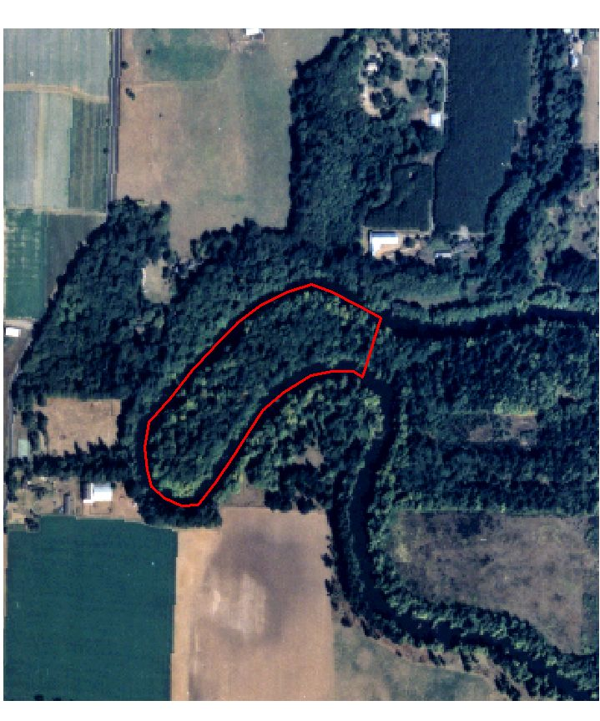
Figure 1. Approximate boundary of addition #3 (Westphal property) showing intact mature riparian forest and surrounding area. Land east of the Tualatin River in the lower right corner is owned in fee by TRNWR.

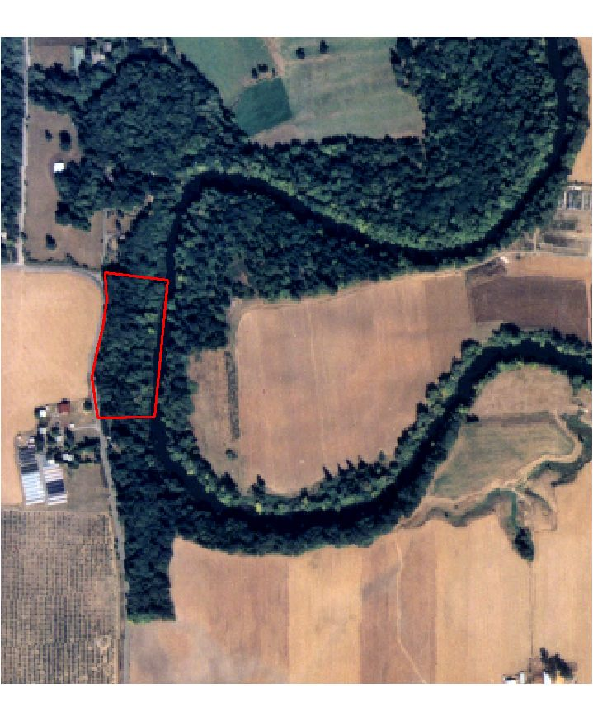
Figure 2. Approximate boundary of addition #4 (Markley property) showing intact mature riparian forest and encroaching agricultural lands.
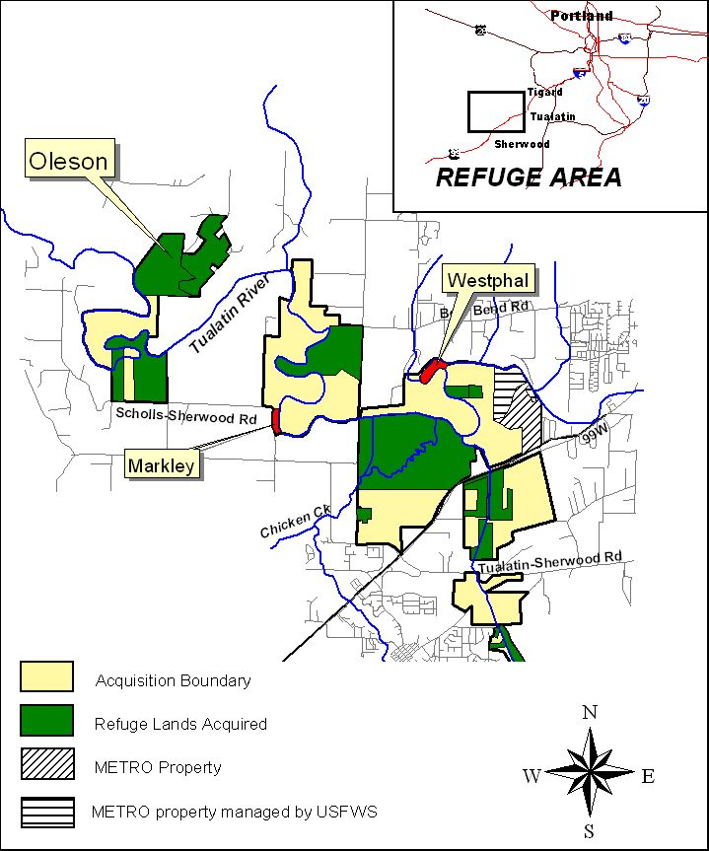
Figure 3. Location map showing proximity of parcels proposed for acquisition and restoration.

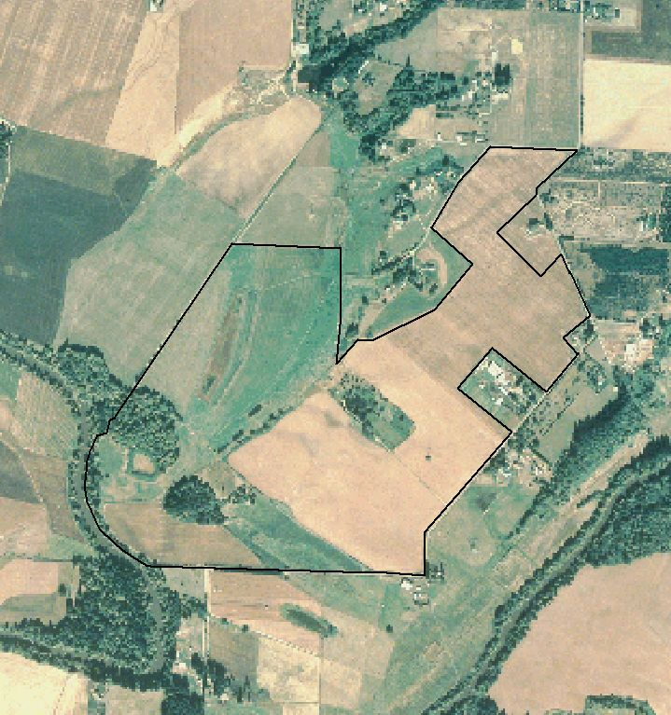

Figure 4. Approximate boundary of additions 1 & 2 (Oleson parcels 1 & 2). The Tualatin River is adjacent to the property along the southwest boundary and in the lower right corner of the photograph.

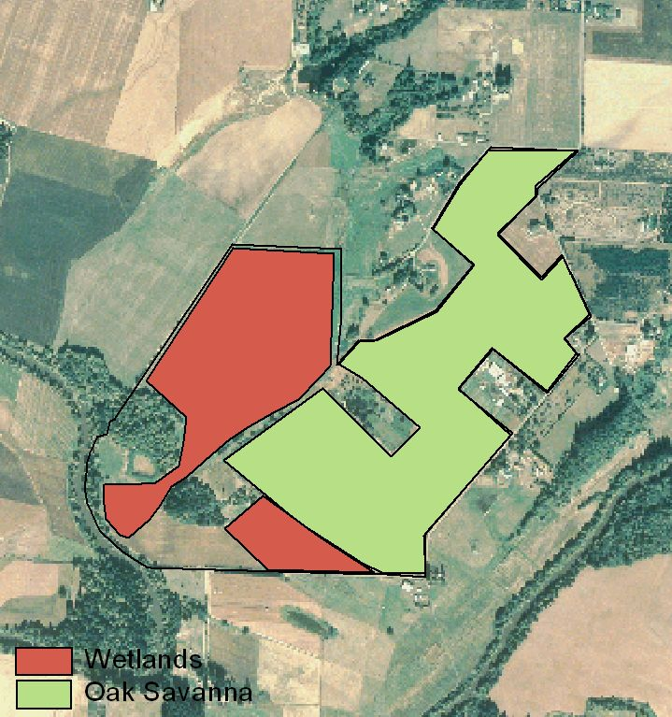

Figure 5. Additions 1 & 2 showing approximate location of oak savanna and wetland restoration sites. The remainder of the property will be a mix of riparian forest, forested wetland, and deciduous/coniferous forest.

c. Rationale and significance to Regional Programs

TRNWR is dedicated to working in a watershed prospective to accomplish restoration goals. Indeed, our restoration projects to date have included not only floodplain habitats, but also adjacent prairies, mixed deciduous/coniferous forests, and other important connected habitat types. By focusing on restoring a variety of habitat types a more holistic response by plants, fish, and wildlife can be achieved. This project will contribute to enhancing a highly altered and fragmented landscape by approaching the cause rather than just the symptoms of habitat degradation.
The project is consistent with several areas of the Council’s Fish and Wildlife Program (FWP). Specifically, it is consistent with Overarching Biological Objectives of the FWP which calls for 1) A Columbia River ecosystem that sustains an abundant, productive, and diverse community of fish and wildlife, 2) mitigation across the basin for the adverse effects to fish and wildlife caused by the development and operation of the hydrosystem, and 3) Recovery of the fish and wildlife affected by the development and operation of the hydrosystem that are listed under the Endangered Species Act. It is also consistent with the Primary Wildlife Strategy: complete the current mitigation program for construction and inundation losses and include wildlife mitigation for all operational losses as an integrated part of habitat protection and restoration. The project will mitigate for in-kind off-site habitat and target species losses associated with Willamette hydroelectric projects. Willamette Basin target species to benefit include black-tailed deer, beaver, river otter, wood duck, mink, yellow warbler, bald eagle, ruffed grouse, pileated woodpecker, American dipper, and waterfowl.

This project addresses several of the specific habitat needs described in the Willamette Subbasin Summary including “Substantially increased areas where improved floodplain function facilitates vital ecological processes; more and better-connected habitat, both upland and lowland, especially through riparian areas and wetlands which connect the two; higher quality water with temperatures closer to natural historic patterns;” and “improved access to critical habitats through the Willamette system, especially for anadromous or locally-migratory fish populations.” In addition, this project will address key salmon conservation measures identified in Factors Influencing Production Of Willamette River Salmonids & Recommendations For Conservation Actions (Martin et al. 1998). Measures include: “Floodplain restoration (including active reconnection of off-channel sloughs and backwaters, more effective riparian protection, and more functioning wetlands); hydrologic management to begin to restore the natural flow and temperature patterns to the extent possible; reduce impacts from exotic fish species; improved urban storm water management; education and monitoring to inform people about the causes of habitat degradation and involve them in monitoring results.” Historically, meandering river channels and riparian shrub benefited upstream spawning populations of native cutthroat trout and provided passage functions for wild migrating steelhead and Chinook salmon.

This project enjoys a host of partnerships forged by sound working relationships and similar goals. These partners include the Bureau of Reclamation, Ducks Unlimited, the Friends of the Refuge, Tualatin Riverkeepers, Portland Bureau of Environmental Services, and the Friends of Trees. Terms of partnering have been formalized in writing using either cooperative agreements or letters of commitment for specific projects.

d. Relationships to other projects

TRNWR works in partnership with many groups and organizations on restoration projects in the Tualatin River watershed. Most recently we have worked with the Bureau of Reclamation (BOR), Ducks Unlimited, (DU), Metropolitan Services District (METRO), and Portland Bureau of Environmental Services (BES) to accomplish wetland and upland restoration projects. BOR recently completed design and installation of a fish-screened pump lift station on refuge lands to provide flooding capabilities for emergent and forested wetland habitat types. In addition, DU and BOR collaborated with TRNWR on a large restoration project encompassing several habitat types to benefit migratory and resident birds, herpetafauna, locally occurring mammals, as well as indirectly benefiting anadromous fish by improving water quality. TRNWR collaborated with METRO and BES to complete a multifaceted habitat restoration project on METRO owned property within our acquisition boundary. This project is managed as a unit of TRNWR by an interagency agreement with METRO and will be operated and maintained by the refuge staff. Initial revegetation and subsequent maintenance was contracted through BES on this and other refuge projects.

This project is related to several Reasonable and Prudent Alternatives (RPA) listed in National Marine Fisheries Service 2000 FCRPS Biological Opinion. First of all, RPA #100 states the Action Agencies shall continue to implement and study methods to reduce the loss of juvenile salmonids to predacious fishes in the lower Columbia and lower Snake rivers. Potential predators including northern pikeminnow and smallmouth bass are present in the Tualatin River. Predation by these fish in the lower Tualatin River may reduce the survival of migrating smolts. This project will help determine survivorship and health benefits to juvenile salmonids in restored off-channel habitats designed to mimic natural river hydrologic functions. Second, RPA #149 says that under the NWPPC program, BPA should addresses passage, screening, and flow problems, where they are not the responsibility of others. This project will construct a screened diversion to fill off-channel wetlands during low flow conditions thus protecting listed salmonids while improving habitat conditions for other wildlife species. This proposal would address diversions in the Willamette River basin that could potentially impact listed upper Willamette River steelhead. Third, RPA #150 recommends that in subbasins with listed salmon and steelhead, BPA shall fund protection of currently productive non-Federal habitat, especially if at risk of being degraded. This project seeks to acquire two parcels of highly productive riparian forest at risk to logging. These acquisitions will gain permanent protection within the National Wildlife Refuge System. The fourth RPA supported is #151 recommends BPA shall, in coordination with NMFS, experiment with innovative ways to increase tributary flows by, for example, establishing a water brokerage. Lands acquired as part of this project are restored from agricultural use to wildlife habitat and as such the water right period of use is changed from summer to fall/winter thus improving water flow and quality during the critical summer months. The fifth RPA, #152, states the Action Agencies shall coordinate their efforts and support offsite habitat enhancement measures undertaken by other Federal agencies, states, Tribes, and local governments by the following: Leveraging funding resources through cooperative projects, agreements and policy development. This project seeks to obtain funds through a partnership of Federal and non-Federal entities to maximize leverage of funding and accomplish numerous restoration goals benefiting a multitude of fish and wildlife. Finally, RPA #185 indicates the Action Agencies shall continue to fund and expand, as appropriate, fish marking and recapturing programs aimed at defining juvenile migrant survival for both transported and nontransported migrants and adult returns for both groups. This project will employ fish marking techniques to provide valuable data on movement, growth, and survival of Juvenile salmonids using restored off-channel habitats.

Several projects funded by Bonneville in the Willamette Subbasin are related to work being conducted by TRNWR. Our acquisition program with Bonneville began with OWC (Project #19975900) Securing Wildlife Mitigation Sites in Oregon. The program focused on acquiring and protecting habitat valuable to fish and wildlife resources throughout Oregon. The Multnomah Channel Riparian Habitat Restoration Project (#199906600) focused on habitat restoration and enhancement of various wetlands and degraded riparian habitat along the Multnomah Channel and adjacent creeks. The Amazon/Willow Creek Wildlife Mitigation Project (#199205900) acquired and enhanced land contiguous with the 330 acre Willow Creek Wildlife project area in Eugene, OR, and continued restoration and enhancement of native wet prairie and oak woodland habitat. Burlington Bottoms - Phase I (Project #199107800) developed management plan for Burlington Bottoms Wildlife tract to protect, maintain, and enhance habitat for fish and wildlife. The Willamette Basin Mitigation Program (Project #199206800) seeks to mitigate for wildlife habitat losses through the use of easements, acquisitions, management plans, and enhancement activities to benefit fish and wildlife “while maintaining and improving water quality and quantity, habitat connectivity and functionality, biodiversity and overall ecosystem health.”

The US Army Corps of Engineers (USACE) through its Section 1135 and 206 programs is conducting similar restoration projects in the Willamette Valley. Among theses are 1) Lower Amazon Creek Wetlands project that seeks to restore wet prairie wetlands and natural floodplain function adjacent to Amazon Creek, a tributary of the Long Tom River. 2) The Fern Ridge Marsh project sponsored by ODFW will provide additional permanent marsh habitat for waterfowl and other species. 3) The USACE is evaluating the potential for restoring flows into Mission Lake, an oxbow lake along the main stem Willamette River at Mission Bottom State Park. Oregon State Parks Department is the local sponsor. 4) The Richardson Park project will benefit native cutthroat trout and other species by restoring a small stream feeding Fern Ridge Lake at Richardson Park, Lane County. 5) The Bowers Rocks project is evaluating the potential for restoring habitat and hydrology associated with a gravel pit and stream along the main stem Willamette River at Bowers Rock State Park, near Albany. Modification of the stream flows to the gravel pit lake could have benefits for juvenile salmonid rearing habitat and other purposes. 6) The Eugene Delta Ponds project, sponsored by the City of Eugene, is evaluating opportunities for modifying hydrologic flow conditions through this series of old gravel pits and connecting them with the main stem Willamette, with possible water quality and salmonid rearing benefits.

Conservation efforts near the refuge are also being undertaken by METRO Open Greenspaces Program. METRO has purchased lands adjacent the Tualatin River within and near TRNWR to compliment our protection efforts. In addition, METRO is establishing two large open greenspace reserves north and south of TRNWR. This project also supports the goals of the Tualatin River Watershed Council. Specific goals of the Tualatin River Watershed Action Plan are referenced in Chapter 4.0 (priority action items: #2, #4, and #6). Action items are: #2) conserve and improve fish and wildlife habitat (focusing on anadromous fish), #4) develop demonstration projects in priority areas to encourage restoration on private lands in cooperation with willing landowners, and #6) promote management practices that improve watershed functions and protect watershed values.

e. Project history

Project Number: 200001600

Adaptive Management: The first phase of this project consisted of acquisition of two parcels of land (under the umbrella of OWC, project #199705900) totaling 230 acres, completion of baseline HEP surveys and analysis, preliminary planning for restoration activities, and initial clean-up and land preparation. The Oleson 1 parcel was purchased in 1999, and the Oleson 2 parcel purchase was completed in 2000. The HEP team conducted baseline field surveys in 2001, and will complete analysis of habitat units in early 2002 to credit Bonneville for protected habitat units. Preliminary restoration planning has been ongoing since 2000, and includes acquisition of data such as soil surveys, historic vegetation analysis, hydrology, and current vegetation types. Further planning will include scooping and conceptual design with affected agencies, a complete topographic survey and construction engineering, development of a restoration and management plan, and preparation of environmental documents and permits. Initial clean-up, exotic vegetation species control, and land preparation has resulted in considerable improvement for wildlife. Several miles of interior fencing that were detrimental to wildlife movement and safety have been removed. Non-native vegetation was mowed or disced to provide improved conditions for resident and migratory wildlife species.

Project Reports: No project reports have been completed to date.

Years Underway: 1 year.

Summary of Results Achieved: By placing purchased parcels under the protection of the US Fish and Wildlife Service (FWS) former agricultural land has improved in value for fish and wildlife. Nesting and foraging cover for grassland songbirds has increased, semi-aquatic habitat has been left undisturbed for herpetafauna, reduced summer water pumping from the Tualatin River and reduced agricultural chemical use on the property, have improved conditions for listed salmonid species. An existing agricultural lease on the Oleson 2 parcel was honored by TRNWR and we are working closely with the lessee to encourage wildlife-friendly farming practices. In addition, the Oleson 1 parcel is no longer in agricultural production. This parcel has received interim measures to improve habitat conditions such as mowing Himalayan blackberries, discing reed canary grass, and allowing desirable grasses to pioneer formerly cropped fields. TRNWR signed an intergovernmental agreement with Bonneville for allocating phase I of restoration funding.

Past Costs:
Purchase of Oleson 1 parcel | $750,162
Purchase of Oleson 2 parcel | $686,956
Total: | $1,437,118

f. Proposal objectives, tasks and methods

The overall objective of this project is to acquire and protect 20 acres of at-risk mature riparian forest (Westphal and Markley parcels) along the main stem Tualatin River; restore, enhance, and maintain 230 acres of seasonal and forested wetland, riparian forest, and oak savanna (Oleson 1 & 2 parcels) to benefit both wildlife and listed anadromous fish by providing critical off-channel habitat; and conduct research and monitoring to determine use and escapement of listed salmonid species. Oleson 1 & 2 were purchased under the umbrella of OWC (project #199705900) for TRNWR, and planning and restoration of floodplain habitats was funded under project # 200001600.

Objective 1: Acquire Westphal and Markley parcels to protect high-risk mature riparian habitat for the benefit of listed salmonid species and other wildlife. Lands will be protected and maintained in perpetuity as part of the National Wildlife Refuge System.
Task a. Obtain funding and purchase Westphal parcel.
Task b. Obtain funding and purchase Markley parcel.

Objective 2: Restore native plant communities on additions #1 & 2 (Oleson 1 and Oleson 2 parcels) to benefit migratory and resident birds, listed salmonid species, other wildlife, and people by meeting the objectives outlined in the Willamette Subbasin Summary for habitat restoration.
Task a. Implement restoration activities on addition #1 (Oleson 1 parcel) according to plans and designs.
Methods: Contract earthwork for upland habitat using a competitive bid process. DU will conduct contract management and inspection services. Contract native herbaceous and woody species planting as required by restoration plans. TRNWR personnel will assist in earthwork preparation including fence removal, mowing, and discing.
Task b. Implement restoration activities on addition #2 (Oleson 2 parcel) according to plans and designs.
Methods: Contract earthwork for upland habitat using a competitive bid process. DU will conduct contract management and inspection services. Contract native herbaceous and woody species planting as required by restoration plans. TRNWR personnel will assist in earthwork preparation including fence removal, mowing, and discing.

Objective 3: Conduct monitoring of listed salmonids, water quality, and habitat at restored, off-channel areas along the Tualatin River. Vegetation, resident and migratory birds, and other wildlife will also be monitored to quantify changes in habitat quality, as part of regular refuge operations. Management recommendations will be developed and adaptive management employed based on the results of surveys.

Since this research is being conducted for the first time at this site, some of the monitoring procedures will require refinement during the first year. Specific hypotheses about changes in the growth rate of fish, fish abundance, and habitat will be developed during the first year of sampling. These hypotheses will test, for example, whether the rate of growth rate of juvenile salmonids changes before versus after habitat restoration activities, using statistical models such as BACI (Before-After Control-Impact; Underwood 1994; Stewart-Oaten et al. 1995). Recent studies have shown that floodplain habitats may enhance both the growth and survival of juvenile Chinook salmon (e.g., Sommer et al. 2001). Development of these specific tests will require preliminary data for sample design and power analyses (Peterman 1990; Osenberg et al 1994; Brown et al. 1996).

Sampling efforts will be coordinated with the Oregon Department of Fish and Wildlife, which has conducted fish and habitat surveys near the Tualatin National Wildlife Refuge (1993-1995 and1999-2001; David L. Ward, ODFW, personal communication).
Task a. Sample wetlands and backwater areas after flood events to determine the fish assemblage and the presence, survival, and growth rate of salmonids.
Methods: Wetlands will be sampled through a variety of methods for salmonids and other fishes. Where possible, we will use fyke nets (mesh size 0.25 in) at water control structures to capture fishes moving through the areas (see Jezorek and Petersen 2001). If possible, samples will be collected at both the entrance to the wetland units and the exit of the units to attempt to estimate survival and travel time through the units. Nets will be checked daily. Other means of sampling will be attempted where feasible, including “Gee” style minnow traps baited with salmon eggs, backpack electroshocking, and seining. Captured salmonids will be anesthetized, weighed to the nearest 0.1 g, measured for fork length to the nearest mm, and released below the net in which they were captured. Some tagged fish may be released above collection sites for efficiency testing. All salmonids will be scanned for PIT tags, and PIT tags will be inserted in those fish without tags (ISO FDX-B tags; 134.2 kHz; 12 mm length). PIT tags will allow us to individually identify fish on the wetlands and detect changes in size or condition for this that are re-captured. Salmonids captured at the exit nets will be inspected for PIT tags, and weight and size measurements taken. We will explore the possibility of using nonlethal, RNA/DNA sampling to determine growth rates of salmonids.
Fishes other than steelhead will be identified and enumerated. A sub-sample of each species will be weighed and measured for fork length. Particular attention will be paid to sampling predators that may occur within the refuge, such as largemouth bass (D. Ward, Oregon Department of Fish and Wildlife, personal communication).
Data analysis: Condition factors will be computed for captured salmonids as K = mass/(length)³ (Bagenal and Tesch 1978). For individuals that have been recaptured on wetland units (based on PIT tag detection), we will estimate daily growth rate for length and mass. For some wetlands and flow conditions, we may be able to sample and tag all incoming and outgoing fishes (see for example, Jezorek and Petersen 2001). In these cases, we will estimate the proportion of fish successfully transiting the wetland (“survival”) and their travel times. Growth rates and condition factors will be compared to travel times to see how time in wetlands may affect salmonids. Standard statistical methods such as Analysis of Variance (ANOVA) will be used to test hypotheses about changes over time or differences between specific sample areas (e.g., Underwood 1994).
Task b. Sample water quantity and quality, including temperature and turbidity in the project area.
Methods: Recording thermographs (Optic StowAway; Onset Computer Corporation) will be deployed at 12 locations throughout the Refuge, to record water temperature every hour during spring, summer, and fall. Flows will be measured at major inflows and outflows for wetlands with a Marsh-McBirney flow meter following Gallagher and Stevenson (1999). Turbidity will be measured to the nearest 0.1 Nepholometric Turbidity Unit (NTU; Hydrolab, e.g.). Using standard FWS protocol, sample water quality parameters at input areas and discharge from restored wetlands to determine and document improvements in water quality.
Task c. Fish habitat in restored units will be surveyed annually using standard techniques.
Methods: Permanent vegetation transects will be monitored annually to determine species composition, height, frequency, and percent cover. Water depth, velocity, and temperature will be measured at established transects. Data will be collected prior to restoration and following restoration so that null hypotheses can be tested about habitat improvements and changes.
Task d. Survey wildlife response using standard refuge protocol.
Methods: TRNWR biologist will employ instantaneous scan sampling to survey migratory waterbirds during fall, winter, and early spring to correlate use with changing habitat conditions. Point counts will be conducted to elucidate Neotropical landbird species richness and abundance.

Objective 4: Maintain restored habitats. Includes maintenance and management of wetland, riparian, forested wetland, deciduous/coniferous forest, and upland habitat types.
Task a. Biological and maintenance personnel control water levels, mow, disc, control exotic vegetation, care for new plantings until established.
Task b. Maintain equipment and supply materials necessary for efficient habitat management.

g. Facilities and equipment

The project is within the boundary of TRNWR. Parcels proposed for purchase are within the approved acquisition boundary. Restoration activities proposed will be conducted on property previously purchased in fee title by the TRNWR with funding provided by Bonneville. Research and monitoring will be conducted within the TRNWR; however, portions of the land are owned by METRO and are managed as part of the refuge under a perpetual interagency agreement. Research and monitoring will be conducted jointly by TRNWR and USGS personnel.

The TRNWR is staffed with five full-time personnel that include a project leader, deputy refuge manager, wildlife biologist, maintenance worker, and administrative assistant. The refuge has heavy equipment including backhoe, dozer, and farm tractors, as well as operators to support the project. Nearby refuges have additional equipment that is also available for use to aid the project. Work that is not sub-contracted can also be accomplished using leased equipment.

h. References

Reference (include web address if available online) | Submitted w/form (y/n)
Bagenal, T. B., and F. W. Tesch 1978. Age and growth. Pages 101-136 in T. B. Bagenal, editor. Methods for assessment of fish production in fresh waters, 3rd edition. Blackwell Scientific Publications, Oxford, England. | N
Brown, B. W. and 5 co-authors. 1996. STPLAN, Calculations for sample sizes and related problems. Version 4.1. University of Texas, Houston, Texas. Downloaded from: ftp://odin.mdacc.tmc.edu/pub/source/stplan-4.1.tar.gz. | N
Gallagher, A. S., and N. J. Stevenson. 1999. Streamflow. Pages 149-155 in M. B. Gain and N. J. Stevenson, editors. Aquatic habitat assessment: common methods. American Fisheries Society, Bethesda, Maryland. | N
Jezorek, I. G., and J. H. Petersen. 2001. Monitoring and assessment of juvenile steelhead on Toppenish National Wildlife Refuge. Report submitted to the U.S. Fish and Wildlife Service, Toppenish, Washington. | N
Martin, J., et al. 1998 Factors Influencing Production of Willamette River Salmonids and Recommendations for Conservation Actions. Corvallis, Oregon. | N
Osenberg, C. W., R. J. Scmitt, S. J. Holbrook, K. E. Abu-Saba, and R. Flegal. 1994. Detection of environmental impacts: natural variability, effect size, and power analysis. Ecol. Appl. 4:16-30. | N
Peterman, R. M., 1990. Statistical power analysis can improve fisheries research and management. Can. J. of Fish. Aquat. Sci. 47:2-15. | N
Sommer, T. R., M. L. Nobriga, W. C. Harrell, W. Batham, and W. J. Kimmerer. 2001. Floodplain rearing of juvenile Chinook salmon: evidence of enhanced growth and survival. Can. J. Fish. Aquat. Sci. 58:325-333. | N
Stewart-Oaten, A., W. W. Murdoch, and S. J. Walde. 1995. Estimation of temporal variability in populations. Am. Nat. 146:519-535. | N
Underwood, A. J., 1994. On beyond BACI: Sampling designs that might reliably detect environmental disturbances. Ecol. Appl. 4:3-15. | N
Willamette Subbasin Summary (Draft) | N

Section 10 of 10. Key personnel

Project Leader – Ralph Webber has 22 years experience with the US Fish and Wildlife Service as a biologist and manager. He has worked both in Oregon and Washington at a number of field stations and the regional office. He has implemented countless habitat restoration projects with budgets in excess of $1,000,000 and will serve as overall manager for this project. Mr. Webber received a BS degree in Wildlife Biology and a BS degree in Range Management in 1977 from Washington State University.

Deputy Refuge Manager – Chris Lapp has worked for the FWS in Oregon, California, North Dakota, Colorado, and Minnesota the past 11 years. He has worked as both a biologist and manger in a variety of habitat types and oversees many of the day to day operations and personnel on the TRNWR and will be responsible for permitting and other aspects of this project. He graduated in 1988 from Evergreen State University in Washington with a BS degree in Wildlife Management.

Wildlife Biologist – Peter Schmidt came to the FWS in 2000 after working for Ducks Unlimited, Inc., and California Department of Fish and Game for the previous 8 years. He has worked on and administered numerous restoration projects across a variety of landscapes. He was responsible for contracting and budgeting projects in excess of $1,000,000. Mr. Schmidt will coordinate restoration planning, construction, and monitoring activities on this project. He received a BS degree in Wildlife Management in 1997, and an MS degree in Wildlife Management in 1999 from Humboldt State University in California.

Other Refuge Personnel - Maintenance Worker John Schweitzer has been with FWS for 5 years. He has worked at several field stations in Oregon. Administrative Assistant Leslie Rist has 9 years experience with FWS both at field stations and the regional office in Oregon.

Fisheries Biologist – Dr. James Petersen has worked as a fisheries biologist since 1983. He will oversee and coordinate research and monitoring for salmonid species on project areas. He is currently a Research Fishery Biologist, U.S. Geological Survey, Western Fisheries Research Center, Columbia River Research Laboratory, Cook, WA. He is project leader on research projects to determine survival of steelhead on Toppenish National Wildlife Refuge and in the Wind River Basin (WA), Co-leader on various mainstem Columbia and Snake River projects concerning juvenile salmon passage at dams and predation evaluation. Dr. Petersen received his Ph.D. in marine ecology from the University of Oregon, Eugene in 1983, a Rotary Fellowship from University of Queensland, Australia in 1976, and a BS in biology from Boise State University, Boise, Idaho in 1975. His expertise lies in predator-prey dynamics, bioenergetics, fish behavior, and application of various modeling techniques to fisheries.

Publications

DeAngelis, D. L., and J. H. Petersen. 2001. Importance of the predator’s ecological neighbourhood in modeling predation on migrating prey. Oikos. 94:315-325.

Petersen, J. H., and D. L. DeAngelis. 2000. Dynamics of prey moving through a predator field: a model of migrating juvenile salmon. Mathematical Biosciences 165:97-114.

Petersen, J. H., and D. L. Ward. 1999. Development and corroboration of a bioenergetics model for northern pikeminnow feeding on juvenile salmonids in the Columbia River. Transactions of the American Fisheries Society 128:784-801.

Ward, D. L., J. H. Petersen, and J. J. Loch. 1995. Index of predation on juvenile salmonids by northern squawfish in the lower and middle Columbia River and in the lower Snake River. Trans. Am. Fish. Soc. 124:321-334.

