Bonneville Power Administration

FY 2003 Provincial Project Review

PART 2. Narrative
Project ID: 31006

Title: Protect Wood's Landing Chum Spawning Site

Section 9 of 10. Project description

a. Abstract

The project will protect the largest Lower Columbia River chum production site between the Grays River near the mouth of the Columbia River and Hardy/Hamilton Creeks just below Bonneville Dam. Federal, state, and regional reports including the Federal Columbia River Power System Biological Opinion and the Lower Columbia Subbasin Summary, have described the importance of good chum spawning habitat in the Lower Columbia.

Through acquisition the project will protect the area, 11.96 acres and 1000 feet of shoreline, above this significant chum spawning habitat on the Columbia River shore in Vancouver, Washington. The properties include tidelands and mostly forested upland areas with very good riparian habitat. The current zoning allows 1 unit per 10,000 square feet (0.23 acres). Such residential development degrades habitat by increasing pollutant loading and bringing people and pets that disturb the spawning chum and their eggs.

Restoration of 350 feet of the Joseph’s Creek, which enters the Columbia River immediately downstream of the main stem spawning site, will provide additional spawning habitat. The restoration will include adding spawning gravel, removing invasive plants from the banks, and stabilizing and revegetating the banks.

Partners in the project are Washington Department of Fish and Wildlife, Columbia Land Trust, City of Vancouver and the Wood family members who own the property. All partners share salmon conservation goals. Washington Department of Fish and Wildlife will develop a management plan in cooperation with the partners. Columbia Land Trust will manage the acquisition and then give the title and easements to Washington Department of Fish and Wildlife. The project provides a unique opportunity within the Lower Columbia subbasin to protect existing, critical, high quality chum salmon habitat in the main stem.

b. Technical and/or scientific background

The project will protect significant spawning and early life history rearing habitat for Columbia River chum in the Lower Columbia. In the “Statement of Fish and Wildlife Needs” the Lower Columbia River and Columbia River Estuary Subbasin Summary reports (p. 135) “Additional land acquisition and purchase of conservation easements for total protection of the Wood’s Landing …This is essential to protect one of the only two mainstem spawning sites for Columbia River chum salmon.” The information is from the Washington Department of Fish and Wildlife as part of BPA project 1999-003-001, Evaluation of spawning for fall Chinook and chum salmon just below the four lower most Columbia River Dams. The Subbasin Summary (p. 50) states that, based on a survey of 33 areas on the Washington side of the Columbia, the Wood’s Landing population is the “largest population between the Grays River and Hamilton/Hardy/Ives Island index populations”. A survey of 33 Oregon Columbia River tributaries observed one chum individual. The Wood’s Landing chum are genetically similar to the Habilton/Hardy population which is distinct from the Grays River population.

The project includes attaining fee simple title or conservation easements on parcels including the tidelands and upland areas above the spawning site. (Attached photos and maps show the site.) In cooperation with the partners Washington Department of Fish and Wildlife will develop a management plan for all the properties.
- Parcel A – 3.3 acres, 348 feet of shoreline; Wood family donates conservation easement for the property; family use consistent with the management plan, includes use and remodeling of existing house and guest house maintaining same size footprint and height, no other structures to be added; easement value donated by family to be used as grant match
- Parcel B – 2.1 acres, 126 feet of shoreline; grant buys fee simple
- Parcel C – 1.4 acres, 126 feet of shoreline; grant buys conservation easement; current owner may build 1000 square foot cottage; other easement requirements the same as for Parcel A
- Parcel D – north half – 2.5 acres, wooded with a creek flowing east to west; grant buys fee simple
- Parcel D – south half – 2.5 acres, 400 feet of shoreline; Wood family donates conservation easement for the property similar as for Parcel A
Washington Department of Fish and Wildlife’s ownership of the property and the conservation easements will protect the sites from development and provide a site for future research and education.
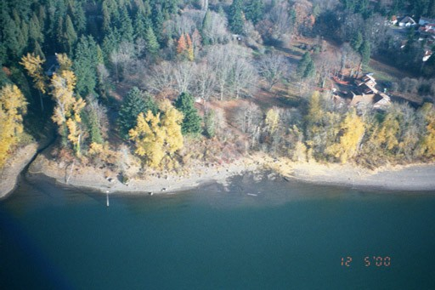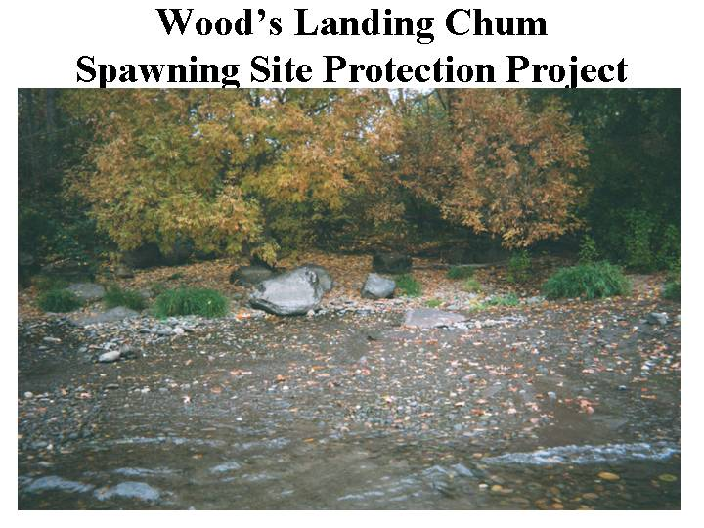

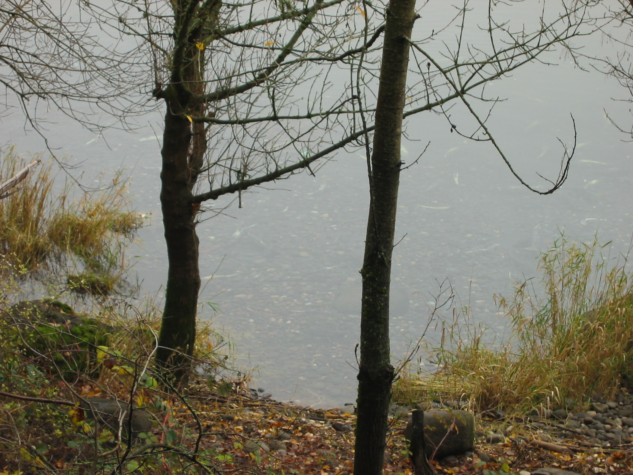

In addition to the acquisitions, the project includes restoration of Joseph’s Creek to provide additional spawning habitat in the immediate area. The creek enters the Columbia between Parcels A and D. The water source is a spring fed creek flowing across the north end of Parcel D. Washington Department of Fish and Wildlife will manage the restoration of the lower 350 feet of the creek and its banks. The project will add spawning gravel, remove invasive plants, stabilize the banks and replant with native vegetation.

The chum spawning site is created by springs’ bubbling out from under rocks and up through gravel. The land parcels included in the project consist of the tidelands and the mostly forested upland areas immediately above the springs and spawning areas and those adjacent downriver. Wetlands above the parcels feed the springs. Aquifers, recharged from rainfall and storm water infiltration throughout the Cascade plateau area, feed the wetlands. (Photos are attached.)

Numerous documents describe the habitat degradation due to urban development including residential development. The Subbasin Summary refers to the Lower Columbia River Estuary Partnership (formerly Program) studies and action plan (e.g. p. 58) and the Washington State Conservation Commission’s Salmon and Steelhead Limiting Factors Water Resource Inventory Area 28 (p. 39). In its 4(d) Rule the National Marine Fisheries Service details potential threats of urban development to properly functioning conditions for salmon.

The particular threat at the Wood’s Landing site is posed by its potential development of four houses per acre. The project site now has one unoccupied house, one house occasionally occupied, and a cottage where one person lives. The development would increase the likelihood that pollutants would run off into the spawning area or contaminate the shallow ground water. The people and pets resulting from development would be a significant threat by scaring away or harming the spawning chum and destroying their eggs. The vegetated areas will remain rather than being replaced with impervious surfaces, manicured lawns and additional shoreline development.

It is critical to do the project now because of the existing opportunities and threats. The properties, which are zoned for residential use, are available now as part of an estate settlement. The family members who own the properties are committed to conservation, but must pay estate taxes. The opportunities to obtain and protect the properties will disappear within a couple of years. City, state and federal agencies cannot deny the owners’ use of the properties and, therefore, cannot prevent the development.

Protection of this spawning site and the enhancement of the adjacent creek provide a buffer against potential disturbances to the few remaining spawning sites in the Lower Columbia. Washington Department of Fish and Wildlife is exploring the option of using this native, wild stock for enhancement of other potential chum sites in Lower Columbia River tributaries.

c. Rationale and significance to Regional Programs

The project implements three actions in the Reasonable and Prudent Alternatives Summary in the National Marine Fisheries Service 2000 Federal Columbia River Power System Biological Opinion.

Action 157. “BPA shall fund actions to improve and restore tributary and mainstem habitat for Columbia River chum salmon in the reach between The Dalles Dam and the mouth of the Columbia River.” The project clearly provides an opportunity to protect an important, existing, threatened chum spawning site and restore an adjacent site.

Action 150. “In subbasins with listed salmon and steelhead, BPA shall fund protection of currently productive non-Federal habitat, especially if at risk of being degraded, …” As stated above the project clearly provides an opportunity to protect an important, existing, threatened chum spawning site and restore an adjacent site.

Action 152. “The Action Agencies shall coordinate their efforts and support offsite habitat enhancement measures undertaken by other Federal agencies, states, Tribes, and local governments by the following: … leveraging funding resources through cooperative projects, agreements and policy development…” The project is a partnership among the Washington State Department of Fish and Wildlife, the City of Vancouver, the non-profit Columbia Land Trust and the Wood family and has the support of the Lower Columbia Fish Recovery Board and the Washington Department of Ecology.

The project implements the salmon recovery strategies of the Washington State Salmon Recovery Funding Board, the Washington Department of Fish and Wildlife and the Lower Columbia Fish Recovery Board to protect existing good habitat of critical stocks (e.g. p. 100 of the Subbasin summary). Washington Department of Fish and Wildlife and the Lower Columbia Fish Recovery Board both rated the Columbia River chum as Tier 1 in stock priority.

d. Relationships to other projects

Other projects to enhance Lower Columbia River chum have occurred. In Duncan Creek, funded in part as BPA project #200125300, the Washington Department of Fish and Wildlife restored 1700 feet of spawning habitat and reintroduced Lower Columbia chum from Ives Island in 2001. In the late 1990’s the US Fish and Wildlife Service restored spawning areas in Hamilton Creek. The Lower Columbia Fish Recovery Board, through the Washington State Salmon Recovery Funding Board funded Skammania Landing Homeowner’s Association removal of a dam to allow access to chum spawning habitat. The later funding agencies along with other agencies have funded acquisition and restoration projects in the Grays River near the mouth of the Columbia.

The proposed project is closely linked to other projects through the partners. The Washington Department of Fish and Wildlife was the lead on the Duncan Creek projects and is involved with the Lower Columbia Fish Recovery Board. Staff and a board member of the Lower Columbia Fish Recovery Board are part of the Wood’s Landing project team. The City of Vancouver representative is on the Board’s technical advisory committee. The Columbia Land Trust was the lead on the Gray’s River acquisition and restoration projects. The Wood’s Landing project team has interacted with National Marine Fisheries Service staff.

e. Project history (for ongoing projects)

This is a new project.

f. Proposal objectives, tasks and methods

PLANNING AND DESIGN PHASE

Objective 1. Plan acquisition of properties and easements
(Note: See map for labeled parcels.)
Tasks in objective 1 will be managed by the Columbia Land Trust.

Task 1a. Appraise parcel B north half of parcel D for fee simple value.
A qualified, independent appraiser will appraise the fair market value for parcel B. Another qualified, independent appraiser will review and approve the appraisal.

Task 1b. Appraise parcels A, C, and south half of D for conservation easement value.
A qualified, independent appraiser will appraise the value of the conservation easement which is developed in partnership by the Columbia Land Trust, Washington Department of Fish and Wildlife and the property owners, the Wood family. Another qualified, independent appraiser will review and approve the appraisal.

Task 1c. Perform baseline inventory of parcels A,B,C,D.
The Columbia Land Trust will document the current condition and conservation values of the site. Aspects documented include habitat areas, native and non native species, structures, erosion, and presence of threatened or endangered species.

Task 1d. Assess parcels A, B, C, D for hazardous substances.
A qualified subcontractor will test soils on site to determine if hazardous substances are present. Based on the previous and existing land use of low density residential it is expected that the site contains no hazardous materials.

Task 1e. Assess parcels A, B,C, D for archaeological resources.
A qualified archaeologist will assess the site for the presence of archaeological resources.

Task 1f. Carry out NEPA process for acquisition sites.
A subcontractor will work with the project partners and BPA to complete the NEPA process. In developing the project, the partners have worked with neighboring property owners, the City of Vancouver Water Resources Education Center, the nearby Columbia Springs Environmental Education Center, the Evergreen School District, and other members of the public. The partners plan to continue public involvement as the project unfolds.

Objective 2. Design Joseph’s Creek restoration.
Tasks in objective 2 will be managed by the Washington Department of Fish and Wildlife.

Task 2a. Survey site.
A licensed surveyor will survey the 350 feet of creek and its banks.

Task 2b. Develop engineering plans.
A subcontractor will design the project including any necessary erosion control; site construction mobilization; dewatering; excavation; placement of stream gravel, toe rock and channel structures; removal of invasive vegetation, bank stabilization and revegetation; and repair to the access road.

Task 2c. Obtain permits.
The Washington Department of Fish and Wildlife will obtain necessary permits.

Task 2d. Conduct Environmental Assessment including hazards assessment.
A contractor will prepare an environmental assessment. The assessment will include testing the sediment in Joseph’s Creek for hazardous substances.

Task 2e. Carry out the NEPA process for the restoration.
The Washington Department of Fish and Wildlife will work with the project partners and the BPA to complete the NEPA process.

CONSTRUCTION/IMPLEMENTATION PHASE

Objective 1. Acquire properties and easements
The Columbia Land Trust will carry out the acquisitions and then transfer title and easements to the Washington Department of Fish and Wildlife.

Task 1a. Purchase parcel B.

Task 1b. Purchase north half and the tidelands of parcel D.

Task 1c. Purchase easement of Parcel C.

Task 1d. Record titles for Parcels A, B, C, D.

Task 1e. Pay taxes for all parcels.

Task 1f. Get title reports for all parcels.

Task 1g. Pay closing costs for all parcels.

Task 1h. Manage the acquisitions.
The Columbia Land Trust will carry out all the acquisition tasks.

Objective 2. Restore the lower 350 feet of Joseph’s Creek to provide additional spawning gravel and stable banks vegetated with native riparian vegetation. The restoration work will be done by a contractor managed by the Washington Department of Fish and Wildlife.

Task 2a. Excavate sediment.
The contractor will excavate fine sediments and take them to an upland disposal site.

Task 2b. Dewater stream.
The contractor will provide the dewatering necessary for the in-stream work.

Task 2c. Control erosion.
The contractor will prevent erosion at all stages of the project. No site disturbance will occur until erosion control measures are in place and approved by the City of Vancouver.

Task 2d. Mobilize for project.
The contractor will set up the site including the staging area and access road. The mobilization will occur with minimum disturbance to the surrounding area.

Task 2e. Place spawning rock.
The contractor will place spawning rock, similar to that on the spawning site in the main stem, about three feet deep, 50 feet wide and 350 feet up the creek from the mouth.

Task 2f. Place toe rock.
The contractor will place toe rock necessary to prevent damage to the creek by boat wakes.

Task 2g. Place stream channel structures.
The contractor will place any channel structures such as large woody debris. The appropriateness of such structures will be determined in the design phase.

Task 2h. Remove invasive plants, stabilize banks, revegetate.
The contractor will remove invasive plants, except any large trees, from the banks with little disturbance of the soil. The contractor will stabilize the banks with heavy duty fabric. The contractor, with assistance from experienced volunteers managed by the City of Vancouver, would plant native riparian vegetation.

Task 2i. Repair access road.
The contractor will repair any damage to the access road. The contractor will also revegetate any area cleared for access.

Task 2j. Provide contingency funds.
The project budget will include 20% contingency funds. The Washington Department of Fish and Wildlife will manage the restoration and will approve use of the contingency funds.

g. Facilities and equipment

The Columbia Land Trust, which is acquiring the properties and easements, is located in Vancouver, Washington. The Land Trust has a great deal of experience in acquiring land and easements and their office contains the necessary equipment.

The restoration of Joseph’s Creek would require equipment such as morookia, a track-hoe and other small equipment. Washington Department of Fish and Wildlife has experience working with contractors on similar projects. Several contractors in the region have the appropriate equipment and experience.

h. References

Reasonable and Prudent Alternatives Summary in the National Marine Fisheries Service 2000 Federal Columbia River Power System Biological Opinion.  http://www.cbfwa.org/reviewforms/SpecificSolicitationRPA.doc.  Lower Columbia River and Columbia River Estuary Subbasin Summary http://www.cbfwa.org/reviewforms/lwrcol  Lower Columbia Fish Recovery Board Interim Habitat Recovery Strategy  http://www.lcrfb.gen.wa.us  Washington State Conservation Commission’s Salmon and Steelhead Limiting Factors Water Resource Inventory Area 28  State of Washington Salmon Recovery Funding Board Mission, Roles, Responsibilities and Funding Strategy  http://www.iac.wa.gov | Submitted w/form (y/n)

Section 10 of 10. Key personnel

Columbia Land Trust.
Acquisitions of properties and easements will be done by the Columbia Land Trust.

- Glenn Lamb, Executive Director. Mr. Lamb has been associated with Columbia Land Trust for over ten years, as founding board member, president, treasurer, secretary and now staff. Mr. Lamb has managed acquisition of over 6,000 acres and $35,000,000 of land conservation projects with the Land Trust and previous employers.

- Cherie Kearney, Program Director. Ms Kearney has been associated with Columbia Land Trust for four years, as contract employee and now as staff. Ms. Kearney has overseen much of the organizational growth of the Land Trust, led community outreach and partnership-building efforts and managed dozens of acquisition projects for the organization.

- Ian Sinks, Conservation Director. Mr. Sinks has been associated with Columbia Land Trust for four years, as board member and now staff. Mr. Sinks has overseen preparation of baseline assessments and stewardship plans for all 25 Land Trust conservation areas and conducts annual monitoring of all properties.

Washington Department of Fish and Wildlife
Washington Department of Fish and Wildlife will accept the properties and conservation easements and manage them according to the management plan developed with all the partners. The Department will also manage the restoration project on Joseph’s Creek

- Joe Hymer, Fish and Wildlife Biologist 3, Pacific States Marine Fisheries Commission, Vancouver, Washington. Mr. Hymer hasTwenty-one years of service for Washington Department of Fish and Wildlife/Pacific States Marine Fisheries Commission on fishery management and research programs including eighteen years experience on Columbia River data collection and fisheries management and extensive experience in data collection, coordination, summarization, and analysis plus designing and planning research activities. Part of current daily duties includes supervising the adult and stranding studies on BPA Project # 199900301, “Evaluate Spawning of Fall Chinook and Chum Just Below the Four Lowermost Mainstem Dams”. Also, current daily duties include supervising chum brood stock collection on BPA Project # 200105300 “Re-Introduction of Lower Columbia River Chum Salmon into Duncan Creek”. Mr. Hymer’s publications include:
  - Hymer, Joe. 1994. Estimating the Chum Salmon Population in Hardy Creek 1957-93. Washington Department of Fish and Wildlife. Columbia River Laboratory Progress Report 94-11.
  - Hymer, Joe. 1993. Estimating the Natural Spawning Chum Population in the Grays River Basin, 1944-91. Washington Department of Fisheries. Columbia River Laboratory Progress report 93-17.

Wood Family
The Wood family will donate conservation easements on some parcels and will spend time at the site in accordance with the conservation management plan.
- Mary Wood. Dr. Wood is a professor of Environmental Law at the University of Oregon and has extensive experience in environmental and tribal issues. She, as many of the family members, grew up on the site, and is the spokesperson for the family in developing the project.

City of Vancouver
The project is located in the City of Vancouver, and the City is the lead in developing the grant proposal.
- Vicky Ridge-Cooney, Environmental Policy Coordinator. Dr. Ridge-Cooney has extensive experience in resource management, project management, education, facilitation and research.

Attachments:

BPAchum1.pdf
BPAchum2.pdf

