Bonneville Power Administration

FY 2003 Provincial Project Review

PART 2. Narrative
Project ID: 31019

Title: FISH PASSAGE ASSESSMENT AND PRIORITIZATION PROGRAM

Section 9 of 10. Project description

a. Abstract

Washington County Department of Land Use and Transportation operates and maintains approximately 1,300 centerline miles of roads within the Tualatin River Watershed (HUC 17090010). There are 236.10 miles of major stream corridors within this watershed, of which 217.30 miles are considered productive habitat for threatened and endangered fish species (SteamNet query 11/16/01). It is unknown how many times these roads and streams intersect, but it is likely in the thousands. Each road – stream crossing has the potential to block access to current or historic areas of high quality habitat. Currently, the driving force in culvert replacement is culvert condition; fish passage is a component of project design, not the project selection process. Without a comprehensive road – stream crossing assessment it is impossible to logically prioritize the replacement or remediation of culverts that block fish passage.

This proposal fills that critical need for a comprehensive road – stream crossing assessment that incorporates environmental as well as transportation components into project selection. The approach that Washington County proposes is to evaluate fish passage barriers on a hydrologic unit basis. We have chosen to evaluate and prioritize barriers at the 5th field HUC level. By taking this smaller HUC approach, we can evaluate each barrier in relationship to obtaining access to core areas of productive habitat within the context of the smaller watershed. HUCs will be assessed in descending habitat importance order with data from each individual HUC incorporated into the database until all the crossings within the Tualatin River Watershed (Washington County jurisdiction) are evaluated. Once the assessments are complete we can then assess the 5th field barrier data for each to determine the best removal – retrofit scenario, taking into consideration the value of the smaller fields within the context of the larger Tualatin Basin.

b. Technical and/or scientific background

The Tualatin River is the most northern tributary within the Willamette River Subbasin. It enters the Willamette River at river mile 28.5. The Tualatin River is about 80 miles long and has four elevation drops at Ki-a-cuts Falls, Haines Falls, Lee Falls and Little Lee Falls before it enters the Tualatin Valley Plain at an elevation of 120 feet, near Cherry Grove. The Tualatin River drainage basin is approximately 43 miles long and 29 miles wide and covers an area of 712 square miles.

Annually, more than 1.1 million acre-feet of water flow out of the watershed into the Willamette River (including water imported from the Trask and Bull Run Rivers). Nearly 85 percent of this flow is discharged during November through March, and less than 3 percent typically is discharged during June through October.(Tualatin River Watershed Council website 2/29/00)

In March 1999, steelhead trout (Onchorhynchus mykiss) in the Upper Willamette Evolutionarily Significant Unit (ESU) were listed as threatened under the Federal Endangered Species Act (NMFS 1999). Steelhead and areas of essential indigenous salmonid habitat currently exist in the Tualatin River Watershed as shown at the link below. (http://statelands.dsl.state.or.us/maps/washington.pdf) Other resident and anadromous fish species also exist within the watershed. The table below identifies a recent study in the 4 main tributaries within the Tualatin River Watershed. (Leader & Hughes, 2001)

Table 2. Fish collected in 10 reaches of 4 tributaries of the Tualatin River and 2 reaches of the upper Tualatin River in summer, fall, winter, and spring 1999-2000. Relative tolerance and trophic group classifications from Zaroban et al. (1999).
Family,  Species | Relative tolerance | Adult trophic group | Percent of Catch | No. of streams (reaches)
Petromyzontidae
Western Brook lamprey Lampetra richardsoni | Intermediate | --ª | 2.4 | 5 (11)
Unidentified Lampetra spp. | Intermediate | -- | 0.1 | 1 (2)
Salmonidae
Coho salmon Oncorhynchus kisutch | Sensitive | Insectivore | 0.2 | 2 (3)
Cutthroat trout Oncorhynchus clarki | Sensitive | Insectivore | 11.1 | 5 (10)
Rainbow trout Oncorhynchus mykiss | Sensitive | Insectivore | 1.2 | 3 (5)
Mountain whitefish Prosopium williamsoni | Intermediate | Insectivore | 0.1 | 1 (1)
Unidentified Salmonidae | Sensitive |  | 1.0 | 4 (5)
Cyprinidae
Northern pikeminnow Ptychocheilus oregonensis | Tolerant | Piscivore | 0.2 | 1 (2)
Redside shiner Richardsonius balteatus | Intermediate | Insectivore | 5.5 | 4 (5)
Speckled dace Rinichthys osculus | Intermediate | Insectivore | 5.8 | 4 (7)
Longnose dace Rhinichthys cataractae | Intermediate | Insectivore | 1.0 | 2 (3)
Catostomidae
Largescale sucker Catostomus macrocheilus | Tolerant | Omnivore | 0.7 | 4 (5)
Centrarchidae^{b}
Unidentified Lepomis spp. | Tolerant |  | 0.1 | 2 (3)
Cottidae
Reticulate sculpin Cottus perplexus | Intermediate | Insectivore | 57.2 | 5 (12)
Torrent sculpin Cottus rhotheus | Intermediate | Piscivore | 9.3 | 4 (6)
Prickly sculpin Cottus asper | Intermediate | Insectivore | 4.2 | 4 (7)

Of the 4-H strategies commonly adopted by restoration and environmental groups, habitat is the primary focus of this proposal. Restoring habitat connectivity is an important component of increasing salmonid spawning & rearing areas and subsequent population increases. It is interesting to note that there are no current hatchery releases within the Tualatin system, therefore the “native vs. hatchery” debate is not a factor when developing restoration plans in the watershed.

The need for a barrier inventory and prioritization plan for threatened and endangered salmonid species recovery is well recognized and documented. The Oregon Watershed Enhancement Board has completed the Oregon Aquatic Habitat Restoration and Enhancement Guide http://www.oweb.state.or.us/publications/habguide99.shtml, which gives detailed descriptions of each restoration activity. In regards to road - stream crossing problems the guide states:
“Road-stream crossings have caused serious losses of fish habitat due to improperly designed or placed culverts. The blocking or hindering of upstream migration at road crossings has many adverse effects, including:
• The loss of spawning habitat available to adult anadromous salmonids;
• The loss of habitat available to juvenile anadromous and resident fish for feeding and predator avoidance;
• The loss of genetic diversity in resident fish in upstream reaches;
• The loss of nutrients from anadromous spawning adult carcasses;
• Changes in fish community assemblages upstream of blockages;
• Prevention of the re-colonization of headwater areas by resident fish after periodic losses or
• evacuations caused by extreme flood or drought events.
In addition, improperly sized or placed culverts can cause catastrophic or chronic sediment inputs into streams.”
The first step to correcting these negative impacts and restoring habitat connectivity is to identify road – stream crossings that block passage to viable habitat. . In order to spend dollars effectively to benefit fish populations, a greater understanding of passage problems and viable adjacent habitat should be identified in a watershed before decisions are made to prioritize dollars spent for corrective actions

Phillip Roni, et al evaluated the effectiveness of restoration techniques and recommended:
“Following a watershed assessment, we recommend that restoration focus on reconnection of isolated high-quality fish habitats such as instream or off-channel habitat made inaccessibly by culverts or other man-made obstructions. Once the connectivity of habitats within a basin has been restored, efforts should focus on restoring hydrology, geologic (sediment delivery and routing), and riparian processes through road decommissioning and maintenance, exclusion of livestock, and restoration of riparian areas. Instream habitat enhancement (e.g. additions of wood, boulders, or nutrients) should be employed only after restoring natural processes or in cases where short-term improvements in habitat are needed (e.g. habitat for endangered species. Finally, existing research and monitoring is inadequate for all the techniques we reviewed and additional comprehensive physical and biological evaluations of most watershed restoration methods are needed”. When discussing fish passage projects, they stated: “Fish Passage projects should be prioritized after basin wide objectives are developed and fish passage impediments are identified throughout the watershed. The inventory should identify culvert and other artificial blockages, along with specific information on habitat quantity and quality, and fish presence and absence above and below each blockage. A prioritized list based on cost – benefit analysis can then be developed (Pess et all. 1998)”

Table six of the cited report illustrates typical response time, duration, variability in success and probability of success of common restoration techniques. In substance, when removing culverts to reconnect habitats, it takes 1-5 years to achieve response, the longevity of action is 10-50+ years, and there is a low variability of success among different projects with a high probability of success.

c. Rationale and significance to Regional Programs

Watershed

Set within a growing and thriving metropolitan area, a productive agricultural landscape, and upland forests, the Tualatin Watershed is in a dynamically changing region of the country. Its lowlands, which predominantly have been agricultural lands, are giving way to increased residential and industrial settlement. Its headwaters in the upland forests are particularly important for water quality and fish and wildlife habitat. As the population and economic base of the region grows, stresses to the watershed are expected to increase. In order to foster a biologically healthy and functional resource, while still supporting the economy of the region, active stewardship of the watershed is essential. A biologically healthy watershed will reduce the likelihood of long-term degradation of the local environment and will maintain public health and the quality of life for which this region is known. (Pinnell, Gries, March 2001)

Tualatin River Watershed Map

The Tualatin River Watershed Council prepared the “Tualatin River Watershed Action Plan” in February, 1999. Two Action Items (1B & 2B) are directly applicable to this proposal. In substance, they state
“….For areas outside the Urban Growth Boundary (UGB), a general lack of information about in stream habitat including riparian areas exists…..Initial efforts would focus on surveying streams with potential anadromous fish habitat such as Gales Creek, Dairy Creek and McKay Creek. Stream Habitat surveys and mapping would provide information regarding:
• Habitat quality and quantity
• Riparian characteristics and quality
• Potential priority enhancement areas
• Artificial obstructions to fish passage (1B).
Action Item 2B further states
“The purpose of this action item is to facilitate anadromous fish passage to historic spawning habitat areas in the watershed to the maximum extent possible. This action item will become a high priority with a listing of steelhead or cutthroat under the Endangered Species Act…..”

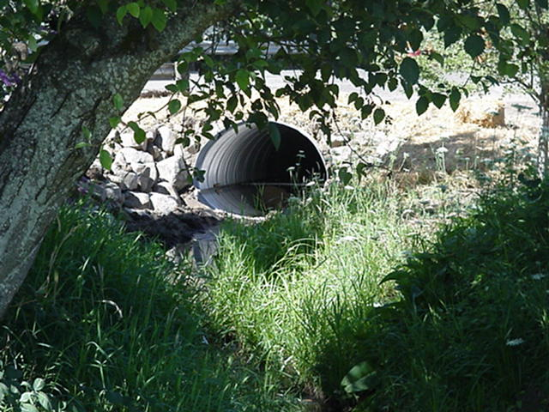
Example of completed fish passage project (Oatney)

Clean Water Services (formally USA) through their “Watersheds 2000” has initiated a stream health and water quality analysis for the portion of the Tualatin River watershed that falls under USA jurisdiction (primarily urban). The focus is water quality and stream health; however, limited data may be incorporated about in-stream structures. The Watersheds 2000 website states:
“…. While the project will provide a wealth of technical information, it will not address the following:
- Policy or programmatic issues (especially those related to ESA response, riparian buffers, Goal 5, and land use design standards)
- Fish-friendly internal audits by local entities in their ESA response efforts
- Social value and economic evaluation regarding ESA response
- Water quality modeling and TMDL development (part of TMDL program)
- Prioritization across the Basin’s watersheds (across land type sectors) for fish and water quality improvements”

The project proposal will fill the data gaps for the county owned road – stream crossing barrier analysis and the data will be forwarded to Clean Water Services for inclusion in the Watersheds 2000 project.

Willamette Subbasin

The Willamette Restoration Initiative (WRI) has outlined in their restoration strategy 27 critical actions necessary to restore salmon habitat in the Willamette River Basin. Action item 11 states “Inventory, map, and conserve priority fish and wildlife habitats in the basin”. Action item 12 further states “Improve both upstream and downstream fish passage at dams, culverts, and water diversions.”

The “Draft Willamette Subbasin Summary” http://www.cbfwa.org/files/province/lwrcol/subsum.htm (query Willamette download) prepared for the Northwest Power Planning Council and submitted October 2001 addresses fish passage assessments on page 102:
“Fish Passage assessments at road / stream crossings have been performed by Oregon Department of Fish and Wildlife, the U.S. Forest Service, Clackamas County, Clean Water Services and other local government and private entities. However, assessment methodologies vary considerable, dependent upon agency focus and need. ….Therefore existing data and reports probably understate the degree to which connectivity limits fish migration and production within the Willamette River subbasin. The lack of a consistent subbasin-wide fish passage barrier inventory inhibits the subbasin’s ability to accurately reflect the loss of access to high quality spawning and rearing habitat”.

The report continues on page 103:
“Most local road authorities have begun the remediation process of replacing or retrofitting road / stream crossings within their jurisdictional responsibility that are barriers to either juvenile or adult fish passage. Currently, the driving force for these projects is culvert condition and capacity………Washington County Department of Land Use and Transportation has begun developing its fish passage assessment and prioritization program, but long term funding remains the outstanding limiting factor….”
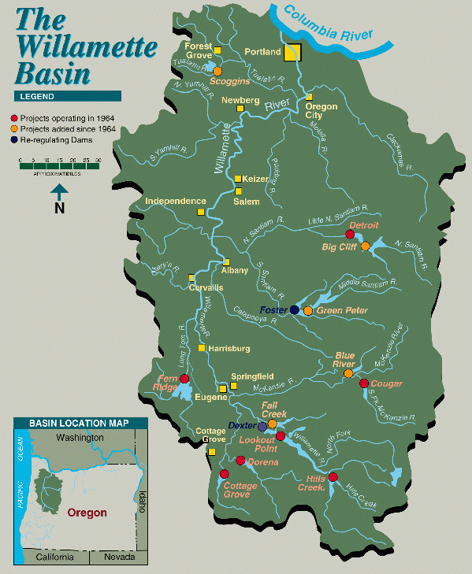
Columbia Basin
There are 24 major hydroelectric power generation facilities in the Willamette basin. Specific impacts of the Federal Columbia River Power System (FCRPS) are listed within the subbasin summary. Approximately 302.4 lineal miles and 4,751,308 yds² of spawning habitat have been lost due to construction of the Willamette Project dams (mainstems, not tributaries). In addition to habitat losses due to passage barriers at the dams, 85.6 miles of river habitat has been inundated by the reservoirs created behind the dams. (Page 50 of the summary). It is highly unlikely that this habitat will be restored within time to benefit the fish species that historically populated these reaches.
The 2000 FCRPS Biological Opinion http://www.nwr.noaa.gov/1hydrop/hydroweb/docs/Final/2000Biop.html lists offsite mitigation measures in the Reasonable and Prudent Alternatives (RPA) as an option for restoring habitat for species impacted by the FCRPS. The habitat strategy is intended to accelerate efforts to improve survival in priority areas in the short-term, while laying a foundation for long-term strategies through subbasin and watershed assessment and planning. (Section 9.6.2 page 9-135) Section 9.62.1 lists passage and diversion as an objective of tributary habitat efforts.

RPA Action 150 states:
“In subbasins with listed salmon and steelhead, BPA shall fund protection of currently productive non-Federal habitat, especially if at risk of being degraded, in accordance with criteria and priorities BPA and NMFS will develop by June 1,2001.”

Action 152 continues by stating:
“The Action Agencies shall coordinate their efforts and support offsite habitat enhancement measures undertaken by other Federal agencies, states, Tribes, and local governments by the following:….. Using or building on existing data management structures, so all agencies will share water quality and habitat, data, databases, data management, and quality assurance.”

The project proposal combines methodologies, techniques, and data from City, State, Local, Regional, State, and Federal agencies in order to objectively assess and prioritize barriers to fish passage. The prioritization component will balance environmental gains as well as transportation needs to build a decision-making framework to aid in project selection. Although the emphasis in correcting problems is within the public right-of-way, partnerships with private landowners are pursued where priority activities are identified in a watershed. For example, where a priority blockage exists on private lands and there is extensive suitable fish habitat available adjacent to the publicly owned barrier, the county will forward information to the local watershed council and soil and water conservation district to work with landowners to compete for salmon restoration dollars to correct the problem. Lack of cooperative landowners contiguous to the county owned barriers may result in a lower “significant barrier” ranking than the habitat warrants. The final version will be available through StreamNet as well as the BPA.

Action 154 claims:
“BPA shall work with the NWPPC to ensure development and updating of subbasin assessments and plans; match state and local funding for coordinated development of watershed assessments and plans; and help fund technical support for subbasin and watershed plan implementation from 2001 to 2006. Planning for priority subbasins should be completed by the 2003 check-in. The action agencies will work with other Federal agencies to ensure that subbasin and watershed assessments and plans are coordinated across non-Federal and Federal land ownerships and programs.”

The subbasin and watershed plans are in place as well as the action plans. As mentioned earlier, each assessment and action plan identifies the need to restore habitat connectivity within high and/or historic areas of fish habitat. It is logical that a systematic barrier removal program cannot occur without first identifying where those barriers lay within the watershed and ascertaining adjacent habitat viability. The project proposal implements concurrent goals within the Tualatin River Watershed, The Willamette River Subbasin, Lower Columbia River Province, and the Columbia River basin. In addition, the proposal is consistent with the Council’s Fish and Wildlife Program by “pooling” stream scale level data to provide a landscape view of opportunities to restore passage to anadromous and resident fish species within the watershed in order to mitigate habitat losses brought about by the construction and operation of the Willamette Basin dams.

d. Relationships to other projects

200088 – Assess McKenzie Watershed Habitat & Prioritize Projects
The technical strategy and philosophy of both project proposals are based on the need to accumulate available watershed information, identify data gaps (fish passage barrier information on public roads is the focus for our current proposal), and then build upon the existing and acquired data. The assessment will then explore impacts on fish and wildlife habitat in the Tualatin River Watershed from road – stream crossings, identify historic and current high-quality habitat locations, and identify potential sites for barrier removal and habitat gain. The project will conclude with a comprehensive assessment report and recommendations for projects within the Tualatin River Watershed.

200001600 – Tualatin River National Wildlife Refuge Additions.
The refuge develops mitigation sites through acquisition of lands within the approved boundary of the Tualatin River NWR. The refuge is located in Rural Washington County within the Lower Tualatin basin adjacent to the Tualatin River. Identifying fish passage barriers and prioritizing their removal will help meet refuge goals by eventually restoring hydrologic functions to the wetland system within the refuge.

199206800 – Willamette Basin Mitigation Program One of the goals of the program is to restore habitat connectivity and functionality within the stream systems of the Willamette Basin. Identifying and prioritizing fish passage barriers will supplement the information acquired by the program.

198403600 – Willamette River Projects Wildlife and Habitat Loss Assessment
A total of 30,000 acres and 94,000 Habitat Units were estimated to be lost as a result of the development of the Willamette River Basin Federal hydroelectric facilities. The project proposal will identify off-site mitigation opportunities for this lost habitat.

e. Project history (for ongoing projects)

not applicable

f. Proposal objectives, tasks and methods

The chart below outlines the process that will be followed throughout the assessment process.

When developing a program such as this, it is tempting to gather all the information that is possibly available at each site. This strays from our philosophy of getting “just enough” data at each site to make a decision about its ranking in the active level of assessment. These levels of assessment are designed to act as process filters so that each crossing that is moved forward in the process gains additional scrutiny until the ranked list of culverts that are significant barriers emerge. First, the barriers are identified, and if they are in significant production areas, the corridor is analyzed for viable habitat. If viable habitat is present, the barrier significance within that stream reach or smaller HUC is evaluated. Transportation factors such as scheduled maintenance, cost, and project complexity will be factored when making the final list. This simple yes/no filter keeps the focus towards significant barriers and eliminates gathering data for crossings that will never be considered for replacement due to poor habitat quality, natural barriers, or excessive cost.

At this time, the amount of crossings that will require evaluation is unknown. The map below graphically illustrates the road - stream crossing density that currently exits in Washington County.

Authors Note: to avoid redundancy, some objectives from Section 4 have been consolidated, and may be performed concurrently rather than consecutively

- Finalize Barrier Assessment Methodology
a. Incorporate USFS “Measurements of Surrogates” techniques for fish passage assessment. Fish passage evaluation and prioritization methods will be performed in accordance with the techniques developed as part of the Forest Road Fish Passage Guide (May 23, 2000) (http://www.4sos.org/wssupport/ws_rest/OregonRestGuide/index.html). This guide captures and organizes much of the current rules, regulations, and guidance regarding road - stream crossing installations and is the best reference to date for culvert assessments and project prioritization. The primary barriers to fish passage within a culvert are high water velocity, jump height, culvert slope (a factor in high velocity), and low flow water depth.

Marganne Allen of the Oregon Department of Forestry has evaluated four methods of barrier analysis: observing actual fish passage success, hydraulic analysis, velocity measurements, and lastly, the measurement of surrogates indicative of hydraulic conditions. Ms. Allen has concluded that the measurement of surrogates to be the most efficacious method of determining barriers to fish passage as she described during the Fish Passage Short Course in 2000. (http://www.4sos.org/wssupport/ws_rest/fpsc/4SOSCulvEvalTalk/index.htm)
Surrogate in this instance is best defined as “to put in place of another, to substitute”. Measurement of on-site conditions can be put in place of or substituted for more rigorous, dangerous, or time-consuming methods yet still reach the same conclusion of those more exacting techniques. In substance, this technique measures outlet drops and jumps, velocity, sediment retention patterns, backwatering (when downstream conditions cause water to “back-up” into the culvert), culvert and stream gradients, inlet drops, channel constriction, stream channel bankfull width, and water depth. The barrier analysis evaluation flow chart is located at: http://www.4sos.org/wssupport/ws_rest/fpsc/4SOSCulvEvalTalk/sld019.htm and http://www.4sos.org/wssupport/ws_rest/fpsc/4SOSCulvEvalTalk/sld020.htm .The advantages of this methodology are multiple: it doesn’t require strong background in fisheries biology, hydrology, and hydraulics (though working knowledge of these areas are important); you can cover the greatest number of crossings in the shortest time; the information can be used for hydraulic analysis and project design, and the data is repeatable.

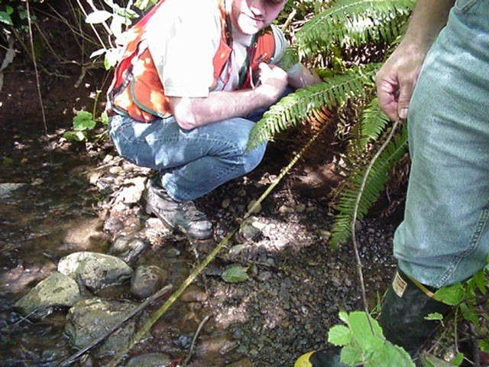
Measuring stream bankfull width (Lewis)

Oregon Department of Fish and Wildlife and National Marine Fisheries Service have previously approved the techniques and prioritization methodologies listed in the applicant’s proposal. Both agencies were instrumental in developing the Forest Road Guide Stream Crossing Restoration Method which will be utilized for the study, and have developed and ultimately endorsed the Clackamas County prioritization method, another component of this application. One of the reasons these methods have received ODF&W and NMFS’s “seal of approval” is to facilitate usage by other agencies as a pre-approved methodology for evaluating and prioritizing road - stream crossings that are barriers to fish passage

The methodology for assessing the structural integrity of the crossing structure will be based upon the US Department of Transportation Culvert Inspection Manual. The structural assessment includes information about culvert type, size, slope, and condition as well as basic stream information.

- Develop Inspection Protocol. An inspection manual will be prepared by combining the USFS barrier assessment methodology and the Washington County culvert inspection protocol for use by staff and private citizens. Emphasis will be on objective, measurable criteria. Habitat quality and viability will be based on existing studies, or if none exist, via ODF&Ws fish presence and abundance studies. If fish are currently present in the stream reach, it is a good indication that viable habitat exist. The presence and abundance study is additionally valuable when evaluating private & public lands, lack of contiguous fish population presence within a given stream reach is indicative of a loss of connectivity due to a natural or man-made barrier.

- Initiate Recruitment Process. Recruitment will follow standard Washington County personnel practices. If possible, limited or temporary employees will be hired for the positions as described in the personnel section. The recruitment for the project coordinator position will emphasize the need for environmental as well as engineering knowledge, skills, and abilities. The temporary summer employee will be recruited from current staff to take advantage of their knowledge of the local road and drainage systems.

2. Develop Prioritization Plan. Those crossings that meet the barrier & habitat qualifications will then be prioritized based on the “Guide to Prioritizing Fish Passage Projects in Clackamas County, Oregon” developed by the Clackamas County Fish Passage Technical Team (copy available upon request). The guide was developed by Clackamas County, Oregon Department of Fish and Wildlife, and National Marine Fisheries Services. Currently, the plan is under review by National Marine Fisheries Service (NMFS) for inclusion in Clackamas County’s 4(d) rules. Utilizing the methodology outlined in the guide, a prioritization plan will be developed that incorporates weighting factors specific to Washington County needs. The Road - Stream Crossing Restoration Method outlined in Forest Road Fish Passage Guide outlines seven steps in restoring fish passage at road - stream crossings in a basin:

- Find and prioritize problem road - stream crossings
- Gather information about stream and other conditions at crossings to be restored
- Decide if installation can be repaired, improved, or must be replaced

This proposal covers the first three steps outlined in the Guide. Once this information is obtained, the crossings will be prioritized and the following steps, as outlined in the guide, will occur for high priority road - stream crossings:

- Decide on design strategy based on information collected
- Prepare a design
- Install new road - stream crossing structure
- Monitor and maintain structure

Weighting factors will include amount of viable habitat (considering upstream and downstream barriers) gained by barrier removal, culvert condition and replacement schedule, scheduled road maintenance activities, project cost, results of catastrophic failure, and ability to obtain outside funding.

3. Incorporate Existing Environmental data. Information will be obtained from Clean Water Services, ODF&W, and Metro for incorporation into the significant viable habitat component of the assessment. StreamNet will be consulted early in the process to ensure spatial integration of data. Multnomah County has offered their previously developed database and GIS links for use by the County. Most Oregon Counties utilize the same database structure, Integrated Road Information System (IRIS) for all road maintenance activities. Using the links provided by Multnomah County will ensure usability of the program by other Oregon Counties.

- Conduct Assessments. 5th field HUCs will be evaluated in the following order of descending habitat importance: Dairy / McKay, Gales Creek, Upper Tualatin / Scoggins, Middle Tualatin / Rock Creek, and the Lower Tualatin. Almost 100% of the federally owned lands are contained within the Dairy / McKay, Gales, and Upper Tualatin watersheds, which will be the first 5th field HUCs evaluated. The fact that the initial assessments will occur adjacent to most of the federal land in the County allows us to “tie-in” to barrier removal projects that have occurred under the direction of the US Forest Service and Oregon Department of Forestry. As each smaller field is evaluated, data will be compared within the smaller watershed and in the larger landscape of the Tualatin River Watershed for off-site mitigation opportunities.

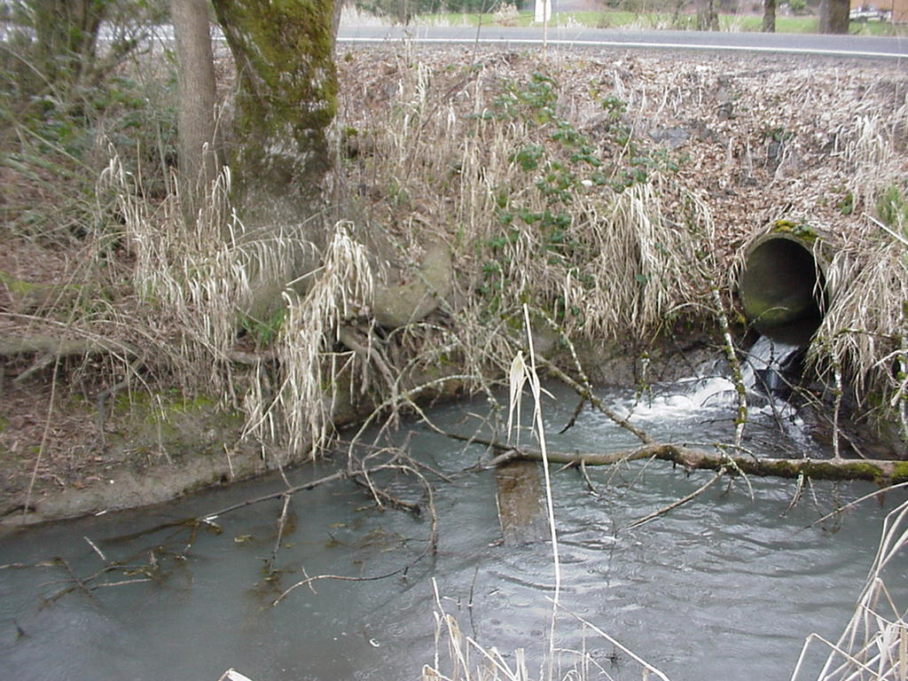
Example of typical Washington County fish passage barrier (velocity, jump, water quality)

- Produce electronic and hard copy final assessment report. This report will be available in electronic and hard copy, as well as data sets to outside agency stakeholders. The report will outline the process, methodology and results of the assessments, include potential environmental gain.

- Produce Washington County prioritization plan for removing barriers that block passage to fish species. This will be an addendum to the previous objective. This will be the final project list after running the prioritization program. High priority culvert locations will be forwarded to the Washington County Soil and Water Conservation District, Tualatin River Watershed Council, and the Tualatin River Keepers to determine if any barriers on private property exist that may impact the ranking of the barrier. The methodology for assessing and prioritizing crossings that may be barriers to fish passage will be forwarded to the watershed council and conservation districts for use by private citizens. Data collected about off right-of-way crossings will be incorporated into the database. If a high-ranking barrier is adjacent to publicly owned forestlands, the appropriate agency will be contacted for determination of barriers within the impacted stream.

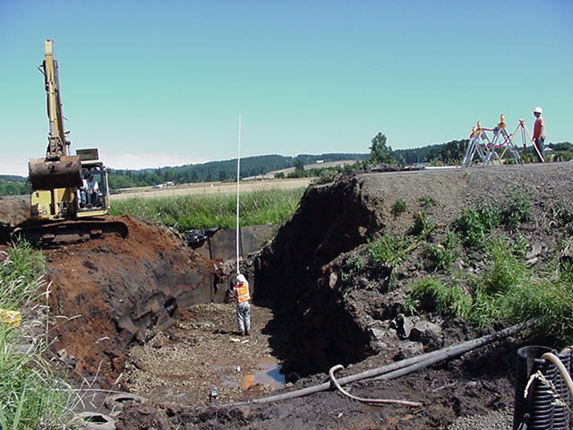
Ensuring proper bedding elevation for culvert installation during culvert replacement & fish passage project (Oatney)

g. Facilities and equipment

This program will be included in the FY 2002-2003 budget and work program (currently unfunded with the exception of the local match), the program will be based in Washington County’s Walnut Street Center which has sufficient office space, vehicles, and computers, as well as the personnel necessary to support the additional employees and equipment.

Based on EPA’s 1996 “Precision, Bias, and Accuracy in Measurements” study we have chosen field equipment that is equal to the evaluation criteria. A surveyor’s self-adjusting level, legs, and rod will be used to determine stream and culvert slope, engineering measurements 1/10’, 1/100’ will be used, digital cameras will record on - site conditions and data will be entered into laptops or hand-held computers.
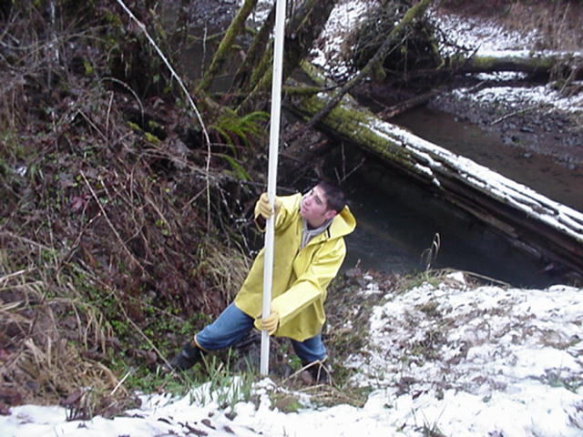
Determining culvert slope in the field with surveyors level and rod (Oatney)

h. References

Reference (include web address if available online) | Submitted w/form (y/n)
Allen, Marganne “Methods for Evaluating Culverts for Fish Passage” Fish Passage Short Course December 2000  http://www.4sos.org/wssupport/ws_rest/fpsc/4SOSCulvEvalTalk/index.htm | N
Allen, Marganne; Mirati, Albert; Robison, George; & Runyon, John “Fish Passage Short Course” December 2000  http://www.4sos.org/wssupport/ws_rest/fpsc/index.html | N
Bastasch, Rick, Bilbao, Anita, Sieglitz, Greg “Draft Willamette Subbasin Summary” http://www.cbfwa.org/files/province/lwrcol/subsum.htm (query Willamette download) prepared for the Northwest Power Planning Council and submitted October 2001 | N
Clackamas County Fish Passage Technical Team “Guide to Prioritizing Fish Passage Projects in Clackamas County, Oregon” | N
Clean Water Services “Healthy Streams - Watersheds 2000” website  http://www.cleanwaterservices.org | N
FISRWG (10/1998). Stream Corridor Restoration: Principles, Processes, and Practices. By the Federal Interagency Stream Restoration Working Group (FISRWG)(15 Federal agencies of the US gov't). GPO Item No. 0120-A; SuDocs No. A 57.6/2:EN 3/PT.653. ISBN-0-934213-59-3.  http://www.usda.gov/stream_restoration | N
Furniss, Flanagan, McFadin “Hydrologically-Connected Roads: An Indicator of the Influence of Roads on Chronic Sedimentation, Surface Water Hydrology, and Exposure to Toxic Chemicals”  http://www.stream.fs.fed.us/streamnt/jul00/jul00_2.htm | N
Leader, Kevin A.; & Hughes, Michele L. “Distribution and Abundance of Fish, and Measurement of Available Habitat in the Tualatin River Basin Outside the Urban Growth Boundary” Columbia River Investigations Program, ODF&W, 2001 | N
Mills, Keith P.E. “Forest Roads, Drainage, and Sediment Delivery in the Kilchis River Watershed” Oregon Department of Forestry, June 1997  http://www.odf.state.or.us/FP/fpmp/Misc%20PDF/kilchis.pdf | N
NOAA The 2000 FCRPS Biological Opinion http://www.nwr.noaa.gov/1hydrop/hydroweb/docs/Final/2000Biop.html | N
ODF&W Fish Passage Program for Oregon Department of Fish and Wildlife,  http://www.dfw.state.or.us/ODFWhtml/InfoCntrFish/Management/FishPassage.html website 11/01 | N
ODOT “Routine Road Maintenance - Water Quality and Habitat Guide, Best Management Practices” July 1999  http://www.odot.state.or.us/eshtm | N
ODSL The Oregon Division of State Lands website,  http://statelands.dsl.state.or.us/maps/washington.pdf website 11/01 | N
Oregon Road – Stream Crossing Guide, (No Author given)  http://www.4sos.org/wssupport/ws_rest/OregonRestGuide/index.html  website 11/01 | N
OWEB “Oregon Aquatic Habitat Restoration and Enhancement Guide”  http://www.oweb.state.or.us/publications/habguide99.shtml | N
Pinnell Andree N & Gries, Sue, “The Tualatin River Watershed Atlas”, TRWC March 2001 | N
Roni, Phillip et al “A review of stream restoration techniques and a hierarchical strategy for prioritizing restoration in Pacific Northwest watersheds” Oregon Chapter American Fisheries Society Watershed Restoration Workshop, November 2001 | N
Roni, Phil “Validation Monitoring: Measuring Fish Responses to Restoration Activities” Northwest Fisheries Science Center, American Fisheries Society Presentation, November 2001
.TRWC “The Watershed”, query Water, Hydrology, Existing Conditions, Tualatin River Watershed Council website http://www.trwc.org February 2000 | N
TRWC “Tualatin River Watershed Action Plan” Tualatin River Watershed Council, February 1999. | N
US Department of Transportation “Culvert Inspection Manual” Supplement to the Bridge Inspectors Training Manual FHWA- IP-86-2, July 1986 | N
USFS “Water/Road Interaction Toolkit” Water/Road Interaction Technology Series, San Dimas Technology & Development Center http://www.fs.fed.us/rm/RRR
Washington Department of Fish & Wildlife Fish Passage Technical Assistance website,  http://www.wa.gov/wdfw/hab/engineer/fishbarr.htm, August 2000 | N

Section 10 of 10. Key personnel

Engineer: Keith Lewis EIT Civil Engineer, BS Oregon Institute of Technology, 1983, Engineering Associate, Manager of Project Development Section (not included in budget)
Relevant Experience: Responsible for section engineering, program and project management.

Program Manager / Grant Administrator: Janet Oatney Inspection Technician II, Project Development Section
Relevant Experience - Education: Project Manager for numerous projects during the last six years including fish passage improvements, minor betterments, local improvement districts, FEMA disaster recovery, and assorted road maintenance projects from project inception through permitting, design, construction and closeout. Have taught several classes on bio-engineered stream bank restoration, erosion control, disaster management, and ESA issues. Received certification as a wetland delineator from Portland State University (3/98), have completed the Culvert Fish Passage Remediation series (2/98), Endangered Species Listing (8/98), Crystal Reports (5/99), Project Management (8/99), Erosion & Sediment Control (3/00), Fish Passage Short Course (6/00) and the Watershed Restoration Workshop (11/01) in addition to numerous engineering courses. Skilled in Project Management and Grant Administration (have administered over $3,000,000 in grant funds during the past six years which have been audited by independent auditors with no errors). Currently in charge of the Local Improvement District program which partners with residents to provide road improvements beyond county maintenance standards. Obtaining permits and ensuring project / program compliance with Federal, State, and Local regulations is another assigned duty. Co-Founder of Northwest Passage, the local users group that educates other agency staff on issues pertaining to the Endangered Species Act and transportation issues. Member of the Metro Green Streets Fish Passage Technical Advisory Committee and served on the Willamette Subbasin summary team. Considered the engineering point of contact for fish passage and environmental compliance by the organization.

Temporary Inspection Technician II: will recruit for individual with environmental educational background with high skills in field assessments, database construction and maintenance, GIS, and fish passage.

Temporary Inspection Technician I: will recruit from existing staff to take advantage of thorough knowledge of the County road systems and stream crossings. Data entry skills as well as pertinent field experience will be weighted during recruitment.

GIS/Database: Richard Crucchiola, GIS specialist . (BS Portland State University; resume not available due to his vacation) Responsible for database construction and integration, GIS analysis and development. Ensure compliance with compatible outside software. GIS duties may be incorporated under the Temporary Inspection Technician II position.

Fiscal Manager: Ray Neilson, Management Analyst II M.P.A. Brigham Young Marriott School of Management 1986. Oversees all fiscal operations in the Division. (not included in budget)

