Bonneville Power Administration

FY 2003 Provincial Project Review

PART 2. Narrative
Project ID: 31022

Title: Establish a Water Cleanup Plan (temperature TMDL) for the East Fork Lewis River subbasin

Section 9 of 10. Project description

a. Abstract
This project is designed to accurately assess and address water quality factors limiting anadromous species throughout the East Fork Lewis River subbasin—a broad spatially geographic area, over a two-year period. It would employ a rapid airborne sampling technique to gather temperature data on 70 miles, validation using an extensive network of on the ground water quality monitoring, production of technical analyses and GIS coverage, and development of a water cleanup plan, also called Total Maximum Daily Loads (TMDLs), outlining strategies to achieve water quality standards for temperature. This project would complete the watershed by combining data with the partial FLIR measurements conducted by Pacific Corps for WDFW in March 2001.

The overall success of this project is critical to the enhancement of fish populations in the East Fork Lewis subbasin. By identifying the sources of heat, and recommending strategies to lower the summer temperatures to healthy ranges, this project integrates the work of numerous other fish restoration projects in this subbasin. It will directly complement the success of such other projects as water right and land acquisitions, riparian habitat improvements, fish traps, ladders, and screens.

b. Technical and/or scientific background
The East Fork Lewis River is one of the largest subbasins in the Lower Columbia Basin. Its rivers and streams historically provided important spawning and rearing habitat for anadromous and resident fish. The East Fork Lewis subbasin currently supports anadromous runs of Chinook, Chum, Steelhead and Coho. Bull Trout and Costal Cutthroat Trout are also present. All anadromous salmonids in the subbasin have experienced a long term, in most cases, severe decline in abundance, diversity and habitat productivity. The Chinook, Chum, and Steelhead were listed under the Endangered Species Act.

There are serious water quality problems in the subbasin. Forestry, farming, irrigation diversions, and road construction have degraded the water quality and damaged the species environment and critical habitat for spawning, rearing, and migration.

The subbasin summary cites water quality problems, especially temperature, as limiting factors influencing salmonid survival in the mainstem of the East Fork Lewis River. The East Fork Lewis and several tributaries are on the 1998 State of Washington 303(d) list (see map) for failure to meet water quality standards for temperature and fecal coliform. Summer temperatures have been recorded in excess of 24°C, which exceeds healthy conditions for the species of concern.

The East Fork Lewis River is classified by the state of Washington as Class A waters. Compliance for Class A waters includes: temperature not to exceed 18 degree C, fecal coliform not to exceed a geometric mean of 100 colonies per 100ml. Turbidity also exceeds standards 45% of the time. A water cleanup plan (TMDL) identifies the pollutants problems and sources, allocates the maximum allowable pollution from various sources, and develops strategies to achieve the limits and meet water quality standards.

East Fork Lewis Watershed TMDL listings

Water Body | Parameter
East Fork Lewis | Temperature, fecal coliform
Lockwood Creek | Temperature, fecal coliform
McCormack Creek | Temperature, fecal coliform
Rock Creek North & South | Fecal coliform
Yacolt Creek | Fecal Coliform
Source: Department Of Ecology

The East Fork Lewis system is a fifth order stream draining 212 square miles and enter the mainstem Lewis River RM 3. The Lewis River enters the Columbia River below Vancouver, Washington at River Mile 87. The upper portion of the watershed, above Sunset Falls lies within the Gifford Pinchot National Forest. The President’s Forest Plan categorizes this basin as a “Tier 1, key watershed” that provides habitat for anadromous salmonids. The US Forest Service manages 32% of the watershed for multi-use benefits. The lower portion of the East Fork Lewis River basin consists of non-federal lands managed for timber harvest, residential development, agriculture, gravel mining, and recreation. The USFS has signed a memorandum of understanding with Ecology that spells out the steps the USFS will take to implement TMDL requirements.

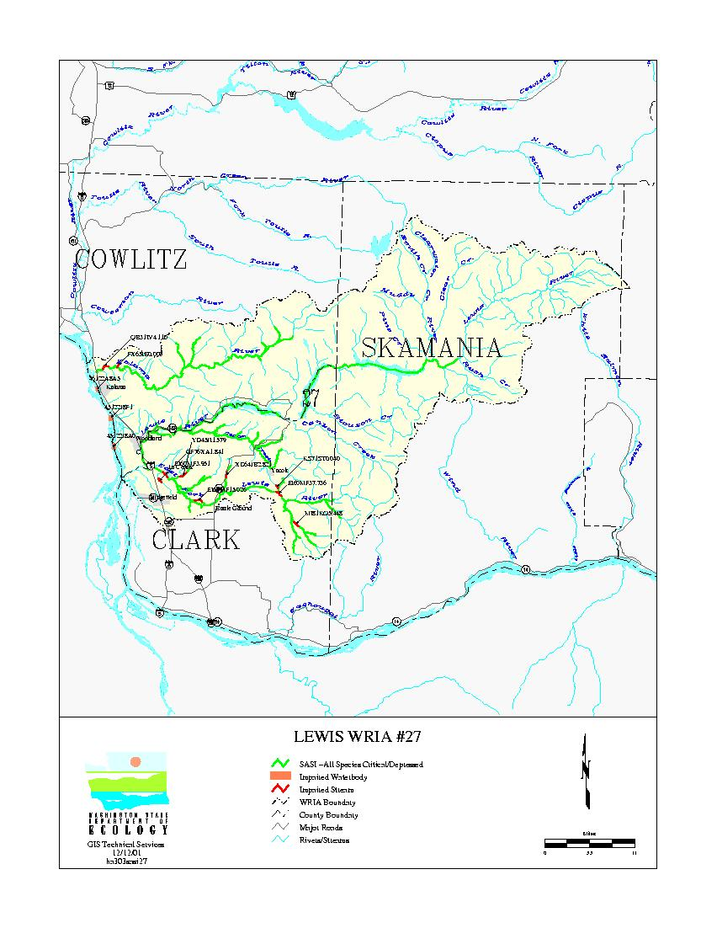

c. Rationale and significance to Regional Programs
We are requesting BPA support to expedite the development of TMDLs for temperature by providing resources needed in FY 2003 and 2004. The TMDL will address water quality and aquatic habitat factors relating to temperature, and fecal coliform. The analysis and resulting TMDL will eventually guide corrective actions and priorities in the subbasin. By implementing best management practices residents and property owners in the affected areas can begin to reverse the current trend and progress toward removal of streams from the 303(d) list, as well as protect the salmon streams that currently meet state water quality standards from future listings.

Ecology is currently in the decision phase of allocating resources for a TMDL addressing the fecal coliform in the East Fork Lewis subbasin. This is a preliminary step to begin assessing the current extent of pollution. The poor condition of the salmon, bull trout and sea-run cutthroat trout supports the need for immediate and urgent work to accurately assess the sources of water quality temperature problems and develop effective comprehensive strategies to address those sources within the next two years. The information and strategies developed in the TMDLs are essential to the development of the Lower Columbia Fish Recovery Board Salmon Recovery plan in 2003, the NPPC subbasin plan in 2005 and implementation of a basin cleanup plan for the East Fork Lewis River projected for FY 2005. Without BPA support, the start of the temperature TMDL work would be delayed six years.

The proposed project addresses NMFS’ Draft Columbia River Biological Opinion (NMFS, 2000) by supporting the objectives of the RPA identified under Water Quality Strategy (9.6.1.7.1), which emphasizes the importance of clean, cool water salmonids. The proposal also supports the water quality objective outlined in section 9.6.2.1 Actions Related to Tributary Habitat objective: “water quality comply with water quality standards, first in spawning and rearing areas, then in migratory corridors.”

Additionally, the proposed project supports RPA actions 150 and 152: “In subbasins with listed salmon and steelhead, BPA shall fund protection of currently productive non-Federal habitat, especially if at risk of being degraded, in accordance with criteria and priorities BPA and NMFS will develop by June 1, 2001”; “The Action Agencies shall coordinate their efforts and support offsite habitat enhancement measures undertaken by other federal, states, Tribes, and local governments”; and “measures implemented by the Action Agencies to improve habitat can complement efforts by...local entities.”

In the Habitat Strategies section of the 2000 Columbia River Basin Fish and Wildlife Program (FWP), there is considerable emphasis on projects that will “build from strength” to “expand adjacent habitats that have been historically productive or have a likelihood of sustaining healthy populations by reconnecting or improving habitat.”

Finally, Section 3.1 of the July 27, 2000 Draft Final “All-H” Paper speaks to the importance of protecting and restoring water quality. “Riparian conditions that determine water temperature…” is identified as one of four habitat factors which will influence performance measures throughout the basin. The All-H Paper list the Lewis as a high priority subbasin.

The project will support several habitat goals, objectives and strategies outlined in the subbasin summary for the Lewis Subbin. It will provide accurate and complete data for the Salmon Steelhead Habitat Inventory Assessment Program (SSHIAP) EDT modeling and monitoring activities listed in the subbasin.

d. Relationships to other projects
Ecology has given a grant for $800,000 to the Lower Columbia Fish Recovery Board to develop a watershed plan for the Lewis and Salmon/Washougal subbasins. The Board is currently developing a work plan for filling data gaps identified in stage one of this process. The information and data generated from this proposal would be of key assistance in developing implementation priorities in the Lower Columbia Salmon Recovery Board plan.

e. Project history (for ongoing projects)

f. Proposal objectives, tasks and methods
This project requires considerable coordination, public outreach and education. First, Ecology has found that executing a project of this size involving on the ground monitors and helicopter overflights requires extensive public information, education, and preparation before, during and after the project. Second, stakeholders in the area need to be informed and included into an implementation steering committee to ensure effective implementation of the strategies to improve water quality. Ecology is cost sharing the cost for follow-up activities including monitoring and compliance. However the result of this proposal is synergy with the local communities to accomplish the best management practices requisite to reducing summer temperatures.

The data from this project along with the local planning and work activities must and will be shared with numerous other project leaders in the area. Data collection will be coordinated and shared on a continuous basis. The data will reside at Ecology and will be available on the Agency’s web site. Resulting load allocations for vegetation and shading and other implementation activities will also be coordinated for use by other ongoing projects in the area hosted by Tribes, County, Washington Department of Fish and Wildlife, Conservation Districts, and others.

The data should improve the outcome of EDT modeling by providing accurate and complete information on water quality within the mainstem and tributaries of the East Fork Lewis River. The water cleanup plan (TMDL) should be the basis for developing an effective watershed and subbasin plan for the East Fork Lewis system (as stated in the subbasin summary water quality factors, especially temperature issues are the major factors influencing salmonid survival).

Goal:
Protect and restore water quality to met fish conservation requirements of ESA, as well as water quality requirements of the clean Water Act.

Objective 1. Accurately assess water quality factors limiting anadromous fish populations and develop a water cleanup plan to protect and restore water quality to meet the needs of listed species. The plan will guide and integrate with state, federal, tribal and local decisions, priorities and actions concerning anadromous fish protection and restoration.

Tasks and Methods:
- Collect using the Forward Looking Infrared Radiometry (FLIR) multispectral imaging of riparian vegetation, stream temperatures, and habitat information over approximately 70 miles of this watershed. FLIR products, including a digital video are invaluable from a number of aspects. They enable the identification of heat sources, the assessment of the effects of thermal refugia, tributary input, groundwater input, and the assessment of streamside conditions.

- Validate the broad spatial scale data with on the ground data from in-stream data loggers and continuous gages operated by Ecology and others. Accurate data profiles will be generated to understand water quality and aquatic habitat factors related to temperatures. The data will help us identify and model heat inputs and devise credible implementation plans to reduce water temperatures to healthy levels.

- Document and share stream temperatures and habitat conditions within the East Fork Lewis subbasin with federal, state and tribal fish managers, for improved habitat assessments.

- Digitize data for stream banks and riparian vegetation attributes for use in ArcView. Maps will show stakeholders the location and magnitude of temperature problems and associated land use activities, throughout the East Fork Lewis system. This information, along with the digital video produced by FLIR, is key as a catalyst and stimulant for establishing future local implementation plans and activities to correct water temperature exceedences. Furthermore, but equally important, is their use to show and convince landowners, and resource agencies, of the real need for riparian restoration to achieve lower water temperatures.

- Statistically analyze data using predictive stream temperature analytical models, to determine appropriate vegetative shade targets to achieve water quality standards. This task defines the total maximum allowable daily loads from various sources to reduce temperatures and meet anadromous fish needs. Technical analysis is essential to the credibility of designated shade targets to improve temperatures.

- Coordinate and share the information with other state agencies (WDFW), tribes, EPA, and local governments and other entities. Encourage others to use the data for a number of analyses relating to habitat, fecal coliform, water temperatures, and overall watershed health. A key effort is the use of the information for diagnostic and treatment modeling to improve the state of existing knowledge about water quality. As stated above, a special effort will be taken to share the information and the water cleanup plan with the Lower Columbia Fish Recovery Board, the Governor’s Salmon Team, and Clark Conservation District.

Products:
All final products will be present on CD-ROM and available for use with other products in the basin. They include
- ArcInfo GIS database containing image (<1 meter pixel resolution), locations, stream temperatures, tributary temperatures, river kilometer, and image interpretations.
- Longitudinal profile of stream temperature with ± 0.5°C resolution versus river kilometer mapped either from the mouth or headwaters.
- Quantitative analysis and verification of radiant temperature accuracy based on comparison to in-stream temperature measured with Onset Stowaway continuous monitors.
- Overlapping geo-referenced FLIR and associated digital day images for the entire extent of the flight.
- Draft and Final Reports including discussions of data quality and interpretations of FLIR imagery.
- Database of continuous temperatures and flows.
- Technical analysis report of stream dynamics with recommendations for targets for the establishment of shade that influence stream temperatures.

Objective 2. Establish implementation plan and a monitoring program to evaluate the effectiveness of water quality strategies and related salmonids responses at the subbasin level. The follow-on implementation activities over time will result in heat reductions to maximize the habitat that is optimal for salmonids.

Tasks and Methods.
- Develop a detailed implementation plan with locally involved entities: the Yakama Tribe; The Lower Columbia Fish Recovery Board; Clark County; Clark Public Utilities; Clark Conservation District; Friends of the East Fork; the Departments of Fish and Wildlife and Natural Resources; and the US Forest Service. Ecology will cost share this task beginning in 2003 by absorbing the multi-year cost of facilitation and implementation activities throughout the period to achieve healthy temperatures. This task is projected to be completed in FY2005.

- Coordinate an effectiveness monitoring program with the entities listed above. A local organization of involved entities (could be the watershed planning group established under the state law) will be formed to implement best management practices until temperature standards are met and healthy aquatic conditions for salmon and trout are established.

Cost Sharing:

Ecology will contribute $50,000.000 per year to this project for:
- Project Management. This effort includes overall organizational, personnel, training, scheduling, material, and resource management.
- Technical Support and Guidance. This effort represents developing a quality assurance plan, and guiding all technical aspects of the sampling, data gathering, and analysis.
- Onsite Coordination of stakeholders, other related project leaders, and interagency information sharing throughout the project preparation and execution periods.
- Public education, information, and involvement. This effort includes preparing public information and coordination requisite to gaining stakeholder and general public project acceptance and building interest in follow-on implementation activities during both the preparatory and execution phases.
- Continued monitoring of Ecology’s core and rotating water quality data monitoring stations during the project period.

As previously stated, Ecology intends to follow through in subsequent years most of the cost of implementation plans to ensure healthy temperatures are achieved.

g. Facilities and equipment

Ecology will contract the data collection using Forward Looking Infrared Radiometry (FLIR) and associated digital daylight images. FLIR allows detection of a 0.5°C difference in temperature of water surfaces. In-stream data loggers will be placed throughout the 70 miles of the subbasin. In stream validation and calibration of FLIR images is necessary to ensure confidence of the data. Additionally, data loggers add an element of temporal continuity to be coupled with the spatially continuous data provided by the thermal images. The products of FLIR are both infrared temperature assessment and a digital video of the waters and their riparian areas.

h. References

Reference (include web address if available online) | Submitted w/form (y/n)
Draft Lewis River Subbasin Summary-October 26, 2001, prepared for the Northwest power planning Council.  Hallock, D. and Ehinger, W. (1999). River and Stream Ambient Monitoring Report for Wateryear 1997. Olympia: Washington Department of Ecology. 99-332. http://www.ecy.wa.gov/biblio/99332.html  Mendel, G., and V. Naef, D. Karl 1999. Assessment of Salmonid Fishes and their Habitat Conditions in the Walla Walla River Basin – 1998 Annual Report. Washington Department of Fish and Wildlife Report # FPA99-01, for U.S. Department of Energy, Bonneville Power Administration Fish and Wildlife Project # 98-20  McIntosh, B.A., D. M. Price, C.E. Torgerson, and H.W. Li. 1995. Distribution, habitat utilization, movement patterns, and the use of thermal refugia by spring chinook in the Grande Ronde, Imnaha, and John Day basins. Progress Report. Portland, OR: Bonneville Power Administration, Project No. 93-700. 16 pp.  Torgerson, C.E., D.M. Price, H.W. Li, and B.A. McIntosh. 1995. Thermal refugia and chinook salmon habitat in Oregon: applications of airborne thermal videography. In: Proceedings of the 15 th Biennial Workshop on Color Photography and Videography in Resource Assessment. Terre Haute, ID: American Society for Photogrammetry and Remote Sensing. Pages 167-171.  Torgerson, C.E., D.M. Price, H.W. Li, and B.A. McIntosh. 1999. Multiscale thermal refugia and stream habitat associates of chinook salmon in Northeastern Oregon. Ecological Applications. 9(1), pp 301 – 319.  Hutton, R.1954, Draft East Fork Lewis River Watershed Characterization Background Report, Clark County, Water Quality Division, Vancouver WA, 92 pages.  Lewis County GIS, 1999, GIS Fish Distribution Maps and Analysis of Various Habitat Conditions within WRIA 27, Lewis County WA.  Caldwell J Shedd and H. Beacher, 1999, East Fork Lewis Fish Habitat Analysis Using the Instream Flow Incremental Methodology and Toe-Width Method for WRIA 27, publication number 99-151, Department of Ecology, Olympia, WA, 48 pages. | N  N  N  N  N  N  N  N  N  N

Section 10 of 10. Key personnel

Gregory J. Pelletier, P.E.
Department of Ecology
P.O. Box 47710
Olympia, WA 98504-7710
(360) 407-6485
Professional Experience
February 1988 to Present: Environmental Investigations and Laboratory Services Program,
Washington State Department of Ecology, Olympia, Washington
Water Quality Engineer. As a licensed Professional Engineer:
- Conducts basin-wide studies of pollutant loading, fate, and transport. Recent modeling studies of stream temperature include basin-wide monitoring and analysis of the Wind River and Stillaguamish River.
- Directs complex water quality modeling studies throughout the state, resulting in recommendations for developing or changing departmental management strategies, policies, and regulations for water pollution control.
- Provides professional engineering expertise in environmental engineering, including technical review, evaluation, and recommendations on issues associated with modeling applications and maintenance of water quality standards.
- Provides supervision and training of staff.
April 1984 through January 1988: Harper-Owes (currently named Harding Lawson Associates)
Seattle, Washington, Water Quality Engineer. Performed environmental engineering duties in the field of water quality assessment and modeling. Determined effects of waste water on water quality of surface and ground water. Independently designed, conducted, and managed projects in the field of environmental engineering for water quality assessment and modeling.
April 1982 through March 1984: unicipality of Metropolitan Seattle, Seattle, Washington
Water Quality Scientist. Performed water quality data analysis and technical report writing. Summarized results of water quality monitoring studies in technical reports.
January 1982 through December 1983: Herrera Environmental Consultants, Seattle, Washington
Water Quality Scientist. Project manager for a water quality investigation of Wapato Lake, Tacoma. Managed investigation of effectiveness of environmental engineering controls of stormwater and lake quality.
Education
1979 –to 1985: University of Washington, Seattle, Washington
Master of Science in Engineering, Department of Civil Engineering
1975 to 1979: Springfield College, Springfield, Massachusetts
Bachelor of Science, Environmental Studies

WILL KENDRA

Watershed Ecology Section Manager

Environmental Assessment Program

Department of Ecology

POB 47600
Olympia, Washington 98504-7600
Phone: (360)407-6698
E-mail: wken461@ecy.wa.gov

EDUCATION B. S. Fisheries Resources, University of Idaho, 1981
M. S. Fisheries Resources, University of Idaho, 1983

EXPERIENCE Fisheries Research Biologist
Washington State Department of Game, 1983-1985
- Conducted steelhead stock assessment for Washington State as part of the Columbia Basin Anadromous Salmonid Stock Assessment project.

Aquatic Pollution Ecologist
Washington State Department of Ecology, 1985-1991
- Conducted water quality monitoring and assessment studies to determine the sources, effect, and fate of pollutants discharged to Washington waters.

Watershed Studies Manager
Washington State Department of Ecology, 1991-2001
- Managed a staff of 40+ environmental scientists, engineers, and hydrogeologists responsible for conducting a statewide water quality monitoring program on surface and ground waters including the development of Total Maximum Daily Loads (TMDLs) required under Section 303(d) of the Federal Clean Water Act.

