Bonneville Power Administration

FY 2003 Provincial Project Review

PART 2. Narrative
Project ID: 31024

BPA Project Contract Number 96BI97789

Title: Protect, Enhance and Maintain Wetland, Riparian and Upland Habitat on the Shillapoo Wildlife Area

Section 9 of 10. Project description

a. Abstract

The 2,371 acre Shillapoo Wildlife Area (SWA) is located in Clark County in Southwest Washington (Figure 1). This Wildlife Area was originally established in 1952 with the purchase of 277 acres between Shillapoo Lake and the Columbia River. Other parcels were added, primarily in the 1990's, to bring the wildlife area to its current size.

The primary management goal of the Shillapoo Wildlife Area is to protect, enhance, and maintain wetland, riparian, and upland habitats that support breeding and wintering Canada geese, mallards and dabbling ducks, as well as mink, great blue herons, sandhill cranes, black capped chickadees, western meadowlark, and yellow warblers. With the exception of the sandhill crane, these species were identified as “indicator” species in the construction and loss assessments for Bonneville, The Dalles and John Day dams (Rasmussen and Wright 1989). Numerous other wildlife species also benefit directly from this project.

Planned and ongoing habitat enhancement, maintenance and protection measures include riparian and oak forest tree plantings, wetland developments, weed control, waterfowl forage improvements such as pasture management and food plots, and maintenance of water control structures, fences, roads and other necessary infrastructure. Long-term operation and maintenance (O&M) is required in order to protect and maintain habitat/wildlife values on all units comprising the Shillapoo Wildlife Area. Planned monitoring activities include measuring both wildlife and habitat response to habitat manipulation and protection measures.

WDFW proposes to fund all startup, enhancement and O&M activities for 2003 using existing BPA MOA funds. This funding proposal request is for only out-years 2004 and 2005.

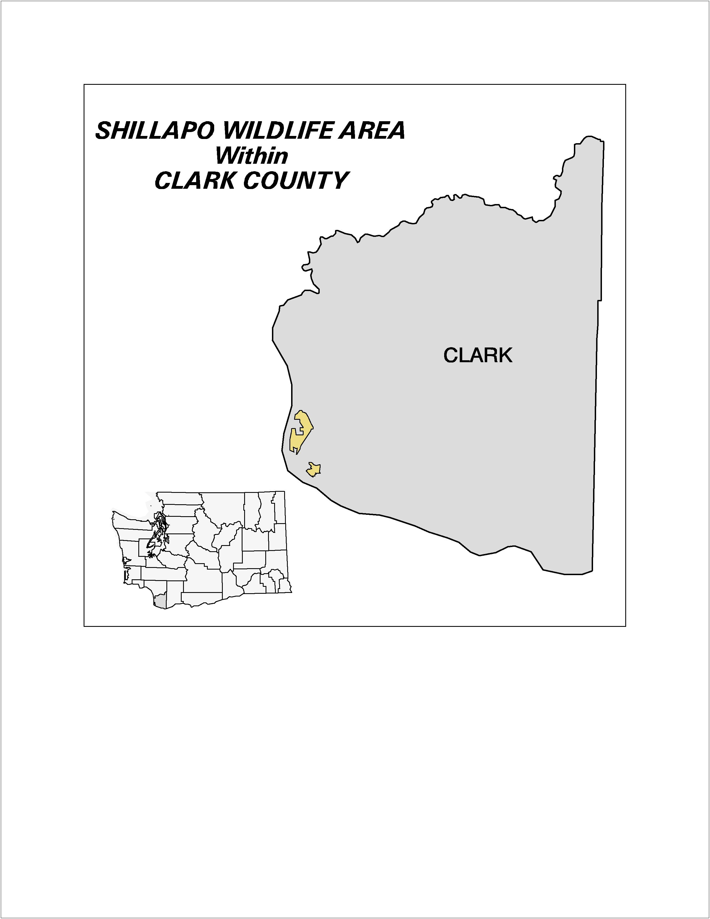

Figure 1. Shillapoo Wildlife Area Locator Map

b. Technical and/or scientific background

The Shillapoo Wildlife Area mitigation project addresses declining quantity and quality of riparian, wetland and oak woodland habitat. The Lower Columbia River and Columbia River Estuary Subbasin Summary (Marriott, Debrah 2001) clearly documents the need for restoration and maintenance of composition and diversity of plant communities in riparian areas and wetlands to support diverse fish and wildlife populations as essential components of a healthy watershed.

The Shillapoo Wildlife Area is comprised of six management units; the 672 acre North unit, the 1,012 acre South unit, the 477 acre Vancouver Lake unit, the 416 acre Vancouver/Clark Parks property, the 400 acre New Columbia Gardens Property, and the recently acquired 210 acre Herzog Property (Figure 2). The New Columbia Gardens unit is proposed for purchase. The Vancouver/Clark Parks unit owned by the city and county respectively will be managed based on a cooperative agreement.

The Vancouver Lowlands, where the SWA is located, were a highly diverse mixture of both herbaceous and forested wetlands, oak woodland, and riparian habitat. Shillapoo Lake was a dominant feature of the landscape. Lewis and Clark noted the abundance of waterfowl in the area whose calls kept them awake at night. Restoring these wetlands for waterfowl and salmonids is a goal stated in the Subbasin Summary and shared by WDFW.

The area has undergone major changes in the past 50 years. The most significant change was the draining of Shillapoo Lake and its development as agricultural and pasture land. This was made possible by the construction of dikes around the area and the installation of a pump which constantly keeps the area drained except for the winter months when some water generally accumulates. The construction of dams upstream on the Columbia River has also reduced water fluctuations and virtually eliminated periodic flooding that once occurred.

The control of flows in the Columbia River, diking, draining and clearing for agricultural uses have altered the vegetative landscape and composition of plant species, facilitating the introduction and/or proliferation of non-native plants in many areas. This drier condition has allowed both agricultural and industrial development in the area.

The top priority for WDFW’s acquisition program is to acquire the remaining portions of the Shillapoo Lakebed which are still in private ownership so the lake can be restored and managed for the highest quality wetland habitat possible. While the development of the area for agriculture destroyed large quantities of native habitat, it also created habitat in a different form. Agricultural lands are today seen as important habitat, particularly for Canada geese and other waterfowl that use them. While restoring much of the native habitat in this area is a high priority, maintaining some lesser level of agriculture in the area is also considered very important.

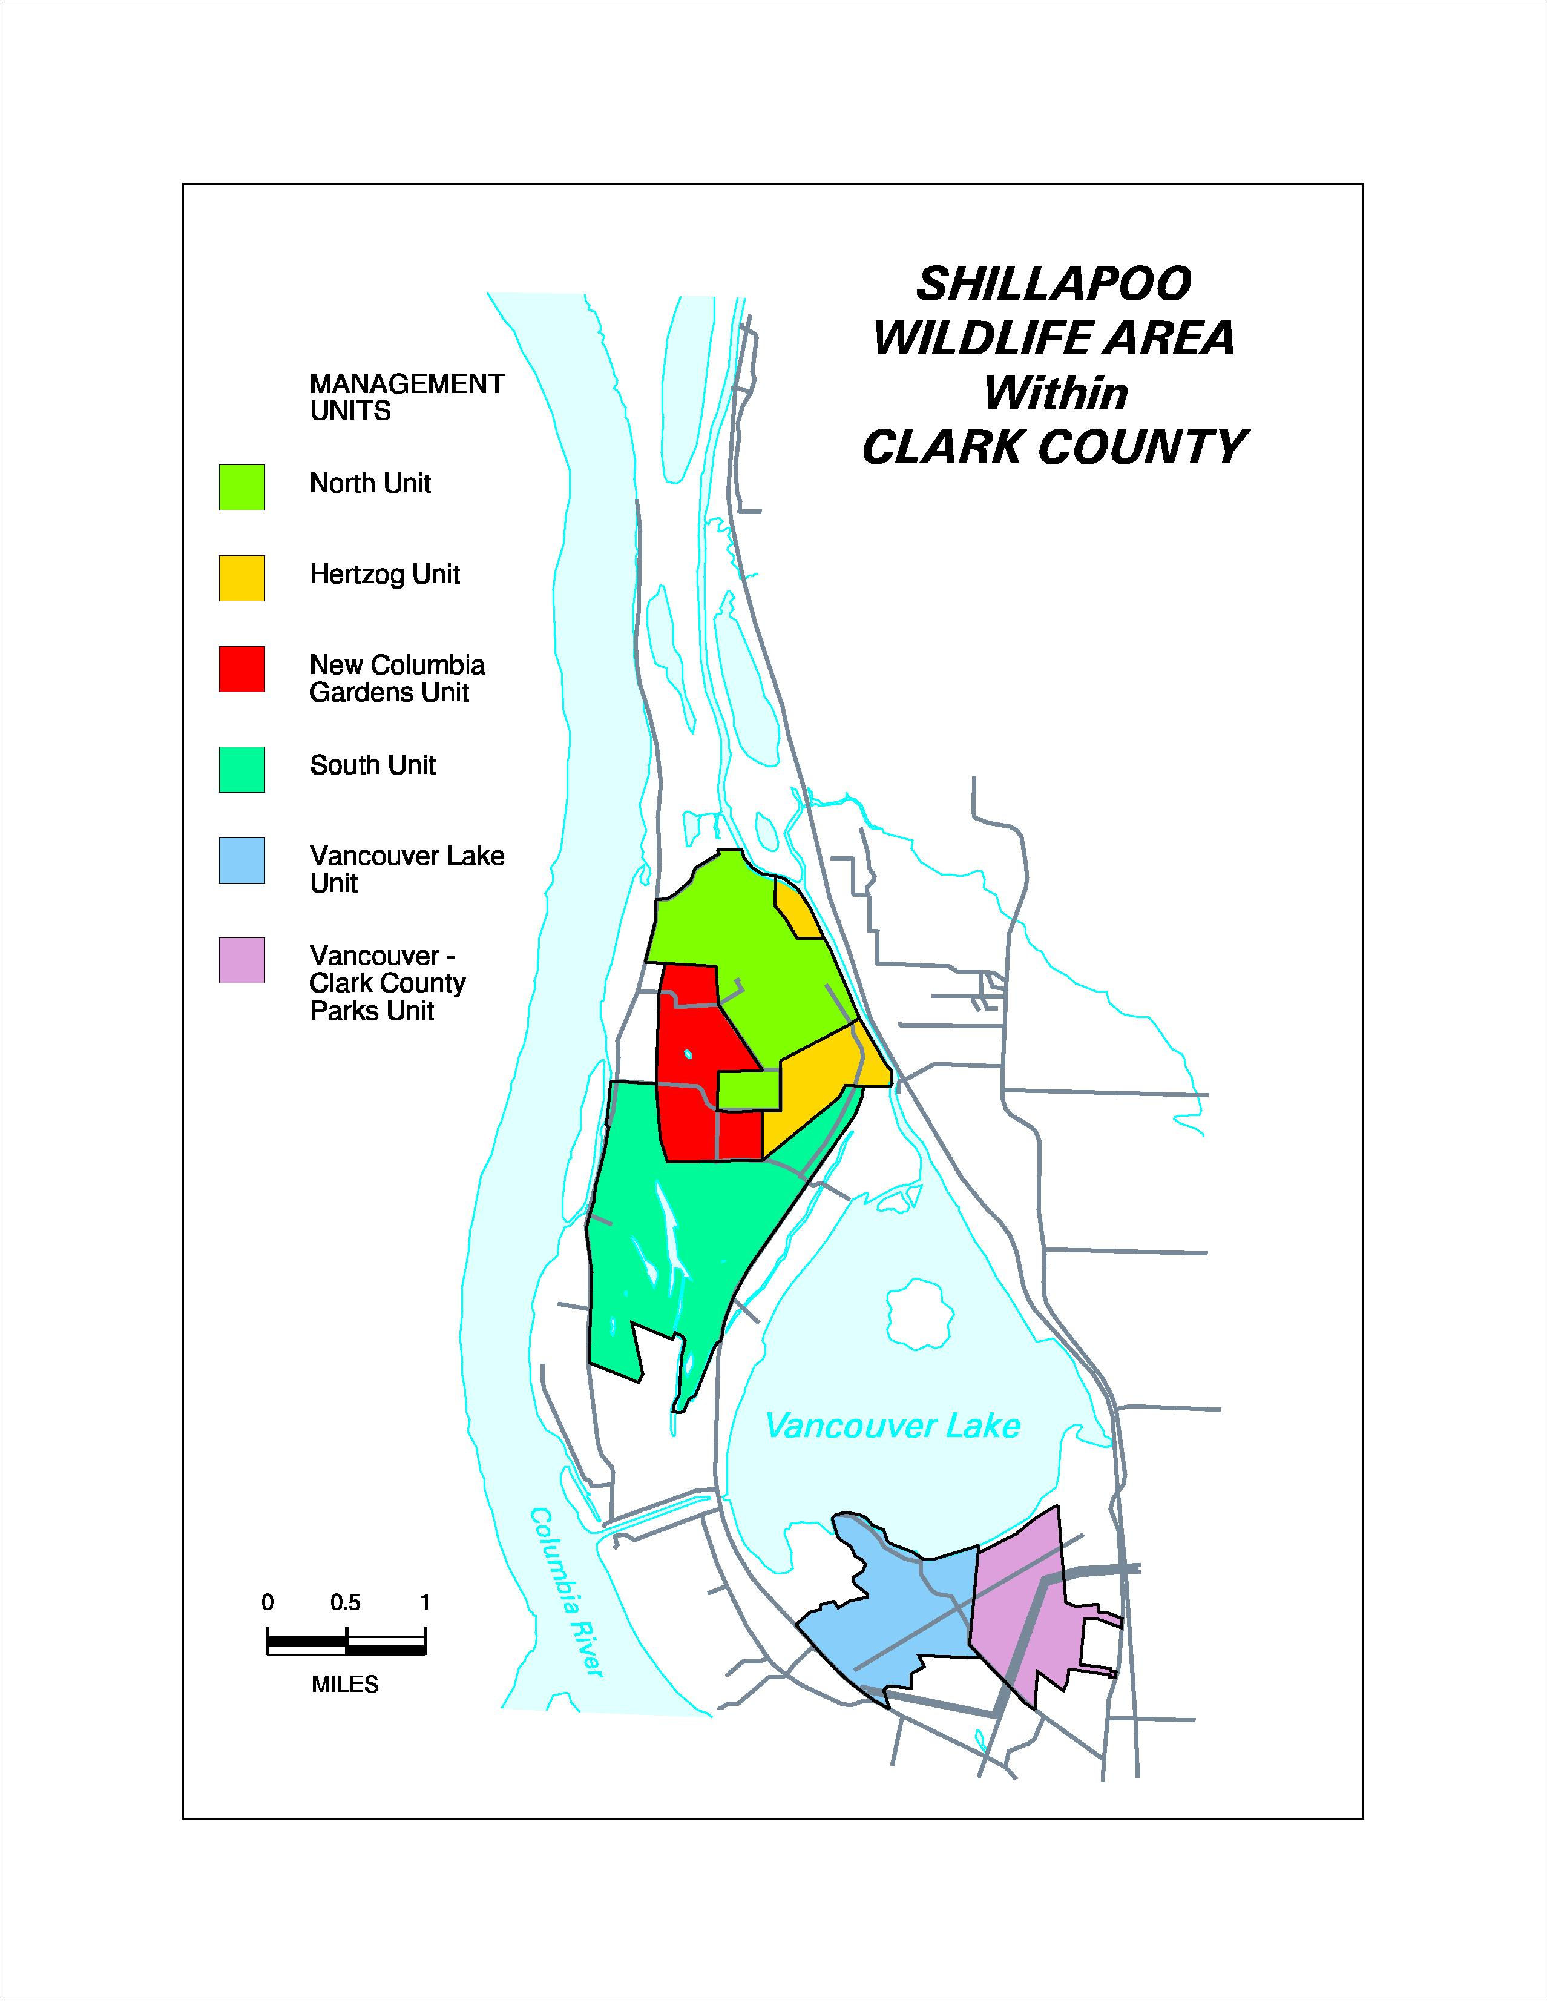

Figure 2. Shillapoo Wildlife Area Management Units
WDFW’s primary goal for this area is to replace much of the developed agricultural land with herbaceous native-type wetland habitat that will continue to provide a secure forage base for wintering waterfowl and restore some of the species diversity lost during development. The agency will also seek to restore other native habitat types and maintain a reduced level of agricultural habitat to help offset winter waterfowl habitat losses on a more regional scale. Salmonid habitat restoration is also a goal. Riparian habitat will be restored along Lake River and seasonally flooded wetlands will be enhanced. Maintenance of these efforts will be critical.

c. Rationale and significance to Regional Programs

The presence of over 2,300 acres of undeveloped habitat adjacent to the Columbia River creates a unique opportunity to provided and maintain quality wetland, riparian and oak woodland habitat in the subbasin. This BPA funded mitigation project provides habitat for both T&E and Priority Habitat & Species (PHS) animals. It is an important link in WDFW’s efforts to protect, enhance and increase wetland and oak woodland habitats for associated wildlife species including, within a limited area, anadromous fish.

The goals, objectives and strategies described for the Shillapoo Wildlife Area Workplan Draft (WDFW) are consistent with those identified in the Lower Columbia River and Columbia River Estuary Subbasin Summary (see the following table).

Lower Columbia River Goals, Objectives and Strategies | Shillapoo Wildlife Area Goals, Objectives and Strategies
Manage functional aquatic, wetland, riparian and upland habitats that support diverse native fish and wildlife populations as essential components of healthy watersheds. | Maintain, improve and restore desired habitats in specific areas including herbaceous, scrub shrub and forested wetlands, riparian forest, oak and grass/shrub habitat for multiple species benefits.  Develop and/or maintain the infrastructure necessary for effective management of the Shillapoo Wildlife Area and conduct maintenance activities, as required, throughout the site.
Maintain and restore the species compositions and structural diversity of plant communities in riparian areas and wetlands to provide adequate summer and winter thermal regulation, nutrient filtering, appropriate rates of surface erosion, bank erosion and channel migration, and to supply amounts and distributions of coarse woody debris sufficient to sustain physical complexity and stability. | Restore, enhance and maintain an estimated 194 acres of riparian, upland and wetland forested habitats in identified areas.  Reestablish wetland hydrology to approximately 900 acres within the Shillapoo lakebed.  Implement moist soil management practices on an estimated 155 acres within the South Unit.
Protect high quality habitat while providing education and passive recreation opportunities compatible with habitat function. | Manage appropriate public use and recreation in a manner which minimizes impacts to habitat and its use by wildlife.  Develop and publish a pamphlet for public distribution, with maps, that outlines history, objectives, and rules for the Wildlife Area by the end of FY 2003. Develop similar products for posting at public access points.
Provide high-quality wintering habitat for all Canada geese, especially the dusky subspecies, to ensure a healthy, viable goose population that minimizes damage to private agricultural lands in the lower Columbia River area. | Rehabilitate or improve management of an estimated 950 acres of pasture and agricultural areas located throughout the Shillapoo Wildlife Area that will remain following native type habitat developments in order to continue to provide a diverse forage base critical to management of wintering waterfowl in the region.
Protect, restore and develop habitats for, and otherwise support, the recovery of federally listed endangered and threatened species and help prevent the listing of candidate species and species of concern. | Expand and rehabilitate areas no longer suitable for Great Blue Heron nesting within a 40-acre area where trees have died and fallen. Clear brush as necessary and plant cottonwood trees by the end of FY 2002.
Protect, restore and develop a diversity of habitats for all other migratory birds such as neotropical songbirds, wading birds, shorebirds and waterfowl, as well as indigenous fish and plant species of the lower Columbia River ecosystem. | Restore, enhance and maintain an estimated 194 acres of riparian, upland and wetland forested habitats in identified areas.  Reduce the levels of noxious weeds and other undesirable plants that limit habitat quality and pose a significant threat to the long-term viability of planned enhancements.
Provide high-quality opportunities for wildlands and wildlife-dependent recreation and environmental education to enhance public appreciation, understanding and enjoyment of fish, wildlife, habitats and cultural resources. | Establish or improve four access points and an estimated eight miles of travel routes located throughout the Shillapoo Wildlife Area and develop materials for public distribution and posting.

As an ongoing mitigation project, the Shillapoo Wildlife Area project is also consistent with the Northwest Power Planning Council’s 2000 Program including, but not limited to the following sections: Overall Vision (Section III A-1) “Wherever feasible, this program will be accomplished by protecting and restoring the natural ecological functions, habitats, and biological diversity of the Columbia River ecosystem….”, Planning Assumptions (Section III, A-2) “This is a habitat based program, rebuilding healthy, natural producing fish and wildlife populations by protecting, mitigating, and restoring habitats and the biological systems within them…”, Scientific Principles (Section III, B-2) i.e., Principles one through eight, Biological Objectives (Section III, C-1) “Recovery of fish and wildlife affected by the development and operation of the hydro system that are listed under the Endangered Species Act,” (Section III, C-2a.4) “Develop and implement habitat acquisition and enhancement projects to fully mitigate for identified losses; Coordinate fish and wildlife activities throughout the basin…; maintain existing and created habitat values; and monitor and evaluate habitat and species responses to mitigation actions,” and Wildlife (Section III, D-7) “Complete the current mitigation program for construction and inundation losses and include wildlife mitigation for all operational losses as an integrated part of habitat protection and restoration”.

The Shillapoo Wildlife Area Project also contributes toward prioritized actions outlined in NMFS Biological Opinion: Action 153- BPA shall, working with agricultural incentive programs such as the Conservation Reserve Enhancement Program, negotiate and fund long-term protection for 100 miles of riparian buffers per year in accordance with criteria BPA and NMFS will develop by June 1, 2001. Action 160: The Corps and BPA, working with LCREP, shall develop and implement an estuary restoration program with a goal of protecting and enhancing 10,000 acres of tidal wetlands and other key habitats over 10 years, beginning in 2001, to rebuild productivity for listed populations in the lower 46 river miles of the Columbia River. The Corps shall seek funds for the Federal share of the program, and BPA shall provide funding for the non-Federal share. The Action Agencies shall provide planning and engineering expertise to implement the non-Federal share of on-the-ground habitat improvement efforts identified in LCREP, Action 2.

The Shillapoo Wildlife Area has been approved as a wildlife mitigation project by BPA. This project will partially meet BPA's mitigation obligation to compensate for wildlife losses resulting from the construction of Bonneville, The Dalles and John Day dams (Rasmussen and Wright 1989). Breeding and wintering Canada geese, mallards and other dabbling ducks, mink, great blue herons, black capped chickadees, western meadowlark, and yellow warblers were identified in the loss assessments and were used as HEP indicator species.

d. Relationships to other projects

The Shillapoo Wildlife Area project compliments WDFW’s statewide efforts to protect and restore oak woodlands, wetlands, and riparian zones. Priority, habitat and species management recommendations are in place to guide efforts (Larsen 1998, Knutson 1997).

Activities also compliment efforts on the adjacent Ridgefield National Wildlife Refuge. Efforts include those to provide high-quality wintering habitat for all Canada geese, especially the dusky subspecies, to ensure a healthy, viable goose population that minimizes damage to private agricultural lands in the lower Columbia River area. Additional efforts include activities to protect, restore and maintain a diversity of habitats for all other migratory birds such as neotropical songbirds, wading birds, shorebirds and waterfowl, as well as indigenous fish and plant species of the lower Columbia River ecosystem.

WDFW also cooperates with several additional efforts to restore and protect sensitive riparian and wetland habitats and open space in the area which is directly adjacent to the Vancouver city limits. The Shillapoo Wildlife Area project directly complements efforts by several entities to restore wetland habitats for fish and wildlife. North American Wetlands Conservation Grants have been secured to restore and enhance over 4,000 acres of wetlands in the Vancouver Lowlands- much on the Shillapoo Wildlife Area. Project cooperators include Ducks Unlimited, Oregon Dept. of Fish and Wildlife, Washington Dept. of Fish and Wildlife, Clark County, City of Vancouver, Metro, US Fish and Wildlife Service and private landowners.

e. Project history (for ongoing projects)

Background

The geographical area known as the Vancouver Lowlands, which includes the Shillapoo Wildlife Area, was a diverse mix of both herbaceous and forested wetlands, oak woodland, and riparian habitat prior to agricultural development. Shillapoo Lake was the dominant landscape feature prior to agricultural development of the area. Control of flows in the Columbia River, diking, draining and clearing for agricultural uses have altered the vegetative landscape and composition of plant species, facilitating the introduction and/or proliferation of non-native plants in many areas.

Among many other species, the area supports breeding and wintering Canada geese, mallards and other dabbling ducks, mink, great blue herons, black capped chickadees, western meadowlark, and yellow warblers. These species were identified as “indicator” species in the construction and loss assessments for Bonneville, The Dalles and John Day dams. The Shillapoo Wildlife Area is an approved BPA project (Project Contract Number 96BI97789) that now receives operations and maintenance funding from BPA. A plan is nearly completed to guide restoration and enhancement activities as well as O&M.

General History and Description of the Vancouver Lowlands Area

Most of the northern portion of the lowlands is within the boundaries of the 5,147 acre Ridgefield National Wildlife Refuge. The area to the south encompasses lands owned primarily by WDFW, Clark County, The City of Vancouver, The Port of Vancouver, The Washington Department of Natural Resources (DNR), five major private landowners and other small private ownerships (Figure 3).

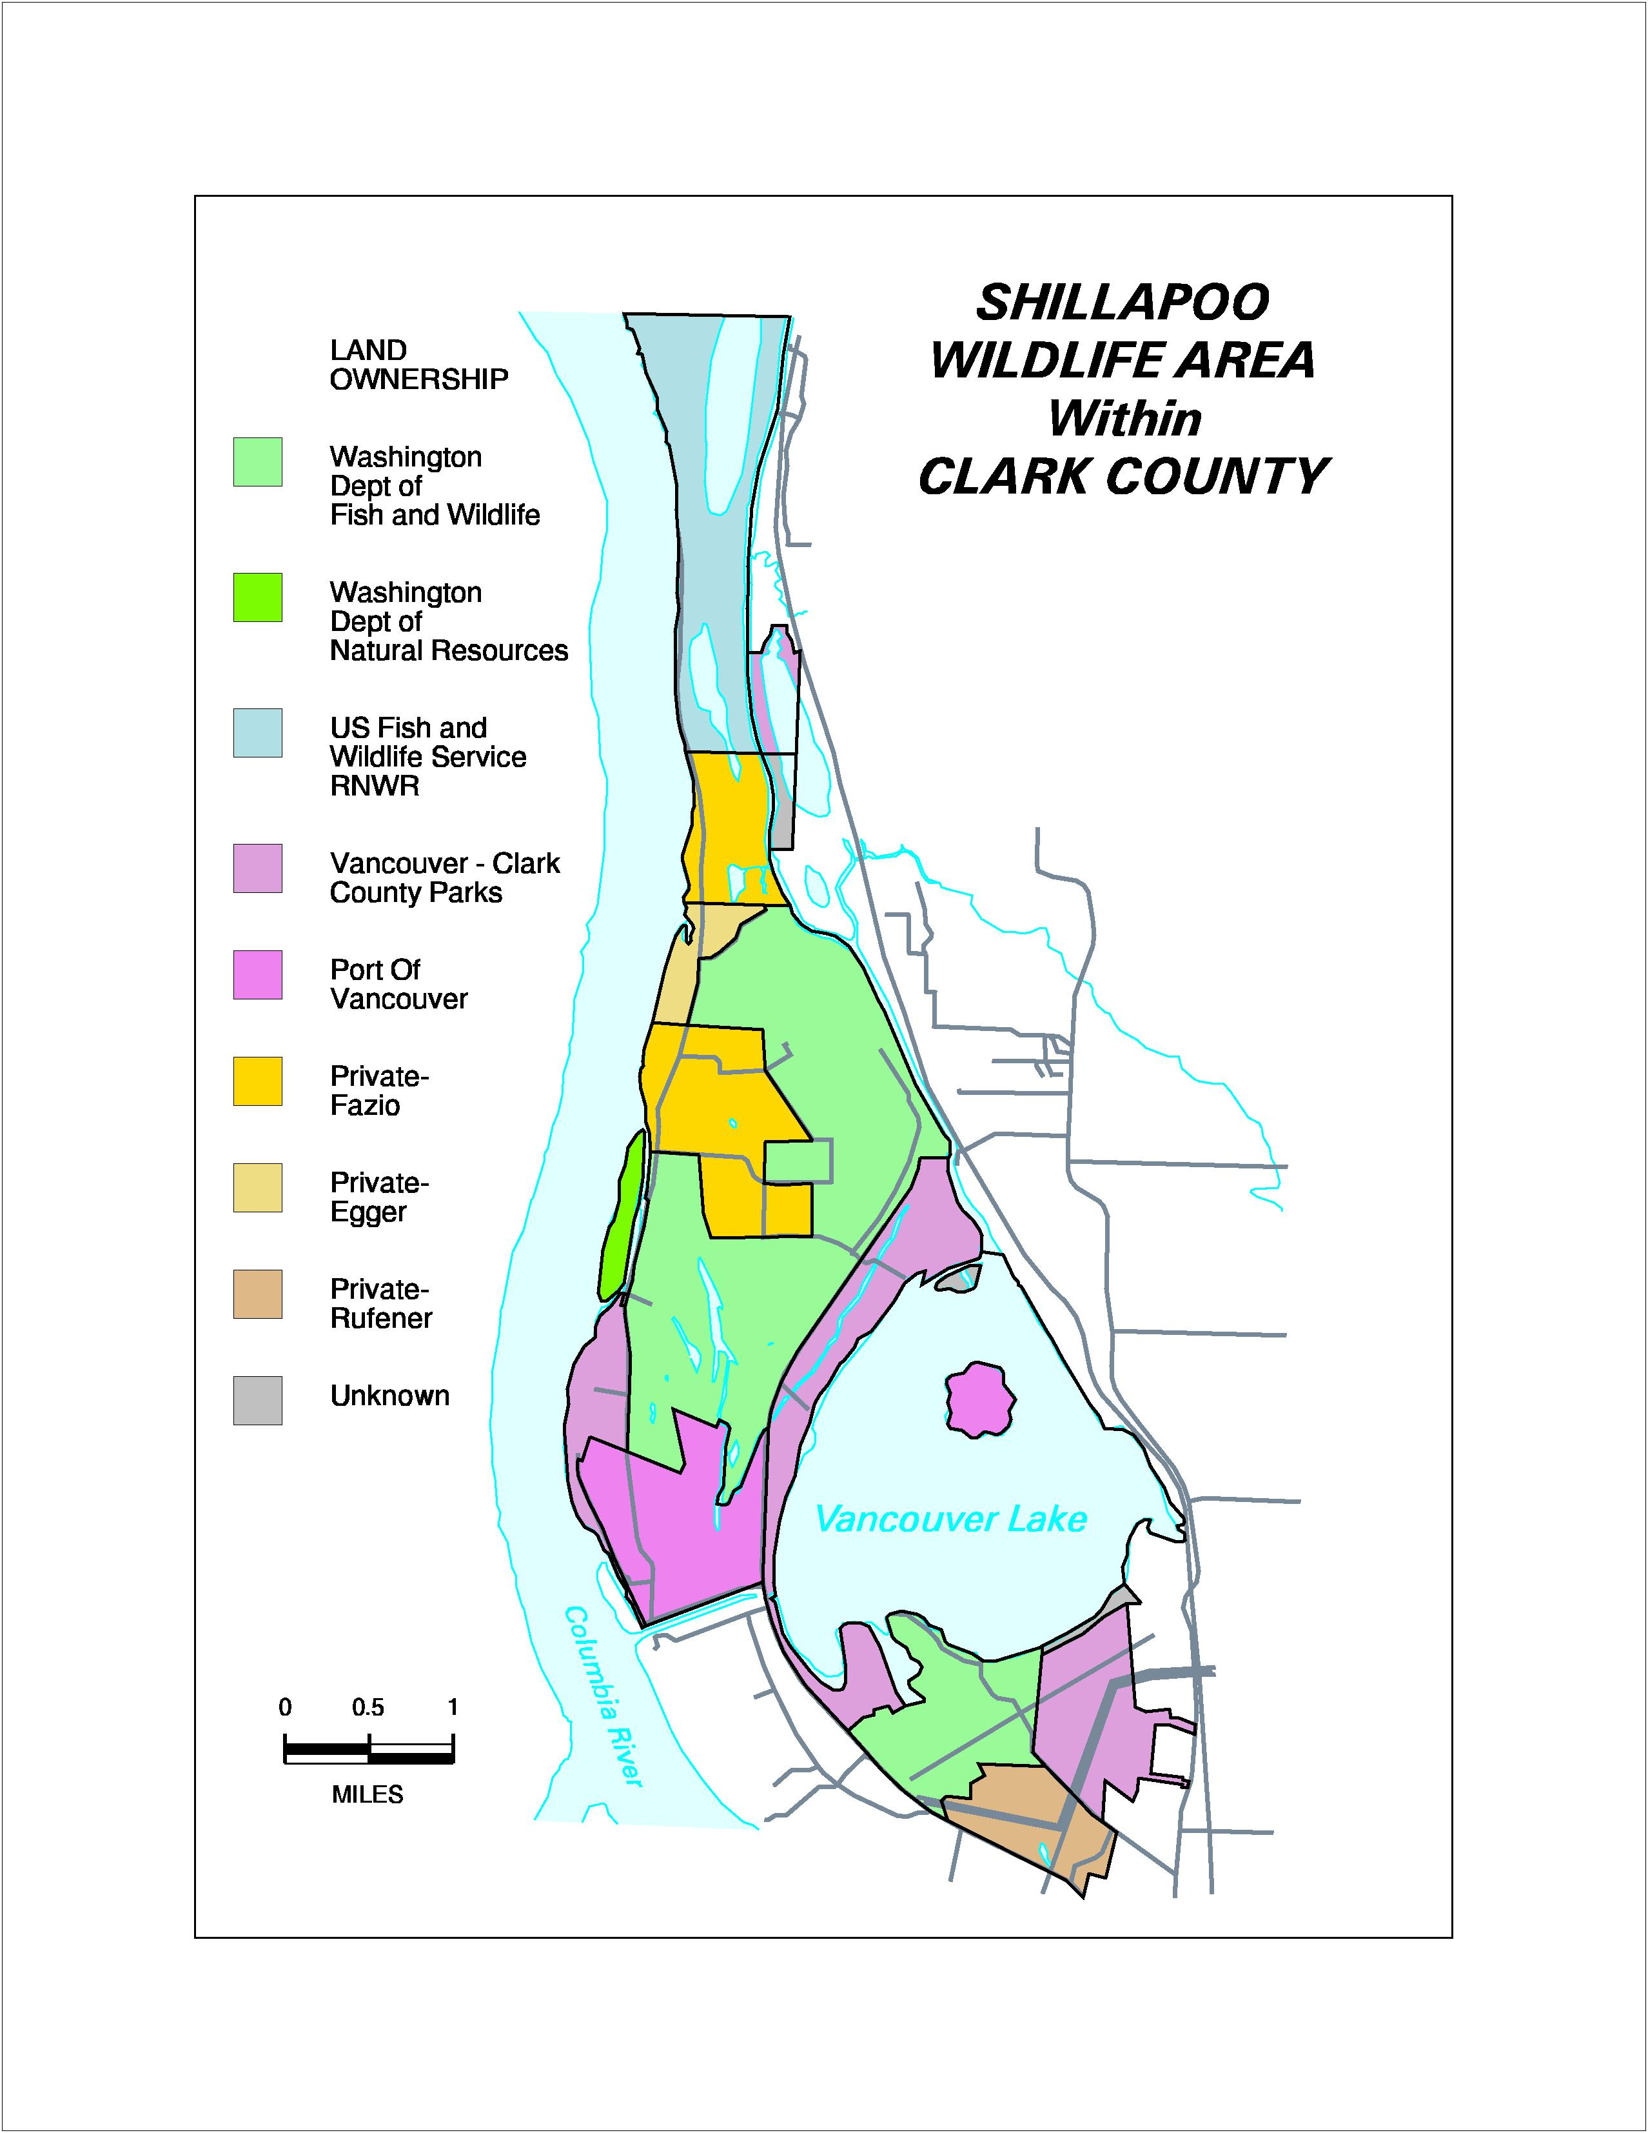

Figure 3. Regional Landowners

The Vancouver Lowlands is an area that has undergone major changes in the past 50 years. The most significant change was the draining of Shillapoo Lake and its development as agricultural and pasture land. This was made possible by the construction of dikes around the area and the installation of a pump which constantly keeps the area drained except for the winter months when some water generally accumulates.

Currently, industrial development has been limited to the area south of the Vancouver Lake flushing channel. However, the Port of Vancouver owns land north of this line that is currently proposed as an industrial park and potentially some recreational uses. WDFW has been unsuccessful in past attempts to purchase this land. WDFW’s Habitat and Wildlife Lands programs have worked closely with the Port in their planning processes to encourage the protection of this area’s most sensitive habitats. Other past development plans in the area have included a heavy industrial park and a major airport which would have been located in the Shillapoo lakebed. These development plans were thwarted largely by a planning/zoning process in 1986.

The “HABITEK” consortium, made up of citizens and agency representatives, created a zoning plan which was adopted by the Clark County Board of Commissioners. This plan included a large area zoned as agriculture/wildlife. Approximately one half of the lowlands are in this designation. All uses permitted under this designation are quite restrictive. Recently the City of Vancouver annexed all of the Port lands raising some concern that development may take place that otherwise may not have occurred. The proposed Columbia River Channel Deepening Project may help to speed development of some of the Port’s lands by providing large quantities of fill material needed to develop the area for industrial uses.

Some recreational development has taken place here as well. Two major county parks are located on the west shore of Vancouver Lake and on the Columbia River. They have also aggressively pursued purchase of shoreline areas around Vancouver Lake and riparian zones along two creeks that feed the system. This open space acquisition program has helped to protect many sensitive habitats in the area.

Since the 1940s, WDFW has undertaken numerous efforts to protect and restore as much wildlife habitat as possible in the Vancouver Lowlands. A plan was developed listing properties that should be acquired and/or protected including lands in and around Shillapoo Lake. Prior to 1991, WDFW accomplished little in the area of habitat acquisition, purchasing only the 277-acre SWA and the 170-acre Vancouver Lake parcel.

In the 1990's, Washington Wildlife and Recreation Program (WWRP), BPA and Ducks Unlimited (DU) funds were used to acquire additional lands in the area. A total of 1,924 acres, acquired in five parcels, have been secured through these funding sources. The top priority for WDFW’s acquisition program is to acquire the remaining portions of the Shillapoo Lakebed that are still in private ownership so the lake can be restored and managed for the highest quality wetland habitat possible.

Unit Descriptions (see Figure 2)

North Unit History and Description:

The 672 acre North Unit includes the two most recent properties acquired by WDFW: 60 acres acquired in 1994 with WWRP and DU funds and 612 acres acquired in 1998 with WWRP and BPA funds.

This unit consists of blocks of agricultural and grazed pasture lands and a large block of pasture land that was abandoned after the 1996 flood primarily due to the financial burden of repairing fences lost during the flood. An adjoining landowner fenced and leased a portion of the total pasture area. These events were unfortunate because the entire pasture area, when grazed, was heavily used by waterfowl. WDFW has maintained agricultural and grazing management on fenced areas which continue to be considered valuable as wintering waterfowl habitat.

This unit contains the northern portion of the Shillapoo lakebed. Almost all of this part of the lakebed is developed and used for agricultural crop production except for small portions within the pasture areas. Numerous wetlands also were present on the site prior to the extensive draining and diking that took place. Major enhancement efforts will be focused here to restore wetland habitat and improve the remaining pasture areas to maintain their value to wintering waterfowl populations. Some continued level of agricultural use is also envisioned, at least to the extent that interested lessee’s can be found. Due to the short history and limited funding, WDFW has not undertaken any significant enhancements on this unit although funds have been received in partnership with the Columbia Land Trust and DU to restore a wetland area of approximately 80 acres by installing ditch plugs with water control structures.

South Unit History and Description:

The 1,012-acre South Unit includes three acquired properties that historically were all used for dairy production. One of the parcels is the original 277-acre property acquired in 1952. The other two properties of 281 and 454 acres were acquired in 1991 with WWRP funds. The smaller property is the site of one of the largest great blue heron rookeries on the lower Columbia River. This rookery contained over 350 active nests in 2000. The nesting site was abandoned in 2001 possibly due to drought affecting forage conditions or an increase in bald eagle activity in the area. A second newer rookery, also on the south unit, grew substantially to 142 active nests in the same year.

Management objectives on the original 277-acre property shifted from waterfowl management in the late 1970's or early 80's. Public desires prompted the agency to move toward managing the area primarily as a recreational upland bird hunting area. Both grazing and farming leases were changed to provide hiding cover as opposed to waterfowl food resources. Some waterfowl use still took place on the agricultural lands but the pastures received little use. Management shifted back in the early 1990's to focus on providing goose wintering habitat in particular. An interim plan was developed to manage the area and proposed acquisitions. Even though the release of pheasants still occurs, waterfowl use has increased substantially during late winter and early spring.

The unit as a whole is a diverse mix of agricultural, pasture, wetland and riparian habitat. Agricultural and pasture management on this unit is also accomplished solely through agreements with local farmers except for some WDFW involvement in weed control and occasional fertilization of pastures. A project was recently completed on the west side of the unit which enables the hydrologic restoration of wetlands on the area. Different vegetation management techniques are being employed and closely monitored, as part of a regional study, to determine the most effective means to manage wetlands for native plant communities. Both avian and plant response are being studied by the U.S. Fish and Wildlife Service, DU and the University of Idaho.

This unit contains the southern tip of Shillapoo Lake. A project funded by DU, the Natural Resources Conservation Service (NRCS), and a grant through the North American Wetlands Conservation Act is currently under way to restore approximately 150 acres of the historic lake to wetland habitat. This acreage was previously used as annual cropland under private and early WDFW management. The restoration of high quality wetland habitat is seen as a means to maintain or increase the food supply for wintering waterfowl while dramatically increasing the diversity of habitat and wildlife communities on the area. Maintaining the wetland quality to achieve the desired objectives for target species will require ongoing management and maintenance in the long term.

Vancouver Lake Unit History and Description :

This 477-acre unit at the south end of Vancouver Lake was acquired in two parcels. The first acquisition of 170 acres from the Alcoa Company and DNR included about half of the south shore of Vancouver Lake. At the time of purchase, this was the only truly public access to the
lake. The second acquisition of 307 acres from the Alcoa Company was made with WWRP funds in 1991. The unit is very popular with the public and receives a diverse range of use as it is the closest of the three units to the City of Vancouver.

Approximately half of this unit consists of willow-dominated, forested wetland in the Mulligan Slough area. The Mulligan Slough area is unique as it represents one of the largest non-diked flood plain areas in the Vancouver Lowlands. Even though regulation of the Columbia has effected water levels the remaining periodic flooding has allowed native wetland communities to maintain a foothold here. A wetland restoration project where water control structures were put in place to restore hydrology to approximately 65 acres was partially completed here in 1998. Funding is currently available, and it is hoped that a water supply will be in place in 2001.

The flood of 1996 demonstrated here that increasing the depth and duration of flooding can be an effective means of restoring native plant communities. The increased water presence eliminated reed canary grass in many areas, which allowed native plants including wapato, spike rush, beggar tick and smartweed to predominate.

Over the past three years WDFW has developed a cooperative volunteer partnership with the Vancouver Wildlife League which has provided labor, equipment and materials for maintenance and improvements on the area. With some monetary assistance from WDFW’s volunteer program, the group has helped with nuisance brush removal, pasture mowing, weed control, planting small food plots for waterfowl and providing nesting boxes for wood ducks. The group has been extremely helpful with a wide range of smaller projects in addition to those listed above.

The unit is adjacent to Vancouver/Clark Park’s South Vancouver Lake property where WDFW hopes to assist with management through a cooperative agreement. This protected area has enhanced wildlife use of adjacent habitat on WDFW land by providing a large uninterrupted block of open space. The Vancouver/Clark Parks lands are discussed in more detail below.

Vancouver/Clark Parks–South Vancouver Lake Unit History and Description:

This 416-acre unit is currently owned and managed by Vancouver/Clark Parks, a combined agency of the City of Vancouver and Clark County which manages all parks and open space lands owned by the city or county. The property was acquired in two parcels with WWRP and Clark County Conservation Futures Funds. The property was acquired to preserve open space adjacent to developed urban areas and to provide wildlife habitat. WDFW proposes to enter into a cooperative agreement with Vancouver/Clark Parks to facilitate wildlife habitat improvements and associated maintenance on the property. Although specifics have not been worked out, the Parks staff have expressed an interest in this type of agreement.

This unit consists almost entirely of areas developed and used for agriculture including a large “dredge spoils cell” that was created during the dredging of Vancouver Lake. Until 1996 the property was protected from ordinary high water events by the dikes around the spoils cell and a small dike along part of WDFW’s property boundary. The 1996 flood overtopped the small dike, which was not constructed to full standards, and caused it to fully breach in two locations. The damage has gone unrepaired which has allowed more normal water fluctuations on part of the area.

Through funding and assistance from DU, the NRCS, WDFW, and the North American Wetlands Conservation Act, Vancouver/Clark Parks has been able to undertake wetland restoration measures that are scheduled for completion in 2001. However, absent outside assistance, maintenance and further wildlife habitat improvements may be outside the abilities of the Parks agency.

Due to funding limitations, the property has been managed largely through cooperative farming agreements. These agreements have maintained the area’s high value for wintering waterfowl but as with WDFW’s own units, there is concern as to how long interested farmers will be available in the area.

Herzog Unit History and Description:

This unit is WDFW’s most recent acquisition of approximately 210 acres of private farmland located in the central and east part of the Shillapoo Lakebed and a small separate parcel along Lake River. Portions of this property will eventually be added to both the North and South Units. The larger parcel is the site of the diking district’s expulsion pump that drains Shillapoo Lake. The property consists primarily of drained lands within the Lakebed and pasture areas along Lake River.

All of the agricultural lands were farmed annually with a mixture of corn or barley until a few years ago. Since that time, limited amounts of grazing have occurred on both the agricultural and pasture areas. Farming on the property has been essentially abandoned except for some disking and mowing to control weeds and to satisfy hunters that lease waterfowl blinds during the hunting season.

As the property was developed for agriculture, virtually all riparian vegetation was removed. If acquired, riparian restoration will be an important component in making wildlife habitat improvements.

New Columbia Gardens Unit History and Description:

This unit is a proposed acquisition of approximately 400 acres located in the western and central portions of the Shillapoo Lakebed. Portions of this acquisition would also be added to both the North and South Units.

The area proposed for acquisition includes part of a private farm consisting of drained agricultural land and pasture within the Lakebed. This is an active farm where crops include pasture, silage corn, barley and potatoes. The property also includes a portion of the original channel that connected Shillapoo Lake to the Columbia River which is now a stagnant long narrow water body flanked by remnant riparian forest stands. Wetland restoration could occur in this portion of the lakebed independently from other properties.
Present and Future Landscape Conditions

Prior to regulation of the Columbia River, diking, draining, and agricultural development, the Vancouver Lowlands area was a highly diverse wetland complex. While agricultural crops provide a level of important habitat for some species such as Canada geese and other migratory waterfowl, habitat for many other species was greatly reduced or eliminated.

WDFW’s primary goal for this area is to replace much of the developed agricultural land with herbaceous native-type wetland habitat that will continue to provide a secure forage base for wintering waterfowl and restore some of the species diversity lost during development. The agency will also seek to restore other native habitat types, and maintain a reduced level of agricultural habitat to help offset winter waterfowl habitat losses on a more regional scale.

WDFW conducted a Habitat Evaluation Procedure (HEP) analysis in 1994-95 to assess habitat quality relative to several HEP wildlife species models based on vegetation and other physical conditions. Development of habitat cover type maps was an integral part of this process. The maps were developed by placing clear mylar sheets over large-scale orthophotos obtained from DNR and subsequently transferring information to the mylar sheets. Aerial photographs and ground truthing were used with the orthophotos to develop an accurate map at a scale of 1:12,000 where one inch on the map is equivalent to 12,000 inches or 1,000 feet on the ground. Maps were then transferred into a computer database and produced as a composite for the entire study area indicating habitat cover types (Figure 4).

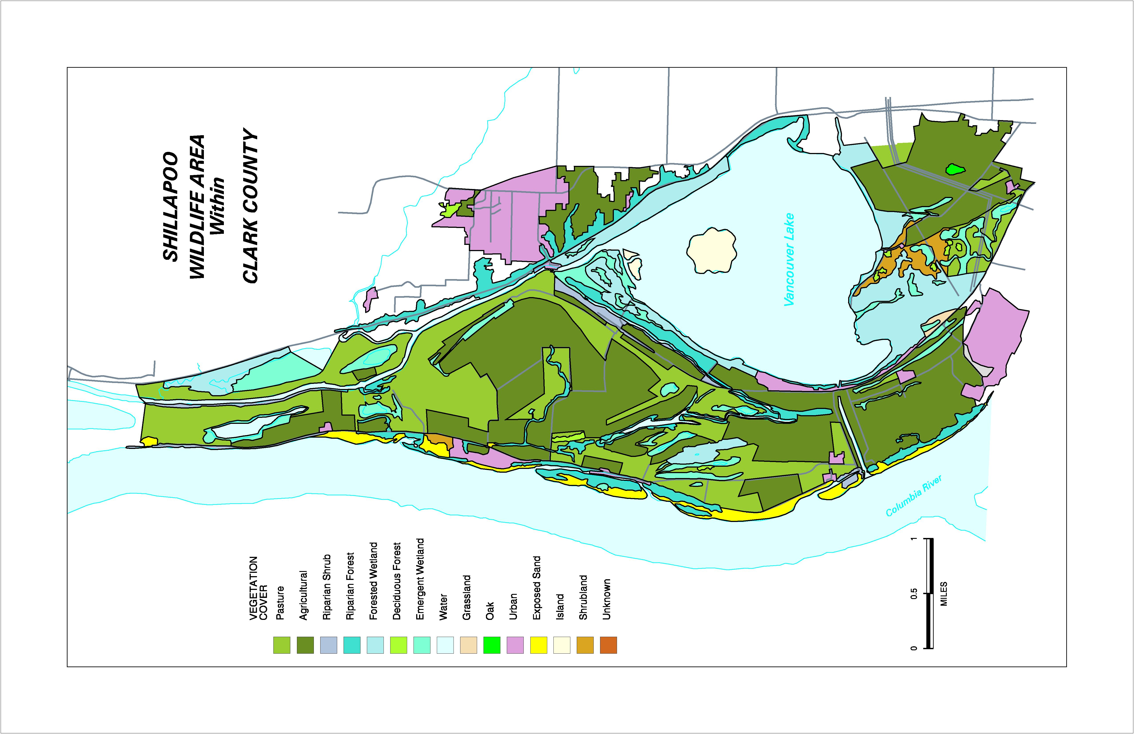

Figure 4. Shillapoo Wildlife Area Habitat Cover Types
The Shillapoo Wildlife Area cover types and descriptions are as follows.
Agricultural | Areas used for the production of agricultural crops.
Pasture | Grazed or mowed grass/forb areas.
Emergent Wetland | Wetland areas dominated primarily by herbaceous plant species.
Forested Wetland | Wetland areas dominated by tree and tall shrub species.
Riparian Forest | Forested areas along water bodies including lakes, rivers and sloughs
Dense Deciduous Forest | Uplands with deciduous tree canopy exceeding 70% canopy cover.
Oak Forest | Forest stands where Oregon white oak comprises at least 20% of canopy.
Shrub/Grassland | Largely unmanaged areas with mixed herbaceous and/or shrub canopies.
Urban/Developed | Developed areas i.e. Farm headquarters, parking lots, etc.

North Unit Present/Future Landscape Conditions:

Present Landscape Conditions The 672 acre North Unit is comprised of four cover types: agricultural, pasture, emergent wetland, and riparian forest. Cover types and acreage are listed below.

North Unit cover types and acreage
Cover Type | Acres
Agricultural* | 301
Pasture | 335
Emergent Wetland | 26
Riparian Forest | 10
*Includes acreage abandoned since 1996 flood. See discussion below.

Agricultural
With the exception of one field, the agricultural lands on this unit are fully in annual crop production (corn, barley or green silage crops). The vast majority of this cropland is within the Shillapoo lakebed and is flooded to varying degrees each winter. The agricultural acreage in Table 2 includes one field where significant topsoil loss occurred during the 1996 flood and has not been farmed since.

Pasture
Pasture habitat includes all areas that have been cleared or otherwise developed for grazing livestock. Well over half of this area has not been grazed since the 1996 flood which caused significant damage to fencing. A portion of the pasture area was re-fenced prior to purchase by WDFW and is currently under lease to a private farm. The portion of the pastures currently under grazing management includes areas dominated by either reed canary grass or introduced pasture plants (grasses, legumes). Canada Thistle is present at moderate levels. The area currently not under grazing management is dominated by dense stands of reed canary grass, rank pasture plants, thistles, tiesel or Himalayan blackberry. Poison hemlock occurs as isolated plants or small stands in both areas. Small emergent wetlands occur within this type.

Emergent Wetland
One site on this unit was classified as an emergent wetland on the eastern edge of the lakebed agricultural area. This wetland is predominately a dense stand of reed canary grass however, a forest component of cottonwood is developing along one edge.

Riparian Forest
A remnant of riparian forest occurs along a now blocked channel near the center of the Shillapoo Lakebed. Most of the narrow water body is dry during some parts of the year and is flanked on both sides by a narrow band of Oregon ash and black cottonwood. The understory is generally a dense stand of Himalayan blackberry with a few native shrubs including redosier dogwood and willow species.

Future Landscape Conditions This unit has moderate to heavy infestations of exotic weeds such as reed canary grass, Canada thistle, tiesel and Himalayan blackberry. Both large and small wetlands throughout the area have been drained for agricultural or pasture production. Riparian forest habitats are also absent along Lake River or limited in other areas. Upland forest habitat is absent on the site. Abandoned pasture and agricultural lands currently provide little benefit to the area’s primary target species. WDFW plans to restore as much wetland habitat as possible on the site including a significant portion or the Shillapoo lakebed. Physical, mechanical, biological, chemical and cultural means, including moist soil management techniques, will be employed to control exotic vegetation. Riparian and upland forest habitat will be restored on specific sites by fencing where needed and planting native trees and shrubs. Grazing or hay cutting and agriculture will continue on remaining sites to maintain habitat values for identified target species.

South Unit Present/Future Landscape Conditions:

Present Landscape Conditions The 1012 acre South Unit is comprised of seven habitat types: agricultural, pasture, riparian forest, emergent wetland, forested wetland, dense deciduous forest, and urban. Cover types and acreages are listed below.

South Unit cover types and acreage.
Cover Type | Acres
Agricultural | 344
Pasture | 428
Riparian Forest | 94
Emergent Wetland | 93
Forested Wetland | 41
Dense Deciduous Forest | 11
Urban/Access Sites | 1

Agricultural
Although perennial crops (alfalfa) have been used in the recent past, agricultural habitat here is in annual crop production (barley, corn, and green silage crops) except approximately 150 acres in the Shillapoo lakebed where fallowing has occurred until a wetland restoration project can be completed.

Pasture
Pasture habitat includes areas that are grazed or mowed to produce winter forage habitat for waterfowl. Dominant forage plants are either reed canary grass or introduced pasture plants. Himalayan blackberry, poison hemlock and Canada thistle are abundant in many sites and limit habitat quality. Small stands or isolated trees are present including Oregon white oak, Oregon ash and black cottonwood.

Riparian Forest
Riparian forests consist of generally narrow stands along sloughs within the unit and at the Columbia River shoreline. The overstory is usually open consisting primarily of black cottonwood, Oregon ash, and Oregon white oak. Most trees are large to mid-sized. Young trees are uncommon which is possibly attributed to past grazing and a dense understory of Himalayan blackberry in many areas. Other common understory plants include snowberry, rose species, red elderberry, redosier dogwood, and serviceberry. European brown carp are present in the sloughs and severely impact the growth of submerged aquatic and emergent plants.

Emergent wetland
Reed canary grass is, by far, the most dominant plant in this unit’s emergent wetlands. Other plants encountered include: smartweeds, water plantain, wapato, and beggar tick. Shrubs and trees including willow and redosier dogwood are uncommon. Purple loosestrife is present on the unit but has not yet been located in the wetlands. Carp are present, and limit growth of aquatic plants in one wetland that has permanent water.

Forested Wetland
One large (41 acre) forested wetland occurs on the site. A large great blue heron rookery is located in the stand. The most common overstory species is black cottonwood but Oregon ash and Oregon white oak also occur. A dense understory consisting of snowberry, red elderberry, and redosier dogwood is present. Reed canary grass and stinging nettle are common in areas where shrubs are absent or scarce. Himalayan blackberry is present primarily around the perimeter of the site. Many of the large cottonwoods once used by herons on part of the site have died and fallen.

Dense Deciduous Forest
Two small upland deciduous forest stands are present on the western part of the unit. Dominant overstory trees are black cottonwood, Oregon ash, and Oregon white oak. The shrub layer is usually dense consisting of snowberry, Himalayan blackberry, redosier dogwood, serviceberry, red elderberry and trailing blackberry.

Urban/Access Sites
These consist of parking areas on the west side of the unit and a largely abandoned farm center at the northeast part of the area.

Future Landscape Conditions Weeds including reed canary grass, thistle species, poison hemlock, and Himalayan blackberry are present at moderate to high levels throughout the unit. WDFW will control these plants through mechanical, cultural, chemical, and biological means including the utilization of moist soil management techniques in wetlands. The hydrology of wetlands on the site has been impacted by regulation of the Columbia River, diking, draining and other practices. These changes have affected wildlife habitats and plant communities. A recently built water management system on the west part of the unit will enable WDFW to manage water levels to restore native wetland plant communities to benefit habitat conditions. A similar project is planned for the southern end of the Shillapoo lakebed on the east side of the unit. Although agriculture and pasture management would continue in some upland areas for specific target species, WDFW’s objective for these areas is to replace or compliment the waterfowl food values in agricultural and pasture habitat with wetland plants. Carp are present in permanent water bodies and affect water and habitat quality. Efforts will be made to control carp to aid in aquatic plant development. Upland, riparian and forested wetland habitats will be improved or expanded by removal of exotic plants and replanting native trees and shrubs where necessary to foster shrub and tree regeneration.

Vancouver Lake Unit Present/Future Landscape Conditions:

Present Landscape Conditions The 477 acre Vancouver lake Unit is comprised of six habitat types: agricultural, forested wetland, emergent wetland, shrub/grassland, dense deciduous forest and urban/access sites. Cover types and acreages are listed below.

Vancouver Lake Unit cover types and acreage.
Cover Type | Acres
Agricultural | 44
Forested Wetland | 252
Emergent Wetland | 47
Shrub/Grassland* | 125
Dense Deciduous Forest | 7
Urban/Access Sites | 2
*Includes 15 acres abandoned since 1996.

Agricultural
Agricultural habitat includes areas currently in a grass/legume mix which is mowed or hayed annually to provide winter goose forage and areas with planted grain crops (food plots). The crop areas are rotated as a means of rehabilitating the green forage areas.

Forested Wetland
The predominant overstory species is willow with lesser components of Oregon ash and black cottonwood. The density of small snags is high (>25/acre), however larger snags over 10" DBH are more limited (2/acre). Inclusions exist of herbaceous emergent wetlands which are generally of high quality and comprised primarily of native plants. The understory is variable depending on elevation and overstory canopy closure. Shrubs present include redosier dogwood, rose species, and himalayan blackberry. Native herbaceous understory plants include smartweeds, beggars tick, sedges, rushes and wapato. Many areas have high densities of reed canary grass. Purple loosestrife is present on at least one especially high quality site.

Emergent Wetland
Reed canary grass is the most predominant plant in the emergent wetlands. Higher quality native plant stands generally occur at lower elevations with more extended periods of inundation. Common native plants encountered include wapato, smartweed, beggars tick, spike rush, common rush, and water plantain. Installation of a water management system similar to the South Unit’s has begun which will enable control of water levels in several of the wetlands.

Shrub/Grassland
These two cover types were combined due to similar characteristics and a generally equal value to target species. Shrub and grasslands occur in areas that historically were either farmed or grazed and these activities were abandoned to create wetland buffers or for other reasons. Herbaceous plants often are comprised of those left when the areas were abandoned. Reed canary grass is often present but generally not the dominant plant. Infestations of Canada thistle are common. Shrubs present include Rose species, Himalayan blackberry, willow and red osier dogwood.

Dense Deciduous Forest
This type consists of small forest stands which are dominated by an overstory of black cottonwood with some Oregon ash and Oregon white oak. The shrub layer is generally dense consisting of Rose species, Himalayan blackberry, snowberry, redosier dogwood, serviceberry, red elderberry, and trailing blackberry.

Urban/Access Sites
These areas represent access parking and roadways near the shore of Vancouver Lake.

Future Landscape Conditions Noxious weeds including reed canary grass, Himalayan blackberry, Canada thistle, and purple loosestrife occur throughout the unit, limiting or threatening habitat quality. WDFW will control these plants through chemical, mechanical, biological and cultural means including employing moist soil management techniques and water level manipulation in herbaceous emergent wetlands. WDFW will improve the quality of waterfowl wintering habitat on the small acreage of upland agricultural land by replanting grass/legume stands and continuing to cooperate with volunteer groups in planting small acreages of food plots annually. Forest stands will also be managed to increase density of large snags and increase acreage available as alternate heron nesting sites.

Vancouver/Clark Parks Unit Present/Future Landscape Conditions:

Present Landscape Conditions The 416 acre Vancouver/Clark Parks Unit is comprised of four cover types: agricultural, emergent wetland, forested wetland, and oak Cover types and acreages are listed below.

Vancouver/Clark Parks Unit cover types and acreage.
Cover Type | Acres
Agricultural | 383
Emergent Wetland | 11
Forested Wetland | 15
Oak | 7

Agricultural
As with other units, agricultural habitat is characterized primarily by annual crops such as corn or barley. Some fruit production (strawberries and raspberries) occurs here as a means to make farming contracts more attractive to local farmers. Approximately 80 acres of the agricultural lands occur within a dredge spoils cell created during the dredging of Vancouver Lake. Noxious weeds including poison hemlock, Himalayan blackberry and thistles occur primarily around field borders and along dikes in the unit.

Emergent Wetland
These areas consist of mixed stands of reed canary grass and native plants including smartweeds, beggars tick, spike rush, common rush, and water plantain. The wetlands present exist in the lowest lying areas in the agricultural fields.

Forested Wetland
This type is present in the northeast corner of the unit and is dominated by a dense cottonwood overstory with an understory of willow, red elderberry, and reed canary grass.

Oak
The southwest corner of this unit contains the only example of this habitat type within the planning area. A dense overstory of Oregon white oak, Oregon ash and black cottonwood dominates the stand. A dense understory of snowberry, red elderberry, and Himalayan blackberry is present.

Future Landscape Conditions Wetlands within this unit have been affected by the regulation of the Columbia River, diking, draining, dredge disposal and agriculture. Forested habitats have been largely eliminated and weeds including reed canary grass, poison hemlock, thistles, and Himalayan blackberry are present on the site. Through a cooperative agreement, WDFW will cooperate in the installation of a water management system to restore or create wetland hydrology and plant communities to the fullest extent possible. Forested habitats will be expanded by planting native trees and shrubs. Weeds will be controlled through chemical, mechanical, biological, or cultural means including the utilization of moist soil management techniques.

Herzog Unit Present/Future Landscape Conditions:

Present Landscape Conditions The 210 acre Herzog Unit is comprised of two cover types: agricultural and pasture. Cover types and acreages are listed below.

Herzog Unit Cover Types and Acreage
Cover Type | Acres
Agricultural | 148
Pasture | 62

Agricultural
This type includes areas developed and typically used for production of annual crops such as corn and barley. Crops have not been planted on this area for two to three years, however maintenance including mowing and disking to control weeds has occurred. A wide range of weeds are present including reed canary grass, thistle species, and barnyard grass along with native moist soil plants such as smartweeds, beggars tick, and others. All agricultural lands on this unit lie within the Shillapoo Lakebed.

Pasture
Pasture habitat occurs adjacent to Lake River on the main parcel and on the 37 acre separate parcel to the north. Although these pastures were among the most well maintained in 1994 when HEP sampling was done, they have deteriorated over the past few years due to reduced use and maintenance. Predominant plants in the pastures include reed canary grass, introduced pasture plants, and thistle species. Several large Oregon white oak trees are present on the highest portion of the pasture area.

Future Landscape Conditions This property includes a large portion of the Shillapoo Lakebed which was drained and developed for agricultural production. Reed canary grass dominates other wetlands on the site. Riparian zones along lake river have been completely cleared causing bank erosion and habitat loss. Following acquisition, WDFW would aggressively pursue the restoration of wetland conditions in the Shillapoo Lakebed area and restoration of native conditions to other wetlands through the installation of levees and water management systems. Moist soil management techniques would be employed. Wetland developments may be affected by whether or not the New Columbia Gardens unit is acquired. Agricultural management would resume until restoration of the lakebed area is complete. Riparian forest and shrub habitats along Lake River would be restored through replanting of native trees and shrubs and fencing if necessary. Remaining pasture areas would be improved through weed control and mowing or grazing.

New Columbia Gardens Unit Present/Future Landscape Conditions:

Present Landscape Conditions This unit is a proposed acquisition of approximately 400 acres representing a portion of a private farm which contains four cover types: agricultural, pasture, riparian forest, and emergent wetland. Cover types and estimated acreage are listed below.

New Columbia Gardens Unit Cover Types and Acreage.
Cover Type | Acres
Agricultural | 305
Pasture | 85
Riparian Forest | 9
Emergent Wetland | 1

Agricultural
Agricultural lands within this unit are characterized by annual crops (corn, barley, potatoes). Virtually all of the croplands that would be acquired lie within the Shillapoo Lakebed.

Pasture
Pasture habitat includes all areas developed for cattle grazing characterized by introduced pasture plants, reed canary grass and moderate levels of weeds including Canada thistle, poison hemlock, and Himalayan blackberry.

Riparian Forest
This site is a continuation of the narrow band on the North Unit following the narrow slough channel which once connected Shillapoo Lake to the Columbia River during high water. Habitat conditions are similar, with a mixed black cottonwood, Oregon ash overstory and an understory of red osier dogwood, willow, and Himalayan blackberry.

Emergent Wetland
One small emergent wetland consisting of a pond dug for watering cattle is present in one of the pasture areas. Vegetation around the perimeter is limited to reed canary grass.

Future Landscape Conditions This unit is comprised almost entirely of lands within the Shillapoo Lakebed. Once acquired, WDFW would aggressively pursue hydrologic restoration and begin management for moist soil wetland plants. Reed canary grass and other weeds would be controlled through the use of moist soil management techniques and chemical or biological means if necessary. The narrow riparian band would be improved or expanded by controlling weeds and planting native trees and shrubs. Remaining areas would be improved for use by wintering waterfowl by controlling weeds, managing and replanting pasture areas when necessary, and possibly a small amount of agricultural activity.

f. Proposal objectives, tasks and methods

The Shillapoo Wildlife Area objectives and tasks for fiscal years 2003 through 2005 are consistent with those of the Lower Columbia River Subbasin. WDFW’s primary management objectives for the Shillapoo Wildlife Area are described below. The objectives support agency and regional priorities as well as wildlife habitat needs. Corresponding tasks are listed which identify the location and anticipated time frame for activities which need to take place in order to achieve each goal.

Objective 1: Improve and protect wintering waterfowl habitat, with an emphasis on wetland restoration and management, throughout the Shillapoo Wildlife Area.

Task 1.1: Reestablish wetland hydrology to approximately 900 acres within the Shillapoo lakebed by the end of FY 2006 and begin management for beneficial moist soil plants.

1.1.1: Create a sub-impoundment of approximately 150 acres within the lakebed on the South Unit by constructing a levee and associated control structures by the end of FY 2002.

1.1.2: Develop 1-2 sub-impoundments totaling approximately 261 acres within the North Unit, by constructing levee(s) and associated structures within the lakebed area by the end of FY 2004.

1.1.3: Develop 1-2 sub-impoundments totaling approximately 209 acres within the lakebed on the Herzog and South Units by constructing levee(s) and associated control structures by the end of FY 2006.

1.1.4: Develop two sub-impoundments within the lakebed totaling approximately 369 acres on the New Columbia Gardens Unit by the end of FY 2006.

Strategy: Determine feasibility of utilizing the existing expulsion pump or portable pumps to reroute or recycle water from the draining of one or more cells to maintain water levels in other cells. Implement if determined to be a cost effective means of improving wetland management.

Strategy: In the event the New Columbia Gardens or Herzog Units are not acquired, work with the landowners to develop a system that allows continued draining of private agricultural lands while still maximizing, to the fullest extent possible, wetland acreage on WDFW lands within the lakebed.

Task 1.2: To the extent possible, reestablish wetland hydrology on approximately 240 acres and begin management for moist soil plants on numerous smaller wetlands which are not included in the Shillapoo Lakebed enhancement area. Complete work by the end of FY 2005.

1.2.1: Install control structures to restore an 80 acre wetland within the North Unit by the end of FY 2003. Assess the potential for further enhancement to basins within the northern part of the unit to include the need for a water supply (well or pump).

1.2.2: Complete the enhancement of 60 acres of wetlands within the Vancouver Lake Unit by installing the planned water supply line (paid for largely by others) and repair of one earthen structure by the end of FY 2002. Begin implementation of moist soil management practices in areas dominated by undesirable exotic plants.

1.2.3: Through a cooperative agreement with the landowner and others, develop and begin to operate wetland units on an estimated 88 acres within the Vancouver/Clark Parks Unit by the end of FY 2003.

1.2.4: Install appropriate structures and water supply to enhance/restore a 12 acre wetland lying partially within the Herzog and North units by the end of FY 2006.

Task 1.3: Implement moist soil management practices on an estimated 155 acres within the South Unit by the end of FY 2004 where the ability to manage hydrology is already in place.

1.3.1 Where hydrologic control is already established within the South Unit, implement moist soil management practices on approximately 33 percent of wetlands annually through FY 2004 and subsequently repeat treatments on an as needed basis to control exotic plants and favor native plant communities.

Task 1.4: By the end of FY 2006, rehabilitate or improve management of an estimated 950 acres of pasture and agricultural areas located throughout the Shillapoo Wildlife Area that will remain following native type habitat developments in order to continue to provide a diverse forage base critical to management of wintering waterfowl in the region. Maintain other existing sites, that will ultimately be converted to other habitat types, to the benefit of waterfowl until other habitat improvements occur.

1.4.1: Maintain and enhance the benefits of existing grazed pasture and agricultural areas through continued cooperative lease arrangements and enhanced activity by WDFW by:

1) fertilizing 200 acres of pasture annually,
2) enhance weed control efforts (see task 4.2),
3) plant 50 acres of understory crops annually
4) annually plant 100 acres of fall grain crops.

1.4.2: Maintain a diverse and palatable grass/legume mixture in green pasture areas by over seeding or replanting a minimum of 50 acres annually through FY 2006.

1.4.3: Through a cooperative agreement with the landowner, establish and maintain approximately 150 acres of upland forage areas within the Vancouver/Clark Parks Unit for wintering Canada geese by the end of FY 2004.

Strategy: In areas where, or at such time, grazing or farming becomes infeasible, maintain green forage availability through the use of mowing and fertilizing. Attempt to develop a hay cutting contract program to reduce costs.

Strategy: Where practical or necessary, utilize agricultural crops as a means of “cleaning up” green pasture areas to be replanted. i.e. rotational food plots.

Objective 2: Reduce the levels of noxious weeds and other undesirable plants that limit habitat quality and pose a significant threat to the long-term viability of planned enhancements.

Task 2.1: Initiate control of Himalayan blackberry throughout the Shillapoo Wildlife Area on a minimum of 500 feet of linear occurrences (fence lines etc.) and a minimum of 50 acres where dense stands limit habitat quality annually through FY 2006 beginning in areas where they detract from the quality of wintering waterfowl habitat. Example: A fifty acre waterfowl pasture with smaller acreage of blackberry within it, limiting sight distance and thus waterfowl use.

2.1.1: Prioritize areas for treatment in FY 2002, and begin mowing, spraying, and/or physical removal of blackberry thickets annually.

Task 2.2: Annually initiate enhanced level control activities for Canada thistle and other undesirable herbaceous weeds in 200 acres pasture and grassland areas through FY 2004 beginning in those areas managed as waterfowl wintering habitat. Conduct follow up maintenance activities as required.

2.2.1: Spray, or provide materials to lessees, for control work in identified areas.

2.2.2: Mow infested areas, where possible, to prevent seed spread into other areas.

2.2.3: Introduce biological control agents, if available, in areas where other control mechanisms are ineffective or impractical.

Task 2.3: Reduce the number of major occurrences (Dense stands >200 square feet) of poison hemlock by 75% throughout the Shillapoo Wildlife Area by the end of FY 2005.

2.3.1: Survey, Identify, Map and conduct control efforts throughout the wildlife area. Document survey and control efforts.

Task 2.4: Establish an aggressive control and monitoring program on an estimated 200 acres of known purple loosestrife infestations on the North, South and Herzog Units by the end of FY 2003.

2.4.1: Conduct appropriate control measures to include mowing, spraying, physical removal or other measures which may include the release of biological controls.

2.4.2 Conduct systematic annual surveys of all moist soil sites within the wildlife area to prevent future infestations. Document survey and control efforts.

Objective 3: Maintain, improve and restore desired habitats in specific areas including herbaceous, scrub shrub and forested wetlands, riparian forest, oak and grass/shrub habitat for multiple species benefits.

Task 3.1: Restore or enhance an estimated 194 acres of riparian, upland and wetland forested habitats in identified areas throughout the Shillapoo Wildlife Area by the end of FY 2006.

3.1.1: Fence as necessary, remove undesirable nonnative brush and plant or encourage the regrowth of 10 acres of native trees and shrubs within the Lake River riparian zones and old slough channel within the North Unit by the end of FY 2004.

3.1.2: Fence and clear undesirable nonnative brush, as needed, and reestablish 10 acres of riparian vegetation along Lake River within the Herzog Unit by the end of FY 2004.

3.1.3: Clear/fence as necessary and reestablish or improve riparian vegetation on five acres along the old slough channel within the New Columbia Gardens Unit by the end of FY 2006.

3.1.4: Expand and rehabilitate areas no longer suitable for Great Blue Heron nesting within a 40 acre area where trees have died and fallen. Clear brush as necessary and plant cottonwood trees by the end of FY 2002.

3.1.5: Improve and expand an estimated 83 acres of riparian forest and shrub habitat along Buckmire Slough by removing undesirable nonnative brush and replanting native trees and shrubs by the end of FY 2004.

3.1.6: Create Oak habitat by planting and/or maintaining trees and shrubs on the 5 acre existing site, on one new 5 acre site within the South Unit, and on the abandoned 26 acre agricultural site within the North unit by the end of 2004.

3.1.7: Through a cooperative agreement with the landowner, establish and/or maintain a minimum of 10 acres of new upland and wetland associated forest habitat on the Vancouver/Clark Parks Unit by the end of FY 2004.

Strategy: Develop protocol for monitoring snag density in all existing forested habitats on the wildlife area with identified criteria for snag creation. Create snags as warranted, or provide artificial cavity nest sites where suitable trees for snag creation are absent.

Objective 4: Manage appropriate public use and recreation in a manner which minimizes impacts to habitat and its use by wildlife.

Task 4.1: Establish or improve four access points and an estimated eight miles of travel routes located throughout the Shillapoo Wildlife Area and develop materials for public distribution and posting by the end of FY 2005.

4.1.1: Establish parking area on the North unit with associated trails along dike and to the northern lakebed area by the end of FY 2005.

4.1.2: Establish trailhead at southern end of Vancouver Lake unit and trail through a portion of the unit highlighting wetland habitat and associated wildlife benefits by the end of FY 2005.

4.1.3: Establish parking on the east side of the South unit near the terminus of SR 501 and enlarge the southernmost parking access on Lower River Road. Establish route for foot travel across the unit (east to west) and interior routes to access the southern portions of the unit from the existing site. Complete by the end of FY 2005.

4.1.4: Upon purchase of the Herzog Unit, begin clearing an access route linking the North and South Units which primarily will follow existing levees. Complete by the end of FY 2003.

4.1.5: Develop and publish a pamphlet for public distribution, with maps, that outlines history, objectives, and rules for the Wildlife Area by the end of FY 2003. Develop similar products for posting at public access points.

Objective 5: Develop and/or maintain the infrastructure necessary for effective management of the Shillapoo Wildlife Area and conduct maintenance activities, as required, throughout the site.

Strategy: Lease, purchase or construct an operational facility adequate to accommodate project equipment, supplies and activities and secure equipment necessary to complete designated tasks.

Strategy: Maintain or operate water control devices, pumps, fences, roads, signs and other structures and control weeds as needed throughout the wildlife area.

Methods – Monitoring

Vegetation Monitoring:

The following standardized vegetation/HEP monitoring protocols were developed for use at the Shillapoo Wildlife Area and other WDFW mitigation project sites within appropriate cover types. As new information becomes available and/or monitoring needs change, the following protocols will be modified to meet the new challenges.

Monitoring is a tool for detecting change and identifying problems in the early stages before they become obvious or a crises. If detected early, problems can be addressed while cost effective solutions are still available. For example, an invasive weed species is much easier to control at the initial stages than attempting to eradicate it once established. Monitoring is also critical for measuring management success. Good monitoring can demonstrate that management strategies are working and provide evidence supporting the continuation of management. Conversely, monitoring can also show a need to change current management strategies.

Monitoring is a key component of “adaptive management,” in which monitoring measures progress towards or away from meeting management goals and objectives and provides evidence to continue or change current management strategies (Ringold et al. 1996). In practice, most monitoring measures change or condition of the resource whether it is a plant community, or a wildlife species. If objectives are being met, management is considered effective.

Figure 5. The adaptive management cycle. Note that monitoring provides the link between objectives and adaptive management.

The adaptive management cycle, illustrated in Figure 5, consists of four basic steps.

1. Resource objectives are developed to describe the desired condition.
2. Management is designed to meet the objectives, or existing management is continued.
3. The response of the resource is monitored to determine if the management objective has been met.
4. Management is adapted (changed) if objectives are not reached.

Monitoring, as part of the adaptive management cycle, has two primary components. The first is that monitoring is driven by management objectives. What is measured, how it is measured, and how often it is measured are defined by how an objective is described. The objective describes the desired condition. Management is designed to meet the objective. Monitoring is designed to determine if the objective is met. Objectives form the foundation of the project.

The second component is that monitoring is only initiated if opportunities for management change exist. If no alternative management options are available, expending resources to monitor something is almost futile. For example, since vegetation management (with exception of weed control measures) on shallow lithosols soils is impractical, it is not wise to use limited monitoring resources on these areas (this does not preclude general plant community inventories). In such cases, monitoring resources should be directed towards opportunities where management solutions are available.

Measuring change over time is the main characteristic of monitoring, but change can be measured as trend studies, baseline studies, long term ecological studies, and inventories as well. Monitoring on the Shillapoo Wildlife Area will be tied to management objectives and will include plant community surveys similar to those conducted in conjunction with the baseline HEP analysis .

Basic monitoring on the Shillapoo WA will be accomplished by WA staff , Vegetation Management Team personnel, and volunteers on a periodic basis. M&E protocols and techniques are subject to change as new information becomes available. The following five monitoring surveys will be conducted:

1. HEP surveys (five-year intervals)
2. General cover type/vegetation surveys (five-year intervals)
3. Site specific enhancement and maintenance activity surveys (one to five-year intervals)
4. Wildlife species response/trend surveys (one to three-year intervals)
5. Photo Monitoring

Monitoring falls under two general categories i.e., habitat monitoring and resource monitoring. Replicating HEP surveys is an example of habitat monitoring which describes how well an activity meets the objectives or management standards for a particular cover/habitat type. “Optimum” (1.0) habitat suitability for each HEP model variable is the standard against which the effectiveness of management is measured.

In contrast, resource monitoring focuses on vegetation and/or wildlife and describes some aspect such as height, percent cover, density, frequency, population characteristics, and/or species response. Both general cover type/vegetation surveys and monitoring of site specific enhancement and maintenance activities are examples of resource monitoring.

Wildlife population and species response surveys will be conducted by wildlife area staff, WDFW wildlife biologists, and volunteers where appropriate.

Specific Monitoring and Evaluation Protocol:

The primary concept behind establishing M&E transects is to detect change. Permanent transects are recommended over temporary transects because the statistical tests for detecting change from one period to the next in permanent sampling units are much more powerful than on temporary sampling units. This advantage usually translates into a reduction in the number of sampling units that need to be sampled to detect a given magnitude of change. The monitoring and evaluation protocols described below reflect the minimum monitoring necessary to ensure project goals and objectives are being met. The wildlife area manager will collect additional plant community and wildlife population data if needed.

Habitat Evaluation Procedures:

HEP Transects will be used to monitor general vegetation trends and progress toward habitat objectives. The same sampling protocols used during baseline HEP surveys will be used. Virtually all areas within the project area will eventually receive some sort of maintenance or enhancement treatment. In some cases this will result in a change in habitat cover type. For example areas along Lake River in the North and Herzog units that were cleared in favor of pasture for cattle grazing will be replanted with trees and shrubs in order to restore riparian forest habitat for specific target species such as yellow warbler and mink.

With the exception of agricultural habitat, a minimum of two permanent sampling locations and associated transects will be established within each habitat type in each unit. Whenever possible, the points used in the baseline study will be relocated and used. A minimum of one sampling start point with three associated permanent transects or plots for each major enhancement project where the project changes the habitat type.

Evaluators will repeat HEP surveys within the same general time frame as the original baseline transects to ensure results are comparable. Photo points will also be re-photographed and/or established as needed. If time/funding constraints allow, more detailed plant community inventories will be conducted along with HEP variable information.

General Vegetation Monitoring - Emergent Wetland Habitat Type:

Because one of the major themes and measures of success of this plan is to replace forage habitat for wintering waterfowl populations currently provided largely by agricultural and pasture habitats with high quality emergent wetlands that also provide suitable habitat for a wider range of species, additional sampling will take place to assure that this objective is achieved and to direct when additional maintenance or a change in management strategy is required.

Although the model used to assess the quality of wetland habitat for waterfowl measured emergent and submerged vegetation, there was no distinction made between what would be considered desirable or undesirable plants. For example an emergent zone comprised principally of native sedges and rushes would be favored over a stand of reed canary grass. For this reason a minimum of one permanent transect will be established within each managed wetland unit that will extend between maximum water elevations at either end. The size and topography will of individual wetlands will dictate whether more transects are necessary for effective monitoring. At ten foot intervals along the transect the percent cover of desirable and undesirable plants will be recorded using a plot frame and the most dominant plant species noted.

The objective for these areas will be to maintain a minimum 50% cover of desirable forage producing plants. Monitoring transects will be established prior to initial enhancement in new sites or when funding becomes available on sites where management capability is already established. Monitoring will be conducted at three-year intervals or more frequently if necessary, to direct management activities.

Site Specific Enhancement and Maintenance Activity Monitoring:

Enhancement and operation and maintenance activities will be monitored to ensure that management strategies are accomplishing project objectives. If necessary, adaptive management strategies will be implemented to modify existing enhancement/O&M activities to meet specific objectives.

Evaluators will follow procedures described in previous sections to establish monitoring transects in all cover types. Two monitoring transects will be established at each enhancement site more than 200 acres in size (if less than 200 acres, only one monitoring site will be established).

Enhanced pasture vegetation and associated weed control projects will be monitored at two-year intervals. Weed control monitoring will involve monitoring both desirable and undesirable species. For example, if an area has Canada thistle and the objective is to reduce this and develop a higher quality forage stand, evaluators would monitor both the decline of the thistle and the increase of desirable plants such as clover.

Photo Monitoring:

Pre-enhancement/maintenance photo-documentation and vegetation surveys will occur where possible. Enhancement/maintenance activity results will be photographed one year after enhancement/maintenance activities are implemented and every two years thereafter (after ten years, photographs will be taken at five year intervals for the life of the project, or until not needed). In addition to these site-specific photo points, several other points for photo monitoring will be selected to illustrate changes on a broader landscape scale.

Wildlife Monitoring:

Monitoring will occur annually or on a rotating basis depending on the status of the species. The primary species of concern for monitoring purposes include Canada geese, great blue heron, bald eagle and mourning dove. Monitoring will be accomplished by WDFW District Wildlife Biologists, Shillapoo Wildlife Area staff and volunteers where appropriate.

Bald eagle territories are monitored on a rotating basis with other species utilizing both helicopter and ground survey techniques. All nest sites are monitored and protected from disturbance. Population trends and site protection data is summarized as part of a regional planning/monitoring effort. District Wildlife Biologists will lead the effort while wildlife area staff will assist with the surveys as necessary.

Mourning doves, an important recreational species, are monitored annually. One survey route has been established that includes a portion of the Shillapoo Wildlife Area. This route will be monitored by the Wildlife Area Manager in the future.

Great blue heron rookeries have been monitored on an annual basis by the Wildlife Area Manager with assistance from volunteers or other biologists through direct nest counts. This effort will continue to track general population trends that may potentially be related to habitat conditions or anthropogenic influences.

In addition to regional surveys conducted to estimate numbers of Canada geese in the Lower Columbia Willamette Valley Region, the Wildlife Area Manager has begun surveys on the wildlife area for this species to monitor changes in use and differences between habitat or treatment types. This effort will be supported largely by volunteers who collect a large part of the field survey data. Use by other species such as sandhill cranes, swans and duck species are recorded incidental to these counts as well.

Additional wildlife surveys will be developed to monitor priority species and habitats as needed. If M&E activities indicate that habitat objectives are not being satisfied, the Wildlife Area Managers will apply adaptive management principles to modify this plan accordingly. All M&E information will be documented and submitted to BPA in annual reports.

g. Facilities and equipment

Startup costs including equipment should be purchased in FY2003 with WDFW’s BPA MOA dollars. The Shillapoo Wildlife Area will be equipped with suitable farm equipment including a tractor/mower, tractor implements, sprayer, trucks, 4-wheeler ATV, radio, GPS unit, etc. Office space is currently available with phone, computer, fax, and copier. A shop facility will be rented for equipment storage and maintenance work.

h. References

Reference (include web address if available online) | Submitted w/form (y/n)
Knutson, K. L., and V. L. Naef. 1997. Management recommendations for Washington’s priority habitats: riparian. WDFW, Olympia. 181pp. | N
Larsen, E. M., and J. T. Morgan. 1998. Management recommendations for Washington’s priority habitats: Oregon white oak woodlands. WDFW, Olympia. 37pp. | N
Marriott, Debrah. 2001. Lower Columbia River and Columbia River Estuary Subbasin Summary (draft). Northwest Power Planning Council. Portland, OR. 174p. | N
Rasmussen, L., Wright, P. 1989. Wildlife impact assessment Bonneville, Mcnary, The Dalles, and John Day Projects. Annual Reports 1989. Bonneville Power Administration. Portland, Oregon. 156 p. | N
Ringold, P.L., Czaplewiski,R.L., Mulder, B.S., Tolle, T., Furnett, K. 1996. Adaptive monitoring design for ecosystem management . Ecological Applications 6 (3): 745-757. | N
WDFW. 2001. Shillapoo Wildlife Area Workplan (draft). Olympia. 74pp. | N

Section 10 of 10. Key personnel

Brian Calkins is the Shillapoo Wildlife Area Manager who will supervise the project.

Education: BS in Wldlife Biology from Washington State University—1984

Experience:

Wildlife Area Manager: Shillapoo/St Helens Wildlife Areas (WDFW: 1992--present)

Manager of a diverse assemblage of wildlife area lands in Southwest Washington for multiple species including elk, waterfowl, band-tailed pigeon, salmonids, bald eagle, great blue heron and numerous other species. Habitat work includes restoration/enhancement of wetland, riparian, instream, oak, and management of upland pastures and agricultural programs.

Wildlife Area Manager: Cowlitz Wildlife Area (WDFW: 1991--1992)

Manager of a multifaceted wildlife mitigation program where habitats were managed for indicator species including black-tailed deer, waterfowl, yellow warbler, pileated woodpecker, river otter and other species. Habitat measures implemented included wetland creation/enhancement, riparian and upland forest restoration and agricultural management.

Wildlife Area Assistant Manager: Cowlitz Wildlife Area (WDFW: 1985—1991)

Principal assistant to the manager of a major mitigation wildlife area funded by Tacoma Power. Implemented and assisted with design/planning of projects on the wildlife area designed to offset the impacts of a hydroelectric project.

The initial development of these planned major improvements would be completed in partnership with the US Army Corps of Engineers, Ducks Unlimited and others.
If the other lakebed units are developed, the further need for levee construction to develop this area would be minimal or unnecessary.
The initial phase and potentially future phases of this action would be completed in partnership with Ducks Unlimited
Acquisition is necessary to complete this action
Acquisition is necessary to complete part of this action
The establishment of travel routes is intended to strategically manage human disturbance away from sensitive areas and improve travel time efficiency for O&M and enhancement tasks.

