Existing Albany – Lebanon Diversion Dam

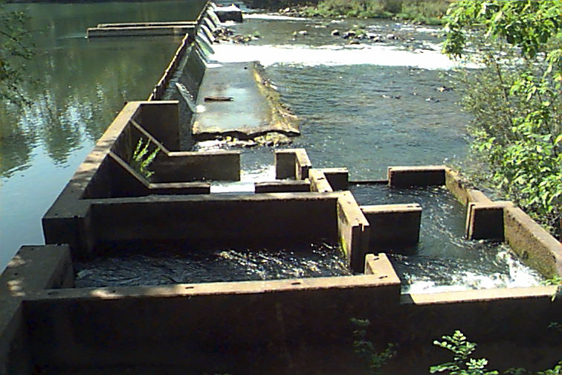

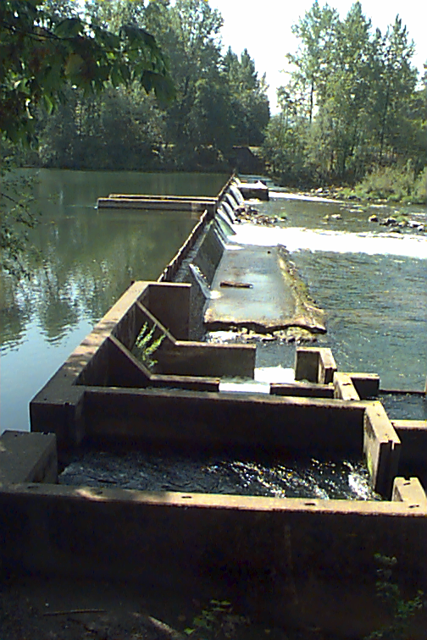
Right Bank View
Figure 2

