Bonneville Power Administration

FY 2003 Provincial Project Review

PART 2. Narrative
Project ID: 35025

Title: Optimization of FCRPS Impacts on Juvenile Salmonids:
Restoration of Lower-Estuary and Plume Habitats

Section 9 of 10. Project description

a. Abstract

This project assembles a group of leading coastal scientists to tackle a complex, urgent problem, optimization of the interaction of the Federal Columbia River Power System (FCRPS) with the lower Columbia River estuary and plume in support of endangered salmonids. The timing and magnitude of flows released by the FCRPS strongly affect juvenile salmonids as they move through the estuary and plume. Restoration of the properties of the lower estuary and plume that constitute habitat for juvenile salmonids requires advances on several fronts. We seek to:
- Objective 1: Define how the lower-estuary and plume interacted historically with coastal currents, how operation of the FCRPS has altered the lower-estuary and plume, and how climate change and the FCRPS will impact the system in coming decades.
- Objective 2: With Action Agencies, define needs and opportunities for science-based input to operational FCRPS management practices, given uncertain climate and coastal circulation forecasts.
- Objective 3: With FCRPS managers, define management scenarios: a) that are based on physical understanding, b) that can be evaluated in terms of habitat opportunity and other constraints on the system, and c) whose implementation can lead to a qualitative improvement in survival of juvenile salmonids.
Innovative oceanographic methods, remote sensing, management science and analyses of numerical model results will be used to achieve the goals of the project, as it moves from research toward provision of definite strategies over the next 6 to 10 years. A Project Advisory Board (PAB) that includes Action Agency personnel, FCRPS managers and external scientists will be formed to help ensure productive application of the insights achieved. Tight cooperation with work carried out in the estuary and plume by the National Marine Fisheries Service (NMFS) will be facilitated by participation of PIs in this project as well as in two projects proposed by NMFS.

b. Technical and/or scientific background

Overview
The 21 December 2000 Biological Opinion dictates that impacts on the juvenile salmonids migrating through the Lower Columbia River (CR) estuary and plume be considered in management of the FCRPS. Improvement of juvenile salmonid survival through restoration of lower-estuary and plume habitat is critical to recovery of endangered stocks (Kareiva et al., 2000) and may also help ameliorate resource conflicts arising landward of Bonneville Dam. Furthermore, any reductions in mortality achieved through improved management of FCRPS impacts on the coastal zone should be more productive (in increasing the return of adult salmon) than changes to more landward parts of the system undertaken without decreases in coastal mortality. This proposal addresses, therefore, Habitat and Hydropower (two of the four H's) by providing an intellectual basis for restoration of lower estuary and plume habitat. We will, in coordination with other on-going work, define how to optimize the interaction of the FCRPS with respect to critical ecosystem support processes of the CR lower-estuary and plume. Over the 6 to 10 year duration of the project, we plan to move from a research focus to provision of clearly defined strategies for improved management.

This proposal is identical in title, scope and budget to one submitted in response to the December 2001 Columbia Estuary Subbasin Solicitation (proposal 30002). Minor changes have been made to clarify the text in response to comments on the original proposal. Also, the information from the Future Needs: Priorities for the Mainstem/System-Wide Fish and Wildlife Program Solicitation document was used to explain the significance of this proposal to regional projects.

The terms of the Biological Opinion require that the "Action Agencies", including BPA, carry out “Reasonable and Prudent Actions” (RPAs) related to the Four H's (Habitat, Hydropower, Harvest and Hatcheries). This project will address Habitat RPAs 158, 159, 161 and 162 related to estuarine habitat. It also addresses Hydropower RPAs associated with RM&E (Research, Management and Evaluation): RPAs 187, 195-197, and 199. These RPAs deal with ocean conditions at the time of entry, juvenile salmonid use of the estuary and plume, and research activities in the estuary and plume. The 2002 One-Year Implementation Plan stresses the need to resolve “Critical Uncertainties” regarding conditions at the time of ocean entry and delayed mortality. This proposal will define present and historical ocean conditions, and how they might be improved through future FCRPS management. The Future Needs document strongly emphasizes the importance of understanding the role of the plume in juvenile salmonid survival.

There is abundant evidence from other systems that the timing and magnitude of river flows (controlled in the CR by the FCRPS) affect growth and survival of juvenile salmonids. A major part of these impacts occur in the coastal ocean close to the source river, i.e., in the proposed study area (Peterman et al., 1998; St John et al., 1992; Fukuwaka and Suzuki, 1998). Effects on salmonids likely occur through changes in plume bulk properties (input timing, volume, salinity, location and relationship to coastal upwelling) and through alteration of other aspects of “habitat opportunity” (e.g., changes in the distribution of plume fronts, primary productivity and turbidity). The proposed work will define the physical response of the lower-estuary/plume system to the FCRPS and changes in coastal and climate forcing. These impacts will be understood through integration of state-of-the-art oceanographic and remote sensing, data analyses, and analysis of numerical model results. A closely related question (the response of juvenile salmonids to plume physical properties) will be addressed by an on-going National Marine Fisheries Service (NMFS) study 199801400, Survival and Growth of Juvenile Salmonids in the Columbia River Plume or SGS (M. Schiewe, PI). SGS will also generate the numerical database, the coastal radar data and part of the remote sensing data that we will use in this project. To guarantee close coordination, PIs Hickey, Jay, Baptista, Kosro, Miller, and Foreman will be involved in both projects.

Means to optimize FCRPS management with respect to juvenile salmonids survival in the lower estuary and plume will be defined through analyses of scenarios defined by our evolving understanding of plume processes. Scenarios will be defined to illustrate the effects of contemporary plume processes, historical changes in the plume related to the FCRPS and climate cycles, and the implications for the plume of future FCRPS management and climate-change scenarios. It is vital, moreover, to formulate future management scenarios so that they can be incorporated into the annual cycle of water management by FCRPS managers and others responsible for survival of juvenile salmonids. This issue is particularly important, in that the FCRPS must be operated in the context of uncertain climate forecasts and numerous other constraints (Pulwarty and Redmond, 1997). A component of the proposed work is directed, therefore, toward determining how management scenarios can be made most helpful to FCRPS managers.
Determination of impacts of the FCRPS requires a "currency" with which to evaluate the utility of potential changes in management, as expressed in management scenarios. Our chosen currency is "habitat opportunity" for juvenile salmonids in the lower-estuary and plume. Habitat opportunity will be defined in such a way that it can be evaluated primarily from numerical models and remote sensing data, once the modeling skill of CORIE model has been demonstrated for the Plume (an FY 2004 activity for SGS). Habitat opportunity will initially be defined in terms of the occurrence and strength of plume fronts and Chlorophyll (Chl) concentration in the plume area. Impacts of the FCRPS on juvenile salmonids occur, however, through "bottom-up" processes (from changes in food resources) as well as "top-down" mechanisms (predation on juvenile salmonids). Thus, turbidity and other factors will be brought into the definition of habitat opportunity as understanding of the system evolves. We anticipate that this project and SGS study will drive evolution of the definition of habitat opportunity over the next few years. SGS will be responsible for judging the effectiveness, from a fisheries management point of view, of the various scenarios. This project will provide a rational basis (in terms of physical process science) for the definition of habitat opportunity and of the management scenarios to be tested. It will also link the definition of scenarios to FCRPS management and climate forecasts.

The investigators assembled for this project represent the “oceanographic memory bank” for the Columbia – three of us have been active in the Pacific NW for more than 25 years, two for at least 14 years. Nonetheless, we will need assistance in working effectively with FCRPS managers. A Project Advisory Board (PAB) will be formed to provide information regarding management strategies, to evaluate the numerical scenarios developed, and to assist in coordinating the proposed work with FCRPS managers and other Pacific Northwest scientists. The PAB will include FCRPS managers, other Action Agency personnel, and independent scientists. Its members will help ensure that a tight focus on regional needs is maintained and will be invited to participate in the scenario workshops convened by the SGS project. Because of the complexity of salmonid interactions with the plume and its high degree of interannual variability, we anticipate a 6 to 10 year scope for the project. The PAB will, during that period, assist project scientists in learning how to formulate and provide climate information, numerical scenarios and scientific results in a manner that is consistent with the annual cycle of water management in the system.

Scientific Background

The lower CR estuary and plume area includes the estuary seaward of the entrance fronts (near Clatsop Spit) and those parts of the coastal ocean where surface salinity is strongly influenced by CR effluent (surface salinity <31.5). During the spring and summer seasons of interest here, this larger plume area can extend from central Washington to Northern California and offshore several hundred km. Our primary interest lies, however, in a more restricted area, the shelf waters between Central Oregon to ~50 km north of the mouth (Fig. 1). It is within this area where much lower salinities are seen (as low as 10-20), strong fronts are present, and important interactions with the coastal upwelling regime take place. This area also shows enhanced primary productivity (Conomos et al., 1972a,b; Hickey, 1989), and elevated numbers of juvenile salmonids have often been found there by SGS cruises.

This proposal is based on a few simple ideas. First, we assert that the lower-estuary and plume constitute a significant habitat for juvenile salmonids, a habitat wherein reductions in mortality associated with the FCRPS would be effective in increasing the return of adult salmonids, as suggested by Kareiva et al. (2000). Second, we argue that the long-term changes in these environments imposed by climate change, climate fluctuations and the FCRPS have significantly affected juvenile salmonid habitat, and thus also juvenile salmonid survival (Weitkamp et al., 1995). Furthermore, we believe that analyses of
Figure 1: Map of 1-km resolution AVHRR-derived surface temperature (ºC). Text salinity values are superimposed to demonstrate that the warm water mass is derived from the Columbia River plume. The outer red box delineates the study region. The inner red box delineates the area where the lowest salinity water is typically found.

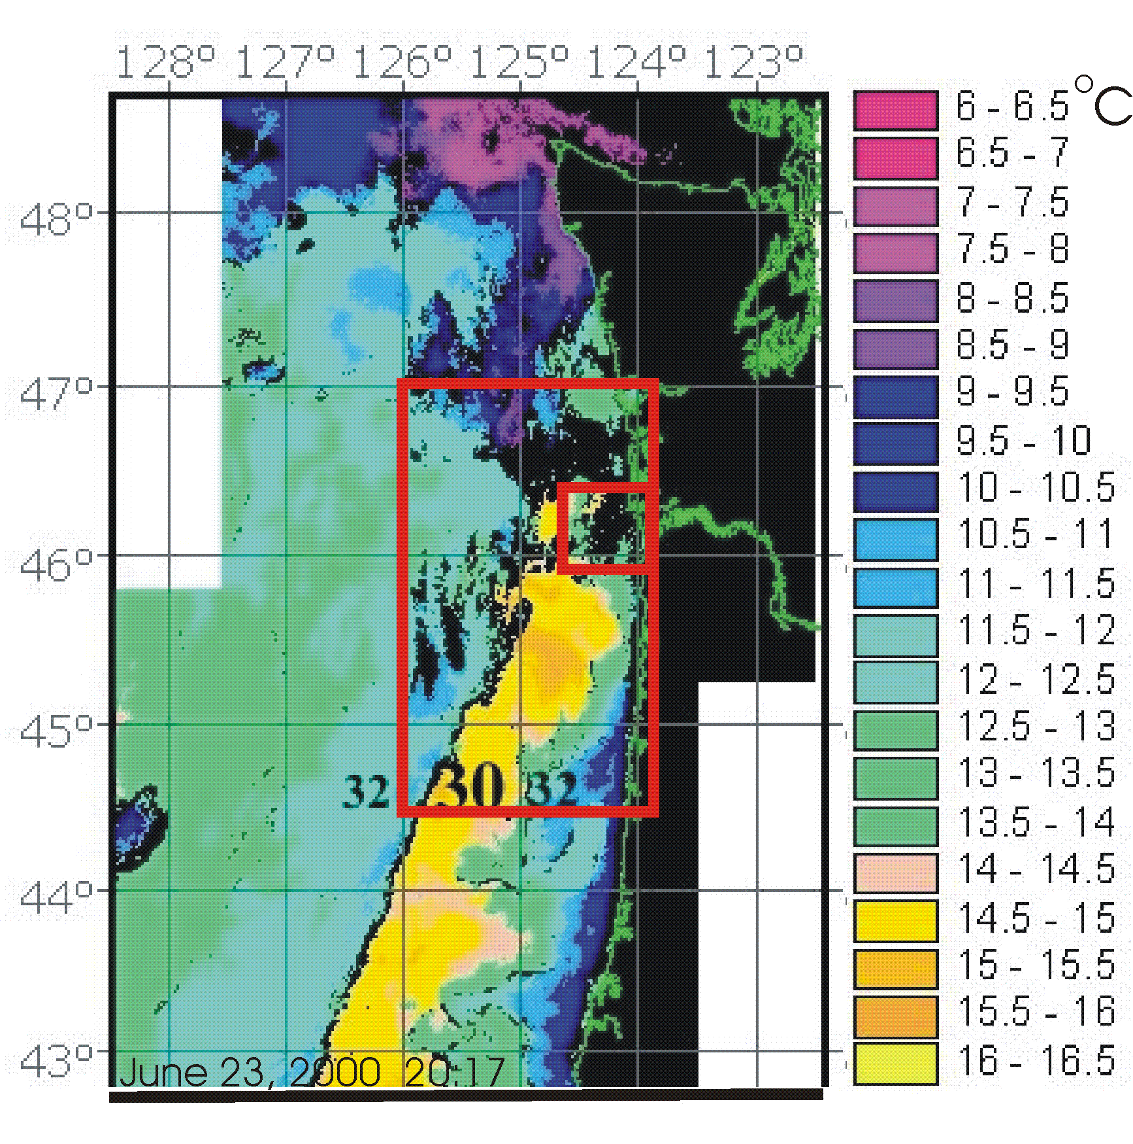

airborne and satellite remote sensing data, vessel observations, and numerical model results will allow us to understand plume processes in an unprecedented way. Finally, we are convinced that analyses of historical and future management scenarios can be an effective means to improve impacts on juvenile salmonids in this environment. The following paragraphs summarize the current state of knowledge on these issues. At the end of that discussion, we suggest opportunities for improved management that may, as part of the proposed work, be the subject of management scenarios. This is followed by the proposed work.
1. Coastal Processes and the CR Plume. Seasonally prevailing currents dictate that the CR plume is usually found north-northwest of the river mouth in winter and southwest of the mouth in summer (Hickey, 1989). The plume dominates the water properties in the upper 10-20 m over the Washington continental shelf in winter and many tens of kilometers seaward of the Oregon shelf in summer. The transition between these two states, the “spring transition” generally occurs in March-April, although the date of the transition has much interannual variability (Hickey, 1989; Bilbao, 1999). Within any season, the position and character of the plume can change by tens of kilometers in a few hours in response to changing wind conditions (Garcia-Berdeal et al., 2002). The plume moves offshore during periods of good weather (upwelling) and onshore during storms (downwelling). During upwelling periods, blooms of plankton develop inshore of the plume and move offshore where they meet the edge of the plume, becoming concentrated along plume fronts or possibly moving under the plume. In years of persistent and strong upwelling, we might expect the plume to remain mostly off the Oregon coast and seaward of the shelf. In years of more intermittent upwelling, we may expect the plume to appear more frequently off the Washington coast or very nearshore off the Oregon coast.
The interaction of the plume with coastal upwelling is believed to be very important to juvenile salmonids through its influence on nutrition, and regional variations in upwelling may be important. For example, average Chl levels off the Washington coast in early summer are higher than those off Oregon (Landry et al., 1989; Strub et al., 1990). If the Chl standing stock is a reflection of zooplankton standing stock, the Washington shelf might be preferable for survival to the Oregon shelf. The timing of juvenile fish release with respect to plume orientation and strength is also critical to survival rates. Most juveniles (except for some chinook) historically entered the ocean after the upwelling season and plankton production had begun, when CR flows are high. If upwelling is weak when salmon arrive at sea, ocean temperatures may be high, turbidity and plankton biomass low, plume-flow either west or north, and feeding conditions poor. Also, the survival of juvenile salmonids at sea may depend on the match/mismatch between the arrival of smolts in the spring and the arrival of predators, notably hake and mackerel. While these predators usually arrive in Oregon waters by May, their arrival time is probably dependent upon weather patterns and currents. Thus, juvenile salmonid survival is promoted by interactions of the plume with coastal upwelling that lead to high concentrations of prey organisms in a relatively turbid environment, e.g., in fronts. This suggests that years with both strong river flow and strong upwelling may be especially favorable for salmonid survival.
2. The Lower-Estuary and Plume as Juvenile Salmonid Habitat. Fluctuations in mortality of salmon in the marine environment are a significant source of salmonid recruitment variability. About half of all preadult (egg through juvenile stage) salmon mortality occurs in the marine environment (Bradford, 1995), and ocean survival of Oregon salmon has varied by a factor of 30 in the last three decades. While physical factors must control a large part of the interannual variability of salmon survival, our understanding of how specific physical ocean processes affect salmon is limited (Brodeur 1997). Therefore, a major focus of our proposed work is to better define what physical features constitute the estuary and ocean conditions that influence salmonids, and how these features have evolved over time.

Influences on juvenile salmonid survival in the lower-estuary and plume can be either “bottom-up” (related to abundance of prey for juvenile salmonids) or “top-down” (related to predation on juveniles). Juvenile salmonid growth rate provides a key link to lower food-web conditions. Faster-growing fishes typically proceed through successive life stages sooner, acquire a greater chance of survival, and higher fecundity at reproduction (Bakun 1996). The initial weeks and month of ocean life is a critical period for determining recruitment success in salmonids (Peterman et al., 1998), and it has been shown that salmon with the highest growth rates are the most likely to survive (Pearcy, 1992). Lower-estuary and plume fronts are, moreover, one of the more important features influencing nutrition for juvenile salmonids. Most juvenile salmon and many of their prey dwell in the upper water column (Brodeur, 1990). They are frequently concentrated in fronts (Lough and Manning, 2001) and utilize plumes and frontal regions both as transitional nursery habitats and to capitalize on their relatively high prey densities (St. John et al., 1992). It therefore appears likely that juvenile salmon gain a critical advantage in survival at sea if they arrive in a coastal area rich with fronts. (Fig. 2). In a focused study of salmon and fronts in May 2001, juvenile coho salmon were significantly more abundant in fronts than in surrounding waters. Juvenile chinook salmon also prefer plume waters, but not as decisively associated with the plume and its fronts as juvenile coho salmon. Several of the largest catches of salmon and various salmon prey during the four-year project were made within these same fronts (Fig. 3).

Fronts are generally productive relative to surrounding waters, and their currents concentrate prey in a relatively restricted area (e.g. Longhurst, 1998). Shore-parallel fronts have additional ecological value for their role as barriers, reducing export of planktonic organisms from the waters overlying the continental shelf (e.g. Bakun 1996). High concentrations of lower trophic-level organisms may be trapped between an upwelling front inshore and plume fronts further off-shore, leading to favorable circumstances for growth of juvenile salmonids. Satellite data and shipboard observations have verified the presence of numerous plume fronts, and upwelling fronts in the lower-estuary and plume region. Upwelling fronts are also frequently present outside of the plume. Shelf-sea fronts, with a lifetime of several weeks, are commonly visible with AVHRR in late summer, extending from Central California to Northern Oregon. Strong fronts are also found within the lower estuary, seaward of the point where the buoyant plume leaves the seabed (Cudaback and Jay, 1996, 2000, 2001).
Figure 2. Location and tidal movement of a tidal plume front after its exit from the estuary on ebb, shown in a front- tracking map. The inset color plot shows salinity profiles on either side of the front 5 hrs after its origin at the estuary mouth.
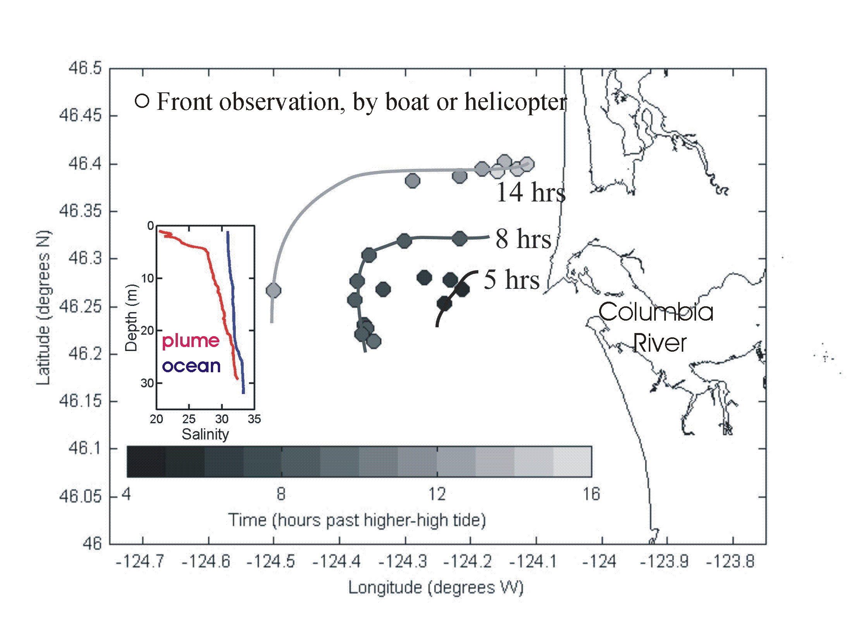
Figure 3. Standardized catch of juvenile salmon in relation to the Columbia plume front in May 2001. Each habitat was sampled in random order a total of seven times over a three day period. Shown are the means (dotted lines), median (center line in box), upper and lower quartiles (box), and 95th percentile (error bars). Catch in front was significantly higher (p=0.024) than outside the front (ANOVA randomized block design).
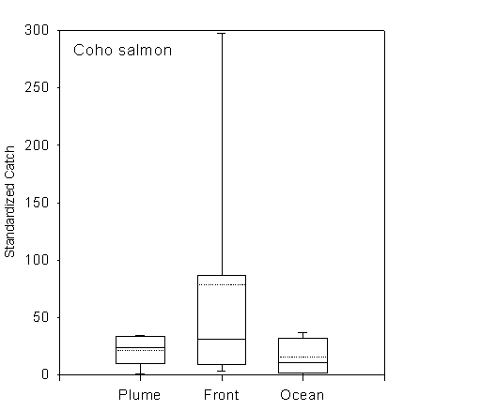
The CR plume may also retain fish and plankton in eddies. Whether river outflow is steady (Garcia-Berdeal et al., 2002) or pulsating (Yankovsky et al., 2001) circulating eddies tend to form within the plume. These eddies allow juvenile fish to easily maintain themselves within the plume region to take advantage of its turbidity or its food. Moreover, off the Washington coast, these eddies are sufficiently large to cause a strong current all along the nearshore region directed back toward the river mouth. During upwelling events, especially during a year with intermittent upwelling, we suspect that plankton is heavily concentrated in this area, making it especially favorable for survival of juvenile salmon.
Water column turbidity is another key aspect of plume conditions relevant to salmonids. Annual spring freshet flows through the CR estuary are ~60% of the traditional levels that flushed the estuary and carried smolts to sea, and fine sediment discharge is ~40-50% of 19th Century levels. Decreased spring flows and sediment discharges have also reduced the extent, speed of movement, thickness, and turbidity of the plume that extended far out and south into the Pacific Ocean during the spring freshet (Barnes et al., 1972; Hickey et al. 1998). This large freshwater “plume” likely provided a high turbidity refuge from predation, fronts and eddies where prey became concentrated, and a stable habitat for northern anchovy spawning (Richardson 1981, Bakun 1996). A strong, quickly moving plume also helps juveniles move rapidly offshore through an areal of potentially high predation (Pearcy, 1992).

3. Climate Effects on the Plume. Juvenile salmonid survival has been affected by climate changes and climate fluctuations, as well as by operation of the FCRPS. Long-term and decadal shifts in climatic processes affect the volume and timing of river outflow and the oceanic context of the plume (Bottom et al., 2000; Jay and Naik, 2001). Thus, Columbia River peak freshet flow since 1858 closely follows the Pacific Decadal Oscillation (PDO) cycle. Flow and the PDO index show correlated variability on time scales of 10-50 yrs, and the long-term decrease in CR flows also mirrors the century-scale warming of sea-surface temperature (SST) seen in the PDO index (Fig. 4). The PDO cycle is strongly related to salmonid marine survival and returns (Francis and Hare. 1994). PDO regime shifts occurred in 1977 and between 1996 and 1998. The abrupt 1977 shift to the warm phase of the PDO may have been a factor in reduced ocean survival of salmon in the Pacific Northwest and increased survival in Alaska (Mantua et al. 1997). The recent shift back to a cold PDO phase is too recent to allow definite inferences regarding its effects, but there are indications of a return to ocean conditions favorable for increased early survival (Schwing et al., 1998; Schwing and Moore, 2000; Peterson et al., 2001). Cold-PDO periods are likely to provide both strong upwelling of nutrient-rich waters and a high-volume CR plume with strong fronts.

The correlation between PDO fluctuations, salmon catches and the long-term trend (1860-date) in PDO also suggests that the 1850-1900 period may not be an appropriate baseline for contemporary salmonid survival. This period was the end of the “little ice age”, with high precipitation all along the West Coast and cold but rising temperatures (Earle, 1993; Engstrom, 1997). Thus, management of the system may need to recognize that conditions are favorable or unfavorable on century as well as decadal scales.
4. Effects of the FCRPS on the Plume. The FCRPS has greatly altered the CR estuary through its impacts on the hydrologic cycle (Bottom et al., 2000). Alteration of the hydrologic cycle has interacted with other human alterations (irrigation diversion, diking, channel construction) to strongly affect estuarine habitat (Sherwood et al., 1990; Simenstad et al., 1992; Weitkamp et al., 1995). FCRPS-related ecosystem impacts on the plume can be illustrated by comparing the extent of the plume in two high flow years, 1961 (before significant freshet regulation) and 1999 (freshet flow greatly reduced); see Fig. 5. Clearly reduction of freshet flow (by ~43% in 1999 and ~40% on average) greatly reduced plume volume and the extend of waters with S < 31. River flow in turn strongly affects salmonid survival (Francis and Hare, 1994). Our results from the SGS study confirm the dependence of plume conditions on river flow shown in Fig. 5. For high river-flow (as now provided by the FCRPS, June 1999; 11,000 m³s⁻¹), 60-80 percent of the study region is covered by plume waters (salinity <31). With moderate riverflow (June 2000; 6100 m³s⁻¹), only
Figure 4: There is a strong correlation between the PDO index based on SST (above) and Columbia River maximum daily flow (below) for the overlapping period, 1858 to 1991. Columbia River flows are high during cold-PDO periods (negative PDO index). There is also a strong trend in the SST indicating warming of the NE Pacific. Both the warming trend and the decadal-scale fluctuations likely affect salmon.

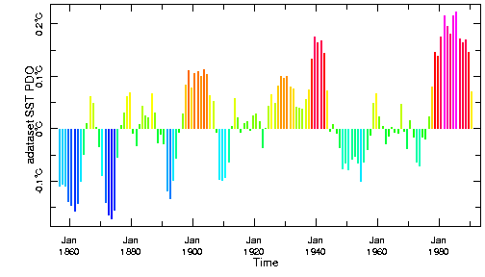

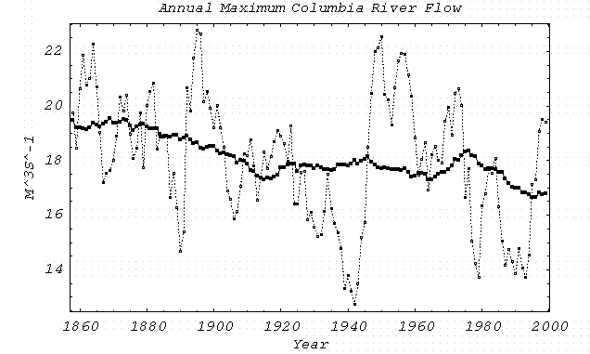

30-40 percent is plume water, whereas with low river flow (Sept. 1999, Sept 2000, May 2001; <4000 m³s⁻¹), less than 15 percent are plume waters. The comparison made in Fig. 5 also illustrates the concept of “analog years” (Pulwarty and Redmond, 1997) – the consequences for the plume of following a natural hydrograph in 1999 is approximated by the conditions observed in 1961.
Until recently it has been difficult to cleanly separate climate, irrigation depletion and FCRPS effects on river and sediment inputs to the CR plume. The virgin flow time series for CR at The Dalles has now been reconstructed back to the 19th Century and the virgin-flow sediment transport estimated (Bottom et al., 2000; Naik and Jay, 2001), facilitating this analysis. Climate change since 1900 has decreased annual average and peak freshet flows by ~7%, and caused the peak of the freshet to occur several weeks earlier than it did before 1900 (Jay and Naik, 2001; Fig. 6). Irrigation losses have decreased annual average and peak flows by 7 and 9 %, respectively. Flow regulation by the FCRPS has decreased peak freshet flow by ~40%. Because sediment transport depends on a power river flow >1, reductions of sediment Figure 5. Impacts of the FCRPS on the CR plume in two high-flow years, 1961 and 1999. Above is the plume observed by Barnes et al. (1972) at the height of the 1961 spring freshet (peak flow ~20,000 m³ s⁻¹; 89% of the virgin peak flow). Note the smaller scale for the 1961 plot. Below is the plume we observed in the SGS project in 1999 just after the freshet. Although the 1999 virgin and 1961 observed hydrographs were very similar, the FCRPS and irrigation depletion reduced the actual peak flow in 1999 to 11,000 m³ s⁻¹, only 57% of the natural level, resulting in a much smaller plume. Using S= 31as the outer limit of the plume, the 1961 plume covered about 90% of the continental shelf from the Strait of Juan de Fuca to Newport, Oregon. The 1999 plume only covered about 65% of this region.

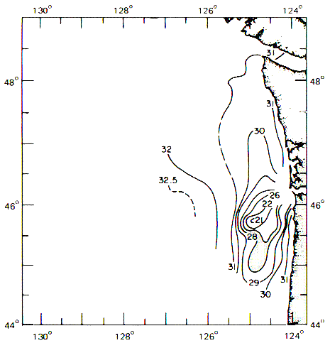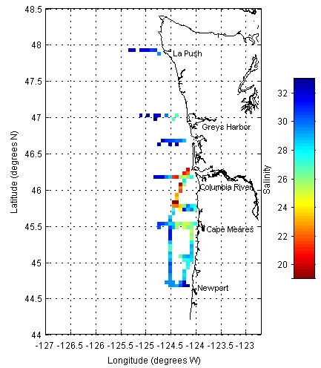

Figure 6. Alteration of the Columbia River flow cycle: the 1971-1999 virgin (), adjusted (⬄) and observed () flows, and the effects of FCRPS () and irrigation depletion (). The virgin flow is the flow that would have occurred naturally, the adjusted flow is the observed flow corrected for reservoir manipulations and evaporation. The virgin and adjusted flows differ by irrigation depletion. Both climate change and irrigation depletion have caused ~7-8% decreases in average flow, whereas the FCRPS has caused a ~40% decrease in peak flow.
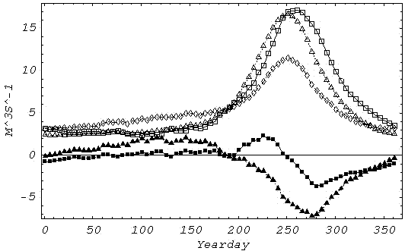

Figure 7: Salinity, transmissivity, and optically determined mean particle size along a transect seaward from the estuary mouth.
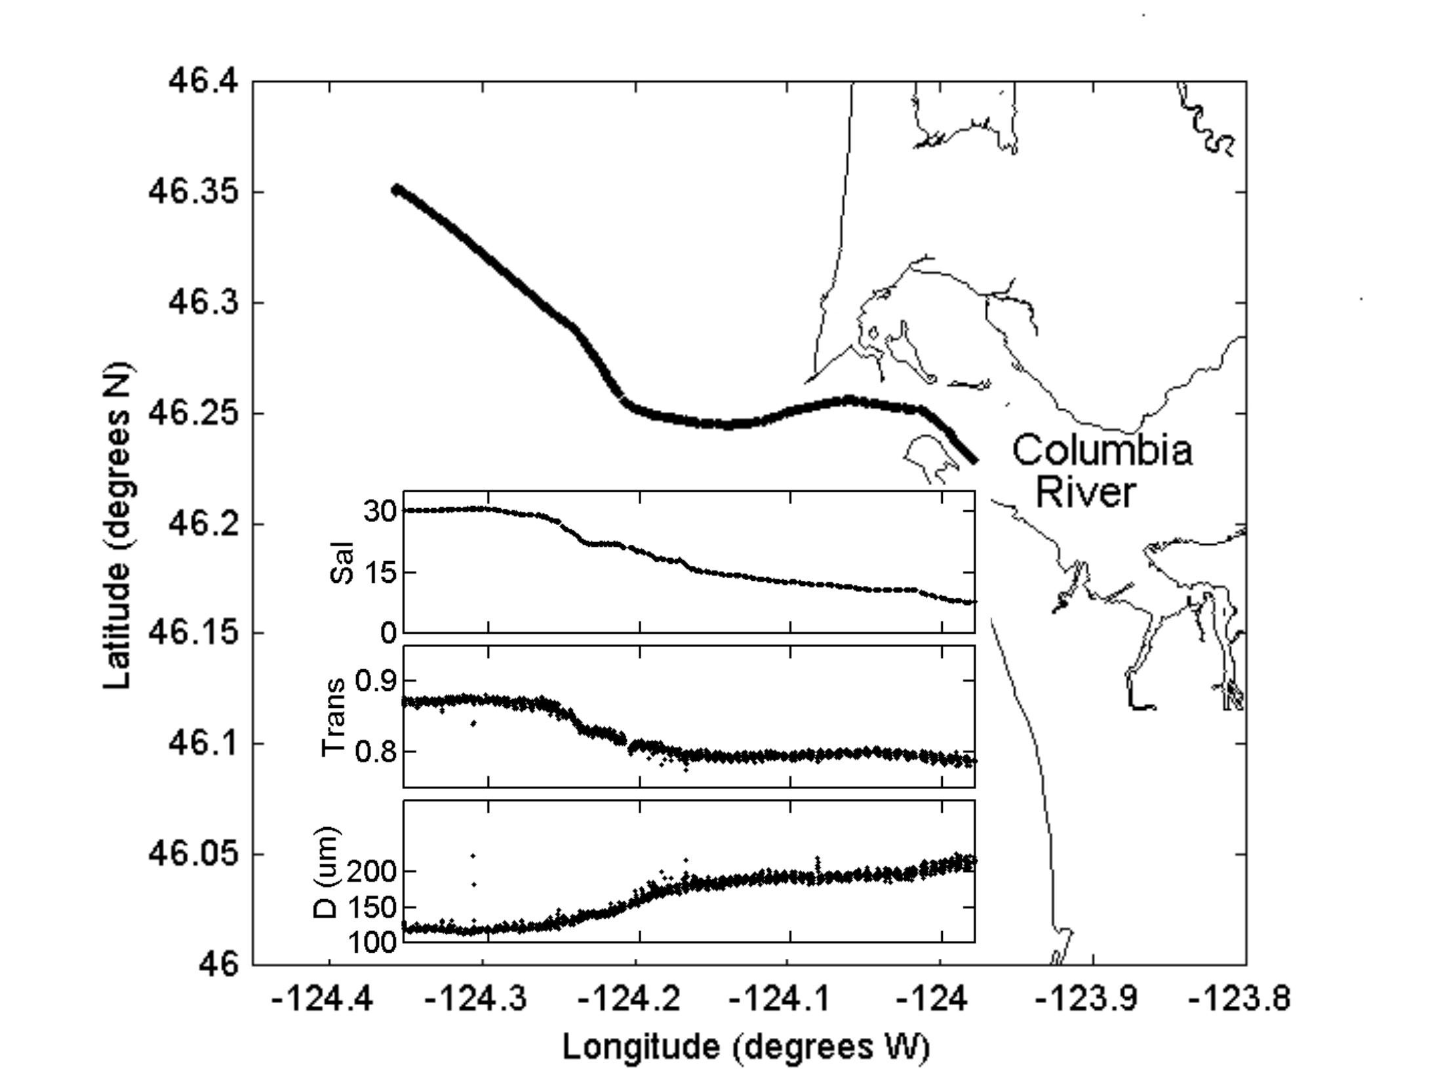
transport, especially peak sediment transport, have been greater than those for river flow. Lower-estuary and plume turbidity levels during a typical spring freshet are likely less than half of those before 1900, with the bulk of the change due to the FCRPS. Turbidity levels are also well below those seen in the Fraser River, where salmon productivity remains high.

5. Small-Scale Plume Processes. Ongoing SGS studies of physical processes have focused on the role of small-scale plume features as salmonid habitat. Plume and non-plume water differ greatly in their time and space scales. Velocity variability in the plume area occurs most strongly at periods between a few hours and a few days, with the shortest periods characteristic of locations where low-salinity water is present (Jay and Hickey, in prep). This contrasts with most continental shelf areas, where periods of 3-10 d predominate. The characteristic scale for a unit change in salinity is 10-500 m when plume water (S <31.5) was present. The corresponding scale for non-plume water was 10 to 100-fold larger. Fronts are an important small-scale plume feature. They exhibit strong near-surface cross-frontal convergence, which can concentrate prey organisms and salmonids. In the May 2001 low-river-flow study, typical cross-frontal convergence rates were ~0.25 ms⁻¹; stronger convergence likely occurs when the flow is higher. On the other hand, there are strong velocity differences across the front in the along-frontal direction, ~1 ms⁻¹. Given the small physical scales of fronts and their concentration of organisms, biological sampling may need to be adjusted to resolve these scales as effectively as possible.
Tidal variability is 3-10x larger in the plume area than is typical for the rest of the Oregon- Washington shelf (as determined by Torgrimson and Hickey, 1979). This enhanced variability is caused by internal tides that are concentrated in the plume area, and are much more variable than surface tides (Jay and Hickey, in prep). Internal tides are important to juvenile salmonids, in part because their strong interfacial shear beneath the plume (usually 3 to 12 m depth), may disperse juvenile salmonids. Furthermore, internal tides represent a mechanism by which nutrients can be mixed up into plume waters from underlying waters. Because internal tides are generated at plume fronts, the interaction between fronts and internal tides likely increases velocities in frontal zones.
The time and space distributions of turbidity in the plume are different from those for salinity. The plume is highly turbid as it enters the ocean, but there is an almost exponential decrease in sediment load with distance from the entrance. Mean size decreases also, as coarser particles sink (Fig. 7). Material settles out of the plume, because plume stratification inhibits the vertical mixing necessary to maintain particulates in suspension. The plume also becomes turbid if in contact with cool waters. This is probably due to primary production, resulting from nutrient enrichment and the stability of the plume. The timing of fine sediment export from the estuary to the plume follows a different annual cycle from the river flow (Fain et al., 2001). The highest turbidity levels are caused by winter, rain-on-snow events that may not correspond to the highest flows (Bottom et al., 2000). Although most of the sediment supplied to the estuary is exported within one year, much of it is temporarily stored in the estuarine turbidity maximum and peripheral bays (Jay et al., 2001). Strong sediment export events occur on each spring tide during and for several months after a strong freshet. Sediment export continues even though the flow has decreased.
6. Observation, simulation and forecasting of plume processes. CORIE, an observation and forecasting system for the Columbia River (Baptista et al. 1998, 1999; Baptista, 2001), is designed to generate long-term information on the coupled circulation of the lower estuary, plume, and coastal ocean. The plume-ocean component of the CORIE modeling system has been and will continue to be developed through SGS. A new 3D numerical circulation code, ELCIRC, has been developed to address the complex, advection-dominated baroclinic circulation in the study area with the required detailed spatial resolution and computational efficiency (Myers and Baptista 2001; Baptista et al. 2000; Myers et al. in prep). Products of the CORIE plume modeling system are (a) daily forecasts of the near-field plume circulation, which will be used to guide vessel and airborne remote sensing surveys, and (b) a database of simulations initially built around selected SGS fisheries cruise periods. This simulation library will be expanded by SGS to encompass a much larger range of historical conditions and potential management scenarios.

The SGS circulation database will include: (a) simulations of circulation for April-October 1998-2005 using ‘actual’ river, atmospheric, tidal, and ocean forcings; (b) four historical scenarios, chosen to capture a broad range of river flow and coastal upwelling conditions; and (c) six management scenarios, that represent future management options for the system. The definition of historical and management scenarios will be based in part on insights generated in the present project. The CORIE observation network (www.ccalmr.ogi.edu/CORIE/network) includes one offshore station (OGI01, deployed by SGS in ~100m depth, south of the Columbia River entrance) and 16 estuarine stations. Stations typically include measurements of water level, salinity and temperature, complemented at several stations (including offshore) by acoustic Dopler profiler measurements of velocity and backscatter. During the 2004 SGS field demonstration of the plume modeling system, a second offshore mooring (OGI02) will de deployed in the near-field of the plume, at about 30-40m depth. Both OGI01 and OGI02 will during that period provide information on the vertical structure of currents, salinity and temperature.
7. Management of the FCRPS in an Uncertain Environment. Building a mutual understanding between scientists and FCRPS managers regarding the nature and details of the annual FCRPS decision cycle is of decisive importance. Without such an understanding, it is doubtful that scientists can provide the necessary information in useful format. Researchers, policy-makers and managers operate on different time-lines, use different languages, and most importantly, respond to different problem definitions and incentives (Pulwarty and Cohen, 2002). How and when technical information is used and how it influences decision-making is affected by a several factors (e.g. trust, credibility, appearance of “manipulation” etc). The utility of information is not controlled by one set of factors (e.g. format), or defined by a single perspective. Thus, the communication process is complex and heavily dependent on the potential user's pre-existing knowledge, institutional context, beliefs and experiences.
Previous analyses of the use of climate information in the CR and Colorado River systems also provide specific information about the difficulties involved in using uncertain predictions. Pulwarty and Redmond (1997) found that the primary climate information desired by FCRPS managers was flow volume and timing, river transit times, and stream temperatures. This information needed to be provided with a 75% certainty level a season in advance. Available climate forecast information, produced with considerable effort and expense, was not widely used in managing the FCRPS. There were a variety of reasons for this disconnect between forecasts and their intended uses. A principal factor was the inevitable uncertainty of such forecasts. There was also a lack of clear linkages between forecasters and users, and forecasts were provided without sufficient contextual information for potential users to judge accuracy and relevance. Analyses of Colorado River management emphasize the need for negotiation when an over-allocated resource (flow in the Colorado River) is impacted by an extreme event like the 1997-98 El Niño (Pulwarty and Melis, 2002). There is a danger of management paralysis if clearly defined coping mechanisms are absent, especially when stakes are high and there are gaps in the knowledge of consequences of management actions. The willingness of managers to use information and consider new strategies is, moreover, strongly constrained by experience with past events. If information is to be used, it must be presented at appropriate "entry points" in the annual hydrologic management cycle and within the context of longer-term goals for adaptive management.
A key part of this study will be to elucidate through interviews and report reviews how tradeoffs are made contingent on the degree of uncertainty and the relative importance of particular decisions to management goals. Partners within the FCRPS have been identified through previous studies involving Dr. Pulwarty (e.g., Pulwarty and Redmond, 1997) and by other PIs involved this study. We have outlined differing approaches to risk, analyzed similarities and differences in communication of short-term climate forecasts and environmental change scenarios, and identified guidelines for overcoming barriers to symmetric interaction between researchers and decision-makers. Partnerships between scientists and FCRPS managers need to be developed along three major lines: a) clarification of management goals at the energy-environment interface, b) construction of a solid foundation for research and management, and c) distillation of transferable lessons from appraisals of current and past practices. Our proposed work builds on the above findings. It outlines the differing approaches to risk communication within the FCRPS decision process and their associated information needs, identifies communication styles for short-term climate forecasts, and identifies guidelines for overcoming barriers to symmetric interaction between researchers and decision-makers.

8. Opportunities for Increased Survival. An improved understanding of estuarine and nearshore ocean environments and the role they play in salmonid survival will suggest management options to increase adult returns; some of these will likely provide increased flexibility in flow volume and timing, also. These will be expressed in terms of management scenarios, present, future or retrospective. Most or all such scenarios will respond to RPAs 158, 159, 161, and 162, dealing with the aspects of the system that constitute favorable habitat for juvenile salmonids. We suggest several examples that might be used in management scenarios, if other analyses suggest that benefits to juvenile salmonids might accrue:

Transportation studies conducted at Lower Granite Dam showed smolts transported during the early part of the 1990 migration season had much lower survival than those transported during the later part, for both hatchery and wild fish (Matthews et al. 1992). Clearly, conditions in the estuary and plume were more favorable early in the season than later. Our process research will help to clarify the meaning of “favorable estuary and plume conditions”. Managers could use this information, as embedded in future management scenarios, to regulate hatchery release times and the river flow cycle in a mutually consistent manner; RPAs 187 and 195, in addition to the Habitat RPAs.
- River flow timing (thus, input of freshwater to the plume) could be optimized with respect to migration of juvenile salmonids from the estuary to the plume. It may be that export occurs predominantly on spring tides, when currents are strongest in the lower estuary. Alternatively, it may be that juveniles leave the estuary primarily on high-river-flow neap tides. If, however, there is any preferred tidal monthly timing for migration from the estuary, there will be opportunities to optimize the timing of water release relative to this migration; RPAs 187, 196 and 197, in addition to Habitat RPAs.
- Understanding the timing of export of fine sediment from the estuary (on each spring tide for several months after a fluvial sediment supply) provides an opportunity for coordination of freshwater supply to the plume and salmonid entry into the coastal ocean with plume turbidity levels. The inhibition by turbidity of plume primary productivity is another factor that needs to be considered in this regard; Habitat RPAs.
- The estuary (Jay, 1984) and plume (Yankowski et al., 2001) respond differently to fluctuating river outflow than they do to steady outflow. Once this transient response is better understood, it may be possible to make use of this response to optimize juvenile salmonid survival; RPAs 196 and 197.
- Shore-parallel fronts caused by upwelling (inshore) and the plume (offshore) tend to contain the new primary and secondary productivity due to upwelling. Timing of river flow to coincide with strong upwelling periods may be favorable for salmonid survival; RPA 197.
- Micronutrients (e.g., iron) carried to the surface by upwelling enhance shelf primary productivity (Johnson et al., 1999), and the CR is a major source of iron to the coastal ocean (Ballard, 1964). The system's export of fine sediment has, however, been decreased by ~50% because of reduced freshet flows. During winters when pre-release of water is necessary to decrease spring freshet strength (e.g., 1996 and 1997), it may be useful to concentrate flow in a near-bankfull flow after a storm, maximizing export of fine sediment to the shelf. This would at least partially compensate for the loss of fine material formerly supplied during the spring freshet; RPA 197.
- Future climate scenarios for the Columbia Basin (Hamlet and Lettenmeier, 1999) suggest enhanced winter precipitation, increased winter temperatures and decreased snow pack, decreased natural spring freshet flow and an earlier spring freshet. These circumstances could sharpen conflicts between water uses during spring and summer. At the same time, the timing of the transition between winter and spring coastal circulation regimes may change, along with the seasonality of strong upwelling. Understanding how the plume will interact with future coastal circulation regimes would help to minimize the adverse effects of decreased future spring flows, should they occur; RPAs 196 and 197.

c. Rationale and significance to Regional Programs

The Federal Columbia River Power System (FCRPS) Biological Opinion of 21 December 2000 requires a broad range of reasonable and prudent actions (RPAs) by BPA and other federal agencies. The RPAs address the four “H’s” (Hydropower, Habitat, Harvest and Hatcheries) and are designed to enhance the survival and recovery of endangered salmonids. These actions include research, monitoring and evaluation (RM&E) programs that will resolve "a wide range of uncertainties, including determining population status, establishing causal relationships between habitat (or other) attributes and population response, and assessing the effectiveness of management actions" (p. 9-4). One of the greatest of these uncertainties is the nature of the specific features and processes of the lower CR estuary and plume that support juvenile salmonids. Resolution of this issue requires acquisition of the process understanding proposed here, and its application through the management scenarios discussed below. Clearly, the proposed work is consistent with the overall intent of the Biological Opinion. As laid out in the following paragraphs, it implements Habitat and Hydropower RPAs specified in the Biological Opinion. It is also consistent with the one and five-year implementation plans, and the Estuary Sub-Basin Summary.

1. Relationship to the Biological Opinion: It is an indicator of the importance of the estuary and plume, that a number of the RPAs address these environments. The specific Habitat RPAs relevant to the proposed work include:
- RPA 158: During 2001, the Corps and BPA shall seek funding and develop an action plan to rapidly inventory estuarine habitat, model physical and biological features of the historic lower river and estuary, identify limiting biological and physical factors in the estuary, identify impacts of the FCRPS system on habitat and listed salmon in the estuary relative to other factors, and develop criteria for estuary habitat restoration.
- RPA 159: BPA and the Corps, working with LCREP [Lower Columbia River Estuary Program] and NMFS, shall develop a plan addressing the habitat needs of salmon and steelhead in the estuary.
- RPA 161: Between 2001 and 2010, the Corps and BPA shall fund a monitoring and research program acceptable to NMFS and closely coordinate with the LCREP monitoring and research efforts… to address the estuary objectives of this biological opinion.
- RPA 162: BPA, working with NMFS, shall continue to develop a conceptual model of the relationship between estuarine conditions and salmon population structure and conditions. The model will highlight the relationship among hydropower, water management, estuarine conditions, and fish response.
- RPA 187: The Action Agencies and NMFS shall work within the annual planning and congressional appropriation processes to establish and provide the appropriate level of FCRPS funding for studies and analyses to evaluate relationships between ocean entry timing and SARs for transported and downstream migrants.
- RPA 195: The Action Agencies shall investigate and partition the causes of mortality below Bonneville Dam after juvenile salmonid passage through the FCRPS.
- RPA 196: The Action Agencies and NMFS shall work within the annual planning and congressional appropriation processes to establish and provide the appropriate level of FCRPS funding for studies to develop an understanding of juvenile and adult salmon use of the Columbia River estuary….
- RPA 197: The Action Agencies and NMFS shall work within the annual planning and congressional appropriation processes to establish and provide the appropriate level of FCRPS funding for studies to develop an understanding of juvenile and adult salmon use of the Columbia River plume.
- RPA 199: The Action Agencies shall implement the specific research/monitoring actions outlined in Appendix H. In Appendix H, Research Action 2004 (research to identify the benefit to juvenile salmon of estuarine habitats) is particularly relevant.
These RPAs are addressed as a group in the document: Future Needs: Priorities for the Mainstem/ System-wide Fish and Wildlife Program Solicitation (http://www.cbfwa.org/reviewforms/systemwide/ FutureNeeds.pdf). This project (working with SGS) will contribute strongly to the following actions, each of which are given the rating: "needs immediate implementation" on p. 16-17:
- "(S)tudy the variability in atmospheric and oceanographic processes to understand the interannual and inter-decadal differences observed in salmonid survival and production".
- "(E)valuate whether bottom-up or top-down processes, or some combination of both, limit salmon production in estuarine and nearshore coastal environments".
- "(F)und programs and projects that result in a coordinated understanding of the factors affecting mortality of salmon through the estuary, plume and nearshore ocean environment".
- "Conduct research that advances the basic understanding of the ecology of the Lower Columbia River and estuary, plume, and ocean, and allows for the incorporation of that information into its current and future management".
- "Protect, conserve, and restore habitats that are important to supporting and enhancing life history strategies of salmonids and overall ecosystem of the Lower Columbia River and estuary, plume and ocean".
- "(A)dopt an ecologically-based framework for estuarine, plume, and ocean management and habitat restoration/conservation".
- "Conduct short and long-term monitoring of parameters important to salmonid life strategies and the overall ecosystem of the Lower Columbia River and estuary, plume, and ocean".
- "(E)valuate the impact of physical change (natural and anthropogenicallyinduced variability) on the availability of critical salmon habitat.".
- "Continue to evaluate the role of the Columbia River plume on growth and survival of juvenile salmon".
- "(C)ontinue to investigate the factors and processes associated with the plume environment that enable or alter salmonid survival potential".
- "(C)haracterize, over a 10-year period, the physical and biological features of the nearshore ocean environment with real-time and modeling projections of the Columbia River plume as it interacts with the coastal circulation regime, and to relate these features, both spatially and temporally, to variation in salmon health, condition, and survival".

2. Relationship to the 2002 and Five-Year Implementation Plans: The Biological Opinion provides a framework within which more detailed planning of actions is carried out at the five-year and one-year levels. The 2002 Implementation Plan is the first annual plan for implementation of the RPAs and provides the most detailed guidance as to specific measures that should be carried out under the five-year plan. The primary requirement of the Five-Year Implementation Plan for estuary and plume projects is that they be consistent with the LCREP plan. The proposed work fits LCREP’s Biological Integrity and Impacts of Human Activity and Growth Priorities. It fulfills an urgent need to provide the physical process basis underlying habitat preservation and restoration in the lower estuary and plume.

The 2002 Implementation Plan will be carried out through a series of strategies and sub-strategies. The most relevant of these for the proposed work occur under the RM&E heading, especially under the Critical Uncertainties category:
RM&E Substrategy 1.4 Status of fish populations and the environment in the estuary and ocean zone. In this substrategy, the Action Agencies will evaluate the relationships between estuary, plume and nearshore ocean conditions and juvenile growth and survival; RPAs 196, 197.
RM&E Substrategy 3.4 Critical Uncertainties at the estuary and ocean level. For this substrategy, the Action Agencies will implement projects in 2002 addressing the critical uncertainty of delayed mortality mechanisms relative to the effect of the timing of ocean entry; RPA 187.
As discussed in Section 9-B.9, this project will develop physical understanding of estuary and ocean conditions, including those that may cause delayed mortality. It will also, together with the SGS project, explore the implications of various FCRPS management strategies for improving these conditions.

d. Relationships to other projects

The proposed work will be closely coordinated with the on-going SGS project. NMFS also proposes to consider historical changes in, and restoration strategies for, estuarine salmonid habitat (proposal 30001): Historic Habitat Opportunities and Food-Web Linkages of Juvenile Salmon in the Columbia River Estuary and Their Implications for Managing River Flows and Restoring Estuarine Habitat, (D. Bottom PI, henceforth, Estuary). This project, SGS and Estuary address related issues using common tools. Together, the three proposals would provide a much-needed, integrated approach towards science-based operation of the FCRPS. Differences and collaborations include (see also Figure 8):
- This project and SGS focus on the lower estuary and plume. Estuary focuses on the estuary and the Columbia and Willamette Rivers up to Bonneville Dam and Willamette Falls. The work proposed here will provide a link between Estuary and SGS through its analysis of lower-estuary physics.
- Both SGS and Estuary include a numerical modeling component, leading to the creation and analyses of extensive simulation databases of historical and scenario conditions. This project relies on SGS to create a shared simulation database for complementary analyses of the plume by both projects.
- All projects aim at the understanding of fisheries response to change; SGS and Estuary include fisheries research. Only this project provides the process-based understanding of plume physics needed for formulating future management options.
- SGS provides only the physical data collection (in 2004) and analyses necessary for demonstration of the CORIE numerical modeling. Process-oriented physical analyses are included in this project. Physical oceanography elements originally included in SGS during 1999-2002 are in this project.
- All projects employ management scenarios, for which fisheries-relevant responses will be analyzed. SGS and Estuary rely on workshops to help define scenarios. Only This project will actually analyze the management context of the FCRPS and determine how to structure management scenarios for maximal utility.
This project is unique in several respects:
- Management Scenarios: This project will define future management scenarios that are based on scientific understanding of the estuary and plume, and of Pacific Northwest climate. Management strategies for the estuary and plume cannot provide benefits to juvenile salmon without this scientific basis. Although SGS involves some of the same investigators as this project, the role of Foreman, Hickey, Kosro and Miller in SGS is to provide specific data or numerical model products in the first two years of the program. They will not be involved in scenario development or evaluation in subsequent years of SGS. Thus, their intellectual contribution to understanding historical and current plume processes and defining future management scenarios comes only through this project.
- Habitat Opportunity: This project will help define habitat opportunity metrics that facilitate evaluation of management scenarios via the numerical modeling funded by SGS and Estuary. Physical and climatological insights from this project are vital to definition of the physical metrics of habitat opportunity that can be evaluated numerically by SGS and that decisively differentiate current and future management practices. Similarly, the remote sensing to be performed by this project is essential to understanding how the plume turbidity and Chlorophyll fields should be included in habitat metrics.
- Management Science: This project will use management science to analyze the annual FCRPS decision cycle in critical high and low-flow years and use the concept of analog years (representing future management scenarios in terms of representative past years) to formulate management strategies, in consultation with FCRPS managers through a Project Advisory Board or PAB. Using this approach, our management scenarios will have real practical utility for improving juvenile salmonid survival in the estuary and plume, a utility that is not provided by any other project. Effort expended in this area will reduce the time required to devise new management strategies for the FCRPS and make the strategies proposed more accessible to FCRPS managers.
- Multi-Year Observations: Only this project will make multi-year measurements of physical processes, beginning before and extending after the proposed SGS observations in 2004. Two categories of data are especially critical: a) measurements of small-scale processes in fronts and eddies that provide plume salmonid habitat, b) aircraft remote sensing of salinity, turbidity and Chlorophyll. Frontal properties, turbidity and Chlorophyll will all figure prominently in definitions of habitat opportunity. While all three are critical parameters for salmonid survival, there is currently little knowledge base about their behavior, and turbidity will not be modeled. Without the data provided by this project, biological results will be difficult to use to guide formulation of future management scenarios.
- Coordination: This project will provide key linkages to other ongoing and proposed studies of Pacific Northwest oceanography. The plume is a poorly understood environment. Other research could, over the next few years, contribute considerably to the understanding of the plume region's circulation, primary and secondary production, and particle dynamics as they impact salmonid survival. These new insights are important for generation of useful management scenarios. Without the participation of PIs Hickey, Kosro, Foreman and Miller in this project, linkages to other research programs that will generate these insights will not be formed. Loss of the opportunity to direct the attention of these other programs toward Pacific Northwest Salmon issues would be unfortunate. Programs like the upcoming National Science Foundation (NSF) Buoyancy Initiative (starting 2003) are highly competitive, and funding is limited. Any given program can only address a defined suite of issues. Funding of this project would improve the chances of bringing other funding to the plume area and increase the amount of attention given to salmon issues in other programs. The highly leveraged funding of these PIs through this project would, therefore, have an unusually large payoff for the FCRPS. Timing is also critical. Delayed funding of this project would weaken the chances of bringing other projects to the Pacific Northwest and decrease the attention given to salmonids in programs that are funded.
Other programmatic relationships important to the proposed work include:
- Estuarine habitat and juvenile salmon – current and historic linkages in the lower Columbia River and estuary, Drs. Jay, Baptista, and others (long-term, beginning 2001). This program, funded by the Corps of Engineers, studies impacts on juvenile salmonids of navigational development. It has developed information (e.g., Fig. 5) regarding modern and historical sediment input that will be very helpful to the proposed work, as will knowledge of the ecological interactions of salmonids.
- National Science Foundation (NSF) GLOBEC program, Long-term monitoring and analysis of currents and water properties on the Southern Oregon (Coos Bay) and Mid-Washington (Grays Harbor) shelves, Dr. Hickey and others. This program will provide current meter data on the Oregon and Washington shelves through 2004. These data are vital for understanding the regional context of plume motion and for numerical model verification.
- Coastal Ocean Advances in Shelf Transport (COAST), Dr. Kosro and others, funded by NSF 2000-04. COAST studies the effects of wind forcing and topography on Oregon shelf circulation. Both the data collected and the ideas developed will support the proposed work. One of COAST’s hypotheses is, for example, that the CR plume provides a downwelling front along the Oregon coast that helps to trap nutrients and organisms between the coast and the plume, concentrating productivity.
- Long-term observation program in the marine ecosystem of the northern California Current, Dr. Kosro and others, funded by NOAA and NSF (1997-2005). This North East Pacific GLOBEC program is making repeated observations along a section extending 150 km out to sea from Newport, OR. Biophysical data are being collected from a mooring near mid-shelf. These data will be valuable in understanding the background coastal circulation and modeling plume movement.
- Two of Dr. Foreman's projects sponsored by Government of Canada are relevant here: a) Fraser River Flow and Temperature Predictions (on-going since April 1995), and b) Climate Change in the Fraser Watershed (since 2000). In the first project, real-time measurements are combined with weather models to produce 10-day river forecasts during the summer salmonid-migration season. In the climate project, results from global climate models are downscaled to the Fraser watershed to forecast physical conditions over the next century, and to estimate the impacts on fisheries, water resources, and hydro-electric power generation. Dr. Foreman's experience in working with power management, climate, and fishery issues will be very helpful to the proposed work.
- Suspended particulate dynamics in advection-dominated environments, D. A. Jay PI, funded 2001-03 by NSF. This project develops advanced methods for analysis of the suspended particle field that can be applied to the plume data set.
- NESDIS: Satellite Ocean Front Mapping in Support of Salmonid Resource Management, D. Jay, R. Brodeur (NMFS) and others, 2002-2004. This pilot project explores use of SAR (Synthetic Aperture Radar) imagery to locate Columbia River plume fronts and develops/applies new methods for interpretation of AVHRR temperature data.
- Quality-scalable information flow systems for environmental observation and forecasting, Dr. Baptista and others, 2001-06. This NSF program will continue development of the software to enable CORIE to deliver reliable information at the right time, in the right form, to the right users.
- ORHAB: Olympic Region Harmful Algal Bloom project, (Drs. Hickey and Foreman) 2000-2004, funded by the NOAA Coastal Ocean Program. ORHAB focuses on understanding physical and biological processes on the northern half of the Washington shelf and in the Strait of Juan de Fuca. Currents and water masses originating in this area sometimes interact with the Columbia plume and are important to understanding changes in plume structure over long time periods. This program has begun to develop a regional numerical model for processes in the Vancouver Island, Washington coast area, using data from both Canadian and US participants.
- ECOHAB Pacific Northwest (funded jointly by the NOAA COP and NSF) is an international 5-year program that will study the physiology, toxicology, ecology and transport of toxic Pseudo-nitzschia species off the Pacific Northwest coast, a region in which both macro-nutrient supply and current patterns are primarily controlled by seasonal coastal upwelling processes. The study will contrast conditions and biochemical processes in the retentive Juan de Fuca eddy with conditions in a typical upwelling region off the mid Washington coast. The study includes twice yearly at-sea studies (July and September), three moored arrays of biophysical sensors, numerical modeling of the entire Washington coast as well as biophysical numerical modeling. Dr. Hickey is the scientific coordinator of ECOHAB PNW and is responsible for the shipboard surveys as well as the moored array; Dr. Foreman is the lead numerical modeler.
- PIs Jay, Hickey and W. Peterson (from SGS) will (with others) submit a proposal to the National Science Foundation Coastal Ocean Program Buoyancy initiative to understand the interaction of the plume and shelf primary and secondary productivity (2003-2008). This work will focus on the possible role of the micronutrient iron supplied by the plume in promoting primary and secondary productivity in the plume area.

e. Project history (for ongoing projects)

Not Applicable (new project).

f. Proposal objectives, tasks and methods

Objectives:

The proposed work has three Objectives:
Objective 1: Define how the lower-estuary and plume interacted historically with coastal currents, how operation of the FCRPS has altered the lower-estuary and plume, and how climate change and the FCRPS will impact the system in coming decades.
Objective 2: With Action Agencies, define needs and opportunities for science-based input to operational FCRPS management practices, given uncertain climate and coastal circulation forecasts.
Objective 3: With FCRPS managers, define management scenarios: a) that are based on physical understanding, b) that can be evaluated in terms of habitat opportunity and other constraints on the system, and c) whose implementation can lead to a qualitative improvement in survival of juvenile salmonids.
Taken together these objectives respond to the RPAs delineated in Section 9-C, the Five-Year Implementation Plan and the RM&E Strategies delineated in the 2002 Implementation Plan.
To achieve these objectives, the proposed work addresses four uncertainties that currently limit management of the FCRPS for the benefit of juvenile salmonids downstream of Bonneville Dam:
Management in the Face of Climate Variability (Objectives 2 and 3): The results of the physical studies proposed below will define how the FCRPS, climate variables and coastal circulation influence properties of the CR plume and juvenile salmonid habitat opportunity. Climate and coastal processes will, however, remain uncertain even after their influence on juvenile salmonid survival in the coastal ocean is better understood. It is vital, therefore, to define how the understanding to be derived by this study can be used by FCRPS managers. Therefore, we ask:
- How can management scenarios best be formulated to provide maximum information in the face of uncertain climate and coastal circulation processes?
- How can our results best be transferred to FCRPS managers?
Plume Circulation Processes (Objectives 1 and 3): The lower-estuary and plume affects salmonids directly (e.g., by rapidly transporting juveniles through a coastal belt of high predation), and indirectly, by altering the ecosystem of which salmonids are a part. Future management of the FCRPS needs, therefore, to be based on a firm understanding of how the plume responds to river flow. This suggests the following questions regarding plume physical processes:
- How have changes in timing and volume of river flow affected plume volume, salinity, temperature, location and movement over the last century?
- How have the interactions of the plume with coastal currents and upwelling been changed due to alteration of the flow cycle? How does the timing of the spring transition in the California Current interact with flow management to affect the ability of the plume to support juvenile salmonids?
- How do small-scale plume processes (e.g., fronts, internal tides, and eddies near the estuary mouth) vary with river flow and coastal processes? How do power-peaking cycles and other fluctuations in river-flow affect small-scale plume properties? How do these interactions create the habitat that constitutes much of the value of the plume to salmonids?
Plume Particulate Properties (Objectives 1 and 3): Organic matter and nutrients supplied by the plume help support the food web in the plume area. Plume turbidity also serves to protect juvenile salmonids from predation. Fluctuations in river flow lead, moreover, to disproportionately larger changes in sediment supply. Thus, historical changes in plume particulate properties have likely been even greater than changes in plume timing, salinity and volume. Understanding these changes is an important part of the overall goal of optimizing impacts of the FCRPS on the plume. These considerations motivate the following questions:
- How rapidly are particulates lost from the plume as it moves away from the estuary mouth? How does the partitioning of the particulates between fluvial material (mostly inorganic in the CR) and planktonic components change over the plume area?
- How have historical changes in the timing and volume of spring freshets affected the turbidity component of habitat opportunity in the CR Plume? How does the spring-neap cycle of particle retention/export from the estuary affect habitat opportunity? Do weekly power-peaking cycles and the spring-neap cycle interact with regard to particle retention/export?

Implications of Climate Change (Objectives 1 and 3): Development of the FCRPS has occurred against a background of strong decadal-scale climate fluctuations and an overall warming of the region since ca. 1850. About half the reduction in annual average CR flow since the 19th Century has been caused by climate change, though flow regulation and diversion have caused most of the decreased spring freshet flow. Future climate change will likely increase winter flows and further decrease the spring freshet, creating additional challenges for the FCRPS. Thus:
- How have climate and the FCRPS together altered plume properties and the interaction of the plume with coastal upwelling and the California Current?
- To what extent is the 19th Century, with its rather different climate conditions, an appropriate reference point for salmonid stocks at the beginning of the 21st Century?
- How can juvenile salmonid plume habitat opportunity be optimized in light of the constraints suggested by present climate forecasts and future climate scenarios?

Tasks and Methods:
The purpose of our program is to optimize the interactions of the FCRPS with juvenile salmonids in the lower-estuary and plume. Acquiring the process understanding necessary to formulating useful definitions of habitat opportunity and effective management scenarios requires addressing the critical uncertainties listed above. Answering these questions will provide new information with regard to how the FCRPS impacts estuary-plume physical processes, how plume physical variability affects habitat opportunity for juvenile salmonids, and how information can best be provided to FCRPS managers. The task structure to accomplish our three objectives is described below and summarized in Fig. 9.
Objective 1: Define the estuary-plume response to the FCRPS, climate, and coastal forcing

Objective 1 provides the necessary physical process understanding for definition of habitat opportunity, and for formulation and interpretation of numerical scenarios. It also collects the necessary physical process data, in conjunction with the SGS project. Analyses of observations will begin in 2003 and continue through 2005. Analyses of numerical scenarios will begin in 2004, as soon as a working definition of habitat opportunity is formulated, historical and management scenarios have been defined (jointly with SGS), and simulations carried out (by the SGS program).
Task 1a: Acquire and process remote sensing and vessel data. PIs: Jay, Miller, timeframe: 2003-2004
The size and rapid movement of the CR plume pose major observational challenges. To obtain process understanding regarding this “moving target”, the proposed work will combine remote sensing, analyses of numerical simulations conducted by the SGS project, and state-of-the-art oceanographic
Figure 9. Flow chart for proposed work; "PAB" indicates Project Advisory Board feedback and input.

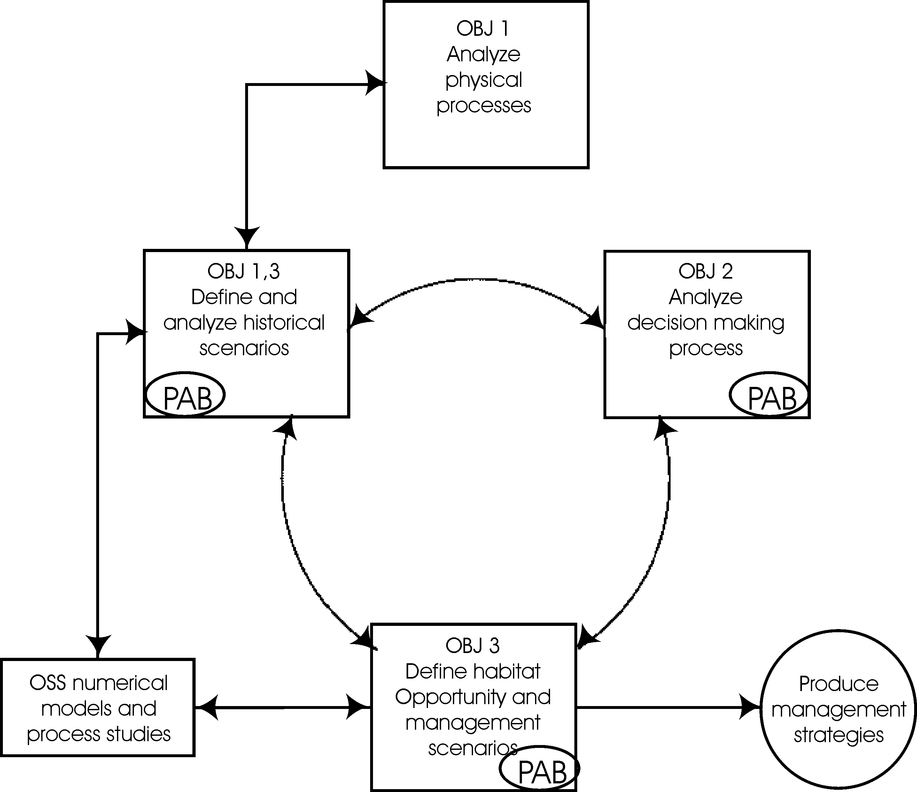

measurements. In 2003, this project will conduct airborne remote sensing of sea-surface salinity (SSS), sea-surface temperature (SST), particulate properties and Chlorophyll Chl. Airbourne remote sensing will be carried out by the SGS project in 2004, but the analyses of the airborne data will occur in this project (Tasks 1b,c). Dr. Jay will also analyze satellite AVHRR and SeaWiFs images for Chl, turbidity and fronts as part of SGS. These images provide valuable regional context through less-frequent but larger-scale maps. The SGS proposal will provide a third remote sensing component in 2004, high-frequency HF radar (SeaSonde) sensing of ocean surface currents in an area of ~1,000 km². This area includes the bulk of the CR plume nearfield, a coastal feature of primary importance to salmonids. Process-oriented analyses of the SeaSonde data will be provided by this project (Tasks 1b).
Oceanographic sampling, a continuation of the work begun through SGS in 1998-2001, will include vessel measurements of salinity, temperature, currents (by an acoustic Doppler current profiler or ADCP) and particle properties (via bottle samples and acoustic and optical backscatter). Vessel data will support remote sensing with calibration data, provide vertical resolution of the highly stratified plume water-column that is not available remotely, and provide detailed resolution of fronts, eddies and other structures sampled by the SGS fishery science program. This sampling, 12 days each in 2003 and 2004, will add to the data that SGS will collect to validate the CORIE model. Vertical profiles of velocity and salinity are particularly important in the plume environment, because numerical-model representation of the vertical mixing between the plume and the underlying sea-water is crucial to proper modeling of the plume. Acoustic and optical profiles will be used to define suspended sediment concentration and size, with bottle samples used for calibration. Cruise sampling will be coordinated with airborne remote sensing to provide improved accuracy for the semi-empirical relationships used to obtain quantitative salinity and turbidity. Chl will be calibrated using measurements collected by the SGS project. The CORIE observation and forecast system will continue to deploy the ADP OGI01 mooring (in 100 m depth south of the estuary entrance) as part of the SGS project. A second SGS ADP mooring will be deployed near the entrance during the 2004 field-season in 30-40 m water depth. These data will be analyzed in Tasks 1b,c.
The SSS, SST, Chl and turbidity distributions in the plume area are critical to juvenile salmonids and highly variable, but have never been assessed in detail. Airborne remote sensing is the only technique that currently provides usable SSS data. It also offers the broad spatial coverage, high resolution and accuracy that are needed for feature identification and monitoring, data assimilation, and numerical forecasting (Breaker et al., 1999). Airborne sensing also furnishes imagery when cloud-cover prevents satellite remote sensing. Images of coastal SSS and SST are produced using L-Band microwave and infrared signals (Miller, 2000, Miller et al., 1998; Goodberlet et al., 1997). Salinity noise levels are <0.2 for 1 km² pixels (Miller, 2000). In addition to SSS and SST, a SeaWiFs compatible seven channel optical spectrometer is used to obtain sea surface turbidity and Chl (Curran and Novo, 1988, O’Reilly et al., 1998). The coupled airborne remote sensing and vessel sampling will occur during the 2003 and 2004 spring freshets (May or June), in coordination with SGS fishery cruises. A total of 10 flights (at 290 km hr⁻¹, duration 4-5 hr) are planned in each year, with the 2004 flights being included in the SGS project. At the beginning and end of each of cruise, a flight will cover the entire plume area from Central Oregon to Southern Washington. Preliminary results from the first flight (available within 24 hr) can be used to guide the first several days of vessel sampling and further overflights. Flights during the cruise will cover the estuary mouth and inner plume, in coordination with vessel sampling. The flight at the end of the cruise provides an opportunity to judge how much the salinity, temperature and turbidity fields have changed during the course of the cruise.
Task 1b: Analyze plume circulation processes. PIs: all, timeframe: 2003-2005

Buoyant plumes are notoriously variable, and the processes that influence them remain poorly understood (Hickey, 1998). Still, determining how the plume responds to forcing by the FCRPS, coastal currents and climate variability is critical to optimization of FCRPS impacts on salmonids. An innovative approach to combining historical and contemporary observations, numerical model results and data analyses is required. The SGS project will provide 10 historical and management scenarios that capture the effects of changes in the system. The data analyses proposed here are essential to formulating: a) the limited number of scenarios available, and b) the definition of habitat opportunity necessary for their evaluation. Analyses of these scenarios will then expand the range of insights that we can achieve, by extending the range of river flow and coastal upwelling conditions analyzed beyond that available in the data set.
Mesoscale Processes
The salinity, volume, position, thickness, temperature and movement of the CR plume are the most basic features of importance to juvenile salmonids, and will form an important part of the definition of habitat opportunity. The plume responds rapidly to forcing by winds, coastal currents and river inflow. The single largest historical change in spring-summer plume properties derives from the >40% decrease in peak spring flows caused by the FCRPS, climate change and irrigation depletion, but changes in coastal circulation patterns have also occurred. Analyses of mesoscale processes will, therefore, focus on the interaction of the plume with river flow, winds and coastal upwelling. This can be assessed by analyses of historical data and the 10 numerical scenarios provided by the SGS program.
Processes influencing plume structure and location will be investigated using four sets of tools: historical data, contemporary data (from moored arrays, HF-radar, airborne remote sensing and coastal weather buoys), vessel surveys, and results from the CORIE model. We envision a sequential strategy over the next three years:
- The comprehensive 3-D data set collected by CR Plume Program (Hickey et al., 1998) in 1990-1991 will be used to characterize how plume depth, stratification and location responds to changes in flow and the wind field; especially the response to a sequence of upwelling and downwelling events.
- Time-series of water properties from contemporary arrays of moored sensors (GLOBEC moorings off Grays Harbor, Newport, and Coos Bay and CORIE moorings near the estuary mouth) will be analyzed in conjunction with AVHRR images furnished by the SGS program. The plume response to upwelling (wind), river outflow and ambient coastal flow conditions will be determined.
- Contemporary time-series data will be integrated with vessel and airborne survey data for the past several years to construct 3-D views of the plume in the spring/summer seasons, especially the response to the spring transition in coastal circulation.
- Results from the numerical model simulations of the 1998-2005 vessel survey periods will be used to understand the structure and location of the plume under the variety of wind and current conditions provided by the surveys in a number of years.
- Analyses of historical scenarios will be used to extend our range of understanding beyond available data, to include very high and very low river-flow conditions over the PDO and ENSO cycles since ca 1970 (see Climate Processes, below).
- Results of these analyses will be used to influence the definitions of habitat opportunity and the management scenarios (see Objective 3).
In future years, we will try to expand our understanding of the system to earlier periods, ca. 1850-1970.
Small-Scale Processes
Mesoscale plume properties are important, but the CR plume and adjacent shelf waters are not undifferentiated water masses; they contain numerous small-scale fronts, eddies and other structures that influence juvenile salmonid survival. Arguably, it is these smaller features that constitute the actual juvenile salmonid habitat of the plume area. As discussed above, the length-scales of plume waters (and likely of upwelling fronts and eddies) are much smaller than those typical of open coastal waters. Preliminary analyses of these vital small-scale processes were carried out using 1990-91 moored instrument data and 1998-2000 vessel transects. The more broadly based analyses described in the following paragraphs are vital to understanding the multiple influences of physics on habitat, defining habitat opportunity and designing biological sampling in the plume.
The relationship of small-scale features of the plume area to external forcing will be discerned from analyses of historical data, vessel and airborne remote sensing data and numerical simulations. The analyses conducted here will also motivate definition of habitat opportunity and of the management scenarios (Objective 3). They will be complemented by analyses of satellite images in the SGS project. The following analyses of small-scale physical processes will be carried out:
- Eddy and front formation: Fronts and eddies form within the plume as a result of the non-linearity of plume propagation. These processes may provide distinct small-scale habitats within the plume area or detach biota from the bulk of plume, e.g., by eddy shedding. The importance of these processes and their interaction with coastal forcing, tides and river flow will be described, using the airborne remote sensing data, augmented by satellite images (analyzed by the SGS project).
- Analyses of surface maps for fronts, length-scales and physical “patchiness”: A 2-D quantitative approach to length analyses is also desirable. Selected surface velocity and salinity maps will be analyzed using 2-D continuous wavelet methods and/or conventional frontal detection algorithms (e.g., Ullman and Cornillon, 2000). Wavelet methods are widely used in the analysis of multi-scale processes and for detection of boundaries (Farge, 1992). Here they will provide 2-D length-scale information that can be used to assess the degree of physical patchiness of the plume area. The maps to be analyzed are as follows: ~1-km spatial maps of SSS (produced 2003-2004 by airborne remote sensing), selected ~1-km surface velocity maps (produced by the HF-radar 2004), and selected salinity and velocity maps produced by numerical modeling of historic and management scenarios.
- Tidal processes in the plume area: Tides are one of the major sources of plume variability. The HF-radar surface velocity maps will resolve for the first time complex tidal variability of the plume. Wavelet tidal analysis methods (Flinchem and Jay, 2000; Jay and Hickey, in prep) can then be used to analyze time series of HF-radar data at individual locations. Contrasting tidal processes in upwelling areas, inside the plume, and in other shelf areas should be very productive.
- Estuary-mouth processes: The NSF-funded Land-Margin Ecosystem Research (LMER) program (1990-1999) collected extensive physical data in the lower estuary. These data are relevant both to SGS numerical modeling of the complex plume lift-off area (Cudaback and Jay, 1996, 2000, 2001) and to understanding estuarine sediment export (Fain et al., 2000). Selected velocity, density and acoustic backscatter sections will be used to provide process understanding and, in some cases, definition of numerical model boundary conditions.
The above analyses of small-scale processes will be very helpful in defining the concept of habitat opportunity in terms of fronts and other plume properties. These analyses will also allow sharpening of intellectual focus on the more important processes, motivating further observations and analyses in the 2006-2008 period. Because the length-scale calculations will be carried out for a range of the historical scenarios, our understanding of changes in small-scale processes can be extended to include the effects of climate fluctuations.
Climate Processes
Substantial changes have likely occurred both in the coastal current systems and the plume as a result of the warming of the NE Pacific over the last 150 years (Fig. 4). Along with this warming has come a ~15% decrease in annual average flow, about half due to climate change and half due to irrigation depletion (Fig 5). Impacts of these changes on plume juvenile salmonid habitat are unknown. The SGS program cannot directly simulate pre-1900 conditions, because of a lack of the requisite forcing data (e.g., winds, large-scale currents). However, historical scenarios based on the cold-PDO conditions that prevailed from ca. 1945 to 1976 will serve as a surrogate for earlier periods. The PIs involved in this project will choose appropriate historical scenarios, so that PDO and ENSO effects can be evaluated in numerical model simulations carried out by SGS. The analyses of historical scenarios described in the preceding paragraphs will then provide an understanding of how climate affects the measures of habitat opportunity that evolve during the program. Just as the climate impacts in question are long-term, extending our understanding of plume processes back to earlier climate epochs will be a 6 to 10 year project, building on the results of other regional programs, particularly GLOBEC.
The SGS project will provide four historical scenarios in the 2003-2005 period. To use these optimally, the concept of paired years will be employed. A historical scenario year will be paired with a year in the 1998-2005 period (for which simulations are also available from SGS). For example, pairing a cold-PDO El Niño year like 1998 with a warm PDO El Niño year (perhaps 1992 or 1983) will elucidate differences associated with PDO in the El Niño years that typically bring the driest and warmest conditions to the Pacific NW. The cold-PDO La Niña year 1999 could be paired with a year like 1989 during the warm PDO period to demonstrate conditions during these typically high-flow years. Effects of FCRPS flow regulation can be clarified for high flow years (e.g., 1972 or 1974 vs. 1999) and low-flow years (e.g., 1973 vs. 2001). As more climate information becomes available, addition comparisons will be defined.
Task 1c: Analyze plume particulate properties. PIs: Jay, Miller, timeframe: 2003-2005
A key issue in defining habitat opportunity is specification of the turbidity field that inhibits primary production in the plume and affects juvenile salmonid behavior. The satellite data (analyzed by SGS) and the airborne SeaWiFs data (analyzed here) will provide numerous realizations of turbidity near the estuary mouth (the plume "nearfield"). Because particles settle rapidly from the sea surface as the plume moves away from the estuary mouth, particulates of fluvial origin are less important to the total particle load in more distant parts of the plume. Away from the estuary mouth then, biological particles will usually dominate the particle field, as modeled by the SGS project.

The near-surface plume-area particulate field will be analyzed from optical observations obtained from the airborne SeaWiFs sensor. The SeaWiFs sensor is nadir-viewing, producing swaths rather than a continuous image. The 1-D length-scale calculation methods previously employed for analyzing vessel transects can be employed along these swaths. There will be several foci:
- Turbidity length-scales: The dependence of bulk turbidity in the plume nearfield on river inflow and coastal processes will be investigated. Turbidity is highest in the nearfield, and most of the particles are inorganic, especially during high-flow periods. We expect (Geyer et al., 2000) to measure in SeaWiFs images an exponential decrease in concentration away from the entrance. How rapidly this decrease occurs may be affected by aggregation and other biologically-mediated processes, but during periods of high sediment supply, particle settling is dominant. The e-folding length of the exponential turbidity decrease, an important parameter needed for the biological modeling to be conducted by the SGS project, can be assessed from aircraft-generated maps.
- Chl variability: Airborne SeaWifs images will be used to understand the influence of plume on the standing stock of Chl, and the interactions of the plume and coastal upwelling with regard to primary production.
- Turbidity, Chl and small-scale features: Turbidity is also influenced by biological processes, and concentration of food organisms in fronts and eddies is believed to be important to juvenile salmonid nutrition. We will analyze turbidity and Chl in small-scale features observed in the airborne SeaWiFs data, with particular attention being given to features sampled by the SGS fisheries vessel. Changes in the ratio of Chl to turbidity may also provide indications of high-productivity areas.
Objective 2: Analyses of the FCRPS Management Context
New scientific understanding is not by itself sufficient to improve management of the FCRPS in the interests of juvenile salmon. Climate and coastal circulation forecasts will remain uncertain, even after there is a firm physical basis for understanding the impacts of the lower-estuary and plume on juvenile salmonids. Also, information gained in scientific studies must be formulated in a context that considers actual management realities. It is vital to understand how FCRPS managers use climate forecasts and other information, so that the management scenarios defined in Objective 3 will be useful. The goal of this part of the study is to ensure congruence between what information is needed, what is requested, what is provided in return, and what actions can actually be taken. Information exchanges must be based on an understanding of the decision context within which trade-offs between diverse system goals take place. Scientists must better comprehend how, for example, the FCRPS annual operating plan is balanced against flow criteria set to benefit endangered species, when the two conflict. Analyses will, therefore, be undertaken to understand the networks within which the FCRPS evaluates information (e.g., climate data and runoff forecasts, and indices of upwelling, recruitment, and adult returns) and makes decisions about the future operations. This objective consists of a single task.

Task 2a: Analyze the use of climate information by FCRPS managers. PI: Pulwarty, timeframe: 2003-2005
The effort led here by Dr. Pulwarty will, together with Task 3c, attempt to engage FCRPS managers and Action Agency personnel as full partners in defining issues of mutual significance and explicitly addressing uncertainties and known barriers to information use, uncovering those contingent on each situation. The goal is to ensure that feedback is maintained with the intended partners (i.e., Action Agency personnel involved in implementing Hydropower and Habitat RPAs) from initial stages of this project through the scenario development.
The following subtasks will be undertaken as a basis for the cooperative use (by scientists and managers) of research-based information, including definition and evaluation of scenarios:
- Describe the hydro-climatic annual cycle of FCRPS management, including planning, information gathering, forecasting, decision making, implementation, and evaluation. Identify entry points for relevant climatic and other forecast information and competing pressures at each stage.
- Document and compare the annual management cycle for individual historical events of significance (e.g. very wet years like 1972, 1997 and 1999 vs. very dry years such as 1977 and 2001) and evaluate the contexts within which decision-making occurred, including lessons learned and incorporated within the FCRPS between events. In some cases, these events will also be the years for which numerical model historical scenarios are generated (by SGS) and analyzed in terms of their physical processes (Task 1b,c). Thus, the both management and coastal science aspects of these years will be analyzed in some detail. These reconstructed events form, therefore, an excellent basis for learning how to formulate future management scenarios. Emphasis will be placed on analyses of the role of these antecedent decisions in constraining or enabling alternatives for salmon recovery.
- Evaluate decision and management scenarios within the context of longer-term climate variations causing decadal-scale wetter and drier periods. For example, how has new information on the PDO cycle been employed? What can be learned from this process about the potential usefulness of the management scenarios to be defined in Objective 3? This analysis is especially appropriate in that adjustment of FCRPS management to the requirements of the Biological Opinion is somewhat analogous to entry into a new climate period, e.g., the onset of relatively dry years following 1977 in contrast to the wet period from 1946 to 1976.
Throughout this effort we will treat the development, communication, and use of scientific information as a process where symmetric learning takes place between providers of scientific information and practitioners over time. Where appropriate, Bayesian decision models and risk analyses will be developed as decision support tools. However, these will be framed within the context of how decisions are actually made within FRCPS and the characteristics of the process, not as highly idealized situations.

To be useful, the physical insights to be developed in Objective 3 must be packaged in such a manner that FCRPS managers can apply them. This Objective builds on the results of Tasks 1b,c to define a structure for management scenarios that will enable them to address real needs. At this point, we envision a management scenario to be one or more CORIE numerical model simulations that represents historical circumstances or the results of a particular FCRPS management strategy, coupled with appropriate climate and coastal forcing. Multiple simulations will be necessary in many cases to represent a range of weather and coastal circulation situations that may occur along with the FCRPS forcing.

Objective 3: Define/Evaluate Habitat Opportunity and Scenarios
Future management scenarios are vital because they will illustrate how modified FCRPS management can influence survival of juvenile salmonids, and form a basis for potential future management strategies. Plume habitat opportunity for juvenile salmonids is the currency through which these management scenarios will be evaluated. Habitat opportunity must, therefore, be defined so that it reflects the changes in juvenile salmonid survival in the lower estuary and plume that would occur through altered FCRPS operation. The definitions of habitat opportunity and of the management scenarios will be based in part on an understanding of plume physical processes provided by Objective 1. The specific roles of this project with regard to habitat opportunity and management scenarios are: a) to ensure that management scenarios and the definition of habitat opportunity have a sound physical basis (Objective 3), b) to evaluate the physical consequences of scenarios modeled by SGS (Objective 1), and c) to understand how to make management scenarios useful to FCRPS managers (Objective 2). Utility has several aspects, but two are primary. The first is to provide relevant scenarios in an understandable manner, conducive to their future use by managers. The second is to use physical process science to provide habitat opportunity definitions that are amenable to evaluation through numerical modeling and remote sensing. In other words, a scientifically correct definition of habitat opportunity might still not be a useful definition, To be useful, each component of habitat opportunity definition must amenable to routine evaluation and/or prediction at reasonable cost. This strongly points toward definitions that can be evaluated through some combination of monitoring, remote sensing and numerical modeling.
Task 3a: Define habitat opportunity and management scenarios. PIs: all, timeframe: 2003-2005
Optimization of FCRPS effects on juvenile salmonids requires encapsulating our evolving understanding of plume physical processes (Objective 1) in a definition of habitat opportunity, and thence in management scenarios. These numerical scenarios explore FCRPS impacts and suggest future management strategies. They both elaborate what we have learned in Objectives 1 and 2, and provide additional opportunities to derive process understanding. FCRPS management strategies to be considered may be suggested by the PAB, by FCRPS managers, or by project participants, e.g., in response to the "opportunities" defined in Section 9B.8. The definition of management scenarios will be carried out jointly with the PAB and the SGS project. Construction of a simulation library will be supported by SGS, but evaluation of scenarios to develop physical process understanding and improved connections to the FCRPS decision process will be carried out in this project (Objective 1). Definition of historical scenarios to be evaluated during the 2003-2005 period will be carried out as part of the climate analyses (Task 1b).
Selection of management scenarios requires, however, at least a preliminary consensus as to what constitutes plume habitat opportunity. This definition must be available by the time that the SGS workshop is convened in fall 2004. Habitat opportunity measures related to plume volume, salinity, fronts, turbidity, and Chl content will all be considered. These habitat opportunity measures will be chosen based on analyses of data and the historical scenarios carried out as part of Objective 1 and by the SGS project. Use of these habitat opportunity measures to evaluate management scenarios will undoubtedly raise questions that require further analyses of data and historical scenarios. Thus, the concept of habitat opportunity will initially evolve during the early years of the project in response to research findings. It will continue to evolve in the direction of lower cost and improved utility as numerical models and remote sensing methods become better established.
Previous experience with Pacific Northwest coastal environments indicates that interannual variability is of enormous importance. Definition of useful management scenarios will, therefore, be a multi-year, iterative process. Encompassing the full range of present and relevant historical climate scenarios for purposes of understanding changes to the system over the last century and optimizing future management is a severe challenge. Still, some scenarios can be defined relatively quickly and evaluated during 2003-2005 period. Scenarios based on historical flows will make use of the high flow variability that has occurred over the last several decades, for which suitable numerical model forcing conditions are available. Water-years 1972, 1974, 1996 and 1997 are amongst the wettest since 1900, while 1977 and 2001 are amongst the driest. There was a warm-PDO phase from ca. 1977 to 1995, while cold-PDO conditions prevailed before 1977 and since 1996. Strong El Niños occurred in 1982-83, 1992-93 and 1997-98, while 1996-1997 and 1999 exhibit the consequences of La Niña. Initial management scenarios related to the consequences of variable river flow, interactions of the plume with the neap-spring cycle and coastal upwelling will likely be evaluated in the 2003-2005 period. These scenarios will be based on historical observations, data to be collected in 2003-2004, and analyses of historical scenarios.
Analysis of selected years from recent decades, within the collective “institutional memory” of FCRPS managers will also help the project grow more useful to these managers over time. Thus, Pulwarty and Redmond (1997) found that FCRPS managers needed predictive tools that accorded with the annual cycle of decisions that managers must make. One concept that managers found useful in planning operations was an “analog year” to that for which they were planning – a recent year with similar large-scale climate patterns and snowpack history. This project will, over time and working with SGS, develop a library of simulations that can be deployed to provide analogs to many climate situations that managers encounter.
Task 3b: Evaluate management scenarios. PIs: all, timeframe: 2004-2005

Management scenarios will be evaluated by this project primarily in terms of how habitat opportunity relates to physical forcing, guiding both future observations and further simulations. SGS will evaluate, from a fisheries-management point of view, juvenile salmonid responses to the scenarios in terms of changes in habitat opportunity. In the future, FCRPS managers can use these scenarios to understand the consequences of management decision on juvenile salmonid survival, via the response of habitat opportunity portrayed in the scenarios. This project provides the necessary physical process understanding and will, in coordination with SGS, actually define scenarios. Modification of scenarios and the definition of habitat opportunity are themselves, however, important parts of scenario evaluation. Thus, PIs in this project will participate in evaluation of habitat opportunity through their interpretations of the scenario results, leading to refinement of the scenarios and the meaning of habitat opportunity.
An example of how a particular management scenario might be evaluated (and the consequences for other tasks) is appropriate. Consider the issue of interaction of plume neap-spring variability with juvenile salmonids, alluded to in Section 9B.8 as an opportunity for increased survival. Once the preferred river flow condition and time of migration (with respect to the neap-spring cycle), is established by the SGS project, a management scenario can be developed to optimize habitat opportunity in the days and weeks immediately following the preferred migration time. Analyses of the simulation results using the current definition of habitat opportunity would be carried out (Tasks 1b,c). These results would likely motivate modification of the management scenario to improve the predicted habitat opportunity. The shape of the hydrograph for the crucial period before during and after the preferred migration time might need to be modified. It may even prove necessary to change the definition of habitat opportunity, to make it more relevant or easier to evaluate. Interaction with the PAB would likely suggest means by which the scenario could be modified to improve its practicality. Finally, analyses of early scenarios will almost certainly point toward specific field observations to determine unknown factors that emerge as critical. In this way, the project can more forward to new scenarios and further analyses.
Task 3c: Liaison with the Project Advisory Board and the SGS. PIs: Jay, Baptista, and Pulwarty, timeframe: 2003-2005
The Project Advisory Board (PAB) will be formed to guide the project, and ensure the consistency of the scientific work of this project with FCRPS management goals and decision processes. The (PAB) will provide advice on formulating useful numerical scenarios, assist in evaluation of the scenarios developed, and help in coordinating the proposed work with managers and other Pacific Northwest scientists. The PAB will consist of five to seven individuals chosen for their roles as Action Agency personnel, FCRPS managers, or independent scientists. They will meet once to twice a year, to advise the PIs and evaluate progress. At least some members of the PAB will also be invited to participate in the SGS scenario workshop in fall 2004. The PAB will assist project scientists to understand the needs and views of the Action Agencies, and ensure consistency with the Lower Columbia River Estuary Program (LCREP).

One of the important goals of the PAB will be to bridge the differences in focus and time-scales between operational decision making (which has definite ends that must be achieved on a fixed annual schedule) and research (open-ended and usually multi-year). Much of the communication between the science team and the PAB will be focused verbal learning, e.g., presentations of research results by scientists, and descriptions of ongoing decision making by managers. The PAB together with selected members of the research team (Drs. Jay and Pulwarty) will also write brief white papers. These may summarize the importance of specific scientific results, review the utility of past project output (historical and management scenarios), or outline possible joint projects between the research team and FRCPS managers as new information arises within the project. These presentations and “white papers”, and the discussion they engender will help both sides understand the difficulties and constraints involved in applying current science to urgent management problems.

The success of this program is also dependent on its close collaboration with the SGS and Estuary projects; these interactions will be led by Dr. Baptista. Analyses of field data and scenarios will be further coordinated between the projects through participation of PIs in both programs, common use of the CORIE system, integrated sampling, and coordinated planning. This project will provide important interactions with FCRPS managers, and physical process understanding that would not be developed otherwise. The evolution over time of this collaboration will strengthen all programs.

Task 3d: Define strategy for future years. PIs: all, timeframe: 2005
This project, like SGS and Estuary, is expected to continue beyond 2005, because of the large degree of interannual variability of climate conditions and salmonid returns, and the complexity of the biophysical interactions that govern juvenile salmonid survival in the plume. Further data collection is anticipated during FY 2006-2008, in order to better encompass the broad range of situations within which the FCRPS must function, and to understand the interaction of the FCRPS with climate change, coastal processes, and plume productivity. A group meeting with the Project Advisory Board and selected PIs from SGS and Estuary early in Year 3 will be used to define work to be carried out in Years 4 to 6.
A key issue that will have to be considered in planning for the future of the project is how to improve the utility of our work to FCRPS managers. Obviously, the focus in the 2003-2005 period will be on research. A transition over time toward practical strategies and monitoring will be needed – the definition of habitat opportunity and the management scenarios provided must become credible tools for managers. One way to establish the utility of management scenarios is to provide some measure of the reliability of the habitat opportunity forecasts associated with a given FCRPS management scenario. By analogy to weather forecasting, a variety of coastal current and wind forcing boundary conditions consistent with the overall climate situation for a given year could be simulated. If all suggest a similar habitat opportunity level, then the management scenario might prove to be a useful tool for a given year. If highly diverse habitat opportunity outcomes are associated with small changes in forcing, then the scenario must be regarded as having dubious utility. Present CORIE computational resources and SGS funding levels do not allow this idea to be implemented in the 2003-2005 period, but it will likely be implemented in future years. For this vision to become reality, however, the process understanding driven by this project will be developed well beyond its present level.

Information Transfer and Storage
There will be three principal means used to disseminate results: peer-reviewed publications, communications with and through the Project Advisory Board or PAB, and the world-wide-web. It is premature to define the number or scope of peer-reviewed publications, as this will evolve during the course of the project and other related projects. However, Objective 1 will advance the state of knowledge with regard to plume physical oceanography, the interaction of the plume with coastal and climate processes, and plume particle dynamics. Objective 2 will lead to publications related to management and climate information. The results of Objective 3 should be of interest to several audiences (public, management-oriented and scientific) in the Pacific NW and nationally. The form of publications resulting from Objective 3 will be decided jointly with the PAB and the scientists of the SGS project. Communication of results to the PAB will occur through the web-site www.ese.ogi.edu/~jaylab (maintained at OH&SU by Dr. Jay), at PAB meetings, and through other forums that the PAB may suggest over time. Selected results will also be publicly available from the web-site www.ese.ogi.edu/~jaylab, which has both public and password-protected areas. The latter will be used for data distribution and for communications directed at project scientists, the PAB and other involved parties. HF-radar current data for COAST are now disseminated via the web (www-currents.oce.orst.edu/seasonde/index.html). The HF-radar data acquired by SGS and analyzed by this project will be similarly distributed. Moreover, the CORIE web site maintained at OH&SU by Dr. Baptista (www.ccalmr.ogi.edu/CORIE), in part supported by SGS, will archive data collected by CORIE and the numerical historical and management scenarios analyzed in the course of this project. CORIE supports password-protected access to data and numerical modeling products. Other individual investigators will be responsible for storage of data generated by their activity in the project. The ability of the investigators to appropriately archive data is demonstrated by the fact that PIs Hickey, Kosro, Foreman, and Jay all now maintain extensive archives of digital data files (with appropriate meta-data) back to the 1970s, some of which will be used in the proposed work. Observational data developed by this project will be made available after an appropriate interval, and by request.

Summary
This project assembles a group of leading coastal scientists to provide the physical and management science basis for optimization of the interaction of the Federal Columbia River Power System (FCRPS) with the lower Columbia River estuary and plume, in support of endangered salmonids. Over a six-10 year period, we will, in collaboration with the SGS project, analyze historical and management scenarios that elucidate climate and ocean conditions leading to high survival of juvenile salmonids. The insights derived from analysis of the historical scenarios will guide definition of juvenile habitat opportunity in terms of coastal ocean physical characteristics (e.g., plume size, volume and position, and upwelling characteristics and timing) and biological properties (e.g., Chl and turbidity levels). This project will also provide part of the physics background for the estuarine habitat project Estuary (D. Bottom, PI). That project will assist our work through providing an improved understanding of climate effects on Columbia River hydrology.
Optimizing the impacts of the FCRPS on juvenile salmonids requires achieving the following three objectives:
- Objective 1: Define how the lower-estuary and plume interacted historically with coastal currents, how operation of the FCRPS has altered the lower-estuary and plume, and how climate change and the FCRPS will impact the system in coming decades. This objective defines and analyzes historical scenarios, laying the basis for definition of management scenarios in Objective 3. It also evaluates results of management scenarios from a management point of view.
- Objective 2: With Action Agencies, define needs and opportunities for science-based input to operational FCRPS management practices, given uncertain climate and coastal circulation forecasts. This objective provides the management science basis for generation of scenarios that could actually be used by FCRPS managers.
- Objective 3: With FCRPS managers, define management scenarios: a) that are based on physical understanding, b) that can be evaluated in terms of habitat opportunity and other constraints on the system, and c) whose implementation can lead to a qualitative improvement in survival of juvenile salmonids This objective defines habitat opportunity, and defines and evaluates management scenarios. Numerical realizations of the management scenarios are provided by the SGS project.
A combination of innovative oceanographic methods, remote sensing, management science, and analyses of numerical model results will be used to achieve the goals of the project, as it moves from research to provision of realistic strategies over the next 6 to 10 years. A Project Advisory Board or PAB that includes resource agency personnel, FCRPS managers and external scientists will be formed to help ensure productive application of the insights achieved.

g. Facilities and equipment

The proposed work uses state-of-the art instruments to measure important physical and ecosystem properties in the plume area. All necessary computers for data analyses are also in place.
Vessel sampling will be carried out using a chartered small vessel. The Elakha from Oregon State University is suited to plume oceanography and is the vessel of choice. Another vessel, the Snowgoose (Bellingham, WA), has been used in the past for similar cruises, and is the backup choice. The following field instrumentation belonging to Dr. D. Jay at OH&SU is available to support vessel sampling. In each case, computers to support data collection and analysis are included:
- A 300 kHz RDI Workhorse ADCP. This instrument profiles current velocities in 0.5 meter range bins from 1 to 60 meters below the transducers. In this program, it will be mounted on a research vessel for mapping currents and measuring particle properties from acoustic backscatter.
- LISST-25 (Laser In-Situ Scattering Transmissometer): The LISST-25 will be used in a flow-through configuration on a vessel to estimate suspended sediment size and concentration (3-500 microns).
- LISST-FLOC (Laser In-Situ Scattering Transmissometer): The LISST-FLOC will be used to conduct detailed profile surveys of the size-concentration distribution of particles between 10 and 1500 microns. The LISST-FLOC is a unique instrument; Dr. Jay’s is the only one in the United States.
- OS-200 Conductivity-Temperature-Depth profilers (CTDs): Two OS-200 CTDs with rapid response sensors will be used. One will be towed behind the vessel to sample depths to ~50 m. The other will be used in a flow-through configuration to obtain a continuous surface salinity trace.
- Satlantic seven-channel SeaWiFs calibrator. This spectrophotometer (to be purchased) will be used to calibrate the airborne SeaWiFs simulator by providing precise subsurface measurement of downwelling and upwelling irradiance at seven different wavelengths.

Dr. Jerry L. Miller will use a second-generation system for airborne remote sensing of sea-surface salinity (SSS) and temperature (SST). Images will be produced using L-Band microwave and infrared signals. Sea surface temperature is obtained as a by-product. A SeaWiFs compatible seven channel optical spectrometer will used to obtain sea surface turbidity and chlorophyll. Stennis Space Center owns all necessary equipment and computers. A suitably equipped aircraft will be chartered and flown to the project site.

h. References
 | Submitted w/form (y/n)
Baptista A.M. (in press). Modern paradigms for modeling and visualization of environmental systems, Enc. of Physical Science and Technology (R.Meyers, Ed.), Academic Press, invited.  Baptista, A. M., D. A. Jay and others, 1998, Towards a multi-purpose forecast system for the Columbia River Estuary, Proceedings of the Marine Technical Society 1998 Conference, Baltimore, Maryland, 16-19 November 1998.  Baptista, A. M., P. B. Pearson, et al. 2000. Operational Forecasts of Estuarine Circulation: Lessons Learned in the Columbia River Estuary. XIII International Conference on Computational Methods in Water Resources (Abstract), Calgary, Alberta, Canada.  Baptista, A.M., M. Wilkin, P. Pearson, P. Turner, C. McCandlish, and P. Barrett, 1999. Coastal And Estuarine Forecast Systems: A Multi-Purpose Infrastructure for the Columbia River, Earth System Monitor, 9(3), pp.1-2,4-5,16, National Oceanic and Atmospheric Administration, Washington, D.C.  Bilbao, Pablo. 1999, Interannual and interdecadal variability in the timing and strength of the spring transition along the United States west coast. Master's Dissertation, College of Oceanic & Atmospheric Sciences, Oregon State University.  Bakun, A. 1996. Patterns in the Ocean; Ocean Processes and Marine Population Dynamics. California Sea Grant College System. 323 pp.  Barnes, C. A, C. Duxbury, and B.-A. Morse. 1972. Circulation and selected properties of the Columbia River plume at sea. In: A.T. Pruter and D.L. Alverson (eds.) The Columbia River Estuary and Adjacent Ocean Waters, University of Washington Press, Seattle. pp. 41-80.  Beamish, R.J., C-E.M. Neville, and B.L. Thompson. 1994. A relationship between Fraser River discharge and interannual production of Pacific salmon (Oncohynchus spp.) and Pacific herring (Clupea pallasi) in the Strait of Georgia. Can. J. Fish. Aquat. Sci. 51: 2843-2855.  Bradford, M.J. 1995. Comparative review of Pacific salmon survival rates. Can. J. Fish. Aquat. Sci. 52: 1327-1338.  Bottom D.L., C.A. Simenstad, A.M Baptista, D.A. Jay, J. Burke, K.K. Jones, E. Casillas, M.H. Schiewe, 2001, Salmon at river’s end: the role of the estuary in the decline and recovery of Columbia River salmon, National Marine Fisheries Service, Seattle, WA., 271 pp.  Breaker, L.C., J.G.W. Kelley, L.D. Burroughs, J. L. Miller, B. Balasubramaniyan, and J.B. Zaitzeff, 1999. The impact of a high discharge event on the structure and evolution of the Chesapeake Bay plume based on model results. J. Marine Env. Engg., 5: 311-349.  Brodeur, R.D. and W.G. Pearcy, 1990. Trophic relations of juvenile Pacific salmon of the Oregon and Washington coast. Fish. Bull. 88: 617-636.  Brodeur, R.D., 1997, The importance of various spatial and temporal scales in the interaction of juvenile salmon and the marine environment. In: R.L. Emmett and M.H. Schiewe (eds.) Estuarine and Ocean Survival of Northeastern Pacific Salmon. NOAA Tech. Memo. NMFS-NWFSC-29, pp. 197-211.  Cudaback, C. N. and D. A. Jay, 1996. Buoyant plume formation at the mouth of the Columbia River -- an example of internal hydraulic control?, Buoyancy Effects on Coastal and Estuarine Dynamics, AGU Coastal and Estuarine Studies 53: 139-154.  Cudaback, Cynthia N. and D. A. Jay, 2001, Tidal asymmetry in an estuarine pycnocline, 2, Transport J. Geophys. Res. 106: 2639-2652.  Cudaback, C. N., and D. A. Jay, 2000, Tidal asymmetry in an estuarine pycnocline: Depth and thickness, J. Geophys. Res. 105: 26,237-26,252.  Conomos, T. J., and M. G. GrSGS, C. A. Barnes, F. A. Richards, 1972a, River-ocean nutrient relations in summer, in Pruter, A. T. and D. L. Alverson, eds., The Columbia River Estuary and Adjacent Ocean Waters, UW Press, Seattle, pp. 148-175.  Conomos, T. J., and M. G. GrSGS, 1972b, River-ocean suspended particulate matter relations in summer, in Pruter, A. T. and D. L. Alverson, eds., The Columbia River Estuary and Adjacent Ocean Waters, UW Press, Seattle, pp. 176-202.  Curran, P.J. and E.M.M. Novo. (1988) The relationship between suspended sediment concentration and remotely sensed spectral radiance: A review. Journal of Coastal Research v. 4, pp. 351-368.  Earle, C.J., 1993, Asynchronous droughts in California streamflow as reconstructed from tree rings, Journal of Quaternary Research, 39, 290-299.  Engstrom, W.N., 1997, The California storm of January 1862, Journal of Quaternary Research, 46, 141-148.  Fain, A.M.V., D. A. Jay, D. J. Wilson, P. M. Orton, and A. M. Baptista, 2001, Seasonal, monthly and tidal patterns of particulate matter dynamics in the Columbia River estuary, Estuaries 24: 770-786.  Flinchem, E. P. and D. A. Jay, 2000, An introduction to wavelet transform tidal analysis methods, Coast. Estuar. Shelf Sci. 51: 177-200.  Farge, M., 1992. Wavelet transforms and their application to turbulence. Ann. Rev. Fluid Mech. 24: 395-457.  Francis, R.C. and S.R. Hare. 1994. Decadal-scale regime shifts in the large marine ecosystems of the North-east Pacific: a case for historical science. Fish. Oceanogr. 3: 279-291.  Fukuwaka, M. and T. Suzuki. 1998. Role of a riverine plume as a nursery area for chum salmon Oncorhynchus keta. Mar. Ecol. Prog. Ser. 173: 289-297.  Geyer, W. R., P. Hill, T. Milligan and P. Traykovski , 2000, The structure of the Eel River plume during floods, Contin. Shelf Res. 20:, 2067-2093.  Garcia Berdeal, I., B.M. Hickey and M. Kawase (2001) Influence of Wind Stress and Ambient Flow on a High Discharge River Plume. J. Geophys. Res., In Press.  Goodberlet M. A., C. Swift, K. Kiley, J. L. Miller and J. B. Zaitzeff, 1997. Microwave Remote Sensing of Coastal Zone Salinity. J. Coastal Res., 13(2): 363-372.  Hamlet, A. F., and D. P. Lettenmaier, 1999, Effects of climate change on hydrology and water resources in the Columbia River basin, J. Amer. Water Res. Assoc. 35: 1597-1623.  Hickey, B. M., 1998, Transport due to freshwater discharge in the coastal ocean. Invited overview presentation, published in the NSF-sponsored Buoyancy Driven Transport Workshop, Salt Lake City, October, 1998.  Hickey, B.M. (1989) Patterns and processes of shelf and slope circulation. In: Landry, M.R. and B.M. Hickey (eds.), Coastal Oceanography of Washington and Oregon, pp 41-115, Elsevier Science, Amsterdam, The Netherlands.  Hickey, B.M. (1998) Coastal Oceangraphy of Western North America from the tip of Baja California to Vacouver Is. pp 345-393 in Volume 11, Chapter 12, The Sea, eds. K.H. Brink and A.R. Robinson, Wiley and Sons, Inc.  Hickey, B.M., L. Pietrafesa, D. Jay and W.C. Boicourt (1998) The Columbia River Plume Study: subtidal variability of the velocity and salinity fields. J. Geophys. Res., 103(C5): 10,339-10,368.  Jay, D. A., 1984, Circulatory processes in the Columbia River Estuary, CREST, Astoria, Oregon, 169 pp. plus appendices.  Jay, D. A. and Flinchem, E. P., 1999, A comparison of methods for analysis of tidal records containing multi-scale non-tidal background energy, Contin. Shelf Res. 19: 1695-1732.  Jay, D. A. and Flinchem, E. P., 1997, Interaction of fluctuating river flow with a barotropic tide: A test of wavelet tidal analysis methods, J. Geophys. Res. 102: 5705-5720.  Jay, D. A. and and B. M. Hickey, in prep, Non-stationary internal tides in the Columbia River plume, for J. Geophys. Res.  Jay, D. A., and P. K. Naik, Separating human and climate impacts on Columbia River hydrology, submitted to Geophys. Res. Letters.  Jay, D. A., P. M. Orton, D. J. Wilson, A. M. V. Fain, and J. McGinity, 2001, Particle trapping in stratified estuaries -- explorations of a parameter space, submitted to Contin. Shelf Res.  Johnson, K. S., F. P. Chavez, and G. E. Friederich, 1999, Continental-shelf sediment as a primary source of iron for coastal phytoplankton, Nature 398: 697-699.  Kareiva, P., M. Marvier, and M. McClure. 2000. Recovery and management options for spring/summer Chinook salmon in the Columbia River basin. Science. 290:977-979.  Landry, M.R., J.R. Postel, W.K. Peterson and J. Newman, 1989. Broad-scale patterns in the distribution of hydrographic variables. In Coastal Oceanography of Washington and Oregon , M.R. Landry and B.M. Hickey, eds. Elsevier Press, Amsterdam, The Netherlands, pp. 1-41.  Longhurst, A. (1998) Ecological Geography of the Sea, Academic Press, New York, 398 pp.  Lough, R.G., Manning, J.P. (2001) Tidal-front entrainment and retention of fish larvae on the southern flank of Georges Bank, Deep-Sea Research II, 48, 631-644.  Mantua, N.J., Hare, S.R., Zhang, Y., Wallace, J.M. and Francis, R.C. 1997. A Pacific interdecadal climate oscillation with impacts on salmon production. Bull. Am. Meteor. Soc. 78:1069-1079.  Matthews, G. M., S. Achord, J. R. Harmon, O. W. Johnson, D. M. Marsh, B. P. Sandford, N. N. Paasch, K. W. McIntyre, and K. L. Thomas. 1992. Evaluation of transportation of juvenile salmonids and related research on the Columbia and Snake Rivers, 1990. Report to the U.S. Army Corps of Engineers, Contract DACW68-84-H0034, 51 p. (Available from Northwest Fisheries Science Center, 2725 Montlake Blvd., E., Seattle, WA 98112-2097).  Myers, E.P. and A.M. Baptista, 2001. Inversion for tides in the Eastern North Pacific Ocean, Advances in Water Resources, Vol. 24(5), pp. 505-519.  Myers, E. P. I. and A. M. Baptista (2000). Baroclinic Modeling of River-Dominated Tidal Inlets and Plumes. XIII International Conference on Computational Methods in Water Resources (Abstract), Calgary, Alberta, Canada  Myers, E., Y. Zhang, et al. (In prep). “A finite volume model of coastal circulation, with application to plumes and river-dominated estuaries.” Continental Shelf Research.  Miller, J.L., 2000. Airborne remote sensing of salinity. Backscatter, 3(3): 24-27.  Miller, J. L., M. A. Goodberlet, and J. B. Zaitzeff, 1998. Airborne salinity mapper makes debut in coastal zone. (Refereed feature article), EOS, Trans. Amer. Geophys. Union, 79(14): 173-177.  Naik, P.K., and D.A. Jay, “Virgin flow estimation of the Columbia River (1879-1928)”, submitted to J. Water Res. Plann. Manag., ASCE.  O'Reilly, J. E., Maritorena, S., Mitchell, B. G., Siegel, D. A., Carder, K. L., Garver, S. A., Kahru, M., & McClain, C. (1998). Ocean color chlorophyll algorithms for SeaWiFS. J. Geophys. Res., 103, 24937-24953.  Pearcy, W.G. 1992. Ocean Ecology of North Pacific Salmon. Washington Sea Grant Program, University of Washington Press, Seattle, WA. 179 pp.  Peterman, R.M., B.J. Pyper, M.F. Lapointe, M.D. Adkison, and C.J. Walters. 1998. Patterns of covariation in survival rates of British Columbian and Alaskan sockeye salmon stocks. Can. J. Fish. Aquat. Sci. 55: 2503-2517.  Peterson, W.T. and D.L. Mackas. 2001. Shifts in zooplankton abundance and species composition off central Oregon and southwestern British Columbia. PICES Press 9(2): 28-31.  Pulwarty, R., 1999: Hurricane impacts in the context of climate variability, climate change and coastal management policy on the eastern U.S. seaboard. In, Downing T., Olsthoorn, A. and, R. Tol, (Eds): Climate, Change and Risk. Routledge, London  Pulwarty, R.,2002: Climate, adaptive management and social choices: Lessons from the Colorado and Columbia River Basins. American Fisheries Society Proceedings (forthcoming)  Pulwarty, R., and S.J. Cohen, 2002: Communicating research-based information: Moving within and beyond scientific impact assessments. Global Environmental Change (submitted)  Pulwarty, R. and Melis, T., 2001: Climate extremes and adaptive management on the Colorado River. J. Environmental Management 63(3) 307-324  Pulwarty, R. S., and T. S. Melis, 2002, Climate extremes and adaptive management on the Colorado rover: lessons from the 1997-98 ENSO event, in press, J. Environ. Management  Pulwarty, R. and K., Redmond, 1997: Climate and salmon restoration in the Columbia River basin: the role and usability of seasonal forecasts. Bull. Amer. Meteorol. Soc. 78, 381-397  Richardson, S. L. 1981. Spawning biomass and early life of northern anchovy, Engraulis mordax, in the northern subpopulation off Oregon and Washington. Fish. Bull. U.S. 78(4):855-876.  Schwing, F, and C. Moore. 2000. A Year Without Summer For California, or A Harbinger Of A Climate Shift. EOS, Trans. AGU. 81: 301 ff.  Schwing, F. B, P. Orton, D. A. Jay, H. Batchelder, and L. K. Rosenfeld,1998, The East Pacific Ocean conference: did El Niño's bite match its hype?, EOS.  St. John, M.A., J.S. McDonald, P.J. Harrison, R.J. Beamish, and E. Choromanski. 1992. The Fraser River plume: some preliminary observations on the distribution of juvenile salmon, herring, and their prey. Fish. Oceanogr. 1:153-162.  Sherwood, C. R., D. A. Jay, R. B. Harvey, P. Hamilton and C. A. Simenstad, 1990. Historical changes in the Columbia river estuary. Progr. Oceanogr. 25: 271-297.  Simenstad, C. A., D. A. Jay, and C. R. Sherwood, 1992, Impacts of watershed management on land-margin ecosystems: the Columbia River Estuary as a case study. In: R. Naimen, ed., New Perspectives for Watershed Management - Balancing Long-term Sustainability with Cumulative Environmental Change, Springer-Verlag, New York, pp. 266-306.  Strub, P.T., C. James, A.C. Thomas and M.R. Abbott, 1990. Seasonal and nonseasonal variability of satellite-derived surface pigment concentration in the California current. J. Geophys. Res., 95 (C7), 11501-11530.  Torgrimson, G. M. and B. M. Hickey, 1979, Brotropic tides over the continental slope and shelf off Oregon, J. Phys. Oceanogr. 9: 945-961.  Ullman, D.S. and P.C. Cornillon (2000) Evaluation of front detection methods for satellite-derived SST data using in situ observations, J. Atmos. Oceanic Tech.,17, 1667-1675  Weitkamp, L.A., T.C. Wainright, G.J. Bryant, G.B. Milner, D.J. Teal, R.G. Kope, and R.S. Waples. 1995. Status review of coho salmon from Washington, Oregon, and California. U.S. Dept. Commer., NOAA Tech. Memo. NMFS-NWFSC-24, 258 pp.  Yankovsky, A.E., B.M. Hickey and A. Munchow (2001) Impact of variable inflow on the dynamics of a coastal buoyant plume. J. Geophys. Res., 106(C9): 19,809-19,824. | Y

Section 10 of 10. Key personnel

David A. Jay
Associate Professor
Department of Environmental Science and Engineering
OGI School of Science and Engineering, Oregon Health & Science University
FTE: 30% in each year, 2003-2005

Dr. David A. Jay will manage the project, lead the research and definition of management scenarios, and organize the Project Advisory Board. Under his direction, his research group will conduct vessel sampling, carry out data analyses related to small-scale physical and particulate processes, and participate in analysis of remote sensing data. The web-site www.ese.ogi.edu/~jaylab provides selected results from previous plume studies.

David A. Jay
Department of Environmental Science and Engineering
OGI School of Science and Engineering, Oregon Health & Science University
Beaverton, OR 97006-8921
E-mail: djay@ese.ogi.edu Web: www.ese.ogi.edu/~djay/

Interests
Dr. David A. Jay has been involved in study of the Columbia River, estuary and plume for more than 25 years. His areas of expertise include ecosystem synthesis, tides and tidal analysis, estuary and plume circulation, mixing in stratified flows, and climate effects on the coastal zone. Much of this work focuses on how physical processes influence ecosystems. He was a co-PI for the NSF-funded Columbia River plume study (1990-1993) and co-founder of the Columbia River estuary Land-Margin Ecosystem Research program (NSF, 1990-1999).

Academic Training and Honors
Ph.D. in Physical Oceanography 1987, Department of Oceanography, University of Washington; thesis advisor: J. D. Smith; title: Residual circulation in shallow, stratified estuaries
M.S. in Marine Environmental Studies 1974, SUNY at Stony Brook, Stony Brook, New York
B.A. (cum laude) in Chemical Physics 1970, Pomona College, Claremont, California

Employment
1995 to date, Associate Professor; OGI School of Science and Engineering, OH&SU, Department of Environmental Science and Engineering
2000 to date, Affiliate Associate Professor, College of Oceanic and Atmospheric Sciences, Oregon State University
1993 to 1995, Research Associate Professor; Geophysics Program, University of Washington
1987 to 1993, Research Assistant Professor; Geophysics Program, University of Washington

Selected Recent Publications
Cudaback, Cynthia N. and D. A. Jay, 2000, Tidal asymmetry in an estuarine pycnocline: 1. Depth and thickness; and 2, Transport, J. Geophys. Res. 105: 26,237-26,252.2001,and J. Geophys. Res. 106: 2639-2652. Modeling the conditions at the point of CR plume lift-off.
Fain, A.M.V., D. A. Jay, D. J. Wilson, P. M. Orton, and A. M. Baptista, 2001, Seasonal, monthly and tidal patterns of particulate matter dynamics in the Columbia River estuary, Estuaries 24: 770-786. Novel acoustic methods to determine Columbia River estuary retention and export of particulates.
Jay, D. A., and P. K. Naik, Separating human and climate impacts on Columbia River hydrology, Geophys. Res. Letters. An analysis of the effects of the FCRPS, irrigation and climate change on CR hydrology.
Hickey, B. M., L. J. Pietrafesa, D. A. Jay and W. C. Boicourt, 1997, The Columbia River plume study: subtidal variability in the velocity and salinity field, J. Geophys. Res. 103: 10339-10368. An overview of the physics of the Columbia River plume.
Cudaback, C. N. and D. A. Jay, 1996. Buoyant plume formation at the mouth of the Columbia River -- an example of internal hydraulic control? Buoyancy Effects on Coastal and Estuarine Dynamics, AGU Coastal and Estuarine Studies 53: 139-154. Analyses of the most detailed data set ever collected at the mouth of the Columbia River estuary.

ANTONIO M. BAPTISTA
Professor and Chair
Department of Environmental Science and Engineering
OGI School of Science & Engineering, Oregon Health & Science University (OGI-OH&SU)
Beaverton, OR 97006-8921
FTE: 3% in each year, 2003-2005

Dr. António M. Baptista has had extensive numerical modeling experience over the last 20 years, with application to estuarine and coastal systems around the world. He is the scientific director of the CORIE observation and forecasting system, which he created in 1996 as a regional infra-structure for the Columbia River below Bonneville Dam. Dr. Baptista is collaborating with NMFS, USFWS and Corps of Engineers in various Columbia River projects where physically based indicators of estuarine habitat opportunity are being developed to address ecosystem and fisheries management issues. The role of Dr. Baptista in this program is leading the coordination with the SGS and Estuary programs. In this role, Dr. Baptista will make available to this project the CORIE modeling database and observational data generated through SGS, will participate in the process-based physical interpretation of the modeling results, and will coordinate the definition of management scenarios between this project and the SGS and Estuary projects. See www. ccalmr.ogi. edu/CORIE for an overview of the CORIE estuarine observation and forecasting system.

ANTONIO M. BAPTISTA
Professor and Chair
Department of Environmental Science and Engineering
OGI School of Science & Engineering, Oregon Health & Science University (OGI-OH&SU)
Beaverton, OR 97006-8921
E-mail: baptista@ese.ogi.edu Web: http://www.ccalmr.ogi.edu/CORIE

Academic Training and Honors
1978 Engenheiro Civil, Academia Militar, Lisboa, Portugal
1984 MSc in Civil Engineering, Massachusetts Institute of Technology
1986 Specialist in Maritime Hydraulics, Lab. Nac. de Eng. Civil (LNEC), Portugal
1987 PhD in Civil Engineering, Massachusetts Institute of Technology
2001 Interdisciplinary Research Award, OGI

Employment
Head, Department of Environmental Science and Engineering, OGI-OH&SU (s. Sep 2000)
Professor, Dept. of Computer Science and Engineering, OGI-OH&SU (joint appointment, s. 1999)
Professor, Department of Environmental Science and Engineering, OGI-OH&SU (s. 1998)
Director, Center for Coastal and Land-Margin Research, OGI-OH&SU (s. 1991)
Assistant Professor (1987/93) then Associate Professor (1993/98), Department of Environmental Science and Engineering, OGI
Researcher, Estuaries Division, Hydraulics Department, LNEC, Portugal (1979/87)
Visiting Engineer, Laboratoire National d’Hydraulique, Chatou, France (1979/80)

Selected Recent Publications
Baptista A.M. (in press). Modern paradigms for modeling and visualization of environmental systems, Enc. of Physical Science and Technology (R.Meyers, Ed.), Academic Press, invited.
Myers, E.P. and A.M. Baptista, 2001. Inversion for tides in the Eastern North Pacific Ocean, Advances in Water Resources, Vol. 24(5), pp. 505-519.
Oliveira A., A.. Fortunato and A.M. Baptista, 2000. Mass Balance in Eulerian-Lagrangian Transport Simulations in Estuaries, ASCE Journal of Hydraulic Engineering, 126(8):605-614.
Baptista, A.M., M. Wilkin, P. Pearson, P. Turner, C. McCandlish, and P. Barrett, 1999. Coastal And Estuarine Forecast Systems: A Multi-Purpose Infrastructure for the Columbia River, Earth System Monitor, 9(3), pp.1-2,4-5,16, National Oceanic and Atmospheric Administration, Washington, D.C.
Myers E.P., A.M. Baptista and G.R. Priest, 1999. Finite element modeling of potential Cascadia Subduction Zone tsunamis, Science of Tsunami Hazards, 17(1):3-18.
Michael Foreman
Research Scientist
Institute of Ocean Sciences, Government Canada
Sidney, B.C., V8L 4B2, Canada
FTE: 7% each year, 2003-2005

Dr. Michael G. G. Foreman has extensive experience in the use of numerical modeling to assist in fisheries management. This work has included modeling currents along British Columbia continental shelf, and forecasting flows and temperatures in the Fraser River both during the annual upstream migration of sockeye salmon, and under likely climate change scenarios. In the Ocean Survival of Salmon project, he will assist Dr. Baptista with various aspects of the numerical modeling through: a) provision of boundary conditions in order to properly represent features such as the California Undercurrent, b) provision of seasonal salinity and temperature climatology for initializing plume circulation runs, and c) the design of plume process studies and interpretation of model results. In this project, he will play a major role in interpretation of numerical model results. See http://www.pac.dfo-mpo.gc.ca/sci/osap/people/foreman.htm for research results and interests.

Michael G. G. Foreman
Research Scientist
Institute of Ocean Sciences, Government Canada
P.O. Box 6000, Sidney, B.C., V8L 4B2, Canada
tel: 604-363-6306 (office) fax: 604-363-6746 (office)
e-mail: foremanm@dfo-mpo.gc.ca

Current Employer
- Government of Canada, Department of Fisheries and Oceans (since 1973)
- Adjunct Professor, University of British Columbia (since 1998)

Education
- Ph.D. 1984, University of British Columbia, Institute of Applied Mathematics
- M.Sc. 1973, University of Victoria, Department of Mathematics and Statistics
- B.Sc. 1971, Queen's University, Major in Mathematics, Minor in Physics

Relevant Expertise
- coastal circulation modelling and biological transport
- data assimilation
- tidal analysis and prediction
- river temperature and flow modelling
- climate forecasting

Responsibilities
- to develop and run numerical models in the northeast Pacific Ocean and British Columbia Rivers in support of fisheries issues

Relevant Publications
Foreman, M.G.G., C.B. James, M.C.Quick, P. Hollemans, and E. Wiebe. 1997. Flow and temperature models for the Fraser and Thompson Rivers. Atmosphere-Ocean, 35(1): 109-134.
Foreman, M.G.G., R.E. Thomson, and C.L. Smith. 2000. Seasonal current simulations for the western continental margin of Vancouver Island. Journal of Geophysical Research, 105: 19,665-19,698.
Foreman, M.G.G., D.K. Lee, J. Morrison, S. Macdonald, and I.V. Williams. 2001. Simulations and retrospective analyses of Fraser Watershed flows and temperatures. Atmosphere-Ocean, 39(2): 89-105.
Smith, C.L., A.E. Hill, M.G.G. Foreman, and M.A. Peña. 2001. Horizontal transport of marine organisms resulting from interactions between diel vertical migration and tidal currents off the west coast of Vancouver Island. Canadian Journal of Fisheries and Aquatic Sciences, 58: 736-748.
Morrison, J., M.C. Quick, and M.G.G. Foreman. 2001. Climate change in the Fraser Watershed: Flow and temperature predictions. Submitted to Journal of Hydrology.

Barbara M. Hickey
Professor
University of Washington
School of Oceanography
Seattle, Washington 98195
FTE: 19% in 2004 and 2005

Dr. Barbara M. Hickey is an internationally recognized expert on buoyant plumes; she was asked to prepare a review on this subject for the NSF-funded Coastal Ocean Program in 1998. She will analyze historical and recent subtidal data, as needed, to improve understanding of plume processes. These data are important for developing an understanding of plume processes with a view to management strategies and for acquiring a three dimensional dataset to use for model validation and calibration. Dr. Hickey will also play an active role in interpretation of model results and definition of management scenarios for the Columbia plume. She has, over the last 25 years, played a leading role in understanding the California Current system and its interaction with the Columbia River plume, and has analyzed the ecosystem implications of ocean-estuary exchange. Data from the NSF-funded Columbia River plume study (1990-1993) that she led will play a major role in validation of numerical models in the SGS project. See www.ocean.wash-
ington.edu/people/faculty/hickey/ hickey.html for an overview of research results and interests.

Barbara M. Hickey

Professor
University of Washington
School of Oceanography, Box 355351, Seattle, Washington 98195
206-543-4737 / 616-9289 email: bhickey@u.washington.edu

EDUCATION
Ph.D., 1975, Scripps Institution of Oceanography, UC San Diego (Physical Oceanography)
M.S., 1969, Scripps Institution of Oceanography, UC San Diego (Physical Oceanography)
B.S., 1967, University of Toronto, Toronto, Ontario, Canada (Mathematics and Physics)

EMPLOYMENT
1985 - present Professor, School of Oceanography, U. of Washington
1980 - 1985 Research Associate Professor, School of Oceanography, U. of Washington
1974 - 1980 Research Assistant Professor, School of Oceanography, U. of Washington

PROFESSIONAL MEMBERSHIPS
Fellow, American Meteorological Society; Member, American Geophysical Union

RESEARCH INTERESTS
Dr. Hickey has studied the oceanography of the California Current System for over 25 years, with research in areas from southern California to the Vancouver Island coast. She is the recognized expert on circulation and water properties of the Washington coast and its estuaries. Her areas of expertise includes dynamics of river plumes, wind-driven shelf circulation and effects of submarine canyons on upwelling, circulation and larval retention. In 1990-1991 she led a study of the dynamics of the plume from the Columbia River. This study resulted in a comprehensive dataset that can provide a stringent test of any plume model. Recently, she has been involved in two modeling studies of the plume (see publications). She is currently involved in several modeling and observational studies in the Pacific Northwest, including GLOBEC, PNCERS and ORHAB. Dr. Hickey has also been involved in numerous interdisciplinary studies, focusing on sediment transport, turbidity, larval transport, and blooms of harmful algae. The skills acquired in these studies are particularly useful for fishery applications.

SELECTED PUBLICATIONS
Landry, M.R. and B.M. Hickey (eds.) (1989) Coastal Oceanography of Washington and Oregon, 607 pp, Elsevier Science, Amsterdam, The Netherlands.
Hickey, B.M., L. Pietrafesa, D. Jay and W.C. Boicourt (1998) The Columbia River Plume Study: subtidal variability of the velocity and salinity fields J. Geophys. Res., 103(C5): 10,339-10,368.
Hickey, B.M. (1998) Coastal Oceanography of Western North America from the tip of Baja California to Vancouver Is. pp 345-393 in Volume 11, Chapter 12, The Sea, eds. K.H. Brink and A.R. Robinson, Wiley and Sons, Inc.
Yankovsky, A.E., B.M. Hickey and A. Munchow (2001) Impact of variable inflow on the dynamics of a coastal buoyant plume. J. Geophys. Res., 106(C9): 19,809-19,824.
Garcia Berdeal, I., B.M. Hickey and M. Kawase (2001) Influence of Wind Stress and Ambient Flow on a High Discharge River Plume. J. Geophys. Res., In Press.

P. MICHAEL KOSRO
College of Oceanic & Atmospheric Sciences
Oregon State University
Corvallis, OR 97331-5503
FTE: 6% in 2002, 17% in 2005

Dr P. Michael Kosro has been instrumental in applying new technology (like shore-based SeaSonde HF radar mapping) to the needs of coastal oceanography, and is an expert on circulation processes off Oregon. Since 1995, he has used the HF radar mapping technique to study spatially varying current fields off central Oregon. The actual HF radar data collection will take place as part of the ongoing SGS project. In the work proposed here, Dr. Kosro will interpret the HF current mapping measurements, participate in analyses of coastal processes, and participate in formulation and evaluation of scenarios. Maps produced by COAST of currents off Newport, OR are posted to the web in near real time, at www-currents.oce.orst.edu/seasonde /index.html)

P. MICHAEL KOSRO
College of Oceanic & Atmospheric Sciences Phone: (541) 737-3079
Oregon State University FAX: (541) 737-2064
Oceanography Admin. Bldg. 104 E-mail: kosro@coas.oregonstate.edu
Corvallis, OR 97331-5503

Education
1973 B.A. Physics University of Calif., Santa Cruz
1985 Ph.D. Oceanography University of Calif., San Diego

Experience
1984-86 Research Associate (Postdoctoral), Oregon State University
1986-92 Assistant Professor (Senior Research), OSU
1992-2001 Associate Professor (Senior Research), OSU
2001-present Associate Professor, OSU

Research Interests/Expertise
Coastal oceanography; current mapping; shelf/deep-sea exchange processes; mesoscale fronts and currents; eastern boundary currents; California Undercurrent; remote sensing, including HF radar; ocean circulation.

Participant in numerous national and international field programs since 1981.

Publications: (five most relevant)
1987 Kosro, P.M. Structure of the coastal current field off northern California during the Coastal Ocean Dynamics Experiment. J. Geophys. Res, 92 : 1637-1654. Early synoptic measurements of spatial structure in coastal currents, from shipborne system.

1987 Huyer, A. and P. M. Kosro. Mesoscale surveys over the shelf and upper slope near Point Arena, California”. J. Geophys. Res, 92 : 1655-1681. Relationship of spatial features in the velocity field with fronts and eddies observed in temperature/salinity.

1997 Kosro, P.M., J.A. Barth and P.T. Strub. The coastal jet: Observations of surface currents along the Oregon Continental Shelf from HF radar. Oceanography, 10(2) , 53-56. Mapping the time-varying spatial structure in the coastal current field using HF technique, like the one proposed here. Response to wind-forcing.

2002 Oke, P., J. S. Allen, R. N. Miller, G. D. Egbert and P. M. Kosro. Assimilation of surface velocity data into primitive equation coastal ocean models. J. Geophys. Res (accepted). Use of HF mapping measurements obtained off the Oregon coast to significantly improve the model forecasts, as judged by independent measurements.

2002 Kosro, P.M. A poleward jet and an equatorward undercurrent observed off Oregon and northern California during the 1997-98 El Niño. Progress in Oceanography (in press). HF currents, along with conventional current measurements, used to detect stronger northward surface transport during 1997-98 El Niño.

JERRY L. MILLER

Oceanographer
Naval Research Laboratory
Stennis Space Center, MS 39529
FTE: 12.5% in 2003 and 8.3% in 2005

Dr. Jerry L. Miller will carry out and interpret airborne remote sensing. In 2003 and 2005, this work will be supported by this project, in 2004 by the SGS project. He is the acknowledged leader in airborne salinity remote sensing and has brought novel data sets to bear on predictive models of systems such as the Chesapeake Bay and Mississippi River plumes.

JERRY L. MILLER

Oceanographer
Naval Research Laboratory, Code 7332
Stennis Space Center, MS 39529

Degrees: Ph.D., 1992, Meteorology and Physical Oceanography, University of Miami
M.S., 1982, Physical Oceanography, University of Rhode Island
B.S., 1978, Marine Science, University of South Carolina

Current Employer: Research Scientist, Naval Research Laboratory, 1996-present.
Current Responsibilities: Proposing, managing, and executing research in salinity remote sensing with applications to estuarine and coastal processes as well as numerical modeling of such coastal environments.
Recent previous employment: Research assistant professor, Center for Coastal Physical Oceanography, Old Dominion University; 1992-1996.
Expertise: Leading interdisciplinary projects investigating the dynamics of coastal and estuarine systems with particular emphasis on interactions between the two. These involve design and execution of (1) numerical simulations of coastal and estuarine currents as well as the associated hydrographic fields; and (2) field campaigns to complement and validate these numerical efforts. Traditional observing systems lack adequate spatial resolution to map important dynamical coastal features. To enable attainment of program objectives, I have collaborated with experts in microwave remote sensing to develop an airborne scanning surface salinity sensor and, in conjunction with interagency teams, have generated the first images of sea surface salinity. Overall focus is on developing, managing, and executing basic and applied research efforts to solve practical environmental problems relevant to naval operations and to investigate the effects of those operations on ecosystems.

Selected Publications:
Miller, J.L., and M. Goodberlet, 2000, Development and application of STARRS – a next generation airborne salinity imager. Intl. J. Remote Sensing, submitted.
Hallock, Z.R., P. Pistek, J.L. Miller, L.K. Shay, and H.T. Perkins, 2000, A description of tides near the Chesapeake Bay entrance using in-situ data with an adjoint model. J. Geophys. Res., in revision.
D’Sa, E.J., J.B. Zaitzeff, C.S. Yentsch, J.L. Miller, and R. Ives, 2001. Rapid Remote Assessments of Salinity and Ocean Color in Florida Bay. In The Everglades, Florida Bay, and Coral Reefs of the Florida Keys: An Ecosystem Sourcebook, J.W. Porter and K.G. Porter, eds., CRC Press, 104pp.
Le Vine, D.M., J.B. Zaitzeff, E.J. D’Sa, J.L. Miller, C. Swift, and M. Goodberlet, 2000. Sea Surface Salinity - Toward an operational remote sensing system. In Satellites, Oceanography and Society, D. Halpern, ed., Elsevier Oceanography Series, pp. 321-335.
Miller, J.L., 2000. Airborne remote sensing of salinity. Backscatter, 3(3): 24-27.

Roger S. Pulwarty
Program Manager
NOAA-Office of Global Programs
Silver Spring, MD 20910
and
Research Scientist III
Cooperative Institute for Research in the Environmental Sciences
University of Colorado
Boulder, Colorado 80309-0449
FTE: 16% in each year, 2003-2005

Dr. Roger S. Pulwarty is an expert in use of risk-based information. He will help define the structure of the proposed management scenarios so that they are of maximum utility to managers. Dr. Pulwarty has considerable experience in analysis of climate data and management systems in the Columbia and Colorado Rivers, as well as elsewhere in the world.

Roger S. Pulwarty
Program Manager
NOAA-Office of Global Programs, Silver Spring, MD 20910 and
Research Scientist III
Cooperative Institute for Research in the Environmental Sciences
University of Colorado, Boulder, Colorado 80309-0449

Roger Pulwarty is interested in climate and its role in society-environment interactions, including the assessment and management of climate-related risks. His publications and research have focused on (1) Hydro-climatic variability and impacts, including El Niño-Southern Oscillation teleconnections and decadal-scale variations; (2) Vulnerability to climate extremes and abrupt changes; and (3) Usability of risk-based information, including forecasts, in ecological, water, and agricultural management in the Western U.S., Latin America, and the Caribbean. He also manages a program of five interdisciplinary teams acrSGS the U.S. focusing on climate impact assessments and decision-making.

Education
BS Atmospheric Sciences w/minor in Applied Mathematics (Hons. 1986). York University
Ph.D. Climatology (1994). University of Colorado, Boulder

Research Experience
08/94-09/98 Research Scientist: Cooperative Institute for Research in Environmental Sciences (CIRES). University of Colorado, Boulder
10/98-05/02 Program Manager (Regional Integrated Sciences and Assessments) Dept. of Commerce/National Oceanic and Atmospheric Administration
After 05/02 Research Scientist: NOAA/CIRES/Climate Diagnostics Center. University of Colorado, Boulder

Recent (relevant) Professional Activities
Chair: American Meteorological Society Committee on Societal Impacts (2002-2005)
NOAA Social Science Advisory Board (2001-2002)
Co-chair U.S. Global Change Research Program Strategic Plan (2000-2001)
NRC Committee on Climate Ecosystems, Infectious Diseases and Health (1999-2001)
Member: Inter-Agency Water Cycle Sciences Committee (1999-2002)

Five Relevant Publications
Pulwarty, R., and S.J. Cohen, 2002: Communicating research-based information: Moving within and beyond scientific impact assessments. Global Environmental Change (submitted)
Pulwarty, R.,2002: Climate, adaptive management and social choices: Lessons from the Colorado and Columbia River Basins. American Fisheries Society Proceedings (forthcoming)
Pulwarty, R. and Melis, T., 2001: Climate extremes and adaptive management on the Colorado River. J. Environmental Management 63(3) 307-324
Pulwarty, R., 1999: Hurricane impacts in the context of climate variability, climate change and coastal management policy on the eastern U.S. seaboard. In, Downing T., Olsthoorn, A. and, R. Tol, (Eds): Climate, Change and Risk. Routledge, London
Pulwarty, R. and K., Redmond, 1997: Climate and salmon restoration in the Columbia River basin: the role and usability of seasonal forecasts. Bull. Amer. Meteorol. Soc. 78, 381-397.

The study area includes the lower estuary seaward of Rm-5, the buoyant outflow of the Columbia River, and the surrounding coastal waters from Central Oregon to Central Washington. The boundary in the lower estuary is the most landward position occupied by the lift-off point of the plume. The fronts associated with the plume lift-off zone are, like other plume fronts, important as juvenile salmonid habitat. This definition is consistent with Biological Opinion, logistically tractable and physically meaningful. It is appropriate for coordination with other projects.

