Confederated Tribes of the
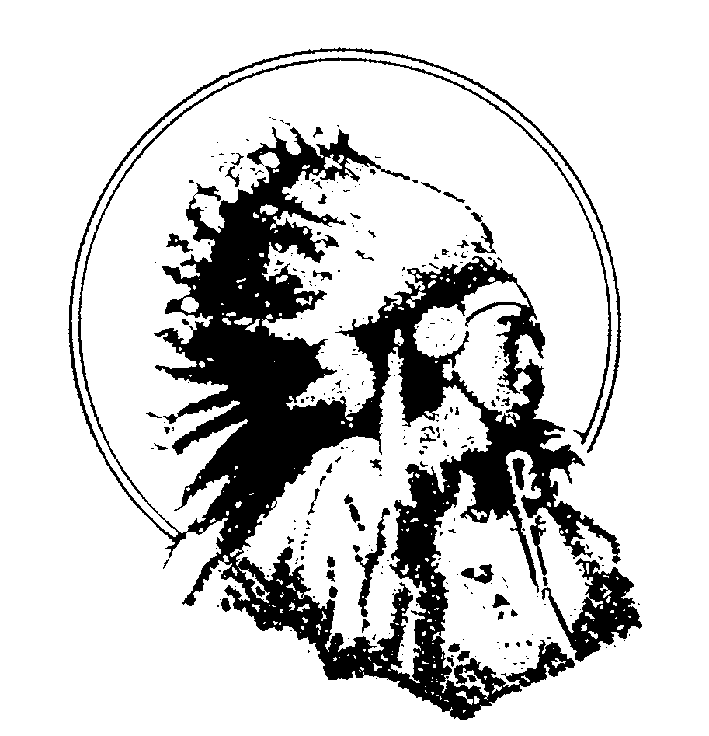
Umatilla Indian Reservation
P.O. Box 638
Pendleton, OR 97801

Department of Natural Resources

Tribal Fish & Wildlife Programs

M e m o r a n d u m

To: Kyle Martin, CRITFC

Copies To: Tara White, ODFW
Brian Zimmerman, CTUIR

From: Gary James, Fisheries Program Manager
Craig R. Contor Fisheries Monitoring and Evaluation Program Supervisor

Date: January 20, 2004

Subject: Support for the procurement and installation of PIT tag detection equipment at Three Mile Falls Dam.

We firmly support the procurement and installation of PIT tag detection equipment at Three Mile Falls Dam. The opportunities associated with improved PIT tag detection capabilities for both juvenile and adult salmonids would improve the local and regional monitoring efforts and satisfy several high priority management information needs.

Our support is based on an understanding that the installation and operation of the new PIT tag detectors will be possible without damage to the fish ladder and without disrupting or impeding fish passage. We expect that any remaining details regarding fish passage and structural integrity associated with the equipment installation can be satisfactorily addressed by working with the individuals and groups familiar with the detection systems currently deployed at Columbia River dams.

