199802800 - Trout Creek Watershed Restoration Project
Sponsor: Jefferson County Soil & Water Conservation District (SWCD)
Province: Columbia Plateau Subbasin: Deschutes
Budgets: FY07: $263,287 FY08: $281,870 FY09: $295,428
Short description: Implementation of numerous riparian and upland habitat improvement projects on private lands in the Trout Creek watershed, Deschutes basin. Monitoring and evaluation of current and past projects.
Recommendation: Response requested

The response needs to provide substantially more detail on past results in biological effectiveness terms. Also more detail is needed on objectives, methods and especially, monitoring and evaluation. The project has a record of successful restoration activities. To merit continued funding, the sponsors need to provide a summary analysis of changes in habitat and fish abundance that have occurred as a result of the past projects. They also need to revise the objectives to more accurately reflect the proposed work and develop a more comprehensive monitoring program.

Changes in habitat for prior channel restoration work:

Trout Creek Channel Habitat Improvement Project

Phase 1-2 Construction Summary

Upper Project Area:
Phase 1

Trout Creek Prior Condition Constructed Condition Change
Stream length 6949 ft 9731 ft +2782 ft
Average flood prone width 60.0 ft 250.0 ft +190 ft
Maximum bankfull depth at a pool 2.7 ft 6.1 ft +3.4 ft
#Pools 8 54 +46
Width/Depth 37.4 15.82

Boardhollow Creek Prior Condition Constructed Condition Change
Stream length 435 ft 668 ft +233 ft
Average flood prone width 8.0 ft 50.0 ft +42 ft
Average bankfull width at a riffle 7.0 ft 5.2 ft -1.8 ft
Width/Depth 25 15

Average Thalweg elevation gain 4.5 Feet
Off channel wetlands created 6.2 Surface Acres
Flood prone width Increase 425%

Phase 2

Trout Creek Prior Condition Constructed Condition Change
Stream length 3911 ft 4573 ft +662 ft
Average flood prone width 60.0 ft 175.0 ft +115 ft
#Pools 6 21 +15
Width/Depth 42 20
Lower Project Area:

Phase 1:

Prior Condition Constructed Condition Change
Stream length 1964 ft 2636 ft +672 ft.
Average flood prone width 196.0 ft 356.0 ft +85%
Maximum bankfull depth at a pool 2.7 ft 7.9 ft +5.2
#Pools 4 15 +11
Width/Depth 52 15

Phase 2:

Prior Condition Constructed Condition Change
Stream length 7263 ft 8505 ft +1242 ft.
Average flood prone width 75 ft 185 ft +246%
Average bankfull width at a riffle 54.6 ft 36 ft - 18.6ft.
Maximum bankfull depth at a pool 2.7 ft 6.2 ft +3.5
#Pools 12 37 +25

A detailed M&E program to address a variety of questions related to restoration action and the biological response to these actions would be highly desirable. But the funding level needed to answer, " analysis of changes in habitat and fish abundance that have occurred as a result of the past projects" has never been approved and there have been strong indications, from various sources, that the current proposals will not receive funding for M&E at this level. We have been directed to focus more on “On the Ground” habitat improvements and not on extensive monitoring and evaluation.

Technical and scientific background: This is an ongoing project that works with private
landowners and multiple funding agencies/sources to improve riparian, aquatic, and upland habitat in the Trout Creek Watershed. It is a companion project to the ODFW Project #199404200) and works to leverage BPA funds by writing grants to numerous funding sources, as sponsors move to finish Phase 3 of the Trout Creek Channel Habitat Improvement Project. This project has, and continues to, implement extensive instream and riparian habitat improvement projects on a basin wide scale to significantly improve habitat for Mid Columbia ESU summer steelhead with several planned projects.

The sponsors supply ample evidence of the habitat work that has been conducted in recent years, although actual data on many of the important long-term metrics were not supplied. The sponsors’ response will need to include additional biological data that address metrics of direct impact on fish survival (i.e., changes in temperature, habitat characteristics, numbers of redds, etc.,) so as to better understand if the habitat changes so readily observed in the proposal photos are in fact altering the stream in a manner that fish are responding to (or are likely to respond to) in a positive manner.

Intuitively, one would expect a positive response in fish densities given the photo points supplied and from the data above. Biological data is being gathered by this project; however, this type of biological data has vast natural variability. To associate any habitat treatment action to any change in biological data will be difficult, and will take several years to statistically validate. The channel restoration work is very new and the habitat response to treatment is being monitored. This sponsor agrees that more biological data would be highly desirable. ODFW has a M&E program that monitors biological components in Trout Creek, including our project area. This project assists ODFW in monitoring the channel habitat improvement work.

Rationale and significance to subbasin plans and regional programs: The Trout Creek habitat project was ranked as the #1 priority in the Deschutes Subbasin Plan. It also addresses elements of the Oregon Plan and the Fish and Wildlife Program.

Relationships to other projects: The sponsors have worked cooperatively with several agencies and groups on restoration projects and more cooperative work is planned. They have worked with local landowners to develop restoration projects.

In past years, the ISRP has been impressed with SWCD's abilities to leverage BPA dollars into additional dollars -- sometimes achieving quite high overall funding levels relative to BPA funding levels. Much of this work occurs through enrollment of local ranchers into stream habitat conservation programs such as CREP. This approach makes BPA dollars go much farther than anticipated. The Jefferson SWCD has been particularly good at this in years past (e.g., Table 1 on Page 5 of proposal).

The Jefferson SWCD has also been instrumental in signing up landowners into FSA’s CREP program in Trout Creek. To date, the SWCD has enrolled 9.92 miles of stream, totaling 145.6 acres into the program, with more planned in the near future.

Project history (for ongoing projects): The sponsors have focused the discussion on the activities that have been undertaken. They needed to provide a better discussion of how successful the restoration actions have been from an action effectiveness perspective, particularly as it relates to fish use (all life stages) and abundance. Quantitatively, if possible, they needed to summarize what changes have occurred in habitat conditions (e.g., has the number of deep pools increased, have summer temperatures been reduced, has the amount of large wood increased, has summer flow increased, has the amount of spawning area increased). Quantitatively, if possible, they should have explained how fish have responded to the habitat changes (fish use by all life stages, and abundance)?

See response to first question above for habitat changes from past projects. ODFW is monitoring fish populations at the watershed scale.

Objectives: The objectives do not accurately reflect the work that will be conducted and do not provide measurable outcomes. Accomplishment of the first biological objective will not be achieved solely by the proposed work. The first objective, however, may serve as an overall goal. The Work Elements appear to be directed more toward a habitat restoration objective and an objective involving landowners participation. A map of the area and project sites is needed. The sponsors also need to explain how the sites were selected and what is the method for prioritizing sites for restoration? It is not clear why the second objective is separate from the first because both involve habitat restoration.

See proposal for objective changes. See map below for channel reconstruction project area and past and future CREP stream reach locations. Infiltration gallery/irrigation improvement projects will be on Antelope creek in the green shaded area as well. See table above for physical habitat changes within project area.

Site selection for stream restoration work was based on the availability of willing private landowners. Luckily, these sites were located at the upper end of the channel straightening/berming work after the 1964 flood. These sites would be the first priority for two reasons, 1) starting restoration at the highest point upstream then working downstream and, 2) will serve to expand core populations within the basin by performing habitat restoration on reaches adjacent to good instream and riparian habitat.

The second objective, improving fish passage, is separate because it focuses primarily on migration, instead of spawning and rearing.
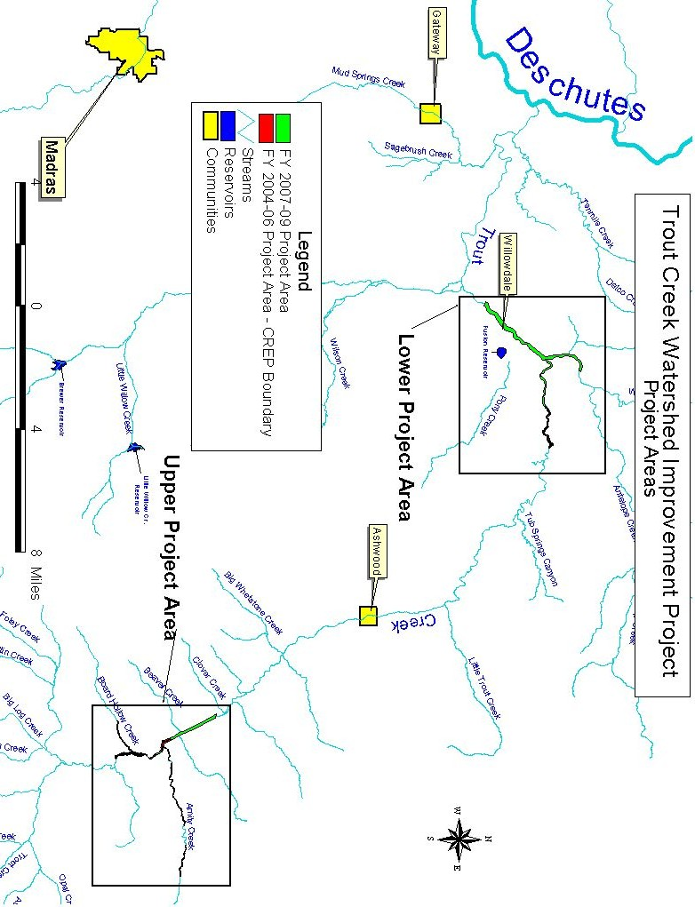
Tasks (work elements) and methods: The sponsors did not clearly explain how the proposed tasks will lead to the accomplishment of objective 2. The methods will not be sufficient to achieve the objective 1.

Removing 2 gravel push-up dams and replacing them with an infiltration gallery at each site will accomplish objective 2, “Improving fish passage”. The infiltration galleries will be used to withdrawal the allowed water for irrigation purposes without having to get instream with heavy equipment every year to construct a gravel dam, causing seasonal fish passage barriers.

See proposal for objective 1 change.

Monitoring and evaluation: M&E was not addressed.

See response to first question. A lot of the biological monitoring of taking place in the Trout Creek watershed is currently being conducted by the ODFW, Trout Creek Project. They conduct annual redd surveys as well as smolt population estimates and adult return estimates. We assist them with the monitoring of the Channel Habitat Improvement Project.

Facilities, equipment, and personnel: Facilities are adequate, and the personnel appear to have limited experience in habitat restoration.

Information transfer is not addressed. It probably will occur via landowner participation.

Benefits to focal and non-focal species: The benefits to focal species cannot be adequately assessed because objectives and some methods are unclear, the site prioritization is not explained, and information on past project effectiveness is not given. The effect on non-focal species is unclear, but the project probably will not cause harm.

Hopefully I have addressed most of the concerns and it is clearer than before. Improving the habitat by increasing stream length, creating riffle-run-pool-glide complexes, connecting the channel to a functioning floodplain and enrolling the entire project area into the CREP program should benefit all species that occur in the project area.

