FY 2007-2009 F&W Program Project Solicitation

Section 10. Narrative

Project ID: 199901700

Title: Protect and Restore Lapwai Creek Watershed
A. Abstract
The Nez Perce Tribe (NPT) Department of Fisheries Resource Management (DFRM) - Watershed Division requests funding to continue watershed restoration efforts in this critical drainage for ESA-listed A-run steelhead. This project is related to the Nez Perce Tribal Hatchery program that has a satellite facility 0.8 miles from the mouth of Lapwai Creek and releases fall Chinook there. In addition, the Tribe has begun a coho salmon re-introduction program into Lapwai Creek.

The Lapwai Creek watershed encompasses a mixture of private, state, and tribal land. Restoration must be carried out on all lands within the watershed regardless of ownership. To accomplish this, a strong relationship has been built between the Nez Perce Water and Soil Conservation District and Nez Perce Tribe since 2002. This project proposal focuses restoration work on Tribal land and complements the NPWSCD project proposal, which will focus on private lands in the watershed. In addition, this proposal has been coordinated with the Idaho Fish and Game, NPT Water Resources, and the NPT Land Services Division. This proposal is based on guidance from the Clearwater Subbasin Summary (Draft) and two completed watershed assessments for the Lapwai Creek watershed. According to these guiding documents, the most significant factors limiting fish production in Lapwai Creek are summer low flows and high temperatures, sedimentation, riparian degradation, channel/bank instability, and passage of aquatic life.

Assessment work under these projects since 2002 has created a solid foundation for stream/watershed restoration work in the watershed. A few examples include: fish distribution and abundance data collected on the mainstem of Lapwai Creek and all major tributaries; stream visual assessment (SVAP) data collected on 120 miles of stream by the NPWSCD; comprehensive baseline habitat monitoring data collected at the watershed scale; fish passage assessment; road erosion assessment and transportation planning; and the development of a Natural Resources Assessment Management Protocol (NRAMP) to assess and make stream restoration project recommendations on individual tribal properties (6 completed in 2005 and 10 planned in 2006). In addition, many on-the-ground projects such as fencing, off-site watering, riparian plantings, and weed control have been implemented since 2002. In fact, by fall 2007 the Lapwai Creek watershed will be one of the most data rich watersheds in the Clearwater Basin, and this comprehensive data will allow us to prioritize reaches for restoration and/or protection and prioritize prescriptions for these areas.

This strong foundation presents a great opportunity to make large strides in stream/watershed restoration implementation. Nez Perce Tribal properties encompass approximately 52 miles of stream within the Lapwai Creek watershed. This project will implement high priority stream/watershed restoration projects based on the data collected above. Examples include: fish barrier replacements; stream/riparian protection through off-site water development, fencing, planting, weed control; and reducing upland chronic sediment sources by decommissioning unneeded roads and upgrading existing roads. Working in an area with highly mixed ownership increases the need to work closely with agencies and the public within the watershed. This project will continue conservation land management planning using the NRAMP, make recommendations to regulating agencies for updating environmental ordinances and policies, and provide outreach and education to the public and local students.

B. Technical and/or scientific background

Watershed Description
Lapwai Creek is a major tributary to the Clearwater River, joining it 11 miles east of the confluence of the Snake and Clearwater Rivers at Lewiston, Idaho. The watershed drains approximately 267 square miles and includes the tributaries of Tom Beall, Sweetwater, Webb, Rock and Mission Creeks (Figure 1) (Cichosz et al. 2001). Watershed characteristics for Lapwai Creek are listed in Table 1. The watershed is characterized by rolling plains dissected by deep stream valleys with extreme fluctuations in stream flow. Most of the land is used for agriculture, with dry land grains and cattle the most important products (Espinosa 1997). Precipitation ranges from an annual average of 18 inches at Lapwai to more than 26 inches at the higher elevations (USDA 2000). The landownership is divided between private, state, federal, and tribal entities (Table 2).

Table 1: Watershed Characteristics.
 | Lapwai Creek Watershed
Order | 5th
Area (Acres) | 174,600
Maximum Elevation (ft) | 4800
Minimum Elevation (ft) | 856
Relief (ft) | 3,944
Main channel Length (mi) | 28

Table 2: Lapwai Creek Watershed Ownership.
Ownership | Acres | Percentage (%)
Private | 150,000 | 86
Nez Perce Tribe | 20,700 | 12
BLM | 1,970 | 1
State Lands | 1,620 | 1
Water | 310 | 0
Total | 174,600 | 100

Justification for Watershed Restoration in the Lapwai Creek Watershed
The Lapwai Creek Watershed (Figure 1) is high priority for restoration and protection for several reasons including:
- Presence of at-risk species and threatened species, namely wild A-run steelhead;
- Lapwai/Sweetwater Creeks have been identified by NOAA BiOp (Draft) as a historic source population for A-run steelhead in the Lower Clearwater River.
- To increase the success of the Nez Perce Tribe Hatchery (NPTH) facility located 0.8 miles upstream from Lapwai Creek’s confluence with the Clearwater River;
- Increase success of Coho Salmon re-introduction efforts;
- A substantial amount of baseline data collected:
    - 2 watershed assessments;
    - fish passage assessment;
    - road erosion survey assessment
    - 3-Transportation Plans;
    - conservation land management plans (NRAMP);
    - fish presence, abundance and distribution surveys;
    - comprehensive habitat baseline data collected;
    - TMDL (due 2006);
    - Stream Visual Assessment Protocol data collected;
- Significant landowner involvement and commitment;
- The amount of watershed restoration effort from other federal, state, and tribal programs that has occurred in the watershed (see section D: Relationships to Other Projects); and
- Projects should reduce water temperatures and sediment delivery to the Clearwater River and will likely improve Fall Chinook salmon habitat downstream of the project area

Species Presence/Distribution
Local oral histories of the Nez Perce Tribe refer to the region’s once significant salmon and steelhead runs. Spawning and salmonid rearing historically occurred within all major tributaries to Lapwai Creek. Steelhead is the most suited anadromous fish to the Lapwai Creek system and has been recorded in all major tributaries. Like many anadromous streams in the Columbia River Basin, salmon and steelhead populations have declined drastically from historic levels. It is believed that anthropogenic degradation of spawning and rearing habitat within these streams has contributed significantly to these declines.

Kucera et al. (1983) found 10 species of fish inhabiting the lotic environments of Lapwai Creek during 1982 surveys streams and stream habitat conditions in lower Lapwai Creek and two of its major tributaries (Table 4). Others have corroborated the 1982 survey findings (Fuller et al. 1985; Kucera and Johnson 1986). Surveys by the Idaho Department of Fish and Game (1999) additionally found westslope cutthroat trout and brook trout inhabiting Mission Creek. Surveys conducted by the Winchester Lake Watershed Advisory Group (1999) and Thomas (et al. 1985) documented the presence of redband rainbow trout in the headwater reaches of Lapwai and Mission Creeks, raising the total number of species inhabiting lotic environments in the Lapwai watershed to 13. To date, a total of 18 distinct fish species have been identified in the Lapwai Creek watershed, including both resident and anadromous forms of rainbow trout and steelhead and 5 other illegally-introduced species in Winchester Lake.

Species at Risk
The Lapwai Creek Watershed provides habitat for a variety of anadromous and resident fish. The anadromous stocks include wild A-run steelhead, Chinook salmon, and the recently reintroduced Coho salmon. Lapwai Creek and its major tributaries are important habitat for Snake River Basin steelhead, which the National Marine Fisheries Service (NMFS) listed as Threatened under the ESA (February 5, 1999, 56 FR 5740). Snake River fall Chinook salmon is also listed as Threatened (December 28, 1993, 58 FR 68543). Local oral histories of the Nez Perce Tribe refer to the region’s once significant salmon and steelhead runs. Like many anadromous streams in the Columbia River Basin, salmon and steelhead populations have declined significantly from historic levels (Idaho Department of Fish and Game et al. 2000).
To date, little if any information has been collected on steelhead adult abundance in the Lapwai Creek watershed. Information on juvenile steelhead abundance was limited to Kucera and Johnson (1983) who compared juvenile steelhead densities in the Lower Clearwater. Recently, Chandler (2005) completed a more comprehensive survey of juvenile densities for Lapwai Creek and Big Canyon Creeks, but unfortunately the final report and information was not available prior to completion of this proposal.
The Interior Columbia Basin TRT independent population report did not recognize any individual steelhead populations in the Lower Clearwater River. However, it is likely that populations exist (given the 500 adult criteria). One example is Big Bear Creek, a tributary to the Potlatch River. Big Bear Creek is also located on the Lower Clearwater approximately 10 km northwest of Lapwai Creek. In the spring of 2005 IDFG trapped 266 adult steelhead in Big Bear Creek (Brindza 2005). Adult steelhead estimates for the whole Potlatch system have not been completed. With Big Bear Creek at 100,753 acres and representing only nearly ¼ of total area within the Potlatch River system it likely meets the 500 adult criteria required by the ICBTRT.
Unfortunately, to this date estimates of adult steelhead abundance for Lapwai creek have not been completed. However, resent data collected by the NPTDFRM Watershed Division may serve a surrogate to speculate the number of adults present in the system. In 2005 (Chandler) found the highest juvenile steelhead densities of 1.13 fish/m2. These densities are comparable to the highest densities reported for tributaries in the Potlatch River system. Steelhead/rainbow densities for the Potlatch River from 2003-2004 included: Little Bear Creek (13.20 fish/m2), Cedar Creek (8.02 fish/m2), Little Boulder Creek (4.68 fish/m2), Bobs Creek (2.20 fish/m2), main stem Potlatch River (2.66 fish/m2), Leopold Creek (1.21 fish/m2), Pine Creek (1.27 fish/m2), and Big Bear Creek (1.24 fish/m2) (Bowersox et al., draft). Given the size of the Lapwai Creek watershed in relationship to the Big Bear Creek watershed, it is unreasonable to say conclusively that the watershed does not currently or will ever contain 500 adults.

Spawning and Rearing Habitat
Spawning and rearing habitat exists throughout the Lapwai Creek Watershed (Table 3). Spawning and rearing of salmonids occur within all major tributaries to Lapwai Creek, including Sweetwater, Mission, Webb, Rock, and Tom Beall Creeks (Figure 4), with spawning typically occurring during March and April (Table 5). Spawning and rearing of steelhead generally occurs in the lower elevation areas below the escarpment that divides the watershed. Passage barriers occur in all tributaries except Tom Beall and Rock Creek, which likely limit upstream movement of anadromous fish. Anthropogenic barriers in Sweetwater and Lapwai Creek are being removed in 2006 using alternative funding sources. These barrier removal projects will restore aquatic species passage for 9.27 miles of mainstem Lapwai Creek and 5.72 miles of Sweetwater Creek. Spawning and rearing of resident salmonids (redband trout) has been documented in the upper reaches of Lapwai and Mission Creeks, and is likely to occur in the upper reaches of Webb and Sweetwater Creeks.

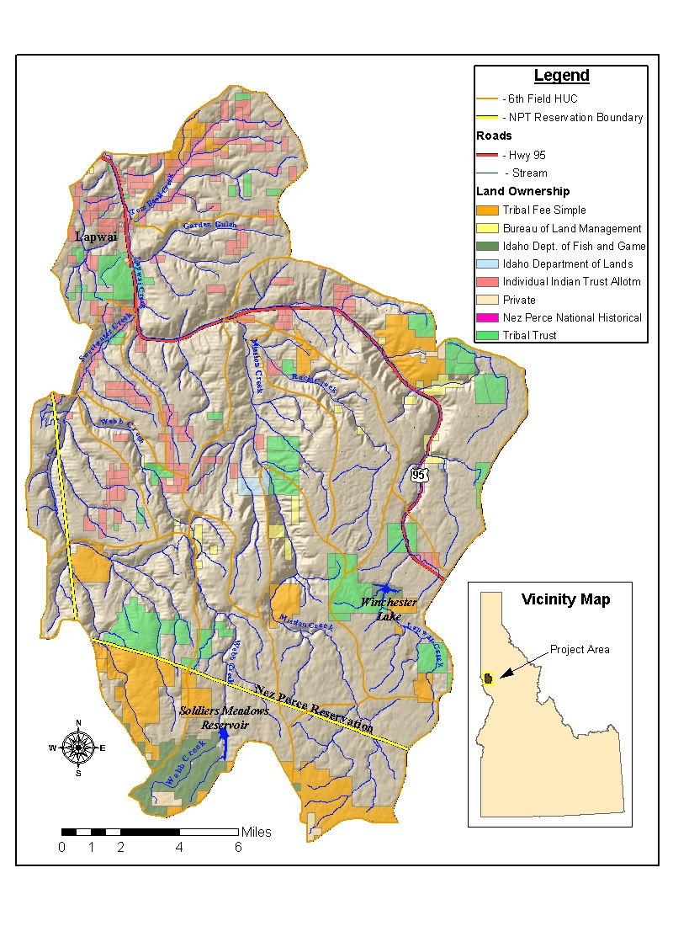
Figure 1: Lapwai Creek Watershed.

Table 3: Spawning/Rearing Habitat Present in the Lapwai Creek Watershed
Stream | Spawning/Rearing Habitat
Lapwai Creek | 21.15 Miles
Sweetwater Creek (tributary) | 8.26 Miles
Webb Creek (tributary) | 15.49 Miles
Mission Creek (tributary) | 15.73 Miles
Rock Creek (tributary) | 9.19 Miles
Tom Beall (tributary) | 1.19 Miles

Table 5. Timing of various life history activities of A-run steelhead for the Lapwai Creek Watershed.
Activity | Timing/Duration
Adult pre-spawn migration (up/downstream) | March-April
Adult post-spawn migration (up/downstream) | April-May
Spawning | March-April
Emergence | June
Rearing | June through 2nd April
Smolt outmigration | 2nd April after emergence
Non-specific adult migration (up/downstream) | October-April
Non-specific juvenile migration (up/downstream) | April-November

Critical Habitat and Essential Fish Habitat
Critical habitat for Snake River fall Chinook salmon includes the Clearwater River from its confluence with the Snake River upstream to its confluence with Lolo Creek. Although not within the designated critical habitat for fall Chinook salmon, as a major tributary to the designated reach of the Clearwater River, activities within the project area influence habitat quality downstream. Critical habitat for threatened steelhead includes the Clearwater River, which includes the Lapwai Creek Watershed (USDA 2000). The Lapwai Creek Watershed is also designated as Essential Fish Habitat, under the Magnuson-Stevens Fishery Conservation Management Act, for Chinook salmon and Coho. In addition, the Nez Perce Tribal Hatchery program has a satellite facility 0.8 miles upstream from the mouth of Lapwai Creek that releases fall Chinook and Coho Salmon outplants.

Wild A-run Steelhead:
Lapwai Creek maintains a wild A-run steelhead population. Wild steelhead of the upper Snake River drainage have generally declined in abundance in recent years due to dam construction, public water supply projects, poor land management practices, and over fishing. Raymond (1978) estimated that 60-80% of the Snake River steelhead returns are the result of Dworshak and Pahsimeroi hatchery releases (Kucera and Johnson 1986). Protection of current Lapwai Creek wild A-run steelhead populations is extremely important for the maintenance of genetic and biological diversity.

Johnson and Stangl (2000) recognized the high potential of habitat restoration along Lapwai Creek to benefit steelhead production in the mainstem Clearwater River drainage. The Lapwai Creek drainage itself has also been characterized as a basin with high potential for steelhead production if degraded habitat were restored (NMFS 2005). Little information on historic fish abundance in the Lapwai Creek drainage is available, but based on the channel morphology in the drainage, anecdotal accounts of numerous steelhead killed in a flash flood in 1986 (documented by the Lewiston Morning Tribune, April 24 and 25, 1986), and operation of traditional steelhead snag fishery operated by the Tribe in Mission Creek until about 30 years ago, the Lapwai Creek drainage likely produced significant numbers of anadromous fish in the past.

Table 4: Fish species identified or cited within lotic environments of the Lapwai Creek Watershed.
Common Name | Scientific Name | Location  (Major Tributary) | Notes | Primary Source(s)
Rainbow trout/Steelhead | Oncorhynchus mykiss | Lapwai, Sweetwater, Webb, Mission and Rock Creeks | ESA threatened species. | 1
Chinook salmon | Oncorhynchus tshawytscha | Lapwai Creek (lower) | Probable stray | 1
Westslope cutthroat trout | Oncorhynchus clarki lewisi | Mission Creek |  | 2
Redband trout | Oncorhynchus mykiss | Lapwai Creek above Winch. Lake  Mission Creek (upper 5.5 miles) |  | 3, 4
Brook trout | Salvelinus fontinalis | Mission Creek | Introduced species | 2
Speckled dace | Rhinichthys osculus | Lapwai, Sweetwater, Webb, Mission Creeks |  | 1
Redside shiner | Richardsonius balteatus | Lapwai, Sweetwater, Mission Creeks |  | 1
Chiselmouth chub | Acrocheilus alutaceus | Lapwai Creek, Mission Creeks |  | 1
Northern pikeminnow | Ptychocheilus oregonensis | Lapwai, Mission Creeks |  | 1
Bridgelip sucker | Catostomus columbianus | Lapwai, Sweetwater, Webb Creeks |  | 1
Largescale sucker | Catostomus macrocheilus | Lapwai Creek |  | 1
Smallmouth bass | Micropterus dolomieui | Lapwai Creek (lower) | Introduced species | 1
Piute sculpin | Cottus beldingi | Lapwai, Sweetwater, Webb, Mission Creeks |  | 1
1 - Kucera et al. 1983
2 - Idaho Department of Fish and Game 1999
3 - Winchester Lake Watershed Advisory Group 1999
4 - Thomas et al. 1985

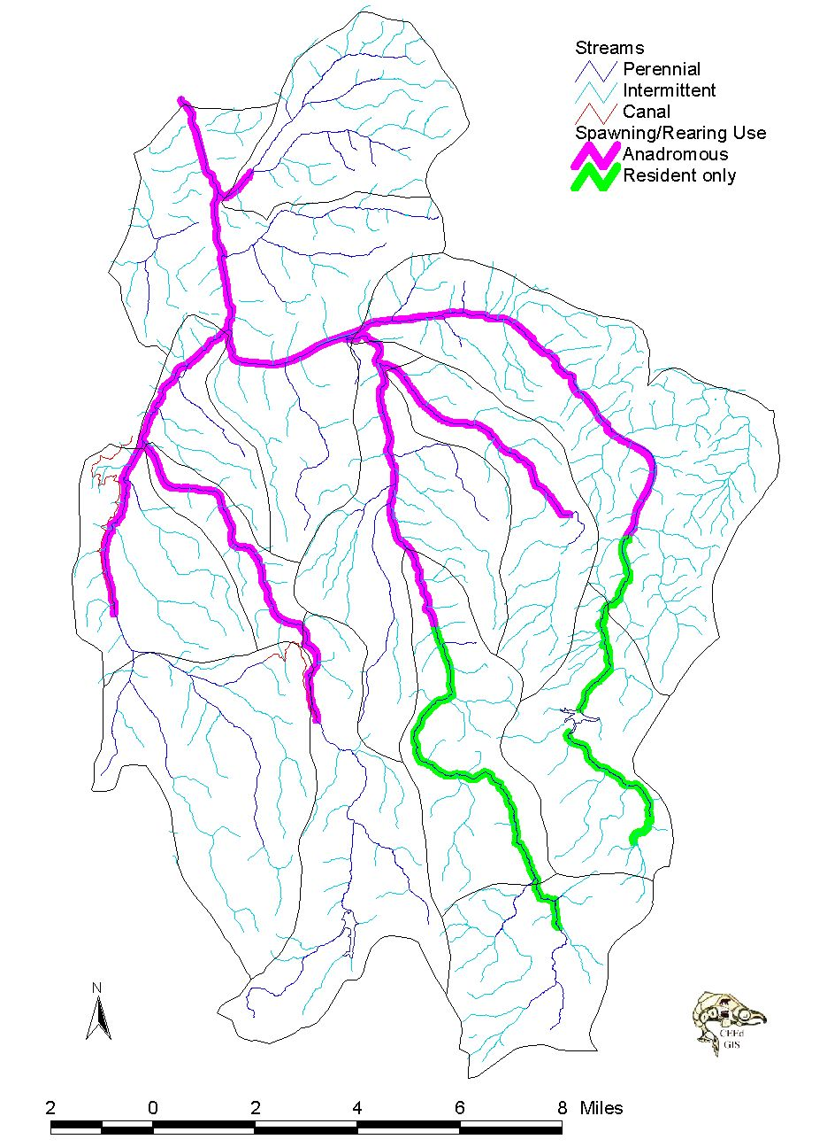
Lapwai Creek
Mission Creek
Webb Creek
Sweetwater Creek
Rock Creek

Figure 2: Spawning and Rearing use by Resident and Anadromous Salmonids in the Lapwai Creek Watershed

Johnson and Stangl (2000) describe Mission Creek, a major tributary to Lapwai Creek, as a major spawning area historically for anadromous fish (NMFS 2005). A study by Kucera and Johnson (1983) suggests that enhancement of riparian vegetation and placement of in-stream structures would substantially increase the smolt yield in Mission Creek. This study estimated that about 55 percent of the Mission Creek system was currently producing steelhead. The projected smolt yield from this area was 1,700 fish. If enhancement measures are implemented, it is estimated that the current low smolt yield could conservatively be tripled or quadrupled. Thomas et al. (1985) estimate smolt production in the Mission Creek system to be as high as 11,366 fish.

The Bureau of Reclamation owns a major water diversion on Sweetwater Creek operated by the Lewiston Orchard Irrigation District (LOID). This facility is currently under Section 7 ESA consultation with NMFS. The Tribe has been very active in this process and is working to get adequate instream flows back into Sweetwater and Lapwai Creeks. Sweetwater Creek is fed by Twenty-one Ranch Springs, which is unique in the amount and quality of water that it provides. It is a high volume perennial spring that discharges a minimum of 3cfs in the summer, with documented flows between 10-12cfs in July-September. The water is a constant 48 degrees all year long with benefits to summer and winter rearing steelhead juveniles. A draft biological opinion has been developed for the LOID system, and it states that in the past, Sweetwater Creek was likely a significant and unique population “source” for steelhead in times of drought (NMFS 2005). The BiOp also states that Sweetwater Creek is one of most important steams in the Lower Clearwater River for A-run steelhead. The Biological Opinion requires minimum in-stream flows and is scheduled to be signed before this year’s irrigation season.

Watershed Analysis:
There are two broad-scale watershed analysis documents for the Lapwai Creek watershed that have been used to guide watershed restoration actions within this proposal. The first is a Watershed Protection Plan-Environmental Assessment produced by the Natural Resources Conservation Service (NRCS) completed in 1990. Two supplements have been added to the original, in which the first (1994) covers the Lapwai Creek area above Mission Creek and the second (2000) the Lapwai Creek area below Mission Creek. The two supplements incorporate treatment strategies to provide enhancement and protection of riparian vegetation to address hydrologic modifications and reduce stream temperatures. The second watershed analysis report was completed by the DFRM Watershed Division under contract to Washington State Universities Department of Environmental Education. This assessment was field checked and completed in August 2001.

Watershed Problems and Major Limiting Factors for Fish Addressed by this Proposal
Technical Reports and Watershed Assessment:
Lapwai Creek has a long history of development. The watershed has experienced numerous sustained impacts associated with: agriculture, logging, road construction, railway construction, grazing, irrigation diversions, and floodplain development. General ecological problems impacting fisheries within Lapwai Creek and the major tributaries include (Kucera et al. 1983, USDA 2000):
- low summer flows,
- wide fluctuation in annual stream flows,
- high summer water temperatures,
- and poor in-stream and riparian cover.
- high siltation of spawning gravels, and
- elevated nutrient levels

These factors decrease survival of steelhead eggs, larvae, and juveniles and decrease the streams carrying capacity for adult (resident) rainbow and juvenile steelhead (USDA 2000). This project proposal is focused on steelhead and Chinook salmon and directly addresses the limiting factors listed above. Proposed riparian fencing and planting and road decommissioning work elements within this project are intended to improve these conditions and habitat conditions for the future survival of and increase in steelhead populations. Peer reviewed research on the effectiveness of these BMPs currently exists in the literature. Water quality has also been reported as marginal with frequent high fecal coliform bacteria levels, seasonally high turbidity, suspended sediment and nutrient concentrations (Thomas et al. 1985). Proposed riparian fencing and road decommissioning work elements will help to ameliorate these problems. It is believed that considerable potential exists for improving anadromous fish populations in Lapwai Creek (Kucera et al. 1983)

The NPT Watershed Division is under contract with the PCSRF to replace the Sweetwater Creek culvert fish barrier with a bridge structure to open 5.72 miles of additional habitat in Sweetwater Creek in the Summer of 2006. In addition, a bridge at stream mile 12 on the main stem Lapwai Creek has been identified by NRCS and NPTFWP as a complete barrier to fish passage (Figure 3). The bridge is blocking 9.27 miles of fisheries habitat upstream to the next barrier culvert. The NPT Fisheries-Watershed Division has completed field surveys, developed bridge replacement plans, and developed stream bank, channel and floodplain restoration plans. A PCSRF grant has been resubmitted in 2006 for funding and implementation of this important project. Removal of this barrier will return 9.27 miles of habitat.

Clearwater Subbasin Summary (Draft):
The Draft Clearwater Subbasin Summary (page 139) states one of the primary limiting factors for resident and anadromous salmonid populations in the Clearwater Subbasin are impacts of land management activities on hydrology, sedimentation, habitat distribution and complexity, and water quality. The Lapwai Creek watershed is a part of the Lower Clearwater Assessment Unit. Table 6 lists the limiting factors for key fish species in the Lower Clearwater Assessment Unit. Watershed disturbances are defined as upland disturbances such as mining, timber harvest, livestock grazing and roading, including in-stream sedimentation resulting from defined upland sources (e.g., roads). Sedimentation is defined as natural and/or elevated sediment loading from undefined sources. Habitat degradation is defined as riparian or in-stream habitat loss or disturbance.
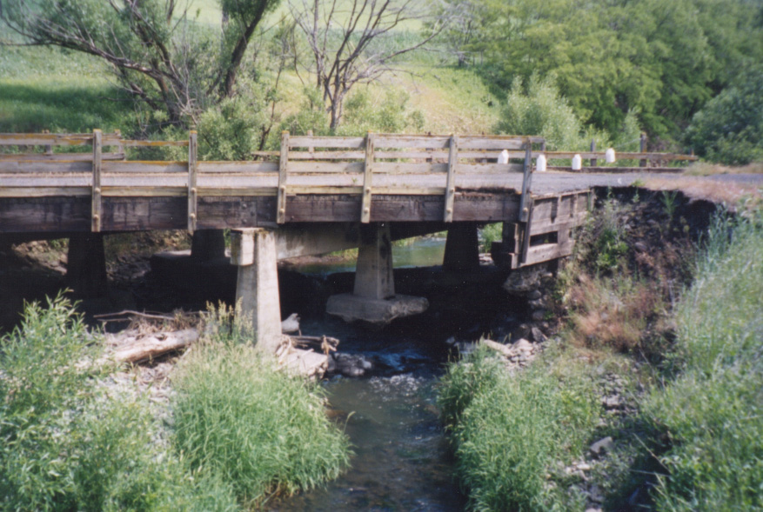

Figure 3: Complete fish barrier at failing private bridge. Notice difference in water elevations above and below bridge.

At a stream reach scale, the summary refers to the Salmon and Steelhead Production Plan produced by the Nez Perce Tribe and the Idaho Fish and Game in 1990, which lists limiting factors given in Table 7 below. Lapwai and Mission Creeks are listed as priority streams for direct habitat improvements, a recommended strategy for A-run steelhead in the plan (NPT and IF&G 1990).

Table 6: Limiting factors for Lower Clearwater Assessment Unit.
 | Temp. | Base Flow | Low Aeration | Sediment | In-stream Cover | Watershed Disturbances | Habitat Degradation | Noxious Weeds | Harvest | Connectivity/passage
Steelhead | X | X | X | X |  | X | X | X |  | X
Chinook | X | X |  | X |  | X | X |  |  | X

Table 7: Limiting factors for A-run steelhead within the analysis area.
Location | Sediment Problems | Low Flow Problems | Water Quality | Riparian Degradation | Channel/Bank  Instability
Lapwai Cr. | X | X | Summer temps | X | X
Mission Cr. | X | X | Summer temps | X

The actions within the previous proposal were formulated as a direct result of the limiting factors listed above, along with discussion and planning with the major players in the watershed (NPWSCD and NPT Water Resources Department). A breakdown of the proposed actions in this current proposal and the limiting factors they directly address is given below in Table 8.

Table 8: Summarized limiting factors proposed work elements address.
Proposed Watershed Restoration Actions  (FY2007-2009) | Temp. | Low (Base) Flow | Low Aeration | Sediment | In-stream Cover | Watershed Disturbances | Fish Habitat Degradation | Noxious Weeds | Harvest | Connectivity/passage | Channel Bank Instability | Elevated Nutrient Levels
Riparian Fencing | X | X | X | X | X | X | X |  |  |  | X | X
Riparian Vegetation Planting | X | X | X | X | X | X | X | X |  |  | X | X
Remove livestock grazing (purchase leases) | X | X | X | X | X | X | X | X |  |  | X | X
Road decommissioning  / Improvement |  |  |  | X | X | X | X |  |  | X
Barrier Replacement |  |  |  | X |  | X | X |  |  | X | X
Land Management Plans (NRAMP) | X | X | X | X | X | X | X | X | X | X | X | X
Noxious/invasive Weed Treatment |  |  |  |  |  |  | X | X
Wetland Protection  / Restoration |  | X | X |  |  | X | X |  |  |  |  | X
Grassed Waterways  / Terraces | X | X | X | X |  | X | X |  |  |  | X | X
Outreach and Education | X | X | X | X | X | X | X | X | X | X | X | X
C. Rationale and significance to regional programs
This project is essential to address the problems and to accomplish many of the objectives identified in the 2003 Clearwater Subbasin Management Plan.

Clearwater Subbasin Management Plan, 2003 (Draft)
The Draft Clearwater Subbasin Management Plan (Nov. 2003) compiles problem statements, objectives, and strategies for the subbasin. The Lapwai Creek Watershed is comprised of 3 Primary Management Units (PMUs); PMU-4, PMU-7 and PMU-8 of the subbasin plan. The proposed restoration and protection efforts within this project proposal meet many of the stated objectives within the Clearwater Subbasin Management Plan for these PMUs. The specific problems, objectives, and strategies addressed in this proposal are listed below:

Problem 2: Anadromous fish production is limited by habitat quality, quantity and connectivity in portions of the subbasin.

B. Objective: Increase anadromous fish productivity and production, and life stage specific survival through habitat improvement. (page 18)

This ongoing project set up a comprehensive baseline monitoring program in 2002-2006 to lay the foundation for restoration actions. The NPWSCD will complete the inventory of all streams within the watershed by fall 2007. These assessments have been developed on a watershed scale. In order to address limiting factors at a stream reach scale, a finer analysis is necessary. This project proposes to complete assessments at this finer scale through the Natural Resource Assessment Management Plan (NRAMP) protocol. Through the NRAMP process, habitat treatments will be evaluated and prioritized for implementation. Post project implementation monitoring is a component of this project. Results from implementation effectiveness monitoring will be incorporated into the project selection and design process.

Problem 7: Water quantity and quality, connectivity, and habitat complexity are key environmental factors that limit the production of anadromous and resident fish species and aquatic wildlife.

P. Objective: Reduce number of artificially blocked streams by 2017.

The Clearwater Subbasin Assessment states that a data gap on culvert conditions in relation to fish passage exists. The Assessment also suggests that fish passage was likely a substantial issue throughout the Clearwater Subbasin. Lapwai Creek has been adversely impacted for many years by poor management, but the greatest impacts have come from transportation projects. Through these projects, it was recognized that there is a general lack of knowledge concerning fish barriers throughout the watershed. In 2003 and 2004, the NPT-Watershed Division conducted an in-depth project, in which all known road crossings were located and surveyed for fish passage (a total of 208 sites) using a stream crossing assessment protocol developed by the USFS. The assessment showed that approximately 60% of the stream miles inventoried were blocked (72.6 of 123.4 miles total). Once all barriers were assessed, they were prioritized for replacement (Figure 4). The methods and results of the analysis and prioritization were documented in a report entitled "Fish Passage Assessment: Lapwai Creek Watershed." The intent of this proposal is to include fish barrier removal work in every project year to open additional habitat.

Q. Objective: Reduce water temperatures to levels meeting applicable water quality standards for life stage specific needs of anadromous and native resident fish, with an established upward trend in the number of stream miles meeting standards by 2017.

Water quality and temperature monitoring is ongoing. Utilizing the NRAMP survey, assessment, project identification and prioritization process, Best Management Practices (BMPs) including fencing, riparian planting, weed control and grassed waterways to restore and protect wetlands will result. Through this proposal, efforts will be made to align local regulatory authorities over protecting natural resources with the most current science. Data and findings will also be shared with the Nez Perce Tribe Water Resources program for TMDL development (scheduled for completion in 2006).

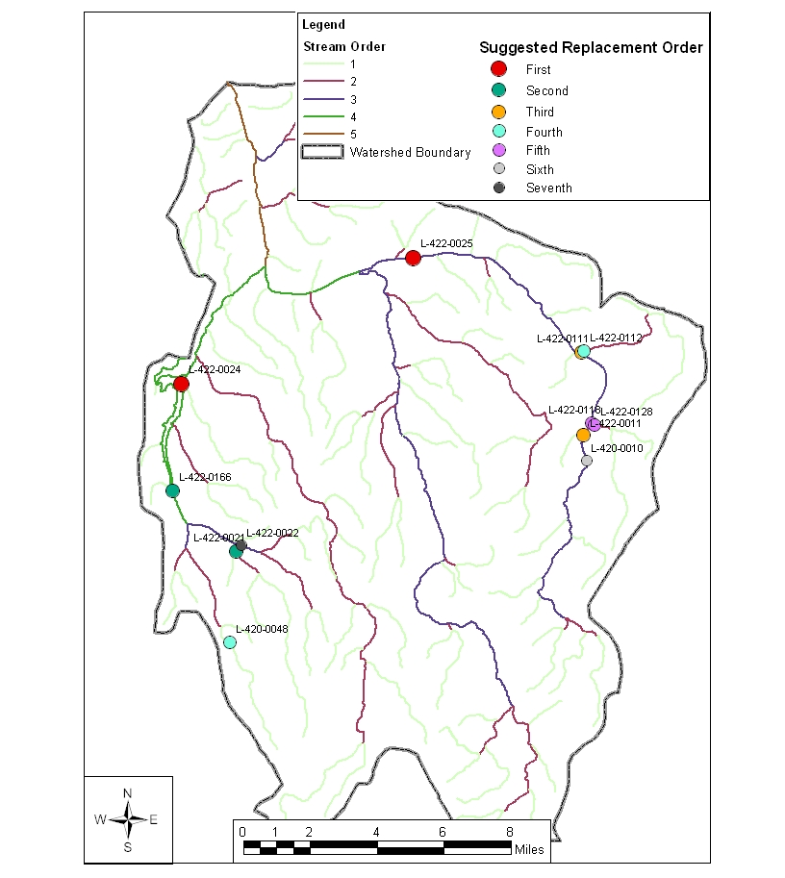
Figure 4: Lapwai Creek Watershed Culvert Priorities

S. Objective: Reduce in-stream sedimentation to levels meeting applicable water quality standards and measures, with an established upward trend in the number of stream miles meeting such criterion by 2017.

Transportation Planning completed under previous work item report “Road Erosion Survey” for roads in the headwaters of Sweetwater Creek identified 124 miles of unneeded forest roads for obliteration to reduce the amount of sediment reaching the streams. Further water quality actions are to be identified through the NRAMP process and ongoing monitoring and achieved through road improvement work and riparian BMPs.

T. Objective: By 2010, develop a nutrient allocation plan for the subbasin which investigates the potential benefits to fish and wildlife of nutrient additions or reductions.

Ongoing monitoring and field data collection thorough the NRAMP process and coordination with the NPWSCD SVAP project will identify needs for nutrient reductions or additions. All information will be shared with the NPT Water Resources program who is leading the TMDL effort for the Lapwai Creek watershed.

U. Objective: Improve aquatic habitat diversity and complexity to levels consistent with other objectives outlined in this document, with particular emphasis on recovery of anadromous and fluvial stocks

Identification of poor habitats will be accomplished through the NRAMP process on Tribal lands and coordinated with the NPWSCD on private lands resulting in prioritized project areas. Through this project in 2002-2006, very comprehensive baseline data has been collected. A resurvey will be conducted at several sites to evaluate trends from habitat improvements.

Problem 10: The loss of wetland and riparian habitats particularly in the Lower Clearwater AU, Lolo-Middle Fork, and South Fork AU has negatively impacted the numerous wildlife species that utilize these habitats.

BB. Objective: Protect and restore an additional 300 miles of riparian habitats by 2017.

The NRAMP process will assist in the identification and prioritization of riparian habitats for protection and restoration. Section 4.4 the of the subbasin plan will be used as guidance to spatially prioritize these efforts. The highest priority habitats will be those that support or have a significant influence on the spawning and rearing of anadromous and native resident salmonids and habitats identified as water quality limited during the TMDL process.

Z. Objective: Protect all currently functioning wetlands.

NPT Water Resources department is in the process of finalizing wetland inventory maps and preliminary assessments of wetlands in the watershed and developing restoration/protection priorities on tribal lands in cooperation with the Watershed Division. The NPSWCD is likewise planning and prioritizing wetland restoration and protection on private lands. Wetland functions and protection/restoration needs have been included in the NPT Watershed Education & Outreach program.

Problem 11: The introduction of noxious weeds and nonnative plant species into the Clearwater subbasin has negatively impacted native terrestrial focal species.

CC. Objective: Protect the existing quality, quantity and diversity of native plant communities providing habitat to native wildlife species by preventing the introduction, reproduction, and spread of noxious weeds and invasive exotic plants into and within the subbasin.

All NPT protection and restoration activities and work elements encourage and specify the use of weed free seeds and locally-adapted, native species in all revegetation activities. The importance and significance of this practice in the protection and restoration of fisheries habitat is included in the NPT Watershed Education & Outreach program.

DD. Objective: Reduce the extent and density of established noxious weeds.

Noxious weed infestations are identified and prioritized for treatment through the NPT NRAMP and NPSWCD SVAP protocols. Information is then coordinated with Clearwater River Basin Weed Management Area Coordinating Committee. Weed treatments include, but are not limited to, mechanical, biological and chemical controls. When appropriate, the use of biological control agents is encouraged as a long-term control strategy without the potentially negative financial and environmental impacts of widespread herbicide use. These methods include insect releases and goat grazing.

Problem 12: Historic and current livestock grazing adversely impacted fish and wildlife habitats and populations in some portions of the subbasin.

EE. Objective: Reduce the negative impacts of livestock grazing on the fish, wildlife and plant populations in the subbasin. Focus efforts on riparian and wet meadow habitats.

The NRAMP and SVAP assessments identify and prioritize areas impacted by grazing for protection and restoration. The work elements Install Fencing, Plant Vegetation, Lease Tribal Lands, Develop Alternative Water Source, and Restore and Enhance Wetlands address this objective in many ways. The NPT Watershed Div. and the NPSWCD has identified all Concentrated Animal Feeding Operations and developed management actions to minimize sediment and nutrient inputs to streams.

FF. Objective: Reduce conflicts between livestock and native wildlife and plant populations.

The work elements Install Fencing, Plant Vegetation, Lease Tribal Lands( for livestock grazing elimination) will help protect important plant populations and reduce impacts to native wildlife..

Problem 16: Road construction, timber harvest and/or fire suppression have altered the size, quality, distribution and juxtapositions in and between habitat patches in the subbasin.

JJ. Objective: Reduce the impact of the transportation system on wildlife and fish populations and habitats

A transportation system analysis on the roads system in the Lapwai Creek Watershed was completed as reported in Road Erosion Survey: Lapwai Creek Watershed. The report includes recommendations for decommissioning roads not critical for transportation, recreation and land management activities. The NEPA process is complete and road decommissioning work will begin in August, 2006. Priorities for decommissioning are roads within 200 feet of the streams with high quality wildlife and fish habitat and those with high surface erosion or are landslide prone.

Problem 18: As reflected in the inventory, numerous agencies and entities are implementing programs and projects in the subbasin. Lack of coordination and integration limit the economic, social, cultural and biological benefits of aquatic and terrestrial protection and restoration in the subbasin.

LL. Objective: Develop programs and project proposals compatible with existing community needs and that integrate with local watershed protection, restoration and management objectives and activities.

Currently, the NPT-Watershed Division and the NPSWCD actively coordinate and cooperate with the following agencies and entities: Idaho Department of Fish and Game, Forest Service, Bureau of Land Management, Clearwater Basin Weed Management Area, Natural Resource Conservation Service, Soil Conservation Commission, Idaho Transportation Department, Idaho Department of Lands, Farm Services Agency, Nez Perce County Road Department and Weed Supervisory, Lewis County Road Department/Weed Supervisor, Latah County Road Department/Weed Supervisory, Peck City Council, Nez Perce County Commissioners, Latah Soil and Water Conservation District, Idaho Soil and Water Conservation District, Lewis Soil and Water Conservation District, Idaho Department of Agriculture, US Fish and Wildlife Service, NOAA, University of Idaho, Department of Environmental Quality, Trout Unlimited, Rocky Mountain Elk Foundation, and Clearwater Resource Council and Development.
Problem 19: There is a great need for prioritization of activities addressing limiting factors. The limited resources available need to be used as efficiently as possible. The great diversity of issues and factors that need to be considered make prioritization a large task that will need to be frequently repeated and fine-tuned based on new information. Key data gaps currently limit the effectiveness of assessment, prioritization and planning in the Clearwater subbasin. Data needs also need to be prioritized and addressed.

MM. Objective: Identify high priority habitat areas requiring protection or restoration.

Ongoing monitoring and field data collection thorough the NRAMP process and coordination with the NPWSCD SVAP project will identify priority habitat areas requiring protection or restoration.

Problem 21: In the past, projects have not been successful in conditions where the local groups are not supportive. Long-term program implementation is more successful where projects are locally developed and implemented.

PP. Objective: Participate in existing, and contribute to the further development of, local watershed and technical advisory groups.

NPT-Watershed Division and NPSWCD currently work with and Assist Soil and Water Conservation Districts, Watershed Advisory Groups, and other existing groups to organize project goals and implementation strategies.

QQ. Objective: Maximize social and economic benefits as much as possible while implementing the Clearwater Subbasin Plan.

The leasing of tribal grazing allotments for the elimination of livestock grazing will result in no loss of local government (Tribal) revenues.

The implementation of all work elements with out side labor on Tribal lands is given tribal preference with the local labor force and is coordinated through the Tribal Employment Rights Office.

RR. Objective: Increase resource information and education delivery in the subbasin.

This on-going project provides project specific and general fish habitat protection and restoration information to the public through local news papers, school news letters, radio announcements, public awareness meetings, billboards and educational presentations at the local schools through the Education & Outreach work element.

Clearwater Subbasin Plan Supplement and Response to Council Staff Subbasin Plan Amendment Recommendation (Draft)
This project proposal implements projects to address the restoration issues stated in the “Clearwater Subbasin Plan Supplement and Response to Council Staff Subbasin Plan Amendment Recommendation” (draft). The Lapwai Creek Watershed consists of PMU-4, Pmu-7 and PMU-8 of the subbasin plan and amendment recommendation. The following was copied from pages 9 and 10 of the draft:

Table 4 is derived from the Clearwater Subbasin Management Plan and shows restoration issues and priorities by PMU. Colors shown in the following data matrices show the priority assigned to the restoration issue assigned by the management plan: yellow = highest, red = high, green = medium, and blue = low.

Restoration Issue | PMU-4 | PMU-7 | PMU-8
Landslides | X | X | X
Erosion | X | X | X
Water Use | X
Ponderosa Pine | X |  | X
Prairie Grasses | X | X | X
Water Temperature | X | X | X
In-stream Work | X | X | X
Riparian | X | X | X

Table 4: Restoration Issues and Priority

Private Lands Prioritization Discussion
Based on a cursory evaluation of Table 4, the highest priority is for protection and restoration of Ponderosa Pine stands and Prairie Grassland habitats, and in dealing with the widespread risks of erosion and increased water temperatures. The risk of surface erosion is a high priority concern in PMU’s 4, 7 & 8, coupled with apparent impacts from grazing, landslides, and sediment load. This proposal includes road decommissioning and improvement projects that specifically address surface erosion. The need for riparian protection and in-stream habitat work appears common to many of the Tribal and private land ownership PMUs, but of lower priority, and is also addressed by this proposal.

NOAA Biological Opinion on Remand, 2004
In this report, NOAA Fisheries presents analyses completed to identify the potential for actions implemented offsite to mitigate for effects resulting from the annual operation of the Federal Columbia River Hydropower System. NOAA provided results for the Snake River steelhead (threatened) ESU, in which the Lapwai Creek drainage is a part of.

The report lists Lapwai Creek as a primary fish-producing area for the steelhead subpopulation along with Big Canyon Creek, Little Canyon Creek and the Potlatch River. It states that Lapwai Creek produced significant numbers in recent history but is currently depressed.

The analyses lists the Index of Potential to increase Population as medium, the Ecological Improvement Potential as medium and the Qualitative Assessment of Potential to Improve/Increase Habitat as high based on the numerous anthropogenic changes that could potentially be remedied.

NOAA ESA Section 7 Consultation on Operation and Maintenance of Lewiston Orchards Project (Draft), 2005
Water withdrawal is listed as a major limiting factor in the Lapwai Creek drainage by the Clearwater Subbasin Assessment and Plan and by the Remand BiOp. This consultation has been on-going since 2002 and is scheduled to be completed by the spring of 2006, before irrigation season. The Tribe has been highly active in this consultation because of its importance in restoring Sweetwater, Webb and Lapwai Creeks. Twenty-one Ranch Springs feeds Sweetwater Creek and is highly unique. The spring discharges unusually large stream flows (minimum of 3cfs and has been recorded to be between 10-12cfs in July-September) and likely provided a refuge for juvenile steelhead during periods of drought when similar streams would likely be dry. The water from Twenty One Ranch Springs also provides nearly optimal temperatures for steelhead between 8.3ºC to 10.6ºC. Consequently, in the past, Sweetwater Creek was likely a significant and unique population “source” for steelhead in times of drought, while presently, it functions in most years as a population “sink” due to the Lewiston Orchards Project. The conversion of the area from a significant population source to a population sink can have widespread and dramatic adverse effects on the persistence of local populations (NFMS, 2005).

With the BiOp to be completed and signed in the Spring of 2006, minimum flows will be mandated into the streams. This action will start the process of this critically important stream to become a “source” population again. Restoration to complement this action, as proposed here, is important to not only the Sweetwater/Lapwai steelhead population, but the entire local populations.

Goals and Objectives
The goals and objectives of the Nez Perce Tribe that this project proposal strives to achieve are listed below:

Goals:
- Restore anadromous fishes to the rivers and streams that support the historical, cultural and economic practices of the Nez Perce Tribe. Emphasize restoration strategies that rely on natural production and healthy river systems
- Protect tribal sovereignty and treaty rights
- Reclaim the anadromous fish resource and the environment upon which it depends for future generations
- Conserve, restore and recover native resident fish populations including sturgeon, westslope cutthroat trout, and bull trout
- Protect Nez Perce cultural resources, including enforcement of ARPA and NAGPRA, Antiquities Act, and other related laws.

Objectives:
- Restore anadromous fishes to historical abundance in perpetuity
- Rebuild resident fish populations in order to restore and sustain traditional subsistence fisheries for native resident fish species
- Produce healthy productive ecosystems, for the increase of anadromous fish populations to parallel the goals and objectives of the Wy-Kan Ush-Mi Wa-Kish-Wit
- Protect, restore, and enhance watersheds and all treaty resources within the ceded territory of the Nez Perce Tribe under the Treaty of 1855
- Coordinate tribal, federal and state supplementation, management, habitat restoration and habitat protection efforts to increase anadromous and resident fish populations.

Mission-Lapwai Creek Watershed - Supplemental Watershed Protection Plan – Environmental Assessment Supplemental No. 1 & 2
This project proposal is needed to accomplish many of the objectives identified in the Mission-Lapwai Creek Watershed - Supplemental Watershed Protection Plan – Environmental Assessment Supplemental No. 1 & 2. The original Protection Plan was produced by the Natural Resources Conservation Service (NRCS) and completed in 1990. Two supplements have been added to the original, in which the first (1994) covers the area above Mission Creek and the second (2000) the area below Mission Creek. The two supplements incorporate treatment strategies to provide enhancement and protection of riparian vegetation to address hydrologic modifications and reduce stream temperatures. These supplements give the following project purpose and goals:

Project purpose: Improve anadromous and resident cold-water fish habitat and water quality through: 1) Riparian are enhancement and protection; 2) Enhancement of in-stream habitat; 3) Reductions in sediment, nutrient, and bacterial loadings; and 4) Improvement of base stream flow conditions.

Goals:
- Improve anadromous and resident cold-water fish habitat through riparian area enhancement and sediment reduction.
- Reduce stream temperatures through riparian enhancement (lower the maximum mid-summer water temp. by 5 degree centigrade).
- Enhance degraded hydrologic conditions and decrease sediment yield in the upper watershed through runoff retention and detention practices.

All aspects of this project proposal work towards achieving the purpose and goals of these supplements.

1994 and 2000 Fish and Wildlife Program
The program is habitat-based focused on rebuilding healthy, naturally producing fish and wildlife populations by protecting, mitigating, and restoring habitats and the biological systems within them. This project proposal works towards accomplishing the vision and objectives of the program by protecting and restoring the ecological functions and habitats of the Lapwai Creek Watershed.

NMFS Biological Opinion
The proposed project is aligned with and complies with numerous BiOp objectives.

Salmon Recovery Strategy (SRS)
The SRS habitat plan includes 1) immediate actions – restore water quality, remove passage barriers, secure high quality habitat, 2) manage federal lands to protect fish, 3) protect and improve tributary habitat (Federal Caucus 2000).

This project proposal fits into this plan by implementing immediate actions in road obliteration, culvert replacements, bridge replacement, riparian planting, and riparian and wetland fencing that will restore water quality and return quality habitat to key fisheries species. All aspects of this project are coordinated with NRCS, NPWSCD, NPT Water Resources Department, Idaho Fish and Game, and private landowners.

Spirit of the Salmon Fish Restoration Plan
Protecting and restoring the Lapwai Creek Watersheds is called for in the objectives and goals of the Spirit of the Salmon Anadromous Fish Restoration Plan of the Nez Perce, Umatilla, Warm Spring, and Yakama Tribes (Volume II). This proposal addresses the following recommended actions for the Clearwater River System including: (1) eliminate or severely restrict logging, road building, and grazing, (2) restore riparian vegetation and riparian areas, (3) enforce Clean Water Act, reduce diversions, (4) control land use in highly erosion prone areas.

D. Relationships to other projects

NPT Hatchery Satellite Facility and Coho Salmon Outplants
Under BPA project #83350, Nez Perce Tribal Hatchery satellite facility was constructed and began operation in 2002. The satellite facility is located in Lapwai Creek, 0.8 miles upstream of its confluence with the Clearwater River. The facility is used for rearing fall Chinook salmon for release into Lapwai Creek. This satellite facility receives fall Chinook from the Cherry lane facility, rears these fish, and releases them into Lapwai Creek. Retuning adults captured by a temporary weir are transported back to the Cherry lane facility (BPA et al. 1997). Fall Chinook rearing does not fully utilize the capacity of this facility. To maximize production at this facility, the hatchery began the rearing of Coho salmon for release into Lapwai Creek. This proposed project would protect and restore Coho habitat for releases into Lapwai Creek and prevent degradation of fall Chinook spawning and rearing habitats in the Clearwater River.

The Nez Perce Tribe Fisheries program has been reintroducing Coho salmon into Lapwai Creek since 1998 in an attempt to restore their populations into the Clearwater River Subbasin. In order for this project to be successful, restoration of stream, riparian, and watershed functions is extremely important in the Lapwai Creek Watershed.

Other Agency Restoration Efforts
Within the Lapwai Creek Watershed, other federal, state and tribal programs are involved with restoration, which allows for many collaborative effort and cost-share opportunities. All actions within this proposal have been coordinated with and will be done collaboratively with these agencies as described in the project objectives, tasks and methods.

Nez Perce Soil and Water Conservation District (NPSWCD)
NPT Fisheries-Watershed Division and the NPSWCD have been working cooperatively developing and implementing management plans on individual landowner and tribal properties throughout the watershed since 2002. One of the drawbacks of some programs has been the inability of landowners to provide in-kind expertise or cost share funding. One of the goals of this proposal is to collaborate our efforts, share resources, and get the most on-the-ground work implemented as efficiently and cost-effective as possible.

In addition, NPSWCD will be submitting a sister project proposal for work to be accomplished in the Lapwai Creek Watershed. A strong relationship has been built with the Nez Perce Water and Soil Conservation District since 2002. This proposal’s projects focus on Tribal land and complement the NPWSCD project proposal that will focus on private lands.

Nez Perce Tribe Water Resources Department
The NPTWRD is currently implementing several projects with EPA funding to include a Wetlands Program Development Grant, Non-Point Source 319 Grants and the completion of a TMDL on Upper Lapwai Creek and Winchester Lake. Through the TMDL process, $300,000 is allocated and currently being implemented for the upper Lapwai Creek Watershed above Winchester Lake. In addition, the Water Resources program is in the final stages of finishing a TMDL on Lower Lapwai Creek (scheduled completion is 2006). This project proposal will complement these efforts.
E. Project history (for ongoing projects)
Overview
The Lapwai Creek watershed project was originally funded in 1999 to complete a watershed analysis. Since that time, the NPT Watershed Division has been working on resource assessments and project implementation throughout the Lapwai Creek watershed. Prior to the initiation of this project, a massive data gap existed on fish, the condition of fish habitat, and limiting factors within the watershed. Only a minimal amount of baseline data collection had occurred. We felt it was of utmost importance to address this issue prior to any large-scale implementation of restoration activity. Thus, the early years of the project (1999-2001) were focused on watershed assessment and subbasin planning. Unfortunately, these efforts were very broad in scope, and the watershed assessment was based on what minimal data existed on the watershed at that time. This proved to be much too coarse to provide any substantial direction or guide our restoration activities.

To fill this data gap, beginning in 2002 we developed and/or modified existing protocols to facilitate the collection of relevant baseline data within the watershed. In realizing that this data collection phase would involve a substantial amount of manpower and take several years to complete, NPT Watershed in collaboration with the NPSWCD began implementing watershed rehabilitation activities concurrently with the data gathering activities. Due to the lack of a comprehensive watershed assessment to help prioritize restoration activities, our implementation activities since 2002 have been concentrated on the “hot spots” or obvious areas in need of rehabilitation (e.g., livestock feeding operations, un-vegetated riparian areas, and areas with direct livestock access to the stream). For example, the NPSWCD has treated and or removed all winter livestock feeding areas adjacent to major streams within the watershed. NPT Watershed has completed several livestock exclusion projects (e.g., fenced horses from main stem Lapwai Creek at the Young Horseman Facility). As mentioned previously these projects have been implemented in the interim while the detailed baseline data collection phase is completed. By fall 2007, a very comprehensive baseline data set for the Lapwai Creek watershed should be assembled.

This baseline data will include information from various agencies within the watershed. Some of the major products from each agency are included below:

NPT Watershed
  - Fish distribution and abundance data as well as habitat data has been collected since 2002. 2006 is the final year of data collection, and all reports are expected to be completed by fall 2007.
  - A fish passage assessment was produced in 2003, which assessed all road/stream crossings in the watershed using a modified USFS protocol.

NPT Water Resources
- A TMDL assessment will be completed by Dec. 2006. This effort has included several years of water quality data collection at strategic points within the watershed, development of thermal infrared imagery, and a complete LiDAR survey of the watershed.

NPSWCD
- By fall 2007, the main stem and all major tributaries of Lapwai Creek will have been assessed using the Stream Visual Assessment Protocol (SVAP). SVAP is a rapid assessment of stream/riparian/landscape condition that allows qualitative comparison between reaches.
- A riparian canopy assessment through the use of digital ortho-photos has been completed. This assessment delineates reaches of poor (bare ground), fair (< 15m), or good (>15m) riparian buffer widths.

The synergistic power of these data sets will allow us to see a clear picture of what is occurring in the watershed. With the assistance of GIS, we will be able to use these data sets and the professional judgment of all those who collected the data to identify priority reaches for protection and restoration in the watershed.

ACCOMPLISHMENTS

Fiscal Year 1999 Funding: $150,000
In this year, Washington State Universities (WSU) Center for Environmental Education was contracted to complete a comprehensive watershed analysis using the Oregon Watershed Assessment Manual, modifying the protocol where necessary to compensate for watershed location, resources, and size. The assessment evaluates how well the watershed is working and allows resource managers to direct actions to restore, protect, and enhance the watershed. Within this fiscal year, data was compiled and a 60% draft document completed.

Fiscal Year 2000 Funding: $61,300
Within this fiscal year, the only on-the-ground activities that occurred were ground-truthing the draft document. WSU and NPTFWP employee worked together accomplishing this goal.

Due to the recognized needs for a subbasin planning effort by our program and Northwest Power Planning Council directive, a Clearwater Subbasin Assessment and Plan was approved and initiated with Protect and Restore Lapwai Creek Watershed funds. WSU Center for Environmental Education was again contracted to complete this effort, and for this reason, the Lapwai Creek Watershed Assessment was pushed back for completion. In addition, the Clearwater Subbasin Summary was initiated which again pushed back to completion date of the Lapwai Creek watershed assessment to August 2001.

Fiscal Year 2000 Major Accomplishments: Funding: $156,196
- Worked on on-going Clearwater Subbasin Summary project
- Completed annual BPA report

Fiscal Year 2001 Major Accomplishments: Funding: $155,883
- Transportation planning process was begun on NPT lands within the watershed
- Completed Watershed Assessment and Subbasin Planning projects
- Road survey planning was begun and continued through the field season
- Completed annual BPA report

Fiscal Year 2002 Major Accomplishments: Funding: $204,286
- Compiled maps of current road system and obtained permission to perform culvert surveys from all landowners;
- Provide culvert fish passage survey training;
- Survey 199 road crossings (culverts, bridges, etc.);
- Obtain permission from 5 additional properties for development of conservation plans;
- Finish transportation plan from roads surveyed in 2001, identifying roads for obliteration and roads needing improvements;
- Collaborative efforts with NPT Water Resource program on wetland areas and fence location;
- Performed cultural surveys on 2 tribal and acquired permission to Fence 2 miles of riparian area;
- Planted 5 acres of vegetation on tribal and private landowner property following conservation plans;
- Administered site-specific fencing and vegetative BMP project agreements for projects where NPTFWP labor is used for implementation;
- Conducted electro-fishing and snorkel count collection for Presence, Abundance and Distribution in 91 sites data;
- Conducted biological, chemical and physical stream habitat surveys in the watershed
- Completed annual BPA report.

Fiscal Year 2003 Major Accomplishments: Funding: $205,445.87
- Completed “Fish Passage Assessment: Lapwai Creek Watershed” report;
- Completed over 199 miles of road erosion WEPP surveys on tribal lands;
- Completed 3 conservation plans;
- Planted 1,650 riparian trees and shrubs;
- Developed a weed control plan for a 25 acre area;
- Analyzed 2002 fish presence, abundance, and distribution data sampled in the Lapwai Creek watershed;
- Analyzed 2002 biological, chemical, and physical habitat data collected within the Lapwai Creek watershed;
- Completed annual report.

Fiscal Year 2004 Major Accomplishments: Funding: $466,793.99
- Completed draft grade control structures design for the Sweetwater Bridge fish passage project;
- Completed analysis and report “Road Erosion Survey: Lapwai Creek Watershed Report”;
- Completed 2 conservation plans on private lands and 1 on tribal lands;
- Completed cultural surveys with reports for the Waha and Mud Springs Riparian planting and fencing projects;
- Completed 4.2 miles of new fence construction with over 150 acres protected and 10 miles of fence maintenance;
- Planted 8 acres of native trees at 300 trees per acre;
- Completed bioengineering project on Mud Spring project on Upper Lapwai Creek;
- Treated 45 acres of weeds using biological methods (goat grazing);
- Conducted electro-fishing (Presence, Abundance, & Distribution) on Webb Creek for a total of 12 sites;
- Completed biological, chemical and physical streamside habitat survey data collection on 4 sites each on Lapwai, Mission, Sweetwater and Webb Creeks.

In 2004, coordination and collaboration with the NPSWCD, NPT Water Resources, Forestry and Land Services Divisions and the NRCS were expanded and continued.

Fiscal Year 2005 Funding: $442,131.83
- Final Report “Road Erosion Survey-Lapwai Creek Watershed was completed;
- Transportation planning documents completed in the Sweetwater, Cold Springs, and Talmaks areas of tribal ownership;
- Education and Outreach program was expanded with local governments and school districts;
- “Culvert Design Spreadsheet” developed and implemented;
- 2 miles of riparian/wetlands fencing constructed;
- Completed 3 fish barrier replacements and the Sweetwater Creek Bridge project designs;
- 80 acres of weed controlled and treated mechanically and biologically;
- 10 tribal properties surveyed in the NRAMP process;
- NRAMP data analysis, recommendations and report completed;
- M&E was performed for fish abundance and distribution;
- Herndon Bridge Replacement and Flood Plan Restoration projects planning and design completed, with PCSRF grant application completed for implementation in 2006;
- Sweetwater Creek Culvert replacement project design, including bid and specification package, with PCSRF grant application completed for implementation in 2006.

In 2005, coordination and collaboration with the NPSWCD, NPT Water Resources, Forestry and Land Services Divisions, and Idaho Fish & Game was expanded further.

Project Reports & Technical Papers
2005 Riparian Buffer Recommendations for Northern Idaho Based on the Best Available Science
This report and project researched over 125 published articles and investigated other agencies policies on protection riparian and aquatic resources. The report makes recommendations as to the buffer widths needed to restore and protect aquatic habitat and water quality from agriculture, grazing, timber harvest and development. This work is important to ensure buffer widths are consistent and implemented with the most current science.

2005 Natural Resources Assessment and Management Plan Protocol
The purpose of this Assessment and Management Plan is to provide guidance on the planning process the Nez Perce Tribe Department of Fisheries Resource Management (DFRM) - Watershed Division uses to help develop, implement, and evaluate conservation plans and restoration projects for tribal allotments and tribal trust lands. The process integrates comprehensive research of the history of the property combined with an on the ground assessment of current conditions. The process works with other Natural Resource professionals to determine the appropriate restoration projects for the property and assign a priority ranking for the property compared to other properties in the watershed.

2005 Road Erosion Survey – Lapwai Creek Watershed
An assessment of existing roads surveys for erosion potential, sediment detachment and sediment delivery predictions to streams in the watershed. This report includes Transportation Plans for the Talmaks Reserve and Sweetwater Block areas within the NP Reservation used for planning and prioritizing road obliteration projects within these areas.

2004 Fish Passage Assessment – Lapwai Creek Watershed
An assessment of existing culverts surveyed for their ability to pass fish, including a prioritization for upgrading and /or replacement projects. This document is used for barrier culvert replacement planning.

2001 – 2004 BPA Annual Reports – Lapwai Creek Watershed
Cumulative reports on annual project activity and accomplishments.

F. Proposal biological objectives, work elements, and methods

This proposed restoration and protection project in the Lapwai Creek Watershed follows the watershed restoration approach mandated by the Nez Perce Tribe (NPT) Department of Fisheries Resource Management (DFRM) Watershed Division. The NPT DFRM Watershed Division vision focuses on protecting, restoring, and enhancing watersheds and treaty resources within the ceded territory of the Nez Perce Tribe under the Treaty of 1855 with the United States Federal Government. The program uses a holistic approach, which encompasses entire watersheds, ridge top to ridge top, emphasizing all cultural aspects. We strive toward maximizing historic ecosystem productive health for the restoration of anadromous and resident fish populations (Nez Perce Tribe General Council Report 1999).
All aspects of this proposal have been coordinated and developed with the Nez Perce Soil Water Conservation District (NPSWCD), and the Nez Perce Tribal Water Resources and Land Services Departments, using the Clearwater Subbasin Management Plan (Draft) and several other guiding documents as listed in section “C” above.

Ultimate Goal: The ultimate goal of this project is to protect and restore the ecological and biological functions of the Lapwai Creek Watershed to assist in the recovery of anadromous and resident fish species.

An important part of this project in 2002-2006 was to set up and collect baseline data on a watershed scale for status and trend monitoring. A comprehensive plan was developed “Protocols for Inventory and Monitoring & Evaluation of Streams within the Lapwai and Big Canyon Creek Watershed.” This protocol randomly selected 4 sites on Lapwai, Sweetwater, Webb, and Mission Creeks. At each site, very intense data was collected to include:

Biological
- Fish (50+ m triple-pass depletion electrofishing)
- Macroinvertebrates (eight .09 m² surber samples within riffle habitats)
- Periphyton (eleven 12 cm² substrate samples from representative site habitats)
Chemical
- Dissolved Oxygen, % Dissolved Oxygen Saturation, pH, Specific Conductivity, Salinity, Total Dissolved Solids, Total Suspended Solids, Escherichia coli, Total Nitrogen, Nitrogen-Ammonia, Nitrate-N + Nitrite-N, Total, Phosphorous, Ortho Phosphorus
Thermal
- Hourly temperatures recorded via thermal dataloggers deployed during baseflow
Physical
- Channel Geomorphology, Longitudinal Thalweg Profile (laser & stadia), Riffle Cross-Section (laser & stadia), Pool Cross-Section (laser & stadia), Sinuosity, Pebble Count (100 particle riffle, 100 particle pool, 100 particle reach composite), Riffle Stability Index (30 particle point bar counts), Cobble Embeddedness (100+ particles measured from pool tailouts), Surface Fines (Grid & ocular hybrid survey- pool tailouts & low gradient riffles), Upper and Lower Bank Stability, Riparian Vegetative Width, Density & Composition, % Canopy Cover (Convex Densiometer-66 readings per survey site), Stream Discharge (20-30 cells/transect with vertical-axis pygmy meter at 0.6d), Photo Points (49 fixed points per survey site)

This data is currently under analysis and is tentatively scheduled to be completed by December 2006. These data sets up the stage to determine whether the Lapwai Creek streams are in compliance and track trend monitoring over time. A goal of this project is to reach target monitoring levels for all parameters at all locations.

The Nez Perce Tribe Water Resources Division is leading the effort to develop a TMDL in Lapwai Creek by the end of 2006. This project collected an abundance of water quality data. An additional goal of this project is to reach TMDL goals for the watershed.

The NPWSCD is working on completing a Stream Visual Assessment on all stream miles within Lapwai Creek. This data is currently under analysis as well and is scheduled for completion in 2008. The preliminary data shows most of the stream miles to be in poor condition. It is a goal of this project to have all stream miles good to excellent condition starting with the mainstem and major tributaries, Sweetwater, Webb, and Mission Creeks.

This project and the project proposed by the NPWSCD works towards the goals stated above. All the objectives and work elements were developed with these goals in mind.

The format for this section is as follows:
- The individual objectives for this project are listed first;
- Next are the work elements proposed to implement the objectives of this project and the subbasin plan’s problems, objectives and strategies. The work element format is as follows:
  - First the work element number
  - Second is the work element name with the number listed that corresponds directly to the electronic form of this proposal.
  - Third is the timeline associated with the work element
  - Fourth is the methodology for implementing the work element.
  - Finally is the associated metric for the work element.

PROJECT OBJECTIVE 1: Manage, COORDINATE and Administer the “Protect and Restore the Lapwai Creek Watershed” Project

Work Element | Work Element Title | Timeframe | Methodology | Metrics
01a | Manage and Administer Project (WE 119) | Annually in 2007, 2008 and 2009 (March – February) | Project Management includes coordinating and communicating project administration, planning, technical review, reporting and implementation activities with BPA and partners to ensure project goals, objectives and expectations are being met. Included are attending meetings, preparing statements of work, managing budgets, completing reports and responding to BPA requests. In addition, this work element will search for and seek additional funding to further the objectives of the subbasin plan and this project. | 3 SOW packages, Any BPA Requests, 3 Annual Reports, 2 Grants Solicited per Year
01b | Coordination (WE 118) | Annually in 2007, 2008 and 2009 (March – February) | Coordination with federal, tribal, state, local and other interests to avoid program and project duplication, increase cooperation/collaboration, coordinate efforts and education and outreach goals. Coordination will occur with, but is not limited to the Nez Perce Tribe Natural Resources Department Programs (Water Resources, Wildlife and Land Services), Idaho Department of Fish and Game, Lewis County, Nez Perce County, Idaho Department of Transportation, NRCS, Idaho Department of Lands and the Idaho Department of Environmental Quality. In addition, coordination and communication will occur at the Clearwater and Columbia River scales with the Clearwater Policy Advisor Coordination group, NWPPC, CBFWA, NOAA and US Fish and Wildlife Service. Coordination will occur through meetings, correspondence, phone calls and e-mails. Involve the community in project planning and implementation including the completion of public meetings for local input and involvement. | 15 Coordination Meetings
01c | Provide Technical Review (WE 122) | Annually in 2007, 2008 and 2009 (March – February) | Technical Assistance provided to NPSWCD, NPT Natural Resources-Water Resources and Forestry Divisions and NP County Road & Bridge Dept. with design, consultation and technical review of project plans, designs and implementation. | Environmentally friendly projects by other agencies.
01d | Create/Manage/Maintain Database (WE 160) | Development: March 2007 – February 2008; Project Updates Annually in 2007, 2008 and 2009 (March – February) | Revise and update NPWSCD database and GIS layers to track project installation location and project specific information over time. This is in coordination with the NPWSCD and the NPT Water Resources program. The database and GIS files will be updated on a yearly basis and shared with other agencies as well as BPA’s annual RPA reporting. Past projects will be included as feasible. | Project Tracking Database and GIS Infrastructure
01e | Produce Status Report (WE 185) | Annually in 2007, 2008 and 2009 (March – February) | Produce quarterly status reports in Pisces. | Quarterly Status Reports
01f | Produce Annual Report (WE 132) | Annually in 2007, 2008 and 2009 (March – February) | Annual report describes all yearly activities, successes and problems encountered including photos and data collected summarized. An existing and developed format will be utilized. | 3 Annual Reports
01g | Produce Inventory or Assessment (WE 115) | 2007 (March – February) | Complete a literature review to obtain environmental protection ordinances, regulations, and policies from state, local, federal, and tribal governments with authorities within the Lapwai Creek watershed. Work includes the publishing of a bibliography and summary of the findings. This summary will be available to private landowners, and government agencies to assist in planning and guide development processes. This work element will be completed in cooperation with the Nez Perce Water and Soil Conservation District. | Report detailing environmental protection ordinances, regulations and policies with authorities in the Lapwai Creek watershed.
01h | Produce Plan (WE 174) | 2008 and 2009 ( March – February) | Complete an extensive literature search on the best available science and agencies within the State of Idaho, Washington and Oregon on ordinances, regulations and policies to protect the environment. Present and make recommendations to local agencies on how to update or create new ordinances and policies consistent with the most current science. This work element will be coordinated closely with the Nez Perce Water and Soil Conservation District. | Report detailing recommendations; presentations to the Nez Perce Tribe, Nez Perce County, Lewis County, and the Idaho Department of Lands.

PROJECT OBJECTIVE 2: Inventory, assess, identify projects and produce watershed/stream restoration plans on individual Tribal lands (trust, fee and allotment)

Work Element | Work Element Title | Timeframe | Methodology | Metrics
02a | Produce Inventory or Assessment (WE 115) | Annually in 2007, 2008 and 2009 (April – December) | The NRAMP protocol provides an assessment of the condition of individual tribal lands and their affect on watershed health and fish habitat and provides support for restoration projects (buffer establishment, fencing, grassed waterways, planting, weed control, etc). The process integrates a comprehensive research of the history of the property and current management activities (grazing leases, agricultural, etc.) combined with an on the ground assessment of current conditions. The protocol inventories and assesses the following parameters:  - Preplanning Activities  - Compiles maps and aerial photos  - Gathers all historic and current information  - Land Use / Management  - Roads, Barriers and Existing features  - Channel Morphology  - Wolman Pebble Count  - Bank Stability  - Riparian Condition and Density  - Stream Biological Parameters  - Wetland Survey  - Noxious Weed Survey  Once this information is gathered and the field surveys are completed, the DFRM Watershed Division works with other Natural Resource professionals and agencies to determine the appropriate restoration projects for the property and assign a priority ranking for the property compared to other properties in the watershed. | The target for this work element is to inventory, assess and complete restoration plans with project recommendations and cost-estimates on 10 tribal properties per year.
02b | Produce Design and/or Specifications (WE 175) | Annually in 2007, 2008 and 2009 (September – June) | Complete surveys to obtain site specific data for the completion of engineering and technical designs. This work includes, but is not limited to, cross-sections, benchmark elevation determination, topographic and photometric surveys. Design package includes surveys, engineering or technical drawings, site maps, construction or installation specifications and material specifications, and cost-estimates. A list of projects is developed each fall following the filed season and then designs are prepared through the winter for the highest priority projects. Designs are completed through an ITD team of professionals including NPSWCD, Nez Perce County Road & Bridge Dept., local Highway Districts, Idaho Department of Fish & Game, and others. | Finalized Plans, Designs, Specifications and Cost-Estimates for Restoration Projects Ready for Bid and Implementation.
02c | Produce Environmental Compliance Documentation (WE 165) | Annually in 2007, 2008 and 2009 (March – February) | Secure landowner approval for restoration action implementation. Landowner approval will be from the Nez Perce Tribe, Tribal Allotment owners and BIA. Produce Environmental Compliance documentation for review and approval for all on-the-ground implementation projects and actions. NEPA will occur through BPA's NEPA process checklist and ESA compliance through BPA's HIP BiOp process. Cultural resource surveys and compliance will be contracted to the Nez Perce Cultural Resources Department. In addition, NEPA will be completed through the NPT's process. | Approval and Compliance from all Landowners and Agencies for Project Implementation.

PROJECT OBJECTIVE 3: Restore, Enhance and Protect Anadromous Fish Habitat in the Lapwai Creek Watershed

Discussion: Tasks completed under this objective include those relating to land improvement projects for anadromous fish habitat improvements and protection. All projects installed through this objective have been identified as a high priority through the NRAMP process. Within the Lapwai Creek Watershed on Tribal properties, there are many management actions that historically and currently occur resulting in needed restoration projects. Most Tribal lands are managed to produce revenue from grazing, agriculture and timber harvest and development is also occurring, mostly from home building. When an individual property is assessed, one or a multitude of work elements may need to be implemented to restore fish habitat on that property. The NRAMP process has been implemented on 6 properties in 2005 and it is planed on 10 properties in 2006. From this information and consultation with the NPT Land Services and Water Resources Programs and the NPWSCD, the following work elements are needed to implement restoration on Tribal lands. The target deliverables for each work element are based off of historical and predicted future needs. Given the variability of disturbances and resulting projects, more implementation with one work element may occur than another in a given year. These details will be determined in the SOW development phase of the project. When a project reaches this phase, all designs and environmental compliance activities are completed. Tasks include the layout, inspection and physical installation of the projects listed.

Work Element | Work Element Title | Timeframe | Methodology | Metrics
02d | Install Fish Passage Structure (WE 184) | Annually in 2007, 2008 and 2009 (July – Aug) | Replace barrier culverts with fish friendly structures as recommended and prioritized by IDT team and NRAMP. Once a barrier has been identified for replacement, a feasibility study will be conducted to evaluate what type of structure is most appropriate (embedded squash pipe, railcar bridge, embedded round pipe, etc.). Implementation items other than construction funding will include advertisement for bid, site inspection, bid award and notification, contract management and administration, final inspection, and implementation monitoring. Structures will be replaced by a subcontractor selected through the NPT DFRM Watershed Division. | Target is to replace 2 structures per year.
02e | Develop Alternative Water Source (WE 34) | Annually in 2007, 2008, and 2009 (May – December) | Where livestock water directly from stream sources or springs, alternative water sources will be developed. These water sources include wind, solar and gravity fed systems. Typical components of a water system include a trough and pipeline. | Target is to construct 2 off-site watering structures per year.
02f | Install Fence (WE 40) | Annually in 2007, 2008 and 2009 (May – December) | Install riparian protection fencing as recommended by NRAMP process. Work items include prepare materials list, order and acquire materials and install fence using NPT Fencing Crew. | Target is to construct 2 miles of fence protecting 1 mile of stream per year.
02g | Remove Vegetation (WE 53) | Annually in 2007, 2008 and 2009 (May – August) | Implement invasive weed treatment methods before planting as recommended by NRAMP, for reducing weed densities and competition to assist the establishment of native plant communities. Treatments will be completed by mechanical (pulling or by weed eaters) or chemical means. Given the low elevation and mild climate of the Lapwai Creek Watershed, weed control will need to be done twice per year. This work element is directly related to the "Plant 10 acres of vegetation per year" work element below. Work will be completed by the Idaho Department of Corrections Prison Crew. | Target is to treat 10 acres per year.
02h | Plant Vegetation (WE 47) | Annually in 2007, 2008 and 2009 (March – December) | Plant vegetation in riparian areas recommended and prioritized through the NRAMP program to increase stream shading and habitat diversity and complexity. Trees, shrubs and grasses include only native species and are determined by soil types and elevations. Cuttings will be collected by employees; native rootstock will be propagated through contracts; and native weed free seed will be purchased as field supplies. Implementation will be accomplished with the NPT Fencing Crew, volunteers, and student Internships in collaboration with the NPSWCD and NPT Water Resources Division. The lower valleys of Lapwai Creek are extremely rocky and are difficult to plant. In those areas, a subcontractor may be used to dig holes for tree cuttings to ensure the summer low water table is reached or by an expandable stinger. All seed will be certified weed free. | Target is to plant 10 acres of riparian buffer vegetation per year.
02i | Lease Land (WE 92) | Annually in 2007, 2008 and 2009 | Lease Tribal grazing leases as they expire to eliminate grazing, as recommended by NRAMP. Currently, the average lease rate per acre per year is $4. This work element will work in coordination with the NPT Land Services Division to lease these lands with alternative funding sources as grazing leases expire and remove the livestock from the land. Implementation of this work element will improve the quality and quantity of fish and wildlife habitat, improve water quality, protect wetlands, riparian habitats and wet meadows, and reduce conflicts between livestock and native wildlife and plant species. | Target is to lease 500 acres per year with 10 year easements.
02j | Upland Erosion and Sedimentation Control (WE 55) | Annually in 2007, 2008 and 2009 (April – October) | Implement erosion control measures such as grassed waterway, terraces, and buffers as recommended by NRAMP to reduce or prevent sediment from reaching the stream. Alternative funding sources will be targeted for construction implementation. The NPT DFRM Watershed Division will work in cooperation with the NPT Land Services department and the NPSWCD to implement this work element. | The target is to implement practice on 1 mile of stream per year.
02k | Restore and Enhance Wetlands (WE 181) | Annually in 2007, 2008 and 2009 (April – December) | Implement wetland restoration and enhancement measures as recommended by NRAMP. | Target is to restore or enhance 3 acres of wetland per year.

PROJECT OBJECTIVE 4: Reduce Sediment Delivery to Anadromous Fish Streams

Discussion: In the last contract period (2002-2006), the NPT DFRM Watershed Division assessed the Waha properties in the headwaters of Sweetwater Creek with the greatest road densities (15.64 miles per square mile: see Figure 5) and greatest sediment delivery and impact to anadromous fish habitat within the Lapwai Creek Watershed. In 2002-2005, approximately 166 miles of road were surveyed in this block of land using the Water Erosion Prediction Potential Model developed by the USFS to estimate sediment delivery to streams from forest roads. This model estimated approximately 352 tons of sediment are delivered from these roads annually. Using this information, a report and transportation plan was developed (Road Erosion Survey- Lapwai Creek Watershed, 2005) and is being finalized by the NPT. This transportation plan recommends a future road network of approximately 42 miles of road (see Figure 6) with a density of 3.91 miles/mi.² and the potential to decommission a total of 124 miles of road. This reduces the amount of sediment being delivered to the stream to 105 tons of sediment delivered per year, a reduction of 247 tons per year. In addition, the roads to be retained are severely degraded with no base rock and limited cross-drainage. The following work elements are to implement the transportation plan by decommissioning the unneeded roads and improving the roads that are to remain for access purposes.

Work Element | Work Element Title | Timeframe | Methodology | Metrics
03a | Produce Design and/or Specification (WE 175) | Annually in 2007, 2008 and 2009 (January – June) | The roads selected for decommissioning and improvement will be determined by an IDT approach with personnel from the NPT DFRM Watershed Division, Water Resources Department, Forestry Division and Land Services Department using the sediment delivery number produced by the WEPP model, targeting the highest offenders first. Produce bid packages and contract documents for 5 miles of road decommissioning and 1 mile of road improvement projects each year. Bid contract and select qualified subcontractor to perform work. | Contract and Qualified Subcontractor
03b | Decommission Road (WE 33) | Annually in 2007, 2008 and 2009 (June – November) | Decommission forest roads. Work items include contract administration and site inspection. A full recontour approach will be employed removing all drainage features, reestablishing natural drainage patterns. | Target is to decommission 5 miles of road per year.
03c | Plant Vegetation (WE 47) | Annually in 2007, 2008, and 2009 (June – Nov.) | All decommissioned roads will be revegetated with native, certified weed free grass seed. | Target is to revegetate all disturbed soil (~25 acres).
03d | Improve/Relocate Road | Annually in 2007, 2008 and 2009 (May – October) | Improve permanent roads, as specified by 2005 Transportation Plan, by upgrading cross section to a 14' width, with 2" of crushed gravel driving surface and an adequate roadside drainage ditch. Improvements include upgrading cross section and ditch, addition of base and surface aggregates and upgrading inadequate cross drains to reduce erosion from entering the streams. | Target is to improve 0.5 mile of road per year.
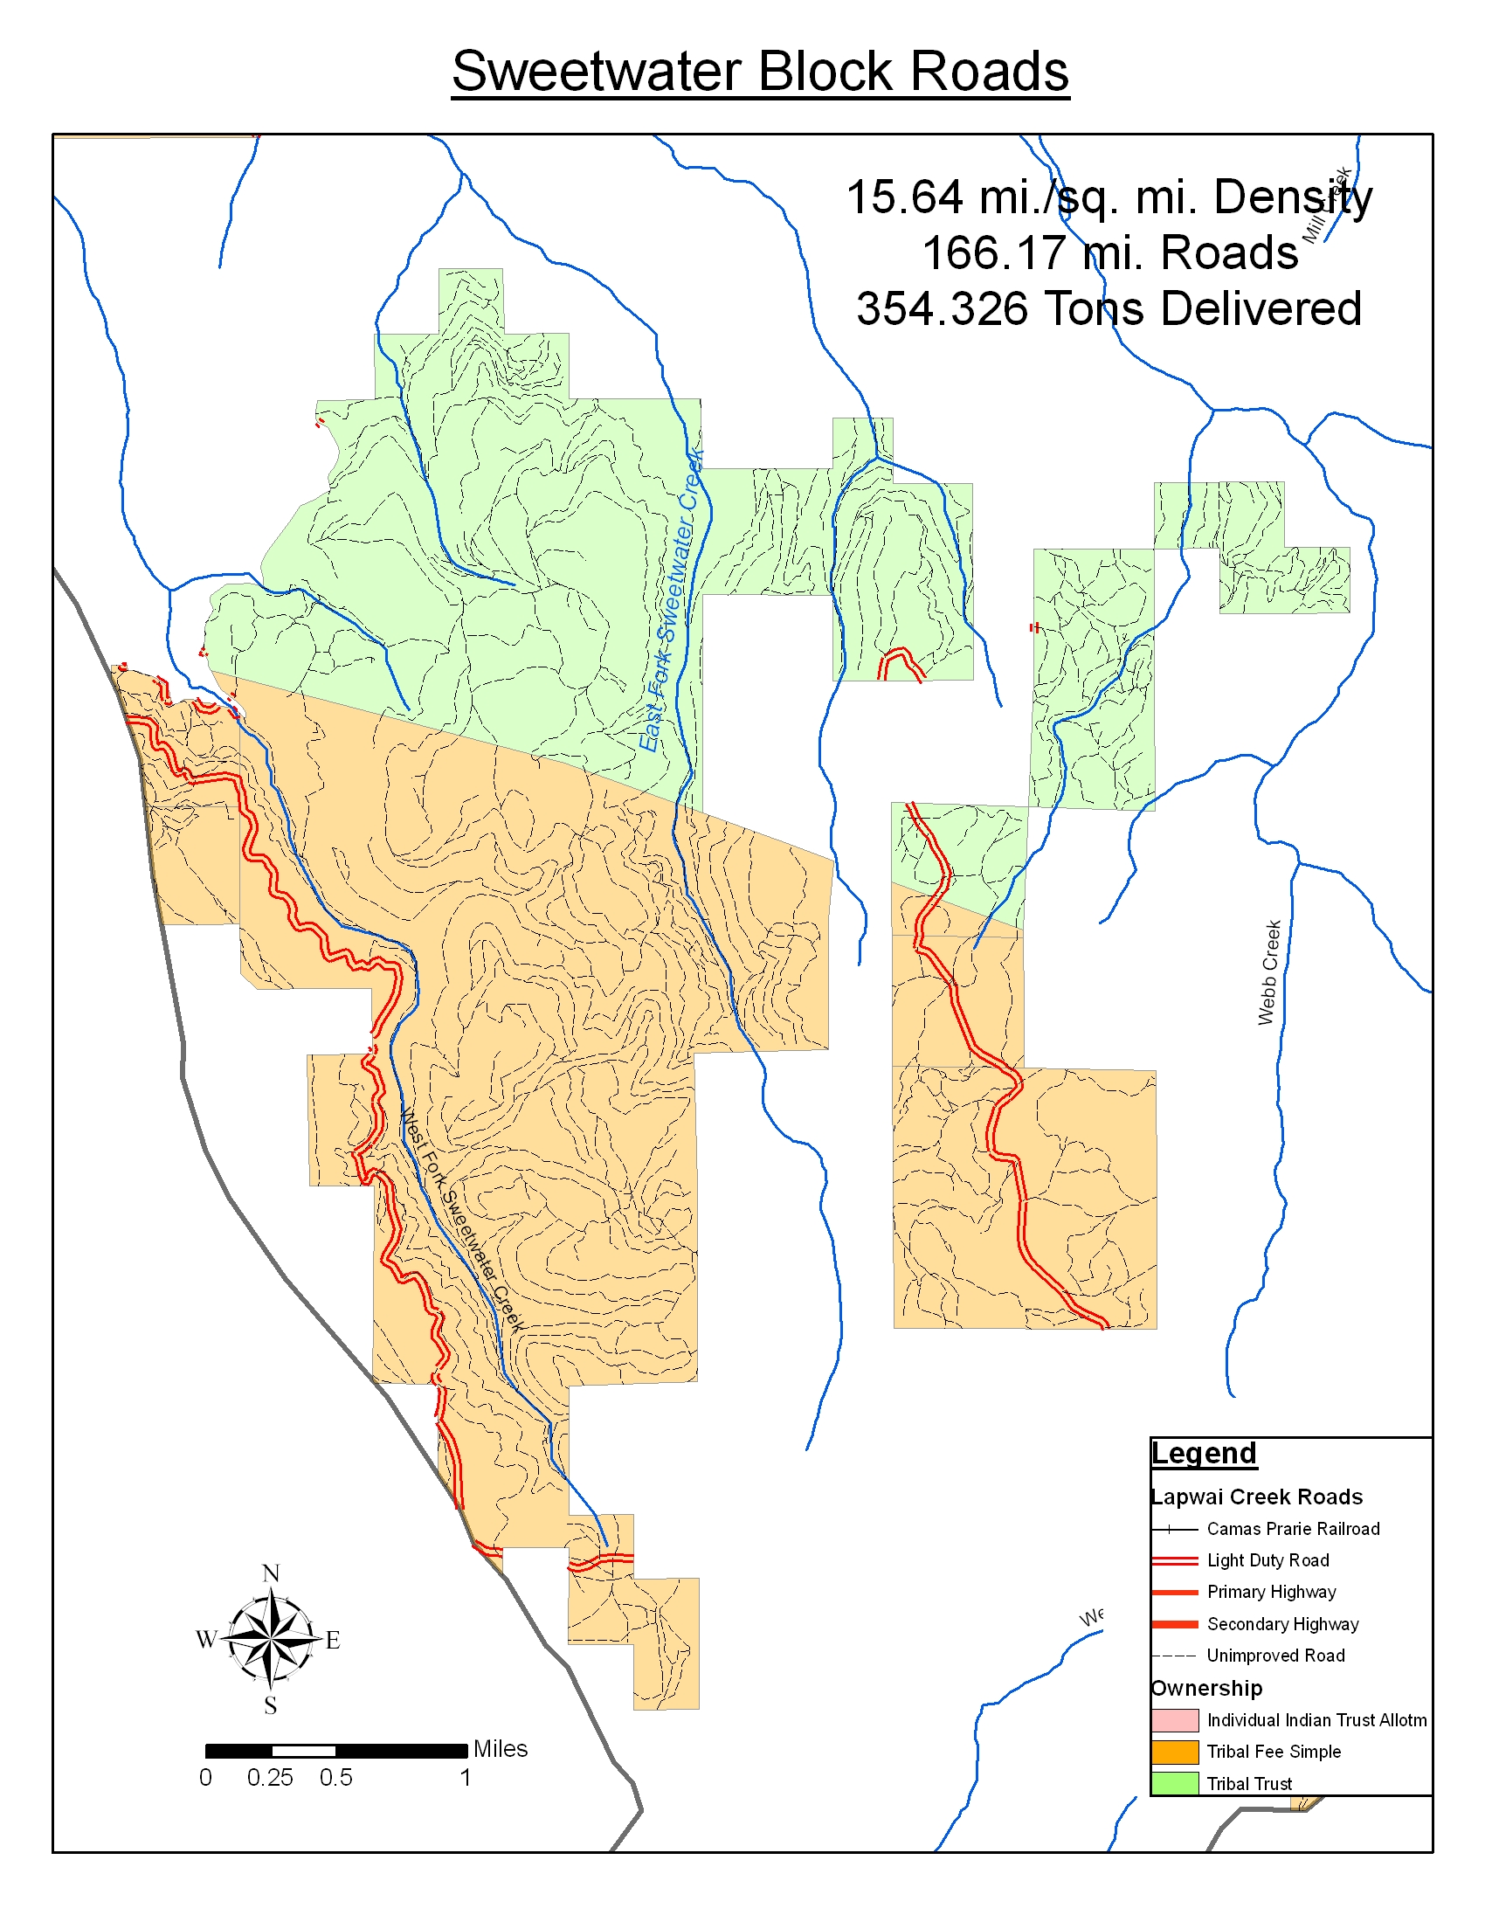
Figure 5: Existing Sweetwater Road Network
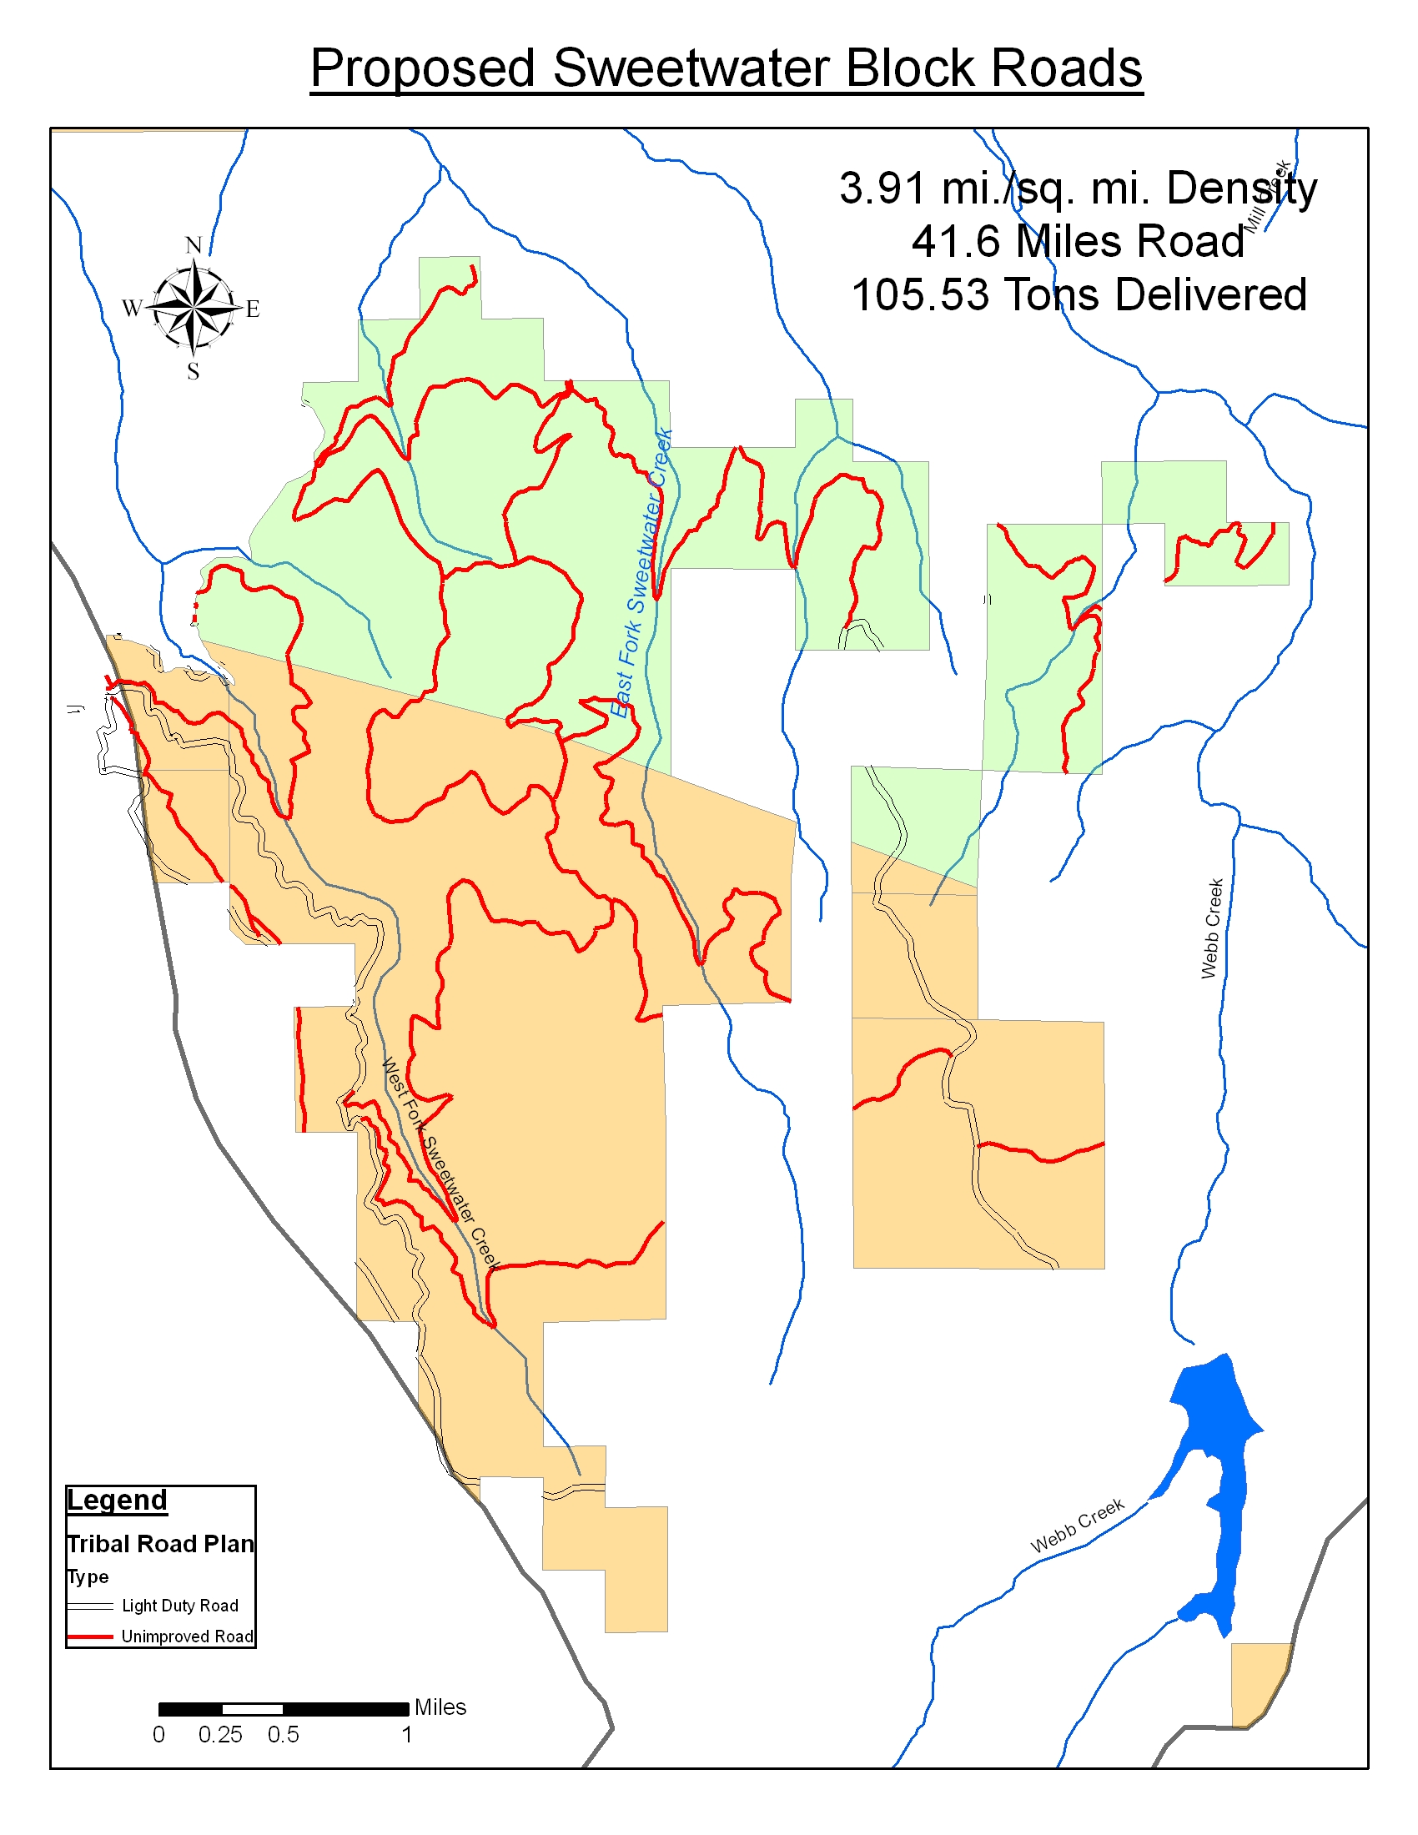
Figure 6: Proposed Sweetwater Road Network

PROJECT OBJECTIVE 5: Maintenance of Previously Implemented Projects

Work Element | Work Element Title | Timeframe | Methodology | Metrics
04a | Maintain Vegetation (WE 22) | Annually in 2007, 2008 and 2009 (May – August) | Maintain all previously planted vegetation by controlling noxious invasive weeds. Weed control methods include one or a combination of mechanical (pulling or mowing) herbicide (spot spraying) or biological means as recommended by NRAMP. Control will be completed by a combination of prison and tribal crews. | Target is to implement 60 acres of weed control per year.
04b | Operate and Maintain Habitat/Passage (WE 186) | Annually, April – November | Maintain previously constructed fence. | Target is to maintain approximately 15 miles of fence per year.

PROJECT OBJECTIVE 6: ENSURE PROJECT OBJECTIVES ARE ACHIEVED

Work Element | Work Element Title | Timeframe | Methodology | Metrics
05a | Collect/Generate/Validate Field and Lab Data (WE 157) | Annually in 2007, 2008 and 2009 (April – October) | Post project monitoring to ensure project specifications were completed. Set up and collect data to evaluate restoration projects to ensure desired outcomes are met over time. Data collection may include photo points, vegetation plots, cross-sections and post-year site inspections. | Post project compliance and implementation monitoring data.
05b | Analyze/Interpret Data (WE 162) | Annually in 2007, 2008 and 2009 (March – February) | Analyze project compliance and implementation monitoring data to ensure projects are meeting desired outcomes. Additional work and lessons learned will be incorporated into NRAMP plans. | Report detailing post-project success, listing any follow-up work and lessons learned.

PROJECT OBJECTIVE 6: INCREASE PUBLIC AWARENESS AND SUPPORT FOR STREAM/WATERSHED STEWARDSHIP AND PROJECTS

Work Element | Work Element Title | Timeframe | Methodology | Metrics
06a | Outreach and Education | Annually, March – February | Provide project specific and general fish habitat protection and restoration information to the public through local news papers, school news letters, radio announcements, public awareness meetings, billboards and educational presentations at the local schools. | Quarterly articles in NPWSCD publication, Tribal paper and Lewiston Morning Tribune Outdoors section; 1 watershed tour per year in coordination with the NPWSCD; 1 week of in class and field exercises within the 7th, 8th and 10th grade Lapwai High/Middle school classes

G. Facilities and equipment
Activities for this project will be based out of the Nez Perce Tribe Department of Fisheries Resources Management - Watershed Division offices. This project has been on-going since 1999. The project since then has acquired much of the needed infrastructure to complete this project. The project has 4 desk top computers and field equipment for monitoring, surveying and planting. The project will need to purchase a laptop computer for field work. Material will need to be purchased by the project for fencing and equipment will need to be purchased for the weed control. The project leases vehicles from GSA.
H. References

Clearwater Subbasin Team. 2001. Draft Clearwater Subbasin Summary

Clearwater Subbasin Management Plan (Draft), 2003

Clearwater Subbasin Plan Supplement and Response to Council Staff Subbasin Plan
Amendment Recommendation (Draft)

Ecovista, 2003. Draft Clearwater Subbasin Management Plan. Pullman, Washington.

Ecovista, Nez Perce Tribe Wildlife Division, Washington State University Center for Environmental Education. 2002. Final Draft Clearwater Subbasin Assessment. Pullman Washington.

Federal Caucus. 2000. Conservation of Columbia Basin Fish, Final Basin wide Salmon Recovery Strategy. Volume
I.
Furniss, M.J., M.A. Love, and S. A. Flanagan, 1997. Diversion Potential at Road-Stream Crossings. Water/Road Interaction Technology Series, 9777-1814-SDTC, USDA Forest Service, Technology and Development Program, San Dimas, California.

Christian, Richard, E.. Taylor, Jr. 2004. Fish Passage Assessment – Lapwai Creek Watershed. Lapwai, Idaho.

Johnson, C., and K. Stangl. 2000. Clearwater River, North Fork Clearwater River, and Middle Fork Clearwater River Subbasins biological assessment of ongoing and proposed Bureau of Land Management activities o fall Chinook salmon, steelhead trout, bull trout, and BLM sensitive species. Bureau of Land Management, Cottonwood Field Office, Cottonwood, Idaho.
National Marine Fisheries Service. 2000. Biological Opinion, Re-initiation of Consultation on Operation of the Federal Columbia River Power System, Including the Juvenile Fish Transportation Program and 19 Bureau of Reclamation Projects in the Columbia Basin.

National Marine Fisheries Service. 2005. ESA – Draft Section 7 Formal Consultation Biological and Conference Opinion for the Operation and Maintenance of the Lewiston Orchards Project (Draft).
Nez Perce Tribe and Idaho Department of Fish and Game. 1990. Clearwater River Subbasin Salmon and Steelhead Production Plan. Lapwai and Boise, Idaho.

Nez Perce Tribe Treaty of 1855 with the United States Federal Government

Northwest Power Planning Council. 1994. Columbia River Basin Fish and Wildlife Program. Northwest Power Planning Council. Portland, Oregon.

Northwest Power Planning Council. 2000. 2000 Columbia River Basin Fish and Wildlife Program. Northwest Power Planning Council. Portland, Oregon

Regional Interagency Executive Committee. 1995. Ecosystem Analysis at the Watershed Scale, Federal Guide for Watershed Analysis. Portland, Oregon

Steward, Cleveland R. 1996. Monitoring and Evaluation Plan for the Nez Perce Tribal Hatchery. Nez Perce Tribe Department of Fisheries Resource Management.
I. Key personnel

NAME: Emmit E. Taylor Jr.
TITLE: Project Leader
AGENCY: Nez Perce Tribe Fisheries/Watershed Division
HOURS: FTE
EDUCATION: B.S. Civil Engineering, Colorado State University, CO, 1995
CURRENT RESPONSIBILITIES: Project leader; road obliteration inspector; culvert prioritization; culvert survey, design, contract administration and construction inspection; gathering, analyzing, and interpreting watershed data; represent program in various inter-disciplinary teams; assist in surveying project areas; aide in assessing water resources/quality; knowledge of current computer software programs; design of civil engineering projects; supervise field crews; co-coordinate program projects.
RELEVANT TRAININGS:
- Fish Passage Design Workshop, 1999, USFS
- Public Works Contract Administration Training, 1999, USFS
- River Morphology & Applications, 1999, Wildland Hydrology
- Applied Fluvial Geomorphology, 1998, Wildland Hydrology
- AutoCAD R14 Fundamentals, 1998, PacifiCAD Inc.
- Road Obliteration Training, 1998, USDA Forest Service
- Riparian Proper Functioning Condition Training, 1998, Bureau of Land Mgmt.
DUTIES ON PROJECT: Mr. Taylor will be the Project Leader for all activities of this proposal. As project leader, Mr. Taylor will manage all tasks of this project to final completion and monitoring and evaluation.
PREVIOUS EMPLOYMENT:
- August 1997 – present: Nez Perce Tribal Fisheries/Watershed
Civil Engineer
- October 1995 – August 1997: Womer and Associates Engineering and Architecture Firm
Civil Engineer-In-Training
- May 1993 – October 1995: Colorado State University Tribal Transportation program Engineering Aide

EXPERTISE: Mr. Taylor background is in Civil Engineering with an emphasis in hydrology. Mr. Taylor’s analysis, design, and construction work concentrates on stream rehabilitation, stream morphology, water quality, road obliteration, in-stream structures, and fish passage improvements.
RELEVENT JOB COMPLETIONS:
1) Inspector on West Fork of Squaw Creek bottomless arch culvert installation, 2) Inspector on installation of Badger and Wendover Creek culvert installations, 3) Survey and design of Badger and Wendover Creek culvert replacements, 4) Road obliteration project leader and inspector, 1997-present, and 5) Geiger Boulevard Environmental Analysis.

NAME: Mark D. Reaney, Jr., P.E.
TITLE: Engineer-Watershed
AGENCY: Nez Perce Tribe Fisheries/Watershed Division
HOURS: FTE

Education:
1983 - B.S. Civil Engineering – Oregon Institute of Technology
Major: Public Works

Current Responsibilities: Watershed Engineer; Design and Implementation of watershed restoration projects: bridge design, culvert replacement alternatives, road obliteration, and surveying project areas; contract administration; gathering, analyzing, and interpretation of watershed data.

Relevant Training:
• Fluvial Geomorphology For Engineers, 2006, David Rosgen of Wildland Hydrology
• Interagency Watershed Restoration Coordination Workshop, 2005, Nez Perce Tribe
• Noxious Weed Identification, 2005, Dr. Rich Olds, University of Idaho
• River Channel Restoration, 2005, Teton Science School

DUTIES ON PROJECT: Mr. Reaney will be the Design Engineer for all road, culvert, bridge, and stream channel design activities of this proposal

Employment History:
• March 2005 – present NEZ PERCE TRIBE FISHERIES/WATERSHED
Engineer-Watershed
• Jan. 2002 – Feb. 2005 Cuddy & Associates
Civil Engineer
• June 1995 – Dec. 2001 MDR Engineering (Self employed)
Civil Engineer/ Consultant
• Aug. 1985 – June 1995 Oregon Dept. of Transportation
Transportation Engineer

Expertise: Professional experience includes professional registration as a Professional Engineer, with background working with bridge design projects, CAD design, soil stabilization projects, mechanically stabilized earth walls, road construction projects, transportation engineering and planning, surveying, and field research

Relevant Job Completions: Sweetwater Creek Bridge design; Herndon Bridge Replacement; Culvert Design Spreadsheet project design, final report, 2005 Road Erosion Survey-Lapwai Creek Watershed, Sweetwater Block Transportation Plan

NAME: Kent B. Werlin
TITLE: Habitat Biologist / Project Leader
AGENCY: Nez Perce Tribe Department of Fisheries Resource Management Watershed Division
HOURS: FTE
EDUCATION: Mr. Werlin graduated from the University of Colorado in 1999 with a Bachelors degree in Environmental Studies and from South Dakota State University in 2002 with a Master of Science Degree in Wildlife and Fisheries Sciences.
CURRENT RESPONSIBILITIES: project management, grant proposal writing, report writing, managing financial budgets, design and implementation of stream/wetland restoration projects, biological monitoring, community outreach and education, and coordination with state, federal and private organizations. Typical restoration activities include: livestock exclosure construction, off-site livestock watering developments, riparian weed control, planting native vegetation, bioengineering, and in-stream grade control structures.
RELEVANT TRAININGS:
2005. How to become a more effective supervisor. One-day course training course taught by CareerTrack. October, 2005.
2004. Introduction to ArcGIS 8.3. Two-day course hosted by the University of Idaho Geography Dept.
2004. Weed Identification Training. Short course taught by Dr. Rich Old and hosted by Idaho Fish and Game.
2004. Rapid River Reconnaissance for River Restoration Design and Appraisal. One-day short course taught by Nicholas Clifford, PhD, Professor of River Science, University of Nottingham, UK.
2004. Basic Wetland Delineation Training. Five-day (40 hr.) course hosted by Portland University and taught by the Wetland Training Institute.
2003. Introduction to Terra Sync and Pathfinder Office Software. Course provided by certified Trimble instructor Gunner Gardenhire. May 2003.
2003. Applied Fluvial Geomorphology. Course taught by Dave Rosgen of Wildland Hydrology Inc. of Pagosa Springs, CO.
2003. Native Plant Specifications for Restoration and Mitigation Projects. Course taught by staff from Sound Native Plants.
2003. Grant Writing Workshop. Taught by grant writing professionals from the University of Idaho.
2003. National Environmental Policy Act Training on Endangered Species Act Theme. Two-day course hosted by NOAA Fisheries. Boise, ID.
DUTIES ON PROJECT: Mr. Werlin will be the project leader of this project. As project leader, Mr. Werlin will be responsible for all coordination, management, and administrative duties related to this project.
PREVIOUS EMPLOYMENT:
- November 2002 – present: Nez Perce Tribal Fisheries/Watershed
Habitat Biologist/Project Leader
- June 2000 – October 2002: South Dakota State University
Wildlife and Fisheries Department
Research Assistant / Wetland Ecologist
- Jan. 1999 – Dec. 1999: Aquatic Restoration Technologies
Boulder, CO Reasearch Assistant / Grant Writer

EXPERTISE: Mr. Werlin has a strong technical background in aquatic and wetland ecology as well as significant experience with administrative and project management duties such as: coordination, budget management, and project oversight.
RELEVENT JOB COMPLETIONS:
1) Implementation and land management planning project lead for Lapwai Creek and Big Canyon Creek BPA projects, 2) Over 200 hours of outreach and watershed education to local students and landowners, 3) Planted over 5000 native trees and shrubs, 4) Designed and managed over 10 miles of riparian habitat restoration , and 5) Project lead on a 40+ acre riparian restoration project along Lapwai Creek.

NAME: Clint Chandler, Fisheries Biologist II
TITLE: Fisheries Biologist II
AGENCY: Nez Perce Tribe Fisheries/Watershed Division
HOURS: 1.0 FTE
EDUCATION: B.S. Biology, Eastern Oregon State University, La Grande, OR 1991
CURRENT RESPONSIBILITIES:
Responsible for budget preparation, subcontract preparation and management, equipment selection and procurement, personnel interviews, training and supervision, data collection and analysis, database management, report writing and proposal development.
EMPLOYMENT:
2002-Present: Nez Perce Tribe Fisheries/Watershed Division
Fisheries Biologist II/Project Leader
1999-2002: Nez Perce Tribe Fisheries/Research Division
Fisheries Technician II
1998: Science Application International Corporation
Terrestrial Ecologist
1997: USGS Columbia River Research Lab (subcontracted by Johnson Controls Inc.)
Fisheries Biologist
RELEVANT EXPERIENCE:
Thirteen years fisheries experience, eight of which juvenile salmonid research.
Experience with snorkel, screw-trap, gee-trap, weir, trawl, seine, gill-net, long-line, hook and line and electrofishing surveys.
Five years experience with habitat assessment, four of which stream aquatic.
Five years experience training and supervising fisheries aides, technicians and biologists.

Name: Lynn Rasmussen
Title: Project Manager
Agency: Nez Perce Soil and Water Conservation District
Hours: FTE
Project Duties:
Project management, planning, budgeting, to ensure identified work tasks are completed for the NPWSCD BPA project.
Current Responsibilities:
Responsible for managing NPSWCD programs in Nez Perce County, liaison with the Nez Perce Tribe, subcontract development, strategic planning, watershed and area-wide planning, coordination with state, tribe and local governments on priority conservation issues, supervise and train staff, develop and design conservation practices.
Education:
B.S. Crop Science, University of Idaho
Range, chemistry credits, New Mexico State University
M.S. Soils, University of Idaho
Relevant Training:
NRCS Area-wide planning, hydrology, stream morphology, water quality indicators guide, stream corridor restoration, conservation practice engineering design, construction inspection, nutrient management, bio-engineering applications, NEPA and ESA documentation, soil physics, stream visual assessment evaluation, BMP effectiveness evaluation, statistics, conservation program management, personnel management, locally led conservation and public involvement, conservation salesmanship, project management
Previous Employment:
July 2003 – Current: Nez Perce Soil and Water Conservation District, project manager
October 1995 – July 2003: Natural Resources Conservation Service District Conservationist
August 1993 - September 1995: Natural Resources Conservation Service/Watershed Enhancement Team, Resource Conservationist/planner
July 1990 – July 1993: Natural Resources Conservation Service, Soil Conservationist, St. Maries Field Office
June 1988 – June 1990: Natural Resources Conservation Service, Soil Conservationist, Moscow field office
June 1986-May 1988: University of Idaho, Research Assistant
Expertise:
Water quality planning, watershed planning, erosion calculation and analysis, conservation practices design

